Hello Jainam

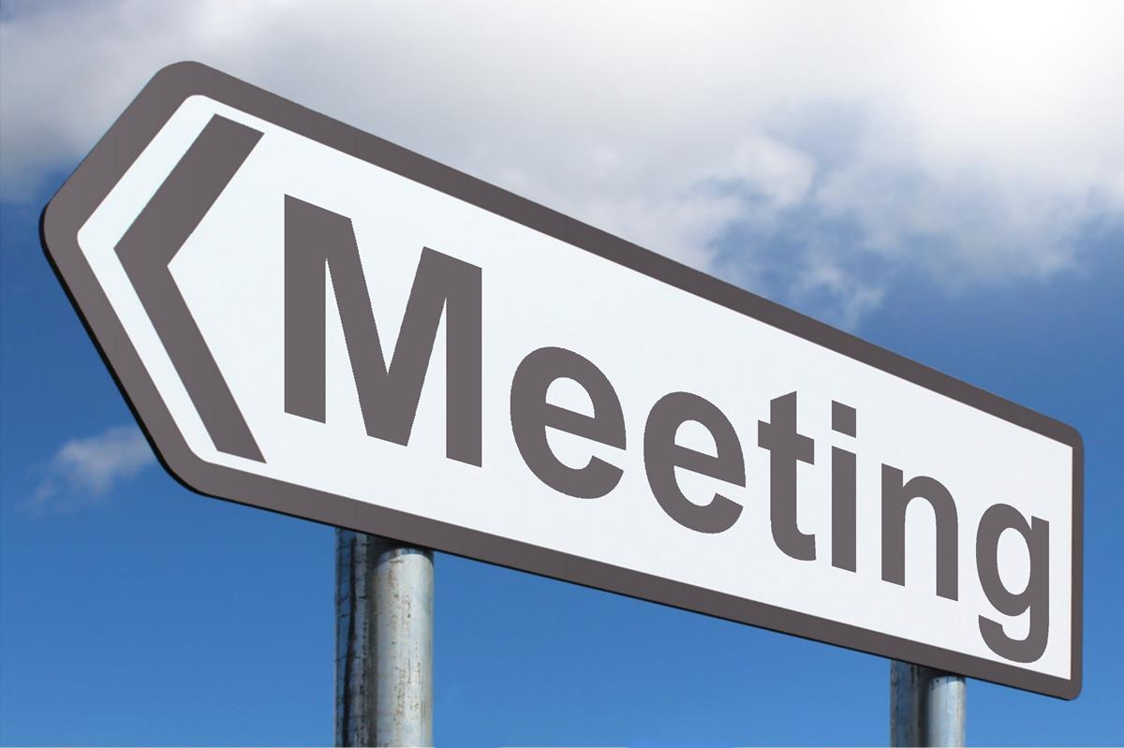

[This Photo](http://picpedia.org/highway-signs/m/meeting.html) by Unknown Author is licensed under [CC BY-SA](https://creativecommons.org/licenses/by-sa/3.0/)

How are you???

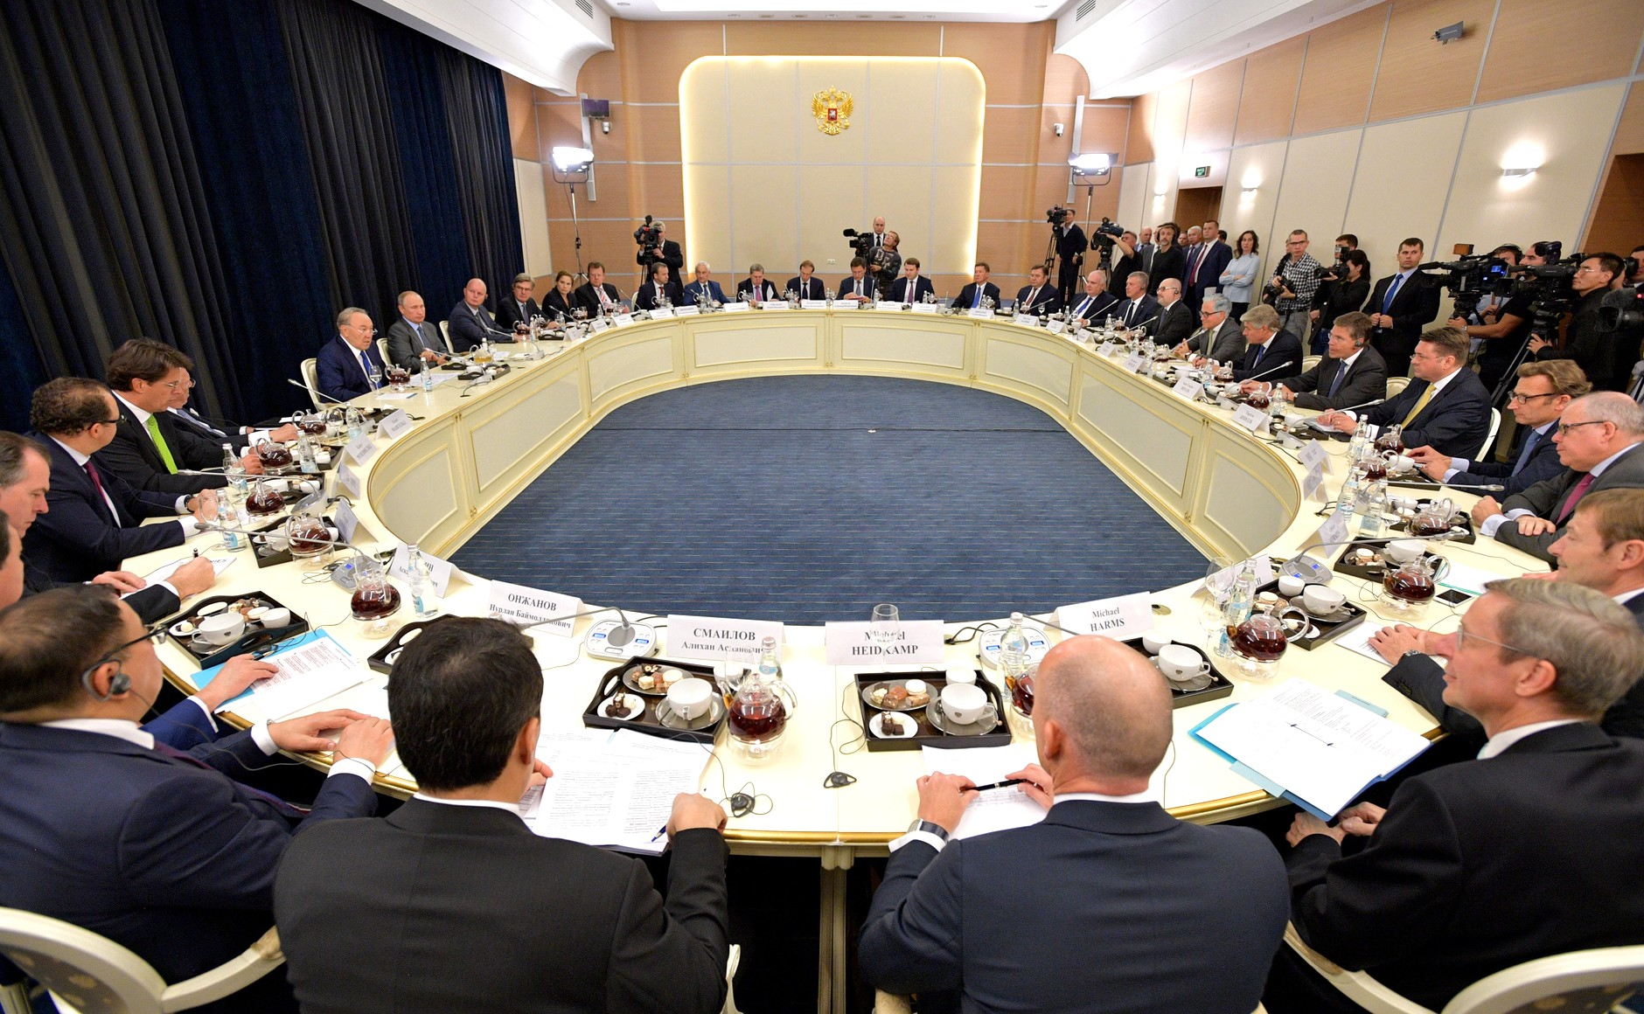

[This Photo](http://www.en.kremlin.ru/events/president/news/55824/photos) by Unknown Author is licensed under [CC BY](https://creativecommons.org/licenses/by/3.0/)

Hope you are fine.