Voltage Regulator Circuit for Raspberry Pi or servo motor
(or anything that needs 5V)

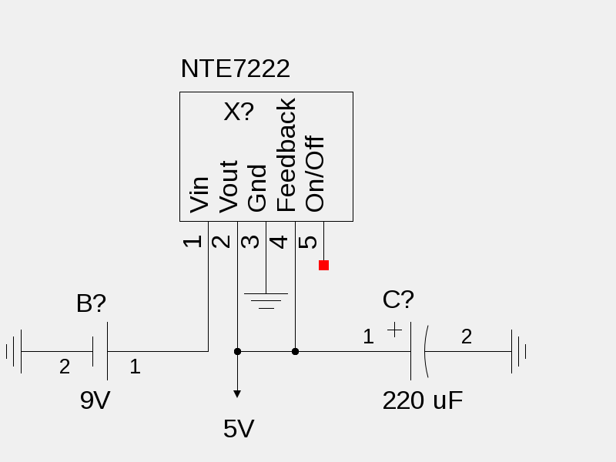
This circuit converts voltage of up to 40V to the 5V required by the Raspberry Pi.

Components: 1 NTE 7222 Voltage regulator, 1 Capacitor (220 uF works well)

Pins: NTE 7222 Pins are numbered from 1 to 5 (left to right, looking at the NTE 7222 from the side carrying the writing.

Wiring:
- Pin 1 is connected to the input voltage
- Pin 2 is the circuit’s output
- Pin 3 is connected to ground
- Pin 4 is connected to pin 2, as shown (this allows the circuit to sense the output voltage and correct deviations from 5V)
- Pin 5 is not used (it can be used to switch off the circuit if set high, if one wishes)
- A capacitor connects the 2 and pin 4 to ground, as shown (this stabilizes the circuit and allows precise voltage regulation – if the capacitor is too small the voltage will be higher than 5V)

