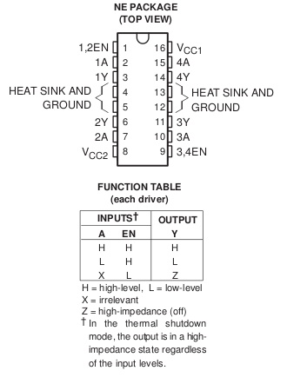
How to wire motor controller TI SN754410 to drive 1 or 2 DC motors

Pin | Connection
1 | Pi GPIO (any free pin)
2 | Pi GPIO (any free pin)
3 | Motor (any terminal)
4 | Ground
6 | Motor (any terminal)
7 | Pi GPIO (any free pin)
8 | Positive battery terminal (4.5 – 36 V)
16 | Pi 5V (or battery)

How to drive the motor
To supply voltage to the motor pin 1 must be high (“enable” pin). Pins 2 and 7 drive the motor in opposite directions and should not be high at the same time. In other words:

Pin 1 | Pin 2 | Pin 7 | Result
H | H | L | Motor spins in one direction
H | L | H | Motor spins in the other direction
L | any | any | Motor off*
H | L | L | Motor off*
H | H | H | Don’t!
* Check whether there is a difference, one might be brake, the other coast

How to control speed
If you just set pin 1 to H and either 2 or 7 to H, and you keep them that way, the motor will turn at the full speed allowed by the battery voltage. Speed control is achieved by “pulse width modulation” (PWM). In short the input pin (either 2 or 7) is turned on and off very quickly so that the motor sees a voltage that is proportional to the time the pin is on vs. off. To drive a motor at 25% of the maximum speed allowed by the battery, for example, the input pin is set to be on 25% of the time. PWM is controlled in software (see, e.g., http://abyz.co.uk/rpi/pigpio).

Note on battery power
Do not use a battery that supplies a higher voltage than the motor can tolerate! Check the motor specs.

How to drive a second motor
The scheme above can be mirrored on the other side of the chip to control a second motor. The only difference is that pin 16 does not change, and the enable signal is sent through pin 9 instead.

