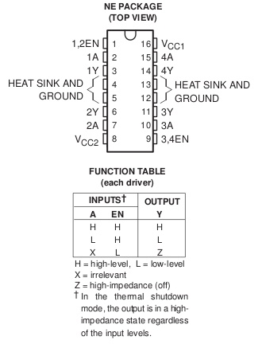
How to wire motor controller TI SN754410 to drive a servo motor

Pin | Connection
1 | Pi GPIO (any free pin)
2/7/10/15 | Pi GPIO (any free pin)
3/6/11/14 | Motor (positive terminal)
4/5 | Ground (PI and Battery must have same ground)
8 | Positive battery terminal (4.5 – 36 V)
16 | Pi 5V (or battery)

Wiring note
Servo motors are controlled through one output only, hence 4 servos can be controlled by one chip (or 2 servos + 1 DC motor, which needs two outputs).

Battery note
Servos usually take 5V input. If the battery supplying the chip is higher voltage, you need a voltage regulator.

How to drive the motor
The length of pulses on the pin encodes the position of the motor and is controlled in software (e.g., http://abyz.co.uk/rpi/pigpio).

