SUPPLEMENTARY MATERIALS

**Exploring the Mechanisms of Sex-Specific Proarrhythmia in Long QT Syndrome through Computational Modeling**

Isabella Doherty,1 Roshni Shetty,1 Haibo Ni,1 Stefano Morotti,1 Eleonora Grandi1

1 Department of Pharmacology, University of California Davis, Davis, California, United States

Correspondence: Eleonora Grandi (ele.grandi@gmail.com)

**Supplementary Methods:**

Equations describing the voltage dependence of steady-state activation (xs1ss, xs2ss) and activation time constant (τxs1, τxs2) of IKs:



in the female and male model respectively.

**Supplementary Figures:**

**Figure S1**. **Sex-specific parameterization of the ORd biophysical model of the human cardiac action potential and Ca2+ handling.** *A:* Simulated transmembrane potential and cytosolic Ca2+ concentration traces upon pacing at 1,000ms BCL in the male (red) and female (blue) ventricular endocardial cardiomyocyte models. *B:* Pacing rate dependence of simulated biomarkers: APD90, APD50, diastolic Ca2+ concentration, CaT amplitude, CaD50, and SR Ca2+ content.

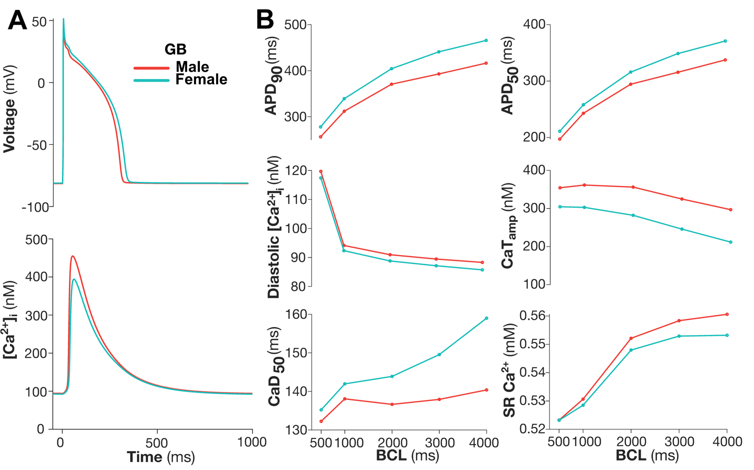

**Figure S2**. **Sex-specific parameterization of the GB biophysical model of the human cardiac action potential and Ca2+ handling.** *A:* Simulated transmembrane potential and cytosolic Ca2+ concentration traces upon pacing at 1,000ms BCL in the male (red) and female (blue) ventricular endocardial cardiomyocyte models. *B:* Pacing rate dependence of simulated biomarkers: APD90, APD50, diastolic Ca2+ concentration, CaT amplitude, CaD50, and SR Ca2+ content.

**Figure S3. Simulation of IKr loss-of-function in male and female** **ORd models**. *A:* Simulated transmembrane potential and cytosolic Ca2+ concentration traces upon pacing at 3,000ms BCL of female (blue) and male (red) in the presence and absence of IKr loss-of-function (LoF) (corresponding to an 80% decrease in GKr, dashed lines). *B:* Pacing rate dependence of simulated biomarkers: APD90, APD50, diastolic Ca2+ concentration, CaT amplitude, CaD50, and SR Ca2+ content.

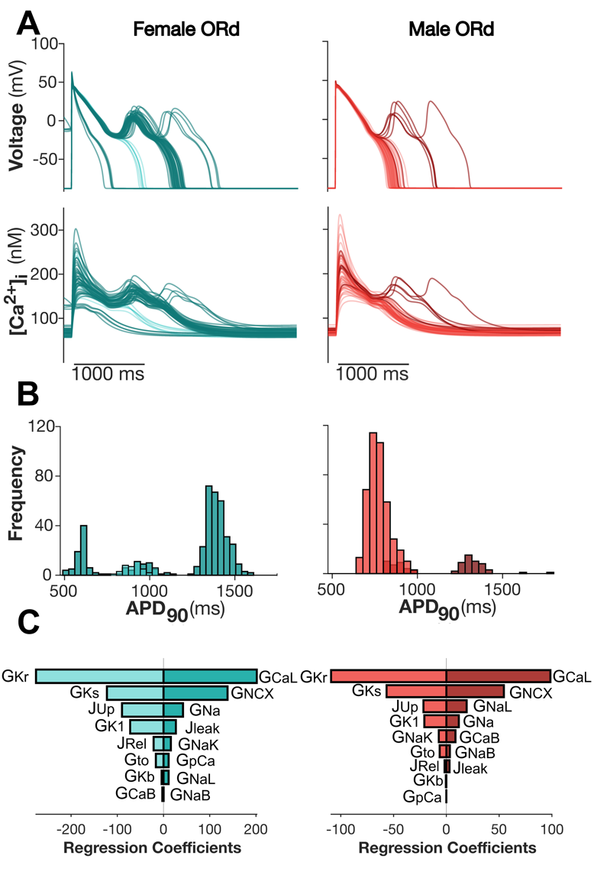

**Figure S4. Male and female populations of ORd models with IKr loss-of-function**. *A:* Representative traces of transmembrane potential and cytosolic Ca2+ concentration for 50 female (EAD+ dark blue, EAD- light blue) and 50 male (EAD+ dark red, EAD- light red) model variants extracted from sex-specific populations of 500 models upon pacing at a BCL of 3,000ms. *B:* Distribution of EAD+ APD90 durations (dark blue female, dark red male) and EAD- APD90 durations (light blue female, light red male) across the total population. EADs occurred in 91.4% of female and 16.0% of male models in the population. *C:* Results of logistic regression analysis for female (R2=0.999) and male (R2=0.999) populations quantifying the sensitivity of development of EADs to changes in the listed model parameters.

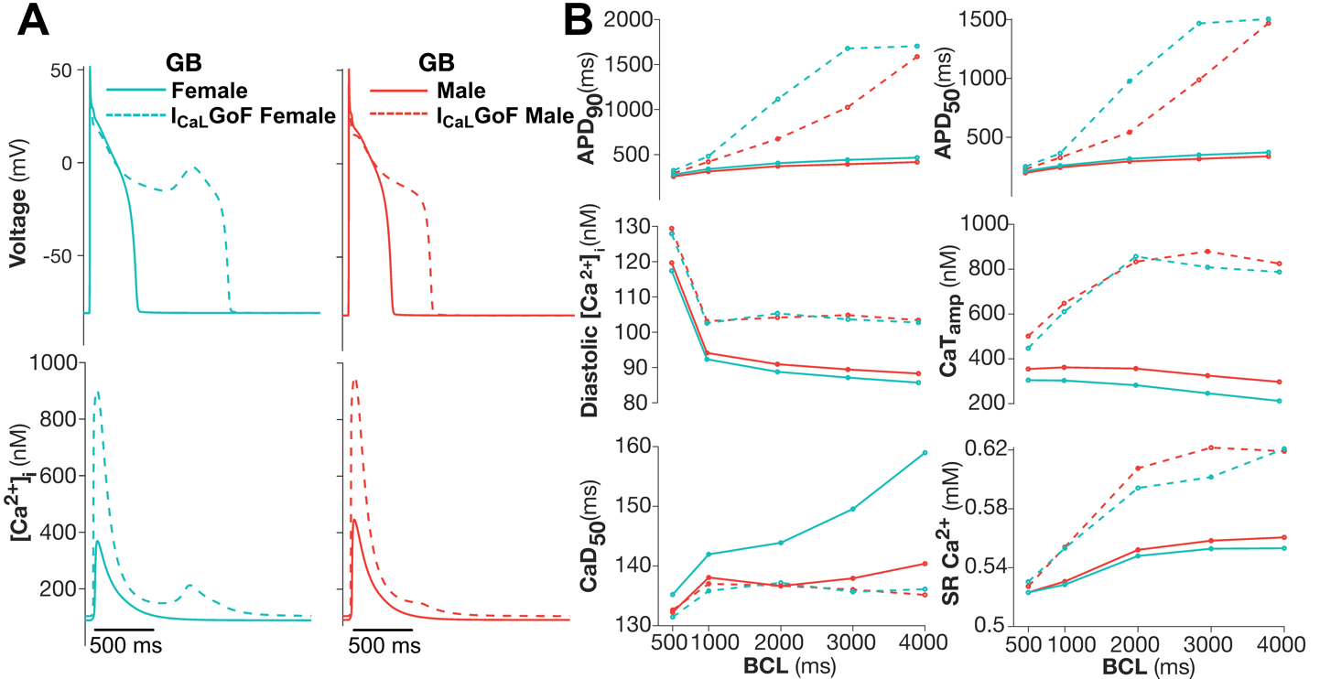

**Figure S5. Simulation of ICaL gain-of-function in male and female** **GB models**. *A:* Simulated transmembrane potential and cytosolic Ca2+ concentration traces upon pacing at 2,000ms BCL of female (blue) and male (red) in the presence and absence of ICaL gain-of-function (GoF) (corresponding to a 5% increase in GCaL and -3mV shift in the steady-state activation, dashed lines). *B:* Pacing rate dependence of simulated biomarkers: APD90, APD50, diastolic Ca2+ concentration, CaT amplitude, CaD50, and SR Ca2+ content.

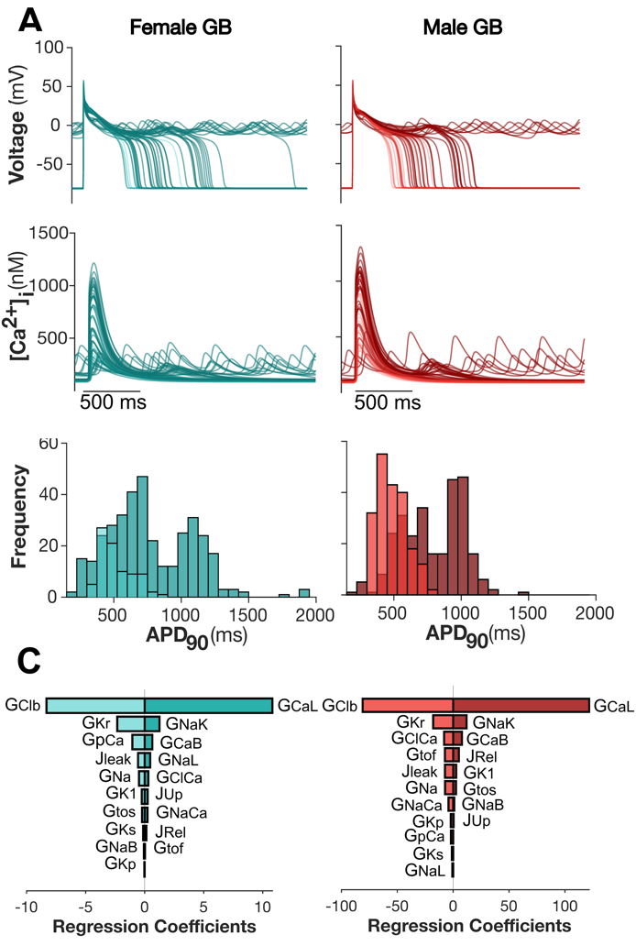

**B**

**Figure S6. Male and female populations of GB models with ICaL gain-of-function**. *A:* Representative traces of transmembrane potential and cytosolic Ca2+ concentration for 50 female (EAD+ dark blue, EAD- light blue) and 50 male (EAD+ dark red, EAD- light red) model variants extracted from sex-specific populations of 500 models upon pacing at a BCL of 2,000ms. *B:* Distribution of EAD+ APD90 durations (dark blue female, dark red male) and EAD- APD90 durations (light blue female, light red male) across the total population. EADs occurred in 52.2% of female and 38.4% of male models in the population. *C:* Results of logistic regression analysis for the female (R2=0.878) and male (R2=0.977) population quantifying the sensitivity of development of EADs to changes in the listed model parameters.

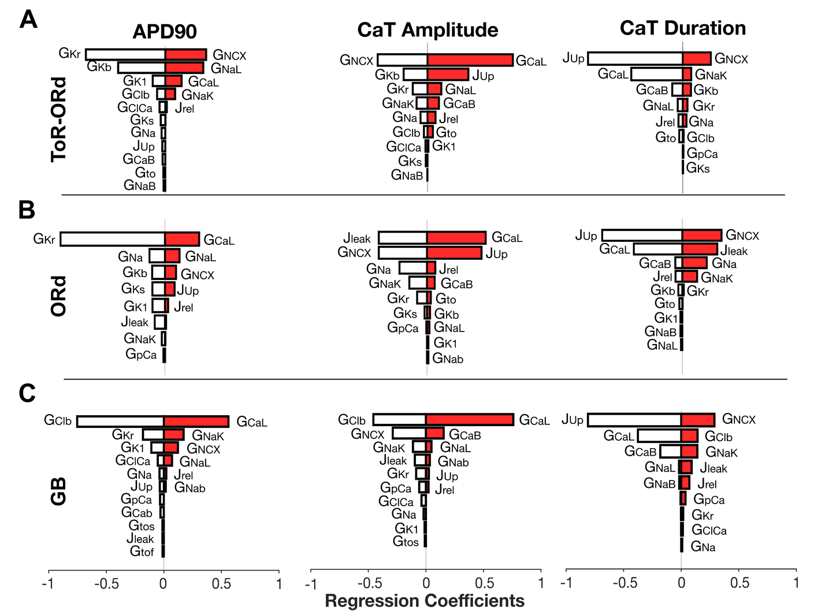

**Figure S7. Linear Regression Analysis for APD90, CaTAmplitude, and CaT Duration**. *A:* Results of linear regression analysis in the male ToR-ORd model paced at a BCL of 1,000ms quantifying the sensitivity of APD90, CaT amplitude, and CaT duration (R2= 1.0, 1.0, 0.99) to changes in the listed model parameters. *B:* Results of linear regression analysis in the male ORd model paced at a BCL of 1,000ms quantifying the sensitivity of APD90, CaT amplitude, and CaT duration (R2= 0.99, 0.99, 0.99) to changes in the listed model parameters. *C:* Results of linear regression analysis in the male GB model paced at a BCL of 1,000ms quantifying the sensitivity of APD90, CaT amplitude, and CaT duration (R2= 0.95, 0.98, 0.99) to changes in the listed model parameters.

**Figure S8. Linear Regression Analysis for APD90, CaTAmplitude, and CaT Duration**. *A:* Results of linear regression analysis in the female ToR-ORd model paced at a BCL of 1,000ms quantifying the sensitivity of APD90, CaT amplitude, and CaT duration (R2= 1.0, 1.0, 0.99) to changes in the listed model parameters. *B:* Results of linear regression analysis in the female ORd model paced at a BCL of 1,000ms quantifying the sensitivity of APD90, CaT amplitude, and CaT duration (R2= 0.99, 0.99, 0.98) to changes in the listed model parameters. *C:* Results of linear regression analysis in the female GB model paced at a BCL of 1,000ms quantifying the sensitivity of APD90, CaT amplitude, and CaT duration (R2= 0.92, 0.98, 0.99) to changes in the listed model parameters.