device: cuda
loading: /content/drive/MyDrive/DSCI_510/splits/final_models/seed_42/best_model

Loading weights: 100%
201/201 [00:00<00:00, 520.35it/s, Materializing param=roberta.encoder.layer.11.output.dense.weight]
loading: /content/drive/MyDrive/DSCI_510/splits/final_models/seed_43/best_model

Loading weights: 100%
201/201 [00:00<00:00, 549.83it/s, Materializing param=roberta.encoder.layer.11.output.dense.weight]
loading: /content/drive/MyDrive/DSCI_510/splits/final_models/seed_44/best_model

Loading weights: 100%
201/201 [00:00<00:00, 542.44it/s, Materializing param=roberta.encoder.layer.11.output.dense.weight]
Running validation inference...
model 1/3
model 2/3
model 3/3

===== Equal-weight val result =====
val_acc = 0.6690
val_f1 = 0.6680

Val confusion matrix:
[[271 45 17]
[ 46 213 75]
[ 29 119 185]]

Plotting validation ROC AUC...
macro-average AUC = 0.8425
ROC figure saved to: /content/roc_auc_val.png

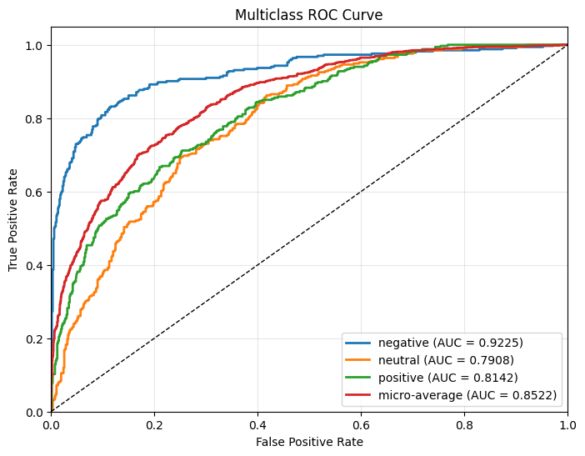
Precision/Recall figure saved to: /content/precision_recall_val.png

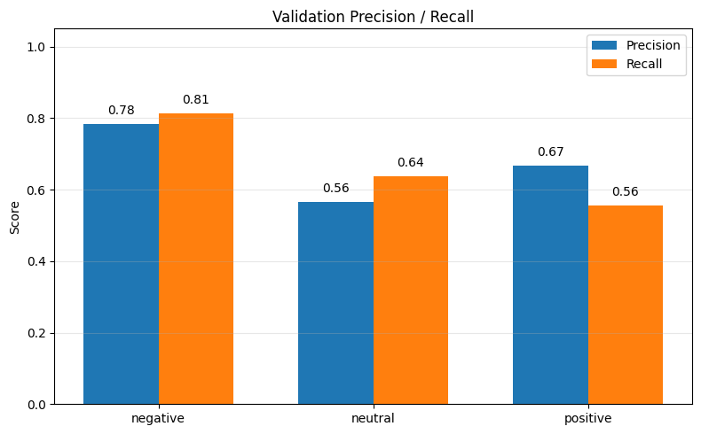
Per-class precision: {'negative': np.float64(0.7832), 'neutral': np.float64(0.565), 'positive': np.float64(0.6679)}
Per-class recall : {'negative': np.float64(0.8138), 'neutral': np.float64(0.6377), 'positive': np.float64(0.5556)}
Support : {'negative': np.int64(333), 'neutral': np.int64(334), 'positive': np.int64(333)}
Saved to /content/val_metrics.png

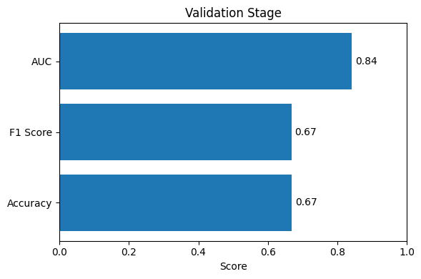
Running test inference...
model 1/3
model 2/3
model 3/3

===== Equal-weight test result =====
test_acc = 0.6530
test_f1 = 0.6547

Confusion matrix:
[[256 57 21]
[ 39 206 88]
[ 25 117 191]]

Plotting test ROC AUC...
macro-average AUC = 0.8323
ROC figure saved to: /content/roc_auc_test.png

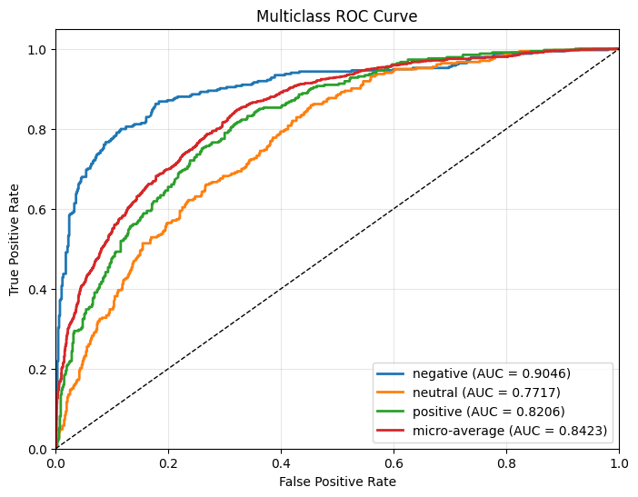
Precision/Recall figure saved to: /content/precision_recall_test.png

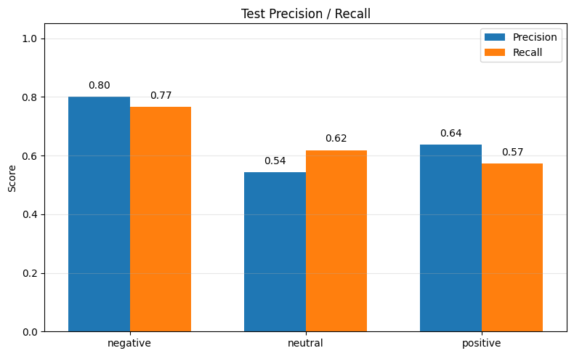
Per-class precision: {'negative': np.float64(0.8), 'neutral': np.float64(0.5421), 'positive': np.float64(0.6367)}
Per-class recall : {'negative': np.float64(0.7665), 'neutral': np.float64(0.6186), 'positive': np.float64(0.5736)}
Support : {'negative': np.int64(334), 'neutral': np.int64(333), 'positive': np.int64(333)}
{'accuracy': 0.653, 'f1_macro': 0.6547300811223623, 'confusion_matrix': array([[256, 57, 21],
[ 39, 206, 88],
[ 25, 117, 191]]), 'auc': np.float64(0.8323207206074904)}
Saved to /content/test_metrics.png

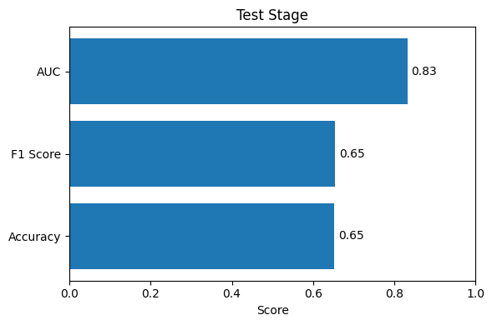
Sample predictions:
Would you like to have them altered ? => negative
Yes , I also felt that . => positive
Why is it called Autumn Moon over the Calm Lake ? => positive
Where are you now ? => neutral
Oh , my God ! => negative
Of course , but I'll have to go now . => neutral
So you want to go to Malibu ? => neutral
What's wrong ? => negative
What are you so excited about ? => positive
I'd like to have steak and a beer . => neutral

