Table of Contents

AMRIT — operator and methods manual
Antimicrobial Resistance Monitoring, Intelligence and Tracking
This manual covers both halves of the system and the reasoning behind them:
- Part I — the desktop application, which a laboratory runs on its own computer, offline.
- Part II — the central web portal, which a programme runs for a country or a network.
- Part III — methods and rationale, which states what each analytical choice is, what the alternatives were, and why this one was taken. Part III is written to be quotable in a paper: every method names the module that implements it.
Every screenshot is captured from a running build — the desktop screens by the application's own AMRIT_CAPTURE_DIR mode against a freshly seeded demonstration database, the portal screens by tools/capture_portal.mjs signed in as each role — and every figure is generated by tools/build_manual_figures.py. Neither is drawn by hand, because a picture that is edited separately from the system drifts away from it and nobody notices until a reader follows it and is wrong.

Contents
Part I — Desktop application
- What it is for, and what it refuses to do
- Install and first run
- Configure the deployment (country, branding, levels)
- Register the laboratory and place it on the map
- Catalogues and breakpoints
- Enter data
- Quality control and decision support
- Analyse
- One Health capture
- Export
- Join a central server (federation)
- Privacy, retention, audit
Part II — Central web portal 13. Deploy the server 14. The site registry and enrolment 15. Asking questions 16. Dashboards, by stakeholder 17. The outbreak console 18. From a signal to an action plan 19. The public view 20. Audit and governance 21. Portal administration: users, roles, capabilities
Part III — Methods and rationale 22. Data model and standards 23. Breakpoint interpretation 24. Deduplication 25. Indicators 26. Outbreak detection 27. Privacy engineering 28. Federation protocol design 29. Dashboard computation 30. Limitations and threats to validity
Appendices — A commands · B environment · C role capabilities · D metric catalogue · E demo credentials

Part I — Desktop application

1. What it is for, and what it refuses to do
A microbiology laboratory produces isolate records: a patient, a specimen, an organism, and a panel of antimicrobial susceptibility results. AMRIT's desktop application is where those records live. It is a local-first application — Electron over SQLite — and it is fully functional with no network at all. A laboratory can install it, type records for a year, analyse them, print an antibiogram and export a WHONET file without ever connecting to anything.
It refuses three things by construction:
- It never uploads a patient row. What leaves this application over the network is a count or a rate (§27, §28).
- It never interprets a susceptibility result against a breakpoint set nobody activated (§23).
- It never invents data. A value it cannot read, map or interpret is reported and left blank, not guessed.
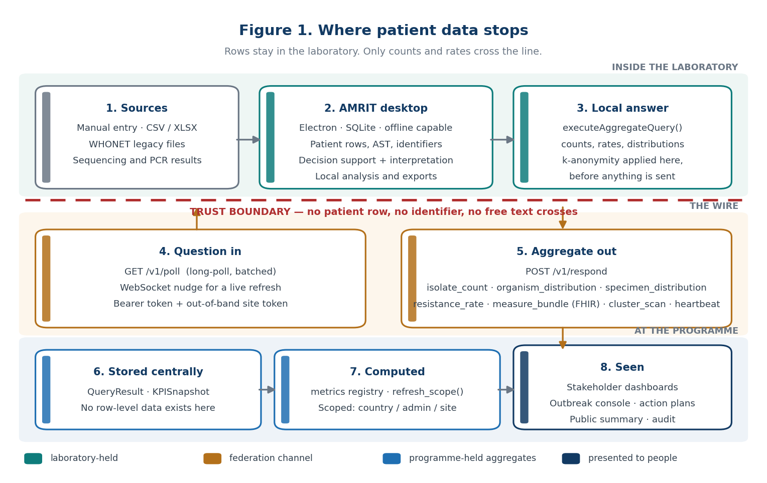
Figure 1 — where patient data stops.
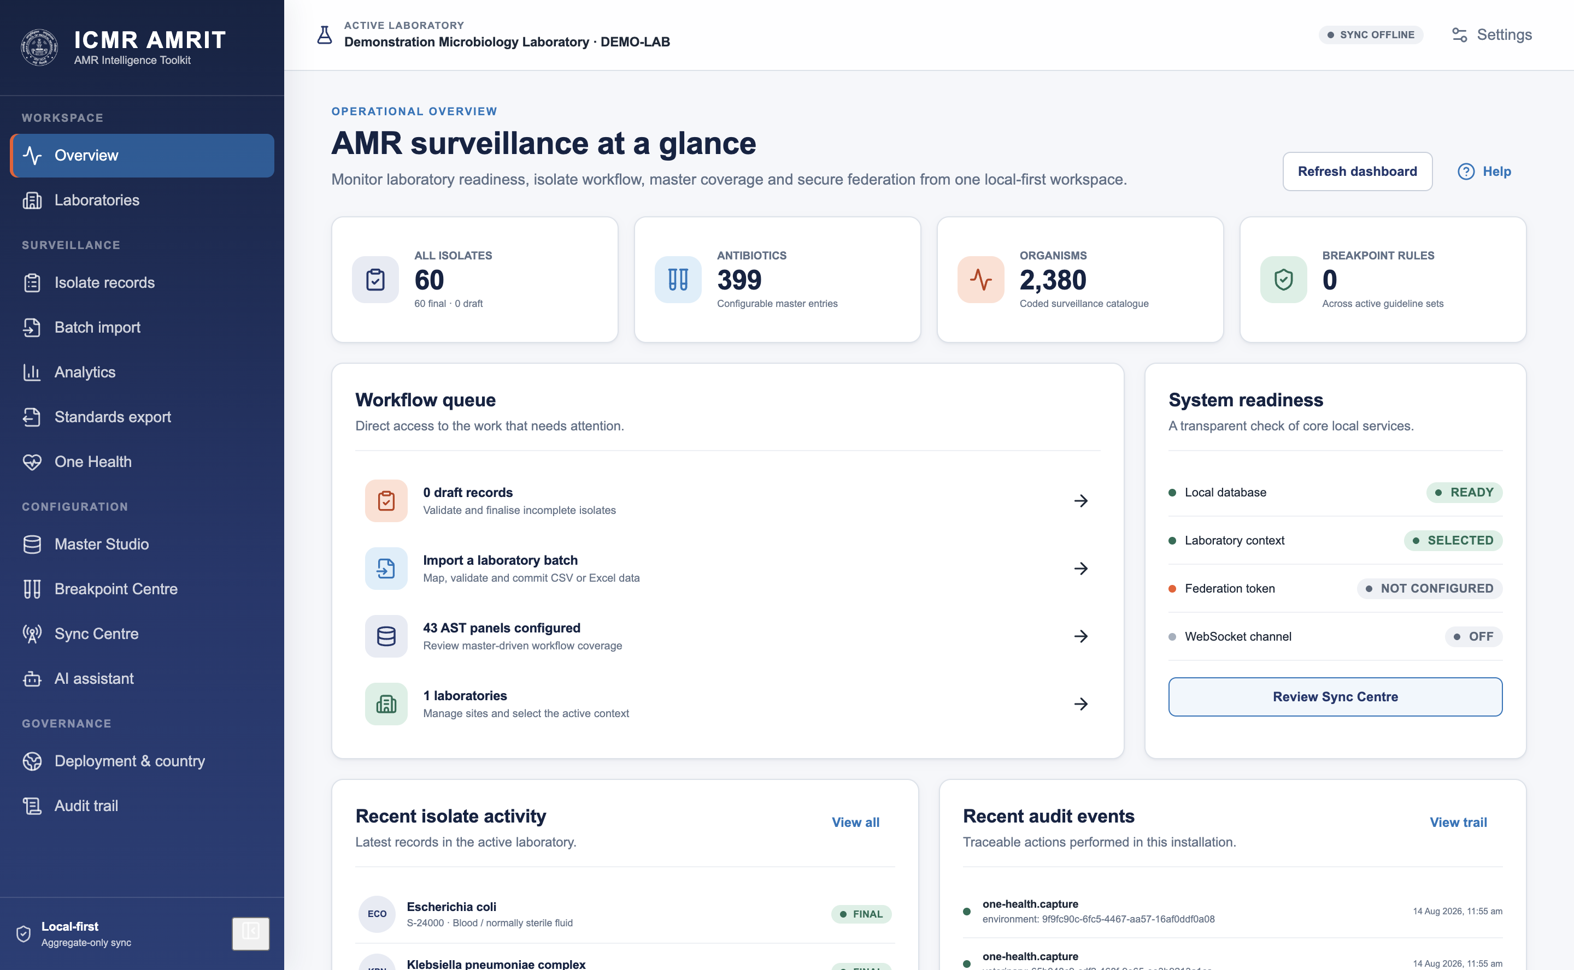

2. Install and first run
Install the build for your platform (.dmg, .exe, .AppImage). On first run the application creates its database under the operating system's application-data directory and seeds the packaged catalogue: WHONET organisms, antimicrobials, specimen types, expert rules and panels, hash-pinned so a tampered catalogue is refused rather than loaded.
Nothing else is created. There is no default account, no default laboratory and no sample data — a deployment holding real results must never inherit invented ones.

3. Configure the deployment
Deployment → country profile. The profile decides the country, its administrative tiers (what they are called and how many there are), the default guideline (CLSI or EUCAST), identifier namespaces, branding and the retention period. A profile is data, not code: the same binary serves any country, and python3 tools/generate_country_reference.mjs scaffolds a new one.
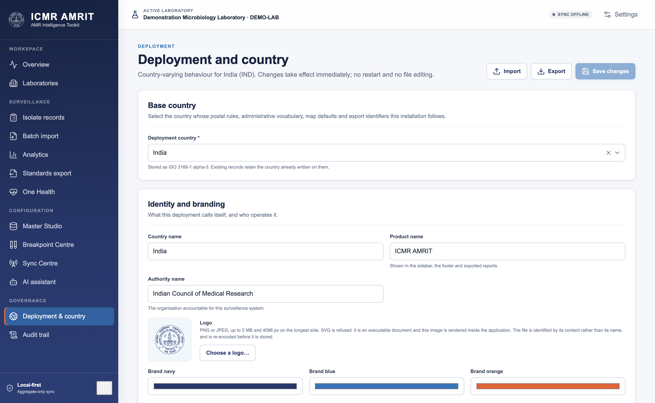
Two changes are irreversible and say so before they are saved: changing the identifier namespace (existing identifiers keep the old one) and changing the country (geography and overrides from the previous country are discarded).

4. Register the laboratory and place it on the map
Laboratories → New laboratory. A laboratory needs a code, a name and an address in the country's own address shape — the form is generated from the profile, so an Indian deployment asks for state and district and a Testland deployment asks for governorate and district.
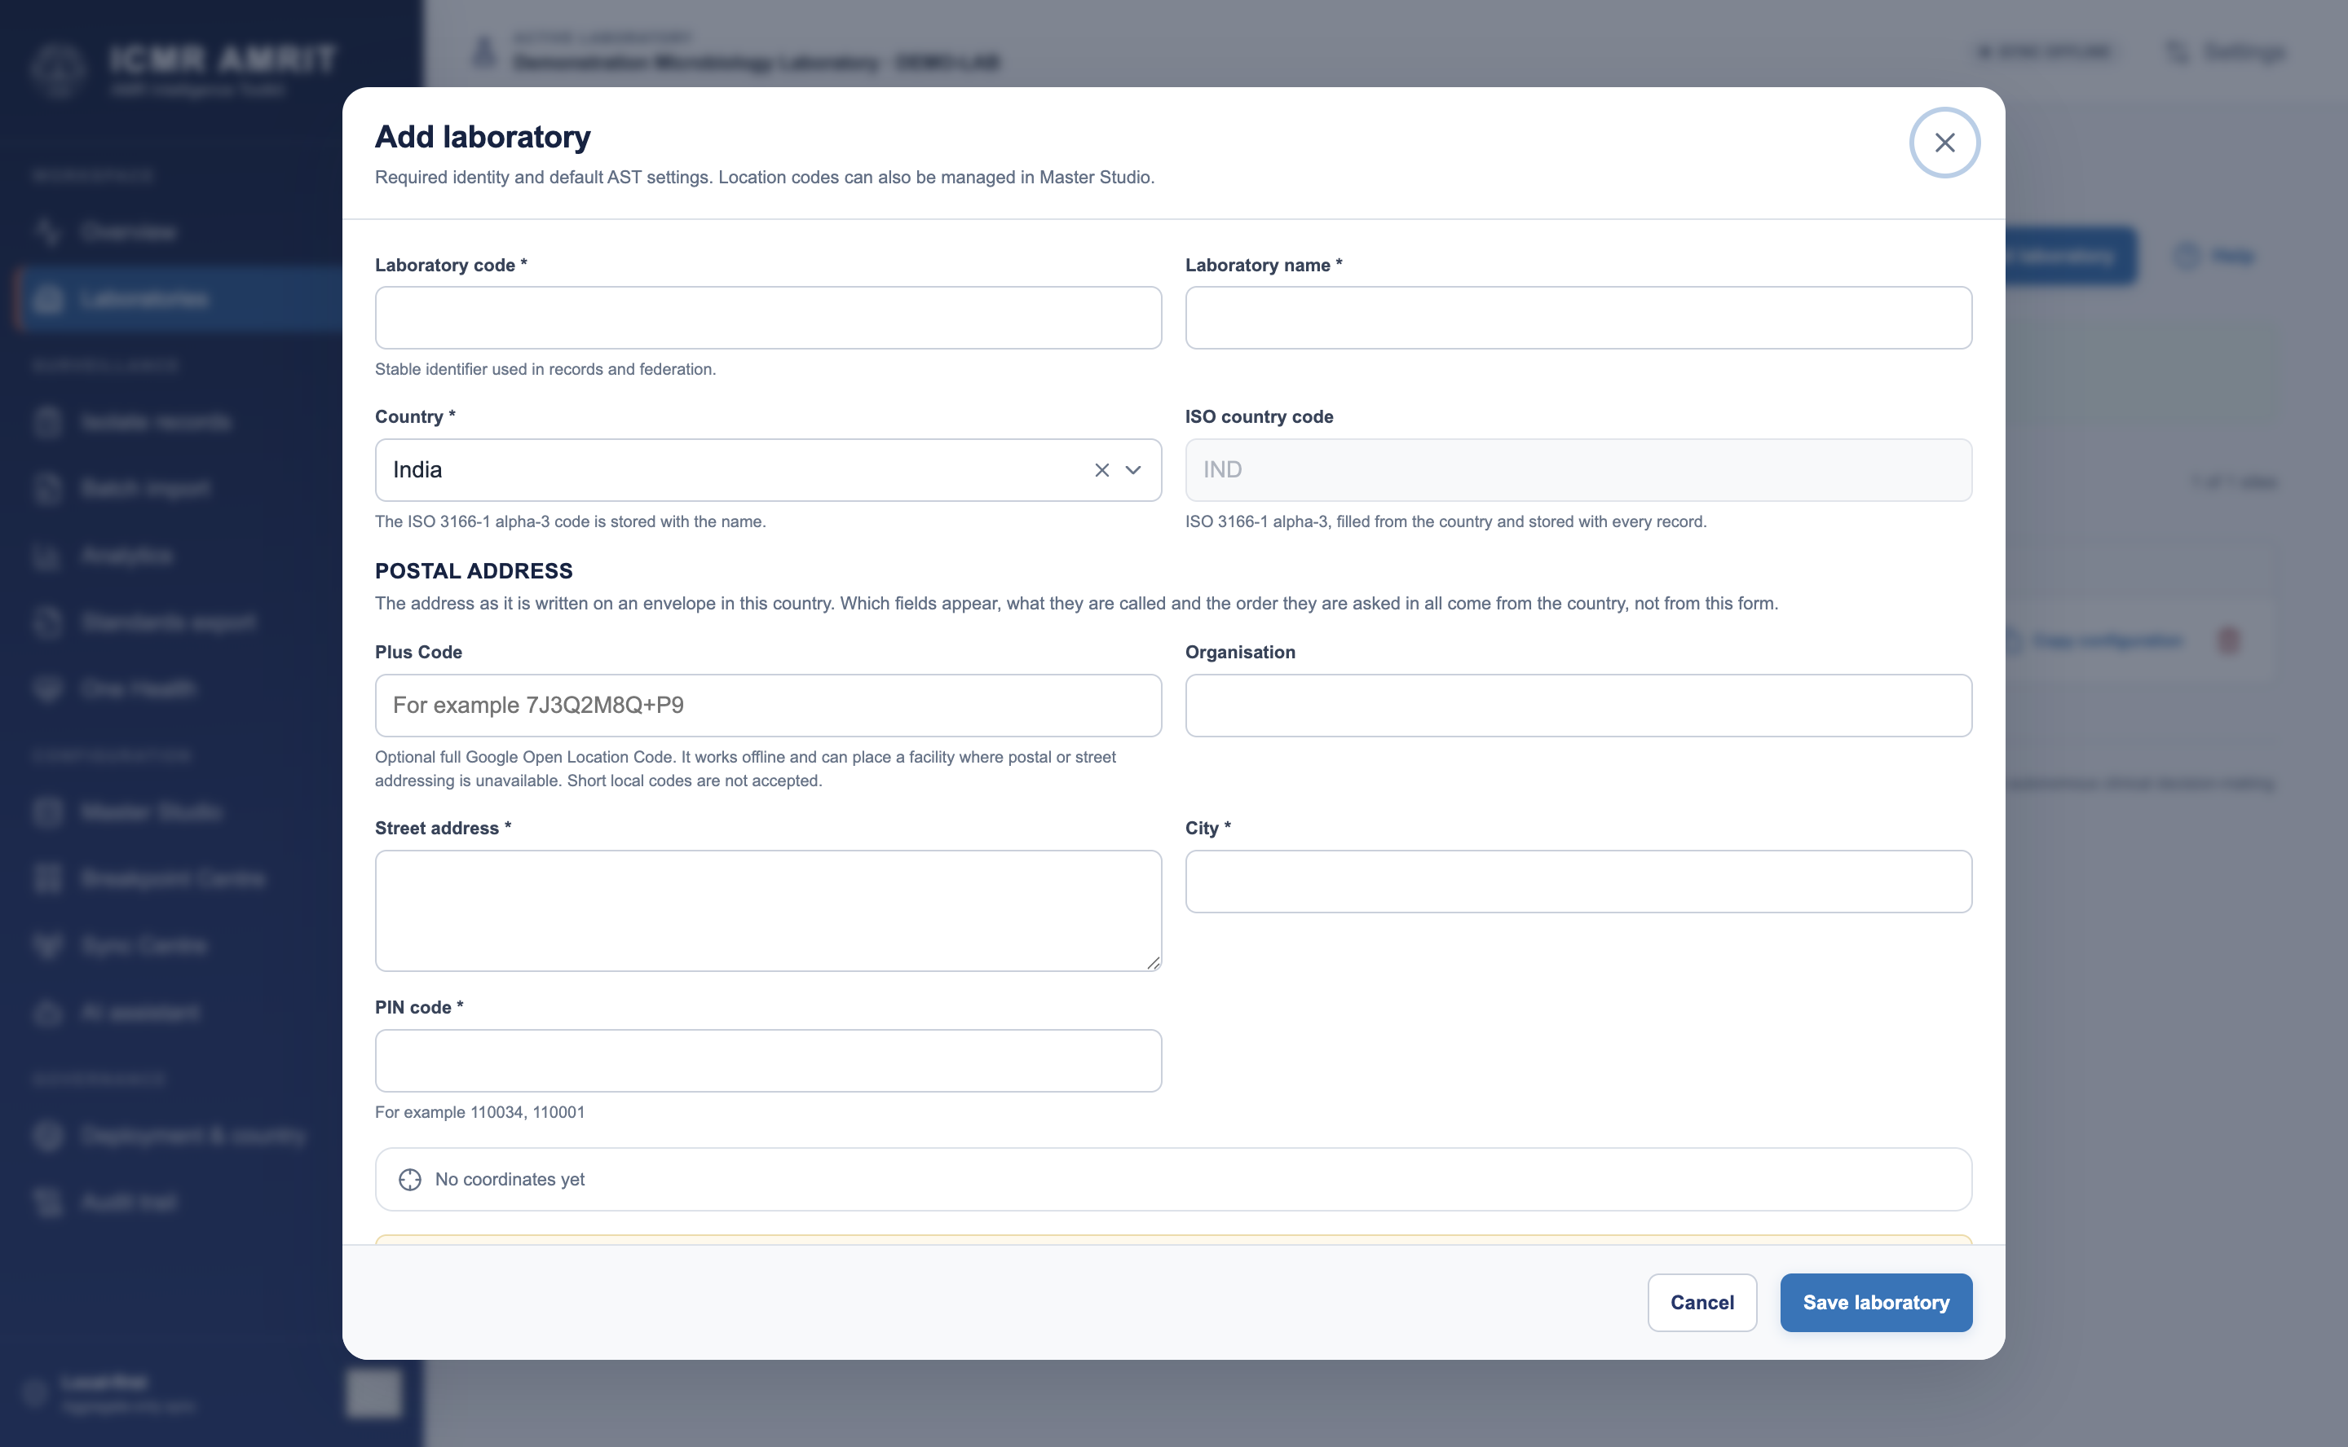
The address resolves to an administrative unit from the bundled geo pack. That unit — not a typed place name — is what every scope filter, dashboard roll-up and map placement uses afterwards.
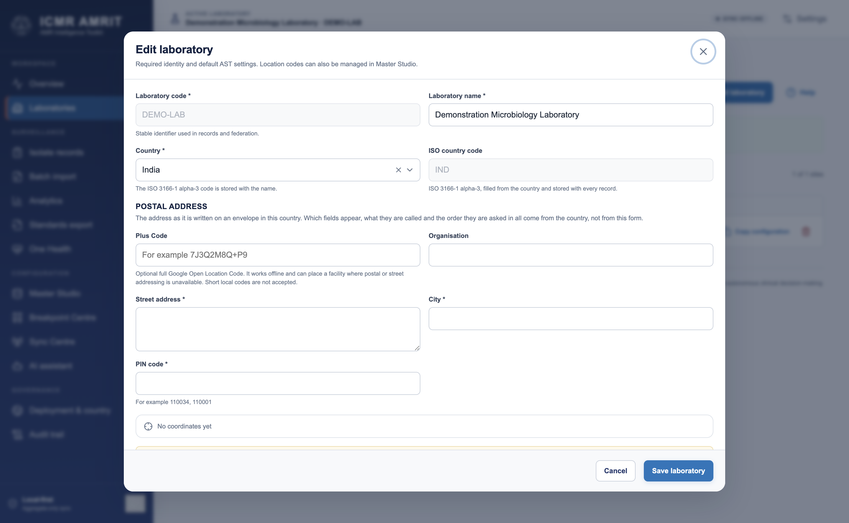
Site coordinates are optional and consent-gated (Sync → Optional location sharing). With consent given, Use this computer's location reads the operating system's location service; the coordinates can always be typed instead, and the source (device or hand-entered) travels with the heartbeat, because how a coordinate was obtained is part of what it means.

5. Catalogues and breakpoints
Master Studio holds the reference data: organisms, antimicrobials, specimens, panels, expected-resistance rules, expert rules, and local additions. Packaged rows are read-only; local rows are marked custom and can be deactivated but never silently overwrite the catalogue.
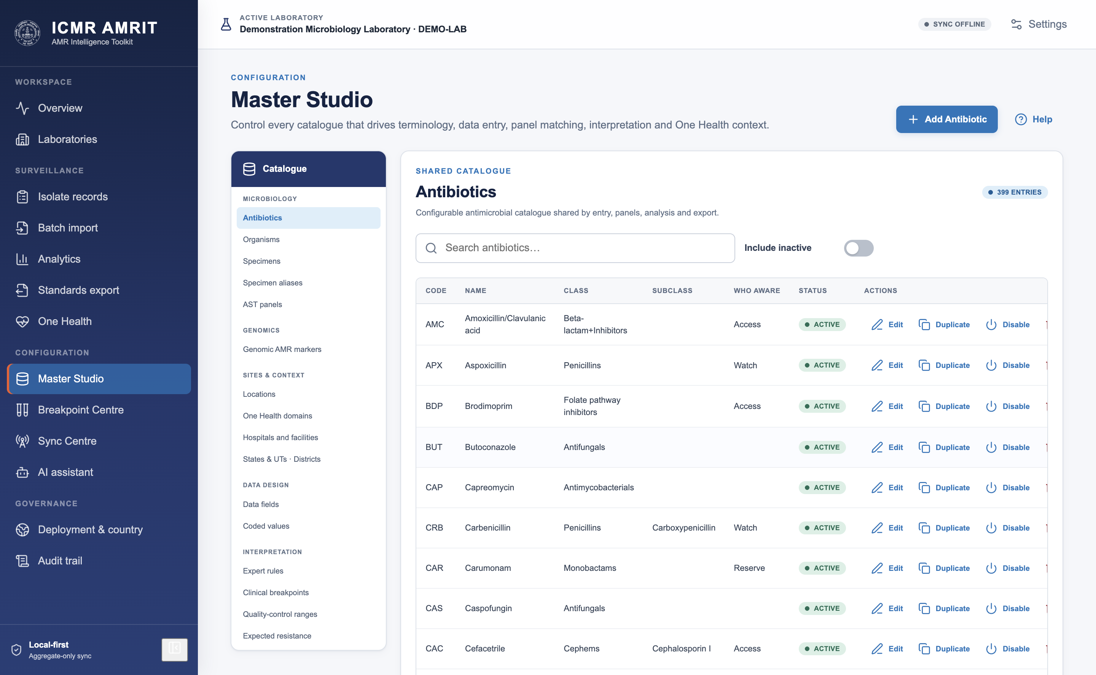
Breakpoint Centre is where guidelines arrive. EUCAST publishes its tables free of charge and permits redistribution, so the application fetches and stages the current edition with one button. CLSI's M100 is a paid standard: the application links to it and imports a workbook you supply. Either way the set is staged inactive and must be activated deliberately (§23).
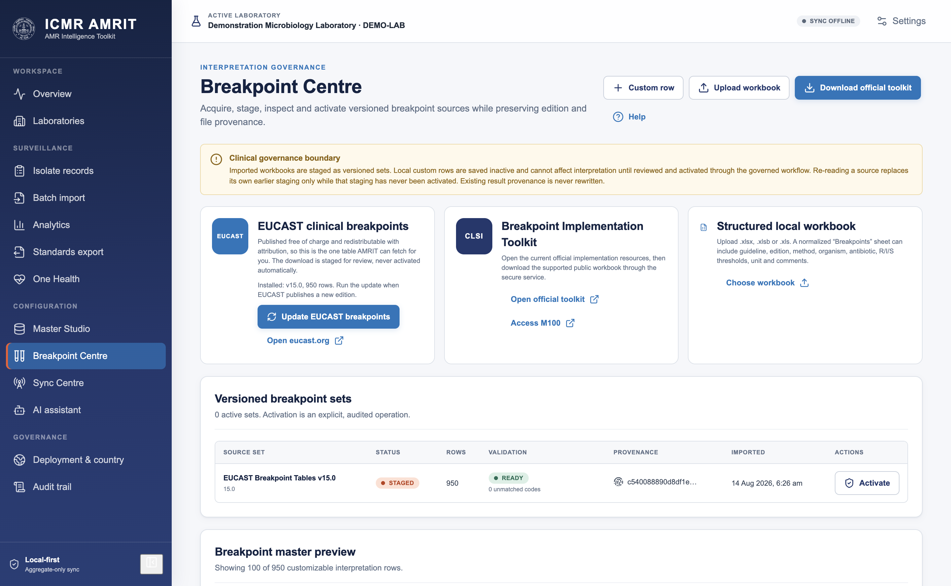
The screenshot above is a live fetch: EUCAST v15.0, 950 rows staged, 0 unmatched codes, READY, and an Activate button that has not been pressed. Until it is, nothing in this set interprets anything.
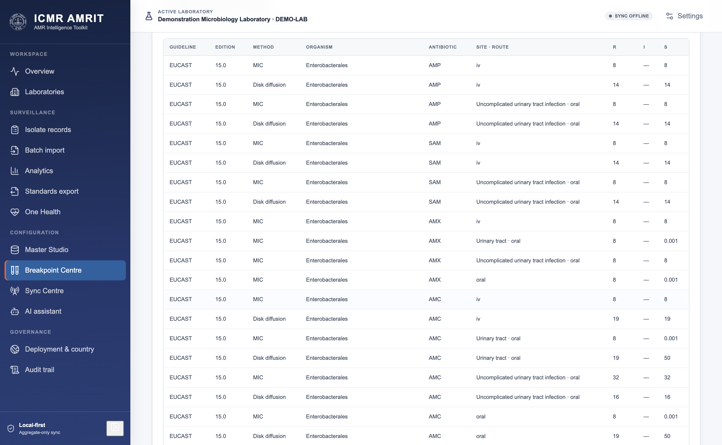
The preview lists what was staged — organism scope, agent, method, site and route, and the R/I/S thresholds — so a reviewer checks rows rather than trusting a row count.

6. Enter data
Three routes, all landing in the same validated shape:
Type a record. Identity first (patient identifier, specimen number and date, specimen type, organism), then residence, then AST. The antimicrobial panel offered is the one matching the organism and specimen, from the panel catalogue.
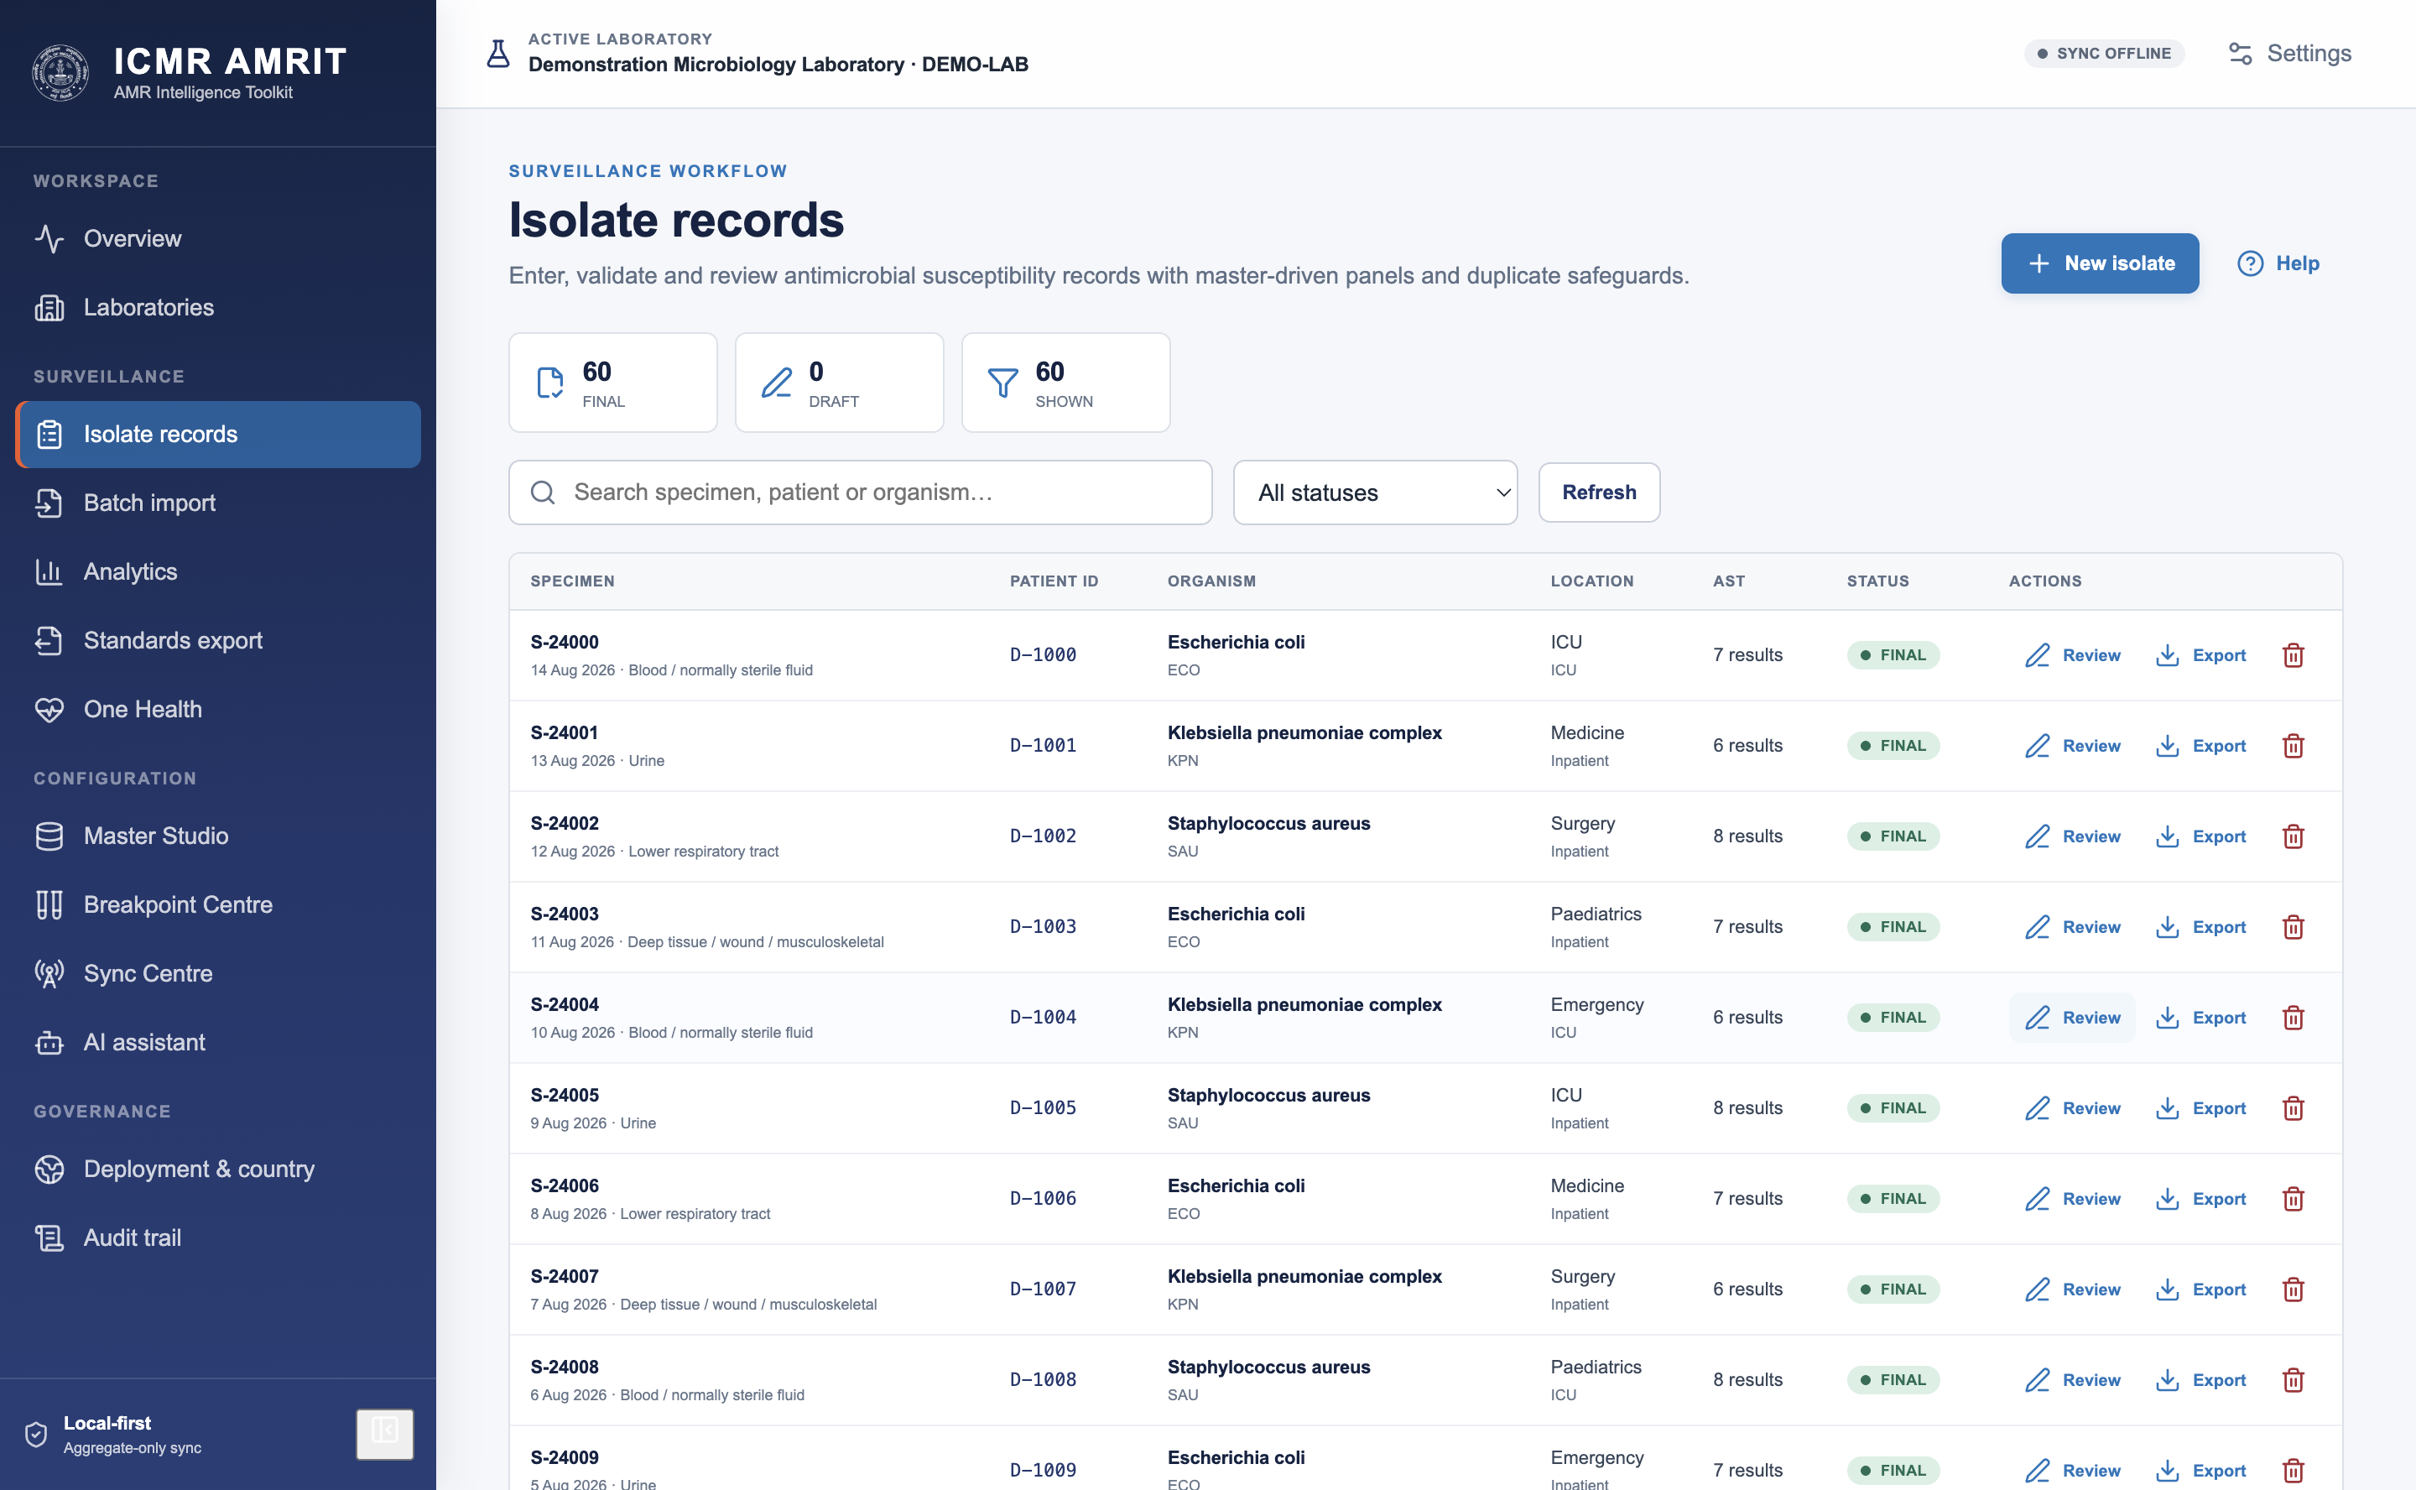
The editor is where identity, specimen, organism and the antimicrobial panel are entered, and where decision support answers as you type:
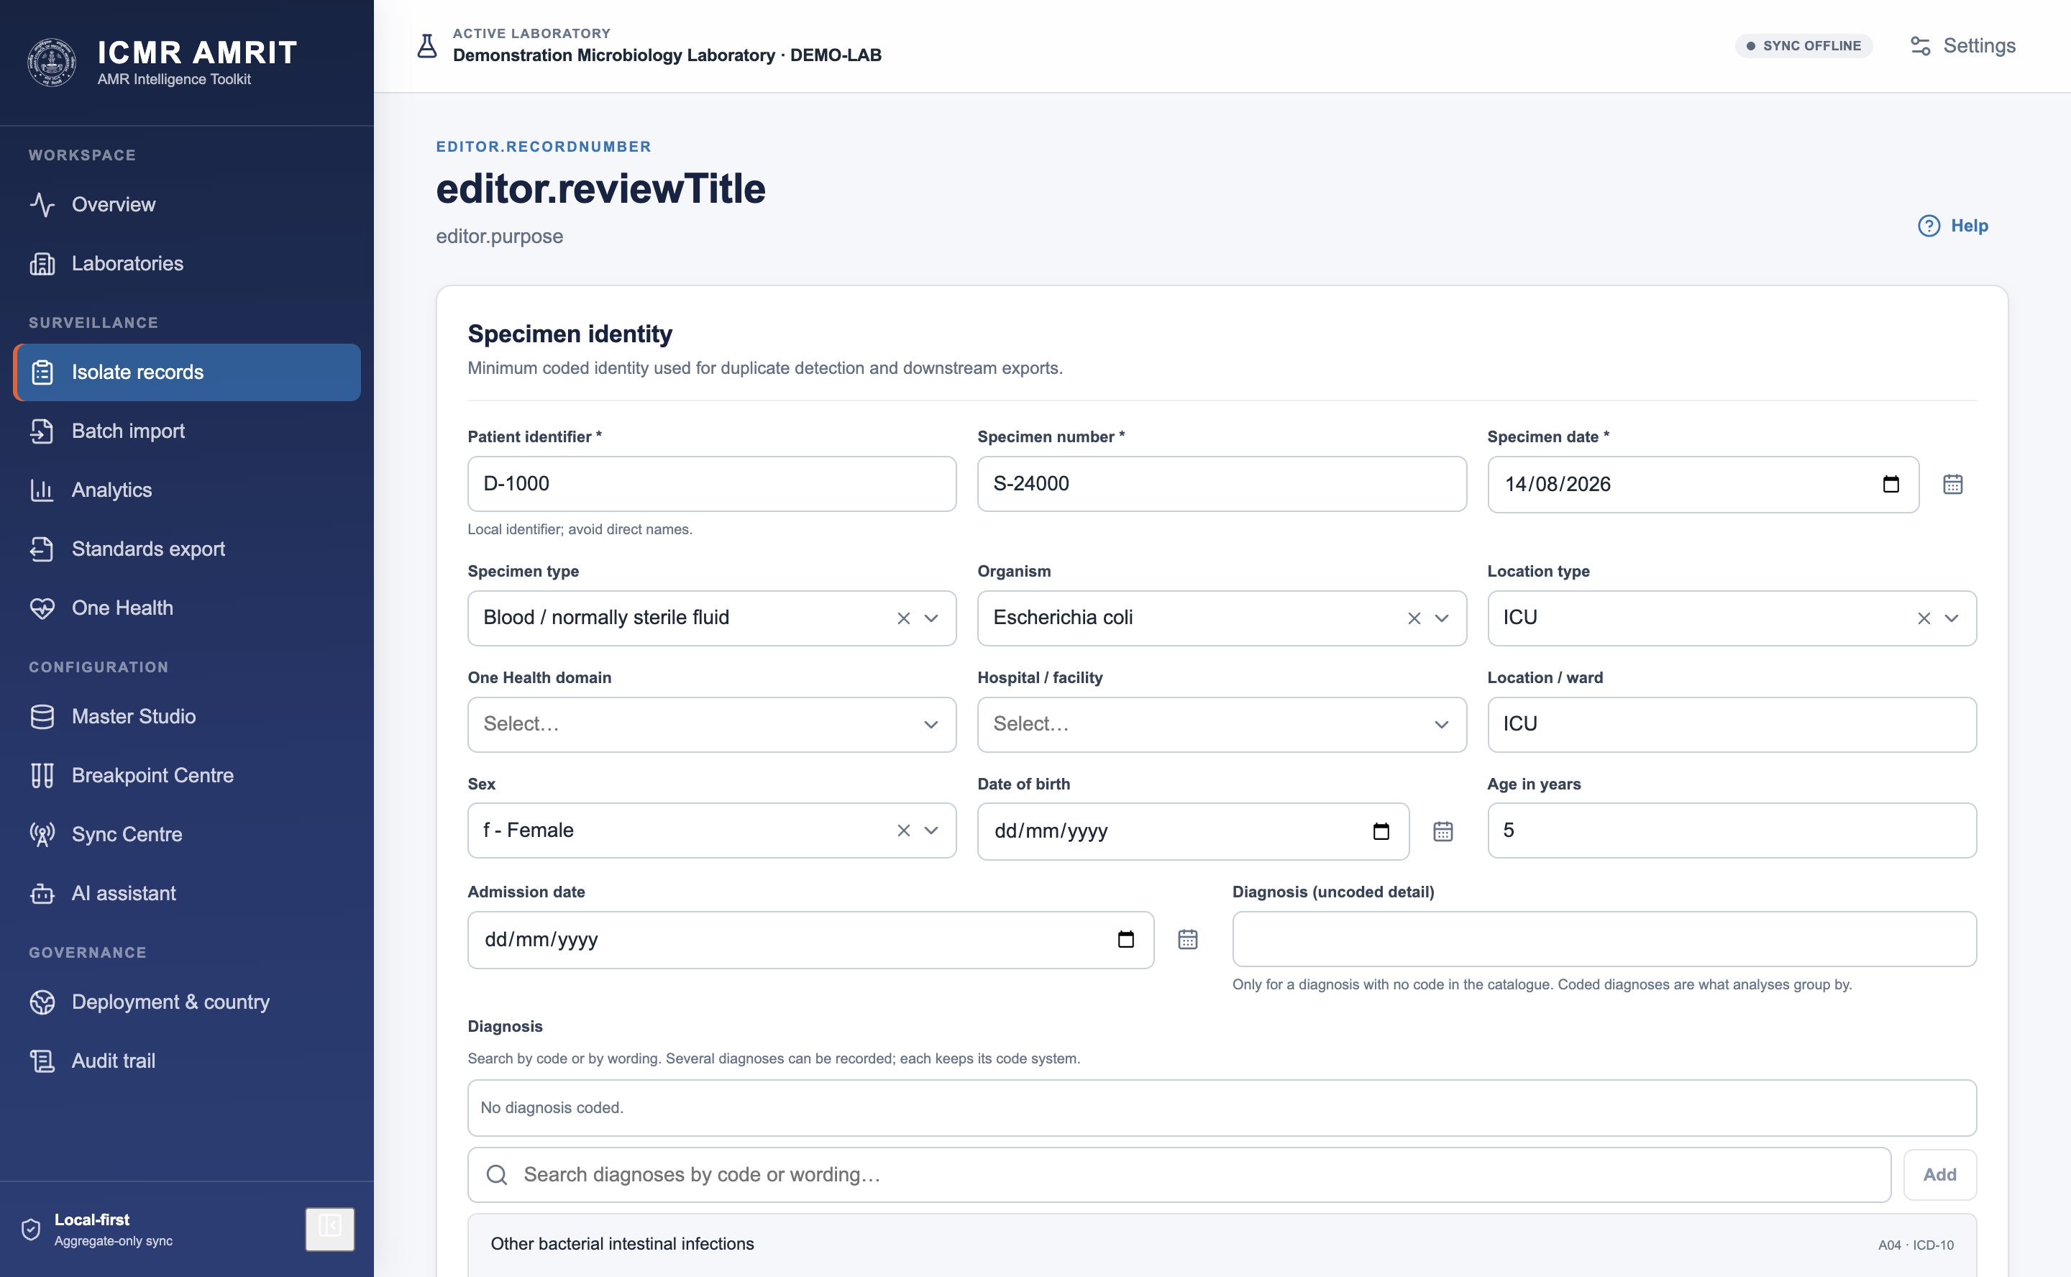
Import a batch. Map columns once, save the mapping as a profile, and reuse it. The preview shows what will be imported, what will land as a draft and what is refused, per row and with a reason, before anything is written.
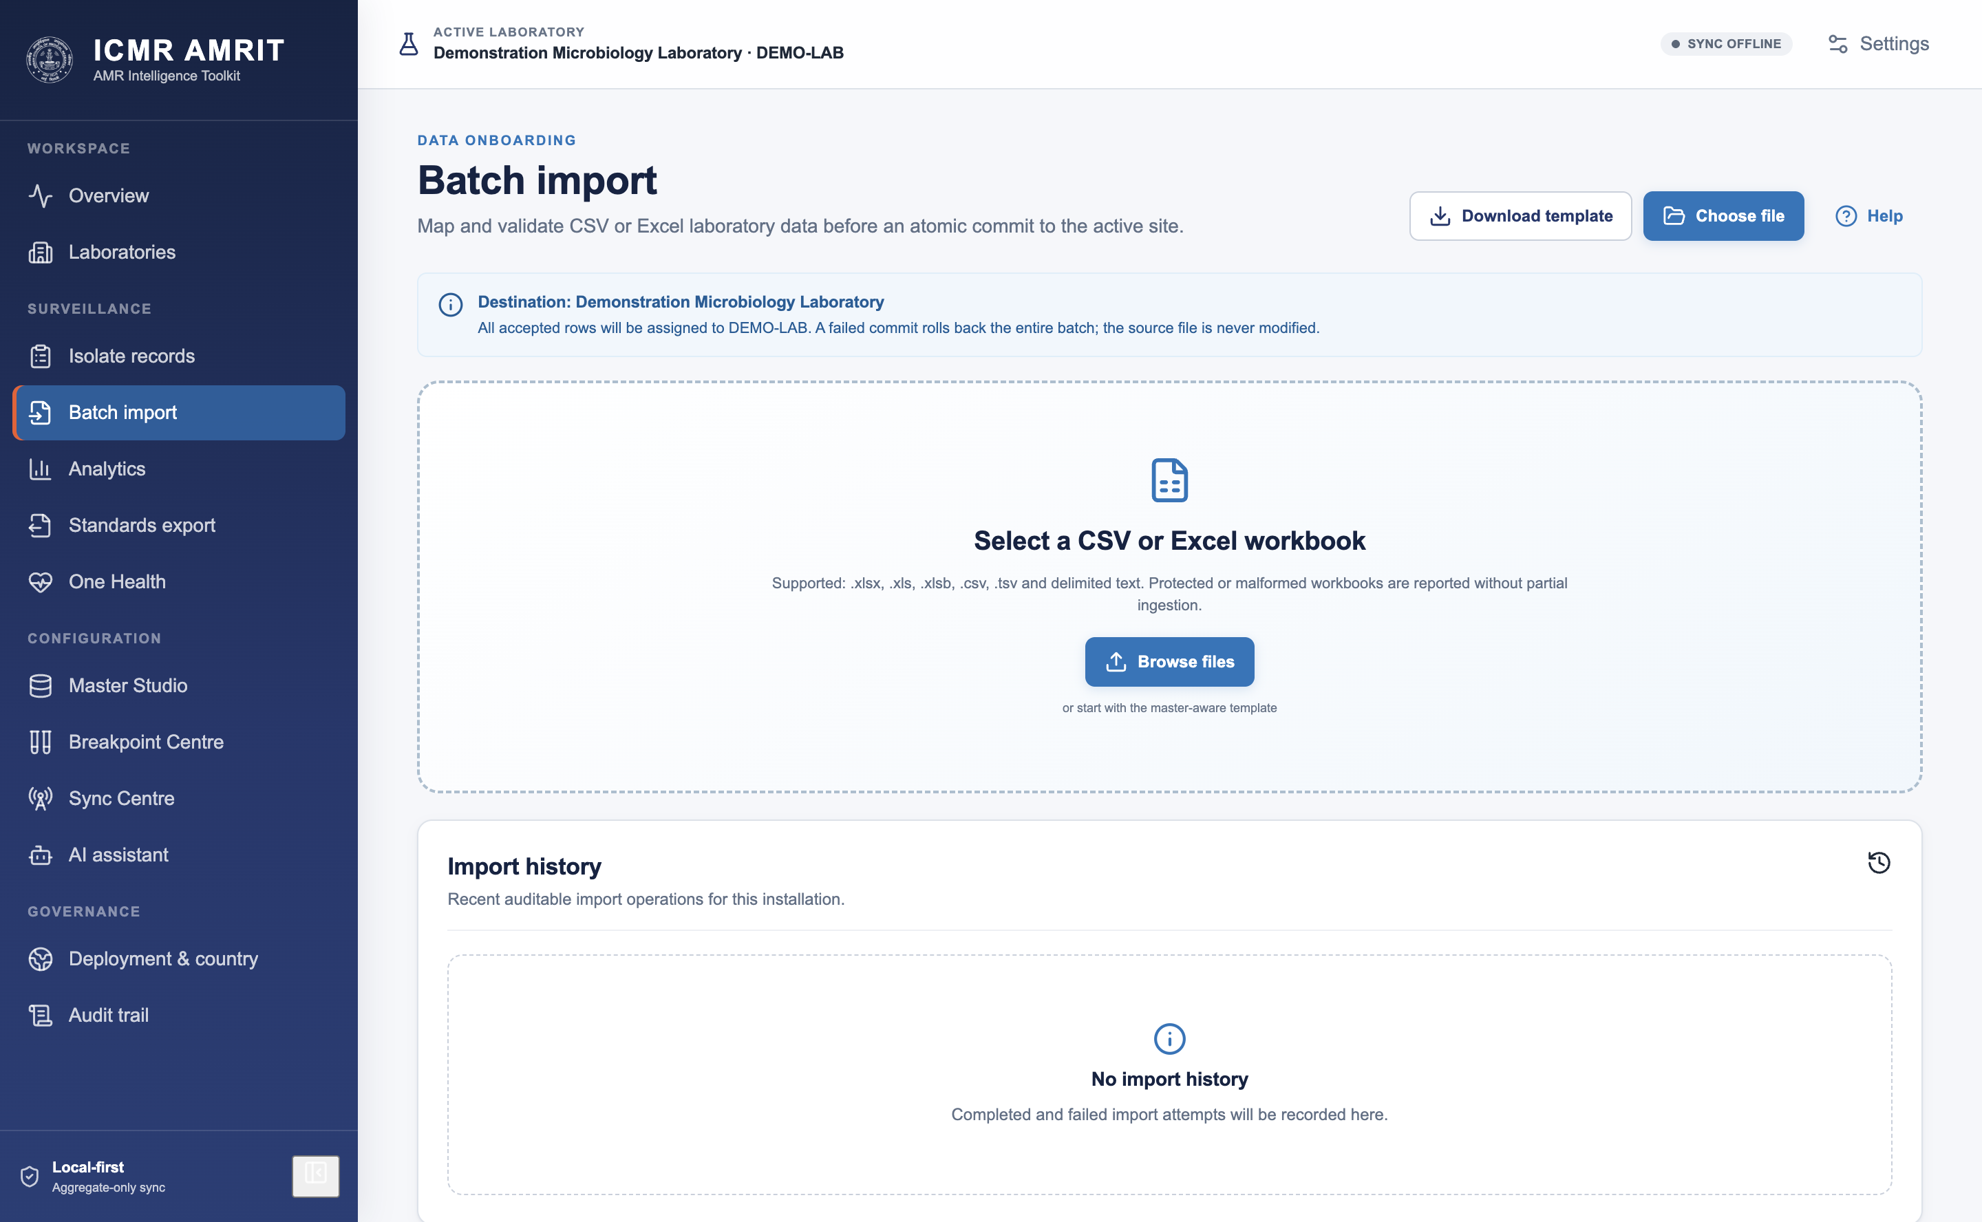
WHONET legacy. Existing WHONET data files import directly, including their code sets.

7. Quality control and decision support
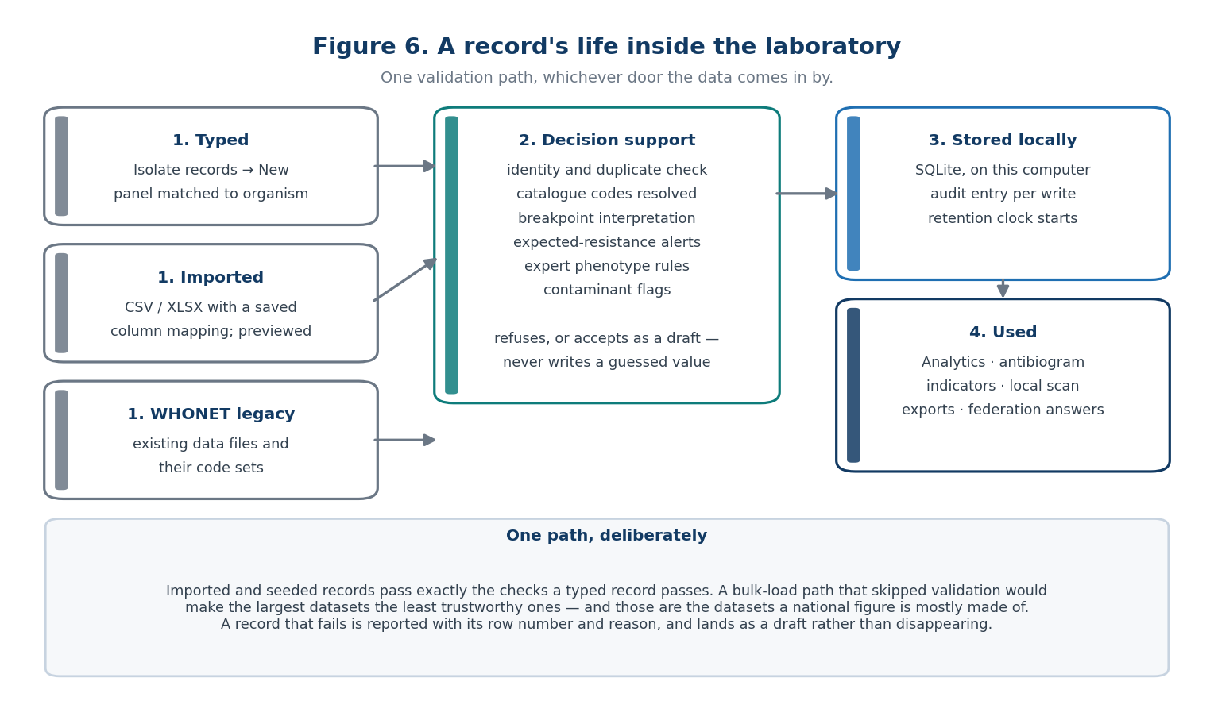
Figure 6 — one validation path, whichever door the data comes in by.
Every write passes the same decision-support layer, whether typed, imported or seeded:
- Interpretation. A measurement with no explicit S/I/R is interpreted from the active breakpoint set — and left blank with a stated reason when the set has no matching row, when two equally specific rows disagree, or when the record does not state something the breakpoint depends on (§23).
- Expected resistance. An organism reported susceptible to an agent it is intrinsically resistant to raises an alert rather than being corrected silently.
- Expert rules. Configurable phenotype rules (ESBL, carbapenemase, MRSA, inducible clindamycin) add comments and alerts.
- Contaminant and duplicate checks. Likely skin flora in a sterile-site culture is flagged; an identical patient/specimen identity is refused as a duplicate.

8. Analyse
Analytics runs deterministic, reproducible analyses over the local database: resistance rates by organism and agent, antibiograms, specimen and organism distributions, priority indicators, time trends, and a local outbreak scan.
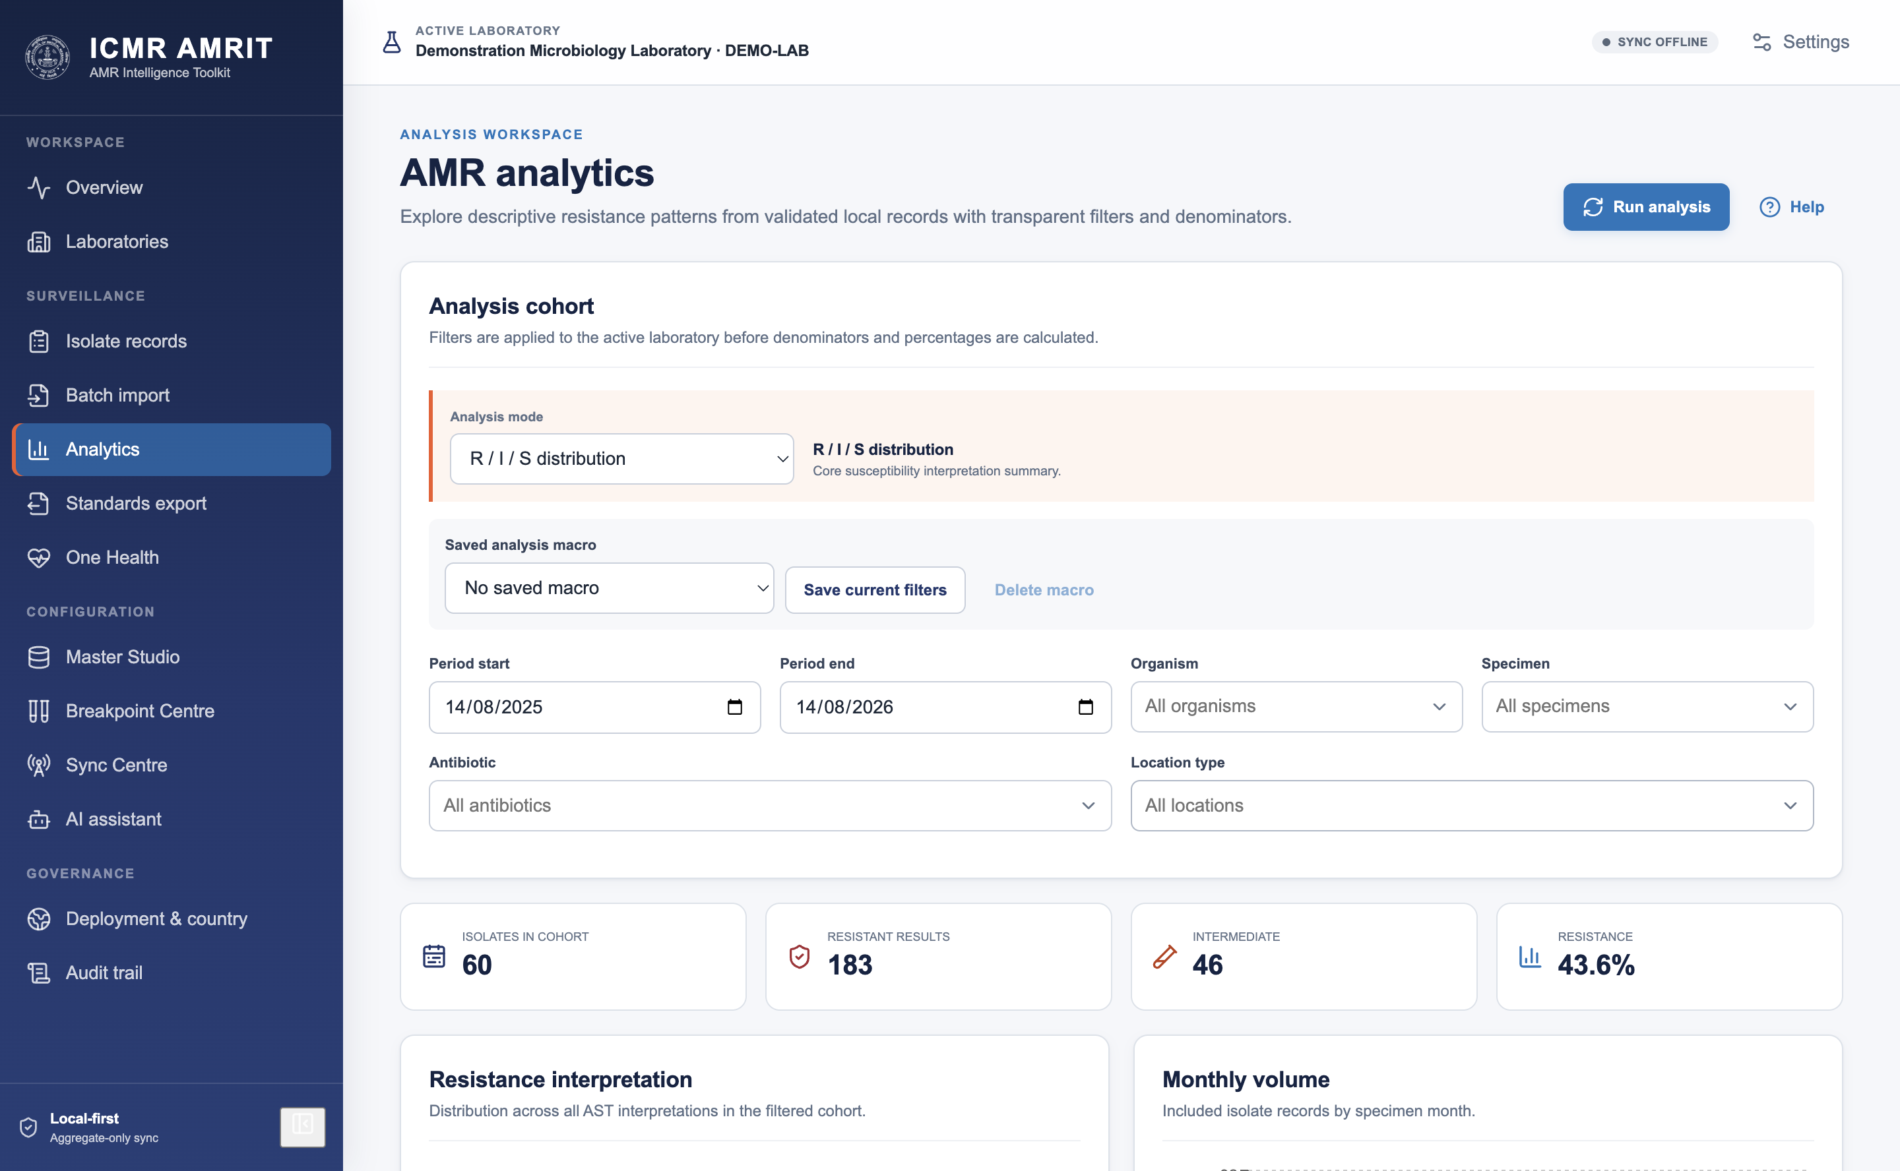
With an analysis run, the same screen carries the antibiogram, the priority indicators and the resistance table computed over the current filter set:

Two things are always explicit on screen because they change every number: the deduplication mode (§24) and the date window. A saved macro stores a whole filter set so the same analysis can be re-run next month and compared honestly.

9. One Health capture
AMR is not only a human-health problem. The One Health workbench captures veterinary, environmental, food-chain, antimicrobial-consumption and laboratory-quality events against the same facility registry, with its own operator accounts and its own governance.
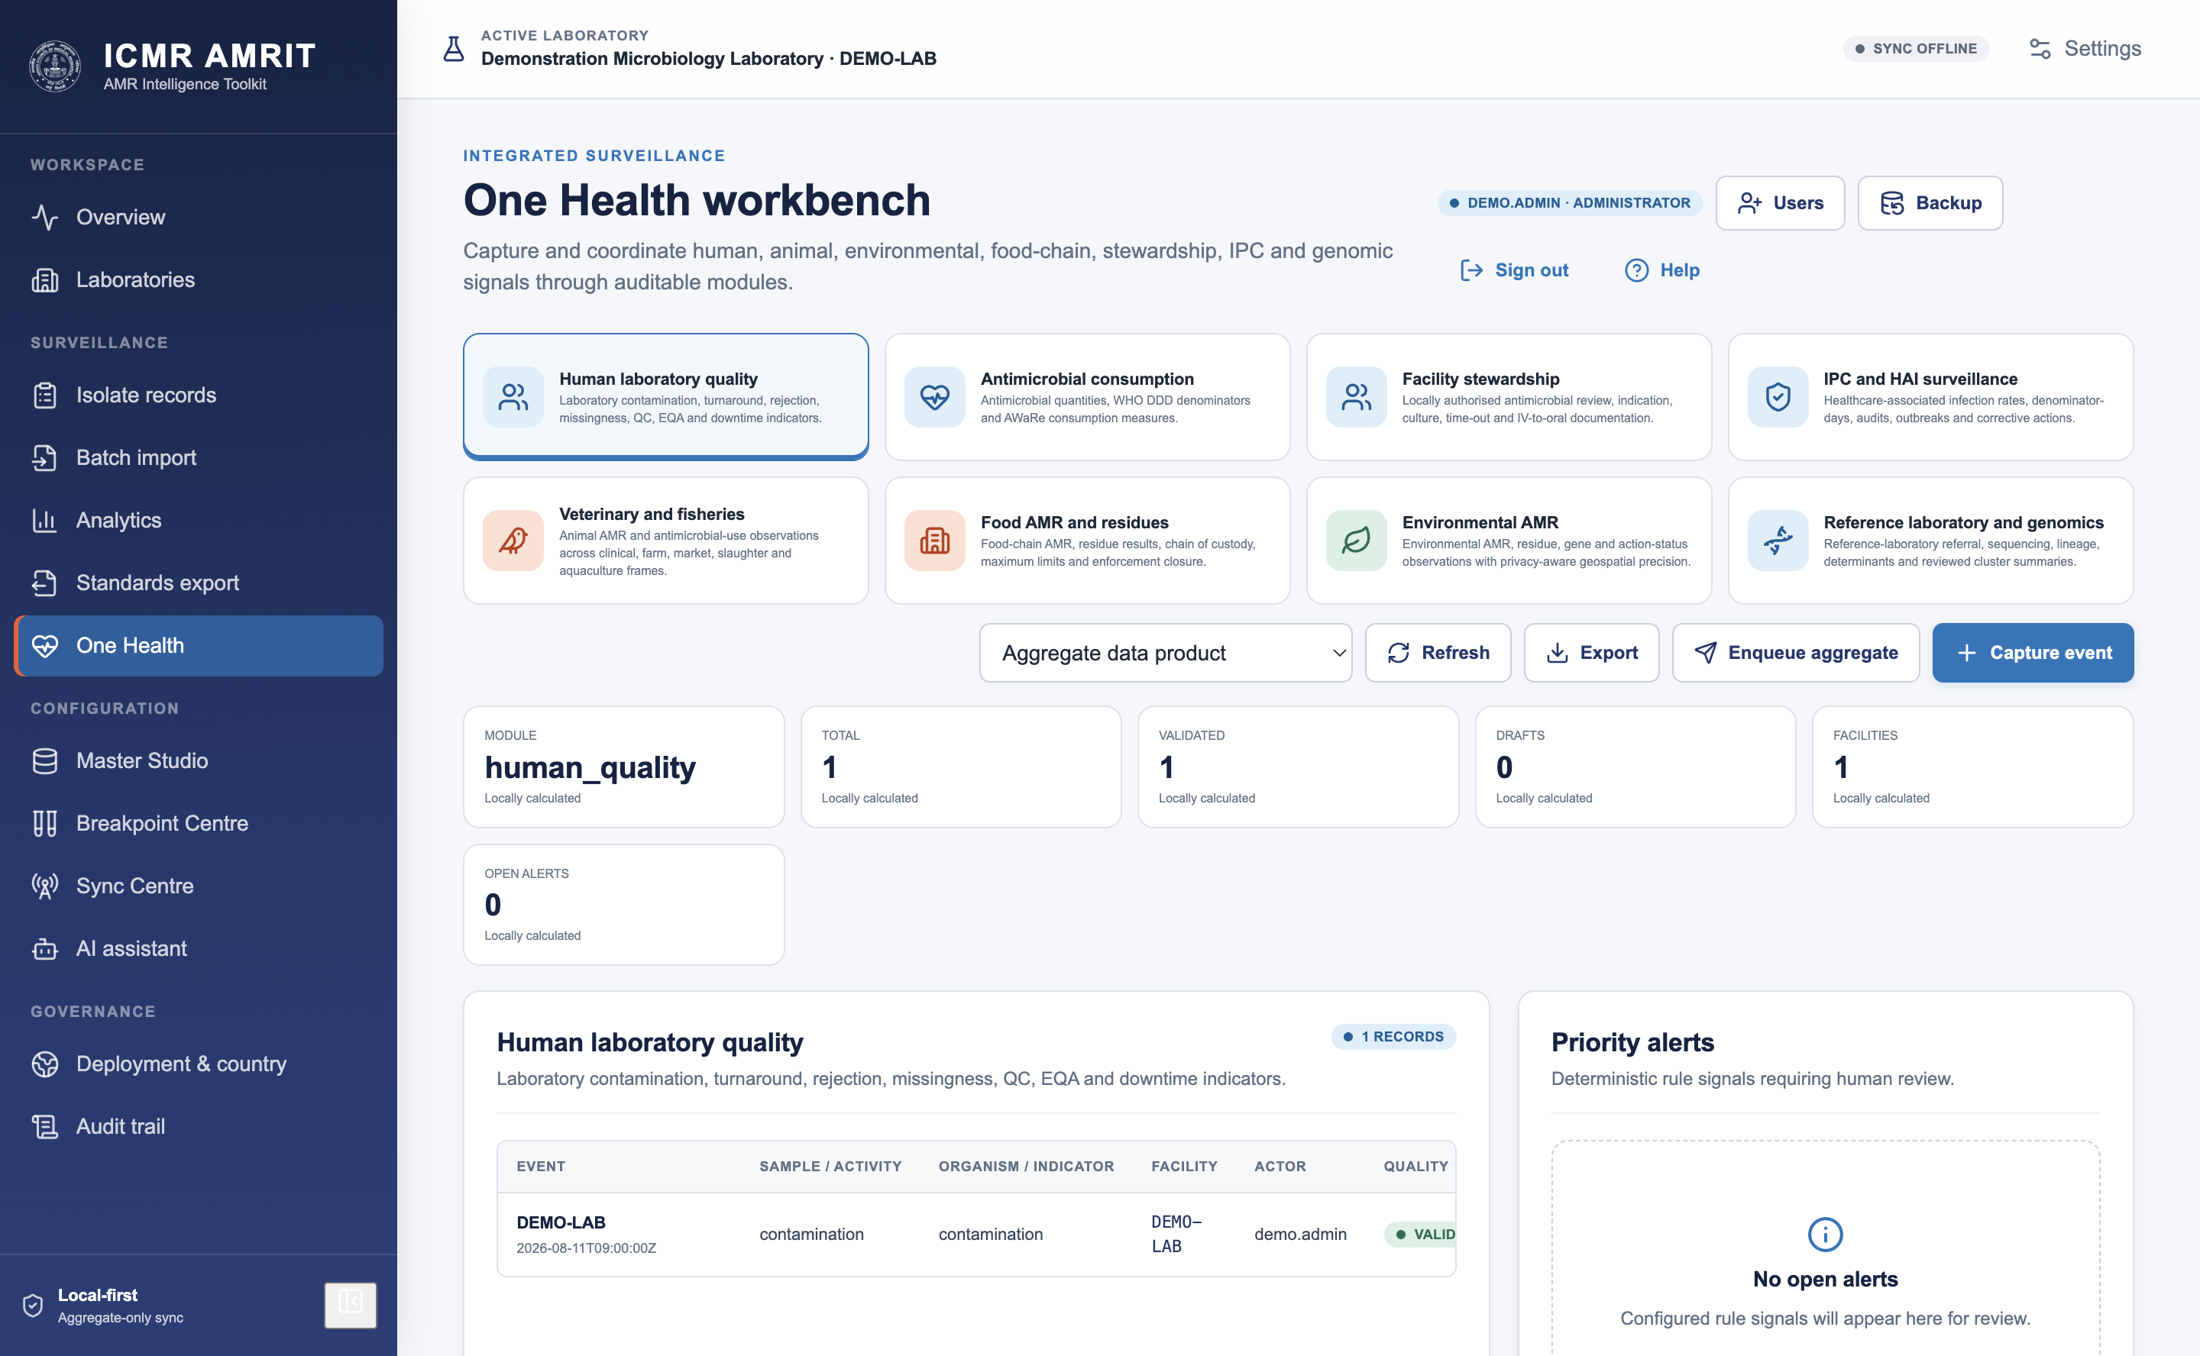

10. Export
Format | What it is for
WHONET | Exchange with the WHONET/GLASS ecosystem
FHIR (Observation / MeasureReport) | Interoperable clinical and aggregate reporting
HL7 v2 | Feeding a hospital information system
Measure bundle | Aggregate indicator reporting to a programme
CSV / JSON | Analysis in R, Python, Excel
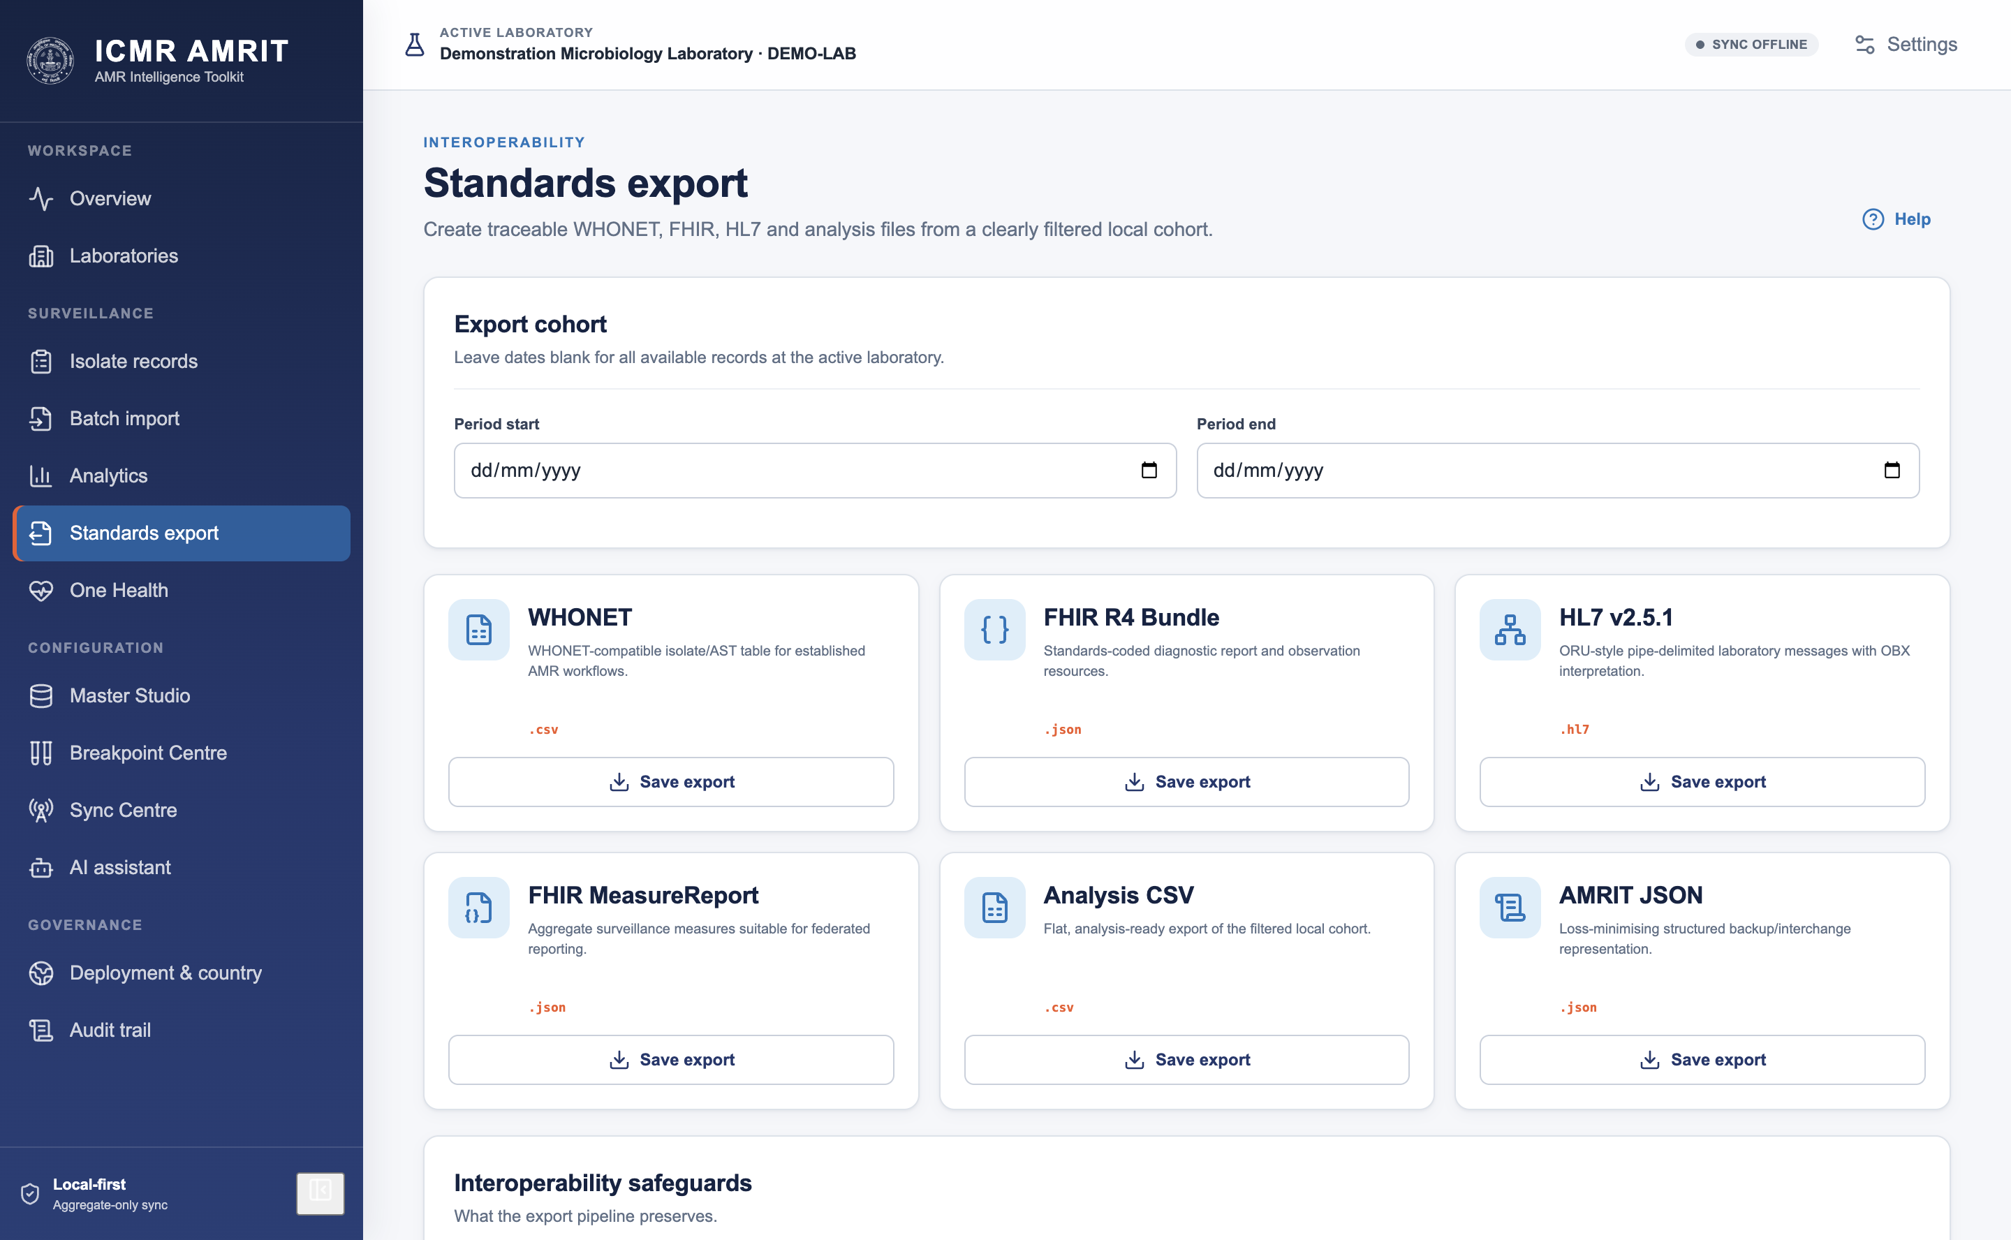
An export is a deliberate act by the operator, and it may contain patient-level data — that is the difference between an export and federation (§28), and the audit log records both.

11. Join a central server (federation)
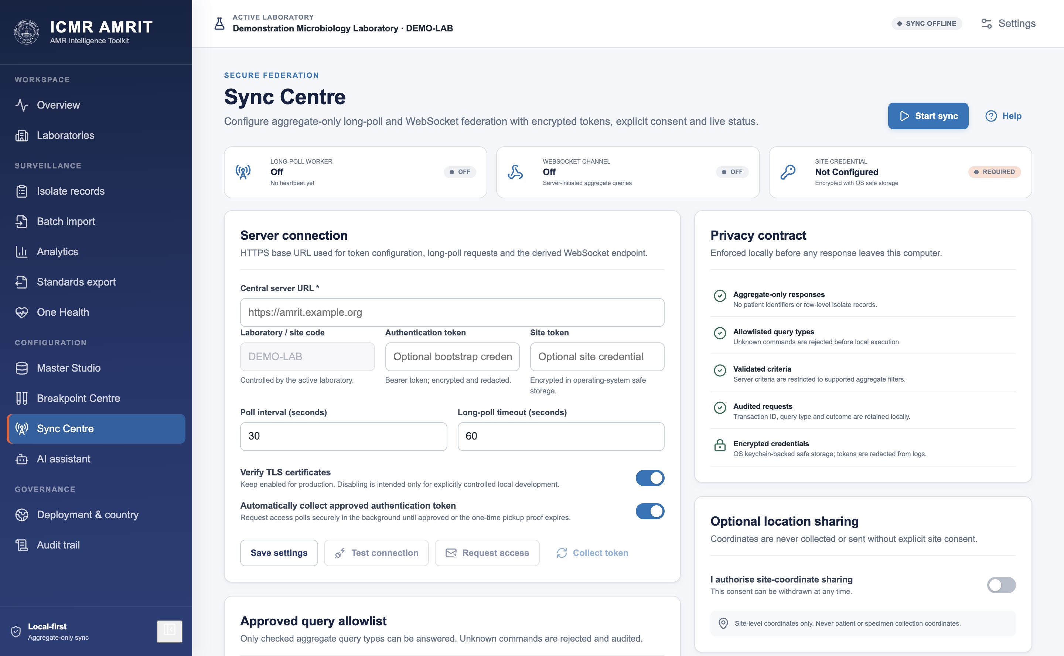
- Request access. The desktop registers its lab code with the server and receives a one-time pickup token. Nothing is granted yet.
- An administrator approves it in the portal, which creates the site and mints a site token delivered out of band.
- Collect the token. The desktop redeems its pickup token for a bearer token it mints and stores in the operating system's credential vault. The server keeps only a hash.
- Allow-list the query types this laboratory will answer. A query type not on the list is refused, logged and answered with an error.
- Start sync. A long-poll worker asks for questions; a WebSocket connection lets the server nudge for an immediate answer. A four-hourly heartbeat reports presence.
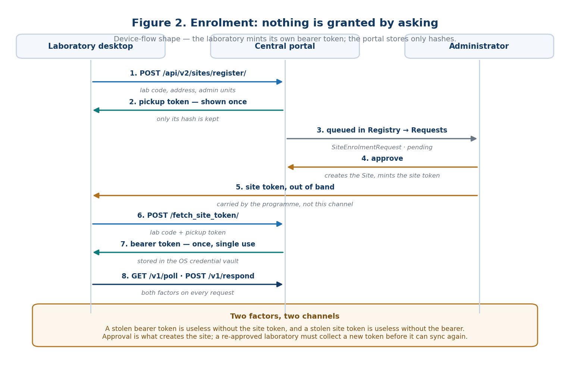
Figure 2 — enrolment and the two-token credential exchange.

12. Privacy, retention, audit
- Retention. The profile sets a retention period; expiry removes row-level data on a schedule, with a dry run that reports what would go first.
- Erasure. A named subject's rows can be erased on request, with the erasure itself audited.
- Audit. Every consequential act — saving a record, activating a breakpoint set, exporting a file, starting sync, answering a query — is written to an append-only local log.
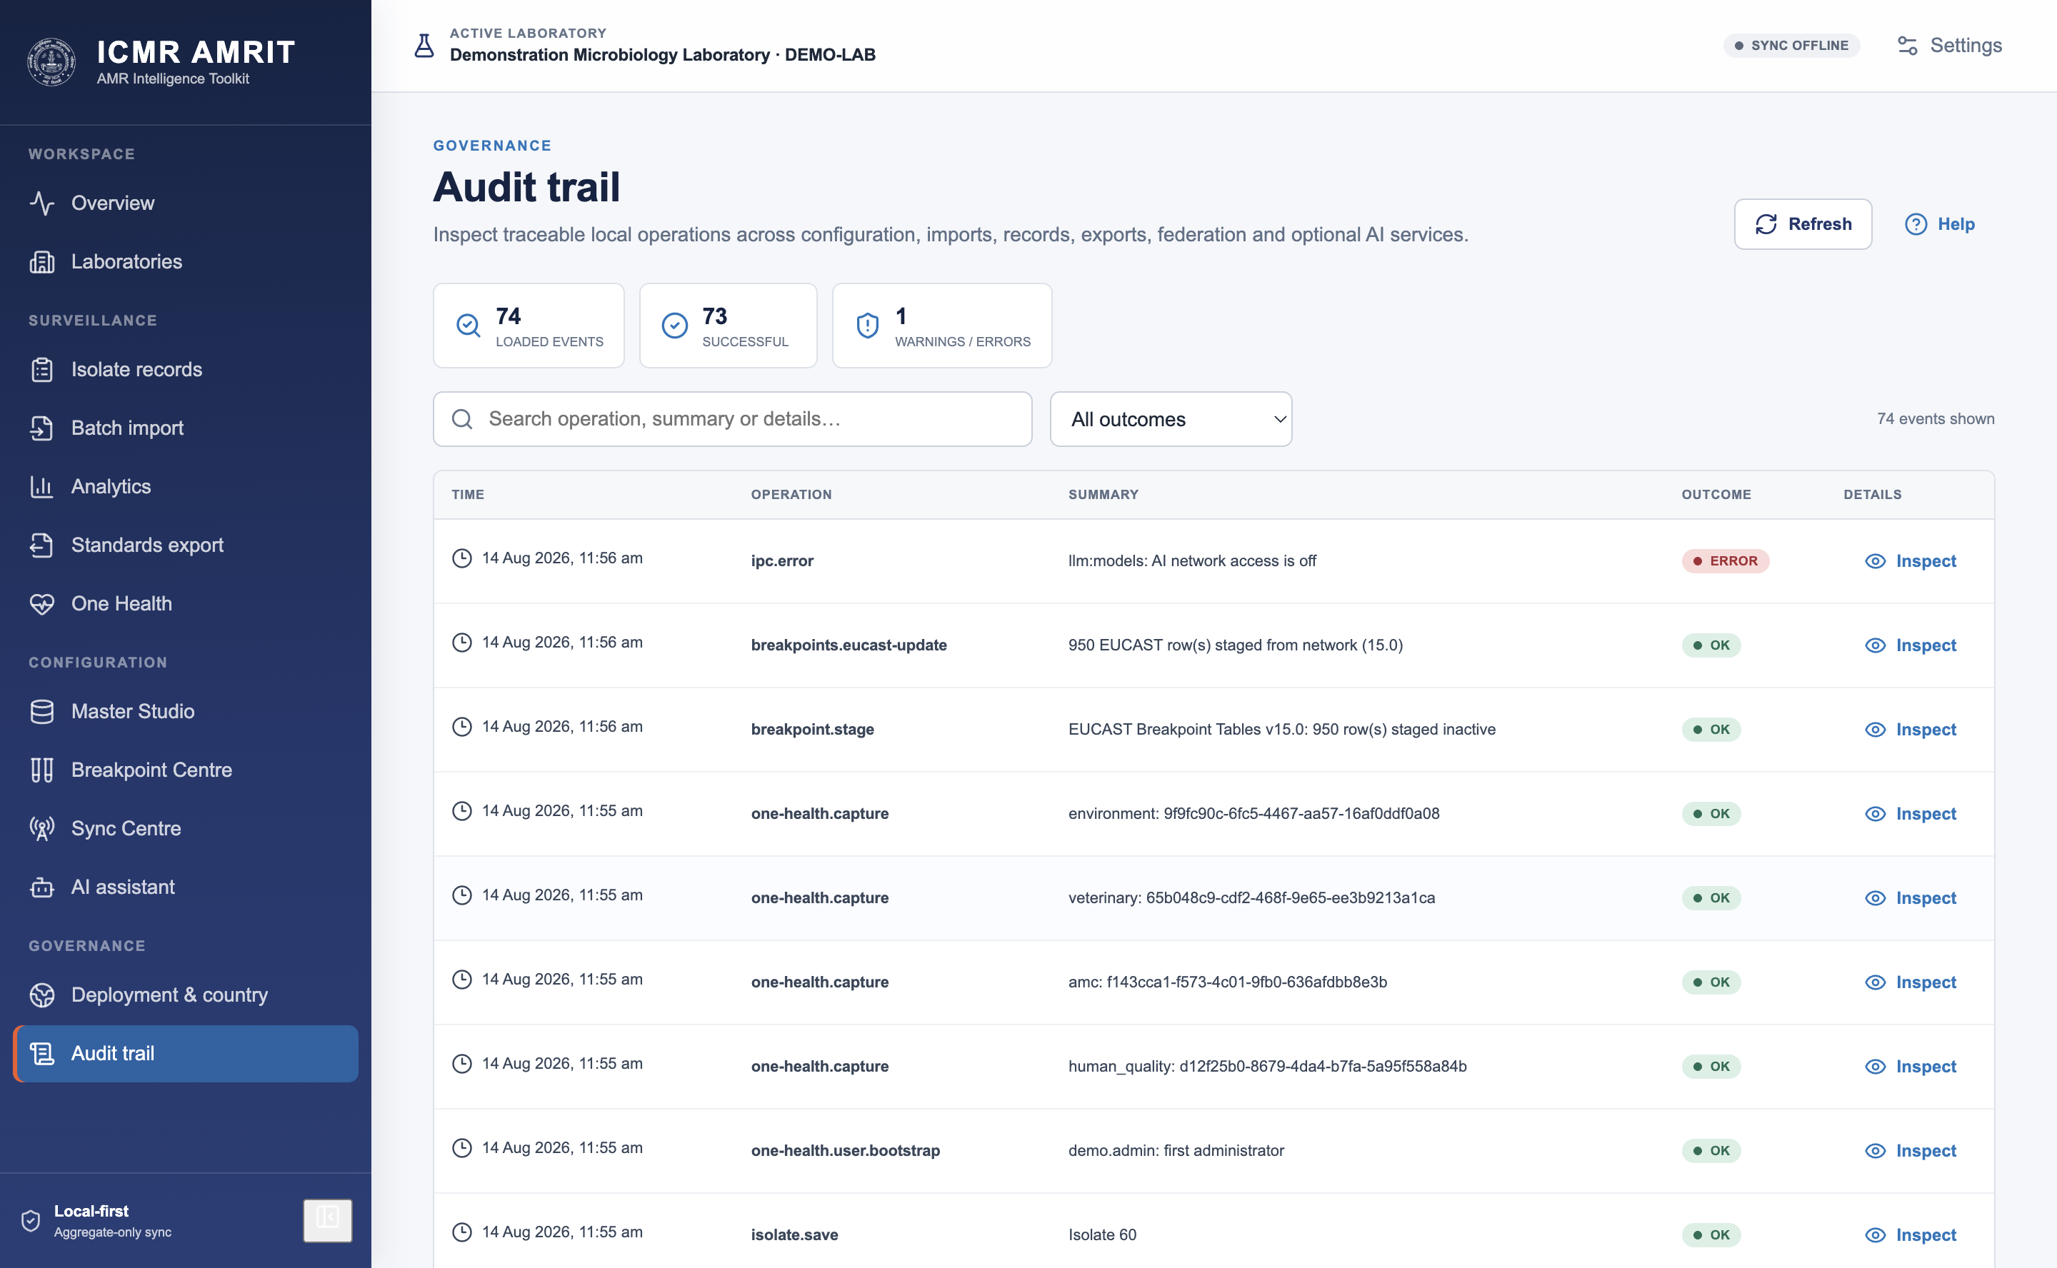

Part II — Central web portal

13. Deploy the server
The portal is Django with Postgres and Redis, shipped as a Docker Compose stack.
cd server/amrit_central_server
cp .env.example .env
# set at least: DJANGO_SECRET_KEY, DJANGO_ALLOWED_HOSTS, POSTGRES_PASSWORD,
# AMRIT_COUNTRY_PROFILE (e.g. IN), AMRIT_ENROLMENT_SECRET
docker compose up -d --build
docker compose run --rm web python manage.py bootstrap # first administrator
The entrypoint migrates, collects static assets and — only when AMRIT_SEED_DEMO=1 — seeds the demonstration pack for the configured country. A country with no pack is reported and skipped, never filled with another country's hospitals.
The stack publishes on loopback only. Nothing in it terminates TLS; put a reverse proxy in front before exposing it, because both operator sign-in and site enrolment carry credentials.

14. The site registry and enrolment
Registry → Sites lists every laboratory, its administrative unit, when it was last seen and whether it is online.
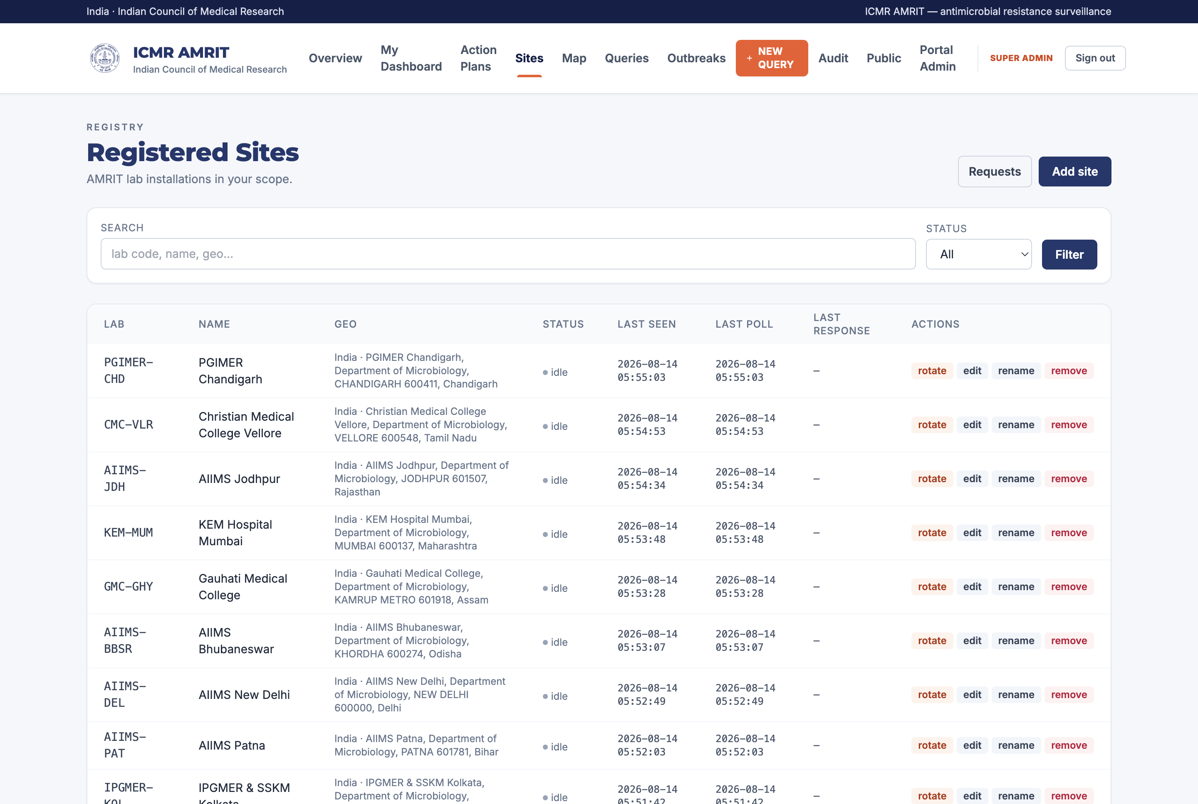
Registry → Requests is the enrolment queue: laboratories that have asked to join and are waiting for a decision. Approving creates the site and shows its site token exactly once.
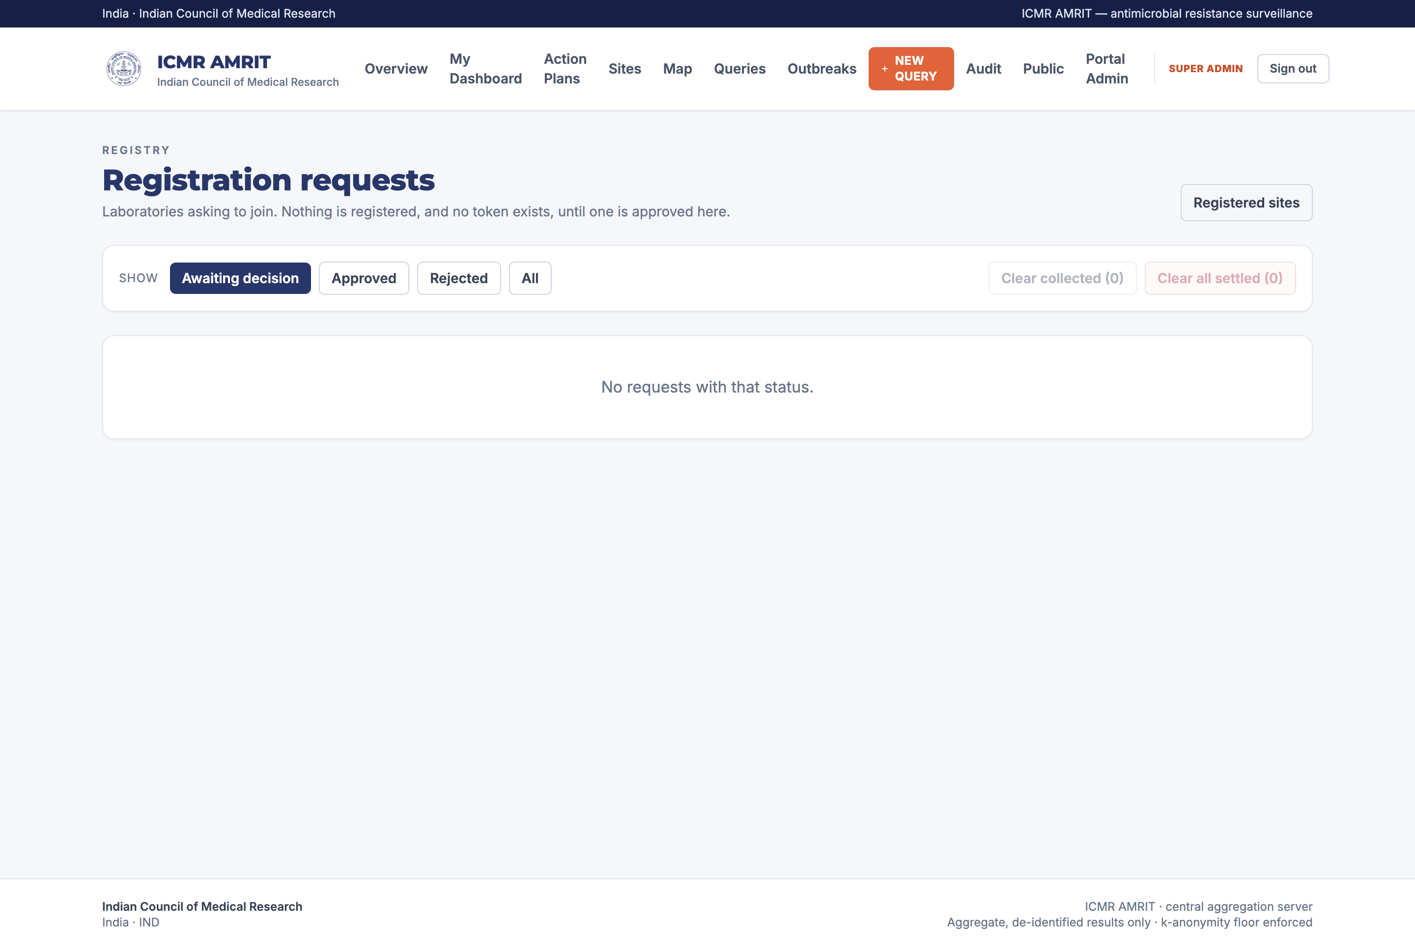
Both credentials can be reset independently, and each reset stops that site syncing until the new value reaches it — which the screen says before the button is pressed.
Registry → Map places every consenting site.
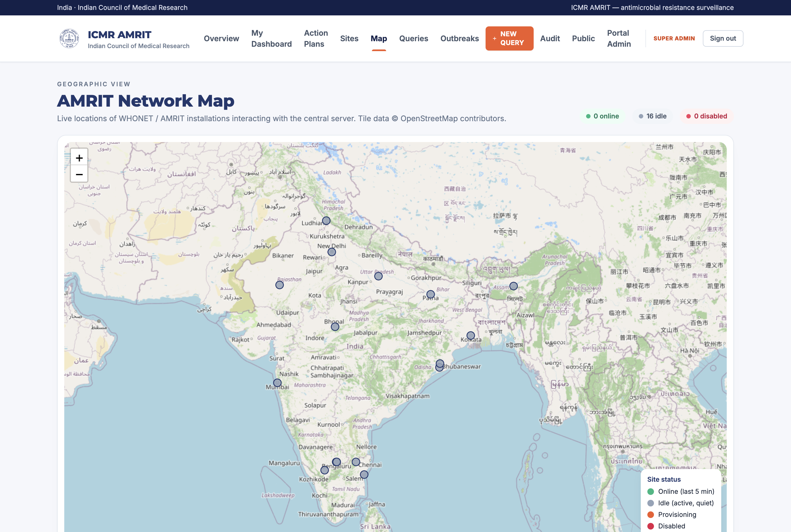

15. Asking questions
Queries → New query composes a question and targets it: all sites, an administrative unit, or named laboratories.
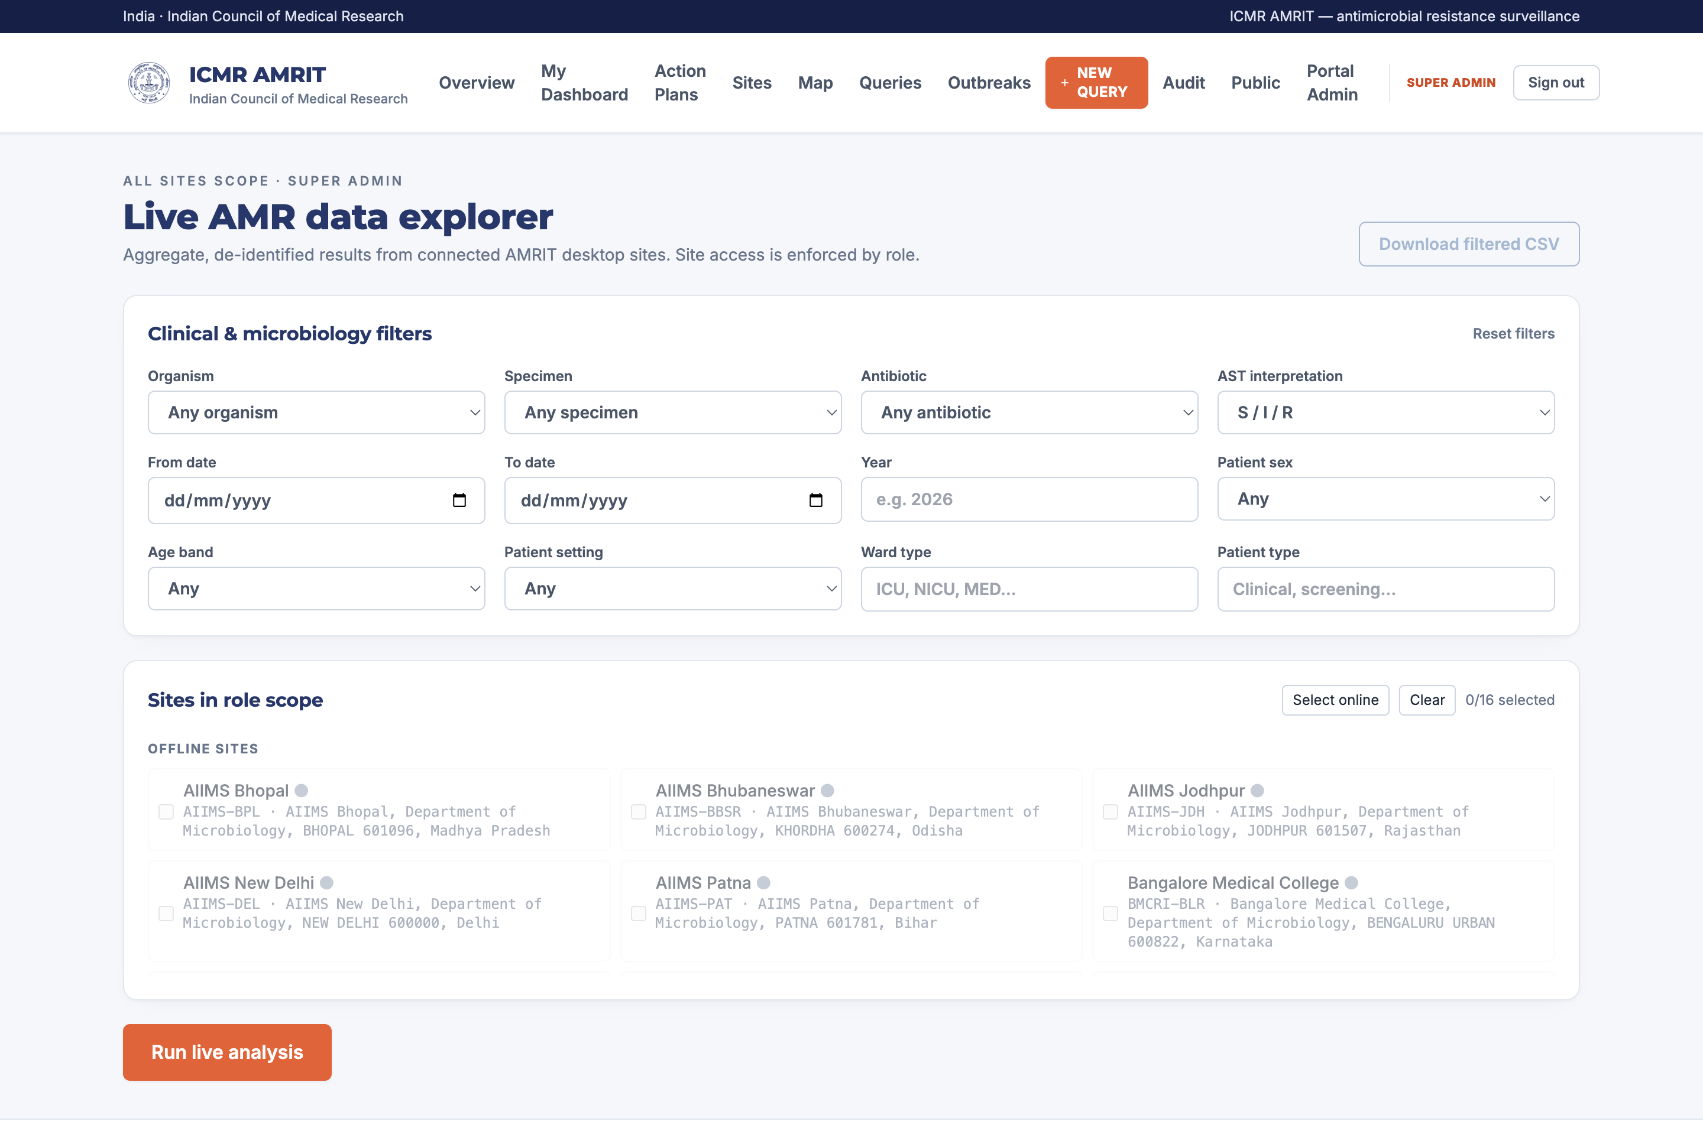
Query type | Answer
isolate_count | How many isolates match the filters
organism_distribution | Counts by organism
specimen_distribution | Counts by specimen type
resistance_rate | Numerator, denominator and percentage for an organism/agent pair
measure_bundle | The same as a FHIR MeasureReport
cluster_scan | Daily case counts by site and phenotype, for outbreak detection
heartbeat | Presence only
Queries expire (AMRIT_QUERY_TTL_SECONDS), and each site's answer is recorded separately, so a partial answer is visibly partial.
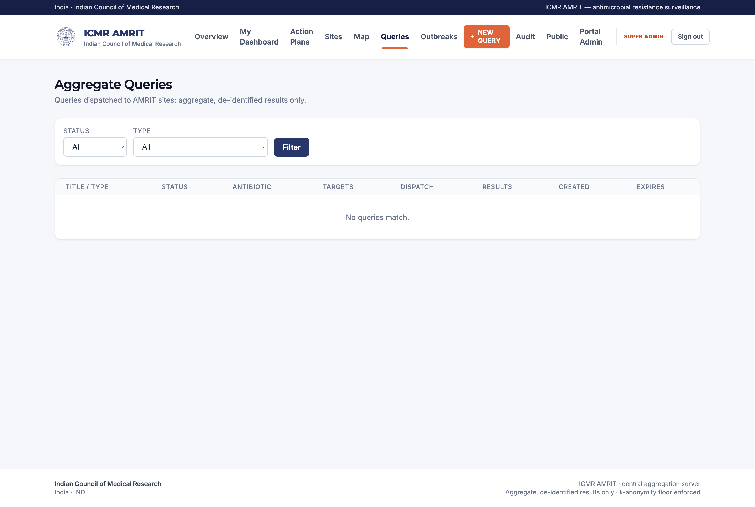

16. Dashboards, by stakeholder
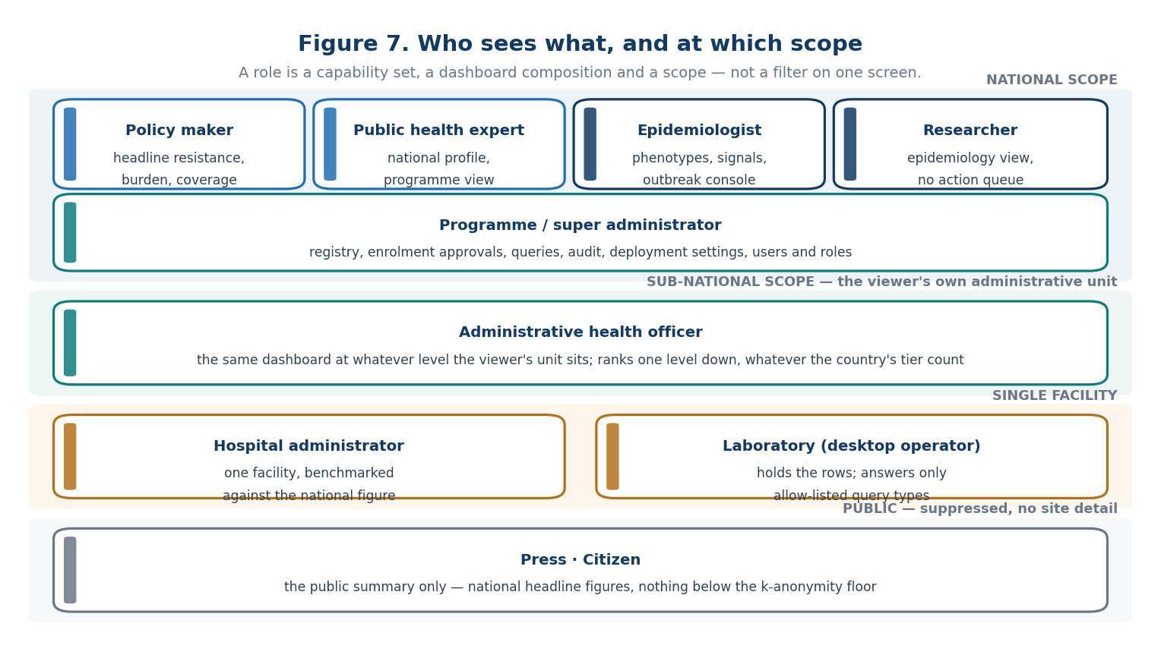
Figure 7 — who sees what, and at which scope.
A role is not a filter on one screen. Each stakeholder gets a different composition at a different scope, because the question each is asking is different.
Policy maker — national scope. Headline resistance, burden, coverage, trend.
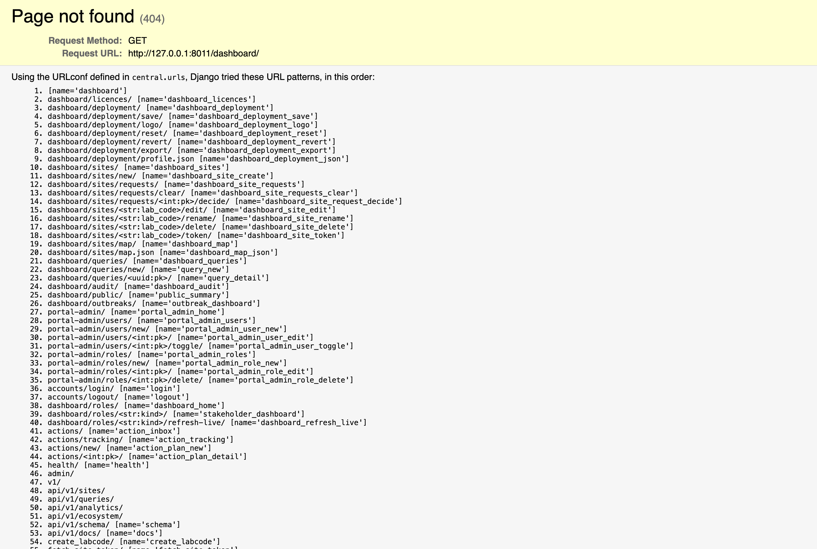
The advanced section opens the full resistance matrix and phenotype panels.
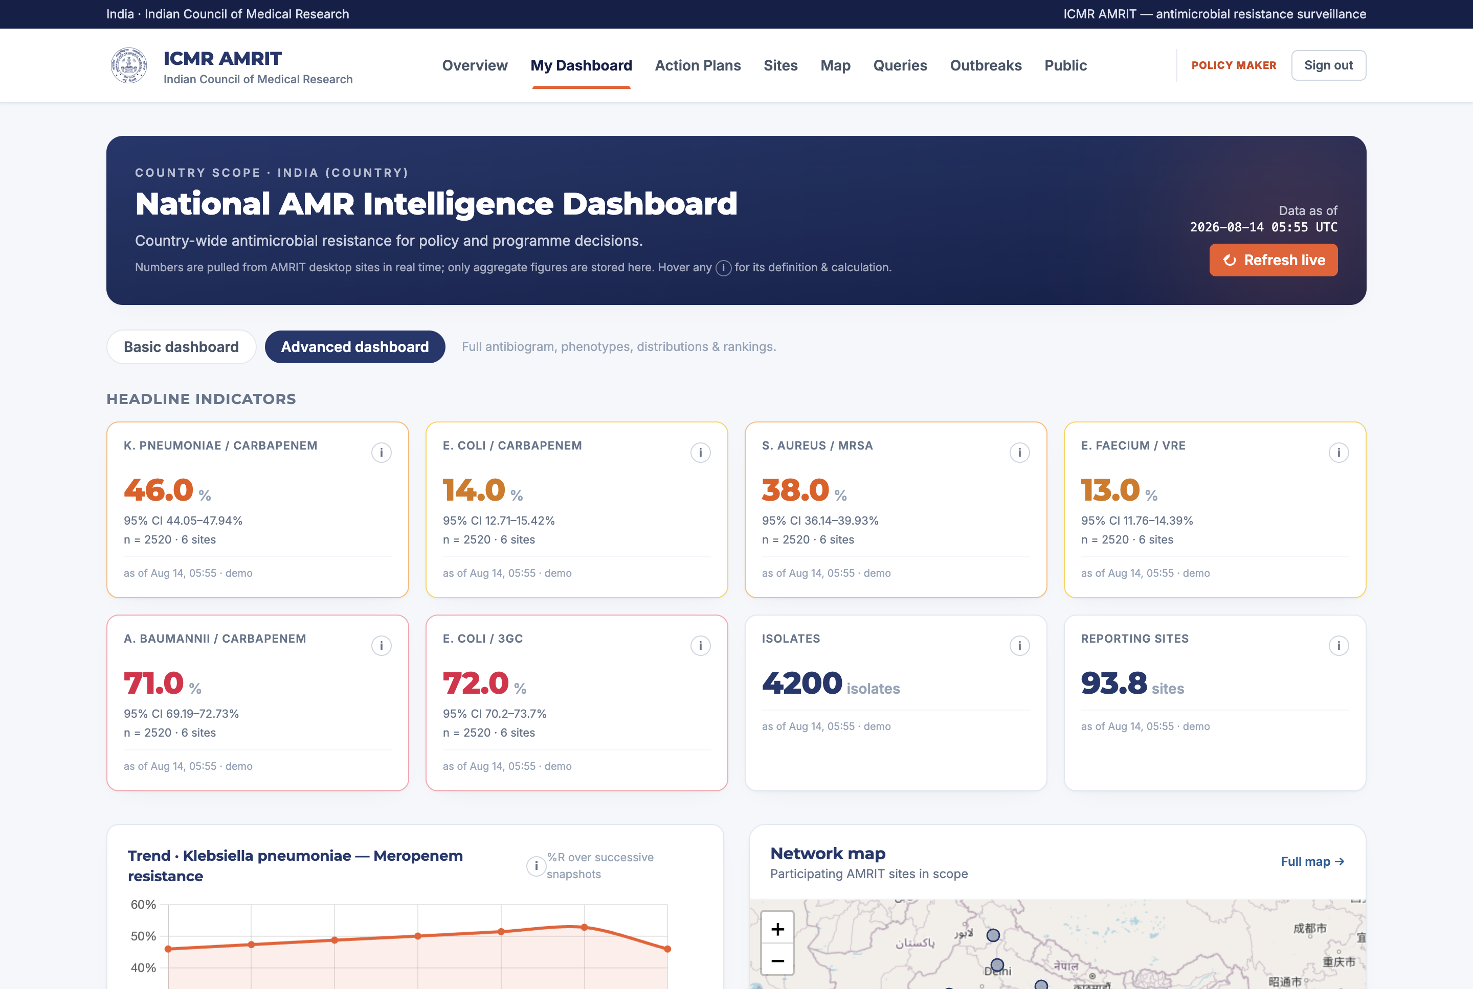
Epidemiologist — national scope with signals. Priority-pathogen phenotypes (CRE, MDR), anomaly signals and the outbreak console.

Researcher. The epidemiology composition without the operational action queue.

Public health expert — national scope.

Administrative health officer — sub-national scope. The same dashboard at whatever level the viewer's own administrative unit sits, ranking one level down. A three-tier country needs three units, not three dashboards.

Hospital administrator — single-facility scope. One facility's profile, benchmarked against the national figure.

Press and citizen. The public summary only (§19).
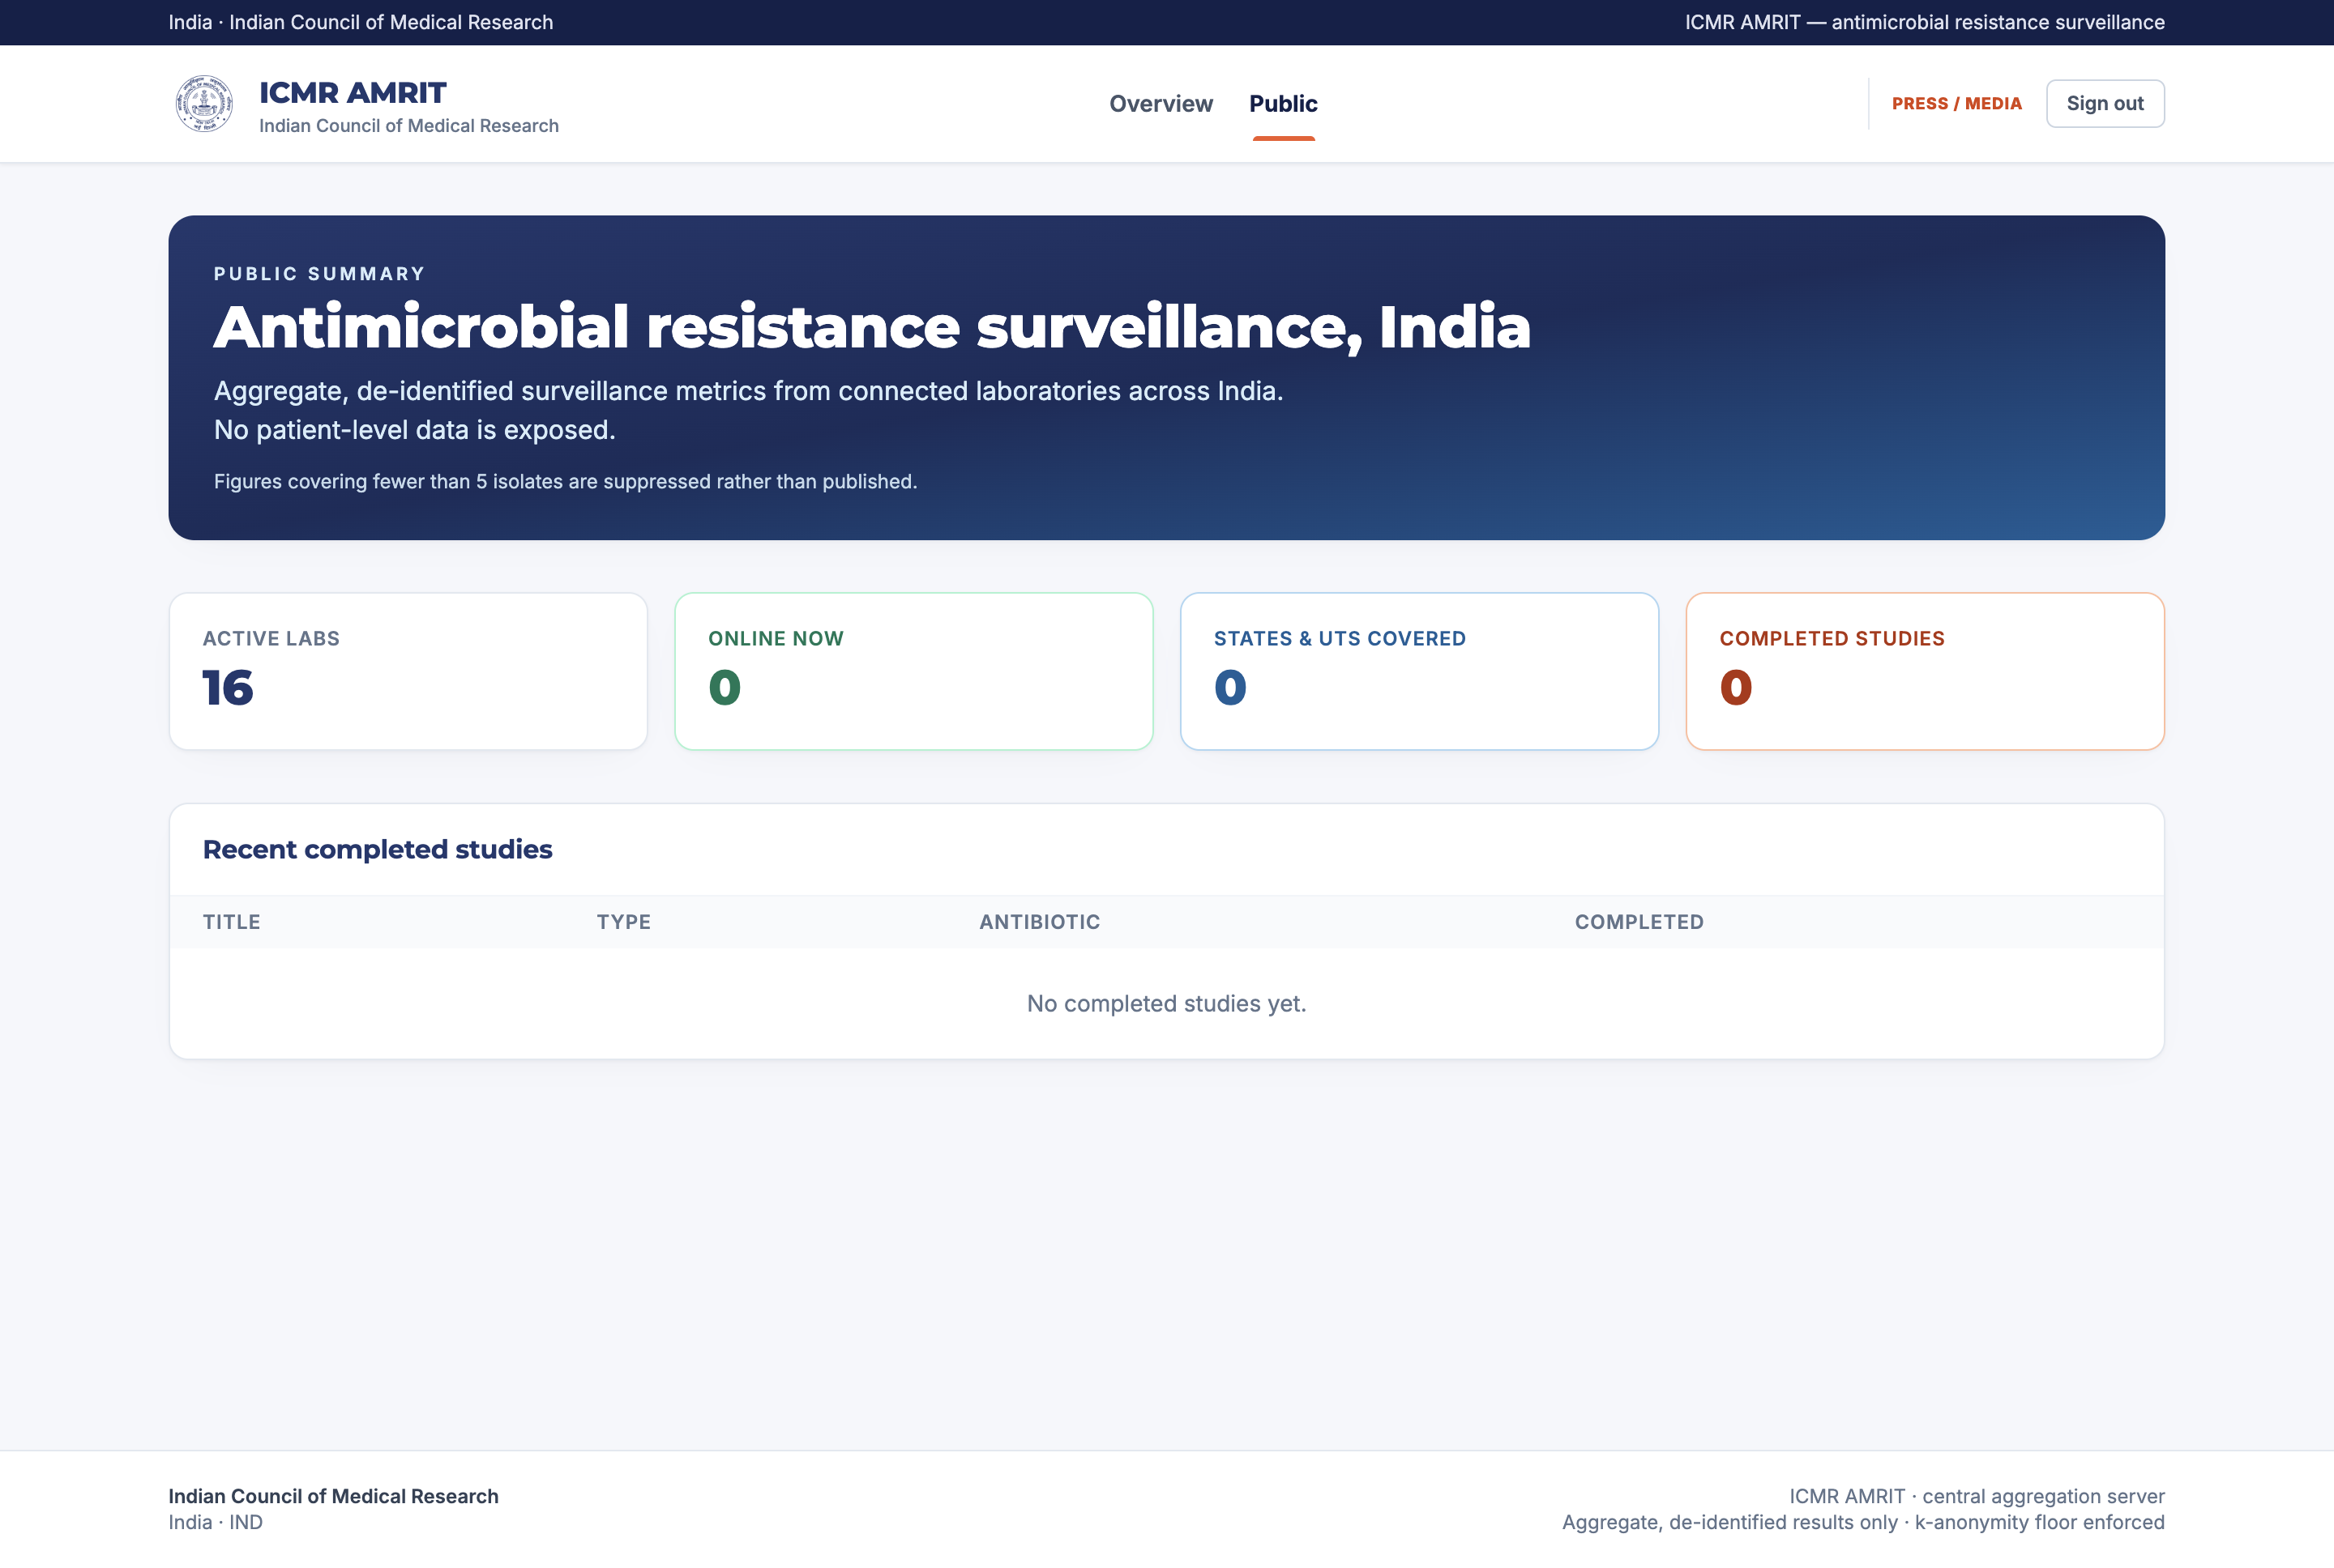
Refresh live dispatches a fresh batch of queries to the in-scope sites, waits for the answers, and recomputes the snapshots for that scope (Figure 3). Historical results are never folded into a new refresh's numbers.
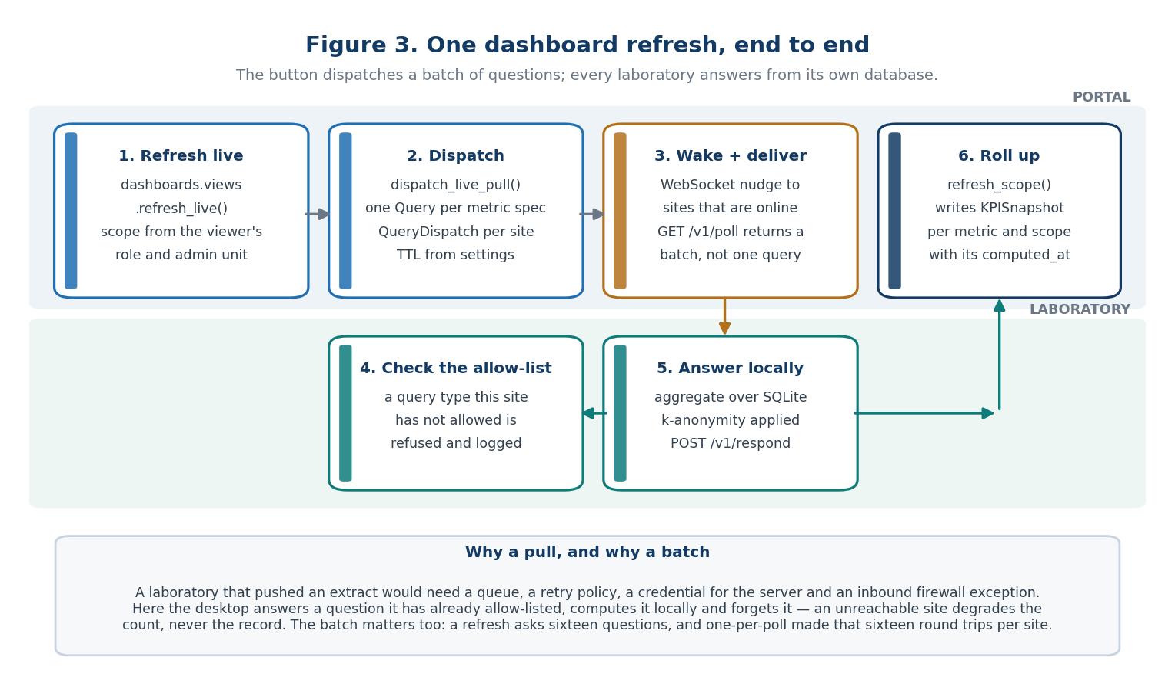
Figure 3 — one dashboard refresh, end to end.

17. The outbreak console
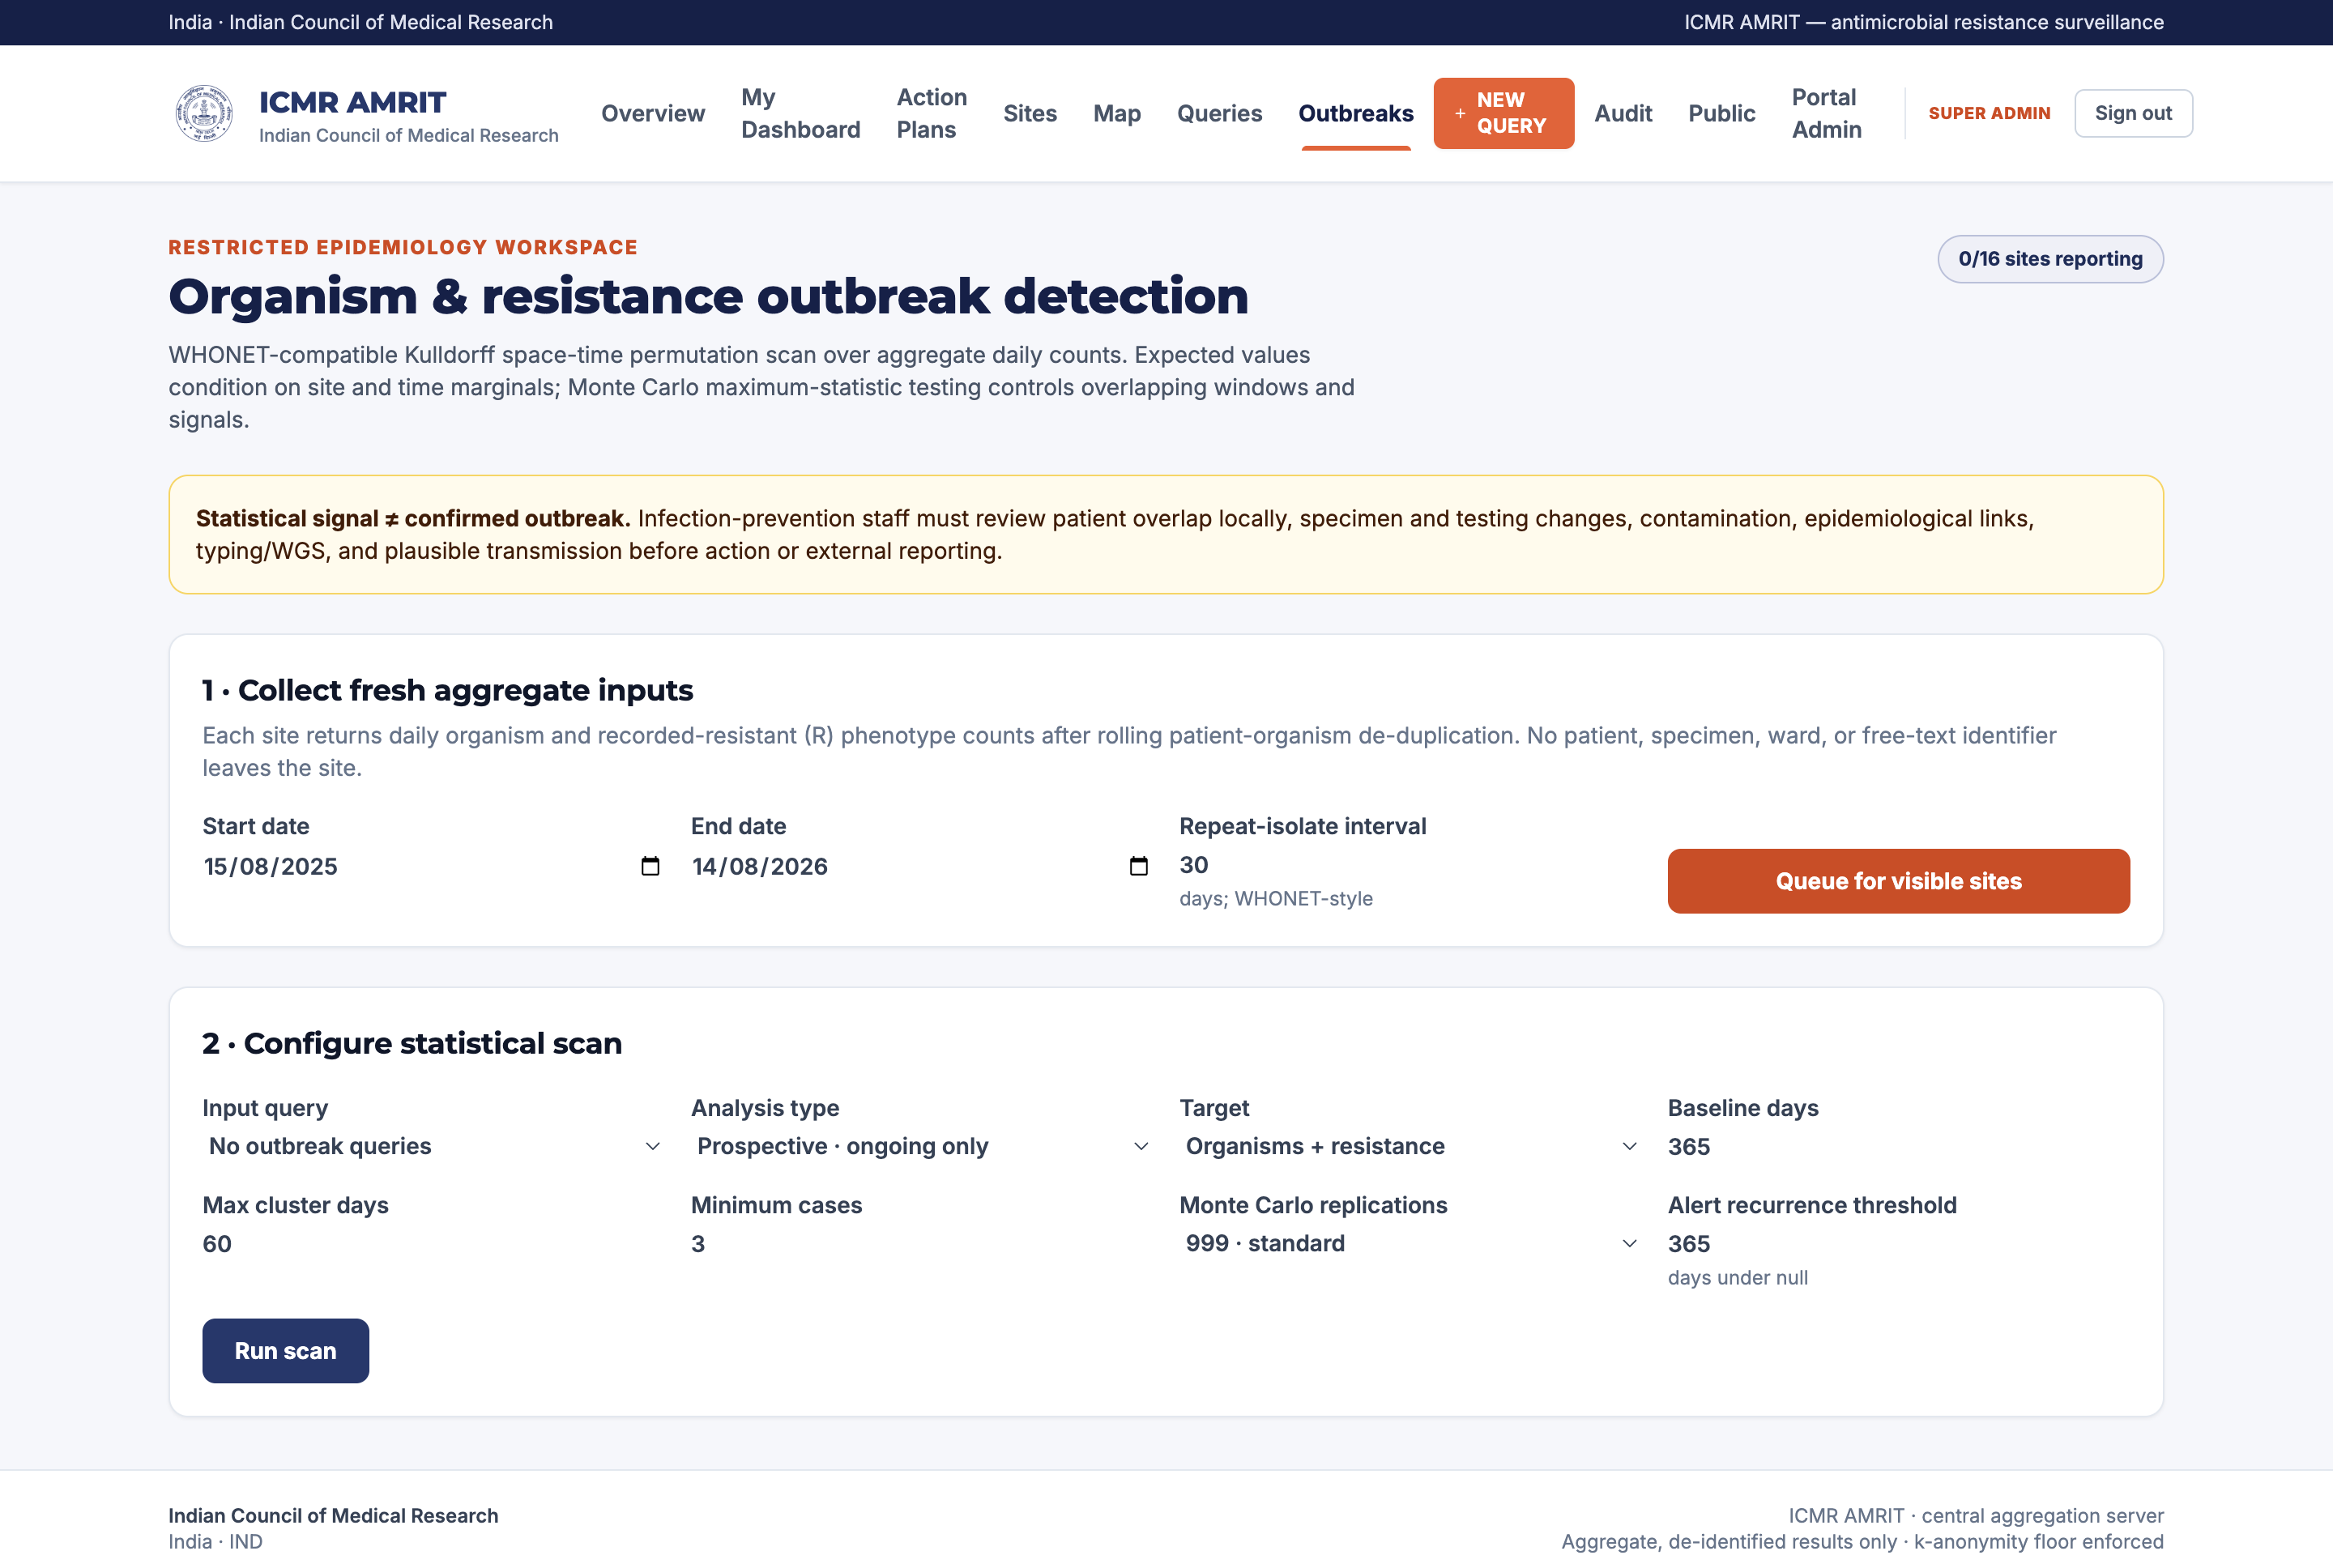
The console runs the space–time permutation scan (§26) over cluster_scan aggregates and lists clusters with their window, sites, observed and expected counts, p-value and recurrence interval. Settings — baseline, maximum cluster length, minimum cases, permutations — are on the screen, because a signal without its parameters is not interpretable.

18. From a signal to an action plan
Threshold rules turn a metric crossing into a draft action plan — never an automatic instruction. A person edits, assigns and schedules it; tracking records what was done.
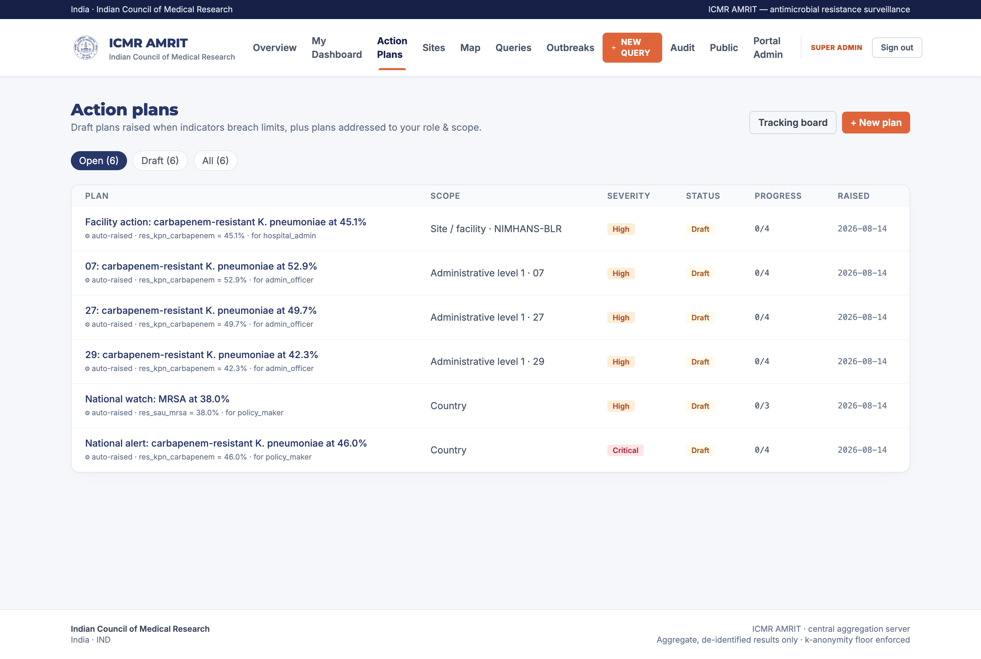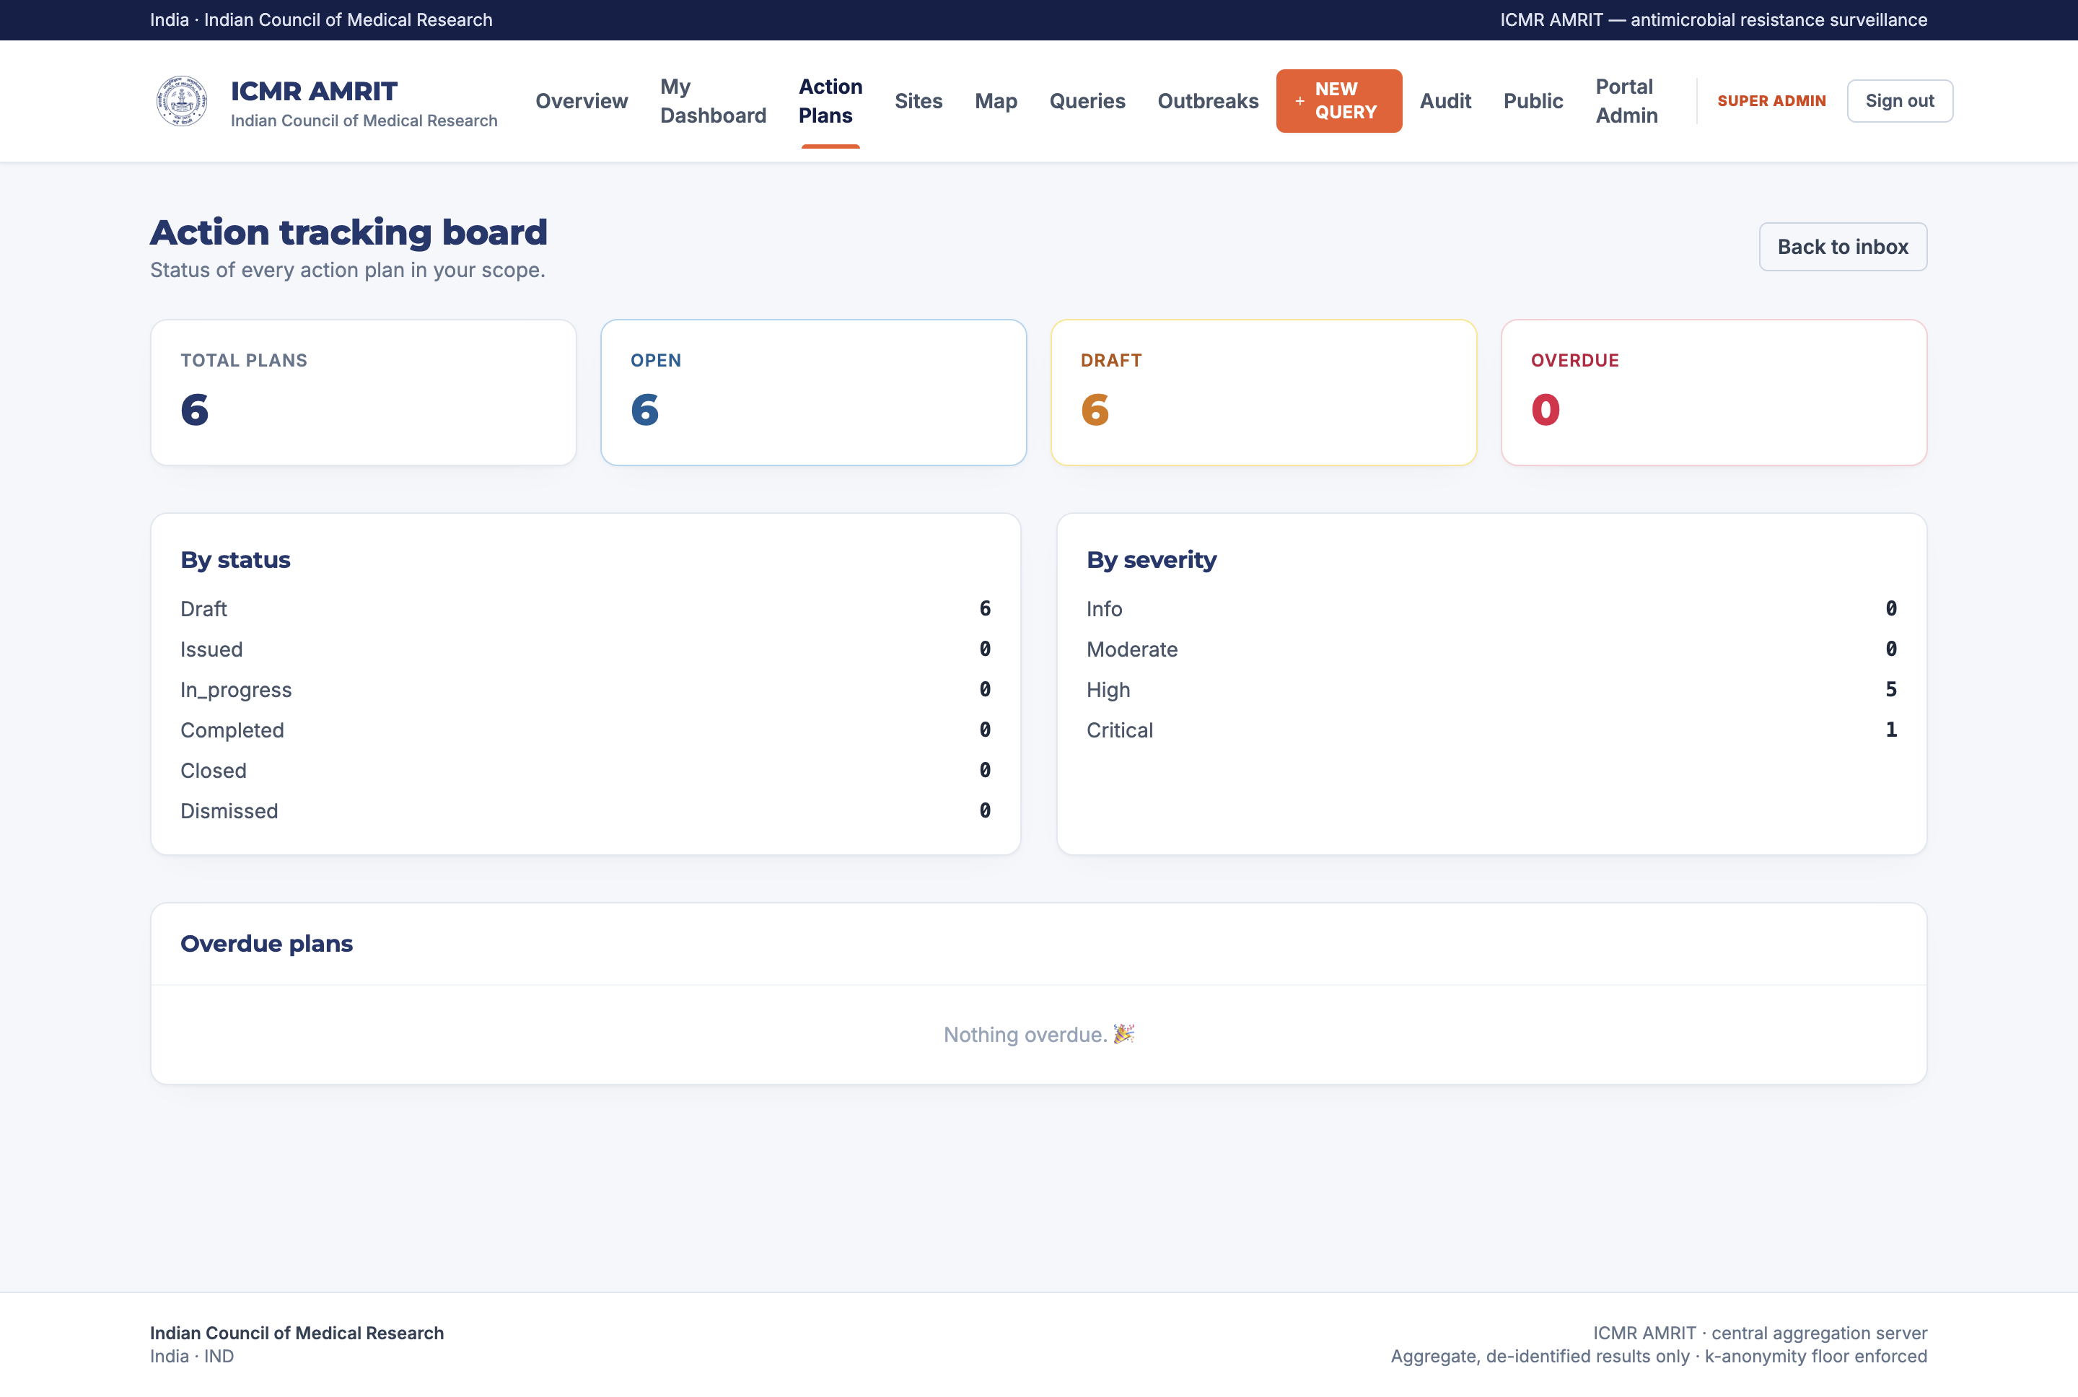

19. The public view
A deliberately reduced summary for press and citizens: national headline figures, no site-level detail, everything already suppressed below the k-anonymity floor.
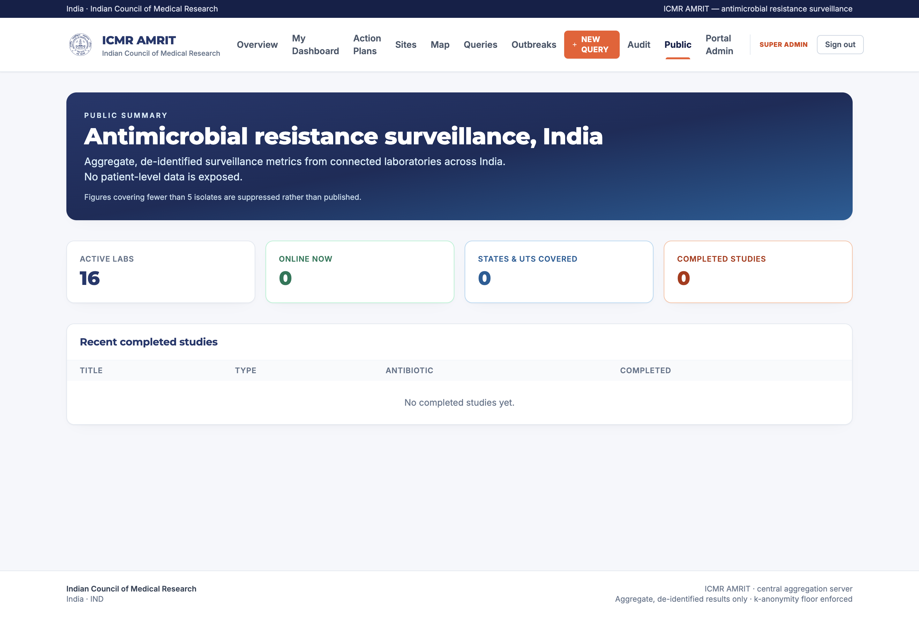

20. Audit and governance
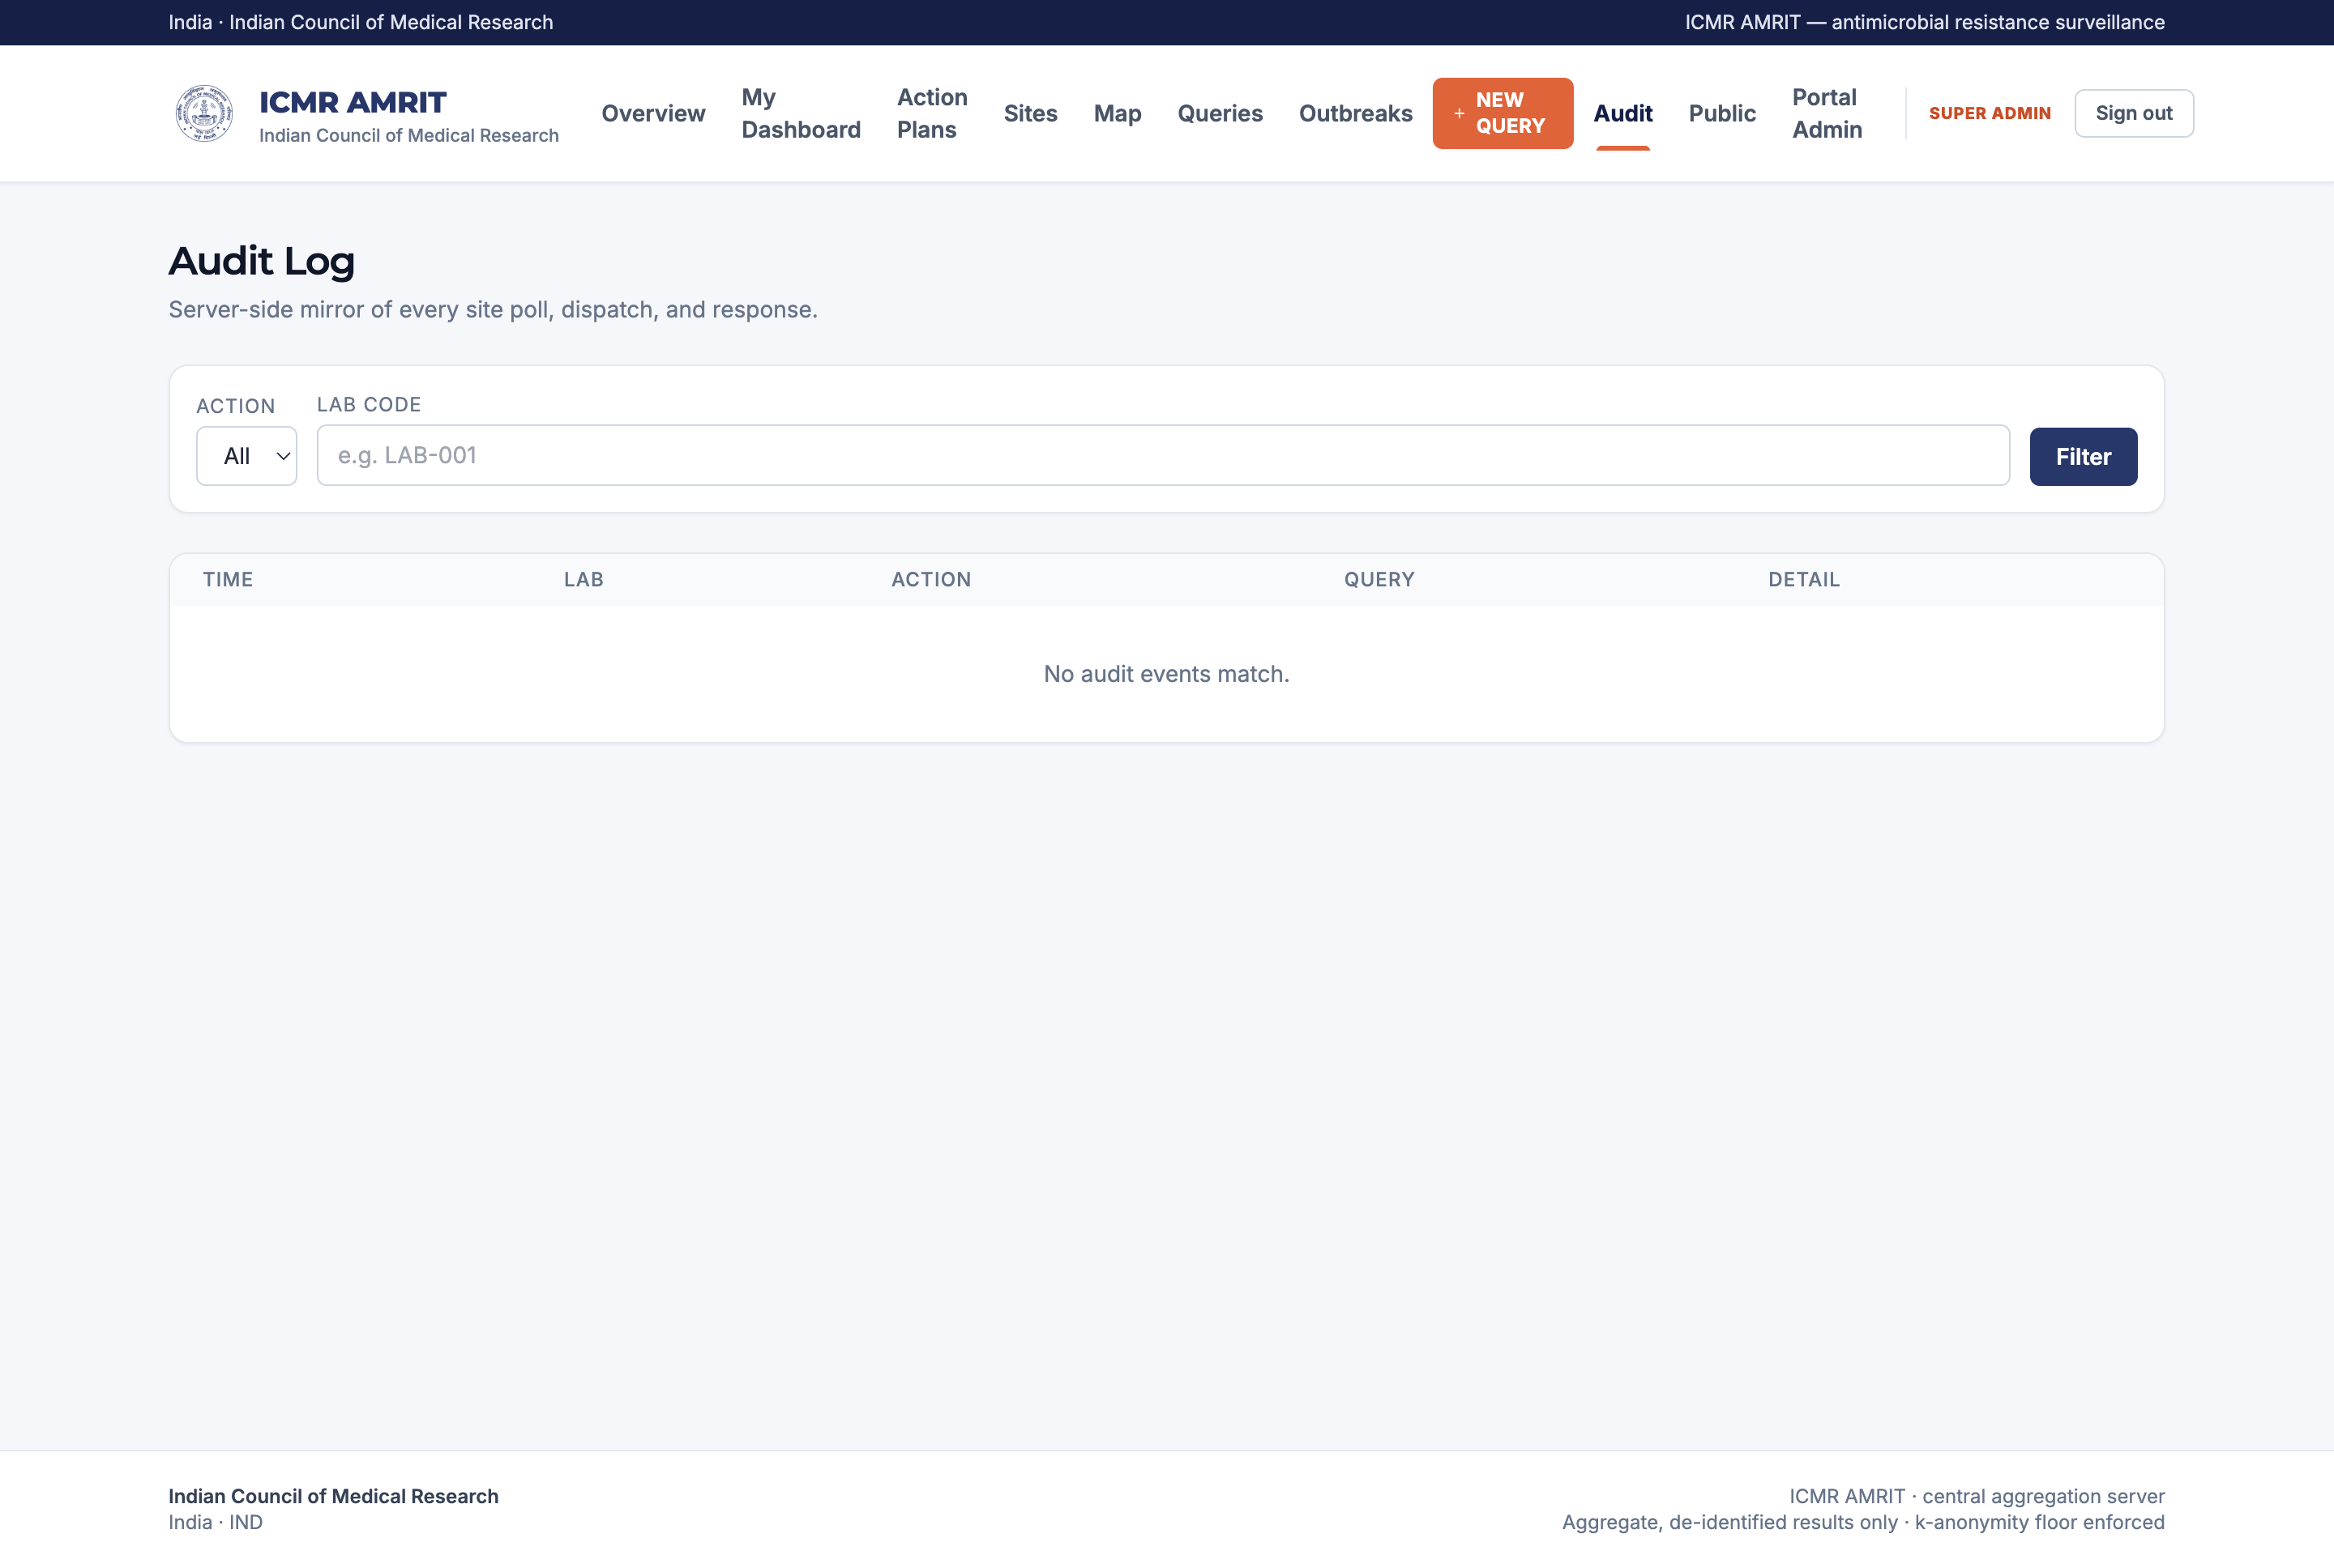
Every dispatch, answer, approval, token reset, rename and deletion is recorded with actor, time and detail. Licences lists every bundled dataset and its terms.
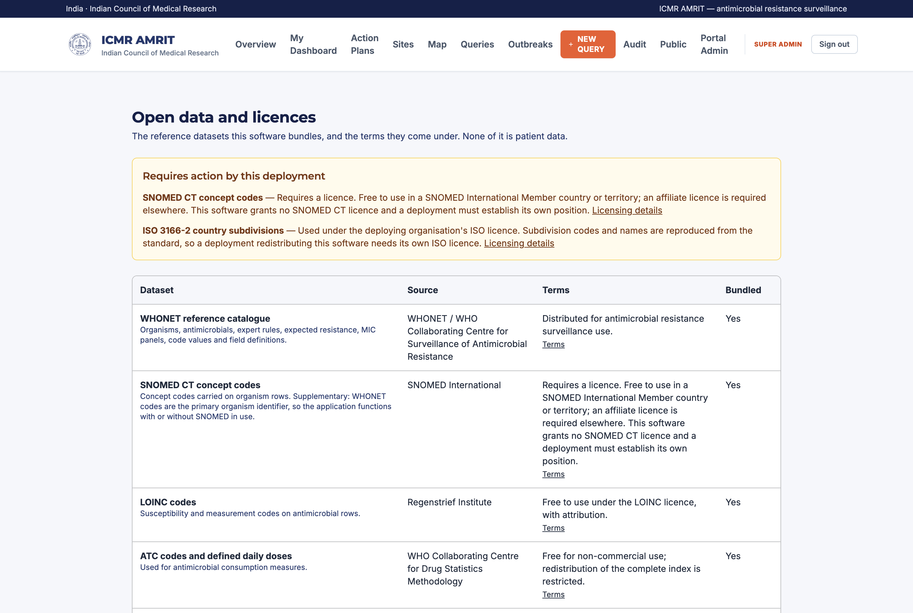

21. Portal administration
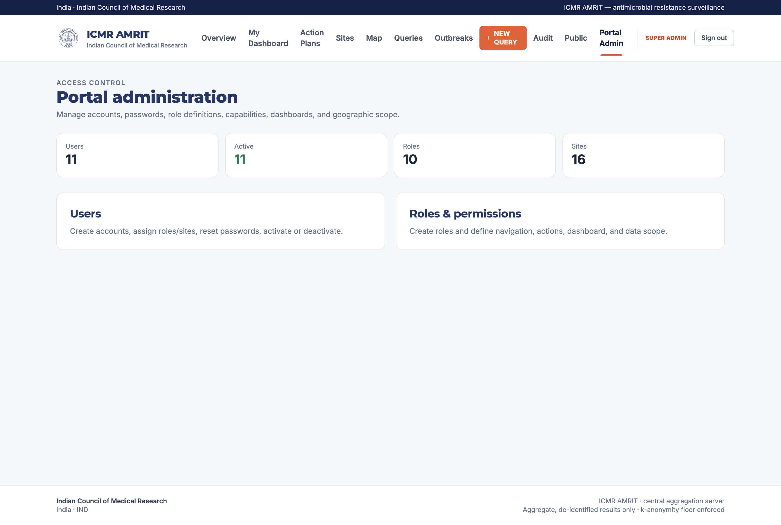
Users and roles are managed in the portal itself. A role is a set of capabilities plus a dashboard kind plus a scope; a deployment can rename roles and change what each may see without a code change.
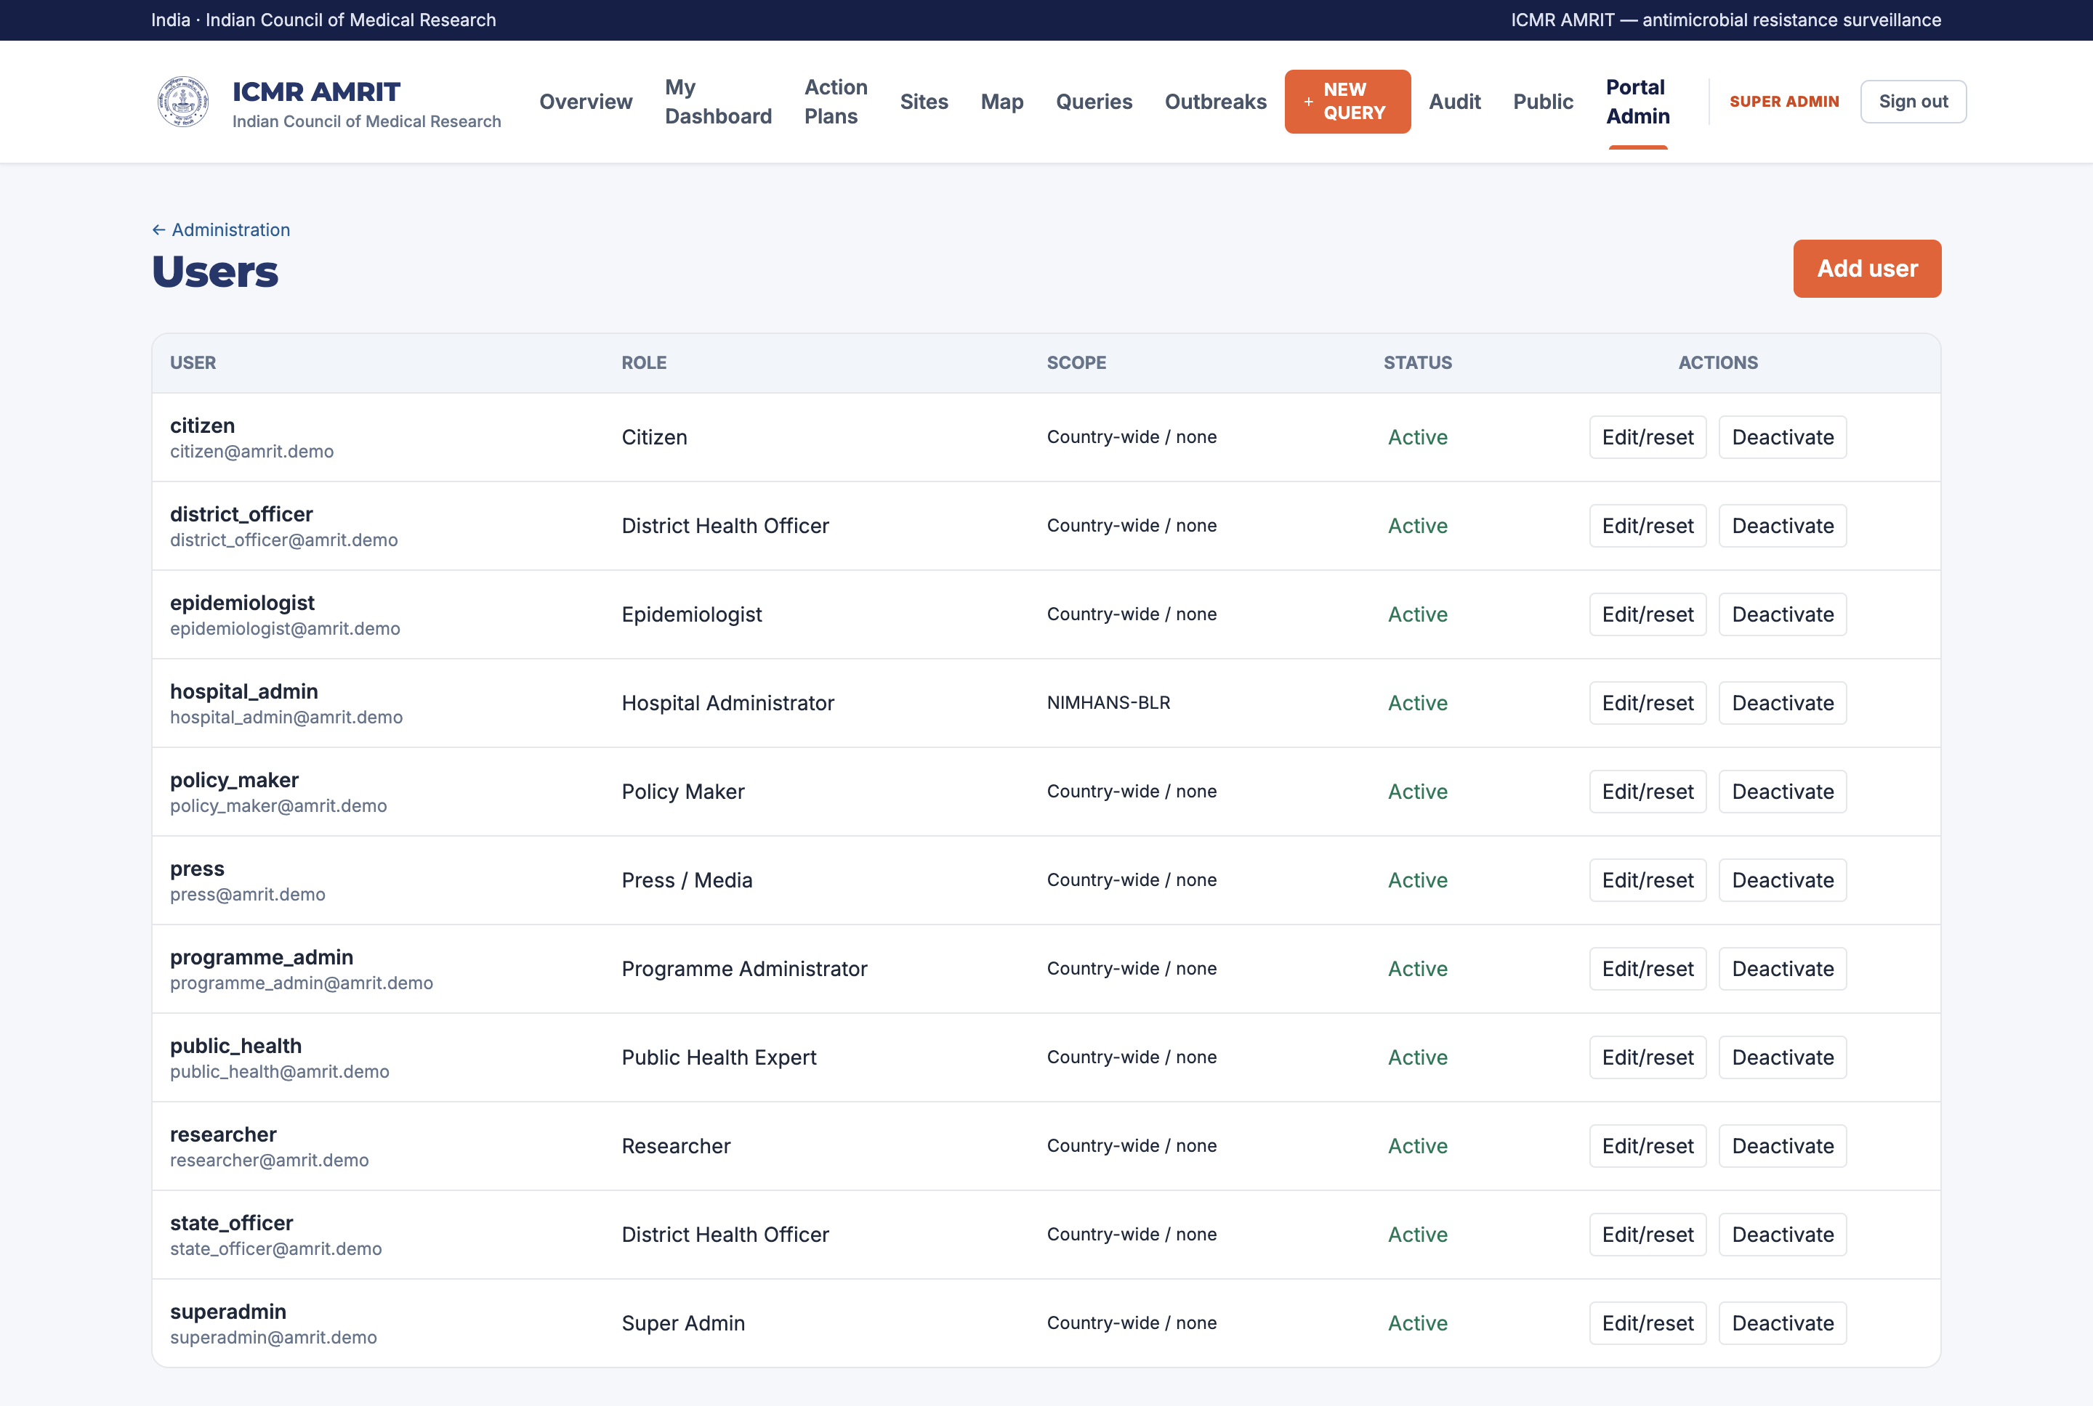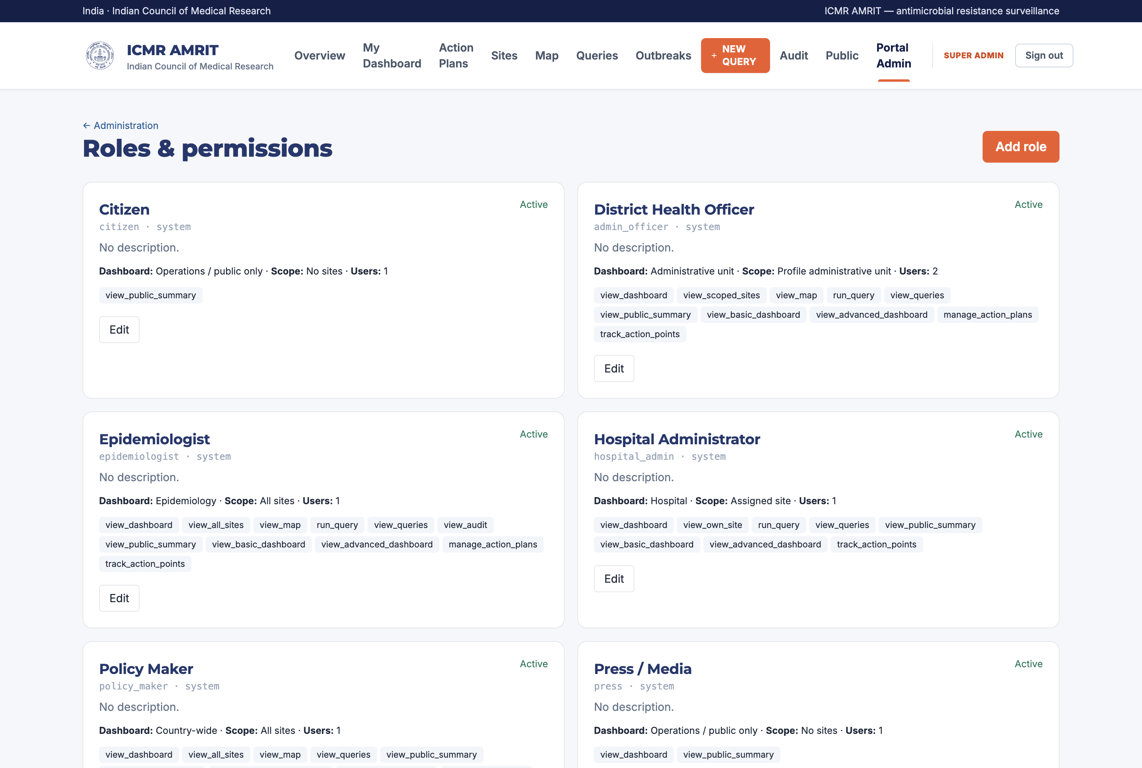

Part III — Methods and rationale
This part states, for each analytical choice: what the method is, what the alternatives were, and why this one was taken. It is the material a paper would cite.

22. Data model and standards
Records are stored in the WHONET code space (organism, antimicrobial and specimen codes) so data is exchangeable with the GLASS ecosystem without a mapping step. Interoperable output is produced on demand: FHIR Observation for results, MeasureReport for aggregates, HL7 v2 for hospital systems. Organism concepts carry SNOMED CT codes and antimicrobials carry ATC and WHO AWaRe classification, so an indicator can be defined in terms a programme already uses.
Why not a bespoke schema? Because the value of an AMR record is comparability. A national system whose codes are its own becomes an island, and the mapping cost is paid later, by somebody with less context.

23. Breakpoint interpretation
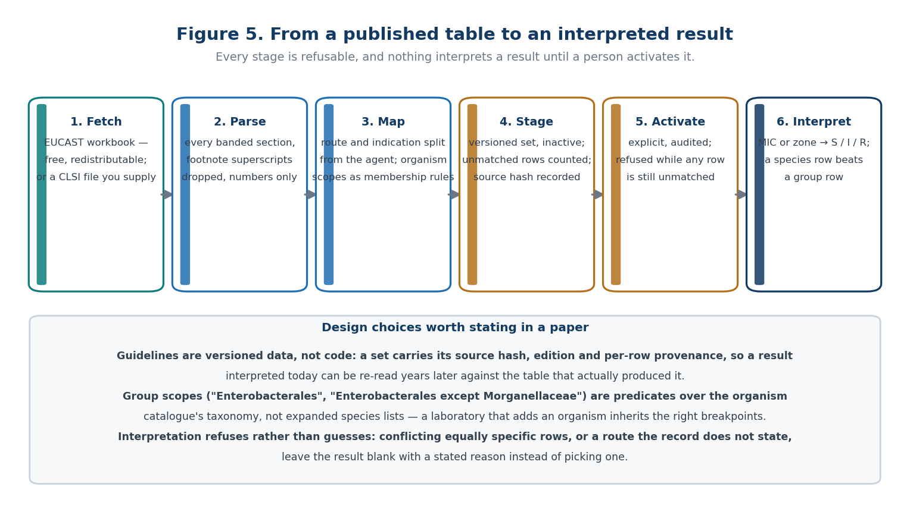
Figure 5 — from a published table to an interpreted result.
Its properties:
- Guidelines are versioned data. A staged set carries its source hash, edition, row provenance and import report, so a result interpreted in 2026 can be re-read in 2030 against the table that actually produced it.
- Organism scopes are membership rules, not expanded species lists. EUCAST writes "Enterobacterales", "Coagulase-negative staphylococci", "Enterobacterales except Morganellaceae"; those are stored as predicates over the organism catalogue's taxonomy. A species-specific row always beats a group row for the same organism.
- Refusal over guessing. Conflicting equally specific rows, a route the record does not state, or a missing matching row all produce a blank result with a stated reason.
- Activation is a human act. A set with unmatched rows cannot be activated at all.
Alternatives considered. Compiling breakpoints into the application makes every guideline revision a software release, which no laboratory can wait for. Accepting a spreadsheet without provenance makes a result unauditable. The staging-plus-activation design is the middle path: data-driven, but never live until somebody takes responsibility for it.

24. Deduplication
Two modes, chosen per analysis and always shown with the result:
- firstPatientOrganism — first isolate per patient per organism within the window. This is the CLSI M39 / WHO GLASS convention.
- allIsolates — every isolate, for laboratory workload and quality questions.
Why first-isolate is the default. Repeat isolates from the same patient are not independent observations: a single long ICU admission with daily cultures can contribute dozens of resistant isolates and shift a national rate on its own. Reporting resistance without deduplication systematically overestimates it in exactly the settings where the sickest patients are — which is where policy attention lands.
Why the alternative is kept. A laboratory asking "how much work did we do?" or "how complete is our AST?" needs every isolate. The mode is therefore a parameter of the question, not a global setting.

25. Indicators
The priority indicators follow WHO GLASS pathogen–antimicrobial combinations: MRSA; vancomycin-non-susceptible enterococci; third-generation-cephalosporin-non-susceptible E. coli and K. pneumoniae; carbapenem-non-susceptible Enterobacterales, P. aeruginosa and Acinetobacter spp.; fluoroquinolone-resistant E. coli; penicillin-non-susceptible S. pneumoniae.
Each is a numerator and a denominator, both reported. Non-susceptible (R + I) is used where GLASS uses it, and the tested-with agent set is stated, because "carbapenem resistance" computed over meropenem alone and over meropenem-or-imipenem-or-ertapenem are different numbers and only one of them matches the neighbouring country's.

26. Outbreak detection
Method: Kulldorff's space–time permutation scan statistic, case-only, prospective by default.
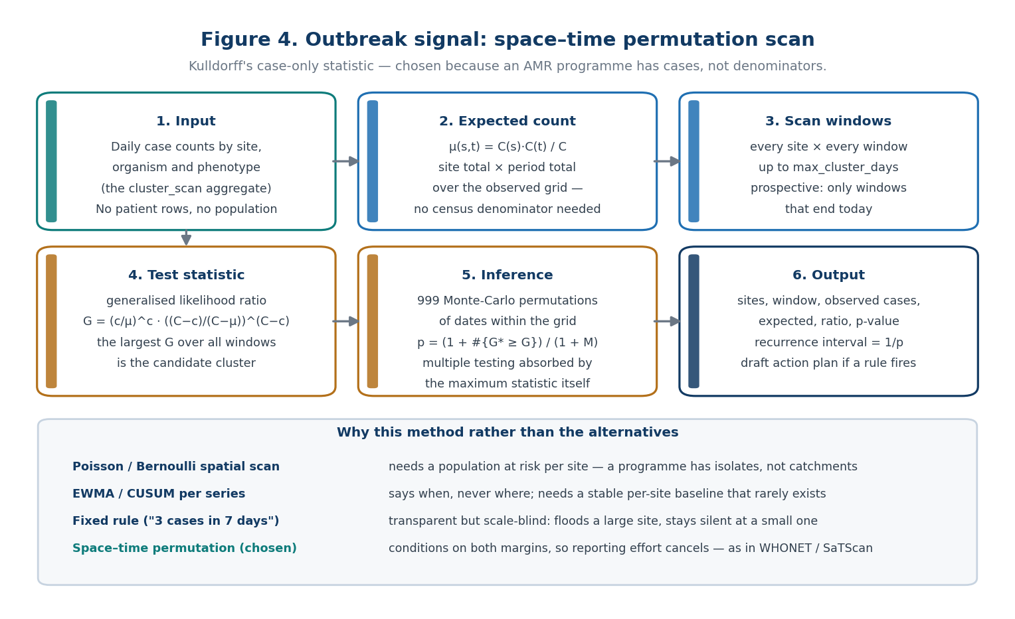
Figure 4 — the scan pipeline and the alternatives it was chosen over.
For each candidate cluster — a site (or set of sites) and a time window up to max_cluster_days — the expected count is the product of that location's total and that period's total divided by the grand total. The test statistic is the generalised likelihood ratio, and significance comes from Monte-Carlo permutation of dates within the observed grid (999 by default), so the multiple-testing burden of scanning thousands of windows is handled by the distribution of the maximum statistic rather than by a correction applied afterwards. Output includes the recurrence interval (1/p), which is what an operational programme can act on: "a cluster this extreme would be seen by chance about once every N days".
Why case-only. The Poisson and Bernoulli scan statistics need a population at risk per location. A national AMR programme does not have one: it has isolates from laboratories with different catchments, different testing rates and different referral patterns. Conditioning on both margins removes exactly that — a site that reports twice as much of everything contributes no signal, which is the property that makes the method usable across heterogeneous reporting.
Why not the alternatives.
Method | Why not
Fixed rule ("3 cases in 7 days") | Transparent but scale-blind: floods large sites, silent at small ones
EWMA / CUSUM per series | Detects when but not where; needs a stable per-site baseline
Poisson / Bernoulli spatial scan | Needs a denominator population AMRIT does not have
Unsupervised clustering | No inferential statement; a cluster is always found
Limitations, stated. The scan detects excess relative to the rest of the observed data, so a uniform national rise is invisible to it — that is what the trend metrics are for. It is sensitive to baseline_days and max_cluster_days, so both travel with every signal. And it operates on aggregate counts, so it can point a programme at a place and a period, never at a patient.

27. Privacy engineering
Four mechanisms, layered:
- Aggregate-only federation. The wire contract carries counts and rates. A middleware guard rejects any response payload carrying patient identifiers, so a bug in a laboratory build cannot become a national disclosure.
- k-anonymity floor. Cells below AMRIT_K_ANONYMITY_FLOOR (default 5) are suppressed before storage, not before display — a suppressed number is never written down.
- Coarsening. Patient residence is stored to a coarsened postal geography; facility coordinates are site-level and consent-gated. Patient coordinates do not exist.
- Retention and erasure. Row-level data expires on the profile's schedule; a subject's rows can be erased on request, and the erasure is itself auditable.
Why not de-identified record sharing? Because de-identified AMR records are re-identifiable in practice: a rare organism, a date and a district are frequently unique. Keeping rows in the laboratory and shipping only answers removes the question rather than mitigating it.

28. Federation protocol design
The laboratory pulls questions (GET /v1/poll, long-poll, with a WebSocket nudge for immediacy) and posts answers (POST /v1/respond). Both credentials — bearer token and out-of-band site token — are required on every request.
Why pull rather than push. A pushing laboratory must hold a queue, a retry policy, a credential for the server and an outbound firewall exception; when it is offline the programme learns nothing about why. A pulling laboratory needs only outbound HTTPS, answers only questions it has allow-listed, and its absence is visible as a missing answer rather than as silence.
Why not a central warehouse. A warehouse is the design that makes every other privacy control a promise. The moment rows are centralised, the protection is policy; while they stay local, it is architecture.
Why the two-token scheme. One token that both authenticates and travels the same channel as enrolment can be replayed by whoever intercepts enrolment. Splitting the factors across two channels means a compromise of either one alone is not enough.

29. Dashboard computation
Metrics are declared in a catalogue (metrics/catalog.py) as key, query type, filters and presentation. A refresh dispatches the de-duplicated set of wire queries the catalogue implies, waits for the batch, then computes each metric from that batch only and writes a KPISnapshot per metric and scope. Snapshots carry their computation time, source and site count, so a dashboard tile can always answer "as of when, from how many sites".
Scopes are canonical (country, admin:<level>, site) and derived from the country profile's tier chain, so a one-tier and a five-tier country use the same code path.

30. Limitations and threats to validity
Stated plainly, because a paper needs them:
- Denominator heterogeneity. Resistance rates depend on which isolates a laboratory tests and refers. Coverage metrics (sites reporting, AST completeness) are published alongside the rates for that reason.
- Breakpoint version effects. A guideline revision can move a national rate without any change in biology. Every result carries the set that produced it.
- Deduplication sensitivity. First-isolate versus all-isolate changes rates materially; comparisons across systems must match modes.
- Suppression bias. k-anonymity suppression removes small cells, which are not missing at random — sparse regions lose more.
- Signal ≠ outbreak. A scan statistic identifies statistical excess; confirmation is an epidemiological act.

Appendix A — Commands
# Desktop
pnpm --dir app install && pnpm --dir app dev # development
pnpm --dir app run check && pnpm --dir app test # types, lint, tests
# Portal
python3 manage.py migrate
python3 manage.py bootstrap # first administrator
python3 manage.py seed_demo [--country IND] [--strict]
python3 manage.py refresh_snapshots --live
python3 manage.py purge_sites --apply # clears the registry
python3 manage.py purge_dashboard_data --apply # clears snapshots and results
# Documentation
python3 tools/build_manual_figures.py
AMRIT_PORTAL_URL=… AMRIT_PORTAL_USER=… AMRIT_PORTAL_PASSWORD=… \
app/node_modules/.bin/electron tools/capture_portal.mjs
python3 tools/build_manual.py

Appendix B — Environment
Variable | Meaning
AMRIT_COUNTRY_PROFILE | Country profile id (IN, TESTLAND, …). Must be passed to the container
AMRIT_SEED_DEMO | 1 seeds the demonstration pack — published passwords, demo only
AMRIT_K_ANONYMITY_FLOOR | Minimum cell size before suppression (default 5)
AMRIT_QUERY_TTL_SECONDS | How long a dispatched query stays answerable
AMRIT_LONGPOLL_MAX_WAIT, AMRIT_LONGPOLL_TICK | Long-poll hold time and poll granularity
AMRIT_REFRESH_WAIT_SECONDS | How long a live refresh waits for answers
AMRIT_ENROLMENT_PICKUP_TTL_SECONDS | Lifetime of a one-time pickup token (default 24 h)

Appendix C — Roles and dashboards
Role | Dashboard | Scope
Super administrator, programme administrator | Country | National
Policy maker, public health expert | Country | National
Epidemiologist, researcher | Epidemiology | National, with signals
Administrative health officer | Administrative | The viewer's own unit
Hospital administrator | Hospital | One facility
Press, citizen | Public summary | National, suppressed

Appendix D — Metric catalogue (extract)
res_* resistance rates per pathogen–agent pair · phen_cre, phen_mdr phenotypes · burden_isolates, burden_organism_mix, burden_specimen_mix · antibiogram · cov_sites_reporting, cov_sites_online, cov_geo, cov_ast_completeness.

Appendix E — Demonstration credentials
Seeded only by seed_demo, with passwords published in this repository. Never enable on a deployment holding real data.
User | Role
superadmin | Super administrator
policy_maker | Policy maker
epidemiologist | Epidemiologist
researcher | Researcher
public_health | Public health expert
state_officer, district_officer | Administrative health officer
hospital_admin | Hospital administrator
press, citizen | Public views

