Add Your Business Details Master=> Shop/Business=> Add Shop/Business Details

**Step 1 :** Add Category Master=>category=>Add Category

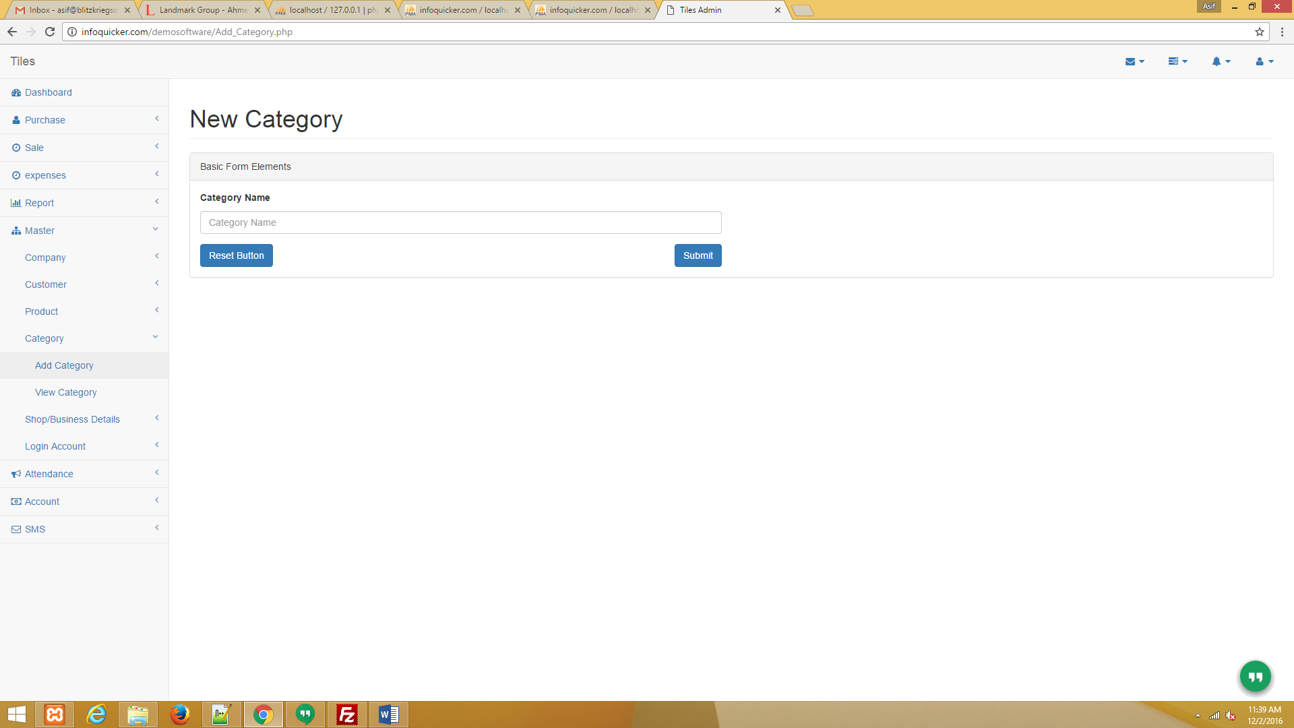

**Step 1.A :** View Category And Update Master=>category=>View Category

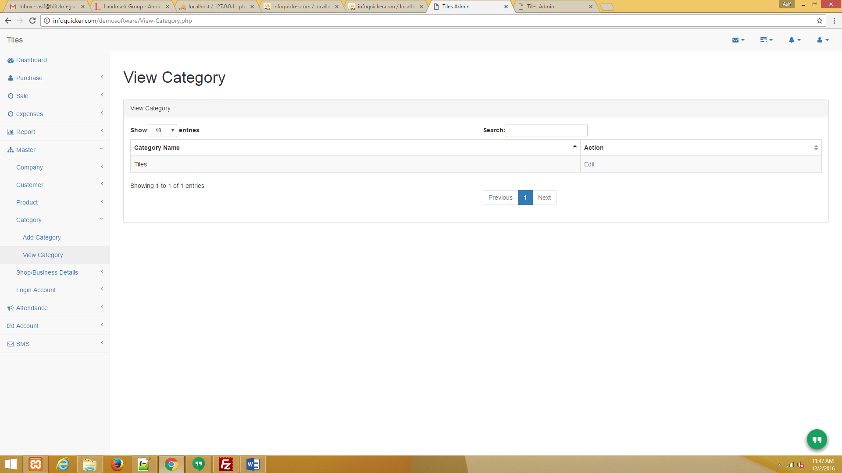

**Step 2 .A:** Add Product Master=> Product=>Add Product

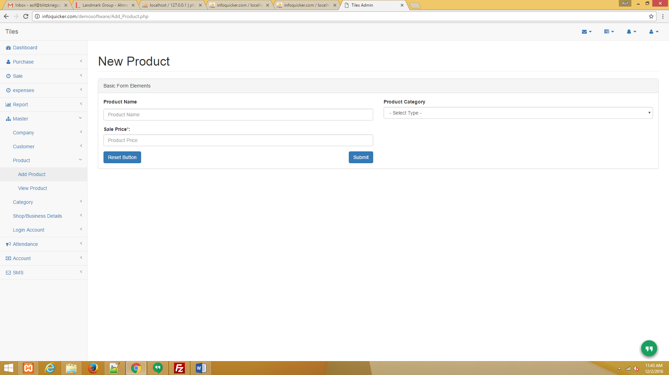

**Step 2.B :** View Product Master=> Product=>View Product

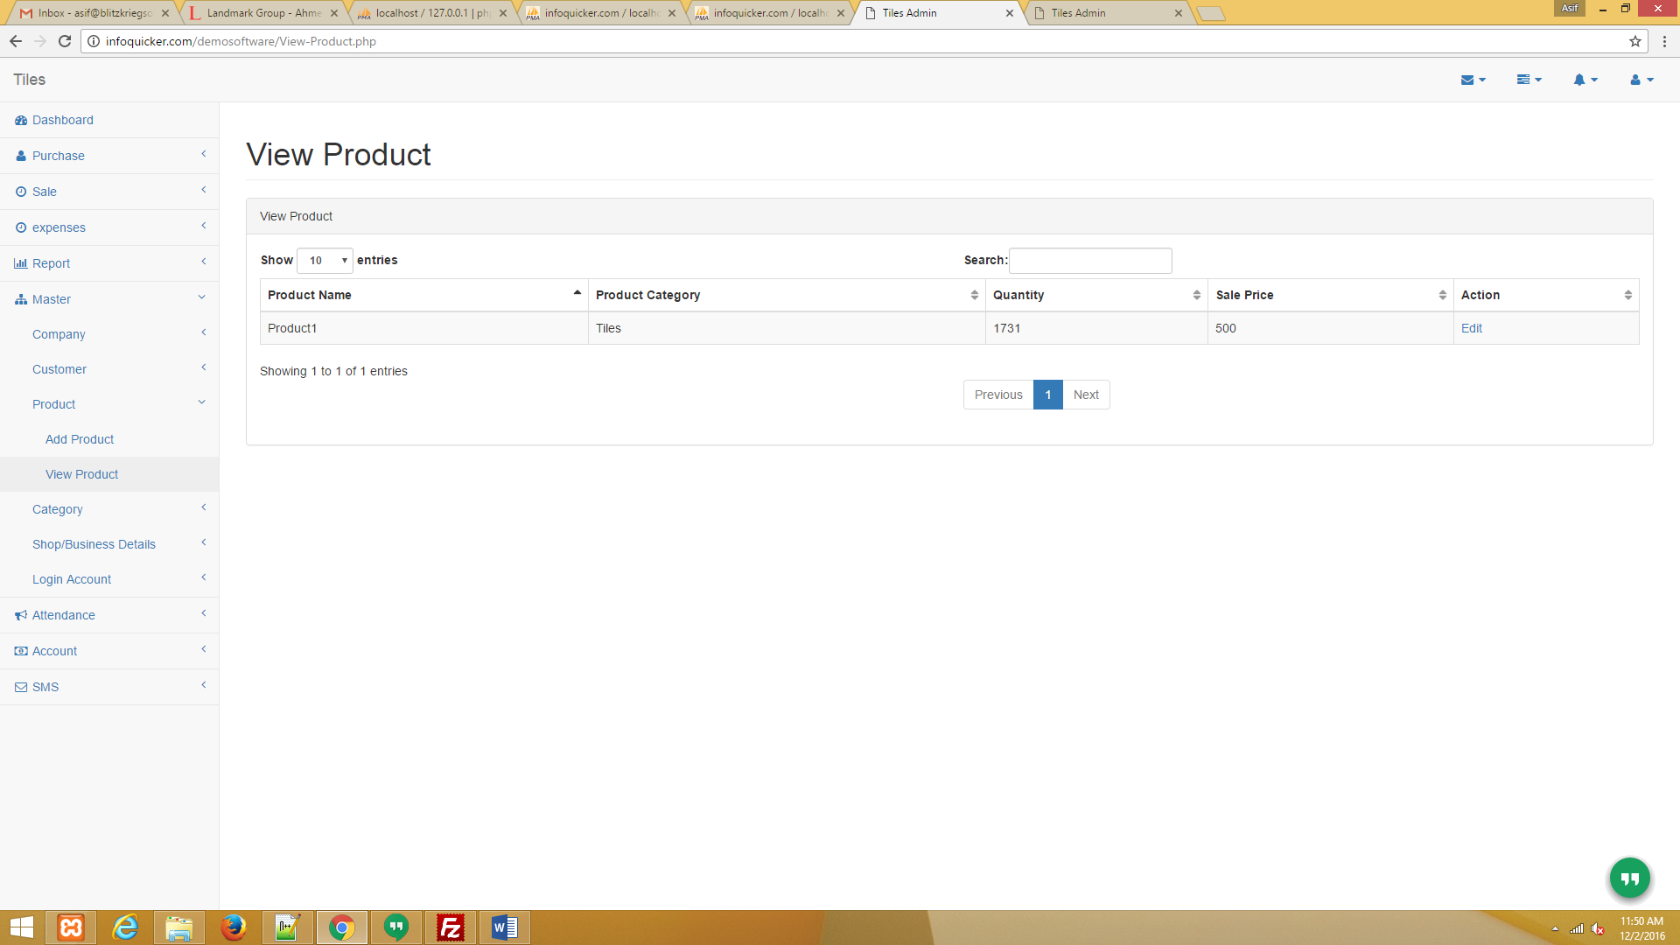

**Step 2.C :** Update Product Master=> Product=>View Product

=>In view product there is Edit option. In Edit product you can manage product stock.

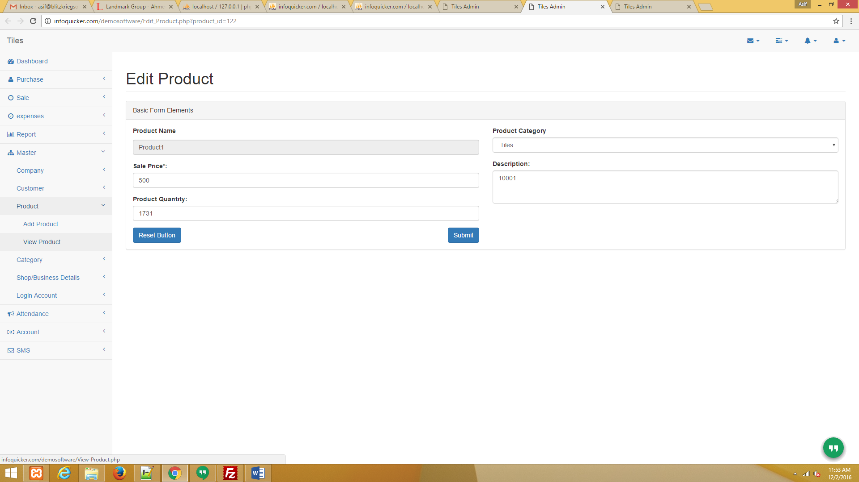

**Step 3.A:** Add Company Master=> Company=>Add Company

=> Add Company Details where you have purchased your product.

Note* : Before Purchase Entry company details should be added in your software.

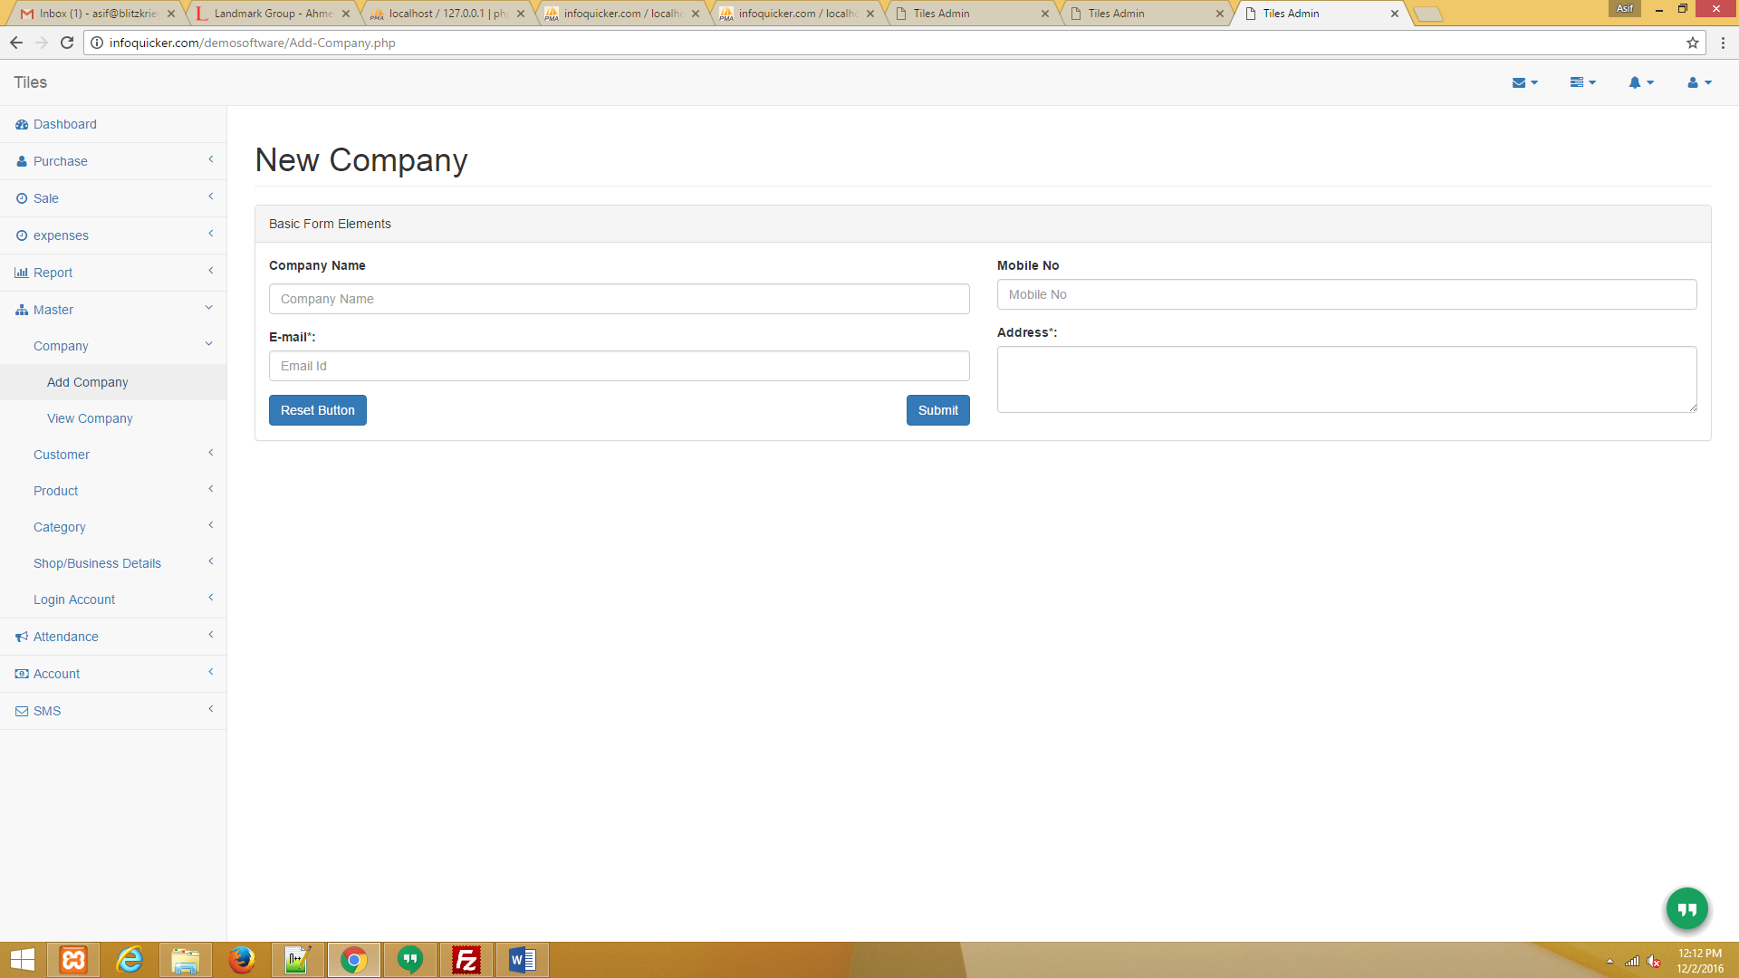

**Step 3.B:** View Company And Update Master=> Company=>View Company

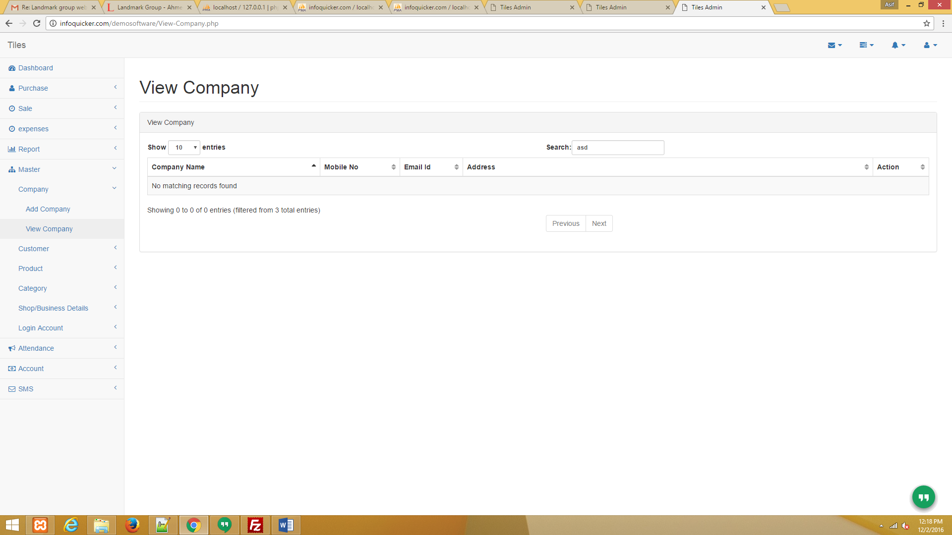

**Step 4.A:** Purchase Entry Purchase=> Purchase Entry

=> Bill No : Purchase Bill No If You Have. (Not Required)

=> Company ID : Enter Company ID (You Can See Company ID In Master=>Company=>View Company) Required

=> When You Have Selected Category Related To That Category Product Show In Product Option

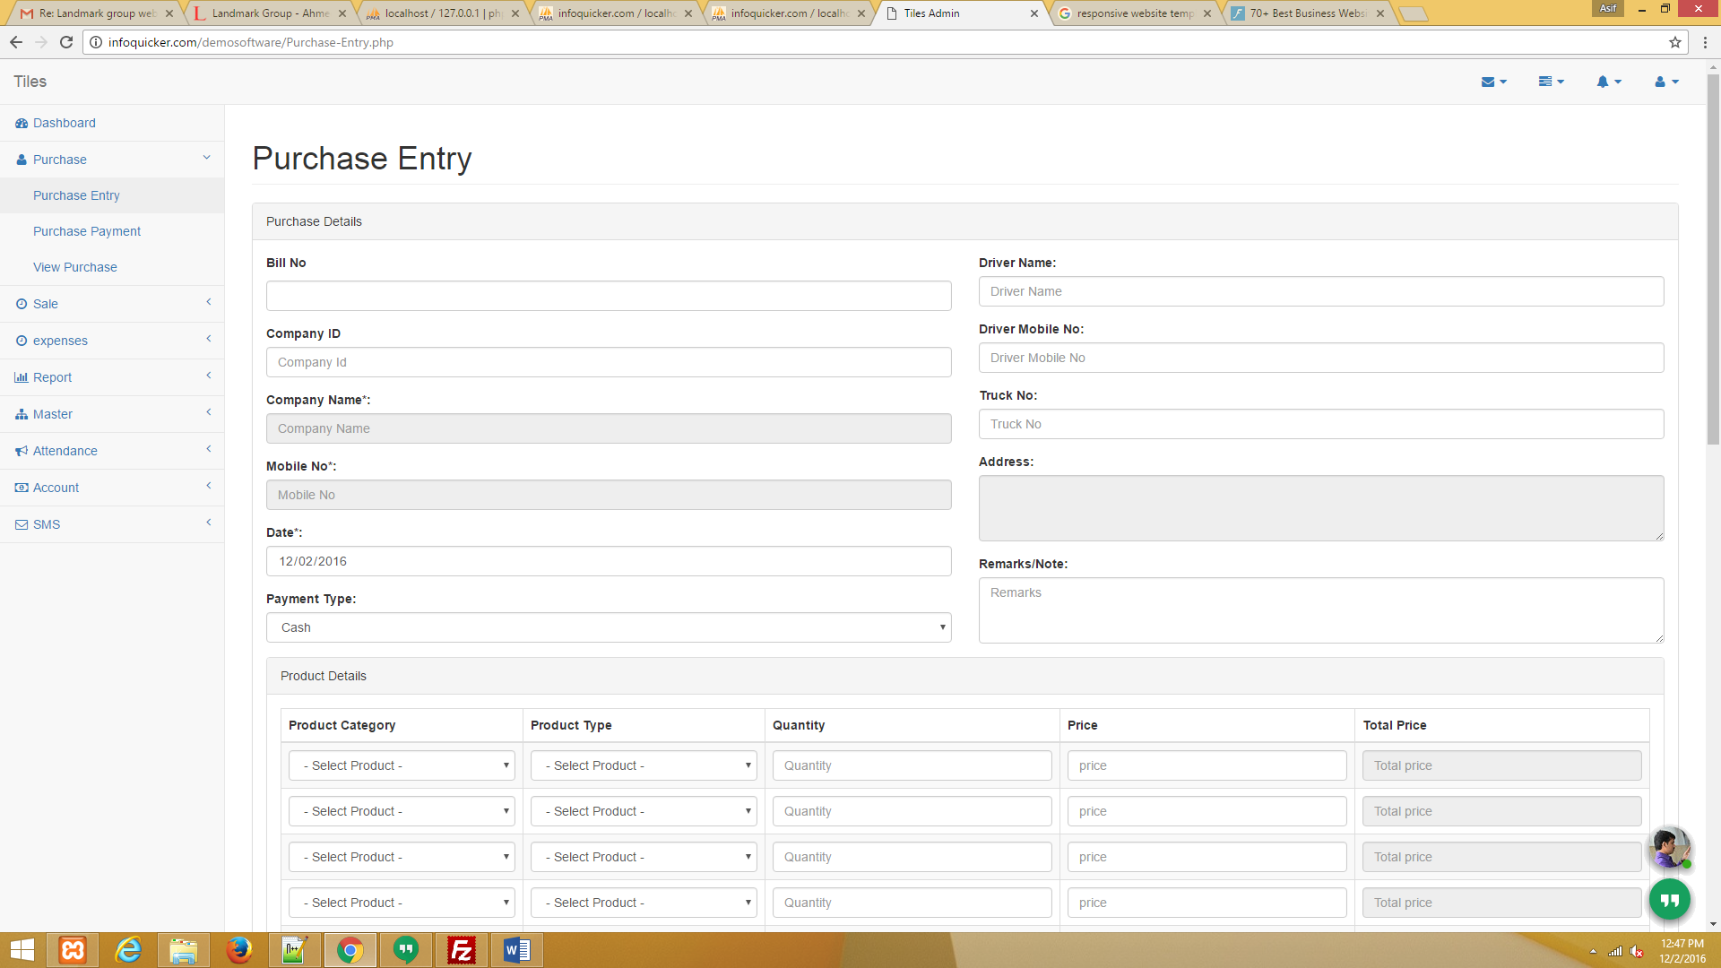

**Step 4.B:** Purchase Payment Purchase=> Purchase Payment

=> Bill No : Purchase Enter Bill No (You Can See Bill No In Purchase=>View Purchase) (Required)

=> After Enter Bill No You Can See Balance Amount (If Not Showing Balance Amount Please Wait Some Time).

=> Payment Amount : Enter How Much You Have Payment. (Required)

=> Date : This Is Payment Date. (Required)

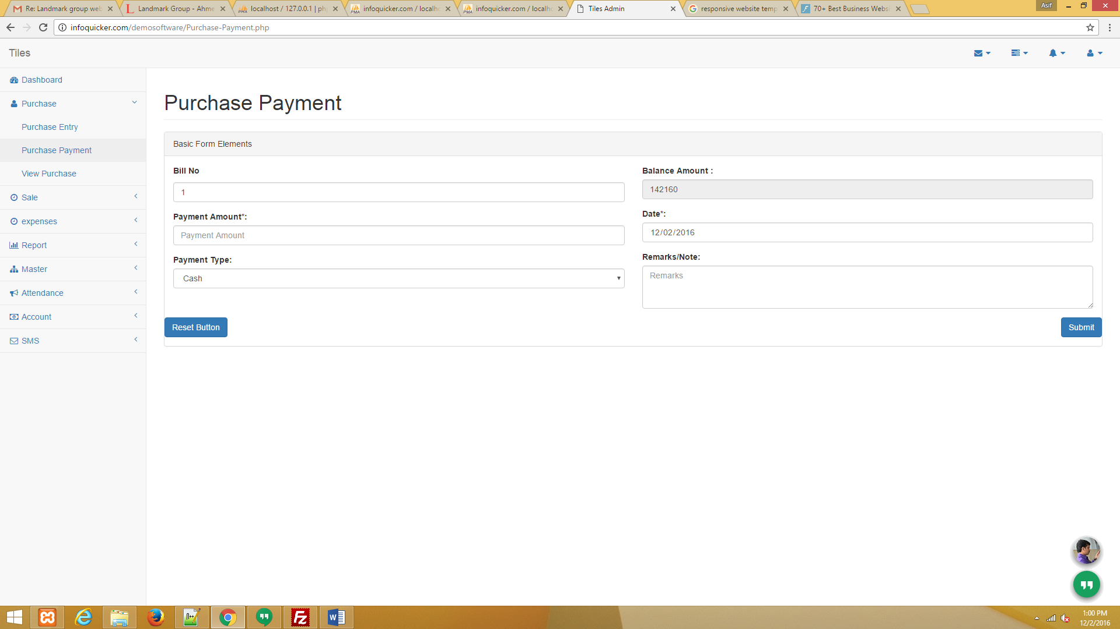

**Step 4C:** Purchase View Purchase=> Purchase View

=> In Action There Is View Option. When You Have Click On View Option You Can See Full Purchase Details And Print Bill.

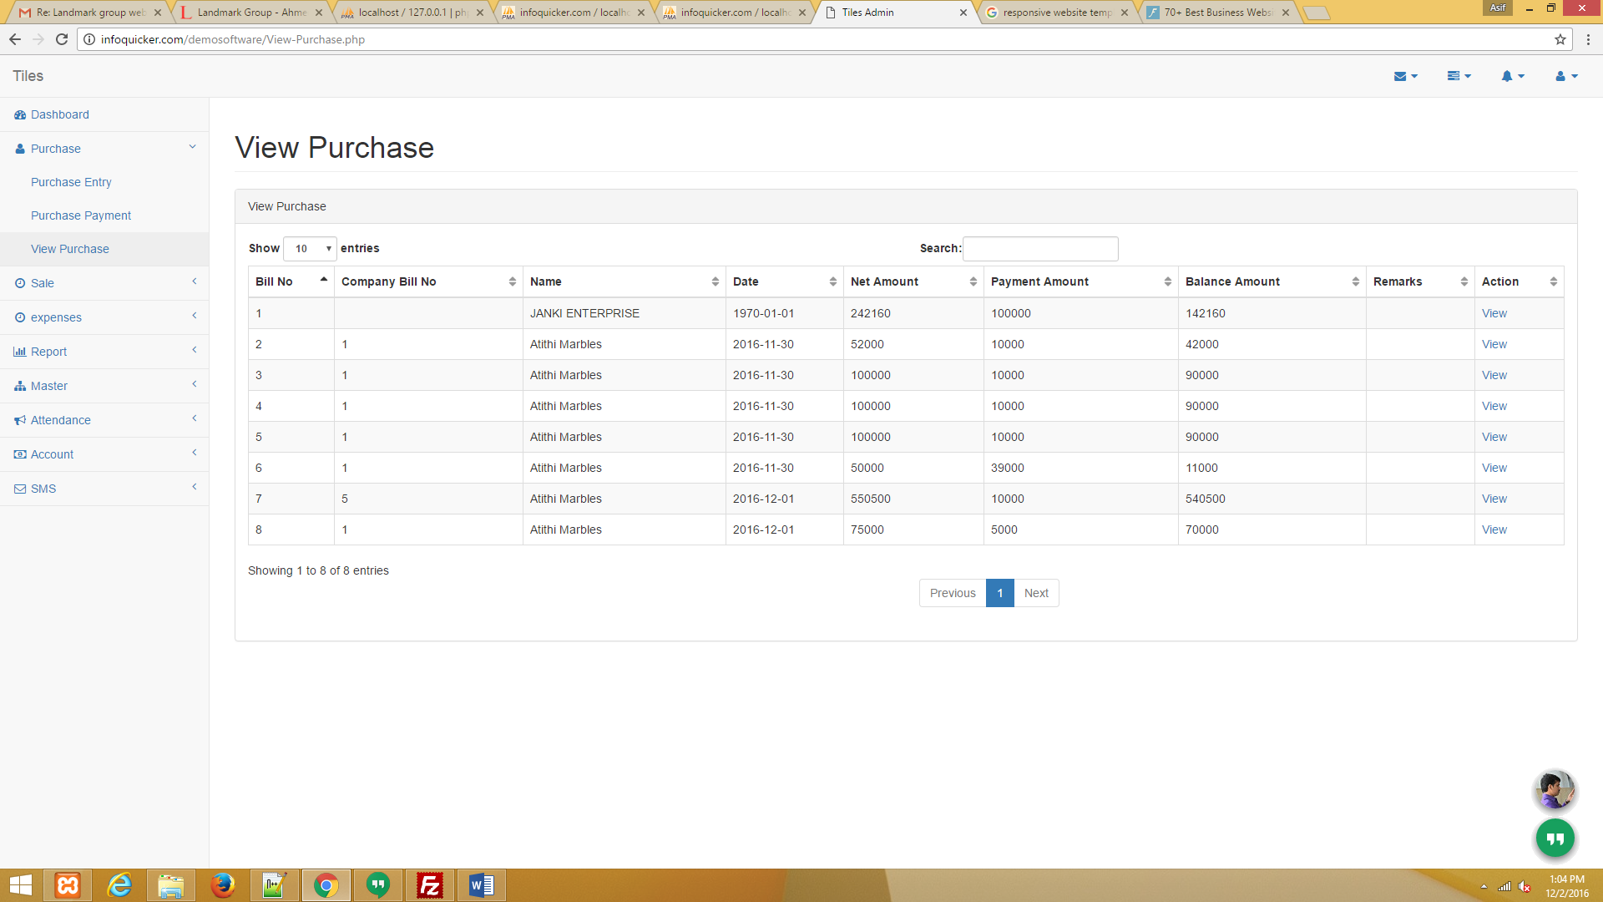

**Step 5.A:** Sale Entry Sale=> Sale Entry

=> Mobile No : First Enter Mobile Number. (Note : If Mobile No Already Added In Your Software Other Details Automatic Display)

=> When You Have Selected Category Releted To That Category Product Show In Product Option

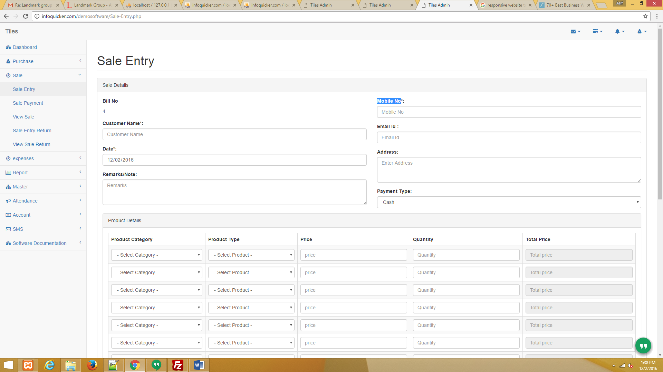

**Step B.B:** Sale Payment Sale => Sale Payment

=> Bill No : Sale Enter Bill No (You Can See Bill No In Purchase=>View Sale) (Required)

=> After Enter Bill No You Can See Balance Amount (If Not Showing Balance Amount Please Wait Some Time).

=> Payment Amount : Enter How Much You Have Payment. (Required)

=> Date : This Is Payment Date. (Required)

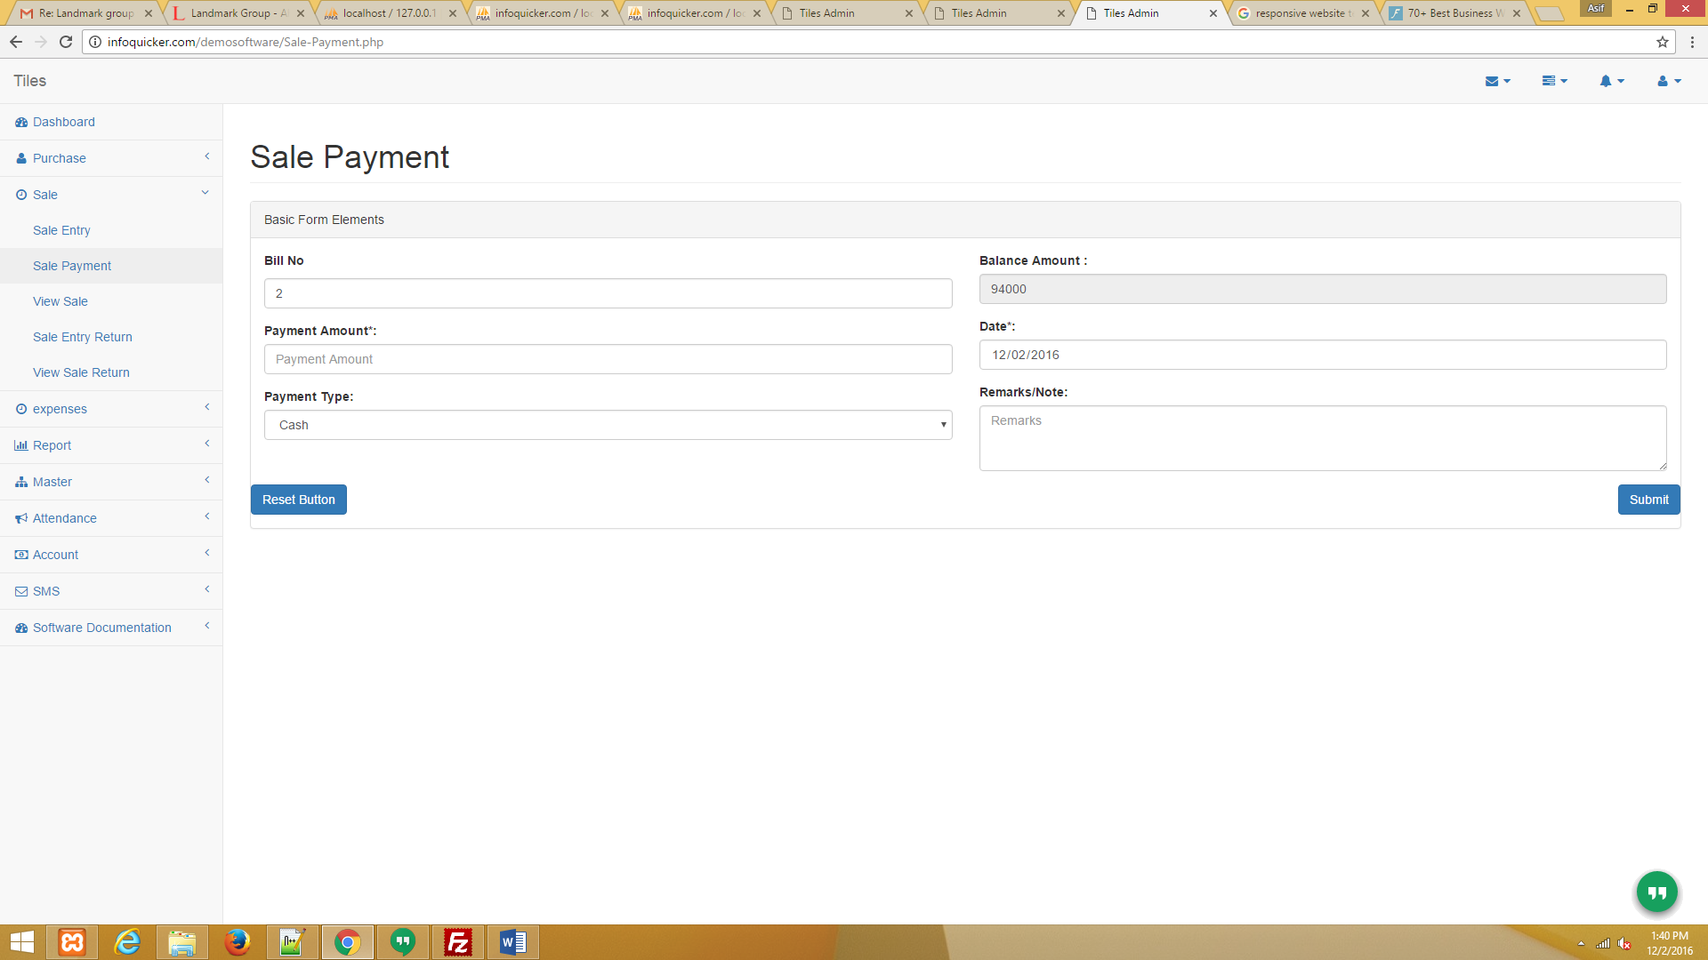

**Step 5.C:** Sale View Sale=> Sale View

=> In Action There Is View Option. When You Have Click On View Option You Can See Full Sale Details And Print Bill.

