The first few steps in a DFS of REACT graph

- Word length max = 3  - Start with vertex 1 and do a DFS from there  - Diagrams below start with DFS having arrived at word length 3 and built the word “rer” | 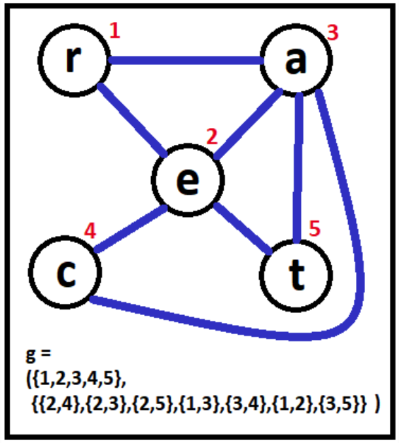

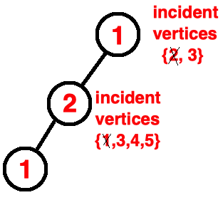 | 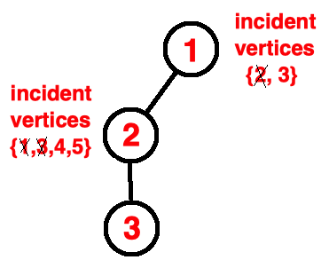 | 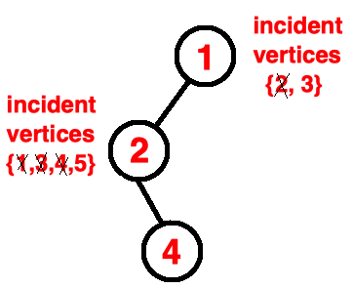 | 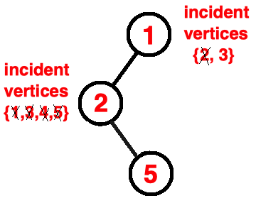
- Hit length limit of 3  - Word = “rer”  - Next step, backtrack to vertex 2 | - From vertex 2, select incident vertex 3 and traverse to it  - Hit length limit of 3  - Word = “rea”  - Next step, backtrack to vertex 2 | - From vertex 2, select incident vertex 4 and traverse to it  - Hit length limit of 3  - Word = “rec”  - Next step, backtrack to vertex 2 | - From vertex 2, select incident vertex 5 and traverse to it  - Hit length limit of 3  - Word = “ret”  - Next step, backtrack to vertex 2

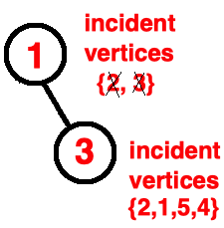
- But when we get back to vertex 2, there are no more incident vertices
- So, backtrack to vertex 1
- From vertex 1, select incident vertex 3 and traverse to it
- Word = “ra”
- Continue with DFS on vertex 3’s incident vertices, which are {2,1,5,4}

