Companion Statistical Report
  - Enriched housing and spatial memory in mice (teaching example)
2026-10-19
Table of contents

Manuscript | Enriched housing and spatial memory in mice
Principal investigator | Your PI’s name
Statistical analyst | Your name
Version code | NECS01V01D0001

1. About this document
This Companion Statistical Report (CSR) accompanies the manuscript named above. It records every decision taken between the raw data and the numbers reported in the paper. The data are simulated for teaching.

2. Analysis request and scope
Question. Do mice housed in an enriched environment find the hidden platform of a water maze faster than mice in standard housing?
Primary outcome. Escape latency (seconds) on the probe day, averaged over four trials per mouse.
Pre-specified hypothesis. Enriched mice have a shorter mean latency than standard-housed mice. The effect of interest is the difference in means (standard minus enriched), reported with its 95% confidence interval.
Changes from the previous version. None (first version).

3. Data provenance and preprocessing

3.1 Data source
Twelve mice (six per housing condition) were tested in four trials each. Trials were capped at 60 s. The raw file is maze.csv, one row per trial.
maze <- read.csv("maze.csv")
maze$group <- factor(maze$group, levels = c("standard", "enriched"))
str(maze)
'data.frame': 48 obs. of 4 variables:
$ mouse_id : chr "M01" "M01" "M01" "M01" ...
$ group : Factor w/ 2 levels "standard","enriched": 1 1 1 1 1 1 1 1 1 1 ...
$ trial : int 1 2 3 4 1 2 3 4 1 2 ...
$ latency_s: num 33.4 31.3 31.7 32.4 32 26 25.7 24.8 43.9 37.1 ...
table(maze$group) / 4 # mice per group
standard enriched
6 6

3.2 Unit of analysis
The mouse, not the trial, is the experimental unit: housing was assigned to mice, and the four trials of one mouse are not independent. Trials are therefore averaged within each mouse before any comparison.
mice <- aggregate(latency_s ~ mouse_id + group, data = maze, FUN = mean)
mice
mouse_id group latency_s
1 M01 standard 32.200
2 M02 standard 27.125
3 M03 standard 41.625
4 M04 standard 37.275
5 M05 standard 43.350
6 M06 standard 32.600
7 M07 enriched 14.525
8 M08 enriched 23.925
9 M09 enriched 59.600
10 M10 enriched 33.500
11 M11 enriched 30.125
12 M12 enriched 25.775

3.3 Exclusions
Rule written in the protocol before testing: a mouse is excluded if it reaches the 58 s mark in at least three of its four trials (non-swimming or floating).
slow_trials <- tapply(maze$latency_s >= 58, maze$mouse_id, sum)
excluded <- names(slow_trials[slow_trials >= 3])
excluded
[1] "M09"
mice_clean <- mice[!mice$mouse_id %in% excluded, ]
table(mice_clean$group)
standard enriched
6 5
1 mouse was excluded (M09), leaving 11 mice for the primary analysis.

4. Exploratory data analysis
stripchart(latency_s ~ group, data = maze, vertical = TRUE, method = "jitter",
pch = 16, col = "grey70", ylab = "Escape latency (s)", ylim = c(0, 62))
stripchart(latency_s ~ group, data = mice, vertical = TRUE, add = TRUE,
pch = 19, cex = 1.4)
ex <- mice[mice$mouse_id %in% excluded, ]
points(as.numeric(ex$group), ex$latency_s, cex = 2.6, col = "red", lwd = 2)
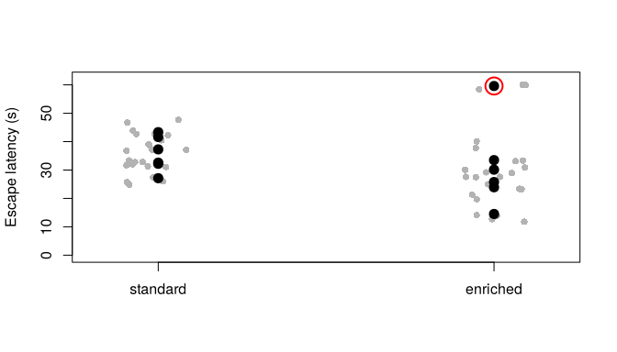
Figure 1: Escape latency per trial (grey) and per mouse mean (black). The red ring marks the excluded mouse.
aggregate(latency_s ~ group, data = mice_clean,
FUN = function(x) c(n = length(x), mean = mean(x), sd = sd(x)))
group latency_s.n latency_s.mean latency_s.sd
1 standard 6.000000 35.695833 6.188688
2 enriched 5.000000 25.570000 7.217565

5. Statistical model
Welch two-sample t-test on mouse means. Welch’s version is chosen because it does not assume equal variances in the two groups. With six mice per group, formal normality tests have little power; the dot plot above was inspected instead and shows no strong skew after the pre-specified exclusion.
res <- t.test(latency_s ~ group, data = mice_clean)
res
Welch Two Sample t-test
data: latency_s by group
t = 2.4703, df = 8.0004, p-value = 0.03869
alternative hypothesis: true difference in means between group standard and group enriched is not equal to 0
95 percent confidence interval:
0.6735635 19.5781032
sample estimates:
mean in group standard mean in group enriched
35.69583 25.57000

6. Inference and effect sizes
diff <- unname(res$estimate[1] - res$estimate[2])
ci <- res$conf.int
Standard-housed mice took on average 10.1 s longer to reach the platform than enriched mice (95% CI 0.7 to 19.6 s; p = 0.039).
Every number in the sentence above is computed by the code. Nothing was typed by hand.

7. Sensitivity analyses
What if the excluded mouse had been kept?
res_all <- t.test(latency_s ~ group, data = mice)
c(difference = unname(res_all$estimate[1] - res_all$estimate[2]),
ci_low = res_all$conf.int[1], ci_high = res_all$conf.int[2],
p = res_all$p.value)
difference ci_low ci_high p
4.4541667 -11.6991158 20.6074492 0.5314226
With the excluded mouse kept, the difference shrinks to 4.5 s and the interval includes zero. The conclusion depends on the exclusion rule, which is why the rule was fixed before testing and is reported here.

8. Figures and tables for the main manuscript
m <- tapply(mice_clean$latency_s, mice_clean$group, mean)
se <- tapply(mice_clean$latency_s, mice_clean$group, function(x) sd(x) / sqrt(length(x)))
tc <- qt(0.975, df = table(mice_clean$group) - 1)
stripchart(latency_s ~ group, data = mice_clean, vertical = TRUE, pch = 19,
col = "grey40", ylab = "Escape latency (s)", ylim = c(0, 50),
xlim = c(0.5, 2.5))
arrows(1:2, m - tc * se, 1:2, m + tc * se, angle = 90, code = 3, length = 0.08, lwd = 2)
points(1:2, m, pch = 95, cex = 4)
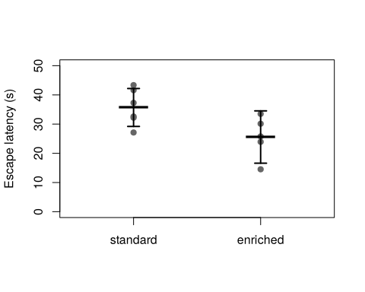
Figure 2: Figure 1 of the manuscript. Mouse means with group mean and 95% CI.

9. Conclusions and next steps
Under the pre-specified analysis, enriched housing was associated with shorter escape latencies. The interval is wide and the result is sensitive to one exclusion, so a larger replication with a pre-registered sample size is recommended.

10. References
Welch BL (1947). The generalization of Student’s problem when several different population variances are involved. Biometrika 34:28–35.

11. Session information
sessionInfo()
R version 4.3.3 (2024-02-29)
Platform: x86_64-pc-linux-gnu (64-bit)
Running under: Ubuntu 24.04.5 LTS
Matrix products: default
BLAS: /usr/lib/x86_64-linux-gnu/blas/libblas.so.3.12.0
LAPACK: /usr/lib/x86_64-linux-gnu/lapack/liblapack.so.3.12.0
locale:
[1] C
time zone: America/Montevideo
tzcode source: system (glibc)
attached base packages:
[1] stats graphics grDevices utils datasets methods base
loaded via a namespace (and not attached):
[1] compiler_4.3.3 fastmap_1.1.1 cli_3.6.2 tools_4.3.3
[5] htmltools_0.5.7 yaml_2.3.8 rmarkdown_2.25 knitr_1.45
[9] jsonlite_1.8.8 xfun_0.41 digest_0.6.34 rlang_1.1.3
[13] evaluate_0.23

