**Appendices and Supplemental Information for**

**Pressure for War: When Constituents’ Concerns over America’s Prestige Drive Presidents’ Foreign Policy**

Contents:

Appendix: Tables and Figures Directly Cited in Paper p. 1

Supplemental Information A: Full Survey Responses and Citations p. 7

Supplemental Information B: Alternative Specification for E.C. Dependence p. 9

Supplemental Information C: LASSOed Regressions p. 12

Supplemental Information D: Alternative Research Design p. 15

Supplemental Information E: The Southern Realignment p. 21

Supplemental Information F: Limited Definition of South p. 25

**Appendix**

Figure A1: Density of MIDs by Year

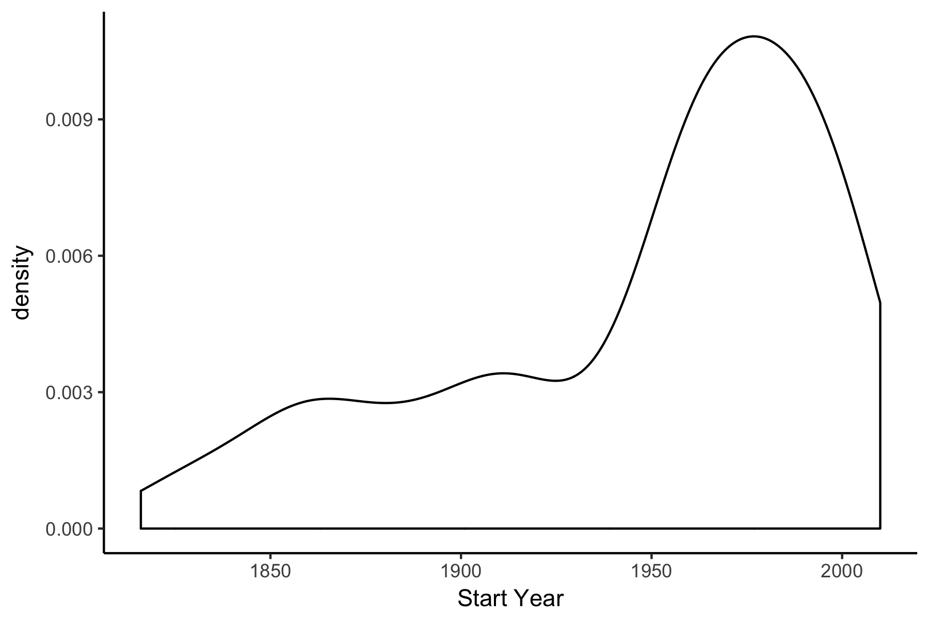

Figure A2: Presidents Over Time

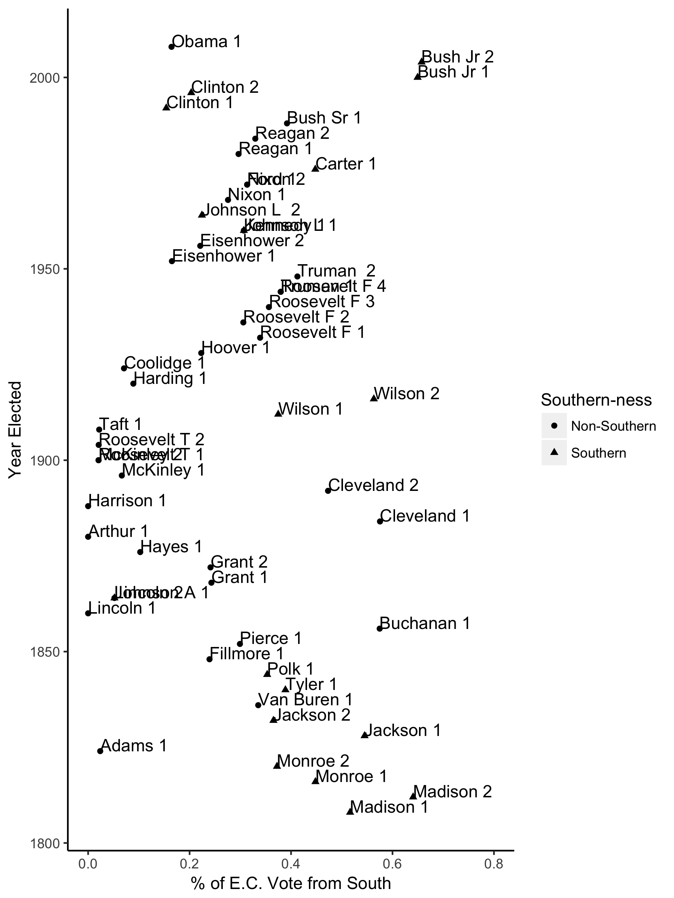

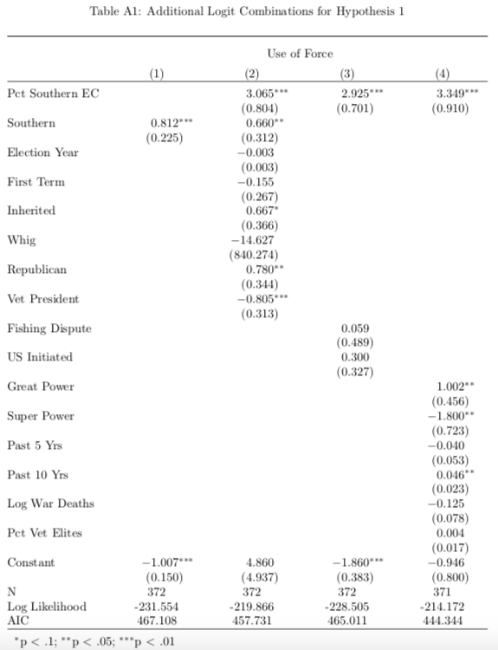

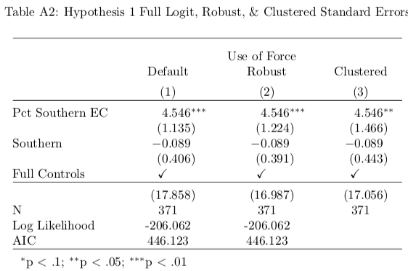

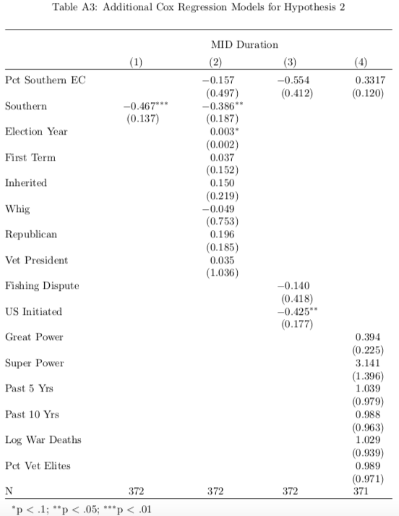

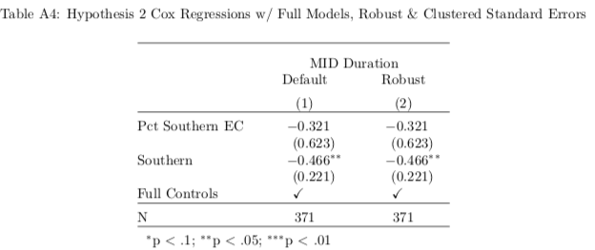

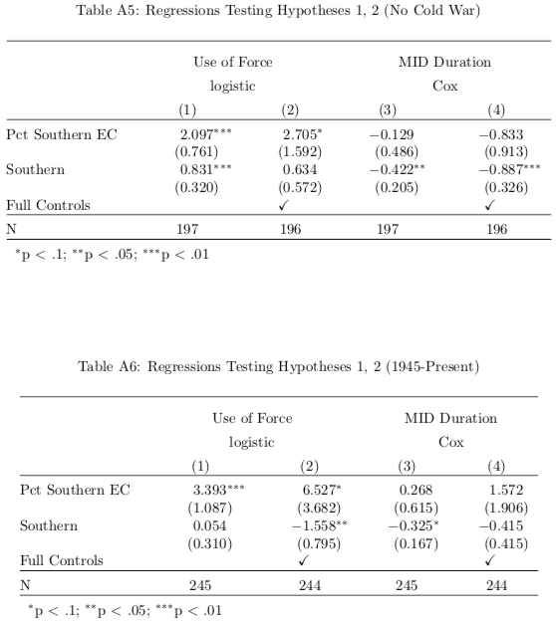

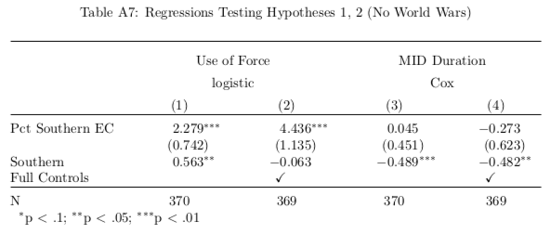

Supplemental Information A

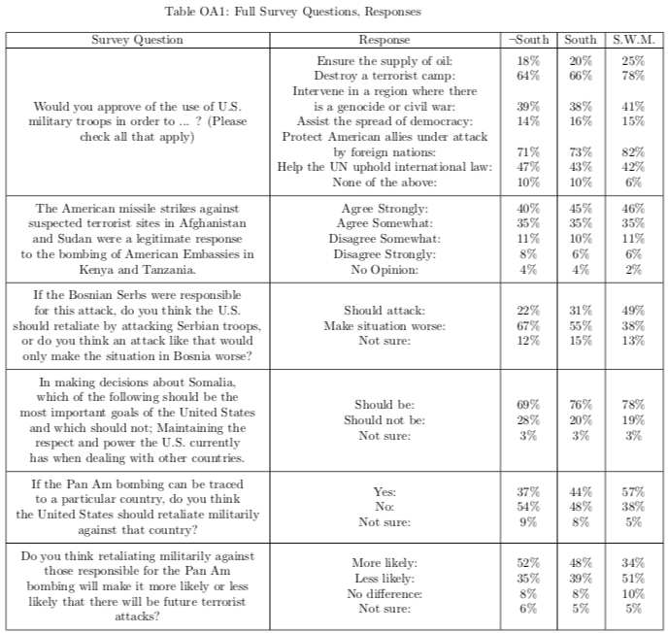

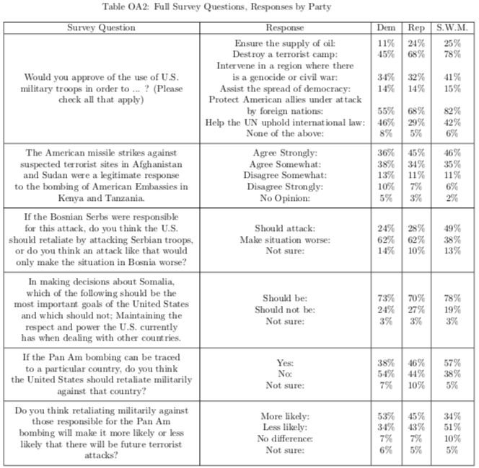

Note: See text for citations, specific sources. To code for political party, I used item pid3 from the 2016 Cooperative Congressional Election Study, item Q76 from the 1999 Survey on the Military in the Post Cold War Era, and item partyid from the June 1995 Time/CNN/Yankelovich Partners Poll, the October 1993 Time/CNN/Yankelovich Partners Poll, and the January 1989 Time/CNN/Yankelovich Clancy Shulman Poll.

Supplemental Information B

Alternative Specification for Southern E.C. Dependence

This section includes a brief discussion of why other potential measures of electoral dependence were not chosen, as well as an alternative specification of the Southern Electoral College dependence measure.

One alternative measure would have been popular support, which could be similarly quantified as the percentage of a president’s popular vote that came from Southern states. However, due to massive population disparities between states both in the early and modern United States, early disparities in how the popular vote was translated into presidential elector selection, and historical norms against popular participation in elections in many Southern states (See Key (1949) for a fuller discussion of this phenomenon), any measure that focused on the pure popular vote would have a difficult time accurately capturing the influence of Southern support. Another measure that was considered was the degree of southern support received by presidents in the course of the presidential primary. Members of Congress appear to give high regard to the wishes of their primary constituencies when considering policy choices (Fenno 1977), so it would stand to reason that presidents would do the same. The problem is that only in recent decades has the presidential primary system opened up to include actual voting at the state level, so it would be incredibly complicated if not impossible to meaningfully quantify state-level primary support for enough presidents to make the analysis worthwhile. Given these considerations, the proportion of Electoral College votes from Southern states appears to be the best option for capturing electoral dependence.

To test the robustness of the paper’s results, I also examine here another specification of the Southern Electoral College Dependence measure. This is designed to cover all possible aspects of how Presidents might consider themselves to be electorally dependent on the American South, offering a richer examination of this idea of dependence.

For this new specification, I aim to look closer at the relative dependence of those Presidents who really needed Southern Electoral College votes to win. I construct this specification first by determining whether the President in question would have failed to win their election w/o any electoral college votes from the South. In calculating this, I subtract the number of electoral college votes that each President won from Southern states from the total number of Electoral College votes that they received, and assign them a value of 0 if this number still exceeds the number that would be needed to win the election. If this number does not exceed the total necessary to win, I then assign each President a value equivalent to the percentage of their Electoral College votes that came from Southern states in the same manner as in the original in-text measure.

Given this alternative specification, I re-run the sparse and full regression models from earlier in the paper, the results of which can be seen in Table OB1[1]. The results from the paper largely hold, with the exception that the coefficient for Southern Electoral Dependence dips slightly below the cut-off for significance in the full “Use of Force” regression.

Given that this model fails to account for relative dependence among those Presidents who would still have won if they lost all of their Southern support, meaning that it lumps together those Presidents who would have be within a point or two of losing and those who would have still won in a landslide, I believe that the in-text specification is a more valid measure of relative dependence. However, the fact that the main results still largely hold true even under a weaker measure demonstrates the robustness of these findings.

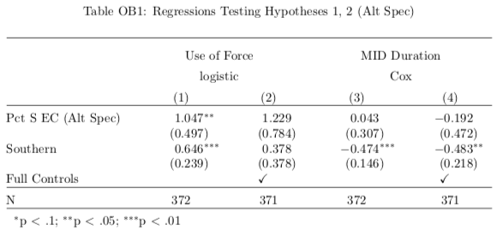

Supplemental Information C

LASSOed Regressions: Output and Resulting Models

In this section I use LASSOed regression methods to first estimate those variables which have a maximal likelihood of being in-truth significant predictors of my two primary outcomes, and then (in the case of the Use of Force outcome) run a logistic regression based on the suggested model. This is made possible by the LASSO’s “Oracle Property” (see Tibshirani 1996), which due to both its asymptotic nature and the relatively small n of my sample implies that these regressions will not necessarily be valid/reliable tests in and of themselves in this case - for this reason I use them as a supplemental analysis and as merely a means of variable selection.

The first of these LASSO-based models indicates that the following variables are likely to have in-truth non-zero relationships with whether or not a given MID involved the use of force[2]:

* Relative electoral dependence
* Whether the president inherited their office
* The United States’ status as a great power or super power
* The number of US-involved conflicts in the previous ten years • The proportion of veterans in elite government roles
* Whether the president is a Whig, or a Republican
* Whether the United States started the conflict

Running a logistic regression using these variables (and with SE’s clustered by President), we get the results seen in Table OC1. This reaffirms and strengthens the findings of the earlier logistic regressions and emphasizes the role of a president’s constituents as a driving force behind presidential use-of-force decisions. Also of note is the fact that the LASSO did not select the personal heritage of the president; this lack of inclusion, coupled with the prominent placement of electoral dependence, is strong evidence for my hypothesis that Southern constituents and not Southern presidents are driving decisions to escalate conflicts.

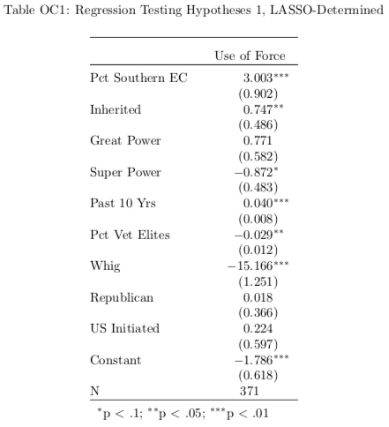

Moving on to the second of my hypotheses, the next LASSO-based model finds the following variables to have in-truth non-zero relationships with the length in days of a given MID:

* Whether the president is Southern
* The president’s term
* The United States’ status as a great power
* Whether the conflict was a fishing dispute
* The number of US-involved conflicts in the previous ten years
* Whether the president is a Republican
* Whether the United States started the conflict

Here, as in the logistic regressions, it looks like presidential heritage is a more important driver of decisions regarding when to withdraw from a conflict than constituency. In contrast to use-of-force decisions, constituency pressures appear to have no significant influence. This points to the theory of Dafoe & Caughey as being the more valid in this case - when it comes to presidential decisions regarding when to withdraw from a conflict, presidents appear to look inward instead of at the voting public.

Supplemental Information D

Alternative Research Design for Comparing Southern Dependence and Southern Heritage

In the text of this paper, I use a variety of statistical methods to test the broad hypothesis that Presidents who are more dependent on the electoral support of Southern constituents will be more likely to evidence the preferences of these constituents in their foreign policy decisions (specifically, that in a given international conflict they will be more likely to use military force and will remain in the conflict for a longer period of time - see the body of the paper for a discussion of why I chose to examine these specific foreign policy decisions). I compare this against the over-arching hypothesis of Dafoe & Caughey (2016), which is that Presidents’ personal heritage in the form of their individual Southern-ness is driving differences in foreign policy, only by including Presidential Southern-ness as a control variable. In both cases, presidents are being influenced by values attributed to Southern culture. I’m interested in teasing out the exact mechanism: whether these values are having an influence through the upbringing and heritage of the individual presidents, or through their relative dependence on constituents who hold these values. In this appendix, I focus more on directly contrasting these two hypotheses with the goal of determining whether Presidential Southern-ness or constituency pressures (or both!) are driving these observed differences in foreign policy decision-making.

To this end, I will consider presidents as being located in one of four buckets, based on two variables: their personal heritage, and their relative dependence on Southern votes. As can be seen in Table D1, I place presidents who have Southern heritage and high Southern dependence (quantified as having an above average percentage of Electoral College votes from the American South) in bucket A, presidents who have non-Southern heritage and high Southern dependence in bucket B, presidents who have South- ern heritage and low Southern dependence in bucket C, and presidents who have non-Southern heritage and low Southern dependence in bucket B.

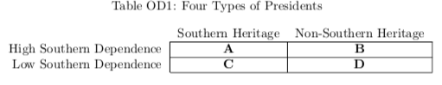

The comparisons made evident by this table can be used to directly compare my hypothesis with that of Dafoe & Caughey. If my hypothesis is correct, then the presidents in bucket A should be more likely to use force in a given conflict and to remain in a conflict for longer than the presidents in bucket C. Those in bucket B should also be more likely to use force in a given conflict and to remain in a conflict for longer than the presidents in bucket D. On the contrary, if Dafoe & Caughey’s hypothesis is correct, then the presidents in bucket A should be more likely to use force in a given conflict and to remain in a conflict for longer than the presidents in bucket B. Those in bucket C should also be more likely to use force in a given conflict and to remain in a conflict for longer than the presidents in bucket D.

Comparing the relative differences between the foreign policy decision-making of the presidents in each bucket will also allow me to go beyond simply saying which (or neither/both) hypothesis is right, and compare the relative effects of personal heritage and constituency on a President. In short, this should help us figure out whether personal heritage or constituent pressure has historically had a greater impact on presidential decisions. For example, if there is a greater difference between buckets A and C than there is between buckets A and B, then this would be an indication that constituency pressures are having a greater impact than personal heritage.

The first step in undertaking this analysis is to actually place each president/term of interest into one of these buckets. The president/terms that fall into each bucket can be seen below in Table D2. Following the name of each president is the specific term(s) for which they are placed in that bucket.

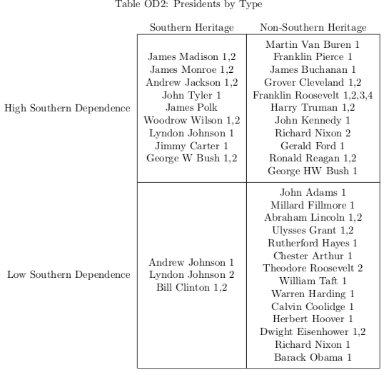

As is clear from the table, there is a relative lack of presidents who have Southern heritage but relatively low Southern dependence. We will have to keep this fact in mind during the later analyses, as it could impact the significance of any findings that are drawn from these tests. The table above also reaffirms the fact that this paper’s examination of presidents based on their Southern dependence groups them in different clusters than previously examined, reducing the probability that these analyses are just picking up other individual differences. For instance, Yarhi-Milo (2018) classifies and analyzes recent presidents based on whether they are high or low self-monitors, grouping Reagan and Clinton as high self-monitors and Carter as a low self-monitor. Here, however, I have Carter and Reagan as highly dependent on the South and Clinton as less dependent, implying that patterns I observe here are not simply picking up the underlying predispositions of presidents towards self-monitoring.

Having divided the presidents up into these buckets, the next step is to calculate the means and standard errors for each of the two variables of interest for each of these buckets. In addition to visually comparing the different values in these buckets, we can then use a set of t-tests to determine whether there are significant differences in the foreign policy decisions made by these groups of presidents, and which of my or Dafoe and Caughey’s hypotheses appear to be better supported by the evidence.

The first specific variable of interest is whether a given conflict involves the use of force. The exact reasons for this variable, the data from which it is sourced, and the details of its construction are detailed in the body of the paper - a key reminder here is that I am not measuring the number of conflicts in which a president was involved, but rather taking each conflict as exogenous, and then looking how each president behaved given that a conflict occurred. In Table D3 below I display the mean and standard errors for this variable for each bucket of presidents. Following this, Table D4 displays the differences in means between these buckets, the statistical significance of these differences, and the hypotheses that they are designed to test (either this paper’s hypothesis, labeled “Constituency”, or Dafoe & Caughey’s, labeled “Heritage”).

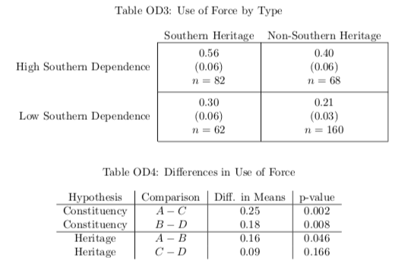

It is clear from the above tables that Southern dependence not only has a larger substantive impact on whether or not a president uses military force in a given conflict than Southern heritage, but also that its impact is more statistically significant. This holds when comparing any of the sets of buckets, and confirms the results from this paper’s main analyses.

Now I turn to my second variable of interest, which is the duration of each conflict. In Table D5 below I display the mean and standard errors for this variable for each bucket of presidents. Following this, Table D6 displays the differences in means between these buckets, the statistical significance of these differences, and the hypotheses that they are designed to test (with the same labelling scheme as above).

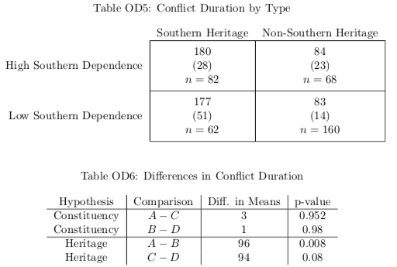

When we look at conflict duration, it becomes apparent that Southern heritage has a far greater impact than Southern dependence, just as was found in the in-text analysis. In fact, the effect of Southern dependence appears to be hardly distinguishable from random noise. This holds across all bucket comparisons.

What we see here is an exact parallel to the earlier findings, and emphasizes that Presidents appear to turn to be influenced by different factors depending on the type of foreign policy decision that they’re making. When they are deciding whether to use military force, they turn to their constituents, but when they are deciding when to withdraw from a conflict they look inwards at their own personally-held values. So both the hypotheses proposed by Dafoe & Caughey and the hypotheses proposed in this paper are correct for some circumstances - it just depends on the specific aspect of foreign policy decision-making that we’re looking at.

Supplemental Information E

The Southern Realignment as a Shock to Southern Dependence

An additional way in which I can test my hypothesis that presidents with higher dependence on support from Southern constituents are more likely to manifest the unique status-related concerns of Southerners in their foreign policy decision-making is by taking advantage of a historic period that saw a change in partisan patterns of Southern Dependence. This period, referred to as the Southern Realignment, was a time when the Republican Party worked to actively gain the support of voters in Southern states. While the bulk of this strategy was focused on appealing to Southern whites on race-related issues, it stands to reason that once the Republican party had increased its dependence on these voters that their opinions on other issues should have been represented in the decision-making of Republican presidents as well. This allows me to examine the impact of one party suddenly becoming far more dependent on Southern voters than they were previously, centered on the presidential election of 1964.

So to test whether higher dependence on Southern constituents actually influences presidential foreign policy decision-making, I compare Democratic and Republican presidents in the 40 years before and after the 1964 presidential election. In doing this, I divide up the presidents over this period into four buckets based on their party and the year of their election, seen below in Table OE1. Table OE2 then specifies which presidents fall into each bucket.

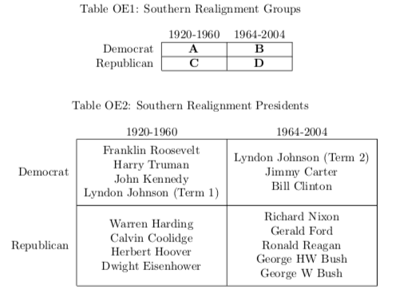

If my hypotheses are correct, Republican presidents in the years after the 1964 presidential election should be significantly more likely to represent Southern status concerns than Republican presidents in the years before the 1964 election, meaning that they should have a greater propensity to use military force in a given conflict and that they should evidence a willingness to remain in conflicts for a longer period of time. The opposite pattern should emerge for Democratic presidents, although to a lesser extent, given that Republicans post-1964 began immediately and actively trying to court Southern voters, while Democratic reliance on these voters slowly faded. In addition, it should also be the case that before 1964, Democratic presidents should appear more honor-focused than their Republican counterparts, with this relationship flipping after 1964.

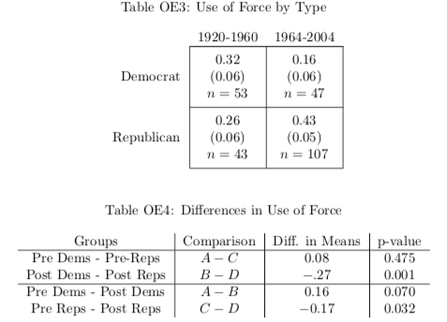

Tables OE3 and OE4 show clear evidence that Republican presidents had a far greater propensity to use military force in a given dispute after their party began to court the Southern vote. They also show significant evidence that in the post-realignment era, Republicans have a significantly greater propensity to use military force in a given conflict than their Democratic counterparts. The two other relationships also run in the directions I hypothesized, albeit without statistical significance. But again, the finding that a strategic shift towards courting Southern voters corresponded with an almost 30 percentage point increase in the propensity to use military force is overwhelming evidence of the influence that constituent status concerns can have on presidential foreign policy decision-making.

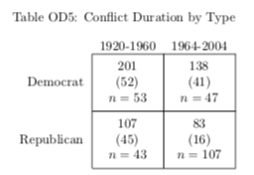

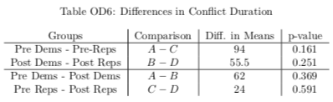

Tables OE5 and OE6 confirm the story that we already know, which is that this responsiveness does not appear to extend to Conflict Duration. See the full paper for a discussion of why this relationship may not hold.

Supplemental Information F

Table OF1: Logistic Regressions Testing Hypothesis 1 w/ Limited Definition of South

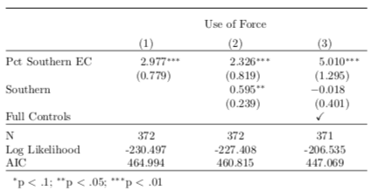

1. Because of how this new specification is constructed, I have to exclude the President who failed to receive a majority of votes in the Electoral College: Andrew Jackson’s first term.
2. The possible variables were the measure of electoral dependence, the measure of personal Southern heritage, and all of the controls.