Github Technical Details

* Git - a version control system based on cloud storage where users can access content anywhere at anytime.
* GitHub - a code hosting platform based on *Git* for version control and collaboration. It lets you and others work together on projects from anywhere.
* Repository - commonly called a “repo” is a *git* file system that keeps track of all changes to all files within a directory.
* Branch - a version of a *repository* that the user can change without changing the master *branch* that will eventually be delivered to the client.
* Clone - when a *repository* is cloned, it is copied to the users local computer so they can contribute to it.
* Checkout - when a user wants to see or make changes to a specific or someone else’s branch, they can *checkout* the *branch* to maintain the structure of their own *branch*.
* Add - when a user adds a file to the directory or removes one.
* Commit - when a user adds a file to the local *branch,* but doesn’t push it to the remote *repository*.
* Push - after a *commit* is made, the user will want other people to see their changes so they *push* it to the remote branch in the cloud.
* Pull request - when the SCRUM master has approved of changes that have been *pushed* to a *branch*, a *pull request* is opened to *merge* these changes to the master branch.
* Merge - When two *branches* have differences or things are being added or removed from them, you can *merge* the branches and choose what contents of each file will remain in the master branch.

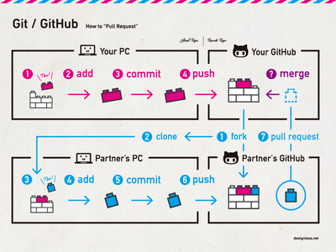

Hello World Guide

git clone [insert URL of your website]

git checkout -b [insert name of your branch you want to create]

\*add some files to this directory on your computer\*

git add \*

git commit

git push origin [insert branch name]