As mentioned above, Scrum is a team based program for managing complex projects, specifically used as an agile framework.However, what makes this software development better than others? Let’s take a look into the time cost management of agile vs. traditional approaches.

Time management is a key aspect in almost any environment, especially when it is work related. In this case, when it comes to engineering, duties have a certain time period to be worked on and completed. Making it important that the software development utilized is up to standard and completes the task accordingly. Scrum for example uses these techniques of many to drive development stabilization: active communication with customers, daily, short meetings, extensive planning, division of work equally, use of iterative development, prioritizing work requirements, revision of work completed and self-organized agile teams working together. With these practices being utilized, scrum thus completes twice the work in half the time. Which then provides better work, less production time, fewer people and lower cost. One aspect mentioned above that benefits work in scrum are the daily meetings enforces. This may seem very time consuming, but the sole purpose of them are to provide the idea of regulatory checking up with teams so work stays on track and completed in time. However, in some cases people don’t have enough to talk in the meetings due to information shared being too complex. This then slowed down progression due to meeting slots being changed too often. So to solve this, scrum separated short, quick proposals from in-depth technical discussions, making the weekly meeting more productive and thus provided more efficient time for faculty.

Similarly, cost is a major key in deciding what software development is to be used. Whether the product has a price or is simply free, it all depends on the performance. For example, IT development is commonly used and is greatly depended on by companies on value creation. But the problem of investing towards IT is noted due to its high budget. However, one approach is to implement methods to increase productivity, agile and scrum development being one. One issue faced with productivity is when defects cause slow progress and more cost to be fixed, especially when found later in progression. However, agile helps with this problem by stabilizing the defects and detecting them early. Defects found either earlier or later are still payed at a cost. But, the earlier a defect is found the cheaper it is to be fixed rather than a defect found later on costing more and also slowing down the project. The graph below shows the cost versus the length of feedback cycle. Furthermore showing the costs of defects by detection skills of agile and traditional strategies against the cost-of-change curve.

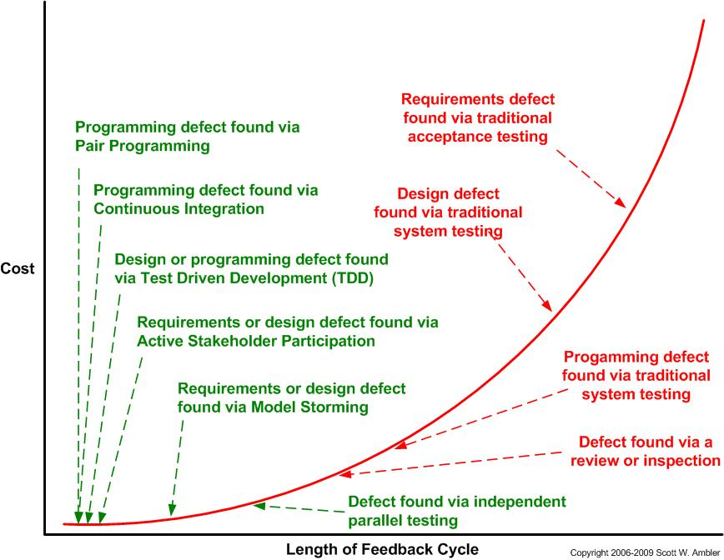

<http://www.ambysoft.com/essays/agileTesting.html>

Agile strategies colored in green and traditional strategies colored in red. Based on the graph it is concluded that an agile approach finds the defect way sooner than traditional approaches. Furthermore, based on the curve, an agile approach is less costly than traditional approaches. This practice of reducing project cycle times and reducing the cost thus increasing the productivity and quality of the project.

Sources:

Boren, A. (2016). Scrum: The Art of Doing Twice the Work in Half the Time. Technical Communication, 63(3), 273.

Carlson, R., Matuzic, P. J., & Simons, R. L. (2012). Applying Scrum to Stabilize Systems Engineering Execution. Crosstalk: The Journal Of Defense Software Engineering, 25(3), 8-13.

Hicks, M., & Foster, J. S. (2010). Viewpoint SCORE: Agile Research Group Management. Communications Of The ACM, 53(10), 30-31. doi:10.1145/1831407.1831421

PASS, S., & RONEN, B. (2014). Reducing the Software Value Gap. Communications Of The ACM, 57(5), 80-87. doi:10.1145/2594413.2594422