Predicting with Frugally-Deep (FD)

For deep learning neural network models you need a powerful computer. One that is able to compute vector products in one clock cycle. For this you need a Graphical Processing Unit (GPU) but these are expensive. Furthermore you will need a powerful software package like Tensorflow/Keras to help you with developing and testing the model. The latest version of TF/Keras does only run on a CPU that supports the AVX instruction set. My computer does not support it. Fortunately the freely available Google Colab does allow me to use both a GPU and TF/Keras in elegant Jupyter notebooks. And the internet does provide a lot of tutorials with ready-to-go python code snippets to make notebooks that can be used to learn how to build and use Computer Neural Network models. I have used the article Develop a Deep Convolutional Neural Network Step-by-Step to Classify Photographs of Dogs and Cats from Jason Brownlee. After fiddling around with it on Google Colab and Google Drive I used it for a similar problem. A member of our insect working group (IWG) studies leafrollers (Tortricidae). Small butterflies that fold leafs of plants from which they feed. He makes photo's of the genitalia of these specimens in order to find out to which genus and species they belong. He does so by comparing these images with drawings and photo's available in the literature. But this is not a trivial task. After a talk about neural networks I have given for the IWG he asked me if I could help him with his leafrollers. I accepted the challenge also because we need to stay at home as much as possible due to the COVID-19 virus that has the world in its grip.

In general there are very few photo's or drawings per species. So I decided to experiment with two different genera that does contain many species: Archips and Clepsis. The drawings he provided did contain a lot of noise in the form of sub drawings. The preparation of the dataset with Gimp was a time consuming labour. But when I run the cat and dogs notebook on this dataset I got a working model based upon the pre-learned VGG16 model. The accuracy was around 98%. We are preparing more drawings so that the model can be extended to other genera.

In the meantime I have searched on internet for a method to predict photo's with this model on our home computers that do not support TF/Keras. So I came along the freely available FD package written in C++ by Tobias Hermann. I developed my first version of Predict on Cygwin64, a Unix like environment. But because my leafroller friend is not familiar with Unix I have also installed the program on Windows with the help of the free available Visual Studio Community C++ compiler from Microsoft. Unfortunately the results of both programs were not exactly the same. It turned out that this was mainly caused by the fact that the rendering of jpeg images on Cygwin64 with the Cimg image software package and its native jpeg implementation differs from the CImg package and the free available jpeg-9d implementation used in my Windows version. When I used the same jpeg-9d version in my Cygwin version the results were still different but less pronounced. To understand where these differences did come from I wrote two extra programs: Inputtensor and Tpredict. The first program allows me to compute the input tensor from an image used to feed into the model and a program that makes a prediction based upon this input tensor. With the help of both programs I could make the predictions results on cygwin64 and Windows 10 exactly the same (see results in table 1 further on). The predictions computed with TF/Keras on a Google Colab shows small differences for two of the eight test images I found on internet.

Comparision of prediction results

The following Tensorflow/Keras python code predicts eight different images of cats and dogs found on internet

# make a prediction for a new image.
from keras.preprocessing.image import load_img
from keras.preprocessing.image import img_to_array
from keras.models import load_model

# load and prepare the image
def load_image(filename):
# load the image
img = load_img(filename, target_size=(224, 224))
# convert to array
img = img_to_array(img)
# reshape into a single sample with 3 channels
img = img.reshape(1, 224, 224, 3)
# center pixel data
img = img.astype('float32')
img = img - [123.68, 116.779, 103.939]
return img

# load an image and predict the class
def run_example():
# load the image
images = ['bw_cat.jpg', 'bw-drawing-cat.png',
'cat_in_shoe.jpg', 'Irish_setter_pups.jpg',
'lady_with_dog.jpg', 'queued_dogs.png',
'sleeping_cat.jpg', 'xxl_dog.png']
# load model
model = load_model('JB_final_model_cats_and_dogs.h5')
for img_name in images:
#img = load_image()
img = load_image(img_name)
# predict the class
result = model.predict(img)
print(img_name + " predicted as " + '{:10.8f}'.format(float(result[0])))

# entry point, run the example
run_example()

In the table 1 I have compared the predictions made by this Python program run on Google Colab (marked as TF in the two middle columns of the table) and by the predict.exe programs compiled on Cygwin64 (CW) and compiled on Microsoft Windows with Visual Studio Community (MW) on the same machine. As you can see the results between both Frugally-deep based programs using the same png and jpeg implementations are in eight decimals equal. There are small differences between the TF results for two difficult (?) images: lady_with_dog (row one, right figure) and queued_dogs (row two, right figure).

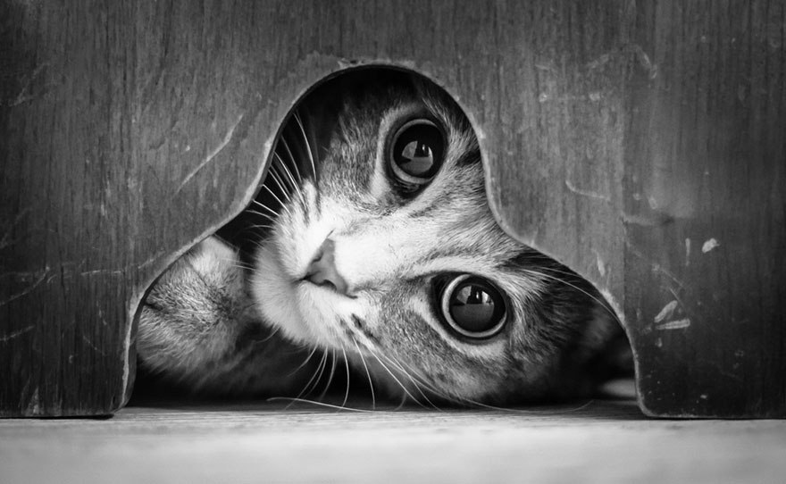 | TF: 0.00000398  CW: 0.00000021  MW: 0.00000021 | TF: 0.99999905  CW: 0.99999952  MW: 0.99999952 | 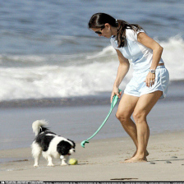
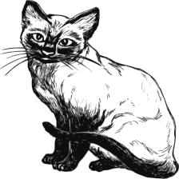 | TF: 0.00000000  CW: 0.00000000  MW: 0.00000000 | TF: 0.99993110  CW: 0.99999237  MW: 0.99999237 | 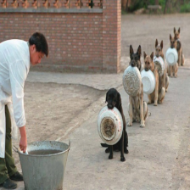
 | TF: 0.00000000  CW: 0.00000000  MW: 0.00000000 | TF: 0.00000000  CW: 0.00000000  MW: 0.00000000 | 
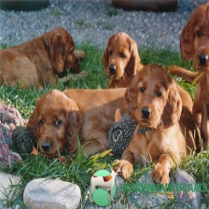 | TF: 1.00000000  CW: 1.00000000  MW: 1.00000000 | TF: 1.00000000  CW: 1.00000000  MW: 1.00000000 | 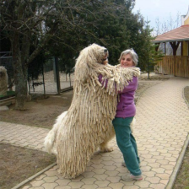
Tabel 1: Predictions made by Tensorflow/Keras model (TF), Frugully-deep versions of predict.exe on Cygwin64 (CW) and Visual Studio Community on Microsoft Windows 10 (MW).The images are linked to the website where I have found them.

Programs predict, inputtensor and tpredict
I have written the programs so that they can be used for other TF/Keras models based upon predicting images. When you run the programs without any arguments you will get a short usage message explaining the allowed arguments. In the TF/Keras model shown above the RGB images are resized to 224x224 pixels and the average RGB values from the VGG16 prelearned model are subtracted. These values are chosen as defaults in the programs that need them but can be overruled by using a configuration file with the same name as the model but with extension .cfg in stead of .json. Here is an example of JB_finalmodel.cfg
# extra data for Cats & Dogs model Jason Brownlee
modelfn = JB_finalmodel.json
# Next values will be subtracted from image RGB values before prediction
meanRGB = {123.68, 116.779, 103.939}
# Images will be resized to following the Width, Height and number of Channels
shapeWHC = {224, 224, 3} # pixels
# This are the two categories the model does recognize
# Prediction 0 means its a cat, 1 means its a dog
categories = {Cats=0, Dogs=1}
To predict to what category the images in folder catsdogs belong we can run predict as follows
./predict.exe catsdogs/JB_finalmodel.json catsdogs/*.{jpg,png}
giving the following output on cygwin64
$ ./predict.exe catsdogs/JB_finalmodel.json catsdogs/*.{jpg,png}
Shape from cfg file = {224,224,3}
MeanRGB from cfg file = {123.68, 116.779, 103.939}
Loading json ... done. elapsed time: 1.243378 s
Building model ... done. elapsed time: 0.755207 s
Running test 1 of 1 ... done. elapsed time: 1.726691 s
Loading, constructing, testing of catsdogs/JB_finalmodel.json took 3.746209 s overall.
catsdogs/bw_cat.jpg belongs to genus 0.00000021
catsdogs/cat_in_shoe.jpg belongs to genus 0.00000000
catsdogs/Irish_setter_pubs.jpg belongs to genus 1.00000000
catsdogs/lady_with_dog.jpg belongs to genus 0.99999952
catsdogs/sleeping_cat.jpg belongs to genus 0.00000000
catsdogs/bw-drawing-cat.png belongs to genus 0.00000000
catsdogs/queued_dogs.png belongs to genus 0.99999237
catsdogs/xxl_dog.png belongs to genus 1.00000000
Categories = {Cats=0, Dogs=1}

On Windows we can't use the expression catsdogs/*.{jpg,png} and have to use a batch file with the following contents
predict.exe catsdogs\JB_finalmodel.json catsdogs\bw_cat.jpg ^
catsdogs\bw-drawing-cat.png ^
catsdogs\cat_in_shoe.jpg ^
catsdogs\Irish_setter_pups.jpg ^
catsdogs\lady_with_dog.jpg ^
catsdogs\sleeping_cat.jpg ^
catsdogs\queued_dogs.png ^
catsdogs\xxl_dog.png
with the following output
predict.exe catsdogs\JB_finalmodel.json catsdogs\bw_cat.jpg catsdogs\bw-drawing-cat.png catsdogs\cat_in_shoe.jpg catsdogs\Irish_setter_pups.jpg catsdogs\lady_with_dog.jpg catsdogs\sleeping_cat.jpg catsdogs\queued_dogs.png catsdogs\xxl_dog.png
Shape from cfg file = {224,224,3}
MeanRGB from cfg file = {123.68, 116.779, 103.939}
Loading json ... done. elapsed time: 1.058904 s
Building model ... done. elapsed time: 1.609555 s
Running test 1 of 1 ... done. elapsed time: 2.884383 s
Loading, constructing, testing of catsdogs\JB_finalmodel.json took 5.588301 s overall.
catsdogs\bw_cat.jpg belongs to genus 0.00000021
catsdogs\bw-drawing-cat.png belongs to genus 0.00000000
catsdogs\cat_in_shoe.jpg belongs to genus 0.00000000
catsdogs\Irish_setter_pups.jpg belongs to genus 1.00000000
catsdogs\lady_with_dog.jpg belongs to genus 0.99999952
catsdogs\sleeping_cat.jpg belongs to genus 0.00000000
catsdogs\queued_dogs.png belongs to genus 0.99999237
catsdogs\xxl_dog.png belongs to genus 1.00000000
Categories = {Cats=0, Dogs=1}
If we don't trust the results we can use inputtensor.exe and tpredict.exe to find out where the problem does come from, the model or in the C++ predictions. I will show this with the funny image of the queued dogs.
This photo is a PNG image consisting of 728x471x4 pixels, each from 8-bit/color in the so called RGBA, non-interlaced mode. Compared to JPG images it does have an extra fourth channel. Before entering the image data to our model we need to resize it to 224x224x3 and have to subtract the mean RGB values [123.68, 116.779, 103.939]. The result is a so called tensor (vector) of 150528x1 elements here shown as 50176x3 RGB triples. To compute this vector we run inputtensor as follows on cygwin64
./inputtensor.exe catsdogs/JB_finalmodel.cfg catsdogs/queued_dogs.png >
queued_dogs224x224x3.txt

and on Windows slightly different

inputtensor.exe catsdogs\JB_finalmodel.cfg catsdogs\queued_dogs.png >
queued_dogs224x224x3.txt

We can use the created tensor with tpredict

./tpredict.exe catsdogs/JB_finalmodel.json queued_dogs224x224x3.txt

giving the following results

$ ./tpredict.exe catsdogs/JB_finalmodel.json queued_dogs224x224x3.txt
Shape from cfg file = {224,224,3}
MeanRGB from cfg file = {123.68, 116.779, 103.939}
Loading json ... done. elapsed time: 1.209285 s
Building model ... done. elapsed time: 0.755424 s
Running test 1 of 1 ... done. elapsed time: 1.730011 s
Loading, constructing, testing of JB_finalmodel.json took 3.716252 s overall.
queued_dogs224x224x3.txt belongs to 0.99999237
Categories = {Cats=0, Dogs=1}

References
Brownlee, Jason 2019. How to classify Photos of Dogs and Cats. Deep Learning for Computer Vision
Last updated on 3 october 2019.
Groenen, Frans 2017. Tortricidae (leafrollers). In Dutch: Overview of publications.
Hermann, Tobias 2019. Frugally-deep, Use Keras models in C++ with ease. Version 2020.

Piet Tutelaers
May 2020

