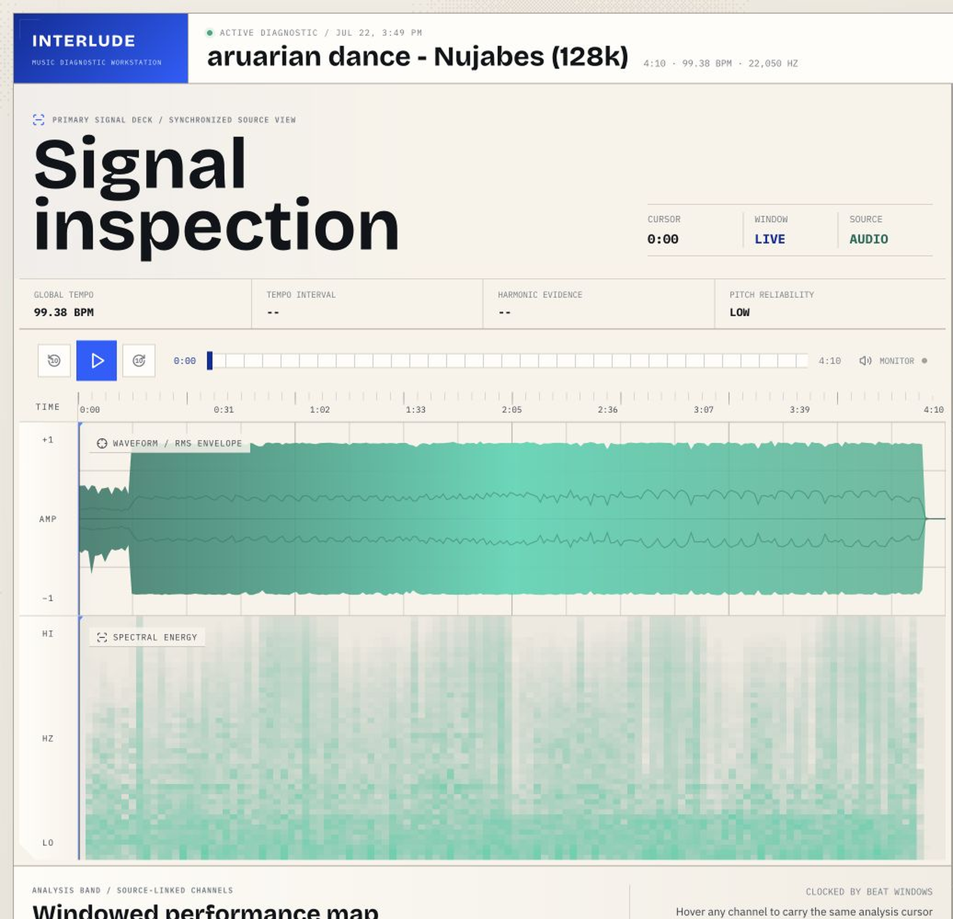

Interlude: Technical Framework and Dashboard Interpretation Guide
From audio waveform to musical diagnosis |  | Prepared for the Interlude project  July 2026

Contents

Executive orientation 1
Read the dashboard in five minutes 3
1. End-to-end architecture 5
2. DSP and music foundations 8
3. Key detection 11
4. Tempo stability 13
5. Pitch accuracy and reliability 15
6. Dynamics contour 16
7. Harmonic complexity 18
8. Complexity-confidence finding 21
9. Dashboard and frontend framework 24
10. API, persistence, and OpenAI interpretation 27
11. Calibration, limitations, and recommendations 29
Appendix A. Equation reference 32
Appendix B. Constants and thresholds 33
Appendix C. Music-theory tables 36
Appendix D. Python function and class catalog 38
Appendix E. Frontend and GLSL function catalog 44
Appendix F. API and result-field dictionary 50
Appendix G. Dashboard field dictionary 61
Appendix H. Sources and provenance 62

Executive orientation
Interlude is a music diagnostic workstation. It converts an uploaded recording into synchronized evidence about beat timing, monophonic pitch behavior, tonal organization, harmonic movement, voicing density, modulation, and loudness contour. The interface is built to reveal relationships: a score is never intended to stand alone from the windowed signal evidence that produced it.
The analysis engine is local and deterministic until the written interpretation stage. Librosa, NumPy, and SciPy extract and summarize the signal. The OpenAI call occurs afterward and receives a compact evidence prompt plus supported audio context. If that call fails, the local measurements, charts, and saved-project structure still exist.
Reader promise. You do not need DSP training or formal music theory to use this guide. Each chapter starts with what the dashboard shows, translates the value into musical language, then reveals the equation and its limitations.

What Interlude measures
• Timing consistency: whether consecutive beat intervals remain proportionally close to the global tempo.
• Pitch accuracy evidence: how closely pYIN’s accepted monophonic fundamental-frequency estimates sit to equal-tempered notes, weighted by voiced probability.
• Tonal center: which major or minor Krumhansl-Kessler profile best matches the full-track pitch-class distribution, with guarded same-tonic modal promotion.
• Harmonic complexity: a composite of chromatic deviation, chord-region movement, tonal instability, pitch-class density, modulation load, and conservative chord-color evidence.
• Dynamics contour: whether local RMS energy follows a steady level or a smooth linear rise or fall.

What Interlude does not measure
• It does not transcribe a complete score or guarantee exact chord names.
• It does not guarantee that full-mix pYIN follows the singer; it may follow bass or another dominant harmonic source.
• Tempo stability does not score swing, syncopation, groove quality, or whether onsets land on a metronomic phase.
• A high harmonic score is not automatically better, and a low score is not automatically worse. The number describes evidence, not artistic value.
• OpenAI-written prose is interpretation, not the source of the numerical measurements.

Read the dashboard in five minutes
1. Start at the signal deck. The waveform shows amplitude over time; the darker inner envelope is RMS energy. The spectrogram shows where frequency energy exists.
2. Read the transport. The blue cursor is the shared time reference. Hovering a metric inspects without seeking; clicking locks evidence and may seek to the window.
3. Check the tonal solution. Correlation asks how closely the pitch-class shape matches the winning key profile. Runner-up margin asks how decisively it wins. Scale fit asks how much analyzed chroma energy lies inside the selected scale mask.
4. Read the four timeline families. Tempo is interval cadence, pitch is probability-weighted monophonic tuning, harmony is segmented evidence with ambiguity gaps, and dynamics is the fit to a simple energy contour.
5. Open the harmonic component register. The composite is most useful when read with its weighted contributors and the analyzable-window ratio.
6. Finish in the diagnostic rail. Local numbers are deterministic evidence; the written recommendation is a model-generated musical reading constrained by that evidence.
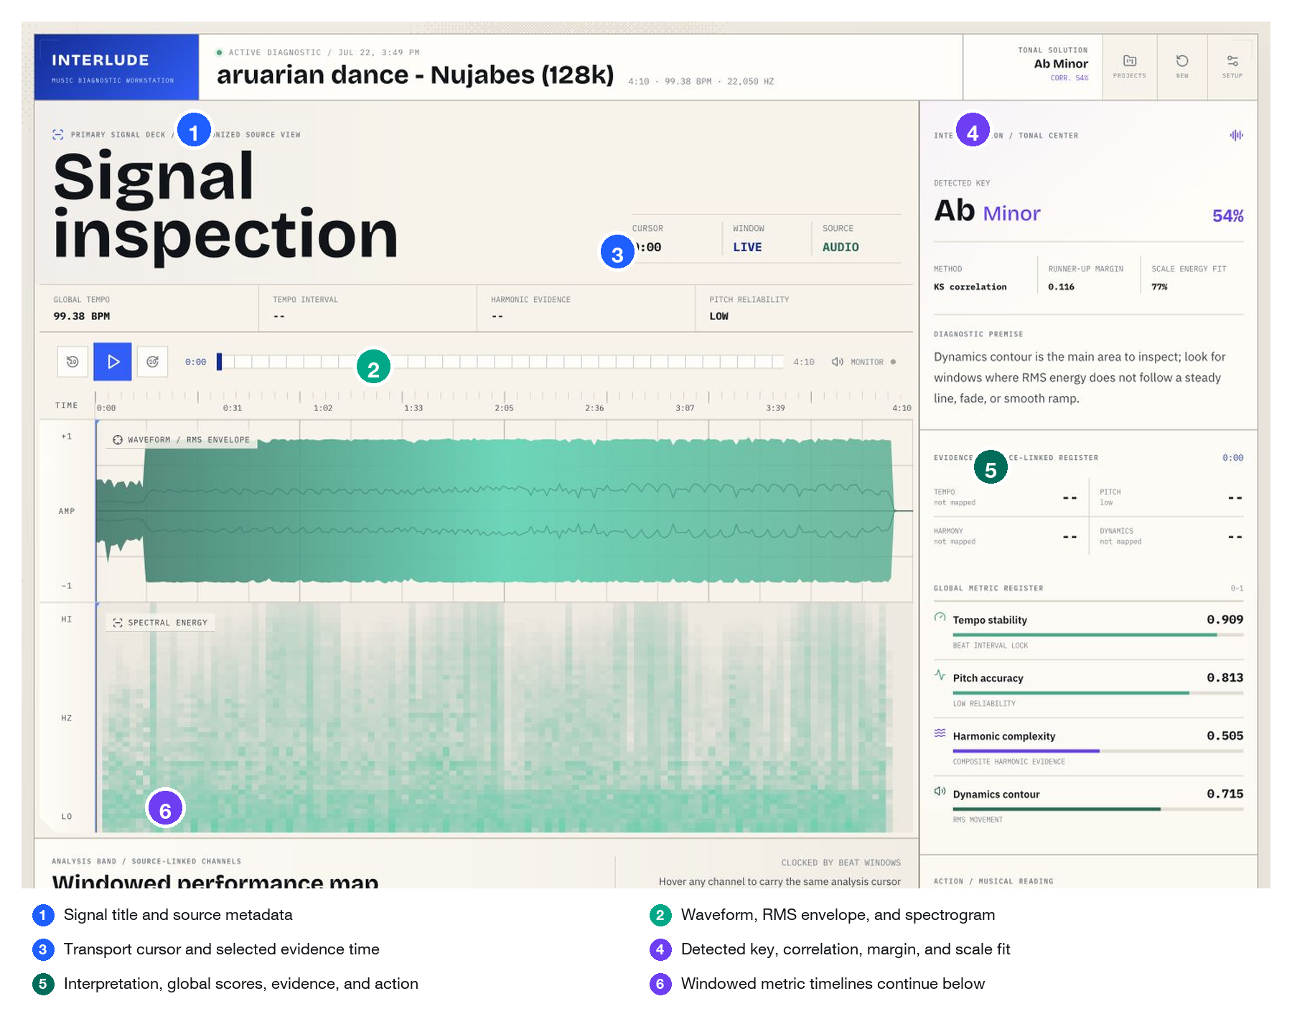
Figure 1. Current Interlude diagnostic workspace. Numbered markers identify the source signal, synchronized cursor, tonal readout, diagnostic rail, and the time-based analysis band.
Marker | Dashboard region | Value source | First caution
1 | Project and signal metadata | Decoded audio duration, sample rate, global BPM, saved-project metadata | Metadata describes the analyzed file, not musical quality.
2 | Waveform / RMS / spectrogram | Original mono mix; waveform chunks and mel-spectrogram matrix | Display matrices are downsampled for transport, not analysis.
3 | Transport and evidence window | Audio currentTime or preview clock; hover/selection state | Hover never seeks; click may lock and seek.
4 | Tonal solution | Krumhansl-Schmuckler detection plus selected-scale energy fit | Correlation and fit answer different questions.
5 | Diagnostic console | Current windows, global scores, model interpretation, follow-up context | Model prose is interpretive and may fail independently.
6 | Analysis band | Beat-synchronous metric windows | A missing harmonic segment can mean ambiguity, not zero complexity.

1. End-to-end architecture
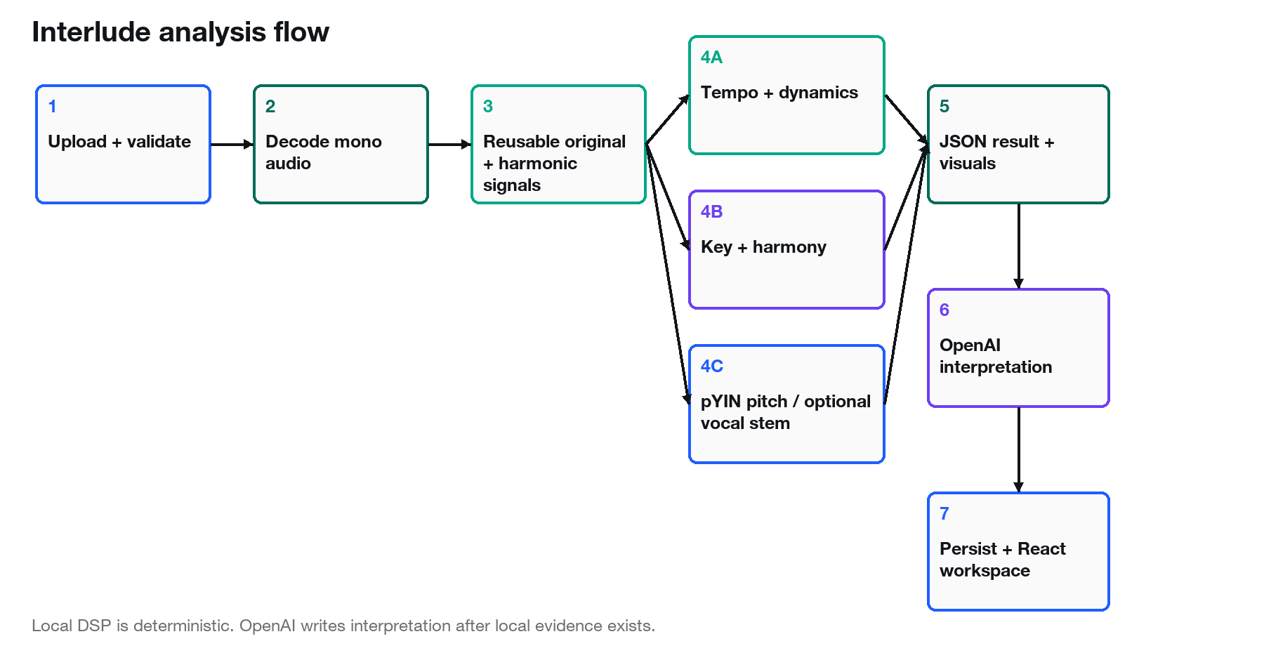
Figure 2. Audio travels through deterministic local analysis before OpenAI interpretation and project persistence.

Upload, validation, and decoding
The React client reads the selected audio file as a data URL and sends its base64 payload to POST /api/analyze. FastAPI strips any data-URL prefix, validates base64, sanitizes the original filename, and accepts AIFF, AIF, FLAC, M4A, MP3, OGG, or WAV. The upload is written to a UUID-prefixed temporary path so two analyses cannot collide.
Librosa then decodes the file once into a mono NumPy array y and a sampling rate sr. Duration is derived from the decoded sample count. Mono conversion intentionally collapses channel placement because the current metrics describe the combined recording, not stereo imaging.

Reusable signals
Signal | Created from | Consumers | Why it stays separate
Original mono mix | librosa.load(..., mono=True) | Onset strength, beat tracking, dynamics, waveform, mel spectrogram, key profile | Rhythm and loudness should represent the heard mix.
Harmonic component | librosa.effects.harmonic(y, margin=8) | Harmony, visualization chroma, default pYIN input | Suppresses transient/percussive energy that can pollute tonal features.
Optional vocal stem | Demucs htdemucs --two-stems vocals | pYIN only | The stem must not silently replace the mix for any other metric.

Optional vocal separation lifecycle
When separate_vocals is false, pitch analysis runs on the reusable harmonic mix. When true, Interlude first checks that the demucs module can be imported. It launches the current Python executable with -m demucs, model htdemucs, and two-stem vocal mode inside a TemporaryDirectory.
Separation timeout
timeout = max(600 seconds, 4 × track duration)
Track duration is the decoded full-song duration in seconds.
Plain language: A short song still receives ten minutes; a long song receives four times its duration.
Worked example: For a 240 s track, max(600, 960) = 960 s.
Exactly one non-empty vocals.wav must be found. The stem is loaded at the original analysis sample rate, checked for non-silent content, used for pYIN, and then deleted automatically when the temporary directory closes. Unavailable, timed-out, failed, malformed, or silent separation returns HTTP 503. Interlude never substitutes full-mix pitch tracking after the user explicitly requested separation.

Persistence and failure paths
After successful local analysis, the API copies the original upload into media/{project_id}{suffix}, adds an audio_url, inserts the complete result in the in-memory project dictionary, and atomically writes ~/.interlude/projects.json through a temporary file and replace operation. The upload scratch file is always deleted in a finally block.
• Invalid file data or unsupported extension: HTTP 400; no project is persisted.
• Silent or tonally empty input: AnalysisInputError becomes HTTP 422; no project is persisted.
• Requested vocal separation unavailable or failed: HTTP 503; no project is persisted.
• Persistence failure after media copy: the in-memory entry is removed and the copied media file is deleted.
• OpenAI failure: the result records api_error and a readable fallback response, but local analysis remains usable and can be persisted.
• Delete project: removes the JSON entry and, for /media/ URLs, deletes the retained audio file.

Source snapshot and provenance
Snapshot. Working tree inspected 23 July 2026. Git revision 9c3d294f8133d835b4ea59907797c7ac7f723342. Dirty status: 36 modified or untracked entries. The report describes the working tree, not only the last commit.
Principal source | SHA-256 | Bytes
Interlude.py | 4c04d6291a5d101ef4b1f6f1cfc904873690695bc75fced1c82b8abd7e01910f | 106722
app.py | cbe533ca29d64f6e4106f4637b85830b07e7da706f123545081ec02949db9989 | 8334
package.json | e5d9880d57edd68fb68b7d500a495b49e6a4c4a437e199f39e8083ef20ca760f | 516
package-lock.json | 81fb9762103dbb1b543a7a68a86245d909ec876524c5850fd9284251f4ecdcac | 90375
src/App.jsx | 1ecf79b05e0852097100353e94994ded284704dde74c042dfc728463255a8f18 | 5146
src/hooks/useAnalysisTransport.js | f0747510c13e7ad627283611b85087d092672a0e3e254b72b48ada96a3035b14 | 9105
src/components/visuals/MetricLaneSuite.jsx | 03622ed4ddcca7276c6e512a713e32868248116adf9a5404debdecdd569a9aa2 | 9535
src/components/visuals/PixelBlast.jsx | 9c682d0f96baf63ff298d7da399a9a2eed5f3b4e535450dff4228805cef1d52d | 10348
src/styles.css | 015be540744bdf2924b086f8a57be790fc50caaa3e5ac04a036621dcbd044064 | 33116
tests/test_analysis.py | 73dbdc9beccd14445b2e8a282a5e2990c956b61314978dfb24417c1058ae1c2f | 27149
scripts/calibrate_harmony.py | 80a24cbfca992cb114bf3dcd53ff1afe15c47377fefa7cf8527aab28f1b77294 | 4976

2. DSP and music foundations
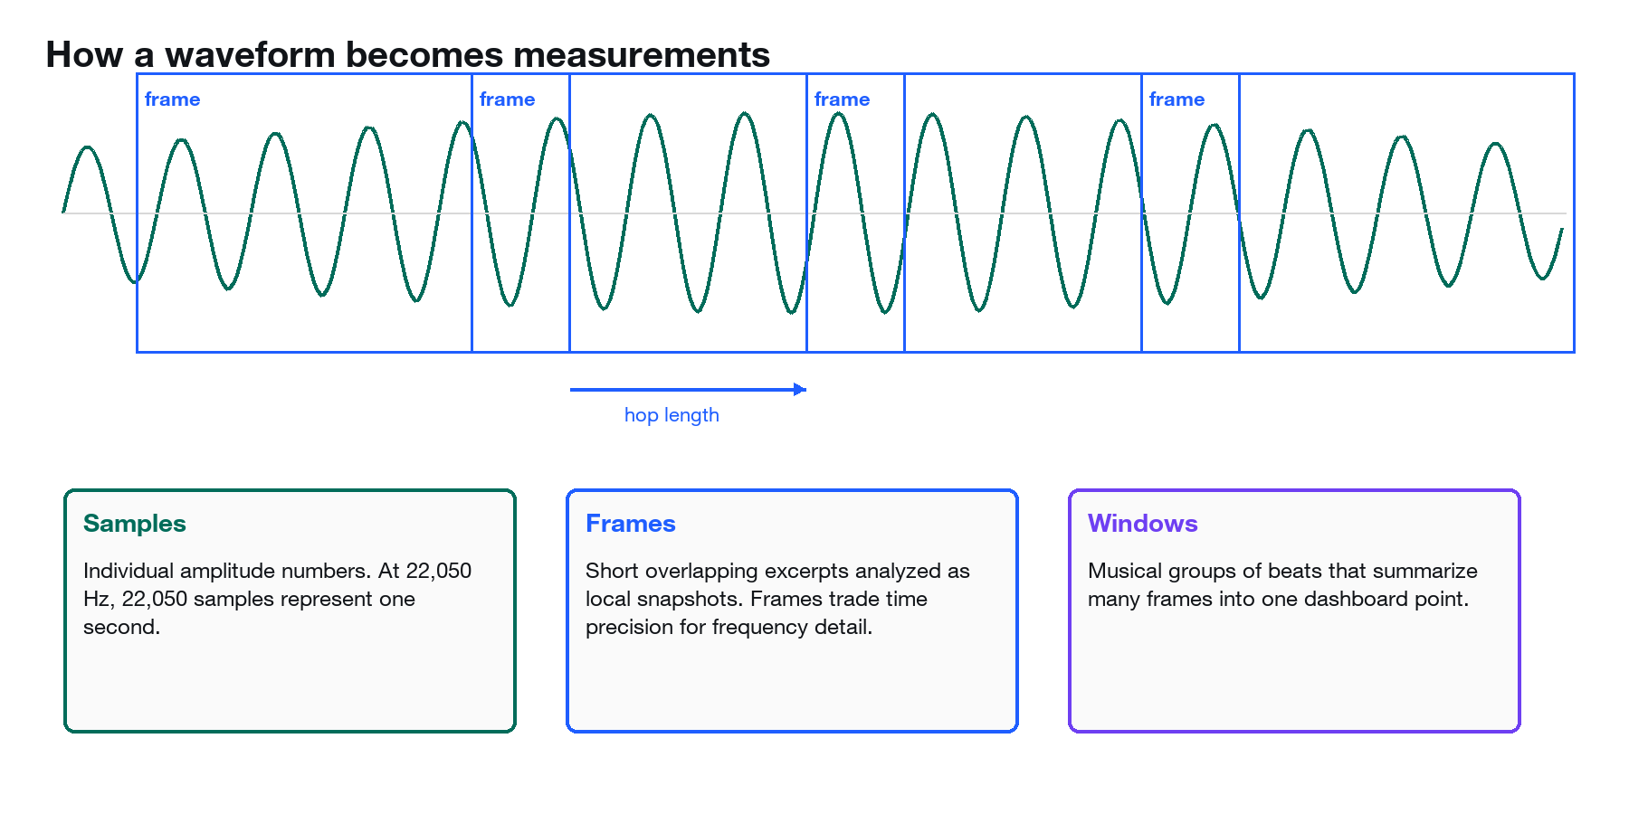
Figure 3. Samples are grouped into overlapping frames; many frames are summarized inside beat-synchronous musical windows.

Samples, sample rate, amplitude, and duration
A digital recording is a long list of amplitude samples. A positive number represents displacement in one direction, a negative number the other, and zero the center line. Sample rate tells us how many samples describe one second. Interlude’s saved project displays the rate used after Librosa loading; the current calibration examples are analyzed at 22,050 samples per second.
Duration
duration = N / sr
N = number of samples; sr = samples per second (Hz).
Plain language: Divide the length of the array by the sampling rate.
Worked example: 4,410,000 samples at 22,050 Hz represent 200 seconds.

Frames and hop length
Most musical evidence changes over time, so algorithms do not inspect only the whole song. They slide a short frame across the waveform. Frame length sets how much sound each snapshot sees. Hop length sets how far the next snapshot advances. Overlap improves continuity: two neighboring frames can share most of their samples.
The default pYIN frame is 2,048 samples and its default hop is one quarter of that when no hop is supplied. Dynamics explicitly uses a hop length of 512. Chart windows are larger and musical: they group beat intervals or pitch/chroma/RMS frames into 4-, 8-, or 16-beat regions.

Frequency, pitch, semitones, MIDI, and cents
Frequency is physical repetition per second, measured in hertz. Pitch is the musical interpretation of frequency. Equal temperament divides an octave into 12 equal logarithmic steps. MIDI note numbers provide a convenient linear coordinate: A4 at 440 Hz is MIDI 69, and each semitone changes MIDI by one.
Frequency to MIDI
m = 69 + 12 log2(f / 440)
f = frequency in Hz; m = continuous MIDI note number.
Plain language: An octave doubles frequency and adds 12 MIDI steps.
Worked example: f = 440 Hz gives m = 69. f = 880 Hz gives m = 81.
Cents error
cents = 100 × |m - round(m)|
100 cents = one equal-tempered semitone.
Plain language: Measure distance to the nearest piano-key pitch.
Worked example: A continuous MIDI value of 69.23 is 23 cents away from A4.
Vibrato and bends are intentional pitch motion. Interlude compares raw pYIN pitch with a seven-frame median-smoothed contour, keeps the kinder error, reduces error by 35% when motion exceeds 10 cents per frame, and caps any remaining frame error at 50 cents.

Beats, BPM, onset strength, intervals, windows, bars, and phrases
A beat is a perceived pulse. BPM counts beats per minute. Onset strength is a time series that rises when spectral energy changes sharply, often near note attacks or drum hits. Librosa’s dynamic-programming tracker estimates a global tempo and selects beat frames that are approximately consistent with it.
Interlude does not treat every onset as a beat. It uses detected beats to define musical windows. Four beats approximate a common bar, eight beats cover two bars, and sixteen beats approximate a phrase-scale region. These are analytical conveniences, not claims about the track’s actual meter.

RMS, spectrograms, mel bands, and decibels
RMS (root mean square) is a short-term energy measure. Squaring makes negative and positive samples contribute equally, averaging summarizes a frame, and the square root returns an amplitude-like scale. A spectrogram organizes energy by time and frequency. Interlude uses a 64-band mel spectrogram for display, converts power to decibels relative to the maximum, then downsamples it to 48 × 120 cells for the browser.
RMS
RMS = sqrt((1/N) Σ x[n]²)
x[n] = sample amplitude in a frame; N = samples in the frame.
Plain language: RMS rises when the frame contains more sustained energy.
Worked example: For samples [1, -1, 1, -1], RMS = 1 even though their arithmetic mean is zero.

CQT chroma and pitch classes
A constant-Q transform uses frequency bins whose spacing follows musical pitch. Chroma folds all octaves into 12 pitch classes: every C contributes to one C lane, every C-sharp or D-flat to the next, and so on. This makes harmony compact but removes octave, register, instrumentation, and voice-leading information.
A pitch-class profile (PCP) is a 12-number summary of chroma energy. It is useful for keys and chords because it asks which pitch classes are present, but it cannot distinguish C4 from C5 or tell which instrument produced a note.

Keys, modes, chords, modulation, and polyphony
A key combines a tonic (home pitch) with a major/minor tonal hierarchy. A mode changes characteristic scale degrees around the same tonic. A chord is a simultaneous or perceptually grouped sonority. Modulation is a sustained change of tonal center, not merely one borrowed chord or tonicization. Polyphony means more than one pitch sounds at once.
Confidence versus strength. A strong measured effect and a confident theoretical label are different. Dense or altered harmony may be strong evidence of complexity while the exact key or chord name remains uncertain. The July 2026 implementation does not fully preserve that distinction; Chapter 7 documents the resulting bias.

3. Key detection

What appears on the dashboard
The tonal solution shows a root and mode, a percentage labeled correlation, a runner-up margin, the method label KS correlation, and scale energy fit. Auto means the engine selected the key. Manual means the user supplied both root and scale/mode; the automatic detection metadata is still returned as evidence.
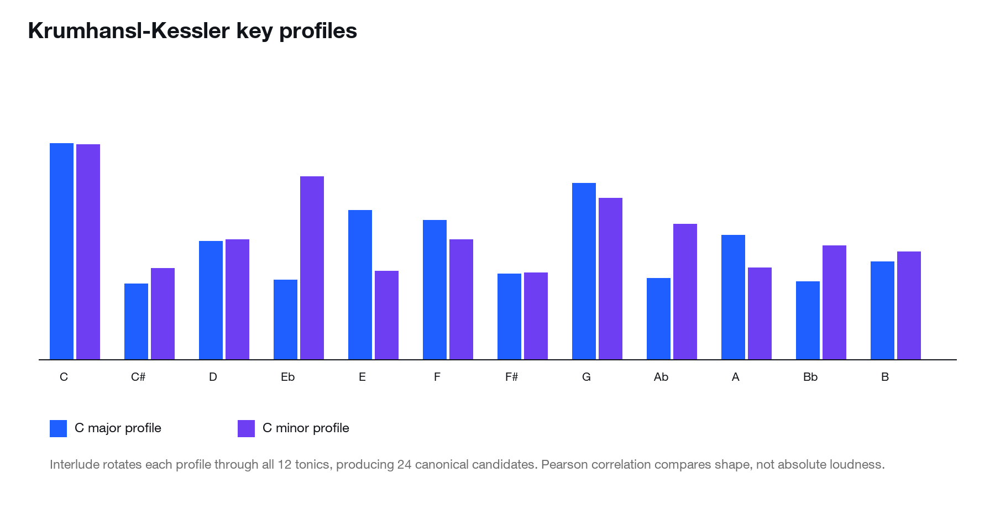
Figure 4. Canonical C-major and C-minor probe-tone profiles. Rotating both through 12 tonics creates 24 candidates.

Dedicated key chroma
Key finding has its own full-track CQT chroma path. Interlude rejects waveforms whose maximum amplitude is at or below 10⁻⁶, trims leading and trailing silence, calculates chroma_cqt on the trimmed original mix, averages each of the 12 lanes over time, and validates the result. A profile is rejected if it is not finite, not 12 bins, has negligible total energy, or its standard deviation divided by mean magnitude is below 0.05.

Twenty-four canonical candidates
The code stores the Krumhansl-Kessler major profile [6.35, 2.23, 3.48, 2.33, 4.38, 4.09, 2.52, 5.19, 2.39, 3.66, 2.29, 2.88] and minor profile [6.33, 2.68, 3.52, 5.38, 2.60, 3.53, 2.54, 4.75, 3.98, 2.69, 3.34, 3.17]. Each is rotated to C through B, then correlated with the observed profile.
Pearson profile correlation
r(P,K) = Σ(Pᵢ-P̄)(Kᵢ-K̄) / sqrt[Σ(Pᵢ-P̄)² Σ(Kᵢ-K̄)²]
P = observed 12-bin PCP; K = candidate key profile; bars denote means.
Plain language: Compare the shape of pitch-class emphasis after removing each vector’s average level.
Worked example: If C major scores 0.68 and G major 0.57, C major wins and the runner-up margin is 0.11.
The winning canonical candidate is always chosen before modal extension. The reported correlation is the winning profile’s Pearson r. The runner-up margin is max(0, winning r minus the relevant runner-up r). High correlation with a tiny margin means the best key shape is plausible but not decisive.

Guarded same-tonic modal promotion
Mode | Parent | Weight swap | Characteristic evidence
Dorian | minor | ♭6 ↔ natural 6 | natural 6 energy > ♭6
Phrygian | minor | natural 2 ↔ ♭2 | ♭2 energy > natural 2
Lydian | major | perfect 4 ↔ ♯4 | ♯4 energy > perfect 4
Mixolydian | major | major 7 ↔ ♭7 | ♭7 energy > major 7
Locrian | minor | natural 2 ↔ ♭2 and perfect 5 ↔ ♭5 | both altered lanes exceed displaced lanes

These are documented heuristics, not empirical Krumhansl probe-tone profiles. Only modes in the winning canonical family and on the same tonic are evaluated. Promotion requires characteristic pitch-class evidence, modal correlation at least 0.60, and at least 0.10 correlation advantage over the canonical parent. Harmonic minor and melodic minor are manual-only.

Scale energy fit is not correlation
Key fit
fit = Σ(Pᵢ × maskᵢ) / ΣPᵢ
maskᵢ is 1 for pitch classes inside the selected scale and 0 outside.
Plain language: Fit asks what fraction of energy lies in the scale; correlation asks whether the whole profile resembles a learned tonal hierarchy.
Worked example: A track can have 0.90 fit but modest correlation if all in-scale notes are equally emphasized and no tonic hierarchy is clear.

Failure modes
• Parallel or relative keys can produce close correlations and a small margin.
• Modal, chromatic, or rapidly modulating recordings can weaken any single full-track key.
• Chroma ignores octave and timbre; bass-heavy mixes can overemphasize particular pitch classes.
• Manual overrides control the harmony scale mask and analysis key but do not rewrite automatic detection metadata.
• Silent or tonally flat material returns HTTP 422 instead of inventing a key.

4. Tempo stability

What appears on the dashboard
The project header shows global BPM. The tempo timeline shows one score per eight-beat window and a global average. The tracking payload also includes median local BPM, target interval, mean absolute log-ratio error, interval count, and the 0.05 tolerance.

One onset envelope, one beat tracker
Interlude computes librosa.onset.onset_strength once and passes it explicitly to librosa.beat.beat_track. The tracker returns a global tempo and beat-frame locations. Frames are converted to seconds. No onset backtracking is used in the stability score.
Target beat interval
T = 60 / BPM
T is seconds per beat; BPM is global beats per minute.
Plain language: A faster tempo has a shorter target interval.
Worked example: 117.45 BPM gives T ≈ 0.5109 s.
Log-ratio error
eᵢ = |ln(dᵢ / T)|
dᵢ = observed gap between consecutive detected beats.
Plain language: Equal proportional speed-up and slow-down produce symmetric errors.
Worked example: If d = 0.520 s and T = 0.5109 s, e ≈ 0.0177.
Per-interval stability
sᵢ = exp[-0.5 × (eᵢ / 0.05)²]
0.05 is TEMPO_LOG_TOLERANCE.
Plain language: Perfect intervals score 1; proportional timing error decays smoothly.
Worked example: e = 0.0177 gives s ≈ 0.939.
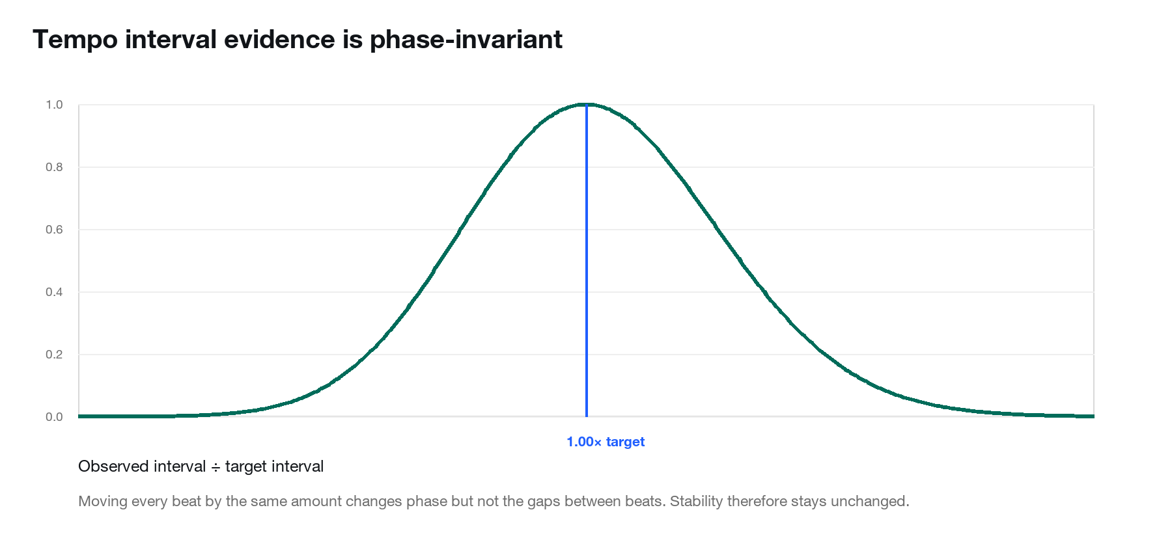
Figure 5. The Gaussian score depends on interval ratios, not absolute beat phase.

Global and local aggregation
The overall score is the arithmetic mean of every valid interval score. Each eight-beat window repeats the same calculation for intervals whose starting beat falls inside the window. Local BPM is 60 divided by the median positive interval. Fewer than two usable beats yields no stability value rather than a forced zero.

Why backtracking previously looked unstable
Backtracking moves onset timestamps toward earlier local energy minima. On the Billie Jean fixture, earlier investigation found shifts of roughly 56 ms even while the global BPM estimate remained correct. A rhythm-grid score treated those phase shifts as instability. The current score uses only consecutive beat gaps, so translating every beat by the same amount leaves all dᵢ unchanged.
Billie Jean acceptance. The implementation target is approximately 117.45 BPM and 0.93 stability. The current five-track harmony calibration does not recompute tempo, but the 37-test suite explicitly proves phase-shift invariance, lower scores for jitter, and null output for insufficient beats.

Limitations
• Double-time or half-time tempo selection can be globally plausible but musically debatable.
• A rubato performance may be expressive yet intentionally score lower.
• The metric does not measure subdivision accuracy, swing ratio, syncopation, microtiming feel, or groove.
• Beat-tracker errors can still contaminate intervals even though onset phase no longer does.

5. Pitch accuracy and reliability

What appears on the dashboard
The pitch timeline shows probability-weighted accuracy over sixteen-beat windows. The rail displays the global score and reliability. The result also reports source, voiced-frame ratio, mean voiced probability, effective voiced ratio, valid and effective frame counts, mean absolute cents error, and whether dense polyphony capped reliability.

pYIN input and accepted frames
Without separation, pYIN runs on the harmonic component of the full mix. With separation, it runs directly on the Demucs vocal stem. Frequency is searched from C2 to C7. Librosa pYIN returns f0, voiced_flag, and voiced_prob. A frame is accepted when f0 is finite and pYIN’s voiced-state decision is true. There is no extra 0.7 probability gate.
Pitch frame score
pᵢ = exp(-cᵢ / 100)
cᵢ = vibrato-tolerant absolute cents error, capped at 50.
Plain language: One semitone of error would imply exp(-1), but the cap means the minimum accepted-frame score is exp(-0.5) ≈ 0.607.
Worked example: 23 cents gives exp(-0.23) ≈ 0.795.
Probability-weighted aggregate
P = Σ(wᵢ pᵢ) / Σwᵢ
wᵢ = clipped voiced_prob for an accepted pYIN voiced frame.
Plain language: A likely voiced frame influences the score more than a doubtful one.
Worked example: Scores 0.90 and 0.60 with weights 0.8 and 0.2 produce P = 0.84.

Coverage and reliability
Effective voiced frames
N_eff = Σwᵢ; effective ratio = N_eff / N_total
N_total includes all frames in the evaluated region.
Plain language: Coverage accounts for both how many frames are voiced and how confident pYIN is.
Worked example: 10 accepted frames each at 0.5 probability contribute 5 effective frames.
Reliability | Implemented rule | Meaning
insufficient | N_eff < 3 | Not enough weighted voiced evidence; score is null.
low | effective ratio < 0.10 OR mean probability < 0.20 | Weak coverage or confidence.
medium | effective ratio < 0.30 OR mean probability < 0.50 | Usable but cautious monophonic evidence.
high | otherwise | Strong pYIN coverage, still source-dependent.

If polyphonic density is flagged and the source is full_mix_harmonic, overall and window reliability are capped at low. The numeric scores remain available as evidence, but low-reliability pitch is excluded from topline weakest-metric selection and the feedback prompt forbids treating it as a confident vocal diagnosis.

Why Billie Jean can confuse pYIN
pYIN estimates one fundamental frequency at a time. In a commercial mix, bass, vocal, guitar, and synth harmonics can overlap. Harmonic extraction suppresses some transients but does not identify a singer. A clean bass line can dominate the same frame in which a vocal is present, so low voiced confidence may be correct uncertainty rather than a failure to hear singing.

Optional Demucs and future polyphonic tracking
The optional setup command is pip install -r requirements-vocal.txt, which installs demucs==4.1.0. Separation increases latency, CPU/GPU use, memory use, and model-download requirements. The API advertises capability before the upload toggle is enabled.
Polyphonic tracking is feasible. Spotify Basic Pitch can emit multiple note events and pitch bends and is instrument-agnostic, but its own guidance says it works best on one instrument at a time. For Interlude, the harder product problem is source attribution: which detected note belongs to the singer, bass, keys, or layered instrument, and which source should an intonation score judge?

6. Dynamics contour

What appears on the dashboard
The dashboard calls the metric Dynamics contour even though the compatibility score field remains dynamics_variation. Each eight-beat window contains a 0–1 score, raw variation, mean RMS, line slope, fitted start/end, direction, residual, and relative residual.

Median-smoothed local energy
RMS is computed with a 512-sample hop. Within each window, the median filter size is approximately one quarter of the number of local RMS frames, forced odd and at least three when possible. This follows the broader energy envelope instead of every drum transient.
Local fitted contour
ŷᵢ = a xᵢ + b
x runs from 0 to 1 through the window; a and b come from a least-squares line fit.
Plain language: A positive slope is a rise, negative is a fall, and near-zero is steady.
Residual and amplitude reference
RMSE = sqrt(mean[(yᵢ-ŷᵢ)²]); A = max(P95(y), range(y), 0.05×global P95, 10⁻⁸)
A prevents quiet sections or nearly flat windows from dividing by an unstable tiny scale.
Plain language: Residual measures deviation from the simple contour; A makes it relative to the section’s usable amplitude.
Dynamics score
D = 1 / [1 + (RMSE/A) / 0.25]
0.25 is DYNAMICS_CONTOUR_TOLERANCE.
Plain language: Perfectly linear energy scores 1. More irregular movement lowers the score smoothly.
Worked example: RMSE = 0.04 and A = 0.20 gives relative residual 0.20 and D = 0.556.

Direction classification
If |slope| is below 5% of the amplitude reference, the window is steady. Positive slopes are rising and negative slopes falling. Direction is descriptive only; all three can score highly when the residual is small.

What a low score means
A low score means the smoothed RMS envelope does not resemble one straight contour inside that window. It may contain several accents, pumping, abrupt arrangement changes, inconsistent performance energy, or a musically intentional shape more complex than a line. It is not a loudness, mastering-quality, or compression score.

7. Harmonic complexity

What appears on the dashboard
The harmony timeline shows the endpoint-normalized composite for confident four-beat windows. Ambiguous windows interrupt the line and are hatched as low-confidence harmonic evidence. The component register exposes diatonic deviation, harmonic movement, tonal instability, voicing density, modulation load, and harmonic color with their fixed weights.

Chroma cleanup and aggregation
Harmony begins with the reusable harmonic waveform. A 36-bin-per-octave CQT chromagram is nearest-neighbor filtered with cosine distance, median-filtered across nine frames, clipped nonnegative, and normalized so each frame sums to one. A pitch class is active at 0.10 or more. Five-frame uniform support produces a persistence factor from 0.65 to 1.35, favoring sustained energy. The weighted frame is normalized again.
Persistence weighting
C'ᵢ,t = Cᵢ,t × [0.65 + 0.70 × sustainᵢ,t], then L1-normalize each frame
sustain is the five-frame local mean of the active/not-active indicator.
Plain language: A pitch class present across nearby frames receives more influence than an isolated transient.
Windows use a 10% trimmed mean across frames: the lowest and highest 10% are discarded when enough frames exist. This reduces transient spikes without assuming every chromatic note is noise.

Diatonic deviation
Per-frame diatonic deviation
δ_t = Σ Cᵢ,t × (1 - scaleMaskᵢ)
The scale mask belongs to the analysis key, automatic or manual.
Plain language: Sum the normalized energy outside the chosen scale.
Worked example: If 18% of frame energy lies outside the scale, δ_t = 0.18.
The global raw value is the mean of window diatonic_deviation values, including ambiguous windows. raw_harmonic_complexity remains a compatibility alias for this raw score. The composite uses adjusted_diatonic_deviation from confident windows only.

Chord-region knowledge and harmonic color
A separate chord chroma path is limited from C2 across four octaves. Beat-bounded regions are compared with normalized templates for triads, suspended chords, augmented/diminished chords, sixths, sevenths, added ninths, ninths, and altered dominant ♭9/♯9 sonorities.
Chord similarity and selection
similarity = Ĉ · T; selection = similarity - 0.08 × colorComplexity
Ĉ and T are L2-normalized 12-bin vectors.
Plain language: Cosine similarity finds the nearest template; the color penalty prevents exotic templates from winning merely because they contain more notes.
A chord region is ambiguous when similarity is below 0.62 or the selection margin is below 0.015. Confidence combines 65% normalized similarity strength and 35% margin strength. Color evidence equals template color × (0.40 + 0.60 × confidence) only for non-ambiguous regions; ambiguous regions receive zero color evidence.
Global harmonic color
color = clip(0.25 μ_color + 0.10 r_colored + 0.65 min(r_altered/0.03,1), 0,1)
μ_color = duration-weighted confident color evidence; r_colored counts color ≥ 0.24; r_altered counts color ≥ 0.80.
Plain language: Rare altered-dominant evidence can remain salient instead of disappearing into a full-song average.

Harmonic movement
Chord extensions are collapsed into movement families so C major, Cmaj7, C6, Cadd9, C9, and altered C dominants do not create false root movement. Transitions touching ambiguous regions are discarded. Movement inside a region group combines chord-change rate and whether a transition is novel in the full track.
Window movement
M_w = 0.75 × clip(changesPerBar / 4,0,1) + 0.25 × novelTransitionRatio
One bar equivalent is four chord regions in this beat-synchronous approximation.
Plain language: Frequent changes matter more than novelty, but a progression with unique transitions receives an additional lift.
Global movement
M = 0.40 × mean(confident window movement) + 0.60 × uniqueTransitionRatio
uniqueTransitionRatio = unique confident transition pairs / all confident transition pairs.
Plain language: The global score emphasizes variety of movement across the song.

Voicing density
Effective pitch-class count
H_t = -Σ pᵢ,t ln pᵢ,t; n_eff = exp(H_t)
p is the normalized pitch-class distribution in a valid frame.
Plain language: Entropy converts a spread across pitch classes into an effective simultaneous count.
Density score
n_est = 0.65 n_active + 0.35 n_eff; V = clip((trimmedMean(n_est)-1)/7,0,1)
n_active also requires ≥0.10 normalized energy and ≥25% of the frame maximum.
Plain language: Density can rise for an in-key seven-note voicing even when chromatic deviation stays low.

Local key confidence and tonal stability
Each four-beat window expands its key context by two window durations on both sides, then runs the same key detector. Required local correlation is min(0.55, max(0.40, 0.75 × global correlation)); required margin is min(0.05, max(0.02, 0.75 × global margin)). Falling below either marks the window ambiguous.
Tonal centering compares local fit to threshold min(0.85, max(0.65, 0.90 × global analysis-key fit)). Exact center gets a factor of 1.0; same tonic and mode family 0.85; same tonic across families 0.55; different tonic 0.
Local tonal stability
S_w = fitStrength × (0.75 + 0.15 confidenceScore + 0.10 centerFactor)
fitStrength is zero below the center threshold and normalized above it.
Plain language: A centered window can be stable even if its exact local label is not identical, but confidence and mode-family agreement still matter.
Global tonal stability
S = 0.50 centeredDurationRatio + 0.30 longestCenteredRunRatio + 0.20 meanLocalStability
Only non-ambiguous windows contribute to centered and confident duration.
Plain language: Staying centered for long continuous spans matters more than isolated centered windows.

Sustained modulation and transition windows
A modulation candidate must be non-ambiguous, differ in root or mode from the global analysis key, reach correlation 0.60 and margin 0.10, persist for at least two consecutive harmony windows, have at least half its windows not tonally centered, and have mean modulation confidence at least 0.30. The boundary window before and after the run is marked as a transition.
Modulation confidence
q = 0.65 clip((r-0.60)/0.40,0,1) + 0.35 clip((margin-0.10)/0.20,0,1)
r is local key correlation.
Plain language: Correlation strength carries more weight than margin strength.
Modulation load
L = clip(0.45 runDensity + 0.30 confidenceWeightedDurationRatio + 0.25 confidenceBreadth,0,1)
runDensity scales run count by max(confidentWindows/16,1); breadth = mean run confidence × min(runCount/4,1).
Plain language: Repeated confident runs and sustained duration both matter.
Chromaticism adjustment around modulation
δ_adj = δ × [1 - 0.55 × q × stateWeight]
stateWeight = 1 for modulation, 0.5 for transition, 0 otherwise.
Plain language: A pitch outside the original key is less likely to be called chromatic when strong evidence says the tonal center actually moved.

Composite evidence and sigmoid
Pre-normalization harmonic evidence
E = 0.08δ_adj + 0.34M + 0.07(1-S) + 0.03V + 0.16L + 0.32C
δ_adj deviation; M movement; S stability; V density; L modulation load; C color.
Plain language: Movement and chord color dominate the current weights; density and raw chromaticism are deliberately small.
Endpoint-normalized logistic
g(x)=1/[1+exp(-x)]; H = [g((E-0.24)/0.10)-g(-2.4)] / [g(7.6)-g(-2.4)]
Center = 0.24 and scale = 0.10. Endpoints are clipped to [0,1].
Plain language: The curve expands the midrange while keeping exact 0 and 1 endpoints after normalization.
Worked calibration example. For aruarian dance, δ_adj=0.207, M=0.251, S=0.592, V=0.427, L=0, and C=0.359. Weighted evidence is 0.258; the endpoint-normalized sigmoid maps it to 0.505. The dominant contribution is harmonic color, followed by movement.

8. Complexity-confidence finding

Current implementation
The July 2026 implementation contains a censoring effect: the exact passages most likely to challenge a major/minor key profile or one-template chord label can be removed from the composite. This is not a simple mistake in the sigmoid or only a weight-tuning problem. It is a coupling between measurement eligibility and interpretation confidence.
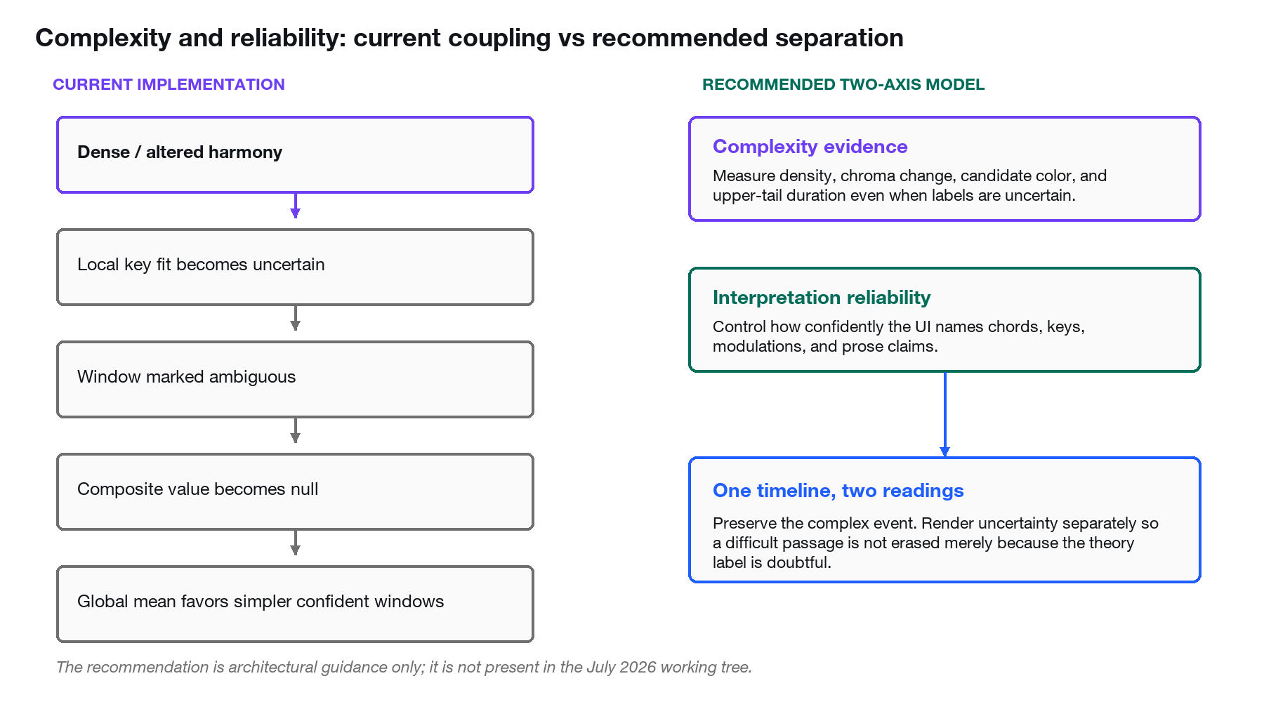
Figure 6. The current pipeline can erase complex evidence when theoretical naming becomes uncertain. The recommended architecture separates complexity from reliability.
1. Low local key correlation or runner-up margin marks a harmonic window ambiguous.
2. An ambiguous window receives harmonic_complexity = null and harmonic_evidence_score = null.
3. An ambiguous chord match receives color_evidence = 0 even if the chroma is dense or strongly altered.
4. Transitions touching an ambiguous chord region are discarded, reducing movement and novelty evidence.
5. Adjusted deviation, movement, density, and tonal summaries aggregate confident windows, so simple well-labeled passages can dominate.
6. The UI correctly labels the gap low-confidence harmonic evidence, but the global scalar can still be lower because the complex event was not scored.
Interpretation. Reweighting can improve ranking among surviving confident windows, but it cannot recover evidence that became null or zero before aggregation. The primary flaw is structural censoring, not merely the current coefficient values.

Recommended correction — not shipped
Adopt two simultaneous axes. Complexity evidence should remain measurable from label-independent features: chroma change magnitude, entropy/density, spectral persistence, duration, candidate-distribution spread, and probability-weighted chord color. Interpretation reliability should control whether the UI names a chord, key, modulation, or source and how certain the prose sounds.
• Replace winner-take-all chord color with probability-weighted candidate color, calibrated so a broad posterior increases uncertainty without forcing color to zero.
• Add label-independent adjacent-chroma change evidence so movement survives when root/quality naming is uncertain.
• Keep ambiguous windows on the harmony timeline with an uncertainty treatment instead of a missing complexity value.
• Ensure a confidence reduction cannot lower complexity when the underlying acoustic evidence is unchanged; it should lower only label reliability.
• Aggregate by duration and include a bounded upper-tail term so sustained complex peaks are not erased by long simple passages.
• Keep prose constraints: the model may say 'harmonically dense/unstable evidence' while withholding a definite chord or modulation label.
Illustrative two-axis aggregation
Complexity = (1-λ) × durationMean(E) + λ × boundedUpperTail(E), 0≤λ≤1
Reliability is reported separately and never multiplied into E.
Plain language: Sustained peaks can influence the track score without letting one frame dominate.
Worked example: This equation is drafted guidance and is not present in source.

9. Dashboard and frontend framework

React component hierarchy
Region | Owning component | Purpose
Application state | App | Loads options/projects, submits analysis, chooses upload or workspace.
Upload preparation | UploadPage + UploadInstrument + RootModeControl | Selects source, optional mode override, optional vocal separation, and diagnostic note.
Workspace shell | DiagnosticsWorkspace | Creates transport state and GSAP relationship animation.
Project header | WorkspaceHeader | Title, metadata, tonal solution, projects/new/setup controls.
Signal observation | MainSignalDeck | Readouts, transport, waveform, spectrogram, evidence regions.
Change over time | AnalysisBand + MetricLaneSuite | Metric timelines, harmonic component register, chroma support.
Interpretation | DiagnosticRail | Tonal evidence, current windows, global register, model prose, anchors, follow-up.
Continuity | ProjectDrawer | Saved analyses, score previews, deletion.

Shared transport clock
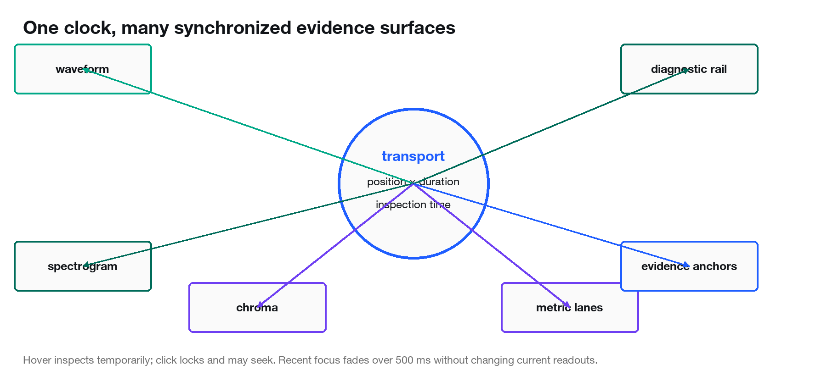
Figure 7. One normalized transport state drives every visual surface and the diagnostic rail.
useAnalysisTransport stores normalized position from 0 to 1. currentTime equals position × duration. When retained audio exists, an HTML Audio element supplies currentTime. Legacy projects without audio_url use a preview clock based on performance.now. GSAP quickSetter writes --analysis-progress continuously, while React state is throttled to about 80 ms for text and window lookup.

Seeking, scrubbing, and playback
• seek clamps a normalized position, updates audio.currentTime when available, resets the preview origin, updates React state, and writes the visual CSS variable.
• seekToTime converts seconds to normalized position.
• togglePlayback pauses when playing; otherwise it resets at the end, tries real audio, and falls back to preview timing if playback fails.
• skip adds or subtracts seconds before calling seekToTime.
• The scrubber, waveform, and evidence anchors all use the same transport functions.

Hover inspection, locking, focus cascade, and memory
inspectTime stores a temporary time and originating metric. Clearing inspection copies the last focus into recentInspection for 500 ms. selectedEvidence persists until replaced. focusMetric prefers live inspection, then locked selection, then recent inspection. focusState is inspecting, selected, recent, or rest.
DiagnosticsWorkspace uses GSAP to stage related targets: the initiating metric, signal deck, spectrogram/chroma, rail rows, and evidence anchors. The animation changes opacity and emphasis but does not invent data. Reduced-motion media queries apply state immediately. The recent state retains a subtle memory without leaving stale tooltip values.

Graph construction
Graph | Geometry | Distinctive behavior | Ambiguity/confidence
Tempo | Linear/stepped cadence | Beat-interval rhythm; firm changes | No score point when insufficient.
Pitch | Bounded smooth trace | Continuous phrase contour | Opacity follows available confidence; gaps when unavailable.
Harmony | Linear segmented trace | Purple modulation regions and transition boundaries | Ambiguous windows break the line and show hatching.
Dynamics | Bounded smooth area contour | Quiet energy envelope | No point for insufficient RMS frames.
Chroma | Twelve discrete lanes | No interpolation; pitch-class intensity cells | Selection window overlays shared time axis.

normalizePoints maps each chart point to start/end seconds. coordinates maps time to a 0–1000 SVG x-axis and score to a 0–100 y-axis. pointGroups breaks the path wherever a point is unavailable or ambiguous. Tempo and harmony use linear path segments; pitch and dynamics use midpoint-bounded cubic curves that do not overshoot the source values.
WaveformCanvas receives min, max, and RMS for up to 260 time chunks. It builds an amplitude polygon plus a quieter inner RMS polygon. SpectrogramMatrix renders the already-downsampled 48 × 120 display payload. ChromaLanes renders the 12 × 120 pitch-class payload with a shared 64 px measurement shoulder and normalized time ticks.

Semantic color
• Blue: cursor, transport, selection, focus and navigation.
• Teal: waveform, signal quality, stability, pitch evidence and dynamics.
• Purple: key, harmony, modulation, chord evidence and chroma.
• Red: errors or genuine ambiguity warnings only.

Pixel Blast background
PixelBlast is adapted from the ReactBits Pixel Blast concept but implemented as a native WebGL2 full-screen plane, avoiding a 3D engine for one ambient background. The current defaults are diamond variant, color #B9AA93, pixel size 2, scale 2.75, density 0.55, jitter 0, edge fade 0, and speed 0.1. Ripples and liquid behavior are absent.
The vertex shader passes a full-screen triangle pair. The fragment shader builds five-octave value noise, applies ordered Bayer dithering, then masks each active cell as a diamond. The canvas is alpha-transparent, so the warm workspace surface remains visible. ResizeObserver updates device-pixel resolution, capped at 2×. Animation pauses when the document is hidden and becomes a static render for reduced motion.

Upload preparation surface
The upload instrument is the preparation landmark: a white/paper source aperture with one full-surface calibration grid, file chooser/drag target, scan motion only during active analysis, and disabled vocal-separation toggle when the capability response says unavailable. It does not perform analysis itself; it prepares an unambiguous request.

10. API, persistence, and OpenAI interpretation

Endpoints
Endpoint | Input | Behavior
GET / | None | Serves dist/index.html or 503 if the React build is absent.
GET /api/options | None | Roots, scale/mode names, and vocal-separation capability/model.
POST /api/analyze | AnalyzeRequest | Complete project result; 400 validation, 422 tonal/silence, 503 separation.
GET /api/projects | None | Compact reverse-insertion list of saved analyses.
GET /api/projects/{id} | Project ID | Complete saved project or 404.
DELETE /api/projects/{id} | Project ID | Deletes JSON entry and retained /media/ file; returns deleted ID.
POST /api/follow-up | FollowUpRequest | Text response/api_error based on saved context; 400 empty, 404 missing.

AnalyzeRequest
Field | Type / default | Meaning
filename | string, required | Original client filename; basename and extension are sanitized.
file_data | string, required | Base64 data URL or raw base64 audio bytes.
extra_prompt | string, "" | Optional musical focus appended to the feedback prompt.
root | string | null | Manual root or auto/null.
scale_type | string | null | Manual scale/mode or auto/null; must accompany root.
separate_vocals | boolean, false | Requests Demucs; old clients remain compatible because default is false.

Options and capability response
GET /api/options returns roots from NOTE_TO_INDEX, sorted scales from SCALE_PATTERNS, and capabilities.vocal_separation with available and model. The frontend enables the toggle only when available is true. Capability reporting prevents a user from requesting a path the server cannot fulfill.

Project/result structure
The result is additive: project, summary, scores, key, tempo_tracking, pitch_tracking, harmonic_analysis, polyphony, charts, windows, visuals, prompt, response, and api_error. Compatibility fields remain present: raw_harmonic_complexity is the global raw diatonic-deviation average, harmony-window raw_complexity aliases diatonic_deviation, and adjusted_complexity aliases the window composite.
Legacy projects are tolerated because React reads optional fields with optional chaining and fallbacks. Missing audio_url activates preview transport. Missing nested harmonic fields fall back to older score aliases. New analysis persistence occurs only after all required local work and any requested separation succeeds.

Feedback prompt
build_prompt selects three lowest tempo, pitch, and dynamics windows and three highest confident harmony windows. It lists every global component, dominant harmonic drivers, confident chord-quality counts, modulation-run count, ambiguity note, analysis key, pitch source, coverage, and reliability.
• The model is asked for strengths, one suggested improvement, and one action step under 140 words.
• It must interpret musically rather than explain DSP.
• Low/insufficient full-mix pitch must not be called a confident vocal measurement.
• Ambiguous harmonic windows must not be described as definite chords, modulations, or hotspots.
• The model is told whether interest is most consistent with chromaticism, modulation, movement, chord color/extensions, or density.

Audio and text model paths
Supported .mp3 and .wav inputs are base64 encoded as Chat Completions input_audio content and sent to the audio-capable model from INTERLUDE_AUDIO_MODEL or default gpt-audio-1.5. Other file types use a text-only Responses call with INTERLUDE_TEXT_MODEL or default gpt-5.5 and an explicit note that computed metrics are primary.
extract_chat_completion_text prefers message.content, then an audio transcript if present. ask_follow_up uses only the saved project title, summary, scores, key, and previous feedback plus the question; it does not re-run DSP or attach retained audio.
Deterministic vs generated. Every numerical score and visualization is produced locally before OpenAI is contacted. The model can explain or misinterpret evidence, but it does not calculate the dashboard values.

11. Calibration, limitations, and recommendations

Verification performed for this report
Check | Result | Evidence
Python unit suite | 37/37 passed | python -m unittest discover -s tests -v; 10.206 s
Frontend production build | Passed | Vite 6.4.3; 1,606 modules; JS 356.37 kB, CSS 67.71 kB
Harmony calibration | 5/5 expectations passed | Billie Jean, Never Gonna Let You Go, Feel Good Inc., aruarian dance, Takarajima
Initial document-runtime attempt | Dependency check failed before collection | The artifact Python intentionally lacked FastAPI/Librosa; rerun used the project Python environment.

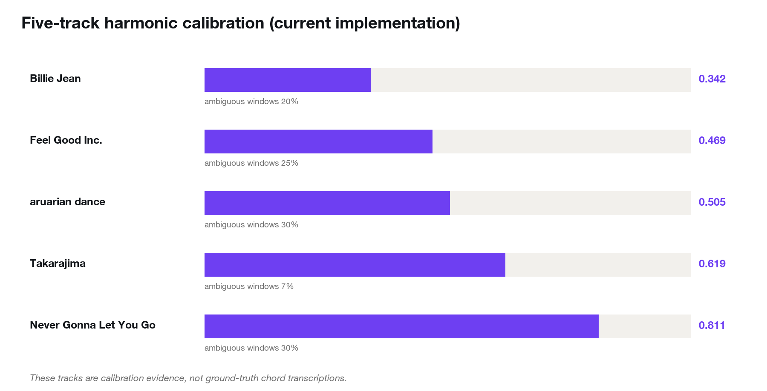
Figure 8. Current harmonic scores on the five local reference recordings.
Track | Composite | Movement | Mod. load | Color | Ambiguous
Billie Jean (Long Version) - Michael Jackson.wav | 0.342 | 0.195 | 0.000 | 0.172 | 20%
Gorillaz - Feel Good Inc..wav | 0.469 | 0.361 | 0.000 | 0.164 | 25%
aruarian dance - Nujabes.wav | 0.505 | 0.251 | 0.000 | 0.359 | 30%
Takarajima - T - SQUARE.wav | 0.619 | 0.498 | 0.178 | 0.138 | 7%
Sergio Mendes - Never Gonna Let You Go.wav | 0.811 | 0.609 | 0.627 | 0.023 | 30%

The ranking now distinguishes repeated pop/modal loops from jazz-pop modulation and fusion movement. However, chord-quality counts are not ground truth. For example, the template matcher reports many major7 and sus labels in Billie Jean and Feel Good Inc.; these labels can reflect spectral overlap and template bias rather than literal played voicings.

Known limitations
• Full-mix pYIN source ambiguity: harmonic preprocessing does not isolate a singer.
• Chord templates: one pitch-class template cannot model inversions, slash bass, rootless voicings, extensions beyond the template set, or temporal voice-leading.
• Chroma folding: octave, register, instrumentation, doubling, and bass function are lost.
• Confidence/complexity censoring: ambiguous key/chord regions can become null or zero before aggregation.
• Beat-window assumptions: four, eight, and sixteen beats are convenient but do not detect meter or phrase boundaries.
• Key profiles: canonical Western major/minor probe-tone profiles do not represent every genre, tuning system, or modal practice.
• Demucs: optional, computationally expensive, environment-sensitive, and not guaranteed artifact-free.
• Dependency reproducibility: the repository has no baseline requirements file for the core Python stack in the inspected snapshot.
• OpenAI interpretation: generated prose is nondeterministic and may be unavailable, while local measurements remain deterministic.

Prioritized recommendations
1. Separate complexity evidence from interpretation reliability. Preserve ambiguous evidence and make uncertainty a second axis.
2. Expand calibration with annotated passages and paired human judgments, not only whole-track ordering constraints.
3. Replace winner-take-all chord color with a calibrated candidate distribution and label-independent chroma-change evidence.
4. Prototype source-aware polyphonic transcription using Basic Pitch after stem separation, with explicit instrument/source attribution.
5. Add a pinned core Python dependency file and automated environment smoke test.
6. Add short redistribution-safe regression fixtures that capture altered harmony, modulation, dense in-key voicing, rubato, vibrato, and polyphonic pitch ambiguity.

How to use the dashboard responsibly
Start with the signal and the timeline, then use the scalar as a summary. A low or high value should prompt a location question: where does it happen, how confident is the evidence, what does the waveform/chroma show, and does listening agree? Interlude is strongest as an inspection environment, not a ranking engine.

Appendix A. Equation reference
Name | Equation | Units / range | Dashboard/API destination
Duration | N/sr | samples, Hz → seconds | project.duration
Target beat interval | 60/BPM | BPM → seconds/beat | tempo_tracking.target_interval
Tempo log error | |ln(d/T)| | dimensionless | mean_log_interval_error
Tempo interval score | exp[-0.5(e/0.05)²] | 0–1 | tempo window score
Frequency to MIDI | 69+12log₂(f/440) | Hz → MIDI | pitch intermediate
Cents error | 100|m-round(m)| | cents | mean_abs_cents_error
Pitch frame score | exp(-c/100) | 0–1 | pitch frame evidence
Weighted pitch score | Σwp/Σw | 0–1 | pitch_accuracy
Effective voiced frames | Σ voiced_prob | weighted frames | pitch_tracking
Effective voiced ratio | N_eff/N_total | 0–1 | pitch_tracking
RMS | sqrt(mean(x²)) | linear amplitude | visual waveform / dynamics
Linear contour | ŷ=ax+b | RMS | dynamics windows
Contour RMSE | sqrt(mean((y-ŷ)²)) | RMS | trend_residual
Relative residual | RMSE/A | dimensionless | relative_residual
Dynamics score | 1/[1+(RMSE/A)/0.25] | 0–1 | dynamics_variation
Pearson key correlation | cov(P,K)/(σPσK) | -1–1 | key.detection.correlation
Runner-up margin | max(0,r₁-r₂) | 0–2 | runner_up_margin
Scale energy fit | ΣP·mask/ΣP | 0–1 | key.fit
Persistence factor | 0.65+0.70×sustain | 0.65–1.35 | harmonic preprocessing
Diatonic deviation | ΣC(1-mask) | 0–1 | diatonic_deviation
Chord similarity | Ĉ·T | -1–1 | chord region similarity
Chord selection | similarity-0.08×color | ranking value | chord template winner
Chord confidence | 0.65 simStrength+0.35 marginStrength | 0–1 | quality_confidence
Color evidence | color×(0.40+0.60confidence) | 0–1 | harmonic color
Entropy | -Σp ln p | nats | voicing density intermediate
Effective pitch count | exp(H) | pitch classes | voicing density intermediate
Voicing density | clip((n_est-1)/7) | 0–1 | voicing_density
Window movement | 0.75 rate+0.25 novelty | 0–1 | harmonic_movement
Global movement | 0.40 meanWindow+0.60 uniqueRatio | 0–1 | harmonic_movement
Local tonal stability | fitStrength(0.75+0.15conf+0.10center) | 0–1 | harmony window
Global tonal stability | 0.50 centerDur+0.30 longestRun+0.20 local | 0–1 | tonal_stability
Modulation confidence | 0.65 corrStrength+0.35 marginStrength | 0–1 | modulation runs
Modulation load | 0.45 density+0.30 duration+0.25 breadth | 0–1 | modulation_load
Modulation adjustment | 1-0.55×confidence×stateWeight | 0.45–1 | adjusted deviation
Harmonic color | 0.25 mean+0.10 colored+0.65 alteredSalience | 0–1 | harmonic_color
Harmonic evidence | 0.08δ+0.34M+0.07(1-S)+0.03V+0.16L+0.32C | 0–1 | evidence_score
Logistic | 1/[1+exp(-x)] | 0–1 | normalizer
Normalized harmonic score | [g((E-.24)/.10)-g(-2.4)]/[g(7.6)-g(-2.4)] | 0–1 | harmonic_complexity
Transport time | position×duration | seconds | all active windows
SVG x coordinate | 1000×time/duration | 0–1000 | metric lane geometry
Waveform RMS point | sqrt(mean(chunk²)) | linear amplitude | visuals.waveform[].rms

All equations above are implemented unless a section explicitly labels them recommended or illustrative.

Appendix B. Constants and thresholds
Constant | Value | Purpose | Source
BEATS_PER_TEMPO_WINDOW | 8 | Beat count per tempo window | Interlude.py:40
BEATS_PER_PITCH_WINDOW | 16 | Beat count per pitch window | Interlude.py:41
BEATS_PER_HARMONY_WINDOW | 4 | Beat count per harmony window | Interlude.py:42
BEATS_PER_DYNAMICS_WINDOW | 8 | Beat count per dynamics window | Interlude.py:43
DYNAMICS_CONTOUR_TOLERANCE | 0.25 | Relative-residual scale | Interlude.py:44
TEMPO_LOG_TOLERANCE | 0.05 | Log-interval Gaussian width | Interlude.py:45
MIN_MODULATION_WINDOWS | 2 | Consecutive windows required | Interlude.py:46
MIN_KEY_CORRELATION | 0.6 | Global/mode/modulation correlation gate | Interlude.py:47
MIN_KEY_CORRELATION_MARGIN | 0.1 | Decisive-key margin gate | Interlude.py:48
MIN_MODE_CORRELATION_ADVANTAGE | 0.1 | Modal promotion advantage | Interlude.py:49
MIN_KEY_PROFILE_VARIATION | 0.05 | Reject flat PCP | Interlude.py:50
MIN_EFFECTIVE_PITCH_FRAMES | 3.0 | Minimum weighted voiced evidence | Interlude.py:51
MIN_LOCAL_KEY_CORRELATION | 0.55 | Local confidence cap | Interlude.py:52
MIN_LOCAL_KEY_MARGIN | 0.05 | Local margin cap | Interlude.py:53
HARMONY_KEY_CONTEXT_WINDOWS | 2 | Neighboring context span | Interlude.py:54
CHROMA_SUSTAIN_FRAMES | 5 | Persistence window | Interlude.py:55
CHROMA_TRIM_FRACTION | 0.1 | Low/high tail removed | Interlude.py:56
ACTIVE_PITCH_CLASS_THRESHOLD | 0.1 | Normalized activity threshold | Interlude.py:57
MIN_CHORD_SIMILARITY | 0.62 | Chord template similarity gate | Interlude.py:58
MIN_CHORD_MARGIN | 0.015 | Chord winner margin gate | Interlude.py:59
CHORD_COLOR_SELECTION_PENALTY | 0.08 | Penalty for complex templates | Interlude.py:60
CHORD_CHROMA_FMIN | C2 | Lowest chord-chroma note | Interlude.py:61
CHORD_CHROMA_OCTAVES | 4 | Chord-chroma span | Interlude.py:62
MAX_HARMONIC_CHANGES_PER_BAR | 4.0 | Movement-rate saturation | Interlude.py:63
MAX_MODULATION_DEVIATION_REDUCTION | 0.55 | Maximum chromaticity reduction | Interlude.py:64
MIN_MODULATION_CONFIDENCE | 0.3 | Run acceptance gate | Interlude.py:65
MIN_MODULATION_NONCENTERED_RATIO | 0.5 | Reject tonicization | Interlude.py:66
HARMONIC_SIGMOID_CENTER | 0.24 | Logistic midpoint | Interlude.py:67
HARMONIC_SIGMOID_SCALE | 0.1 | Logistic softness | Interlude.py:68
HARMONIC_HOTSPOT_THRESHOLD | 0.6 | Topline harmony threshold | Interlude.py:69
HARMONIC_COMPLEXITY_WEIGHTS | {"diatonic_deviation": 0.08, "harmonic_movement": 0.34, "tonal_instability": 0.07, "voicing_density": 0.03, "modulation_load": 0.16, "harmonic_color": 0.32} | Music-theory, API, or implementation lookup | Interlude.py:71
VOCAL_SEPARATION_MODEL | htdemucs | Demucs model | Interlude.py:80
USER_ROOT | null | Music-theory, API, or implementation lookup | Interlude.py:82
USER_SCALE_TYPE | null | Music-theory, API, or implementation lookup | Interlude.py:83
DEFAULT_TEXT_FEEDBACK_MODEL | gpt-5.5 | Text fallback model | Interlude.py:85
DEFAULT_AUDIO_FEEDBACK_MODEL | gpt-audio-1.5 | Audio-context model | Interlude.py:86
SUPPORTED_OPENAI_AUDIO_INPUTS | {".mp3": "mp3", ".wav": "wav"} | Music-theory, API, or implementation lookup | Interlude.py:87
NOTE_TO_INDEX | {"C": 0, "C#": 1, "Db": 1, "D": 2, "D#": 3, "Eb": 3, "E": 4, "F": 5, "F#": 6, "Gb": 6, "G": 7, "G#": 8, "Ab": 8, "A": 9, "A#": 10, "Bb": 10, "B": 11} | Music-theory, API, or implementation lookup | Interlude.py:127
INDEX_TO_NOTE | {"0": "C", "1": "C#", "2": "D", "3": "Eb", "4": "E", "5": "F", "6": "F#", "7": "G", "8": "Ab", "9": "A", "10": "Bb", "11": "B"} | Music-theory, API, or implementation lookup | Interlude.py:147
SCALE_PATTERNS | {'major': np.array([1, 0, 1, 0, 1, 1, 0, 1, 0, 1, 0, 1]), 'minor': np.array([1, 0, 1, 1, 0, 1, 0, 1, 1, 0, 1, 0]), 'dorian': np.array([1, 0, 1, 1, 0, 1, 0, 1, 0, 1, 1, 0]), 'phrygian': np… | Music-theory, API, or implementation lookup | Interlude.py:162
KRUMHANSL_MAJOR_PROFILE | np.array([6.35, 2.23, 3.48, 2.33, 4.38, 4.09, 2.52, 5.19, 2.39, 3.66, 2.29, 2.88]) | Music-theory, API, or implementation lookup | Interlude.py:174
KRUMHANSL_MINOR_PROFILE | np.array([6.33, 2.68, 3.52, 5.38, 2.6, 3.53, 2.54, 4.75, 3.98, 2.69, 3.34, 3.17]) | Music-theory, API, or implementation lookup | Interlude.py:177
CLASSICAL_KEY_PROFILES | {'major': KRUMHANSL_MAJOR_PROFILE, 'minor': KRUMHANSL_MINOR_PROFILE} | Music-theory, API, or implementation lookup | Interlude.py:181
DERIVED_MODE_CONFIG | {"dorian": {"parent": "minor", "swaps": [[8, 9]], "evidence": [[9, 8]]}, "phrygian": {"parent": "minor", "swaps": [[1, 2]], "evidence": [[1, 2]]}, "lydian": {"parent": "major", "swaps": [… | Music-theory, API, or implementation lookup | Interlude.py:189
CHORD_QUALITIES | {"major": {"intervals": [[0, 1.0], [4, 0.9], [7, 0.75]], "color": 0.0}, "minor": {"intervals": [[0, 1.0], [3, 0.9], [7, 0.75]], "color": 0.0}, "sus2": {"intervals": [[0, 1.0], [2, 0.85], … | Music-theory, API, or implementation lookup | Interlude.py:217
CHORD_TEMPLATES | build_chord_templates() | Music-theory, API, or implementation lookup | Interlude.py:1177
Demucs timeout | max(600 s, 4×duration) | Explicit separation timeout | separate_vocal_stem
Pitch smoothing | median size 7 frames | Vibrato-tolerant center | vibrato_tolerant_pitch_errors
Bend threshold | >10 cents/frame | Soften continuous bend-like motion | vibrato_tolerant_pitch_errors
Bend multiplier | 0.65 | Reduces bend-like error | vibrato_tolerant_pitch_errors
Pitch error cap | 50 cents | Bounds accepted-frame penalty | vibrato_tolerant_pitch_errors
Polyphony warning | ratio > 0.35 | Caps full-mix pitch reliability | detect_polyphonic_density
Pixel Blast | diamond; 2 px; scale 2.75; density .55; speed .1 | Ambient WebGL field | PixelBlast defaults
Interaction memory | 500 ms | recentInspection expiration | useAnalysisTransport
React text refresh | ≈80 ms | Throttle state while CSS cursor remains continuous | useAnalysisTransport

Appendix C. Music-theory tables

Pitch-class and enharmonic mapping
Index | Displayed spelling | Accepted alternate
0 | C | C
1 | C# | Db
2 | D | D
3 | Eb | D#
4 | E | E
5 | F | F
6 | F# | Gb
7 | G | G
8 | Ab | G#
9 | A | A
10 | Bb | A#
11 | B | B

Scale masks relative to tonic
Scale / mode | Included semitone offsets
major | 0, 2, 4, 5, 7, 9, 11
minor | 0, 2, 3, 5, 7, 8, 10
dorian | 0, 2, 3, 5, 7, 9, 10
phrygian | 0, 1, 3, 5, 7, 8, 10
lydian | 0, 2, 4, 6, 7, 9, 11
mixolydian | 0, 2, 4, 5, 7, 9, 10
locrian | 0, 1, 3, 5, 6, 8, 10
harmonic_minor | 0, 2, 3, 5, 7, 8, 11
melodic_minor | 0, 2, 3, 5, 7, 9, 11

Chord templates and color values
Quality | Semitone intervals | Color complexity
major | 0,4,7 | 0.00
minor | 0,3,7 | 0.00
sus2 / sus4 | 0,2,7 / 0,5,7 | 0.08
augmented / diminished | 0,4,8 / 0,3,6 | 0.35
major6 / minor6 | 0,4,7,9 / 0,3,7,9 | 0.24 / 0.30
dominant7 | 0,4,7,10 | 0.36
major7 / minor7 | 0,4,7,11 / 0,3,7,10 | 0.44 / 0.38
minor-major7 | 0,3,7,11 | 0.72
half-dim7 / dim7 | 0,3,6,10 / 0,3,6,9 | 0.62 / 0.68
add9 / minor add9 | 0,2,4,7 / 0,2,3,7 | 0.34 / 0.42
dominant9 / major9 / minor9 | 0,2,4,7,10 / 0,2,4,7,11 / 0,2,3,7,10 | 0.64 / 0.68 / 0.70
dominant ♭9 / ♯9 | 0,1,4,7,10 / 0,3,4,7,10 | 0.92 / 0.96

Movement families
Major-family movement collapses major, major6, dominant7, major7, add9, dominant9, major9, dominant ♭9, and dominant ♯9. Minor-family movement collapses minor, minor6, minor7, minor-major7, minor add9, and minor9. Diminished qualities form one diminished family; sus2 and sus4 form suspended. Augmented remains augmented.

Appendix D. Python function and class catalog
This inventory was generated from the current AST. It includes nested helpers and endpoint functions. Purpose begins with the source docstring when one exists; inputs are the exact current signature. Side effects and dashboard impact summarize behavior rather than reproducing code.
Function / source | Purpose | Inputs, outputs, side effects | Equation / dashboard impact
load_local_env  Interlude.py:93 | Load key/value pairs from a local .env file if they are not set already. | load_local_env(env_path=None)  Local helper with no persistent side effects unless noted in source. | See owning function; no new scoring equation  Internal support
chord_movement_family  Interlude.py:287 | Collapse extensions to the root/triad identity used for movement. | chord_movement_family(quality)  Numerical helper; no persistent side effects. | See owning function; no new scoring equation  Feeds analysis metric or prompt
AnalysisInputError  Interlude.py:321 | Raised when uploaded audio cannot support a meaningful analysis. | class AnalysisInputError  Local helper with no persistent side effects unless noted in source. | See owning function; no new scoring equation  Internal support
VocalSeparationError  Interlude.py:325 | Raised when explicitly requested vocal separation cannot complete. | class VocalSeparationError  Local helper with no persistent side effects unless noted in source. | See owning function; no new scoring equation  Internal support
get_client  Interlude.py:333 | Create the OpenAI client lazily so local analysis can still run offline. | get_client()  May read environment variables and call the OpenAI API. | See owning function; no new scoring equation  Written interpretation/follow-up
get_text_feedback_model  Interlude.py:344 | Read the text-only feedback model, allowing a local .env override. | get_text_feedback_model()  Local helper with no persistent side effects unless noted in source. | See owning function; no new scoring equation  Internal support
get_audio_feedback_model  Interlude.py:350 | Read the audio-capable feedback model, allowing a local .env override. | get_audio_feedback_model()  Local helper with no persistent side effects unless noted in source. | See owning function; no new scoring equation  Internal support
encode_audio_input  Interlude.py:356 | Return a Chat Completions audio content part for supported files. | encode_audio_input(song_path)  Reads supported audio bytes and base64-encodes them. | See owning function; no new scoring equation  OpenAI listening context
extract_chat_completion_text  Interlude.py:381 | Safely extract text from an audio-capable chat completion. | extract_chat_completion_text(completion)  Local helper with no persistent side effects unless noted in source. | See owning function; no new scoring equation  Internal support
request_music_feedback  Interlude.py:397 | Ask OpenAI for feedback using audio input when the file type supports it. | request_music_feedback(prompt, song_path)  May read environment variables and call the OpenAI API. | See owning function; no new scoring equation  Written interpretation/follow-up
get_scale_mask  Interlude.py:441 | Return a 12-note binary mask for a root plus scale/mode. | get_scale_mask(root, scale_type)  Local helper with no persistent side effects unless noted in source. | See owning function; no new scoring equation  Internal support
beat_windows  Interlude.py:451 | Create beat-synchronous analysis windows across the song. | beat_windows(beat_times, duration, beats_per_window)  Local helper with no persistent side effects unless noted in source. | See owning function; no new scoring equation  Internal support
tempo_interval_evidence  Interlude.py:477 | Return log-ratio errors and Gaussian stability evidence for beat gaps. | tempo_interval_evidence(intervals, target_interval)  Numerical helper; no persistent side effects. | log-ratio error; Gaussian interval score  Feeds analysis metric or prompt
analyze_tempo_stability  Interlude.py:494 | Score beat-rate stability from inter-beat interval consistency. | analyze_tempo_stability(beat_times, duration, global_bpm)  Transforms numerical evidence; no persistent side effects. | target interval; mean interval evidence  Metric score, confidence, or window metadata
nearest_equal_tempered_errors  Interlude.py:578 | Return cents error from the nearest equal-tempered pitch. | nearest_equal_tempered_errors(frequencies)  Numerical helper; no persistent side effects. | Hz→MIDI; cents  Feeds analysis metric or prompt
vibrato_tolerant_pitch_errors  Interlude.py:590 | Estimate pitch error while reducing penalties for vibrato and bends. | vibrato_tolerant_pitch_errors(f0)  Numerical helper; no persistent side effects. | median smoothing; bend multiplier; 50-cent cap  Feeds analysis metric or prompt
classify_pitch_reliability  Interlude.py:618 | Classify whether pYIN supplied enough trustworthy voiced evidence. | classify_pitch_reliability(effective_voiced_frames, total_frames, mean_voiced_probability)  Transforms numerical evidence; no persistent side effects. | See owning function; no new scoring equation  Metric score, confidence, or window metadata
summarize_pitch_estimates  Interlude.py:640 | Aggregate probability-weighted pitch evidence for one frame region. | summarize_pitch_estimates(frame_mask, valid, voiced_prob, pitch_scores, pitch_errors)  Transforms numerical evidence; no persistent side effects. | probability-weighted mean; effective coverage  Metric score, confidence, or window metadata
cap_pitch_reliability_for_polyphony  Interlude.py:688 | Prevent full-mix pYIN evidence from overclaiming dense material. | cap_pitch_reliability_for_polyphony(pitch_analysis, polyphony_warning)  Local helper with no persistent side effects unless noted in source. | See owning function; no new scoring equation  Internal support
analyze_pitch_accuracy  Interlude.py:707 | Score probability-weighted monophonic pitch over phrase windows. | analyze_pitch_accuracy(y, sr, beat_times, duration, source='full_mix_harmonic')  Transforms numerical evidence; no persistent side effects. | exp(-cents/100)  Metric score, confidence, or window metadata
analyze_dynamics  Interlude.py:775 | Score how cleanly local RMS follows a simple energy contour. | analyze_dynamics(y, sr, beat_times, duration, hop_length=512)  Transforms numerical evidence; no persistent side effects. | linear fit; RMSE; reciprocal score  Metric score, confidence, or window metadata
detect_polyphonic_density  Interlude.py:879 | Estimate whether many notes are active at once in the chroma signal. | detect_polyphonic_density(chroma)  Transforms numerical evidence; no persistent side effects. | See owning function; no new scoring equation  Metric score, confidence, or window metadata
key_fit  Interlude.py:893 | Return how much chroma energy belongs to a candidate key/mode. | key_fit(chroma_profile, root, scale_type)  Numerical helper; no persistent side effects. | in-scale energy ratio  Feeds analysis metric or prompt
validate_key_profile  Interlude.py:904 | Return a finite 12-bin PCP or reject tonally empty evidence. | validate_key_profile(chroma_profile)  Local helper with no persistent side effects unless noted in source. | See owning function; no new scoring equation  Internal support
build_key_chroma_profile  Interlude.py:925 | Build the full-track PCP used only for key and mode detection. | build_key_chroma_profile(y, sr)  Numerical helper; no persistent side effects. | See owning function; no new scoring equation  Feeds analysis metric or prompt
pearson_profile_correlation  Interlude.py:951 | Calculate Pearson correlation without emitting flat-profile warnings. | pearson_profile_correlation(chroma_profile, key_profile)  Local helper with no persistent side effects unless noted in source. | Pearson r  Internal support
derived_mode_profile  Interlude.py:965 | Return one guarded modal extension of a Krumhansl parent profile. | derived_mode_profile(mode)  Local helper with no persistent side effects unless noted in source. | See owning function; no new scoring equation  Internal support
rank_classical_keys  Interlude.py:976 | Rank the 24 canonical Krumhansl major/minor candidates. | rank_classical_keys(chroma_profile)  Numerical helper; no persistent side effects. | See owning function; no new scoring equation  Feeds analysis metric or prompt
detect_key_and_mode  Interlude.py:997 | Run Krumhansl-Schmuckler with conservative same-tonic mode promotion. | detect_key_and_mode(chroma_profile, allow_derived_modes=True)  Transforms numerical evidence; no persistent side effects. | See owning function; no new scoring equation  Metric score, confidence, or window metadata
trimmed_mean  Interlude.py:1058 | Aggregate an array while discarding equal low/high transient tails. | trimmed_mean(values, trim_fraction=CHROMA_TRIM_FRACTION, axis=-1)  Numerical helper; no persistent side effects. | See owning function; no new scoring equation  Feeds analysis metric or prompt
preprocess_harmonic_chroma  Interlude.py:1077 | Normalize chroma per frame and favor pitch classes sustained over time. | preprocess_harmonic_chroma(chroma)  Numerical helper; no persistent side effects. | per-frame L1 normalization; persistence factor  Feeds analysis metric or prompt
aggregate_chroma_profile  Interlude.py:1104 | Return a normalized trimmed-mean pitch-class profile. | aggregate_chroma_profile(chroma)  Numerical helper; no persistent side effects. | See owning function; no new scoring equation  Feeds analysis metric or prompt
estimate_voicing_density  Interlude.py:1114 | Estimate simultaneous pitch-class count separately from chromaticity. | estimate_voicing_density(chroma)  Transforms numerical evidence; no persistent side effects. | entropy; exp(H); normalized effective count  Metric score, confidence, or window metadata
build_chord_templates  Interlude.py:1150 | Create normalized triad, seventh, added-note, and altered templates. | build_chord_templates()  Numerical helper; no persistent side effects. | See owning function; no new scoring equation  Feeds analysis metric or prompt
estimate_chord_region  Interlude.py:1180 | Estimate one chord region with guarded quality and color evidence. | estimate_chord_region(chroma_profile)  Transforms numerical evidence; no persistent side effects. | cosine similarity; penalized selection; confidence  Metric score, confidence, or window metadata
build_chord_regions  Interlude.py:1247 | Estimate and lightly deglitch beat-synchronous chord regions. | build_chord_regions(chroma, chroma_times, beat_times, duration)  Numerical helper; no persistent side effects. | See owning function; no new scoring equation  Feeds analysis metric or prompt
chord_transitions  Interlude.py:1319 | Return confident changes between adjacent chord regions. | chord_transitions(chord_regions)  Numerical helper; no persistent side effects. | See owning function; no new scoring equation  Feeds analysis metric or prompt
summarize_harmonic_movement  Interlude.py:1335 | Measure chord changes, transition novelty, and chord-quality color. | summarize_harmonic_movement(chord_regions, transition_counts)  Transforms numerical evidence; no persistent side effects. | change-rate/novelty; harmonic color  Metric score, confidence, or window metadata
key_confidence_metadata  Interlude.py:1441 | Describe local key strength relative to full-track evidence. | key_confidence_metadata(local_key, global_key)  Numerical helper; no persistent side effects. | relative correlation/margin confidence  Feeds analysis metric or prompt
harmonic_mode_family  Interlude.py:1485 | Group related modes when measuring continuity of one tonal center. | harmonic_mode_family(scale_type)  Numerical helper; no persistent side effects. | See owning function; no new scoring equation  Feeds analysis metric or prompt
modulation_confidence  Interlude.py:1503 | Map correlation and margin above modulation thresholds to 0-1. | modulation_confidence(window)  Numerical helper; no persistent side effects. | threshold-normalized weighted confidence  Feeds analysis metric or prompt
classify_modulation_windows  Interlude.py:1520 | Find confident root-or-mode changes and their transition neighborhoods. | classify_modulation_windows(harmony_windows, root, scale_type)  Transforms numerical evidence; no persistent side effects. | See owning function; no new scoring equation  Metric score, confidence, or window metadata
classify_modulation_windows.finish_run  Interlude.py:1527 | Function named finish_run. | finish_run(end_index)  Local helper with no persistent side effects unless noted in source. | See owning function; no new scoring equation  Internal support
detect_sustained_modulations  Interlude.py:1625 | Compatibility helper returning only sustained modulation window numbers. | detect_sustained_modulations(harmony_windows, root, scale_type)  Transforms numerical evidence; no persistent side effects. | See owning function; no new scoring equation  Metric score, confidence, or window metadata
summarize_modulation_load  Interlude.py:1632 | Measure how much confident, repeated key movement a track contains. | summarize_modulation_load(harmony_windows, modulation)  Transforms numerical evidence; no persistent side effects. | run density/duration/breadth  Metric score, confidence, or window metadata
normalized_harmonic_sigmoid  Interlude.py:1695 | Map evidence to a perceptual 0-1 scale while preserving both endpoints. | normalized_harmonic_sigmoid(score)  Local helper with no persistent side effects unless noted in source. | endpoint-normalized logistic  Internal support
normalized_harmonic_sigmoid.logistic  Interlude.py:1700 | Function named logistic. | logistic(value)  Local helper with no persistent side effects unless noted in source. | See owning function; no new scoring equation  Internal support
harmonic_evidence_score  Interlude.py:1714 | Combine harmonic evidence before perceptual range calibration. | harmonic_evidence_score(diatonic_deviation, harmonic_movement, tonal_stability, voicing_density, modulation_load, harmonic_color)  Numerical helper; no persistent side effects. | six-component weighted sum  Feeds analysis metric or prompt
harmonic_composite_score  Interlude.py:1756 | Return the perceptually calibrated 0-1 harmonic-complexity score. | harmonic_composite_score(diatonic_deviation, harmonic_movement, tonal_stability, voicing_density, modulation_load, harmonic_color)  Numerical helper; no persistent side effects. | weighted sum + logistic  Feeds analysis metric or prompt
summarize_tonal_stability  Interlude.py:1776 | Summarize centered duration, longest centered run, and local confidence. | summarize_tonal_stability(harmony_windows)  Transforms numerical evidence; no persistent side effects. | duration/run/local weighted sum  Metric score, confidence, or window metadata
analyze_harmonic_complexity  Interlude.py:1830 | Analyze chromaticism, movement, tonal stability, and voicing density. | analyze_harmonic_complexity(y, sr, beat_times, duration, root_override=None, scale_override=None, harmonic_signal=None, detected_key=None)  Transforms numerical evidence; no persistent side effects. | all harmony equations  Metric score, confidence, or window metadata
lowest_scored_windows  Interlude.py:2241 | Pick the lowest-scoring windows for feedback and summaries. | lowest_scored_windows(windows, score_key, limit=3)  Local helper with no persistent side effects unless noted in source. | See owning function; no new scoring equation  Internal support
highest_scored_windows  Interlude.py:2247 | Pick the highest-scoring windows when high values are notable. | highest_scored_windows(windows, score_key, limit=3)  Local helper with no persistent side effects unless noted in source. | See owning function; no new scoring equation  Internal support
format_score  Interlude.py:2257 | Format nullable numeric scores for prompt text and CLI output. | format_score(score)  Local helper with no persistent side effects unless noted in source. | See owning function; no new scoring equation  Internal support
format_window_summary  Interlude.py:2262 | Turn selected analysis windows into compact bullet text. | format_window_summary(windows, score_key, limit=3, high_is_notable=False)  Local helper with no persistent side effects unless noted in source. | See owning function; no new scoring equation  Internal support
build_prompt  Interlude.py:2279 | Build the instruction prompt sent to the OpenAI API. | build_prompt(tempo_analysis, pitch_analysis, harmony_analysis, dynamics_analysis, extra_prompt='')  Numerical helper; no persistent side effects. | See owning function; no new scoring equation  Feeds analysis metric or prompt
build_chart_points  Interlude.py:2460 | Convert metric windows into x/y points for React visualizations. | build_chart_points(windows, score_key)  Pure/mostly pure transformation to JSON-friendly display payload. | See owning function; no new scoring equation  Waveform, spectrum, chroma, metric lanes
build_harmonic_chart_points  Interlude.py:2485 | Include composite components and ambiguous regions in the harmony lane. | build_harmonic_chart_points(windows)  Pure/mostly pure transformation to JSON-friendly display payload. | See owning function; no new scoring equation  Waveform, spectrum, chroma, metric lanes
downsample_matrix  Interlude.py:2524 | Shrink spectrogram/chroma matrices so API responses stay lightweight. | downsample_matrix(matrix, target_rows, target_cols)  Pure/mostly pure transformation to JSON-friendly display payload. | See owning function; no new scoring equation  Waveform, spectrum, chroma, metric lanes
enhanced_chroma  Interlude.py:2542 | Build a cleaned chroma matrix for pitch-class lane visualization. | enhanced_chroma(y, sr, harmonic_signal=None)  Pure/mostly pure transformation to JSON-friendly display payload. | See owning function; no new scoring equation  Waveform, spectrum, chroma, metric lanes
build_waveform_points  Interlude.py:2572 | Sample waveform min/max/RMS values for the main signal deck. | build_waveform_points(y, duration, max_points=260)  Pure/mostly pure transformation to JSON-friendly display payload. | min/max/RMS chunks  Waveform, spectrum, chroma, metric lanes
build_signal_visuals  Interlude.py:2597 | Create waveform, spectrogram, and chroma payloads for the UI. | build_signal_visuals(y, sr, duration, harmonic_signal=None)  Pure/mostly pure transformation to JSON-friendly display payload. | See owning function; no new scoring equation  Waveform, spectrum, chroma, metric lanes
build_topline_summary  Interlude.py:2627 | Choose a performance weakness or a genuinely notable harmony result. | build_topline_summary(tempo_analysis, pitch_analysis, harmony_analysis, dynamics_analysis)  Numerical helper; no persistent side effects. | See owning function; no new scoring equation  Feeds analysis metric or prompt
ask_follow_up  Interlude.py:2672 | Answer a project-specific follow-up using the saved analysis context. | ask_follow_up(project_context, question)  May read environment variables and call the OpenAI API. | See owning function; no new scoring equation  Written interpretation/follow-up
vocal_separation_available  Interlude.py:2706 | Report whether the optional Demucs package can be imported. | vocal_separation_available()  Local helper with no persistent side effects unless noted in source. | See owning function; no new scoring equation  Internal support
separate_vocal_stem  Interlude.py:2714 | Run Demucs two-stem separation and load only the temporary vocal stem. | separate_vocal_stem(song_path, duration, target_sr=None)  Runs a Demucs subprocess in a temporary directory; files self-delete. | See owning function; no new scoring equation  Optional pitch source
run_interlude_analysis  Interlude.py:2783 | Run the complete Interlude analysis pipeline for one uploaded song. | run_interlude_analysis(song_path, root=None, scale_type=None, extra_prompt='', separate_vocals=False)  Reads audio; orchestrates DSP and optional OpenAI call; returns JSON-ready dict. | See owning function; no new scoring equation  Complete analysis result
main  Interlude.py:3006 | Manual CLI entry point for quick local testing without the web app. | main()  Prints CLI diagnostics when module is executed directly. | See owning function; no new scoring equation  Manual QA
load_projects  app.py:41 | Function named load_projects. | load_projects()  Reads or atomically writes ~/.interlude/projects.json. | See owning function; no new scoring equation  Saved-project drawer and API
save_projects  app.py:62 | Function named save_projects. | save_projects()  Reads or atomically writes ~/.interlude/projects.json. | See owning function; no new scoring equation  Saved-project drawer and API
AnalyzeRequest  app.py:91 | Class named AnalyzeRequest. | class AnalyzeRequest  Pydantic request schema; validates incoming JSON. | See owning function; no new scoring equation  API request contract
FollowUpRequest  app.py:100 | Class named FollowUpRequest. | class FollowUpRequest  Pydantic request schema; validates incoming JSON. | See owning function; no new scoring equation  API request contract
clean_choice  app.py:105 | Function named clean_choice. | clean_choice(value)  Validates or transforms request data; may raise HTTPException. | See owning function; no new scoring equation  Upload/API behavior
safe_upload_path  app.py:112 | Function named safe_upload_path. | safe_upload_path(filename)  Validates or transforms request data; may raise HTTPException. | See owning function; no new scoring equation  Upload/API behavior
decode_file  app.py:127 | Function named decode_file. | decode_file(file_data)  Validates or transforms request data; may raise HTTPException. | See owning function; no new scoring equation  Upload/API behavior
index  app.py:138 | Async Function named index. | async index()  Reads or mutates project/media state according to HTTP method. | See owning function; no new scoring equation  FastAPI endpoint
options  app.py:149 | Async Function named options. | async options()  Reads or mutates project/media state according to HTTP method. | See owning function; no new scoring equation  FastAPI endpoint
analyze  app.py:163 | Async Function named analyze. | async analyze(request: AnalyzeRequest)  Reads or mutates project/media state according to HTTP method. | See owning function; no new scoring equation  FastAPI endpoint
projects  app.py:232 | Async Function named projects. | async projects()  Reads or mutates project/media state according to HTTP method. | See owning function; no new scoring equation  FastAPI endpoint
project_detail  app.py:250 | Async Function named project_detail. | async project_detail(project_id: str)  Reads or mutates project/media state according to HTTP method. | See owning function; no new scoring equation  FastAPI endpoint
delete_project  app.py:260 | Async Function named delete_project. | async delete_project(project_id: str)  Reads or mutates project/media state according to HTTP method. | See owning function; no new scoring equation  FastAPI endpoint
follow_up  app.py:276 | Async Function named follow_up. | async follow_up(request: FollowUpRequest)  Reads or mutates project/media state according to HTTP method. | See owning function; no new scoring equation  FastAPI endpoint
validate_expectations  scripts/calibrate_harmony.py:18 | Function named validate_expectations. | validate_expectations(measured, expectations)  Reads local reference audio and emits calibration JSON. | See owning function; no new scoring equation  QA only; no dashboard runtime effect
analyze_track  scripts/calibrate_harmony.py:34 | Function named analyze_track. | analyze_track(audio_path)  Reads local reference audio and emits calibration JSON. | See owning function; no new scoring equation  QA only; no dashboard runtime effect
main  scripts/calibrate_harmony.py:85 | Function named main. | main()  Reads local reference audio and emits calibration JSON. | See owning function; no new scoring equation  QA only; no dashboard runtime effect

Appendix E. Frontend and GLSL function catalog
The frontend inventory includes function declarations and named arrow/function expressions. Anonymous inline callbacks are described under the named owner that creates them. GLSL functions are cataloged separately because they execute on the GPU.
Function / source | Purpose | Inputs and side effects | UI impact
App  src/App.jsx:17 | Owns options, upload state, saved projects, analysis status, and page selection. | Inputs: none. Pure render plus hooks/listeners described by the component. | Application orchestration

Function / source | Purpose | Inputs and side effects | UI impact
App.refreshProjects  src/App.jsx:43 | Refresh projects within App. | Inputs: none. Event/state mutation owned by the enclosing component or hook. | Application orchestration
App.handleAnalyze  src/App.jsx:52 | Handle analyze within App. | Inputs: none. Event/state mutation owned by the enclosing component or hook. | Application orchestration
App.handleSelectProject  src/App.jsx:75 | Handle select project within App. | Inputs: projectId. Event/state mutation owned by the enclosing component or hook. | Application orchestration
App.handleDeleteProject  src/App.jsx:87 | Handle delete project within App. | Inputs: projectId. Event/state mutation owned by the enclosing component or hook. | Application orchestration
App.handleNewAnalysis  src/App.jsx:100 | Handle new analysis within App. | Inputs: none. Event/state mutation owned by the enclosing component or hook. | Application orchestration
AnalysisNoteInput  src/components/upload/AnalysisNoteInput.jsx:1 | Analysis note input within AnalysisNoteInput. | Inputs: {…}. Pure render plus hooks/listeners described by the component. | Upload preparation
BrandMasthead  src/components/upload/BrandMasthead.jsx:3 | Brand masthead within BrandMasthead. | Inputs: {…}. Pure render plus hooks/listeners described by the component. | Upload preparation
dominantMetric  src/components/upload/ResumeProjects.jsx:5 | Dominant metric within ResumeProjects. | Inputs: scores = …. Pure geometry/formatting helper unless enclosed by an effect. | Upload preparation
ResumeProjects  src/components/upload/ResumeProjects.jsx:16 | Resume projects within ResumeProjects. | Inputs: {…}. Pure render plus hooks/listeners described by the component. | Upload preparation
RootModeControl  src/components/upload/RootModeControl.jsx:4 | Root mode control within RootModeControl. | Inputs: {…}. Pure render plus hooks/listeners described by the component. | Upload preparation
fileSize  src/components/upload/UploadInstrument.jsx:6 | File size within UploadInstrument. | Inputs: bytes. Pure geometry/formatting helper unless enclosed by an effect. | Upload preparation
UploadInstrument  src/components/upload/UploadInstrument.jsx:12 | Manages file choice/drag target and active scan state. | Inputs: {…}. Pure render plus hooks/listeners described by the component. | Upload preparation
UploadInstrument.acceptFiles  src/components/upload/UploadInstrument.jsx:36 | Accept files within UploadInstrument. | Inputs: files. Event/state mutation owned by the enclosing component or hook. | Upload preparation
UploadPage  src/components/upload/UploadPage.jsx:9 | Upload page within UploadPage. | Inputs: {…}. Pure render plus hooks/listeners described by the component. | Upload preparation
fallbackRows  src/components/visuals/ChromaLanes.jsx:3 | Fallback rows within ChromaLanes. | Inputs: rows = …, columns = …. Pure geometry/formatting helper unless enclosed by an effect. | Visualization geometry/appearance
color  src/components/visuals/ChromaLanes.jsx:13 | Color within ChromaLanes. | Inputs: value. Pure geometry/formatting helper unless enclosed by an effect. | Visualization geometry/appearance
ChromaLanes  src/components/visuals/ChromaLanes.jsx:18 | Renders discrete pitch-class lanes and shared time selection. | Inputs: {…}. Pure render plus hooks/listeners described by the component. | Visualization geometry/appearance
ChromaLanes.timeFromEvent  src/components/visuals/ChromaLanes.jsx:29 | Time from event within ChromaLanes. | Inputs: event. Pure geometry/formatting helper unless enclosed by an effect. | Visualization geometry/appearance
clamp  src/components/visuals/MetricLaneSuite.jsx:4 | Clamp within MetricLaneSuite. | Inputs: value, min = …, max = …. Pure geometry/formatting helper unless enclosed by an effect. | Visualization geometry/appearance
normalizePoints  src/components/visuals/MetricLaneSuite.jsx:8 | Normalize points within MetricLaneSuite. | Inputs: points, duration. Pure geometry/formatting helper unless enclosed by an effect. | Visualization geometry/appearance
pointAtTime  src/components/visuals/MetricLaneSuite.jsx:28 | Point at time within MetricLaneSuite. | Inputs: points, time. Pure geometry/formatting helper unless enclosed by an effect. | Visualization geometry/appearance
coordinates  src/components/visuals/MetricLaneSuite.jsx:32 | Coordinates within MetricLaneSuite. | Inputs: points, duration. Pure geometry/formatting helper unless enclosed by an effect. | Visualization geometry/appearance
pointGroups  src/components/visuals/MetricLaneSuite.jsx:41 | Point groups within MetricLaneSuite. | Inputs: points. Pure geometry/formatting helper unless enclosed by an effect. | Visualization geometry/appearance
pathForGroup  src/components/visuals/MetricLaneSuite.jsx:57 | Path for group within MetricLaneSuite. | Inputs: group, kind. Pure geometry/formatting helper unless enclosed by an effect. | Visualization geometry/appearance
tracePaths  src/components/visuals/MetricLaneSuite.jsx:75 | Trace paths within MetricLaneSuite. | Inputs: points, duration, kind. Pure geometry/formatting helper unless enclosed by an effect. | Visualization geometry/appearance
confidenceFor  src/components/visuals/MetricLaneSuite.jsx:85 | Confidence for within MetricLaneSuite. | Inputs: point. Pure geometry/formatting helper unless enclosed by an effect. | Visualization geometry/appearance
MetricLane  src/components/visuals/MetricLaneSuite.jsx:93 | Renders one metric channel, active window, ambiguity, cursor, and interactions. | Inputs: {…}. Pure render plus hooks/listeners described by the component. | Visualization geometry/appearance
MetricLane.eventTime  src/components/visuals/MetricLaneSuite.jsx:106 | Event time within MetricLane. | Inputs: event. Pure geometry/formatting helper unless enclosed by an effect. | Visualization geometry/appearance
MetricLane.handleSelect  src/components/visuals/MetricLaneSuite.jsx:111 | Handle select within MetricLane. | Inputs: event. Event/state mutation owned by the enclosing component or hook. | Visualization geometry/appearance
MetricLaneSuite  src/components/visuals/MetricLaneSuite.jsx:227 | Renders the shared family of tempo, pitch, harmony, and dynamics lanes. | Inputs: {…}. Pure render plus hooks/listeners described by the component. | Visualization geometry/appearance
MetricTrace  src/components/visuals/MetricTrace.jsx:3 | Metric trace within MetricTrace. | Inputs: {…}. Pure render plus hooks/listeners described by the component. | Visualization geometry/appearance
MetricTrace.xFor  src/components/visuals/MetricTrace.jsx:16 | X for within MetricTrace. | Inputs: x. Pure geometry/formatting helper unless enclosed by an effect. | Visualization geometry/appearance
MetricTrace.yFor  src/components/visuals/MetricTrace.jsx:17 | Y for within MetricTrace. | Inputs: y. Pure geometry/formatting helper unless enclosed by an effect. | Visualization geometry/appearance
compileShader  src/components/visuals/PixelBlast.jsx:135 | Compile shader within PixelBlast. | Inputs: gl, type, source. WebGL/canvas lifecycle, animation frame, resize and visibility listeners. | Visualization geometry/appearance
createProgram  src/components/visuals/PixelBlast.jsx:149 | Create program within PixelBlast. | Inputs: gl. WebGL/canvas lifecycle, animation frame, resize and visibility listeners. | Visualization geometry/appearance
hexToRgb  src/components/visuals/PixelBlast.jsx:170 | Hex to rgb within PixelBlast. | Inputs: hex. WebGL/canvas lifecycle, animation frame, resize and visibility listeners. | Visualization geometry/appearance
PixelBlast  src/components/visuals/PixelBlast.jsx:178 | Creates and manages the ambient WebGL2 diamond field. | Inputs: {…}. WebGL/canvas lifecycle, animation frame, resize and visibility listeners. | Visualization geometry/appearance
PixelBlast.uniform  src/components/visuals/PixelBlast.jsx:209 | Uniform within PixelBlast. | Inputs: name. WebGL/canvas lifecycle, animation frame, resize and visibility listeners. | Visualization geometry/appearance
PixelBlast.renderFrame  src/components/visuals/PixelBlast.jsx:250 | Render frame within PixelBlast. | Inputs: now = …. WebGL/canvas lifecycle, animation frame, resize and visibility listeners. | Visualization geometry/appearance
PixelBlast.animate  src/components/visuals/PixelBlast.jsx:257 | Animate within PixelBlast. | Inputs: now. WebGL/canvas lifecycle, animation frame, resize and visibility listeners. | Visualization geometry/appearance
PixelBlast.resize  src/components/visuals/PixelBlast.jsx:262 | Resize within PixelBlast. | Inputs: none. WebGL/canvas lifecycle, animation frame, resize and visibility listeners. | Visualization geometry/appearance
PixelBlast.restart  src/components/visuals/PixelBlast.jsx:272 | Restart within PixelBlast. | Inputs: none. WebGL/canvas lifecycle, animation frame, resize and visibility listeners. | Visualization geometry/appearance
fallbackRows  src/components/visuals/SpectrogramMatrix.jsx:1 | Fallback rows within SpectrogramMatrix. | Inputs: rows = …, columns = …. Pure geometry/formatting helper unless enclosed by an effect. | Visualization geometry/appearance
colorFor  src/components/visuals/SpectrogramMatrix.jsx:12 | Color for within SpectrogramMatrix. | Inputs: value, variant, tone. Pure geometry/formatting helper unless enclosed by an effect. | Visualization geometry/appearance
SpectrogramMatrix  src/components/visuals/SpectrogramMatrix.jsx:29 | Spectrogram matrix within SpectrogramMatrix. | Inputs: {…}. Pure render plus hooks/listeners described by the component. | Visualization geometry/appearance
fallbackPoints  src/components/visuals/WaveformCanvas.jsx:3 | Fallback points within WaveformCanvas. | Inputs: count = …. Pure geometry/formatting helper unless enclosed by an effect. | Visualization geometry/appearance
WaveformCanvas  src/components/visuals/WaveformCanvas.jsx:18 | Builds the SVG min/max amplitude and RMS envelope. | Inputs: {…}. Pure render plus hooks/listeners described by the component. | Visualization geometry/appearance
AnalysisBand  src/components/workspace/AnalysisBand.jsx:5 | Maps result scores/charts to metric channels and the harmonic support register. | Inputs: {…}. Pure render plus hooks/listeners described by the component. | Diagnostic workspace
windowTime  src/components/workspace/DiagnosticRail.jsx:7 | Window time within DiagnosticRail. | Inputs: window. Pure geometry/formatting helper unless enclosed by an effect. | Diagnostic workspace
valueForWindow  src/components/workspace/DiagnosticRail.jsx:12 | Value for window within DiagnosticRail. | Inputs: window, fallbacks = …. Pure geometry/formatting helper unless enclosed by an effect. | Diagnostic workspace
ScoreRow  src/components/workspace/DiagnosticRail.jsx:20 | Score row within DiagnosticRail. | Inputs: {…}. Pure render plus hooks/listeners described by the component. | Diagnostic workspace
strongestPoint  src/components/workspace/DiagnosticRail.jsx:41 | Strongest point within DiagnosticRail. | Inputs: points, strategy = …. Pure geometry/formatting helper unless enclosed by an effect. | Diagnostic workspace
DiagnosticRail  src/components/workspace/DiagnosticRail.jsx:49 | Composes interpretation, source-linked evidence, global metrics, action, and follow-up. | Inputs: {…}. Pure render plus hooks/listeners described by the component. | Diagnostic workspace
DiagnosticRail.submit  src/components/workspace/DiagnosticRail.jsx:81 | Submit within DiagnosticRail. | Inputs: event. Event/state mutation owned by the enclosing component or hook. | Diagnostic workspace
DiagnosticsWorkspace  src/components/workspace/DiagnosticsWorkspace.jsx:9 | Assembles the workspace and animates focus relationships with GSAP. | Inputs: {…}. Pure render plus hooks/listeners described by the component. | Diagnostic workspace
ComponentReadout  src/components/workspace/HarmonicComplexityPanel.jsx:3 | Component readout within HarmonicComplexityPanel. | Inputs: {…}. Pure render plus hooks/listeners described by the component. | Diagnostic workspace
HarmonicComplexityPanel  src/components/workspace/HarmonicComplexityPanel.jsx:25 | Displays the six composite components, weights, confidence, movement, and modulation. | Inputs: {…}. Pure render plus hooks/listeners described by the component. | Diagnostic workspace
clamp  src/components/workspace/MainSignalDeck.jsx:7 | Clamp within MainSignalDeck. | Inputs: value, min = …, max = …. Pure geometry/formatting helper unless enclosed by an effect. | Diagnostic workspace
EvidenceRegion  src/components/workspace/MainSignalDeck.jsx:11 | Evidence region within MainSignalDeck. | Inputs: {…}. Pure render plus hooks/listeners described by the component. | Diagnostic workspace
LiveCursor  src/components/workspace/MainSignalDeck.jsx:26 | Live cursor within MainSignalDeck. | Inputs: {…}. Pure render plus hooks/listeners described by the component. | Diagnostic workspace
MainSignalDeck  src/components/workspace/MainSignalDeck.jsx:41 | Composes the signal title, readouts, transport, waveform, and spectrogram. | Inputs: {…}. Pure render plus hooks/listeners described by the component. | Diagnostic workspace
MainSignalDeck.timeFromEvent  src/components/workspace/MainSignalDeck.jsx:58 | Time from event within MainSignalDeck. | Inputs: event. Pure geometry/formatting helper unless enclosed by an effect. | Diagnostic workspace
ScorePreview  src/components/workspace/ProjectDrawer.jsx:7 | Score preview within ProjectDrawer. | Inputs: {…}. Pure render plus hooks/listeners described by the component. | Diagnostic workspace
ProjectDrawer  src/components/workspace/ProjectDrawer.jsx:23 | Displays saved analyses and manages delete confirmation. | Inputs: {…}. Pure render plus hooks/listeners described by the component. | Diagnostic workspace
ProjectDrawer.confirmDelete  src/components/workspace/ProjectDrawer.jsx:42 | Confirm delete within ProjectDrawer. | Inputs: projectId. Event/state mutation owned by the enclosing component or hook. | Diagnostic workspace
TransportBar  src/components/workspace/TransportBar.jsx:6 | Transport bar within TransportBar. | Inputs: {…}. Pure render plus hooks/listeners described by the component. | Diagnostic workspace
WorkspaceHeader  src/components/workspace/WorkspaceHeader.jsx:4 | Workspace header within WorkspaceHeader. | Inputs: {…}. Pure render plus hooks/listeners described by the component. | Diagnostic workspace
clamp  src/hooks/useAnalysisTransport.js:4 | Clamp within useAnalysisTransport. | Inputs: value, min = …, max = …. React state, HTML Audio, CSS custom property, timers, animation frames, pointer listener. | Transport and interaction
findWindow  src/hooks/useAnalysisTransport.js:8 | Find window within useAnalysisTransport. | Inputs: windows, time. React state, HTML Audio, CSS custom property, timers, animation frames, pointer listener. | Transport and interaction
useAnalysisTransport  src/hooks/useAnalysisTransport.js:18 | Creates the synchronized audio/preview transport and evidence-focus state. | Inputs: {…}. React state, HTML Audio, CSS custom property, timers, animation frames, pointer listener. | Transport and interaction
useAnalysisTransport.handleMetadata  src/hooks/useAnalysisTransport.js:81 | Handle metadata within useAnalysisTransport. | Inputs: none. React state, HTML Audio, CSS custom property, timers, animation frames, pointer listener. | Transport and interaction
useAnalysisTransport.handleEnded  src/hooks/useAnalysisTransport.js:83 | Handle ended within useAnalysisTransport. | Inputs: none. React state, HTML Audio, CSS custom property, timers, animation frames, pointer listener. | Transport and interaction
useAnalysisTransport.handleError  src/hooks/useAnalysisTransport.js:89 | Handle error within useAnalysisTransport. | Inputs: none. React state, HTML Audio, CSS custom property, timers, animation frames, pointer listener. | Transport and interaction
useAnalysisTransport.update  src/hooks/useAnalysisTransport.js:118 | Update within useAnalysisTransport. | Inputs: now. React state, HTML Audio, CSS custom property, timers, animation frames, pointer listener. | Transport and interaction
useAnalysisTransport.clearInspectionOutsideEvidence  src/hooks/useAnalysisTransport.js:234 | Clear inspection outside evidence within useAnalysisTransport. | Inputs: event. React state, HTML Audio, CSS custom property, timers, animation frames, pointer listener. | Transport and interaction
readFileAsDataUrl  src/lib/api.js:1 | Read file as data url within api. | Inputs: file. Network or FileReader side effect; returns a Promise. | Backend interface
requestJson  src/lib/api.js:10 | Fetch wrapper that parses JSON and throws API detail on non-OK responses. | Inputs: url, options. Network or FileReader side effect; returns a Promise. | Backend interface
fetchOptions  src/lib/api.js:21 | Fetch options within api. | Inputs: none. Network or FileReader side effect; returns a Promise. | Backend interface
fetchProjects  src/lib/api.js:25 | Fetch projects within api. | Inputs: none. Network or FileReader side effect; returns a Promise. | Backend interface
fetchProject  src/lib/api.js:29 | Fetch project within api. | Inputs: projectId. Network or FileReader side effect; returns a Promise. | Backend interface
deleteProject  src/lib/api.js:33 | Delete project within api. | Inputs: projectId. Network or FileReader side effect; returns a Promise. | Backend interface
analyzeFile  src/lib/api.js:39 | Serializes a File to base64 and calls POST /api/analyze. | Inputs: {…}. Network or FileReader side effect; returns a Promise. | Backend interface
askFollowUp  src/lib/api.js:58 | Ask follow up within api. | Inputs: projectId, question. Network or FileReader side effect; returns a Promise. | Backend interface
titleCase  src/lib/format.js:1 | Title case within format. | Inputs: value. Pure geometry/formatting helper unless enclosed by an effect. | Readable labels and scores
formatScore  src/lib/format.js:9 | Format score within format. | Inputs: value. Pure geometry/formatting helper unless enclosed by an effect. | Readable labels and scores
formatPercent  src/lib/format.js:13 | Format percent within format. | Inputs: value. Pure geometry/formatting helper unless enclosed by an effect. | Readable labels and scores
formatDuration  src/lib/format.js:17 | Format duration within format. | Inputs: seconds. Pure geometry/formatting helper unless enclosed by an effect. | Readable labels and scores
formatDate  src/lib/format.js:25 | Format date within format. | Inputs: value. Pure geometry/formatting helper unless enclosed by an effect. | Readable labels and scores
normalizeDiagnosticText  src/lib/format.js:36 | Normalize diagnostic text within format. | Inputs: value. Pure geometry/formatting helper unless enclosed by an effect. | Readable labels and scores

GLSL shader functions
GLSL function | Inputs | Purpose | Source
main (vertex) | none | Vertex main places the full-screen plane; fragment main combines noise, density, Bayer dithering, shape mask, edge fade, and alpha output. | src/components/visuals/PixelBlast.jsx:19
bayer2 (fragment) | vec2 point | Returns the 2×2 ordered-dither base value for a pixel coordinate. | src/components/visuals/PixelBlast.jsx:39
hash11 (fragment) | float value | Generates a repeatable pseudo-random scalar from one float. | src/components/visuals/PixelBlast.jsx:47
valueNoise (fragment) | vec3 point | Interpolates eight hashed lattice corners with a smooth quintic weight. | src/components/visuals/PixelBlast.jsx:51
fbm (fragment) | vec2 uv, float time | Accumulates five value-noise octaves at increasing frequency. | src/components/visuals/PixelBlast.jsx:70
circleMask (fragment) | vec2 point, float coverage | Converts cell coverage into an antialiased circle. | src/components/visuals/PixelBlast.jsx:84
triangleMask (fragment) | vec2 point, vec2 pixelId, float coverage | Alternates triangle orientation by pixel ID and applies derivative antialiasing. | src/components/visuals/PixelBlast.jsx:91
diamondMask (fragment) | vec2 point, float coverage | Returns a hard diamond-shaped step mask; current variant. | src/components/visuals/PixelBlast.jsx:98
main (fragment) | none | Vertex main places the full-screen plane; fragment main combines noise, density, Bayer dithering, shape mask, edge fade, and alpha output. | src/components/visuals/PixelBlast.jsx:103

Appendix F. API and result-field dictionary
Every field path below was inventoried from a current persisted result. Array entries use [] to describe the first-item shape. Optional or null fields can be absent in legacy projects; the frontend uses optional access and fallbacks.
Field path | Type | Example | Meaning
response | str | {"analysis": "Strengths:\n\n* The tem… | OpenAI-written feedback or local API-failure message.
api_error | NoneType |  | OpenAI failure text; null on success.
project | dict |  | Container for nested project data.
project.title | str | aruarian dance - Nujabes (128k) | Human-readable project title.
project.filename | str | aruarian dance - Nujabes (128k).wav | Original uploaded filename.
project.created_at | str | 2026-07-22T08:49:18.515062+00:00 | UTC ISO timestamp.
project.duration | float | 250.43736961451248 | Decoded duration in seconds.
project.sample_rate | int | 22050 | Analysis samples per second.
project.bpm | float | 99.38401442307692 | Global beat-tracker tempo.
project.id | str | a8ce4ce92ad34709b33086fa723034bc | Implemented id value.
project.audio_url | str | /media/a8ce4ce92ad34709b33086fa723034… | Implemented audio url value.
summary | str | Dynamics contour is the main area to … | Implemented summary value.
scores | dict |  | Container for nested scores data.
scores.tempo_stability | float | 0.9093482570195384 | Mean interval-consistency score.
scores.pitch_accuracy | float | 0.8129680950847674 | Probability-weighted pYIN score.
scores.harmonic_complexity | float | 0.5051299238942979 | Endpoint-normalized composite or local window value.
scores.harmonic_evidence_score | float | 0.2584670783868735 | Pre-logistic weighted harmony evidence.
scores.raw_harmonic_complexity | float | 0.21686727944729492 | Compatibility alias for global raw diatonic deviation.
scores.diatonic_deviation | float | 0.21686727944729492 | Out-of-scale normalized chroma energy.
scores.harmonic_movement | float | 0.2514937706585304 | Change-rate and transition-novelty evidence.
scores.tonal_stability | float | 0.5920139804733995 | Centered duration/run/local confidence composite.
scores.tonal_instability | float | 0.4079860195266005 | One minus tonal stability.
scores.voicing_density | float | 0.4272573840843028 | Normalized effective active pitch-class count.
scores.modulation_load | float | 0.0 | Repeated confident key-change evidence.
scores.harmonic_color | float | 0.359398876366885 | Conservative extension/alteration evidence.
scores.dynamics_variation | float | 0.7148302140557306 | Compatibility name for dynamics contour score.
key | dict |  | Container for nested key data.
key.root | str | Ab | Tonic note name.
key.scale_type | str | minor | Scale or mode identifier.
key.fit | float | 0.7748065874458072 | In-scale energy ratio.
key.mode | str | auto | auto or manual selection path.
key.detection | dict |  | Container for nested detection data.
key.detection.algorithm | str | krumhansl_schmuckler_extended_v1 | Named detection/normalization implementation.
key.detection.root | str | Ab | Tonic note name.
key.detection.scale_type | str | minor | Scale or mode identifier.
key.detection.correlation | float | 0.5421741535002828 | Pearson profile correlation.
key.detection.runner_up_margin | float | 0.11565144604580896 | Winning correlation advantage.
key.detection.profile_type | str | canonical | canonical or derived_mode.
tempo_tracking | dict |  | Container for nested tempo tracking data.
tempo_tracking.global_bpm | float | 99.38401442307692 | Implemented global bpm value.
tempo_tracking.median_bpm | float | 99.38401442307782 | Implemented median bpm value.
tempo_tracking.target_interval | float | 0.603718820861678 | Implemented target interval value.
tempo_tracking.mean_log_interval_error | float | 0.013218274077048568 | Implemented mean log interval error value.
tempo_tracking.interval_count | int | 394 | Count of interval.
tempo_tracking.log_tolerance | float | 0.05 | Implemented log tolerance value.
pitch_tracking | dict |  | Container for nested pitch tracking data.
pitch_tracking.source | str | full_mix_harmonic | Pitch input source.
pitch_tracking.reliability | str | low | insufficient, low, medium, or high.
pitch_tracking.voiced_frame_ratio | float | 0.8689041349898016 | Accepted pYIN frames divided by all frames.
pitch_tracking.mean_voiced_probability | float | 0.29506874037672604 | Mean pYIN probability among accepted frames.
pitch_tracking.effective_voiced_ratio | float | 0.2563864486195695 | Sum of probabilities divided by all frames.
pitch_tracking.valid_pitch_frames | int | 9372 | Implemented valid pitch frames value.
pitch_tracking.effective_voiced_frames | float | 2765.3842348106764 | Implemented effective voiced frames value.
pitch_tracking.mean_abs_cents_error | float | 21.22847888767564 | Implemented mean abs cents error value.
pitch_tracking.polyphony_limited | bool | True | Full-mix reliability cap was applied.
harmonic_analysis | dict |  | Container for nested harmonic analysis data.
harmonic_analysis.components | dict |  | Container for nested components data.
harmonic_analysis.components.diatonic_deviation | float | 0.21686727944729492 | Out-of-scale normalized chroma energy.
harmonic_analysis.components.adjusted_diatonic_deviation | float | 0.207185162952235 | Implemented adjusted diatonic deviation value.
harmonic_analysis.components.harmonic_movement | float | 0.2514937706585304 | Change-rate and transition-novelty evidence.
harmonic_analysis.components.tonal_stability | float | 0.5920139804733995 | Centered duration/run/local confidence composite.
harmonic_analysis.components.tonal_instability | float | 0.4079860195266005 | One minus tonal stability.
harmonic_analysis.components.voicing_density | float | 0.4272573840843028 | Normalized effective active pitch-class count.
harmonic_analysis.components.modulation_load | float | 0.0 | Repeated confident key-change evidence.
harmonic_analysis.components.harmonic_color | float | 0.359398876366885 | Conservative extension/alteration evidence.
harmonic_analysis.evidence_score | float | 0.2584670783868735 | Normalized score for evidence.
harmonic_analysis.normalization | dict |  | Container for nested normalization data.
harmonic_analysis.normalization.algorithm | str | endpoint_normalized_sigmoid_v1 | Named detection/normalization implementation.
harmonic_analysis.normalization.center | float | 0.24 | Implemented center value.
harmonic_analysis.normalization.scale | float | 0.1 | Implemented scale value.
harmonic_analysis.weights | dict |  | Container for nested weights data.
harmonic_analysis.weights.diatonic_deviation | float | 0.08 | Out-of-scale normalized chroma energy.
harmonic_analysis.weights.harmonic_movement | float | 0.34 | Change-rate and transition-novelty evidence.
harmonic_analysis.weights.tonal_instability | float | 0.07 | One minus tonal stability.
harmonic_analysis.weights.voicing_density | float | 0.03 | Normalized effective active pitch-class count.
harmonic_analysis.weights.modulation_load | float | 0.16 | Repeated confident key-change evidence.
harmonic_analysis.weights.harmonic_color | float | 0.32 | Conservative extension/alteration evidence.
harmonic_analysis.weighted_contributions | dict |  | Container for nested weighted contributions data.
harmonic_analysis.weighted_contributions.chromaticism | float | 0.0165748130361788 | Implemented chromaticism value.
harmonic_analysis.weighted_contributions.harmonic_movement | float | 0.08550788202390035 | Change-rate and transition-novelty evidence.
harmonic_analysis.weighted_contributions.tonal_instability | float | 0.028559021366862038 | One minus tonal stability.
harmonic_analysis.weighted_contributions.voicing_density | float | 0.012817721522529083 | Normalized effective active pitch-class count.
harmonic_analysis.weighted_contributions.modulation_load | float | 0.0 | Repeated confident key-change evidence.
harmonic_analysis.weighted_contributions.harmonic_color | float | 0.1150076404374032 | Conservative extension/alteration evidence.
harmonic_analysis.dominant_factors | list |  | Container for nested dominant factors data.
harmonic_analysis.dominant_factors[] | item |  | Container for nested dominant factors data.
harmonic_analysis.confidence | dict |  | Container for nested confidence data.
harmonic_analysis.confidence.global_key_correlation | float | 0.5421741535002828 | Implemented global key correlation value.
harmonic_analysis.confidence.global_key_correlation_margin | float | 0.11565144604580896 | Implemented global key correlation margin value.
harmonic_analysis.confidence.ambiguous_window_count | int | 30 | Count of ambiguous window.
harmonic_analysis.confidence.ambiguous_window_ratio | float | 0.30303030303030304 | Normalized ratio for ambiguous window.
harmonic_analysis.confidence.tonal_stability | float | 0.5920139804733995 | Centered duration/run/local confidence composite.
harmonic_analysis.confidence.tonal_instability | float | 0.4079860195266005 | One minus tonal stability.
harmonic_analysis.confidence.centered_duration_ratio | float | 1.0 | Normalized ratio for centered duration.
harmonic_analysis.confidence.longest_centered_run_ratio | float | 0.1303017660965094 | Normalized ratio for longest centered run.
harmonic_analysis.confidence.analyzable_duration_ratio | float | 0.700331125827815 | Normalized ratio for analyzable duration.
harmonic_analysis.modulation | dict |  | Container for nested modulation data.
harmonic_analysis.modulation.runs | list |  | Container for nested runs data.
harmonic_analysis.modulation.window_count | int | 0 | Count of window.
harmonic_analysis.modulation.transition_window_count | int | 0 | Count of transition window.
harmonic_analysis.modulation.modulation_load | float | 0.0 | Repeated confident key-change evidence.
harmonic_analysis.modulation.run_count | int | 0 | Count of run.
harmonic_analysis.modulation.run_density | float | 0.0 | Implemented run density value.
harmonic_analysis.modulation.duration_ratio | float | 0.0 | Normalized ratio for duration.
harmonic_analysis.modulation.confidence_weighted_duration_ratio | float | 0.0 | Normalized ratio for confidence weighted duration.
harmonic_analysis.modulation.mean_run_confidence | float | 0.0 | Confidence for mean run.
harmonic_analysis.modulation.confidence_breadth | float | 0.0 | Implemented confidence breadth value.
harmonic_analysis.movement | dict |  | Container for nested movement data.
harmonic_analysis.movement.chord_region_count | int | 396 | Count of chord region.
harmonic_analysis.movement.chord_change_count | int | 133 | Count of chord change.
harmonic_analysis.movement.mean_window_movement | float | 0.23399758454106284 | Implemented mean window movement value.
harmonic_analysis.movement.unique_transition_ratio | float | 0.2631578947368421 | Normalized ratio for unique transition.
harmonic_analysis.movement.repeated_transition_ratio | float | 0.736842105263158 | Normalized ratio for repeated transition.
harmonic_analysis.movement.harmonic_color | float | 0.359398876366885 | Conservative extension/alteration evidence.
harmonic_analysis.movement.mean_quality_color | float | 0.14558062304355532 | Implemented mean quality color value.
harmonic_analysis.movement.colored_chord_ratio | float | 0.3637925863480516 | Normalized ratio for colored chord.
harmonic_analysis.movement.altered_chord_ratio | float | 0.013228821321747278 | Normalized ratio for altered chord.
harmonic_analysis.movement.altered_salience | float | 0.4409607107249093 | Implemented altered salience value.
harmonic_analysis.movement.chord_quality_counts | dict |  | Container for nested chord quality counts data.
harmonic_analysis.movement.chord_quality_counts.sus2 | int | 82 | Implemented sus2 value.
harmonic_analysis.movement.chord_quality_counts.minor7 | int | 20 | Implemented minor7 value.
harmonic_analysis.movement.chord_quality_counts.major7 | int | 59 | Implemented major7 value.
harmonic_analysis.movement.chord_quality_counts.major | int | 42 | Implemented major value.
harmonic_analysis.movement.chord_quality_counts.minor | int | 30 | Implemented minor value.
harmonic_analysis.movement.chord_quality_counts.minor_major7 | int | 4 | Implemented minor major7 value.
harmonic_analysis.movement.chord_quality_counts.sus4 | int | 17 | Implemented sus4 value.
harmonic_analysis.movement.chord_quality_counts.major9 | int | 1 | Implemented major9 value.
harmonic_analysis.movement.chord_quality_counts.diminished | int | 1 | Implemented diminished value.
harmonic_analysis.movement.chord_quality_counts.minor_add9 | int | 6 | Implemented minor add9 value.
harmonic_analysis.movement.chord_quality_counts.add9 | int | 9 | Implemented add9 value.
harmonic_analysis.movement.chord_quality_counts.dominant_b9 | int | 4 | Implemented dominant b9 value.
harmonic_analysis.movement.chord_quality_counts.augmented | int | 3 | Implemented augmented value.
polyphony | dict |  | Container for nested polyphony data.
polyphony.polyphonic_ratio | float | 0.7234377897274245 | Normalized ratio for polyphonic.
polyphony.warning | bool | True | Implemented warning value.
charts | dict |  | Container for nested charts data.
charts.tempo | list |  | Container for nested tempo data.
charts.tempo[] | item |  | Container for nested tempo data.
charts.tempo[].x | float | 0.9520181405895691 | Time coordinate in seconds.
charts.tempo[].y | float | 0.6397192960962658 | Normalized score value.
charts.tempo[].start | float | 0.9520181405895691 | Window start in seconds.
charts.tempo[].end | float | 5.712108843537415 | Window end in seconds.
charts.tempo[].label | str | 0.95-5.71s | Human-readable time range.
charts.pitch | list |  | Container for nested pitch data.
charts.pitch[] | item |  | Container for nested pitch data.
charts.pitch[].x | float | 0.9520181405895691 | Time coordinate in seconds.
charts.pitch[].y | float | 0.8074469671766819 | Normalized score value.
charts.pitch[].start | float | 0.9520181405895691 | Window start in seconds.
charts.pitch[].end | float | 10.681179138321996 | Window end in seconds.
charts.pitch[].label | str | 0.95-10.68s | Human-readable time range.
charts.harmony | list |  | Container for nested harmony data.
charts.harmony[] | item |  | Container for nested harmony data.
charts.harmony[].x | float | 0.9520181405895691 | Time coordinate in seconds.
charts.harmony[].y | float | 0.6555944157745516 | Normalized score value.
charts.harmony[].start | float | 0.9520181405895691 | Window start in seconds.
charts.harmony[].end | float | 3.3901133786848074 | Window end in seconds.
charts.harmony[].label | str | 0.95-3.39s | Human-readable time range.
charts.harmony[].ambiguous | bool | False | Harmonic naming confidence failed.
charts.harmony[].evidence_label | str | confident harmonic evidence | Implemented evidence label value.
charts.harmony[].modulation_state | str | centered | Implemented modulation state value.
charts.harmony[].components | dict |  | Container for nested components data.
charts.harmony[].components.diatonic_deviation | float | 0.1697678295388652 | Out-of-scale normalized chroma energy.
charts.harmony[].components.harmonic_movement | float | 0.625 | Change-rate and transition-novelty evidence.
charts.harmony[].components.tonal_instability | float | 0.7161641826551082 | One minus tonal stability.
charts.harmony[].components.voicing_density | float | 0.43049091252348604 | Normalized effective active pitch-class count.
charts.harmony[].components.modulation_load | float | 0.0 | Repeated confident key-change evidence.
charts.harmony[].components.harmonic_color | float | 0.08766575368282437 | Conservative extension/alteration evidence.
charts.harmony[].tooltip | str | diatonic deviation 0.170 · harmonic m… | Preformatted chart explanation.
charts.diatonic_deviation | list |  | Out-of-scale normalized chroma energy.
charts.diatonic_deviation[] | item |  | Out-of-scale normalized chroma energy.
charts.diatonic_deviation[].x | float | 0.9520181405895691 | Time coordinate in seconds.
charts.diatonic_deviation[].y | float | 0.1697678295388652 | Normalized score value.
charts.diatonic_deviation[].start | float | 0.9520181405895691 | Window start in seconds.
charts.diatonic_deviation[].end | float | 3.3901133786848074 | Window end in seconds.
charts.diatonic_deviation[].label | str | 0.95-3.39s | Human-readable time range.
charts.harmonic_movement | list |  | Change-rate and transition-novelty evidence.
charts.harmonic_movement[] | item |  | Change-rate and transition-novelty evidence.
charts.harmonic_movement[].x | float | 0.9520181405895691 | Time coordinate in seconds.
charts.harmonic_movement[].y | float | 0.625 | Normalized score value.
charts.harmonic_movement[].start | float | 0.9520181405895691 | Window start in seconds.
charts.harmonic_movement[].end | float | 3.3901133786848074 | Window end in seconds.
charts.harmonic_movement[].label | str | 0.95-3.39s | Human-readable time range.
charts.tonal_stability | list |  | Centered duration/run/local confidence composite.
charts.tonal_stability[] | item |  | Centered duration/run/local confidence composite.
charts.tonal_stability[].x | float | 0.9520181405895691 | Time coordinate in seconds.
charts.tonal_stability[].y | float | 0.2838358173448918 | Normalized score value.
charts.tonal_stability[].start | float | 0.9520181405895691 | Window start in seconds.
charts.tonal_stability[].end | float | 3.3901133786848074 | Window end in seconds.
charts.tonal_stability[].label | str | 0.95-3.39s | Human-readable time range.
charts.voicing_density | list |  | Normalized effective active pitch-class count.
charts.voicing_density[] | item |  | Normalized effective active pitch-class count.
charts.voicing_density[].x | float | 0.9520181405895691 | Time coordinate in seconds.
charts.voicing_density[].y | float | 0.43049091252348604 | Normalized score value.
charts.voicing_density[].start | float | 0.9520181405895691 | Window start in seconds.
charts.voicing_density[].end | float | 3.3901133786848074 | Window end in seconds.
charts.voicing_density[].label | str | 0.95-3.39s | Human-readable time range.
charts.modulation_load | list |  | Repeated confident key-change evidence.
charts.modulation_load[] | item |  | Repeated confident key-change evidence.
charts.modulation_load[].x | float | 0.9520181405895691 | Time coordinate in seconds.
charts.modulation_load[].y | float | 0.0 | Normalized score value.
charts.modulation_load[].start | float | 0.9520181405895691 | Window start in seconds.
charts.modulation_load[].end | float | 3.3901133786848074 | Window end in seconds.
charts.modulation_load[].label | str | 0.95-3.39s | Human-readable time range.
charts.harmonic_color | list |  | Conservative extension/alteration evidence.
charts.harmonic_color[] | item |  | Conservative extension/alteration evidence.
charts.harmonic_color[].x | float | 0.9520181405895691 | Time coordinate in seconds.
charts.harmonic_color[].y | float | 0.08766575368282437 | Normalized score value.
charts.harmonic_color[].start | float | 0.9520181405895691 | Window start in seconds.
charts.harmonic_color[].end | float | 3.3901133786848074 | Window end in seconds.
charts.harmonic_color[].label | str | 0.95-3.39s | Human-readable time range.
charts.dynamics | list |  | Container for nested dynamics data.
charts.dynamics[] | item |  | Container for nested dynamics data.
charts.dynamics[].x | float | 0.9520181405895691 | Time coordinate in seconds.
charts.dynamics[].y | float | 0.8915218223610293 | Normalized score value.
charts.dynamics[].start | float | 0.9520181405895691 | Window start in seconds.
charts.dynamics[].end | float | 5.712108843537415 | Window end in seconds.
charts.dynamics[].label | str | 0.95-5.71s | Human-readable time range.
windows | dict |  | Container for nested windows data.
windows.tempo | list |  | Container for nested tempo data.
windows.tempo[] | item |  | Container for nested tempo data.
windows.tempo[].window | int | 1 | Implemented window value.
windows.tempo[].time_range | str | 0.95-5.71s | Implemented time range value.
windows.tempo[].start | float | 0.9520181405895691 | Window start in seconds.
windows.tempo[].end | float | 5.712108843537415 | Window end in seconds.
windows.tempo[].score | float | 0.6397192960962658 | Implemented score value.
windows.tempo[].local_bpm | float | 101.33272058823528 | Implemented local bpm value.
windows.tempo[].beat_interval_count | int | 8 | Count of beat interval.
windows.tempo[].mean_log_interval_error | float | 0.04346576670232856 | Implemented mean log interval error value.
windows.pitch | list |  | Container for nested pitch data.
windows.pitch[] | item |  | Container for nested pitch data.
windows.pitch[].window | int | 1 | Implemented window value.
windows.pitch[].time_range | str | 0.95-10.68s | Implemented time range value.
windows.pitch[].start | float | 0.9520181405895691 | Window start in seconds.
windows.pitch[].end | float | 10.681179138321996 | Window end in seconds.
windows.pitch[].source | str | full_mix_harmonic | Pitch input source.
windows.pitch[].polyphony_limited | bool | True | Full-mix reliability cap was applied.
windows.pitch[].score | float | 0.8074469671766819 | Implemented score value.
windows.pitch[].valid_pitch_frames | int | 367 | Implemented valid pitch frames value.
windows.pitch[].effective_voiced_frames | float | 97.39914055968876 | Implemented effective voiced frames value.
windows.pitch[].voiced_frame_ratio | float | 0.8758949880668258 | Accepted pYIN frames divided by all frames.
windows.pitch[].effective_voiced_ratio | float | 0.23245618272002092 | Sum of probabilities divided by all frames.
windows.pitch[].mean_voiced_probability | float | 0.26539275356863423 | Mean pYIN probability among accepted frames.
windows.pitch[].mean_abs_cents_error | float | 21.828332393488793 | Implemented mean abs cents error value.
windows.pitch[].reliability | str | low | insufficient, low, medium, or high.
windows.harmony | list |  | Container for nested harmony data.
windows.harmony[] | item |  | Container for nested harmony data.
windows.harmony[].window | int | 1 | Implemented window value.
windows.harmony[].time_range | str | 0.95-3.39s | Implemented time range value.
windows.harmony[].start | float | 0.9520181405895691 | Window start in seconds.
windows.harmony[].end | float | 3.3901133786848074 | Window end in seconds.
windows.harmony[].diatonic_deviation | float | 0.1697678295388652 | Out-of-scale normalized chroma energy.
windows.harmony[].raw_complexity | float | 0.1697678295388652 | Implemented raw complexity value.
windows.harmony[].local_root | str | Ab | Implemented local root value.
windows.harmony[].local_scale_type | str | minor | Implemented local scale type value.
windows.harmony[].local_key_correlation | float | 0.5864938282402844 | Implemented local key correlation value.
windows.harmony[].local_key_correlation_margin | float | 0.11834820245889904 | Implemented local key correlation margin value.
windows.harmony[].local_key_confidence | dict |  | Confidence for local key.
windows.harmony[].local_key_confidence.correlation | float | 0.5864938282402844 | Pearson profile correlation.
windows.harmony[].local_key_confidence.margin | float | 0.11834820245889904 | Implemented margin value.
windows.harmony[].local_key_confidence.relative_correlation | float | 1.0 | Implemented relative correlation value.
windows.harmony[].local_key_confidence.relative_margin | float | 1.0 | Implemented relative margin value.
windows.harmony[].local_key_confidence.score | float | 1.0 | Implemented score value.
windows.harmony[].local_key_confidence.level | str | medium | Implemented level value.
windows.harmony[].local_key_confidence.ambiguous | bool | False | Harmonic naming confidence failed.
windows.harmony[].local_key_confidence.required_correlation | float | 0.40663061512521204 | Implemented required correlation value.
windows.harmony[].local_key_confidence.required_margin | float | 0.05 | Implemented required margin value.
windows.harmony[].ambiguous | bool | False | Harmonic naming confidence failed.
windows.harmony[].harmonic_evidence | str | confident harmonic evidence | Implemented harmonic evidence value.
windows.harmony[].tonally_centered | bool | True | Implemented tonally centered value.
windows.harmony[].tonal_center_strength | float | 1.0 | Implemented tonal center strength value.
windows.harmony[].local_analysis_key_fit | float | 0.78323567111742 | Implemented local analysis key fit value.
windows.harmony[].tonal_center_threshold | float | 0.6973259287012266 | Implemented tonal center threshold value.
windows.harmony[].tonal_stability | float | 0.2838358173448918 | Centered duration/run/local confidence composite.
windows.harmony[].tonal_instability | float | 0.7161641826551082 | One minus tonal stability.
windows.harmony[].harmonic_movement | float | 0.625 | Change-rate and transition-novelty evidence.
windows.harmony[].harmonic_color | float | 0.08766575368282437 | Conservative extension/alteration evidence.
windows.harmony[].mean_quality_color | float | 0.1563773004455832 | Implemented mean quality color value.
windows.harmony[].colored_chord_ratio | float | 0.4857142857142856 | Normalized ratio for colored chord.
windows.harmony[].altered_chord_ratio | float | 0.0 | Normalized ratio for altered chord.
windows.harmony[].altered_salience | float | 0.0 | Implemented altered salience value.
windows.harmony[].chord_quality_counts | dict |  | Container for nested chord quality counts data.
windows.harmony[].chord_quality_counts.sus2 | int | 1 | Implemented sus2 value.
windows.harmony[].chord_quality_counts.minor7 | int | 1 | Implemented minor7 value.
windows.harmony[].chord_quality_counts.major7 | int | 1 | Implemented major7 value.
windows.harmony[].chord_quality_counts.major | int | 1 | Implemented major value.
windows.harmony[].chord_change_count | int | 2 | Count of chord change.
windows.harmony[].changes_per_bar | float | 2.0 | Implemented changes per bar value.
windows.harmony[].novel_transition_ratio | float | 1.0 | Normalized ratio for novel transition.
windows.harmony[].repeated_transition_ratio | float | 0.0 | Normalized ratio for repeated transition.
windows.harmony[].unique_chord_count | int | 3 | Count of unique chord.
windows.harmony[].chord_regions | list |  | Container for nested chord regions data.
windows.harmony[].chord_regions[] | item |  | Container for nested chord regions data.
windows.harmony[].chord_regions[].start | float | 0.9520181405895691 | Window start in seconds.
windows.harmony[].chord_regions[].end | float | 1.6253968253968254 | Window end in seconds.
windows.harmony[].chord_regions[].label | str | F#:sus2 | Human-readable time range.
windows.harmony[].chord_regions[].quality | str | sus2 | Implemented quality value.
windows.harmony[].chord_regions[].movement_label | str | F#:suspended | Implemented movement label value.
windows.harmony[].chord_regions[].similarity | float | 0.8124177331025941 | Implemented similarity value.
windows.harmony[].chord_regions[].margin | float | 0.042651214831481155 | Implemented margin value.
windows.harmony[].chord_regions[].quality_confidence | float | 0.5157346609842726 | Confidence for quality.
windows.harmony[].chord_regions[].color_complexity | float | 0.08 | Implemented color complexity value.
windows.harmony[].chord_regions[].color_evidence | float | 0.05675526372724509 | Implemented color evidence value.
windows.harmony[].chord_regions[].ambiguous | bool | False | Harmonic naming confidence failed.
windows.harmony[].chord_regions[].smoothed | bool | False | Implemented smoothed value.
windows.harmony[].voicing_density | float | 0.43049091252348604 | Normalized effective active pitch-class count.
windows.harmony[].estimated_active_pitch_classes | float | 4.013436387664402 | Implemented estimated active pitch classes value.
windows.harmony[].threshold_active_pitch_classes | float | 3.4235294117647057 | Implemented threshold active pitch classes value.
windows.harmony[].sustained_modulation | bool | False | Implemented sustained modulation value.
windows.harmony[].modulation_transition | bool | False | Implemented modulation transition value.
windows.harmony[].modulation_confidence | float | 0.0 | Confidence for modulation.
windows.harmony[].modulation_state | str | centered | Implemented modulation state value.
windows.harmony[].modulation_adjustment | float | 1.0 | Implemented modulation adjustment value.
windows.harmony[].modulation_load | float | 0.0 | Repeated confident key-change evidence.
windows.harmony[].adjusted_diatonic_deviation | float | 0.1697678295388652 | Implemented adjusted diatonic deviation value.
windows.harmony[].harmonic_complexity | float | 0.6555944157745516 | Endpoint-normalized composite or local window value.
windows.harmony[].harmonic_evidence_score | float | 0.3171806877031752 | Pre-logistic weighted harmony evidence.
windows.harmony[].adjusted_complexity | float | 0.6555944157745516 | Implemented adjusted complexity value.
windows.dynamics | list |  | Container for nested dynamics data.
windows.dynamics[] | item |  | Container for nested dynamics data.
windows.dynamics[].window | int | 1 | Implemented window value.
windows.dynamics[].time_range | str | 0.95-5.71s | Implemented time range value.
windows.dynamics[].start | float | 0.9520181405895691 | Window start in seconds.
windows.dynamics[].end | float | 5.712108843537415 | Window end in seconds.
windows.dynamics[].score | float | 0.8915218223610293 | Implemented score value.
windows.dynamics[].raw_variation | float | 0.018794089555740356 | Implemented raw variation value.
windows.dynamics[].mean_rms | float | 0.1341531506398829 | Implemented mean rms value.
windows.dynamics[].trend_slope | float | 0.013578529573011863 | Implemented trend slope value.
windows.dynamics[].trend_start | float | 0.12736388585337702 | Implemented trend start value.
windows.dynamics[].trend_end | float | 0.14094241542638888 | Implemented trend end value.
windows.dynamics[].trend_direction | str | rising | Implemented trend direction value.
windows.dynamics[].trend_residual | float | 0.004397289953241159 | Implemented trend residual value.
windows.dynamics[].relative_residual | float | 0.030419383720660477 | Implemented relative residual value.
visuals | dict |  | Container for nested visuals data.
visuals.waveform | list |  | Container for nested waveform data.
visuals.waveform[] | item |  | Container for nested waveform data.
visuals.waveform[].x | float | 0.0 | Time coordinate in seconds.
visuals.waveform[].min | float | -0.4123896360397339 | Implemented min value.
visuals.waveform[].max | float | 0.43662241101264954 | Implemented max value.
visuals.waveform[].rms | float | 0.10551400482654572 | Implemented rms value.
visuals.spectrogram | dict |  | Container for nested spectrogram data.
visuals.spectrogram.rows | list |  | Downsampled matrix rows.
visuals.spectrogram.rows[] | item |  | Downsampled matrix rows.
visuals.spectrogram.rows[][] | item |  | Downsampled matrix rows.
visuals.spectrogram.time_bins | int | 120 | Implemented time bins value.
visuals.spectrogram.frequency_bins | int | 48 | Implemented frequency bins value.
visuals.chroma | dict |  | Container for nested chroma data.
visuals.chroma.rows | list |  | Downsampled matrix rows.
visuals.chroma.rows[] | item |  | Downsampled matrix rows.
visuals.chroma.rows[][] | item |  | Downsampled matrix rows.
visuals.chroma.labels | list |  | Container for nested labels data.
visuals.chroma.labels[] | item |  | Container for nested labels data.
visuals.chroma.duration | float | 250.43736961451248 | Decoded duration in seconds.
prompt | str | You are a music analysis assistant. I… | Implemented prompt value.

Appendix G. Dashboard field dictionary
Dashboard label | Source field | Equation/component | Interpretation | Caution
Project BPM | project.bpm | Librosa beat_track global tempo | Pulse-rate estimate | May be half/double time.
Tempo stability | scores.tempo_stability | Mean Gaussian interval evidence | Beat-rate consistency | Not groove or onset phase.
Pitch accuracy | scores.pitch_accuracy | Probability-weighted exp(-cents/100) | Monophonic tuning evidence | May follow bass in full mix.
Pitch reliability | pitch_tracking.reliability | Coverage/probability gates + polyphony cap | How much to trust pitch score | Not source identity.
Harmonic complexity | scores.harmonic_complexity | Weighted evidence + sigmoid | Composite harmonic activity | Ambiguous events can be censored.
Evidence before curve | harmonic_analysis.evidence_score | Six-component weighted sum | Raw composite evidence | Not compatibility raw field.
Diatonic deviation | scores.diatonic_deviation | Trimmed out-of-scale chroma | Chromatic energy | Modulation can mimic deviation.
Harmonic movement | scores.harmonic_movement | Chord change rate + novelty | Progression activity | Ambiguous transitions discarded.
Tonal stability | scores.tonal_stability | Centered duration/run/local score | Persistence of key center | Confidence-filtered.
Voicing density | scores.voicing_density | Active count + entropy count | Simultaneous pitch-class breadth | Octave/register lost.
Modulation load | scores.modulation_load | Run density/duration/breadth | Sustained key movement | Requires strong local key labels.
Harmonic color | scores.harmonic_color | Template color and altered salience | Extensions/alterations | Not exact chord transcription.
Dynamics contour | scores.dynamics_variation | Fit residual reciprocal | Smoothness of local energy shape | Not loudness/mastering.
Detected key | key.root + key.scale_type | KS winner / guarded mode | Tonal center hypothesis | Whole-track summary.
Correlation | key.detection.correlation | Pearson profile correlation | Profile match strength | Can be high with close runner-up.
Runner-up margin | key.detection.runner_up_margin | Winner minus second candidate | Decisiveness | Depends on candidate family.
Scale energy fit | key.fit | In-mask energy / total | Scale membership energy | Different from correlation.
Analyzable windows | confidence.analyzable_duration_ratio | Confident duration / total | Harmony coverage | Low coverage biases composite.
Waveform | visuals.waveform | Chunk min/max/RMS | Amplitude envelope | Downsampled display.
Spectrogram | visuals.spectrogram.rows | Mel power → dB → normalized/downsampled | Frequency energy over time | Display resolution only.
Chroma lanes | visuals.chroma.rows | Enhanced harmonic chroma | Pitch-class activity | No octave/source.
Written interpretation | response | OpenAI prompt + optional audio | Musical reading | Generated, not measurement.

Appendix H. Sources and provenance

Primary research and official technical documentation
• [1] Krumhansl, C. L., & Kessler, E. J. (1982). Tracing the dynamic changes in perceived tonal organization in a spatial representation of musical keys. Psychological Review, 89(4), 334–368. Source
• [2] Ellis, D. P. W. (2007). Beat tracking by dynamic programming. Journal of New Music Research, 36(1), 51–60. Source
• [3] Mauch, M., & Dixon, S. (2014). pYIN: A fundamental frequency estimator using probabilistic threshold distributions. ICASSP. Source
• [4] Harte, C., Sandler, M., & Gasser, M. (2006). Detecting harmonic change in musical audio. Source
• [5] Bittner, R. M., Bosch, J. J., Rubinstein, D., Meseguer-Brocal, G., & Ewert, S. (2022). A lightweight instrument-agnostic model for polyphonic note transcription and multipitch estimation. Source
• [6] Rouard, S., Massa, F., & Défossez, A. (2023). Hybrid Transformers for Music Source Separation. Source
• [7] Librosa 0.11.0: dynamic-programming beat tracker. Source
• [8] Librosa 0.11.0: pYIN fundamental-frequency estimator. Source
• [9] Librosa 0.11.0: CQT chroma, RMS, mel spectrogram, and harmonic extraction. Source
• [10] OpenAI API: audio input with Chat Completions and audio-capable models. Source
• [11] ReactBits Pixel Blast background reference. Source
• [12] Corentin-Lcs/music-key-finder comparison repository (GPL-3.0; consulted, no source copied). Source

Local provenance
• Working tree date: 23 July 2026; Git revision 9c3d294f8133d835b4ea59907797c7ac7f723342; 36 modified or untracked status entries.
• Retained Design Report SHA-256: ba1e11258ff52659318a321462a5e598c7bed33cf991329eb91150788fcd1a7b. The retained file was not modified.
• Python inventory: 85 named functions/classes across Interlude.py, app.py, and scripts/calibrate_harmony.py; 68 belong to Interlude.py and 14 to app.py.
• Frontend inventory: 90 named JavaScript/React declarations plus 9 GLSL functions across src/.
• Result dictionary: 353 nested paths inventoried from the current aruarian dance persisted project.
• Verification logs and report builder remain internal in /private/tmp; the deliverable contains no source audio or lyrics.

Calibration provenance
The five local fixtures are professional recordings used only as local validation material. The report embeds numerical results and titles, not audio. Expectations come from tests/harmony_calibration_manifest.json and are broad ordering/range checks rather than authoritative harmonic transcriptions.

Compatibility statement
The report documents the current working tree and does not change the application, API, schema, persistence, or project format. The proposed two-axis complexity/reliability correction is explicitly non-implemented guidance.

