CURRICULUM VITAE

APPLY FOR POST BDM
KOMAL GUPTA 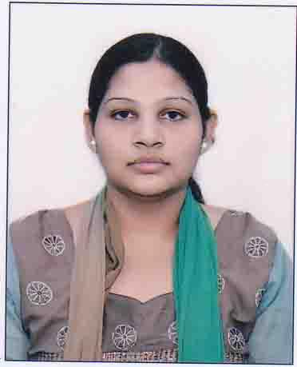
House Number 747, Street Number-6,
Jwala Nagar Shahdara Delhi-110032
Mobile No-9911327012
E-Mail-honestkg2015@gmail.com

Career Objective:-
- To be part of growing and dynamic organization that offers a challenging career. I will maximize my exposure and creativity while contributing to the progress of the organization. I have enough calibers to work with any of management with full of my efforts and able to hold any kind of responsibility to forward organization beyond the limits.

Educational Qualification:-
- 10th passed from C.B.S.E. Board in 2007
- 12th passed from C.B.S.E. Board in 2009
- B.A. English Hons Delhi University 2014
- M.A. English from IGNOU.

Professional Qualification:-
- Basic Computer Course
- CTET (CBSE)
- HTET
- Diploma in Education from Board of Secondary Education M.P.
- B.Ed. from K.U.K

EXPERIENCE
- 8 Months experience of working as assistant teacher primary in Angels Public School, Vishwas Nagar, Delhi.
- 01 year experience of working as PRT in Kendriya Vidyalaya, Vigyan Vihar Delhi.
- 02 years experience of Working in Vivekanand Public School, Anand Vihar.
- Presently working in Modern school, Vaishali as TGT English since April'2017.

Hobbies:-

Listening Music, Reading Newspaper etc

Personal Details:-

Date of Birth | : | 20 th Dec 1991
Husband's Name | : | Mr. Tanuj Singhal
Gender | : | Female
Marital Status | : | Married
Nationality | : | Indian
Religion | : | Hindu
Languages Known | : | Hindi, English
Hobbies | : | Reading Book, Listening Music

Declaration:-

I do here by declare that all statement above is true to the best of my knowledge and belief.

Place:-Delhi

Date: (Komal Gupta)

