SHASHI BHUSHAN
E-Mail: shashibhushan31@yahoo.com
Mobile: +91-9599231342
New Delhi, India.
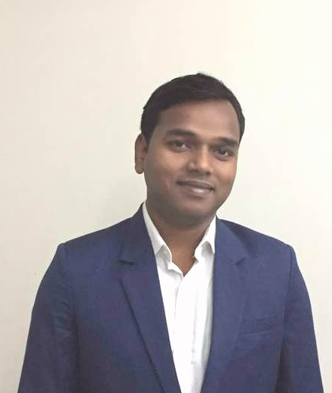

PROFESSIONAL ABRIDGEMENT

- Currently associated with SBS International as Business Development Manager for exports unit in Myanmar (Sales & Marketing).
- More than 8 years of experience in handling a diverse range of sales & marketing functions entailing Institutional Sales, Project Sales, Business development, and Key account Management, Key Initiative Planning & Brand Approval Management, New Product Launch, Maintaining Relationship with Business Associates.
- A keen planner, strategist & implementer with demonstrated abilities in devising sales & marketing activities and accelerating the business growth.
- An effective communicator with excellent relationship building & interpersonal skills. Strong analytical, problem solving & organizational abilities.
- Proficient in handling a team effectively.

PROFESSIONAL EXPERIENCE

Since April’17 – Till date with SBS International, New Delhi-Myanmar.

KEY DELIVERABLES: As Business Development Manager

- Managing business development and marketing strategies for the company comprising various products (Wires & Cables, MCB, MCCB, RCCB, domestic machine, and incense stick).
- Key Account Management: Enhancing the relationship with Key Customers to generate the maximum possible turnover.
- Target Oriented: Achieving assigned goals and turnover for the company.
- Business Development: Formulating strategies to expand the sustainable business across Myanmar.
- Operation Management: Establish operational process to be followed and reviewing frequently to improve the efficiency.
- Customer Relationship Management: Developing relationship with key influencers to leverage in business expansion.
- New Product Launch: Handling new product launch and managing the entire process of establishment to maximize the product sale.
- Market Analysis: Analysing the market dynamics and thereby planning future requirements.
- Negotiation: Negotiating with vendors to crack the best deal as per the existing market scenario.
- Supervising the entire chain of Import to eliminate the possible errors and to reduce the lead period of consignment.
- Leadership: Overviewing and guiding the subordinates to utilize the maximum potential.

ACHIEVEMENTS

- Successfully launched new products “Paramount Cables” and “Reko Machines”.
- Established Paramount Cables and machines across Myanmar through aggressive sales plan within short period of time.
- Successfully build a skilled team across Myanmar to handle the operation and sales.
- Curbed the illegitimate or fake product of our brand from market through legal process which was hampering the sales.
- Achieved assigned annual target allocated by company across various segments.
- Acquired various government certification required to participate in government tenders.
- Added new products in local market like “Spices” to company’s portfolio.

Since April’11- March’17 with Dalmia Cement Bharat Ltd, India (Sales & Marketing).

Growth Path:
Deputy Manager Apr’15 - March’17
Assistant Manager Apr’12 - March’15
Management Trainee Apr’11-March’12

KEY DELIVERABLES: As Deputy Manager, Karnataka, India.

(Apr’11-till date)
- Managing overall sales & marketing operations for South Karnataka & Goa.
- Initiating and developing relationships with key Institutional clients to get bulk business.
- Managing Project Sales for Large scale Builders, Infrastructure and Govt. Projects.
- Maintaining relationship with Project Consulting firms thereby generating new leads of upcoming projects.
- Developing several business associates to leverage the relationship in prestigious projects.
- Managing annual contracts for Key Clients to enter into MoU.
- Managing Industry dynamics by maintaining relationship with key industry influencers.
- Assessing requirements & conducting negotiations for delivering of products at proper pricing to Key Institutional clients.
- Planning and implementing strategies for growth in the region.
- Gathering and managing market information, competition etc. and accordingly implementing marketing plans.
- Coordinating with the marketing team to implement marketing schemes in the region and ensuring the return on investment.
- Managing major Government Tender with proper documentation required for bidding.
- Product specification approval for major projects/key customers.
- Operationally managing logistics to ensure on time service.
- Conducting technical seminars for customers.

ACHIEVEMENTS

- Awarded as “Best Key Account Manager of the year” for FY 2014-15.
- Increased the volume by two folds in existing market through aggressive acquisition of key accounts.
- Successfully reduced the outstanding in the market and collected major amount of pending C- Forms.
- Effectively improved the service levels which was one of the major factor affecting sales & customer’s satisfaction level.
- Increase the customer base substantially and hence move away from dependency on few customers.
- Devised and established new procedures & systems to streamline the operations.
- Consistently over achieved the targets set by the organization.
- Nominated for “Best Management Trainee – Group” in the year 2012-2013.
- Acquired highest brand approvals in the year 2014-15 by conducting planned events which includes architect, consultants and key influencers.
- Successfully participated in major Govt. tenders and thereby generating huge volume.

ACADEMIA

2011 MBA (Marketing) from ICFAI Hyderabad, India.

2009 B.Sc. Honours in Zoology from Hindu College, Delhi University, Delhi.

2005 XII in Science (86.4%) from K V Kusmunda, Chhattisgarh, India.

2003 X from K V Kusmunda (84.2%), Chhattisgarh, India.

SUMMER INTERNSHIP PROGRAM (MBA)
Organization: Gujrat Cooperation Milk Marketing Federation Ltd. (GCMMF), AMUL.
Title: Study of Amul Beverage Market In Hyderabad.
Objectives: 1) To find out the penetration level of Amul Beverage in Hyderabad.
2) To find out various factors influencing the buying decision of retailers.
3) Study on 4Ps of AMUL Beverages.

EXTRA-CURRICULAR ACTIVITIES

- Played in National level of football conducted by K V Sangathan in the year 2005.
- Played in National level of athletics conducted by K V Sangathan in the year 2001.
- Active member of EARTHLINGS’ SOCIETY working for wild life, Hindu College, DU.

PERSONAL DOSSIER

Date of Birth : 16 April, 1988.

Language Proficiency: English & Hindi.

I hereby affirm that the information in this document is accurate and true to the best of my knowledge.

