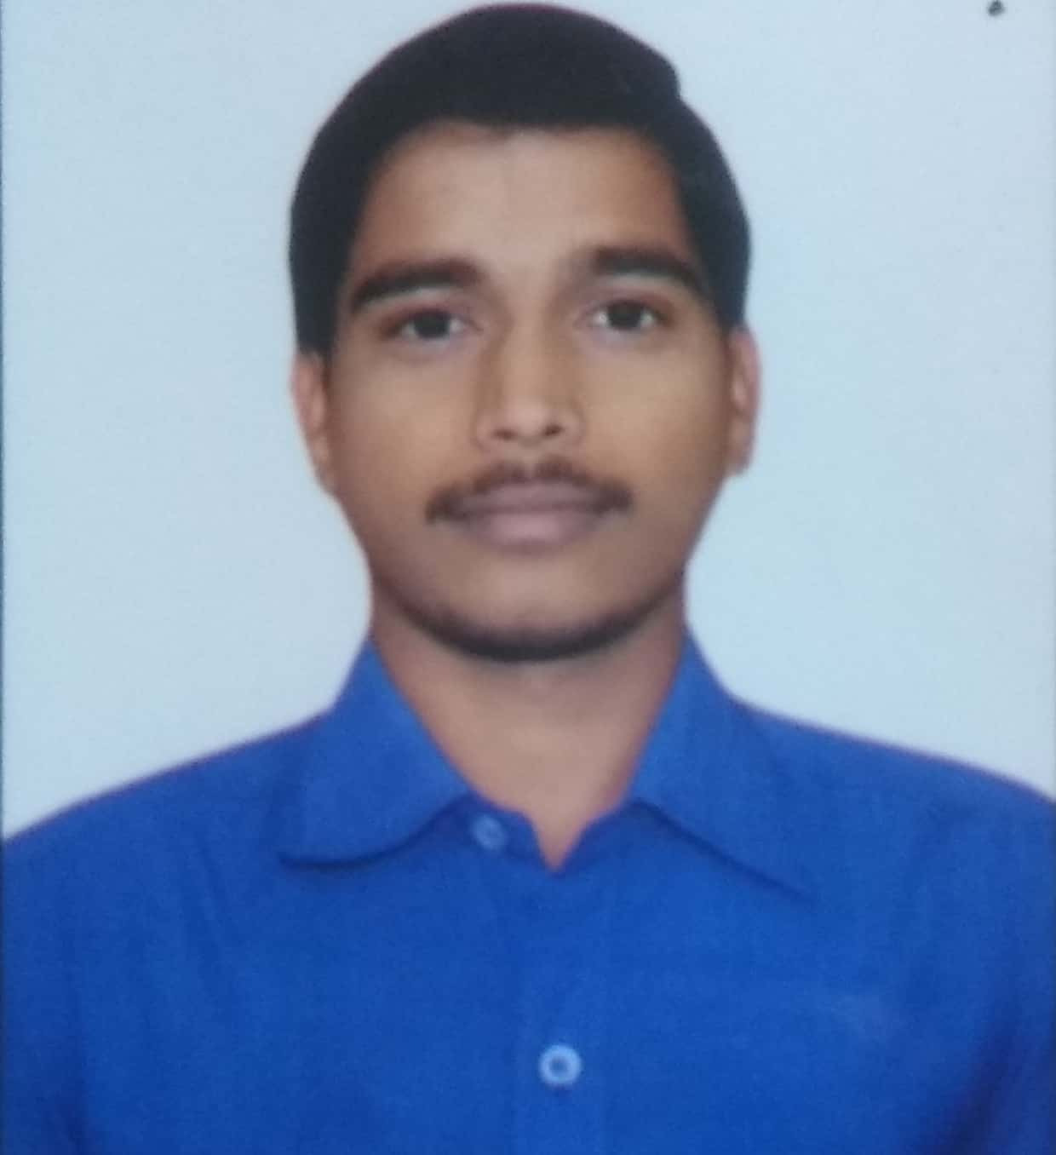

**EDUCATION**

**EVALUATION**

* B.Tech (MINING ENGINEERING) in FIRST CLASS WITH DISTINCTION with aggregate of 73.41% under JNTUH, TELANGANA .
* Intermediate (MPC) with 91.3% under Board of Intermediate Education A.P.
* SSC with 88% under Board of Secondary Education A.P.

**D.VAMSHI KRISHNA**

**INFORMATION**

**EXPERIENCE**

30.08.1996

9553646648,8317675499

d.vamshikrishna30@gmail.com

Godavarikhani

* One year opencast experience in Neyveli lignite corporation from 12.03.2018 to 15.03.2019.
* Knowledge on drilling and blasting , surveying , mine planning ,shovel dumper combination.
* FIRST AID certificate from St.John Ambulance(India).
* Eligible for Second class mines manager's certificate restricted to open cast under CMR 2017.

**SKILLS**

* **Languages:**

Telugu ,english.

* **Interests:**

Cricket, music

**ACTIVITIES**

* Visited Medipally Open Cast Project ,OCP -1 ,GDK-7LEP in Ramagundam.
* Participated in many mining techincal events during accodamics
* Good people management and communication skills. Team player.
* Able to work under high pressure and time limitation.
* Be elegant and with nice personality.
* With good managerial skills and organizational capabilities.