CURRICULUM VITAE

**DHANANJAY KUMAR VISHWAKARMA** 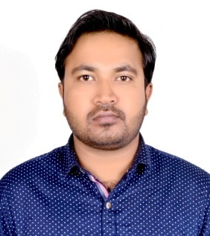

**B.E (Mining Engineering)**

**Mob. No** :- 7355976920

**E-Mail Id**:- dkv0208@gmail.com

**Address: -** Boring Camp, Ghatotand,

Ramgarh:- 825314

Jharkhand

OBJECTIVE

Looking for a challenging career which demands the best of my professional ability in terms of technical and analytical skills, and helps me in broadening and enhancing my current skill and knowledge.

ACADEMIC QUALIFICATION

|  |  |  |  |  |
| --- | --- | --- | --- | --- |
| **Name of Exam** | **Name of Board/University** | **Name of School/Collage** | **Years of Passing** | **Percentage(%)** |
| 10th(SSE) | CBSE | Holy Cross School, Ghatotand | 2009 | 73.50 |
| 12th(SSCE) | CBSE | Tata DAV Public School, Ghatotand | 2011 | 70.67 |
| B.E (MINING) | Nagpur University | RCERT, Chandrapur | 2016 | 64.47 |

CERTIFICATION

* Valid Gas Testing Certificate.
* Valid First Aid Certificate (Medallion)
* Valid Second Class Manager’s Certificate.
* 1 Year PGPT Experience Certificate.
* 1 Year & 6 Month Job Experience

PROJECT DETAILS

* Environment Impact of Blasting in Open Cast Mines.

EXTRA CURRICULAR ACTIVITIES

* I have successfully completed 1 Month “PRACTICAL TRAINING” at Manna Incline(U/G) under WCL,CHANDRAPUR.
* I have successfully completed 1 Month “PRACTICAL TRAINING” at Sarubera(E) Colliery(U/G) under CCL, RANCHI.
* I have successfully completed 1 Year Experience as Trainee “ POST GRADUATE PRACTICAL TRAINING” at Manna Incline(U/G) under WCL,CHANDRAPUR(MAHARASTRA).
* I have successfully completed 1 Year & 6 Month Experience as Asst. Manager in “MATASUKH LIGNITE MINES” NAGAUR(RAJASTHAN).

KEY SKILL

* High level of professionalism
* Active listener
* Confident

TECHNICAL SKILLS

* Operating System:- WINDOWs XP/7/8
* MS-Office (Excel,Word & Power-Point)

CERTIFICATION

* Knowledge in Computer.
* I also participated in “POSTER COMPETITION” organized by ‘ISTE STUDENTS‘ Chapter RCERT, Chandrapur.

PERSONAL DETAIL

* **Father Name** :- Ram Samuj Vishwakarma
* **Date of Birth** :- 30th May, 1989.
* **Hobbies**: - Painting & Sketching.
* **Strengths**: - Honest & Hardworking, Willingness to learn, Good Communication Skills.
* **Language Proficiency**:- English, Hindi.
* **Marital Status**:- Single.

DECLARATION

I Hereby Declare That the Information Given Above is True to the Best of My Knowledge & Brief.

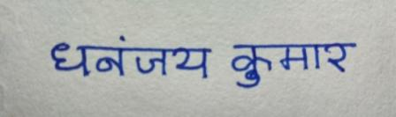

DHANANJAY KUMAR VISHWAKARMA