**PUNNA BHARATH**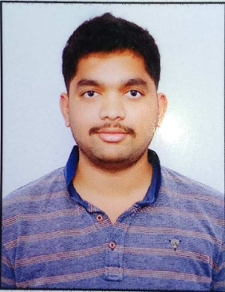

**S/O SREENIVAS.**

**Address:**

H.No:2-67

Vill &Mondal:Vemulapally, ContactNo: **9542224933**

Dist: Nalgonda **7780330274**

508217. E-mail:**bharathpunna1997@gmail.com**

|  |
| --- |
| **CAREER OBJECTIVE :** |

Seeking position in an organization where I can explore my knowledge and skills like problem solving ability, team work in an environment that offers professional competence, constant growth and hope to grow along with the organization.

|  |
| --- |
| **ACADEMIC QUALIFICATIONS:** |

|  |  |  |  |  |
| --- | --- | --- | --- | --- |
| **Qualification** | **University** | **Name of the Institution** | **Tenure** | **Percentage**  **(%)** |
| **B.Tech**  **(MINING ENGINEEING)** | Jawaharlal Nehru Technological University HYD | MallaReddy Engineering College  Hyderabad. | 2015-19 | **9.12 CGPA** |
| **Intermediate**  **(M.P.C)** | Board of Intermediate Educatio | Sri chaitanya junior kalasala,  Ranga Reddy | 2013-15 | **94.7 %** |
| **SSC** | Board of Secondary Educatiion | Chaitanya high school,  Miryalaguda | 2013 | **9.2 CGPA** |

.

|  |
| --- |
| **PERSONALITY TRAITS:** |

* Positive Attitude: Creating a positive work environment.
* Goal oriented: Results achiever, Meeting deadlines.
* Highly motivated and eager to learn new things.
* Ability to produce best result in pressure situation.

|  |
| --- |
| **PROJECT:** |

* **MINOR PROJECT: MINE VENTILLATION SYSTEM IN UNDERGROUND**
* **MAJOR PROJECT: WORKABILITY COMPARISON OF BORD AND PILLAR WITH SDL'S VERSUS BORD AND PILLAR WITH SHORTWALL AND BORD AND PILLAR WITH CONTINUOUS MINER**

|  |
| --- |
| **PERSONAL PROFILE:** |

* **Name**  : P.BHARATH
* **Father’s Name**  : P.SREENIVAS
* **Mother's name** : P.SREELATHA
* **Date of Birth** : 02-10-1997
* **Nationality**  : Indian
* **Marital Status** : Single
* **Gender**  : Male
* **Languages Known** : English, Telugu.
* **Hobbies** :Reading books, Listening music
* **Address**  : H.No-2-67 Vemulapally, Nalgonda,Telangana

|  |
| --- |
| **DECLARATION:** |

* I hereby solemnly declare that the above provided information is true to the best of my knowledge and bear the responsibility for the correctness of it.

Place: Hyderabad **(Punna Bharath)**