|  |  |  |  |  |
| --- | --- | --- | --- | --- |
|  |  | | | |
|  | |  | | |
| Project: | | Auto-Learn | | |
| Team No.: | | Team 2 | | |
| Class: | | CSE 3310.004 - Spring 2020 | | |
| Module: | | System Requirements Analysis (SRA) | | |
| Deliverable: | | SRA Document | | |
| Version: | | [1.5] | Date: | [03/31/2020] |

Contributors:

Edrik Aguilera

William Anderson

Ryan Laurents

Jonathan Padilla

Revision History

| Version number | Date | Originator | Reason for change | High level description of changes |
| --- | --- | --- | --- | --- |
| 1.0 | 03/05/2020 | Edrik Aguilera  William Anderson  Ryan Laurents  Jonathan Padilla | Initial draft |  |
| 1.1 | 03/09/2020 | Ryan Laurents | Section 4 | Added System requirements |
| 1.2 | 03/23/2020 | Edrik Aguilera | Section 5 | Conceptual data model added |
| 1.3 | 03/25/2020 | Edrik Aguilera  William Anderson | Section 5 and 3 | CDM updated, context diagram added |
| 1.4 | 03/27/2020 | Edrik Aguilera  William Anderson | Section 2 updated,  Section 3 updated | Context diagram updated, additional business and system requirements added |
| 1.5 | 03/28/2020 | William Anderson | Convert to docx | Move SRA from Google Docs to Microsoft Word |

TABLE OF CONTENTS

1. Introduction and Project Overview 3

2. Objectives 4

2.1 BUSINESS Objectives 4

2.2 SYSTEM Objectives 5

3. Project Context Diagram 6

4. Systems Requirements Error! Bookmark not defined.

4.1 “Home Screen” Requirements **Error! Bookmark not defined.**

4.2 “Login” Requirements **Error! Bookmark not defined.**

4.3 “Search” Requirements **Error! Bookmark not defined.**

4.4 “Member Registration” Requirements **Error! Bookmark not defined.**

4.5 “Buy/Sell/Lend/Exchange” Requirements **Error! Bookmark not defined.**

4.6 “Form Club” Requirements **Error! Bookmark not defined.**

4.7 “Advertisement” Requirements **Error! Bookmark not defined.**

5. Software Processes and Infrastructure 7

5.1 Hardware and Infrastructure 24

5.2 UML Diagrams 25

5.3 Conceptual Data Model - Database 25

5.4 Screen Shots 25

5.5 Test Plan 25

6. Assumptions and Constraints 26

6.1 ASSUMPTIONS 26

6.2 CONSTRAINTS 26

6.3 Out of Scope material 26

7. Delivery and Schedule 27

8. Stakeholder Approval Form 28

Appendix: 29

# 1. Introduction and Project Overview

Team 2 has been employed to design and implement a software application for vehicle recognition. This Android application should allow their customers to upload their own photo or allow for a photo to be taken using the camera. The system will be up and operational during the last week of April 2020 just in time for new vehicles coming out for the 2021 model year. In addition to the minimum set of requirements listed below, Auto-Learn is open to any suggestions that end-users would like to see implemented in the app.

# 2. Objectives

## 2.1 BUSINESS Objectives

The following is a list of business objectives:

**Objective 1**: Member Registration: All members must provide the following information prior to using the system:

* First Name, Last Name
* Member ID
* Email address
* Password
* Phone number

**Objective 2**: Login functionality: All members must login to the system with a user/password that was established during Member registration stage.

**Objective 3**: “Account Maintenance” functionality must be supported that allows user to close account and edit personal information and includes the following customer data:

* First Name, Last Name
* Email
* Password
* Phone number

**Objective 4**: The user can request classification of up to six different types of Vehicles

* SUV
* Truck
* Coupe
* Convertible

**Objective 5:** The user must be able to view data and statistics of each classification

**Objective 6:** The user must be able to upload their own photo or take a photo using

the device’s camera for image recognition

**Objective 7:** The user must be able to recover their password or username in the event of

unauthorized access or loss of credentials

.

## 2.2 SYSTEM Objectives

The following is a list of system objectives:

**Objective 1**: System will be an Android application

**Objective 2**: Python will be used to implement machine-learning.

**Objective 3:** Firebase will be used to manage login credentials.

**Objective 4:** Java will be used in conjunction with Android Studio in order to develop the

UI of the app.

**Objective 5:** Google’s Material Design will be used as the UI theme of the app

**Objective 6:** App will save data and results for 6 different classifications to keep data persistent only until the app closes

# 3. Project Context Diagram

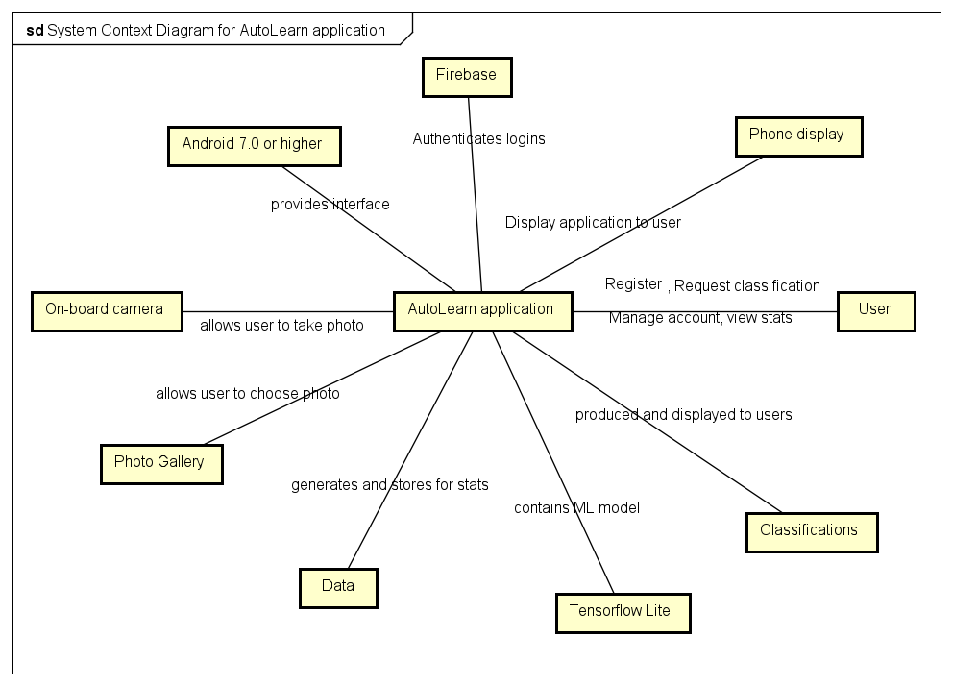

# 4. Systems Requirements

## 4.1 “Login” Requirements

|  |  |
| --- | --- |
| **Requirement Title:** | Sign Up |
| **Sequence No:** | 01 |
| **Short description:** | Allow a new user to sign up for an account. |
| **Description:** | The “Sign Up” button will be located near the bottom of the login screen. Clicking the button will take the user to an Account Creation page. The user will be prompted for the following information:   * Email Address * Password * Confirm Password |
| **Pre-Conditions**: | The user has successfully downloaded the AutoLearn app from the Google Play store and has launched the app. |
| **Post Conditions:** | Logs in the user and navigates them to the home page. The system will automatically send the user a confirmation email to the email address they provided upon signing up. |
| **Other attributes:** | The login system will error check the password and confirm password fields to ensure that they match. The system will also check to make sure the email address entered is a valid email address. |

|  |  |
| --- | --- |
| **Requirement Title:** | Login |
| **Sequence No:** | 02 |
| **Short description:** | Allow a user to log into their account. |
| **Description:** | The login page will display an “Email” entry field and a “Password” entry field. The user can type in their email address and password they provided upon signing up to login to their account. |
| **Pre-Conditions**: | The user has successfully downloaded the AutoLearn app from the Google Play store and has launched the app. |
| **Post Conditions:** | Logs in the user and navigates them to the home page. |
| **Other attributes:** | The login system will check the email and password to make sure they match a corresponding profile in the database. |

|  |  |
| --- | --- |
| **Requirement Title:** | Reset Password |
| **Sequence No:** | 03 |
| **Short description:** | Allow a user to request a password reset. |
| **Description:** | There will be a “Forgot Password?” button at the bottom of the login screen. Clicking this button will prompt the user for their email address. The system will then reset the password for the account associated with that address and send an email to the user with the new password. |
| **Pre-Conditions**: | The user has successfully downloaded the AutoLearn app from the Google Play store and has launched the app. The user must already have an account with AutoLearn. |
| **Post Conditions:** | The user will stay on the login screen and can enter their new password to gain access to their account. |
| **Other attributes:** | The system will send the confirmation email for the password reset to the user. The email will contain the new password that will allow them to login. |

|  |  |
| --- | --- |
| **Requirement Title:** | AutoLearn Logo |
| **Sequence No:** | 04 |
| **Short description:** | Display the AutoLearn logo on the login screen. |
| **Description:** | The login screen will display the logo above the email and password entry fields. |
| **Pre-Conditions**: | The user has successfully downloaded the AutoLearn app from the Google Play store and has launched the app. |
| **Post Conditions:** | N/A |
| **Other attributes:** | N/A |

## 4.2 “Home Screen” Requirements

|  |  |
| --- | --- |
| **Requirement Title:** | Home Screen |
| **Sequence No:** | 01 |
| **Short description:** | The home screen is the central hub for all the actions a user can take inside AutoLearn. |
| **Description:** | The home screen will display buttons that navigate to all of the subsections of the app. The home screen will also display the users statistics as the main function of the screen. If the user does not have any classifications yet, the home screen will display “Upload a picture to try out AutoLearn!” After completing one classification, the home screen will display all statistics available to the user. The subsections shown as buttons are the following:   * Settings (In the top left) * Profile (In the top right) * Take Photo (In the bottom left) * Upload Photo (In the bottom right) |
| **Pre-Conditions**: | The user must successfully login to their user account. |
| **Post Conditions:** | N/A |
| **Other attributes:** | N/A |

|  |  |
| --- | --- |
| **Requirement Title:** | Statistics |
| **Sequence No:** | 02 |
| **Short description:** | Statistics will be shown on the home screen. |
| **Description:** | When the user first launches the app and creates a profile, there will be no statistics to show. Instead there will be a message to the user to try out the classification service first. Once the first classification has been done, statistics will automatically populate the home screen. Statistics such as:   * Accuracy * Average time to classify   Since accuracy will rely on the user to give us that information, there will be a pop-up after each classification asking if the information was correct. That response will go into the accuracy section of the statistics. |
| **Pre-Conditions**: | The user must be logged in to their account and have performed at least one classification. |
| **Post Conditions:** | N/A |
| **Other attributes:** | N/A |

## 4.3 “Settings” Requirements

|  |  |
| --- | --- |
| **Requirement Title:** | Settings Menu |
| **Sequence No:** | 01 |
| **Short description:** | The settings tab will show information about the app as well as some app-based settings options. |
| **Description:** | Pressing the settings button (3 horizontal lines) on the top left of the home screen will expand the settings menu. Within the settings menu there will be several options:   * Preferences * Model Information * Exit AutoLearn |
| **Pre-Conditions**: | The user must be logged in to their account and have pressed the settings button on the home screen. |
| **Post Conditions:** | The settings menu will expand out from the left side of the screen. |
| **Other attributes:** | N/A |

|  |  |
| --- | --- |
| **Requirement Title:** | Preferences |
| **Sequence No:** | 02 |
| **Short description:** | Preferences is an option within the settings menu that will allow the user to pick user-specific settings. |
| **Description:** | Pressing the preferences button will take the user to a “Preferences” screen. Within this screen there will be options such as:   * Light mode or Dark mode * Automatically send emails with details from each classification   At the bottom of this screen there will be an “Update Preferences” button that will save the settings and close the preferences page, which will take the user back to the settings menu. |
| **Pre-Conditions**: | The user must be logged into their account. The user must have also pressed the settings menu button as well as the preferences button within that menu. |
| **Post Conditions:** | The user will be back at the settings menu after updating their preferences. |
| **Other attributes:** | N/A |

|  |  |
| --- | --- |
| **Requirement Title:** | Model Information |
| **Sequence No:** | 03 |
| **Short description:** | The “Model Information” button will show info on the creation of the model used for classification. |
| **Description:** | Pressing the model information button will bring the user to an info screen. The information will include:   * Team members * Model info   There will also be a “Close” button near the bottom of the screen. Pressing the close button will bring the user back to the settings menu. |
| **Pre-Conditions**: | The user must be logged into their account. They must also press the settings menu button as well as the model information button. |
| **Post Conditions:** | The user will be back on the settings menu screen when done. |
| **Other attributes:** | N/A |

|  |  |
| --- | --- |
| **Requirement Title:** | Exit AutoLearn |
| **Sequence No:** | 04 |
| **Short description:** | Press the exit button to close the application. |
| **Description:** | Pressing this button will close the application. It will also have the same effect as logging the user out of their profile at the same time. The user would need to re-login the next time they launch the application. |
| **Pre-Conditions**: | The user must be logged into their account. They must also press the settings menu button and hit “Exit” within that menu. |
| **Post Conditions:** | The application will be closed. |
| **Other attributes:** | N/A |

## 4.4 “Profile” Requirements

|  |  |
| --- | --- |
| **Requirement Title:** | View Profile |
| **Sequence No:** | 01 |
| **Short description:** | Clicking the “Profile” button will show the user their account information. |
| **Description:** | Clicking the “Profile” button will take the user to a seperate profile page. This page will list the following information:   * Email address * Name (optional) * Phone number   In the top left of the profile page there will be a back arrow to return to the home screen. Near the bottom of the page there will be 2 buttons. An “Edit Profile” button and a “Change Password” button. |
| **Pre-Conditions**: | The user must be logged into their account. They must also have clicked the “Profile” button on the home screen. |
| **Post Conditions:** | The user will now be on the “Profile” page. |
| **Other attributes:** | N/A |

|  |  |
| --- | --- |
| **Requirement Title:** | Edit Profile |
| **Sequence No:** | 02 |
| **Short description:** | Clicking the “Edit Profile” button will allow the user to update their profile information. |
| **Description:** | While in “Edit Profile” mode the test boxes that contain their information will be editable. Two new buttons will appear near the bottom of the screen, “Cancel” and “Confirm Changes.” Clicking “Cancel” will take the user back to the Profile page while not saving any changes. Clicking “Confirm” will also take the user back to their profile page but will save all changes made. |
| **Pre-Conditions**: | The user must be logged in to their account and have pressed the profile button on the home screen. Within the profile page they must press the “Edit Profile” button. |
| **Post Conditions:** | The user will be able to edit their profile until they hit either “Cancel” or “Confirm Changes”, at which point they will be returned to the Profile page. |
| **Other attributes:** | This process will need to verify that the updated email address is valid. |

|  |  |
| --- | --- |
| **Requirement Title:** | Change Password |
| **Sequence No:** | 03 |
| **Short description:** | This function allows the user to change their password. |
| **Description:** | Due to the sensitive nature of a password, it will not be visible on the profile page. To change or update your password you must hit the “Change Password” button located near the bottom of the Profile page. When pressed, a pop-up will ask you for your current password and to confirm that password. If both entry fields match each other as well as the database information, the pop-up will ask the user to enter a new password. The pop-up will have a “Cancel” button as well as a “Next” button. The Cancel button will take the user back to their profile page. The Next button will move the user forward through the process. |
| **Pre-Conditions**: | The user must be logged in to their account and have pressed the Profile button on the home screen. They must also press the “Change Password” button within the Profile page. |
| **Post Conditions:** | When the user has completed the pop-up prompts for changing password, they will be back on the Profile page. |
| **Other attributes:** | The system will send a verification email to the user to confirm that the password change has taken effect. |

|  |  |
| --- | --- |
| **Requirement Title:** | Back |
| **Sequence No:** | 04 |
| **Short description:** | The back arrow will take the user back to the home screen. |
| **Description:** | Pressing the back arrow located at the top left corner of the Profile page will take the user back to the home screen. |
| **Pre-Conditions**: | The user must be logged in to their account and have pressed the Profile button on the home screen. |
| **Post Conditions:** | The user will be on the Home Screen. |
| **Other attributes:** | N/A |

## 4.5 “Take Photo” Requirements

|  |  |
| --- | --- |
| **Requirement Title:** | Take Picture |
| **Sequence No:** | 01 |
| **Short description:** | Pressing the “Take Photo” button will open the users camera to take a new photo for classification. |
| **Description:** | The “Take Photo” button will have a picture of a camera on it and will be located in the bottom left of the home screen. Pressing this button for the first time will ask the user for permission/access to the camera. If permission is given, instructions will be shown. The instructions will be as follows:   * Please capture the full automobile in the photograph. * Make sure there is sufficient lighting. * Try to keep your phone parallel with the ground to reduce angle.   The user must hit the “Okay!” button on the pop-up. That will open the camera where the user can take a photograph. Once the photo is taken the classification process will start automatically. |
| **Pre-Conditions**: | The user must be logged in to their account. |
| **Post Conditions:** | The classification process starts immediately after taking a picture. |
| **Other attributes:** | Must prompt the user for permissions to access the camera. |

## 4.6 “Upload Photo” Requirements

|  |  |
| --- | --- |
| **Requirement Title:** | Upload Photo |
| **Sequence No:** | 01 |
| **Short description:** | The “Upload Photo” button will open the users gallery to select a photo to upload. |
| **Description:** | The “Upload Photo” button will have the standard android gallery picture on it and will be located in the bottom right of the home screen. Pressing this button for the first time will ask the user for permission/access to the gallery. If permission is given, the user will be taken to the gallery.  They will be able to navigate their folders to select one (1) image to submit for classification. Once selected, they must hit the “Submit” button. Once the submit button is pressed the system will immediately begin the classification process. |
| **Pre-Conditions**: | The user must be logged in to their account. |
| **Post Conditions:** | The classification process starts immediately after uploading a photo. |
| **Other attributes:** | Must prompt the user for permissions to access the gallery. |

## 4.7 “Classification” Requirements

|  |  |
| --- | --- |
| **Requirement Title:** | Classification |
| **Sequence No:** | 01 |
| **Short description:** | The classification process will use the machine learning model to determine the make/model of the vehicle in question. |
| **Description:** | Immediately after the user either takes a new photo with their camera or uploads a photo from their gallery, the classification process will begin. The photo will be input into the machine learning model. While the user is waiting for the results, they will be shown an active loading bar/circle. When the model is done with the classification process, the results will be shown to the user. On the results page, the system will prompt the user on whether or not the classification was accurate. Once the user presses either the “Incorrect” or “Correct” button they will be taken back to the home screen. Their response will be added to the “Accuracy” statistics and shown on the home screen. |
| **Pre-Conditions**: | The user must be logged in to their account and upload a photo via “Take Photo” or “Upload Photo.” |
| **Post Conditions:** | The user will end on the home screen. |
| **Other attributes:** | N/A |

# 5. Software Processes and Infrastructure

## 5.1 Hardware and Infrastructure

Android 7.0 Nougat and higher

Android SDK

Java Development Kit

Android Studio 3.6

Android Emulator / Google Pixel 3XL

Anaconda 2019.10 / Python 3.7

Jupyter Notebook

Tensorflow 2.1

Google Firebase

## 5.2 UML Diagrams

Please refer to Section 1 of the project binder. Original UML diagrams shown there.

## 5.3 Conceptual Data Model - Database

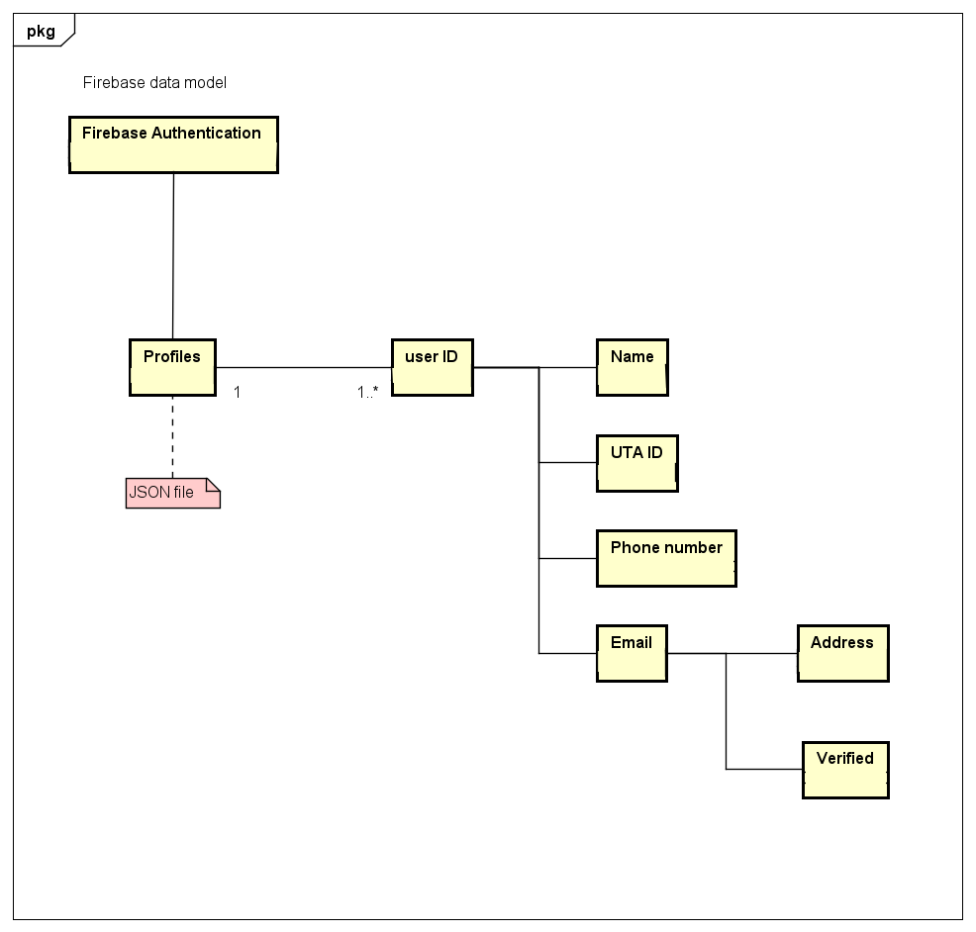

## 5.4 Screen Shots

None available at this time

## 5.5 Test Plan

Test plan will be implemented at a later time.

# 6. Assumptions and Constraints

## 6.1 ASSUMPTIONS

The following is a list of assumptions:

* Ignore collecting money from external advertisement and general accounting
* Ignore compliance issues
* Ignore market conditions and demands
* Ignore future system additions

## 6.2 CONSTRAINTS

The following is a list of constraints:

* Team lacks Android experience
* Schedule very aggressive
* Team lacks TensorFlow experience
* Team lacks Python experience
* Team has very limited Java experience

## 6.3 Out of Scope material

The following is a list of “out of scope” material:

* Post Project maintenance is not covered

# 7. Delivery and Schedule

{List all tasks/milestones from start of the project to the end with specific dates for both Anticipated Start & End Dates

|  |  |  |  |  |
| --- | --- | --- | --- | --- |
| Task/Milestone Description | Anticipated Start Date | Anticipated End Date | Status | Comments |
| Prepare Requirements and UML diagram | 01/31/2020 | 02/21/2020 | Complete | Deliverable will be UL document.  Increment 1 Deliverable |
| SRA document (Includes project objectives, Requirements and UML diagrams) | 03/05/2020 | 03/31/2020 | In Progress | Deliverable will be the SRA document. All stakeholders agree on the content of the SRA by signing in section 8.  Increment 2 Deliverable |
| Home screen design and implementation | 3/31/2020 | 04/02/2020 | To Be Completed (TBC) |  |
| Login and registration design and implementation | 03/31/2020 | 04/02/2020 | TBC |  |
| Set up Jupyter notebook for ML model | 03/31/2020 | 04/02/2020 | TBC |  |
| Import all necessary imports into Jupyter | 03/31/2020 | 04/02/2020 |  |  |
| Test case design | 03/31/2020 | 04/16/2020 |  | Increment 3 Deliverable |
| External Documentation (i.e. User Manual) | 04/20/2020 | 04/20/2020 |  |  |
| Project presentation | 04/28/2020 | 04/28/2020 |  |  |
| Final Milestone: project delivery |  | 4/30/2020 |  | Increment 4 Deliverable |

# 8. Stakeholder Approval Form

|  |  |  |  |
| --- | --- | --- | --- |
| Stakeholder Name | Stakeholder Role | Stakeholder Comments | Stakeholder Approval Signature and Date |
| Rodrigo Augusto | Development Mgr. |  |  |
| Tianhao Li | Project Assistant |  |  |
| Edrik Aguilera | Developer |  |  |
| William Anderson | Developer |  |  |
| Ryan Laurents | Developer |  |  |
| Jonathan Padilla | Developer |  |  |

# Appendix:

{Additional documents or references, if any, go here. If nothing to place in this appendix, just write “None”, do not remove appendix}