ROB501: Assignment 4 Report

Drini Kerciku | 1004750780

# Opening Remarks

For the purpose of performance evaluation of the IBVS system, the following initial camera pose is used on both test setups

$$R_{wc}=\left[\begin{matrix}4.33×{10}^{-17} & -0.809 & 0.588 \\ 0.707 & -0.416 & -0.572 \\ 0.707 & 0.416 & 0.572\end{matrix}] \right], t_{wc}=\left[\begin{matrix}-0.2 \\ 0.3 \\ -5.0\end{matrix}\right]$$

such that the rotation matrix was generated through the dcm_from_rpy(…) function with input angles $\left(ϕ, θ, ψ\right)=(\frac{π}{5},-\frac{π}{4},\frac{π}{2})$. Three of the tracked points in the workspace are initially located outside of the image plane and appear after few iterations in the simulation - the polygon defined by the tracked points performs a counter clockwise rotation during convergence to account for the change in the initial camera pose. In the following sections, we present the effects of controller gains on convergence when depths of features are known accurately versus when estimated by my code in Part 3 of Assignment 4.

# Performance Evaluation

The performance metric is based on the number of iterations it takes for the algorithm to converge and complete the simulation which will include oscillations (if present) about the desired locations of features when in the vicinity. In the simulation, we are terminating the process by comparing the magnitude of the control input with a threshold, thus increasing the gain should affect the step size we take towards the goal and reduce the time frame for convergence. It is important to note that features follow the same ‘trajectories’ for the standard gain of $0.1$ in both experimental setups as outlined earlier, which is depicted on Figure 1 and Figure 2 below.

**Figure 2.** Gain 0.1 with estimated feature depths.

**Figure 1.** Gain 0.1 with exact feature depths.

In order to provide more insight on the effects of control gains and convergence time, I tested values in the range of $[0.05;2.05]$ for both experimental setups as shown on Figure 3 and Figure 4.

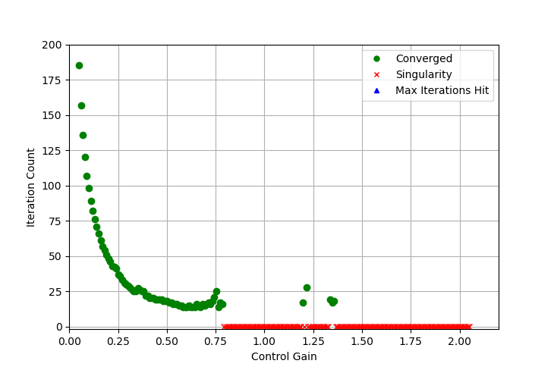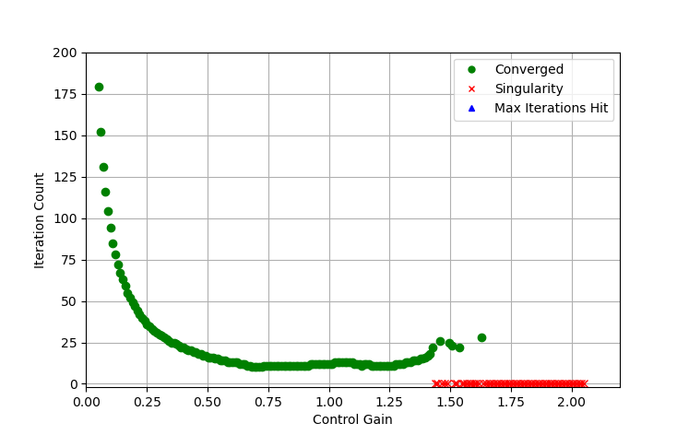

**Figure 4.** Control gain v. iteration count for estimated depths setup.

**Figure 3.** Control gain v. iteration count for exact depths setup.

The data above suggests that the performance of algorithms is approximately the same for gain values in the range of $[0.05;0.6]$ given the visual similarities in curvature and monotony in that region. After a certain gain value is reached and surpassed, the pseudoinverse computation of the Jacobian matrix within the controller module reaches a singularity, indicating that the problem becomes numerically ill-conditioned – in the graphs, results associated with singularities are denoted by red crosses. Such behaviour is observed much earlier in the performance test for the estimated depths experiment, indicating that having an accurate value of feature depths is important for numerical stability and allowance of implementing more aggressive controllers. I kept track of the gain value with the least number of iterations throughout the simulations and the results are summarized in Table 1.

|  |  |  |
| --- | --- | --- |
| **Depth Accuracy** | **Optimal Gain** | **Number of Iterations** |
| Exact | 0.68316 | 10 |
| Estimated Online | 0.58266 | 14 |

**Table 1.** Optimal control gains per feature depths accuracy.

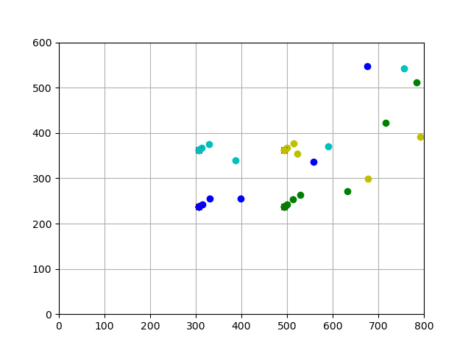It is also noticeable that the performance with exact depth values is not significantly affected by the increased control gain past the optimal value – one can observe a slight increase in the number of iterations for higher gain values prior to the problem becoming numerically unstable. The numerical instability can arise because we have a more aggressive controller and we are overshooting by a large amount the desired feature locations, resulting in a camera pose that projects features on the image plane with coordinates that ‘blow up’ our computations for future control inputs. For completeness, the convergence process for optimal controls in both experiments are depicted on Figure 5 and Figure 6 – it is noticeable that the original trajectory is not traceable due to the magnitude of the control gain and abrupt expansions/shrink of the polygon defined by features can be observed. I would also like to emphasize that a ‘friendlier’ initial camera pose might result in different optimal gains and a smaller range for values that do not result in a singular Jacobian pseudoinverse.

**Figure 6.** Optimal control convergence for exact depths.

**Figure 5.** Optimal control convergence for exact depths.