Republic of the Philippines
Department of Computer Engineering
CPP102: PROGRAMMING LOGIC AND DESIGN
PRELIMINARY EXAMINATION — WEEK 6
SET C — INSTRUCTOR'S ANSWER KEY
Mode: Pen and Paper Time Allotment: 1 hour and 30 minutes Total Points: 100
Coverage: Weeks 1–5 — Introduction to Programming and Python; Git and GitHub Fundamentals; Algorithms, Pseudocode, IPO Analysis, and Flowcharts; Variables, Identifiers, Data Types, and Type Conversion; Operators and Operator Precedence; Conditional Statements and Python Indentation
This answer key follows the same numbering and order as the student examination. It contains complete solutions, scoring guides, the detailed Part III rubric, the test blueprint, and the suggested time allocation.
PART I. MULTIPLE CHOICE — 40 points (40 items × 1 point)
Directions: Choose the letter of the best answer. Write the CAPITAL letter on the blank before each number.
_____ 1. A computer program is best described as:
A. A physical part of the computer
B. A set of instructions that a computer follows to perform a task
C. A collection of computer hardware devices
D. A document that describes computer specifications
ANSWER: B — A program is a set of instructions executed by the computer.
_____ 2. The main purpose of a programming language is to:
A. Replace the computer's operating system
B. Make computers run faster
C. Allow humans to write instructions that a computer can execute
D. Store files permanently on a hard drive
ANSWER: C — Programming languages let humans express instructions for computers.
_____ 3. In the Input–Process–Output (IPO) model, "process" refers to:
A. Displaying the final result on the screen
B. Asking the user to enter data
C. Saving the program to a file
D. Transforming the input data into the desired result
ANSWER: D — Processing transforms inputs into outputs.
_____ 4. In Python, a single-line comment begins with:
A. #
B. //
C. /*
D. <!--
ANSWER: A — Python comments start with the # symbol.
_____ 5. Which Python function displays information on the screen?
A. input()
B. display()
C. print()
D. show()
ANSWER: C — print() writes output to the terminal.
_____ 6. In Git, a repository is best described as:
A. A folder whose files and change history are tracked by Git
B. A website for downloading Python
C. A type of Python data file
D. A backup copy stored on a USB drive
ANSWER: A — A repository is a tracked folder with its full change history.
_____ 7. What does the command git add . do?
A. Creates a new repository
B. Uploads all files to GitHub
C. Deletes all files in the folder
D. Stages all changed files in the current folder for the next commit
ANSWER: D — git add . stages changes; it does not upload anything.
_____ 8. Which shows the correct order of the basic Git workflow after editing a file?
A. git push → git commit → git add
B. git add → git commit → git push
C. git commit → git add → git push
D. git push → git add → git commit
ANSWER: B — Stage first (add), then record (commit), then upload (push).
_____ 9. The main purpose of Git is to:
A. Track the versions and history of files on your computer
B. Design flowcharts automatically
C. Translate Python into machine code
D. Protect the computer from viruses
ANSWER: A — Git is a version control system.
_____ 10. Which statement about Git and GitHub is correct?
A. GitHub must be installed before Git can work
B. Git is a website, while GitHub is installed locally
C. Git manages versions locally, while GitHub hosts repositories online
D. Git and GitHub are two names for the same product
ANSWER: C — Git is the local tool; GitHub is the online hosting platform.
_____ 11. Which is an essential characteristic of a good algorithm?
A. It must be written only in Python
B. It must contain a decision symbol
C. It must run on a computer to be valid
D. Its steps are clear, ordered, and eventually end
ANSWER: D — Algorithms must be finite, ordered, and unambiguous.
_____ 12. Pseudocode is mainly used to:
A. Execute a program without a computer
B. Plan the program logic in human-readable form before coding
C. Draw the symbols of a flowchart
D. Fix syntax errors in Python
ANSWER: B — Pseudocode is a planning tool written in plain language.
_____ 13. In a flowchart, the rectangle symbol represents:
A. A decision
B. Input or output
C. A process or computation
D. The end of the program
ANSWER: C — Rectangles show processes such as computations.
_____ 14. Flowlines (arrows) in a flowchart show:
A. The direction of the program flow
B. The data type of variables
C. The number of repetitions
D. The comments of the programmer
ANSWER: A — Arrows connect symbols and show the order of execution.
_____ 15. Sequential logic means the statements are executed:
A. Only when a condition is True
B. In random order
C. Repeatedly until stopped
D. One after another in the order they are written
ANSWER: D — Sequence = top-to-bottom execution.
_____ 16. Which control structure is used when a program must choose between two possible paths?
A. Sequence
B. Selection (decision)
C. Declaration
D. Documentation
ANSWER: B — Selection/decision structures choose between paths.
_____ 17. A program computes the total price from the quantity and the unit price. In the IPO table, the inputs are:
A. The quantity and the unit price
B. The total price
C. The multiplication formula
D. The print statement
ANSWER: A — Inputs are the values supplied to the program.
_____ 18. Which of the following is a VALID Python identifier?
A. 3rd_score
B. student age
C. else
D. student_age
ANSWER: D — Identifiers cannot start with a digit, contain spaces, or be keywords.
_____ 19. The word else cannot be used as a variable name because it is:
A. Too short
B. Written in lowercase
C. A reserved keyword in Python
D. Already a built-in data type
ANSWER: C — else is a reserved keyword.
_____ 20. In Python, the identifiers Score and score are:
A. The same variable
B. Two different variables because Python is case-sensitive
C. Both invalid identifiers
D. Automatically merged by Python
ANSWER: B — Python is case-sensitive.
_____ 21. Which identifier follows the snake_case naming style?
A. final_grade
B. FinalGrade
C. finalGrade
D. FINAL-GRADE
ANSWER: A — snake_case uses lowercase words separated by underscores.
_____ 22. What is the data type of the value "True" (written with quotation marks)?
A. bool
B. int
C. str
D. float
ANSWER: C — Quotation marks make it a string, not a Boolean.
_____ 23. What is the data type of the value 100?
A. float
B. int
C. str
D. bool
ANSWER: B — 100 is a whole number, so it is an int.
_____ 24. The input() function always returns a value of type:
A. int
B. float
C. bool
D. str
ANSWER: D — input() returns text; convert with int() or float() when needed.
_____ 25. What is the result of float("7.5")?
A. 7.5
B. "7.5"
C. 8
D. An error occurs
ANSWER: A — float() converts the numeric string to the float 7.5.
_____ 26. In the expression 5 + 2 * 3, which operation is performed first?
A. 5 + 2, because Python reads from left to right
B. Nothing; Python reports an error
C. 5 * 3, because the larger numbers are multiplied first
D. 2 * 3, because multiplication has higher precedence than addition
ANSWER: D — Multiplication is evaluated before addition.
_____ 27. Which operator gives the remainder of a division?
A. //
B. %
C. /
D. **
ANSWER: B — % is the modulo (remainder) operator.
_____ 28. What is the value of 2 ** 4?
A. 8
B. 6
C. 16
D. 24
ANSWER: C — 2 ** 4 = 2 × 2 × 2 × 2 = 16.
_____ 29. Which comparison operator means "not equal to"?
A. !=
B. ==
C. <>
D. =!
ANSWER: A — != tests inequality in Python.
_____ 30. Which statement is equivalent to x = x + 5?
A. x =+ 5
B. x == 5
C. 5 += x
D. x += 5
ANSWER: D — += is the addition assignment operator.
_____ 31. What is the value of not False?
A. False
B. True
C. 0
D. An error occurs
ANSWER: B — not reverses the Boolean value.
_____ 32. In the statement amount = 250, the symbol = is called the:
A. Assignment operator
B. Equality operator
C. Comparison operator
D. Arithmetic operator
ANSWER: A — = stores a value in a variable.
_____ 33. A Boolean condition in Python can evaluate to:
A. Any whole number
B. Any text value
C. Only True or False
D. Only "yes" or "no"
ANSWER: C — Conditions produce exactly two possible values.
_____ 34. In an if-else statement, when the condition is False, the program:
A. Stops immediately with an error
B. Executes the if block anyway
C. Repeats the condition until it becomes True
D. Executes the statements in the else block
ANSWER: D — The else block runs when the condition is False.
_____ 35. The keyword elif is used to:
A. End an if statement
B. Test another condition when the previous conditions are False
C. Repeat the previous condition
D. Combine two conditions into one
ANSWER: B — elif adds an alternative condition to test.
_____ 36. In a nested if statement, the inner if is evaluated only when:
A. The inner condition is False
B. The else block runs first
C. The outer condition is True
D. The program has no other statements
ANSWER: C — The inner if is inside the outer block, so the outer condition must be True first.
_____ 37. In an if-elif-else chain, Python executes:
A. Every branch whose condition is True
B. All branches from top to bottom
C. Only the else branch
D. Only the first branch whose condition is True
ANSWER: D — Once a condition is True, the remaining branches are skipped.
_____ 38. In Python, the line if grade >= 75 must end with:
A. A colon (:)
B. A semicolon (;)
C. A period (.)
D. Nothing; no symbol is needed
ANSWER: A — Conditional headers end with a colon.
_____ 39. The statement if x = 5: produces an error because:
A. x is not a valid identifier
B. 5 must be written in quotation marks
C. = assigns a value; the comparison operator == must be used
D. if statements cannot use numbers
ANSWER: C — = is assignment; conditions need the comparison operator ==.
_____ 40. Given the condition if fare >= 20:, what happens when fare is exactly 20?
A. The condition is False because 20 is not greater than 20
B. The condition is True because >= includes equality
C. Python reports an error
D. The else block executes
ANSWER: B — >= is True at the boundary value.
Part I Checking Strip:
1-B, 2-C, 3-D, 4-A, 5-C, 6-A, 7-D, 8-B, 9-A, 10-C, 11-D, 12-B, 13-C, 14-A, 15-D, 16-B, 17-A, 18-D, 19-C, 20-B, 21-A, 22-C, 23-B, 24-D, 25-A, 26-D, 27-B, 28-C, 29-A, 30-D, 31-B, 32-A, 33-C, 34-D, 35-B, 36-C, 37-D, 38-A, 39-C, 40-B
PART II. EVALUATION AND OUTPUT TRACING — 30 points
Part II-A. Expression Evaluation — 10 points (10 items × 1 point)
Directions: Evaluate each Python expression and write the exact result. Boolean values must be written exactly as True or False.
Item | Expression | Exact Answer
1 | 16 + 4 * 2 | 24 (Multiplication first: 16 + 8 = 24)
2 | (16 + 4) * 2 | 40 (Parentheses first: 20 × 2 = 40)
3 | 30 - 12 / 4 | 27.0 (Division first: 30 − 3.0 = 27.0 (division always gives a float))
4 | 29 // 6 | 4 (Floor division keeps the whole-number quotient)
5 | 3 ** 3 | 27 (3 × 3 × 3 = 27)
6 | 82 >= 82 | True (>= includes equality (boundary value))
7 | 14 < 9 | False
8 | (85 >= 75) and (72 >= 75) | False (True and False → False)
9 | not (9 != 9) | True (9 != 9 is False; not False → True)
10 | int("18") + 5 | 23 (The string is converted to 18 before adding)
Part II-B. Program Output Tracing — 20 points (5 programs × 4 points)
Directions: Trace each Python program and write the exact output that appears in the terminal. Observe capitalization, spaces, punctuation, line order, Boolean capitalization, and decimal formatting.
Program 1:
price = 249.5
qty = 3
total = price * qty
print(f"Total: PHP {total:.2f}")
Exact output:
Total: PHP 748.50
Explanation: 249.5 × 3 = 748.5; the f-string format :.2f prints two decimal places, so 748.50.
Program 2:
score = "68"
points = int(score) + 12
print(points)
print(points >= 80)
Exact output:
80
True
Explanation: int("68") + 12 = 80; the comparison 80 >= 80 is True at the boundary. Boolean must be capitalized: True.
Program 3:
speed = 60
if speed > 60:
print("Overspeeding")
else:
print("Within limit")
print("Drive safely")
Exact output:
Within limit
Drive safely
Explanation: 60 > 60 is False (strict comparison), so the else branch runs. The last print is not indented, so it always executes.
Program 4:
kg = 7
if kg <= 3:
fee = 40
elif kg <= 8:
fee = 75
else:
fee = 120
print(f"Shipping fee: {fee}")
Exact output:
Shipping fee: 75
Explanation: 7 <= 3 is False; 7 <= 8 is True, so fee = 75. Only the first True branch executes.
Program 5:
username = "ana"
logged_in = True
if logged_in and username == "ana":
print("Welcome, ana!")
print("Loading files...")
else:
print("Access denied")
Exact output:
Welcome, ana!
Loading files...
Explanation: Both operands of and are True, so both indented statements in the if block execute, in order.
Part II-B Scoring Guide (apply per program):
Score | Description
4 | Entire output is exact.
3 | Values and logic are correct, with one minor capitalization, punctuation, spacing, or formatting error.
2 | At least half of the required output is correct.
1 | Shows a relevant partial result but contains major errors.
0 | Blank, unrelated, or completely incorrect.
PART III. PROGRAM LOGIC AND DESIGN — 30 points (one integrated problem)
Directions: Read the problem carefully, then complete the four tasks. Use the required variable names and the standard flowchart symbols discussed in class. Do NOT write a complete Python program.
Problem: Student Prelim Grade Evaluation
A program asks for a student's three quiz scores. It computes the average score. If the average is at least 75, the program displays "Passed". Otherwise, it displays "Failed". The program then shows the average and the remark.
Required variable names: quiz1, quiz2, quiz3, average, remark
Task 1 — IPO Table (6 points)
Direction: Complete the IPO table for the problem.
Input | Process | Output
quiz1, quiz2, quiz3 (the three quiz scores) | Compute average = (quiz1 + quiz2 + quiz3) / 3; if average >= 75, remark = "Passed", otherwise remark = "Failed" | average and remark
Scoring: 2 pts correct inputs; 2 pts correct average formula and passing condition; 2 pts correct outputs. Per criterion: 2 = complete and correct, 1 = partially correct, 0 = missing or incorrect.
Task 2 — Algorithm (6 points)
Direction: Write a complete numbered algorithm for the problem. Include Start and End.
Step 1: Start.
Step 2: Input quiz1.
Step 3: Input quiz2.
Step 4: Input quiz3.
Step 5: Compute average = (quiz1 + quiz2 + quiz3) / 3.
Step 6: If average is greater than or equal to 75, set remark = "Passed". Otherwise, set remark = "Failed".
Step 7: Display average and remark.
Step 8: End.
Acceptable equivalents: Steps 2–4 may be combined into one input step. Accept logically equivalent wording provided the order and logic are correct (input before computation, computation before decision, decision before output).
Task 3 — Pseudocode (8 points)
Direction: Write the pseudocode using the required variable names.
START
INPUT quiz1
INPUT quiz2
INPUT quiz3
average = (quiz1 + quiz2 + quiz3) / 3
IF average >= 75 THEN
remark = "Passed"
ELSE
remark = "Failed"
END IF
OUTPUT average
OUTPUT remark
END
Acceptable equivalents: DISPLAY instead of OUTPUT; READ instead of INPUT; ENDIF instead of END IF. Do not accept Python-only syntax (e.g., print(), input(), colons with indentation-only blocks) as a complete substitute for pseudocode. Deduct only for errors that affect the logic or required structure; do not deduct repeatedly for the same single error.
Task 4 — Flowchart (10 points)
Direction: Draw the complete flowchart using the standard flowchart symbols discussed in class. Label the decision branches as Yes and No (or True and False).
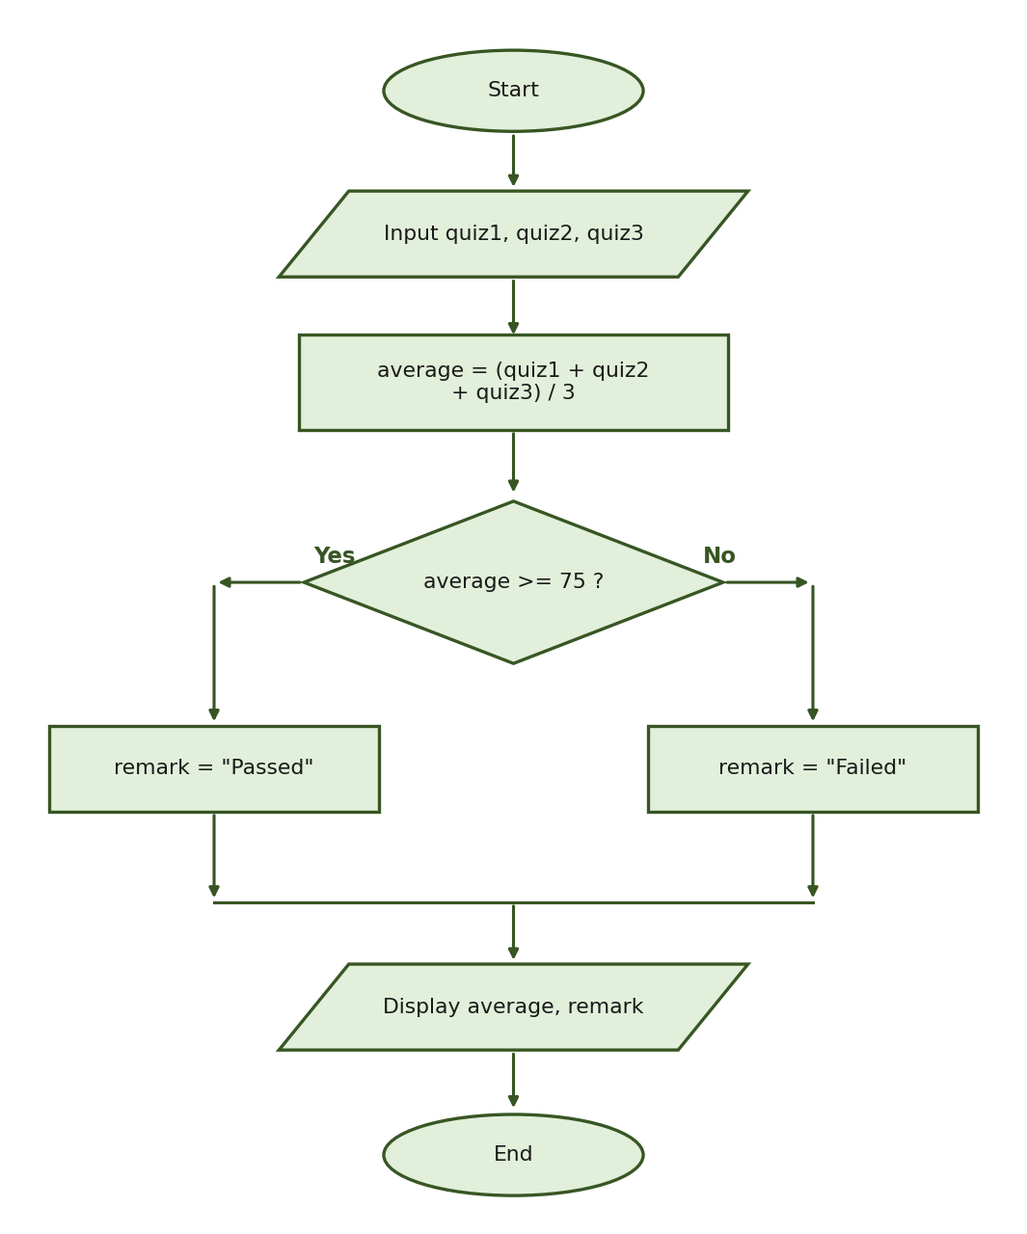
Expected computed result (using quiz1 = 82, quiz2 = 74, quiz3 = 79): average = (82 + 74 + 79) / 3 = 235 / 3 ≈ 78.33, which is at least 75, so remark = "Passed". Allow a small rounding tolerance in handwritten computations (approximately 78.33).
Part III Detailed Rubric — 30 points
Task 1 — IPO Table (6 points)
Criterion | Points
Correct inputs: quiz1, quiz2, and quiz3 | 2
Correct average formula and passing condition | 2
Correct outputs: average and remark | 2
Partial scoring per criterion: 2 = complete and correct; 1 = partially correct; 0 = missing or incorrect | —
Task 2 — Algorithm (6 points)
Criterion | Points
Includes Start and End | 1
Correctly inputs the three quiz scores | 1
Correctly computes the average | 1
Includes the correct decision condition (average >= 75) | 1
Includes both the Passed and Failed results | 1
Displays the average and remark in the correct sequence | 1
Accept different wording provided that the logic and sequence remain correct.
Task 3 — Pseudocode (8 points)
Criterion | Points
Correct START and END structure | 1
Correct input statements | 1
Correct average formula | 2
Correct IF average >= 75 condition | 1
Correct Passed branch | 1
Correct Failed branch | 1
Correct output statements | 1
Deduct only for errors that affect the logic or required structure. Do not deduct repeatedly for the same single error.
Task 4 — Flowchart (10 points)
Criterion | Points
Correct Start and End symbols (ovals) | 1
Correct input symbol (parallelogram) and entries | 1
Correct average-processing symbol (rectangle) and formula | 2
Correct decision diamond and condition (average >= 75?) | 2
Correct Passed and Failed processing branches (rectangles) | 2
Correct output symbol (parallelogram) | 1
Correct arrows and labeled decision paths (Yes/No) | 1
Flowchart Partial-Score Guide (checking guide only — apply the analytic points first):
Performance Level | Score
Complete, correct, and properly connected | 9–10
Minor symbol, label, or arrow error; logic remains correct | 7–8
Basic structure is present, but several symbols or connections are incorrect | 5–6
Partial flowchart with major logic errors | 2–4
No meaningful flowchart | 0–1
INSTRUCTOR TEST BLUEPRINT
Topic Area | Part I (items) | Part II (points) | Part III (points) | Total
Programming and Git/GitHub fundamentals | 10 | 0 | 0 | 10
Algorithms, IPO, pseudocode, and flowcharts | 7 | 0 | 30 | 37
Variables, data types, and conversion | 8 | 5 | included | 13
Operators and expressions | 7 | 13 | included | 20
Conditional statements | 8 | 12 | included | 20
Total | 40 pts | 30 pts | 30 pts | 100
Part II allocation: II-A items 1–5 and II-B Program 1 → operators and expressions (13 pts); II-A item 10 and II-B Program 2 → variables, data types, and conversion (5 pts); II-A items 6–9 → operators (comparison and logical); II-B Programs 3–5 → conditional statements (12 pts).
SUGGESTED TIME ALLOCATION (90 MINUTES)
Part | Suggested Time
Part I — Multiple Choice | 30 minutes
Part II-A — Expression Evaluation | 10 minutes
Part II-B — Output Tracing | 15 minutes
Part III — Program Logic and Design | 30 minutes
Final Review | 5 minutes
Total | 90 minutes
— END OF EXAMINATION —

