CPP102: PROGRAMMING LOGIC AND DESIGN
Week 4 Assessment Test Question Bank
Variables, Data Types, Type Conversion, and Operators
With Complete Instructor's Answer Key
Note to the Instructor
This document is an instructor's question bank. The instructor may select, revise, rearrange, or combine items to create different assessment test versions.
The question bank contains more items than a single test should include. Use the Suggested Test Combinations section at the end of this document as a starting point, or build a custom test by choosing items directly.

Topics covered: valid and invalid Python identifiers; variable declaration and assignment; data types (int, float, str, bool); type conversion using int(), float(), and str(); comments; arithmetic, comparison, logical, and assignment operators; operator precedence; input/processing/output; sequential Python programs; algorithm development; pseudocode; flowchart construction; predicting program output; and finding and correcting errors in Python code. All items use sequential programming logic only — conditional statements, loops, lists, functions, dictionaries, and file handling are not required.

SECTION A — Identifier and Variable Analysis
For items A1–A5, write VALID or INVALID for each identifier. For items A6–A10, write your complete answer in the space provided.
Item | Identifier | Difficulty | Points | VALID or INVALID
A1 | customer_name | Basic | 1
A2 | 1st_place | Basic | 1
A3 | item#price | Basic | 1
A4 | monthly income | Basic | 1
A5 | global | Basic | 1
Problem A6 — Difficulty: Intermediate — Suggested Points: 2
Explain why "grade-level" is an invalid identifier, then rewrite it as a valid identifier.
Answer:

Problem A7 — Difficulty: Intermediate — Suggested Points: 2
Explain why "5th_floor" is an invalid identifier, then rewrite it as a valid identifier.
Answer:

Problem A8 — Difficulty: Intermediate — Suggested Points: 2
Python identifiers are case-sensitive. Are "Score" and "score" the same variable? Explain your answer with a short example.
Answer:

Problem A9 — Difficulty: Intermediate — Suggested Points: 2
A payroll program will record an employee's ID number, monthly salary, number of dependents, and net pay. Suggest one appropriate and valid Python identifier for each of these four values.
Answer:

Problem A10 — Difficulty: Challenging — Suggested Points: 3
A water-billing program needs variables for: the previous meter reading, the current meter reading, the cubic meters consumed, and the total water bill in pesos. Suggest a valid identifier for each of the four values, and identify which of the four is most likely to require the float data type. Explain why.
Answer:

SECTION B — Data Types and Type Conversion
Answer each item completely in the space provided.
Problem B1 — Difficulty: Basic — Suggested Points: 1
What data type does the value 100 belong to in Python?
Answer:

Problem B2 — Difficulty: Basic — Suggested Points: 1
What data type does the value 12.5 belong to in Python?
Answer:

Problem B3 — Difficulty: Basic — Suggested Points: 1
What data type does the value "Python" belong to in Python?
Answer:

Problem B4 — Difficulty: Basic — Suggested Points: 1
What data type does the value False belong to in Python?
Answer:

Problem B5 — Difficulty: Intermediate — Suggested Points: 2
A program contains: name = input("Enter your name: "). If the user types Juan, what is the data type of name, and why?
Answer:

Problem B6 — Difficulty: Intermediate — Suggested Points: 2
A program asks for the number of hours studied and the number of pages read, then multiplies them to estimate pages per study session. Write the Python statements (with proper type conversion) so the two input values can be multiplied correctly.
Answer:

Problem B7 — Difficulty: Intermediate — Suggested Points: 2
A program has: subject = "Math" and grade = 95, then executes print(subject + grade). Explain what happens, and correct the statement so it works.
Answer:

Problem B8 — Difficulty: Challenging — Suggested Points: 3
A shopping-cart program has: qty = input("Enter quantity: ") and price = input("Enter price: "), then computes total = qty * price. Explain the error this produces, and rewrite the program so it computes correctly.
Answer:

Problem B9 — Difficulty: Basic — Suggested Points: 1
What data type does int(input(...)) always produce, as long as the user enters a valid whole number?
Answer:

SECTION C — Operators and Expression Evaluation
For items C1–C10, evaluate each expression and write the exact result. For items C11–C14, show your answer and briefly explain the order of operations where indicated.
Item | Expression | Difficulty | Points | Answer
C1 | 22 + 3 * 4 | Basic | 1
C2 | (22 + 3) * 4 | Basic | 1
C3 | 45 // 7 | Basic | 1
C4 | 45 % 7 | Basic | 1
C5 | 5 ** 3 | Basic | 1
C6 | 20 - 9 / 3 | Intermediate | 2
C7 | 15 == 15 and 4 > 9 | Intermediate | 2
C8 | not (6 <= 2) | Intermediate | 2
C9 | 3 > 9 or 10 > 1 | Intermediate | 2
C10 | 8 != 8 | Basic | 1
Problem C11 — Difficulty: Challenging — Suggested Points: 3
y = 30
y -= 12
y *= 3
print(y)

Determine the final value of y and explain the order of operations.
Answer / Explanation:

Problem C12 — Difficulty: Intermediate — Suggested Points: 2
Using Python's floor division and modulo operators, find both the quotient and the remainder when 205 is divided by 9.
Answer / Explanation:

Problem C13 — Difficulty: Challenging — Suggested Points: 3
z = 8
z += 6
z //= 2
print(z)

Determine the final value of z and explain the order of operations.
Answer / Explanation:

Problem C14 — Difficulty: Challenging — Suggested Points: 3
5 + 2 ** 3 * 2
Answer / Explanation:

SECTION D — Predict the Program Output
Study each program carefully. Write the exact output that will appear in the terminal, including capitalization, spaces, decimal places, currency symbols, and True/False values.
Problem D1 — Difficulty: Basic — Suggested Points: 2
name = "Carla"
course = "1CPE-C"
print(name)
print(course)
Expected Output:

Problem D2 — Difficulty: Basic — Suggested Points: 2
a = 14
b = 5
print(a - b)
print(a * b)
Expected Output:

Problem D3 — Difficulty: Basic — Suggested Points: 2
price = 62.25
qty = 3
total = price * qty
print(f"Total: ₱{total:.2f}")
Expected Output:

Problem D4 — Difficulty: Intermediate — Suggested Points: 2
value = "35"
result = int(value) + 10
print(result)
Expected Output:

Problem D5 — Difficulty: Intermediate — Suggested Points: 2
a = 88
b = 7
print(a // b)
print(a % b)
Expected Output:

Problem D6 — Difficulty: Intermediate — Suggested Points: 2
temp = 30
is_hot = temp > 28
print(is_hot)
Expected Output:

Problem D7 — Difficulty: Intermediate — Suggested Points: 2
has_mask = True
has_pass = False
can_enter = has_mask and has_pass
print(can_enter)
Expected Output:

Problem D8 — Difficulty: Intermediate — Suggested Points: 2
points = 200
points += 50
print(points)
Expected Output:

Problem D9 — Difficulty: Challenging — Suggested Points: 3
x = 5
y = 2
z = 3
result = x + y * z
print(result)
print(result + 2)
Expected Output:

Problem D10 — Difficulty: Challenging — Suggested Points: 3
rate = 12.5
units = 8
cost = rate * units
is_bulk = units >= 10
print(f"Cost: ₱{cost:.2f}")
print(is_bulk)
Expected Output:

SECTION E — Debugging and Code Correction
Each program below contains at least one error. Identify the error, then rewrite the program correctly in the space provided.
Problem E1 — Difficulty: Intermediate — Suggested Points: 2
unit-cost = 45
print(unit-cost)
Corrected Code and Explanation:

Problem E2 — Difficulty: Basic — Suggested Points: 2
Print("Good morning!")
Corrected Code and Explanation:

Problem E3 — Difficulty: Basic — Suggested Points: 2
course = Bachelor of Science
print(course)
Corrected Code and Explanation:

Problem E4 — Difficulty: Intermediate — Suggested Points: 2
header = "Score: "
value = 95
print(header + value)
Corrected Code and Explanation:

Problem E5 — Difficulty: Intermediate — Suggested Points: 2
length = 10
width = 6
area = length + width
print(f"Area: {area}")
Corrected Code and Explanation:

Problem E6 — Difficulty: Basic — Suggested Points: 2
raet = 8.5
hours = 4
pay = hours * rate
print(pay)
Corrected Code and Explanation:

Problem E7 — Difficulty: Intermediate — Suggested Points: 2
None = 5
print(None)
Corrected Code and Explanation:

Problem E8 — Difficulty: Challenging — Suggested Points: 3
quantity = input("Enter quantity: ")
price = 95.0
total = quantity * price
print(total)
Corrected Code and Explanation:

SECTION F — Complete the Missing Code
Fill in each blank with the correct variable name, type-conversion function, operator, or statement.
Problem F1 — Difficulty: Basic — Suggested Points: 2

Total Price of Purchased Items
qty = ______(input("Enter quantity: ")) # Blank 1
unit_price = ______(input("Enter unit price: ")) # Blank 2
total = qty ______ unit_price # Blank 3
print(f"Total Price: ₱{total:.2f}")
Write the missing code above, then state your answers here:

Problem F2 — Difficulty: Basic — Suggested Points: 2

Average of Three Test Scores
score1 = float(input("Enter first score: "))
score2 = float(input("Enter second score: "))
score3 = float(input("Enter third score: "))
average = (score1 + score2 + score3) ______ 3 # Blank 1
print(______"Average: {average:.2f}") # Blank 2
Write the missing code above, then state your answers here:

Problem F3 — Difficulty: Intermediate — Suggested Points: 3

Salary Based on Hours Worked
hours = ______(input("Enter hours worked: ")) # Blank 1
rate = ______(input("Enter hourly rate: ")) # Blank 2
gross_pay = hours ______ rate # Blank 3
print(f"Gross Pay: ₱{gross_pay:______}") # Blank 4
Write the missing code above, then state your answers here:

Problem F4 — Difficulty: Intermediate — Suggested Points: 2

Travel Distance
speed = ______(input("Enter speed in km/h: ")) # Blank 1
time = float(input("Enter travel time in hours: "))
distance = speed ______ time # Blank 2
print(f"Distance: {distance:.2f} km")
Write the missing code above, then state your answers here:

Problem F5 — Difficulty: Basic — Suggested Points: 2

Celsius to Fahrenheit Conversion
celsius = float(input("Enter temperature in Celsius: "))
fahrenheit = (celsius ______ 9 / 5) ______ 32 # Blanks 1 and 2
print(f"Fahrenheit: {fahrenheit:.2f}")
Write the missing code above, then state your answers here:

Problem F6 — Difficulty: Intermediate — Suggested Points: 2

Remaining Student Allowance
allowance = float(input("Enter weekly allowance: "))
expenses = ______(input("Enter total expenses: ")) # Blank 1
remaining = allowance ______ expenses # Blank 2
print(f"Remaining: ₱{______:.2f}") # Blank 3
Write the missing code above, then state your answers here:

Problem F7 — Difficulty: Basic — Suggested Points: 2

Area of a Rectangle
length = float(input("Enter length: "))
width = ______(input("Enter width: ")) # Blank 1
area = length ______ width # Blank 2
print(f"Area: {area:.2f}")
Write the missing code above, then state your answers here:

Problem F8 — Difficulty: Intermediate — Suggested Points: 2

Change from Amount Paid
price = float(input("Enter the price: "))
amount_paid = ______(input("Enter amount paid: ")) # Blank 1
change = amount_paid ______ price # Blank 2
print(f"Change: ₱{______:.2f}") # Blank 3
Write the missing code above, then state your answers here:

SECTION G — Full Problem-Solving Tasks
For each problem, prepare the following: an Input–Process–Output (IPO) table, an algorithm, pseudocode, a flowchart, a complete Python program, and the expected output using the given sample values. Use sequential programming logic only.
Problem G1 — Difficulty: Basic — Suggested Points: 15

Art Supplies Purchase
A student is buying materials for an art class project. The program must ask for the number of canvas boards and the price per board, the number of paintbrushes and the price per paintbrush, and the number of paint tubes and the price per tube. It must then compute and display the total purchase amount.
Given Values: Canvas boards: 3; Price per board: ₱150.00; Paintbrushes: 6; Price per paintbrush: ₱35.00; Paint tubes: 8; Price per tube: ₱45.00

1. Input–Process–Output (IPO) Table
Input | Process | Output

2. Algorithm
Write your algorithm steps here:

3. Pseudocode
Write your pseudocode here:

4. Flowchart — Use standard flowchart symbols (terminator, parallelogram, rectangle, arrow). Follow Start → Input → Process → Output → End. Do not use decision diamonds.
Draw your flowchart in this space:

5. Python Program
Write your Python program here:

6. Expected Output (using the given values)
Expected Output:

Problem G2 — Difficulty: Basic — Suggested Points: 12

Average of Three Long Test Scores
A teacher wants a program that computes a student's average score in three long tests. The program must ask for each of the three scores and display the average.
Given Values: Test 1: 82; Test 2: 77; Test 3: 90

1. Input–Process–Output (IPO) Table
Input | Process | Output

2. Algorithm
Write your algorithm steps here:

3. Pseudocode
Write your pseudocode here:

4. Flowchart — Use standard flowchart symbols (terminator, parallelogram, rectangle, arrow). Follow Start → Input → Process → Output → End. Do not use decision diamonds.
Draw your flowchart in this space:

5. Python Program
Write your Python program here:

6. Expected Output (using the given values)
Expected Output:

Problem G3 — Difficulty: Basic — Suggested Points: 10

Celsius-to-Fahrenheit Conversion
A weather-monitoring kiosk must convert a temperature reading from degrees Celsius to degrees Fahrenheit for display.
Given Values: Temperature: 15°C

1. Input–Process–Output (IPO) Table
Input | Process | Output

2. Algorithm
Write your algorithm steps here:

3. Pseudocode
Write your pseudocode here:

4. Flowchart — Use standard flowchart symbols (terminator, parallelogram, rectangle, arrow). Follow Start → Input → Process → Output → End. Do not use decision diamonds.
Draw your flowchart in this space:

5. Python Program
Write your Python program here:

6. Expected Output (using the given values)
Expected Output:

Problem G4 — Difficulty: Intermediate — Suggested Points: 15

Area and Perimeter of a Classroom Floor
A facilities officer needs a program that computes both the area and the perimeter of a rectangular classroom floor, given its length and width, to plan for tile and molding purchases.
Given Values: Length: 10.8 meters; Width: 7.4 meters

1. Input–Process–Output (IPO) Table
Input | Process | Output

2. Algorithm
Write your algorithm steps here:

3. Pseudocode
Write your pseudocode here:

4. Flowchart — Use standard flowchart symbols (terminator, parallelogram, rectangle, arrow). Follow Start → Input → Process → Output → End. Do not use decision diamonds.
Draw your flowchart in this space:

5. Python Program
Write your Python program here:

6. Expected Output (using the given values)
Expected Output:

Problem G5 — Difficulty: Intermediate — Suggested Points: 12

Tutor's Salary Based on Hours Worked
A part-time tutor is paid based on the number of hours tutored in a week. The program must ask for the number of hours tutored and the hourly rate, then compute the gross pay.
Given Values: Hours tutored: 15; Hourly rate: ₱120.00

1. Input–Process–Output (IPO) Table
Input | Process | Output

2. Algorithm
Write your algorithm steps here:

3. Pseudocode
Write your pseudocode here:

4. Flowchart — Use standard flowchart symbols (terminator, parallelogram, rectangle, arrow). Follow Start → Input → Process → Output → End. Do not use decision diamonds.
Draw your flowchart in this space:

5. Python Program
Write your Python program here:

6. Expected Output (using the given values)
Expected Output:

Problem G6 — Difficulty: Basic — Suggested Points: 10

Change from an Amount Paid at the Canteen
A school canteen cashier needs a program that computes the change to give a student, given the price of a meal and the amount the student paid.
Given Values: Price: ₱87.50; Amount paid: ₱100.00

1. Input–Process–Output (IPO) Table
Input | Process | Output

2. Algorithm
Write your algorithm steps here:

3. Pseudocode
Write your pseudocode here:

4. Flowchart — Use standard flowchart symbols (terminator, parallelogram, rectangle, arrow). Follow Start → Input → Process → Output → End. Do not use decision diamonds.
Draw your flowchart in this space:

5. Python Program
Write your Python program here:

6. Expected Output (using the given values)
Expected Output:

Problem G7 — Difficulty: Intermediate — Suggested Points: 15

Remaining Daily Allowance
A student wants to track a daily allowance. The program must ask for the daily allowance and the amounts spent on jeepney fare, snacks, and printing, then compute the amount remaining.
Given Values: Daily allowance: ₱200.00; Jeepney fare: ₱25.00; Snacks: ₱45.00; Printing: ₱30.00

1. Input–Process–Output (IPO) Table
Input | Process | Output

2. Algorithm
Write your algorithm steps here:

3. Pseudocode
Write your pseudocode here:

4. Flowchart — Use standard flowchart symbols (terminator, parallelogram, rectangle, arrow). Follow Start → Input → Process → Output → End. Do not use decision diamonds.
Draw your flowchart in this space:

5. Python Program
Write your Python program here:

6. Expected Output (using the given values)
Expected Output:

Problem G8 — Difficulty: Basic — Suggested Points: 10

Distance Covered While Jogging
A jogger wants to estimate the distance covered during a morning run. The program must ask for the average speed and the time spent jogging, then compute the distance covered.
Given Values: Speed: 6.5 km/h; Time: 1.2 hours

1. Input–Process–Output (IPO) Table
Input | Process | Output

2. Algorithm
Write your algorithm steps here:

3. Pseudocode
Write your pseudocode here:

4. Flowchart — Use standard flowchart symbols (terminator, parallelogram, rectangle, arrow). Follow Start → Input → Process → Output → End. Do not use decision diamonds.
Draw your flowchart in this space:

5. Python Program
Write your Python program here:

6. Expected Output (using the given values)
Expected Output:

Problem G9 — Difficulty: Challenging — Suggested Points: 18

Simple Interest on a Time Deposit
A bank customer wants to know how much simple interest a time deposit will earn. The program must ask for the principal amount, the annual interest rate (in decimal form), and the time in years, then compute the interest earned and the total amount after interest.
Given Values: Principal: ₱25,000.00; Rate: 0.04 (4%); Time: 3 years

1. Input–Process–Output (IPO) Table
Input | Process | Output

2. Algorithm
Write your algorithm steps here:

3. Pseudocode
Write your pseudocode here:

4. Flowchart — Use standard flowchart symbols (terminator, parallelogram, rectangle, arrow). Follow Start → Input → Process → Output → End. Do not use decision diamonds.
Draw your flowchart in this space:

5. Python Program
Write your Python program here:

6. Expected Output (using the given values)
Expected Output:

Problem G10 — Difficulty: Intermediate — Suggested Points: 12

Monthly Electricity Consumption Cost
A household wants to estimate its monthly electric bill. The program must ask for the number of kilowatt-hours (kWh) consumed and the rate charged per kilowatt-hour, then compute the total cost.
Given Values: Consumption: 280 kWh; Rate: ₱10.75 per kWh

1. Input–Process–Output (IPO) Table
Input | Process | Output

2. Algorithm
Write your algorithm steps here:

3. Pseudocode
Write your pseudocode here:

4. Flowchart — Use standard flowchart symbols (terminator, parallelogram, rectangle, arrow). Follow Start → Input → Process → Output → End. Do not use decision diamonds.
Draw your flowchart in this space:

5. Python Program
Write your Python program here:

6. Expected Output (using the given values)
Expected Output:

Problem G11 — Difficulty: Intermediate — Suggested Points: 12

Total Cost of Computer Peripherals
A student is completing a home computer setup and needs a program that adds up the prices of four peripherals: the keyboard, mouse, webcam, and headset.
Given Values: Keyboard: ₱1,200.00; Mouse: ₱650.00; Webcam: ₱1,800.00; Headset: ₱950.00

1. Input–Process–Output (IPO) Table
Input | Process | Output

2. Algorithm
Write your algorithm steps here:

3. Pseudocode
Write your pseudocode here:

4. Flowchart — Use standard flowchart symbols (terminator, parallelogram, rectangle, arrow). Follow Start → Input → Process → Output → End. Do not use decision diamonds.
Draw your flowchart in this space:

5. Python Program
Write your Python program here:

6. Expected Output (using the given values)
Expected Output:

Problem G12 — Difficulty: Basic — Suggested Points: 10

Converting Total Minutes into Hours and Minutes
A video-editing program needs to convert a clip's duration, given entirely in minutes, into a more readable format of hours and remaining minutes.
Given Values: Total minutes: 319

1. Input–Process–Output (IPO) Table
Input | Process | Output

2. Algorithm
Write your algorithm steps here:

3. Pseudocode
Write your pseudocode here:

4. Flowchart — Use standard flowchart symbols (terminator, parallelogram, rectangle, arrow). Follow Start → Input → Process → Output → End. Do not use decision diamonds.
Draw your flowchart in this space:

5. Python Program
Write your Python program here:

6. Expected Output (using the given values)
Expected Output:

INSTRUCTOR'S COMPLETE ANSWER KEY
The answers below are organized using the same section and problem numbers as the question bank. This section may be omitted when printing the student copy.

Section A Answer Key — Identifier and Variable Analysis
Item | Identifier | VALID or INVALID | Reason, if invalid
A1 | customer_name | VALID | Starts with a letter, uses only letters and an underscore, and is not a reserved keyword.
A2 | 1st_place | INVALID | Begins with a digit (1). Python identifiers cannot start with a number.
A3 | item#price | INVALID | Contains the special character #, which is not allowed in Python identifiers.
A4 | monthly income | INVALID | Contains a space. Identifiers must be a single unbroken word (use monthly_income instead).
A5 | global | INVALID | "global" is a reserved Python keyword and cannot be used as a variable name.

A6: Invalid because the hyphen is read as subtraction (grade - level). Corrected: grade_level.
Any acceptable rewrite using an underscore or camelCase instead of a hyphen is correct.
A7: Invalid because it begins with the digit 5. Corrected: floor_5 (or fifth_floor).
Any acceptable rewrite that starts with a letter/underscore is correct.
A8: No. Python treats "Score" and "score" as two completely different variables because identifiers are case-sensitive.
Example: Score = 95 followed by print(score) raises a NameError, because "score" (lowercase) was never defined — only "Score" was.
A9: Sample acceptable answers: employee_id, monthly_salary, num_dependents, net_pay.
Any valid identifiers that clearly describe each value and follow naming rules should be accepted.
A10: Sample identifiers: previous_reading, current_reading, cubic_meters_used, total_bill. The total_bill most likely requires float, since water bills are usually expressed with peso-and-centavo values.
Meter readings and cubic meters could reasonably be int; the peso total almost always needs float for centavos.

Section B Answer Key — Data Types and Type Conversion
B1:
int
B2:
float
B3:
str
B4:
bool
B5:
str (string).
The input() function always returns a string, no matter what the user types, unless it is explicitly converted using int() or float().
B6:
hours = float(input("Enter hours studied: "))
pages = int(input("Enter pages read: "))
result = hours * pages
Without converting the input() strings using float()/int(), the multiplication would raise a TypeError.
B7:
TypeError: can only concatenate str (not "int") to str. Corrected: print(subject + str(grade)) — or use an f-string: print(f"{subject}{grade}").
The + operator cannot combine a string with an integer directly; the number must first be converted to a string.
B8:
Since both qty and price remain strings from input(), qty * price attempts to repeat a string, raising: TypeError: can't multiply sequence by non-int of type 'str'.
Correction:
qty = int(input("Enter quantity: "))
price = float(input("Enter price: "))
total = qty * price
B9:
int — a whole number, with no decimal part.

Section C Answer Key — Operators and Expression Evaluation
Item | Expression | Answer
C1 | 22 + 3 * 4 | 34
C2 | (22 + 3) * 4 | 100
C3 | 45 // 7 | 6
C4 | 45 % 7 | 3
C5 | 5 ** 3 | 125
C6 | 20 - 9 / 3 | 17.0
C7 | 15 == 15 and 4 > 9 | False
C8 | not (6 <= 2) | True
C9 | 3 > 9 or 10 > 1 | True
C10 | 8 != 8 | False

C11: 54
y -= 12 means y = y - 12 → 30 - 12 = 18. Then y *= 3 means y = y * 3 → 18 * 3 = 54. Assignment operators apply in the order they appear, top to bottom.
C12: Quotient (205 // 9) = 22; Remainder (205 % 9) = 7.
C13: 7
z += 6 → z = 8 + 6 = 14. Then z //= 2 → z = 14 // 2 = 7.
C14: 21
Exponentiation is evaluated first (2 ** 3 = 8), then multiplication (8 * 2 = 16), then addition (5 + 16 = 21).

Section D Answer Key — Predict the Program Output
D1 Output:
Carla
1CPE-C
D2 Output:
9
70
D3 Output:
Total: ₱186.75
D4 Output:
45
D5 Output:
12
4
D6 Output:
True
D7 Output:
False
D8 Output:
250
D9 Output:
11
13
D10 Output:
Cost: ₱100.00
False

Section E Answer Key — Debugging and Code Correction
E1 — Error: SyntaxError: cannot assign to expression here (the hyphen in unit-cost is read as subtraction).
Corrected Code:
unit_cost = 45
print(unit_cost)
Output: 45
E2 — Error: NameError: name 'Print' is not defined — Python's print() function must be written in all lowercase.
Corrected Code:
print("Good morning!")
Output: Good morning!
E3 — Error: SyntaxError: invalid syntax — the text has no quotation marks, so Python cannot read it as a string.
Corrected Code:
course = "Bachelor of Science"
print(course)
Output: Bachelor of Science
E4 — Error: TypeError: can only concatenate str (not "int") to str — a string cannot be joined to a number using +.
Corrected Code:
header = "Score: "
value = 95
print(header + str(value))
Output: Score: 95
E5 — Error: No crash, but the formula is wrong: area should be length * width, not length + width.
Corrected Code:
length = 10
width = 6
area = length * width
print(f"Area: {area}")
Output: Area: 60
E6 — Error: NameError: name 'rate' is not defined — the variable was declared as raet (typo) but referenced as rate.
Corrected Code:
rate = 8.5
hours = 4
pay = hours * rate
print(pay)
Output: 34.0
E7 — Error: SyntaxError: cannot assign to None — True, False, and None are reserved keywords/constants in Python and can never be used as variable names.
Corrected Code:
result_value = 5
print(result_value)
Output: 5
E8 — Error: TypeError: can't multiply sequence by non-int of type 'float' — quantity is still a string from input() and was never converted to a number.
Corrected Code:
quantity = int(input("Enter quantity: "))
price = 95.0
total = quantity * price
print(total)
Output: (numeric total value, e.g. 285.0 if quantity = 3)

Section F Answer Key — Complete the Missing Code
F1 — Total Price of Purchased Items: Blank 1 = int Blank 2 = float Blank 3 = *
qty = int(input("Enter quantity: "))
unit_price = float(input("Enter unit price: "))
total = qty * unit_price
print(f"Total Price: ₱{total:.2f}")
Given: qty = 8, unit_price = 22.75 → Expected Output: Total Price: ₱182.00
F2 — Average of Three Test Scores: Blank 1 = / Blank 2 = f
score1 = float(input("Enter first score: "))
score2 = float(input("Enter second score: "))
score3 = float(input("Enter third score: "))
average = (score1 + score2 + score3) / 3
print(f"Average: {average:.2f}")
Given: score1 = 76, score2 = 85, score3 = 91 → Expected Output: Average: 84.00
F3 — Salary Based on Hours Worked: Blank 1 = float Blank 2 = float Blank 3 = * Blank 4 = .2f
hours = float(input("Enter hours worked: "))
rate = float(input("Enter hourly rate: "))
gross_pay = hours * rate
print(f"Gross Pay: ₱{gross_pay:.2f}")
Given: hours = 35, rate = 58.00 → Expected Output: Gross Pay: ₱2030.00
F4 — Travel Distance: Blank 1 = float Blank 2 = *
speed = float(input("Enter speed in km/h: "))
time = float(input("Enter travel time in hours: "))
distance = speed * time
print(f"Distance: {distance:.2f} km")
Given: speed = 45, time = 3.2 → Expected Output: Distance: 144.00 km
F5 — Celsius to Fahrenheit Conversion: Blank 1 = * Blank 2 = +
celsius = float(input("Enter temperature in Celsius: "))
fahrenheit = (celsius * 9 / 5) + 32
print(f"Fahrenheit: {fahrenheit:.2f}")
Given: celsius = 18 → Expected Output: Fahrenheit: 64.40
F6 — Remaining Student Allowance: Blank 1 = float Blank 2 = - Blank 3 = remaining
allowance = float(input("Enter weekly allowance: "))
expenses = float(input("Enter total expenses: "))
remaining = allowance - expenses
print(f"Remaining: ₱{remaining:.2f}")
Given: allowance = 250.0, expenses = 142.25 → Expected Output: Remaining: ₱107.75
F7 — Area of a Rectangle: Blank 1 = float Blank 2 = *
length = float(input("Enter length: "))
width = float(input("Enter width: "))
area = length * width
print(f"Area: {area:.2f}")
Given: length = 15.0, width = 3.5 → Expected Output: Area: 52.50
F8 — Change from Amount Paid: Blank 1 = float Blank 2 = - Blank 3 = change
price = float(input("Enter the price: "))
amount_paid = float(input("Enter amount paid: "))
change = amount_paid - price
print(f"Change: ₱{change:.2f}")
Given: price = 189.50, amount_paid = 200.00 → Expected Output: Change: ₱10.50

Section G Answer Key — Full Problem-Solving Tasks

G1: Art Supplies Purchase
IPO Table
Input | Process | Output
Number and price of canvas boards, paintbrushes, and paint tubes | Compute the cost of canvas, brushes, and paint, then the total purchase amount | Total purchase amount

Suggested Algorithm
1. Start.
2. Input the number and price of canvas boards.
3. Input the number and price of paintbrushes.
4. Input the number and price of paint tubes.
5. Compute the canvas cost.
6. Compute the brush cost.
7. Compute the paint cost.
8. Compute the total purchase amount.
9. Display the total purchase amount.
10. End.

Suggested Pseudocode
START
INPUT canvas_qty, canvas_price
INPUT brush_qty, brush_price
INPUT paint_qty, paint_price
canvas_cost = canvas_qty * canvas_price
brush_cost = brush_qty * brush_price
paint_cost = paint_qty * paint_price
total_purchase = canvas_cost + brush_cost + paint_cost
OUTPUT total_purchase
END
Suggested Flowchart
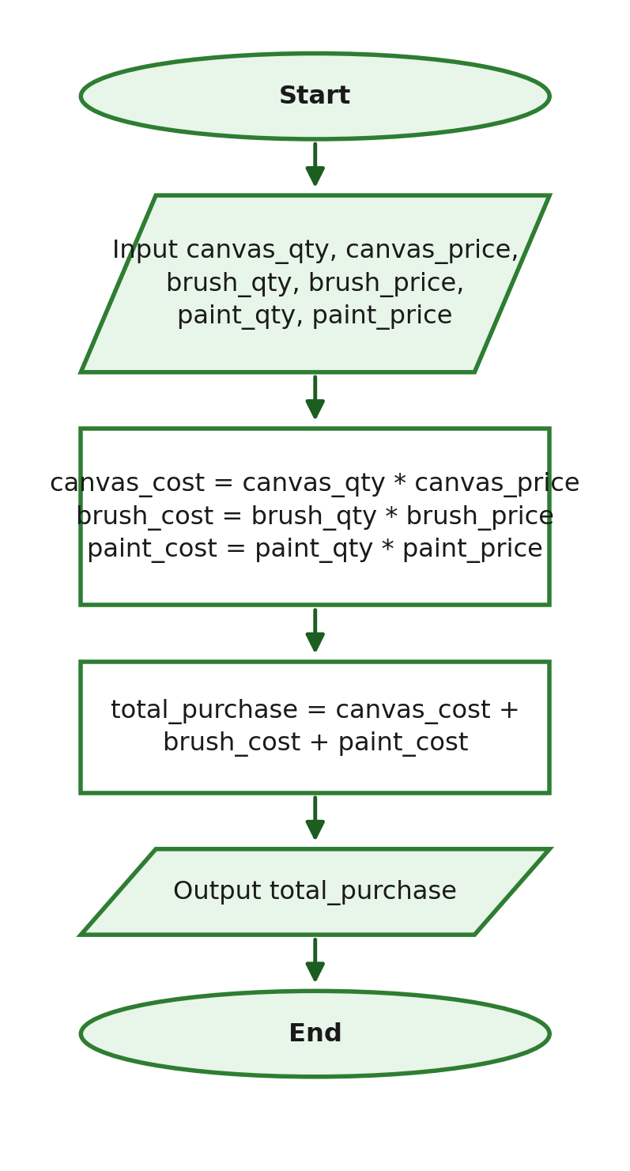
Suggested Python Program
canvas_qty = int(input("Enter number of canvas boards: "))
canvas_price = float(input("Enter price per board: "))
brush_qty = int(input("Enter number of paintbrushes: "))
brush_price = float(input("Enter price per paintbrush: "))
paint_qty = int(input("Enter number of paint tubes: "))
paint_price = float(input("Enter price per tube: "))

canvas_cost = canvas_qty * canvas_price
brush_cost = brush_qty * brush_price
paint_cost = paint_qty * paint_price
total_purchase = canvas_cost + brush_cost + paint_cost

print(f"Total Purchase: ₱{total_purchase:.2f}")
Expected Output Using the Given Values
Total Purchase: ₱1020.00

G2: Average of Three Long Test Scores
IPO Table
Input | Process | Output
Three long test scores | Add the three scores and divide the sum by 3 | Average score

Suggested Algorithm
1. Start.
2. Input the first test score.
3. Input the second test score.
4. Input the third test score.
5. Compute the average of the three scores.
6. Display the average.
7. End.

Suggested Pseudocode
START
INPUT test1
INPUT test2
INPUT test3
average = (test1 + test2 + test3) / 3
OUTPUT average
END
Suggested Flowchart
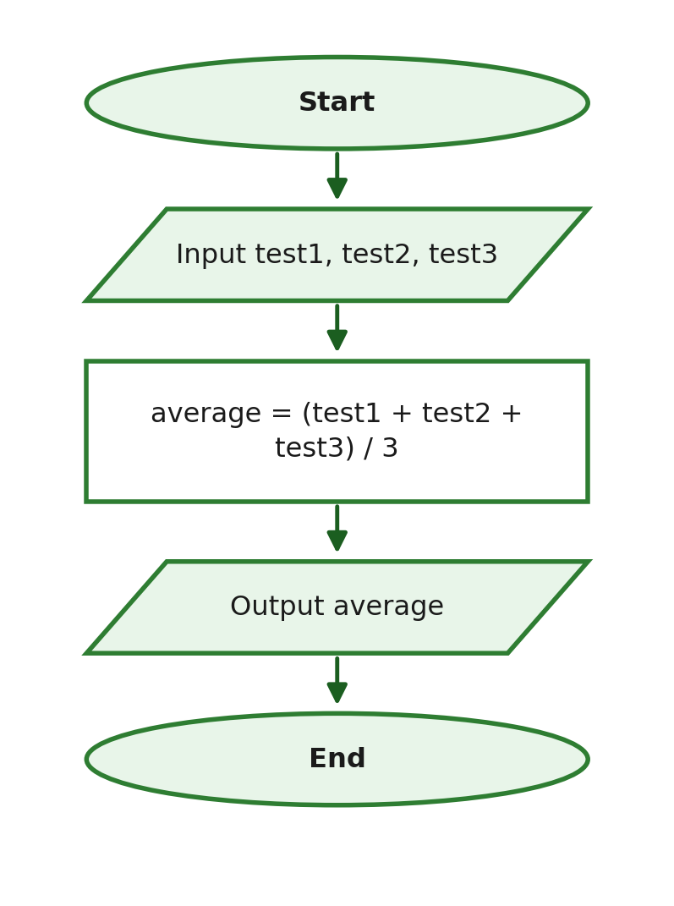
Suggested Python Program
test1 = float(input("Enter first test score: "))
test2 = float(input("Enter second test score: "))
test3 = float(input("Enter third test score: "))

average = (test1 + test2 + test3) / 3

print(f"Average: {average:.2f}")
Expected Output Using the Given Values
Average: 83.00

G3: Celsius-to-Fahrenheit Conversion
IPO Table
Input | Process | Output
Temperature in Celsius | Apply the conversion formula (celsius * 9/5) + 32 | Temperature in Fahrenheit

Suggested Algorithm
1. Start.
2. Input the temperature in Celsius.
3. Compute the equivalent temperature in Fahrenheit.
4. Display the temperature in Fahrenheit.
5. End.

Suggested Pseudocode
START
INPUT celsius
fahrenheit = (celsius * 9 / 5) + 32
OUTPUT fahrenheit
END
Suggested Flowchart
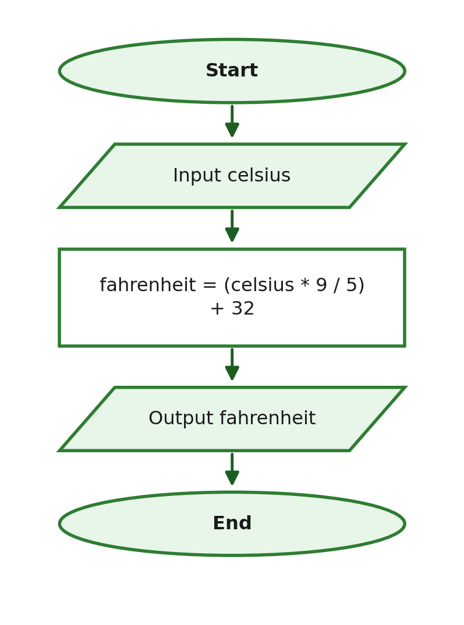
Suggested Python Program
celsius = float(input("Enter temperature in Celsius: "))

fahrenheit = (celsius * 9 / 5) + 32

print(f"Fahrenheit: {fahrenheit:.2f}")
Expected Output Using the Given Values
Fahrenheit: 59.00

G4: Area and Perimeter of a Classroom Floor
IPO Table
Input | Process | Output
Length and width of the classroom floor | Compute the area (length * width) and the perimeter (2 * (length + width)) | Area and perimeter

Suggested Algorithm
1. Start.
2. Input the length of the floor.
3. Input the width of the floor.
4. Compute the area.
5. Compute the perimeter.
6. Display the area and perimeter.
7. End.

Suggested Pseudocode
START
INPUT length
INPUT width
area = length * width
perimeter = 2 * (length + width)
OUTPUT area, perimeter
END
Suggested Flowchart
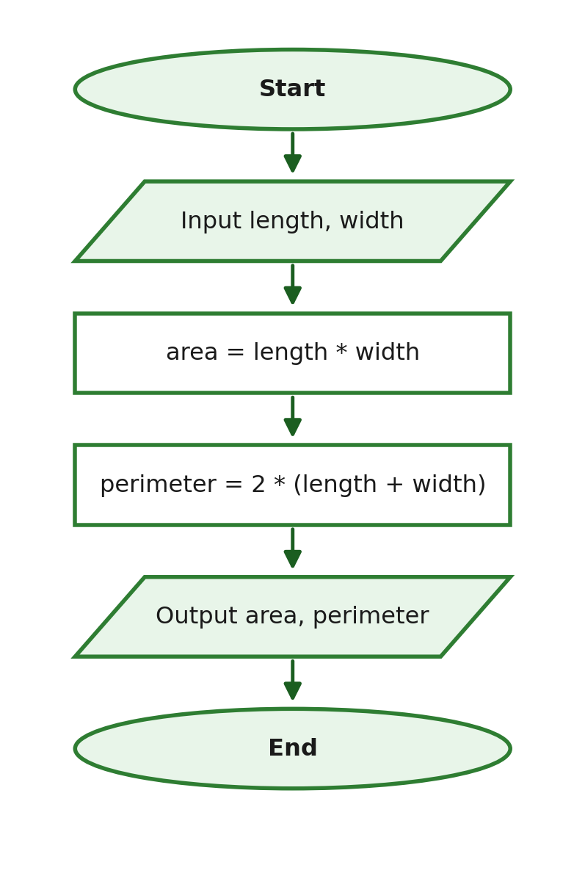
Suggested Python Program
length = float(input("Enter the length of the floor (m): "))
width = float(input("Enter the width of the floor (m): "))

area = length * width
perimeter = 2 * (length + width)

print(f"Area: {area:.2f} sq. m")
print(f"Perimeter: {perimeter:.2f} m")
Expected Output Using the Given Values
Area: 79.92 sq. m
Perimeter: 36.40 m

G5: Tutor's Salary Based on Hours Worked
IPO Table
Input | Process | Output
Hours tutored and hourly rate | Multiply hours tutored by the hourly rate | Gross pay

Suggested Algorithm
1. Start.
2. Input the number of hours tutored.
3. Input the hourly rate.
4. Compute the gross pay.
5. Display the gross pay.
6. End.

Suggested Pseudocode
START
INPUT hours_tutored
INPUT hourly_rate
gross_pay = hours_tutored * hourly_rate
OUTPUT gross_pay
END
Suggested Flowchart
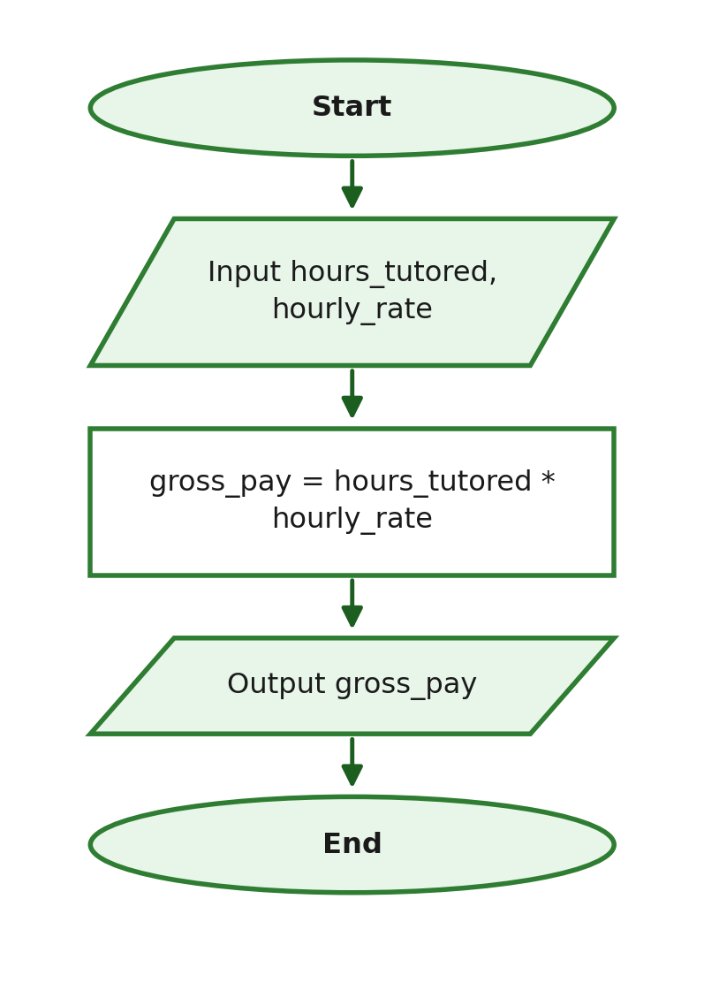
Suggested Python Program
hours_tutored = float(input("Enter hours tutored: "))
hourly_rate = float(input("Enter hourly rate: "))

gross_pay = hours_tutored * hourly_rate

print(f"Gross Pay: ₱{gross_pay:.2f}")
Expected Output Using the Given Values
Gross Pay: ₱1800.00

G6: Change from an Amount Paid at the Canteen
IPO Table
Input | Process | Output
Price of the meal and amount paid | Subtract the price from the amount paid | Change

Suggested Algorithm
1. Start.
2. Input the price of the meal.
3. Input the amount paid.
4. Compute the change.
5. Display the change.
6. End.

Suggested Pseudocode
START
INPUT price
INPUT amount_paid
change = amount_paid - price
OUTPUT change
END
Suggested Flowchart
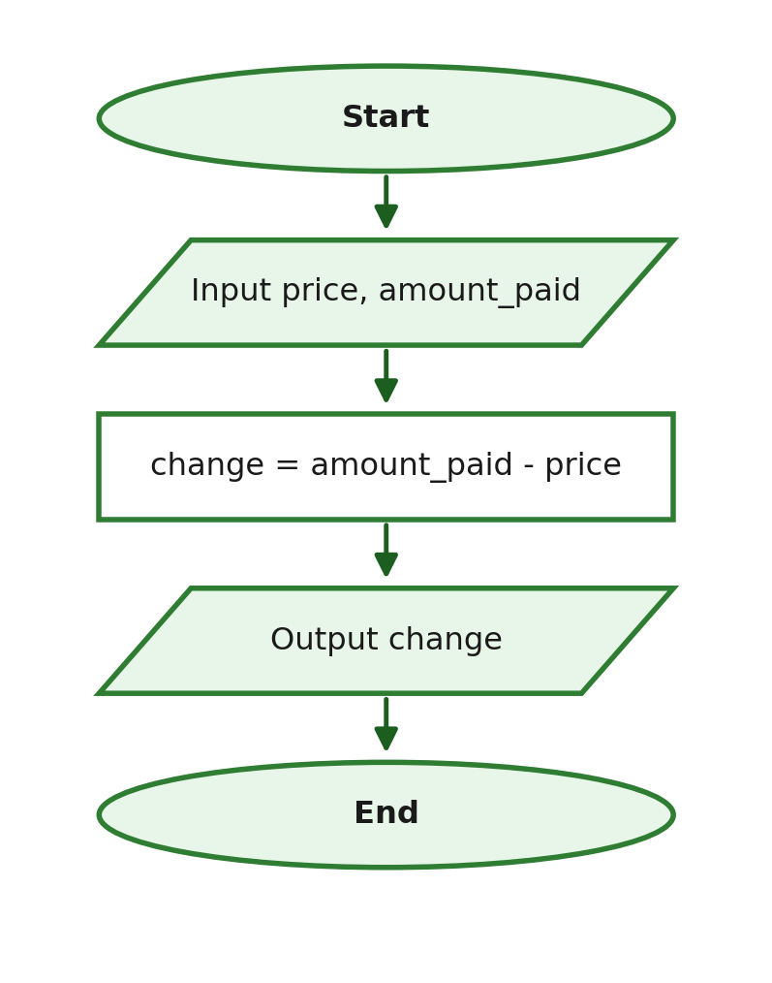
Suggested Python Program
price = float(input("Enter the price of the meal: "))
amount_paid = float(input("Enter the amount paid: "))

change = amount_paid - price

print(f"Change: ₱{change:.2f}")
Expected Output Using the Given Values
Change: ₱12.50

G7: Remaining Daily Allowance
IPO Table
Input | Process | Output
Daily allowance, fare, snacks, and printing expenses | Subtract fare, snacks, and printing from the allowance | Remaining allowance

Suggested Algorithm
1. Start.
2. Input the daily allowance.
3. Input the jeepney fare expense.
4. Input the snacks expense.
5. Input the printing expense.
6. Compute the remaining allowance.
7. Display the remaining allowance.
8. End.

Suggested Pseudocode
START
INPUT allowance
INPUT fare
INPUT snacks
INPUT printing
remaining = allowance - fare - snacks - printing
OUTPUT remaining
END
Suggested Flowchart
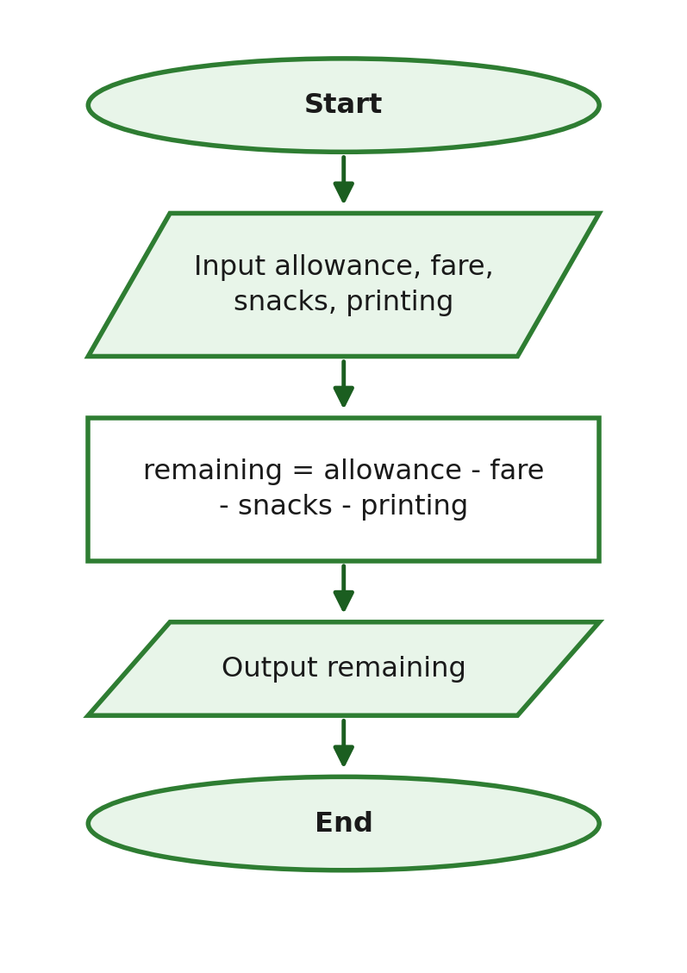
Suggested Python Program
allowance = float(input("Enter daily allowance: "))
fare = float(input("Enter jeepney fare: "))
snacks = float(input("Enter snacks expense: "))
printing = float(input("Enter printing expense: "))

remaining = allowance - fare - snacks - printing

print(f"Remaining Allowance: ₱{remaining:.2f}")
Expected Output Using the Given Values
Remaining Allowance: ₱100.00

G8: Distance Covered While Jogging
IPO Table
Input | Process | Output
Average speed and jogging time | Multiply speed by time | Distance covered

Suggested Algorithm
1. Start.
2. Input the average speed.
3. Input the jogging time.
4. Compute the distance covered.
5. Display the distance covered.
6. End.

Suggested Pseudocode
START
INPUT speed
INPUT time
distance = speed * time
OUTPUT distance
END
Suggested Flowchart
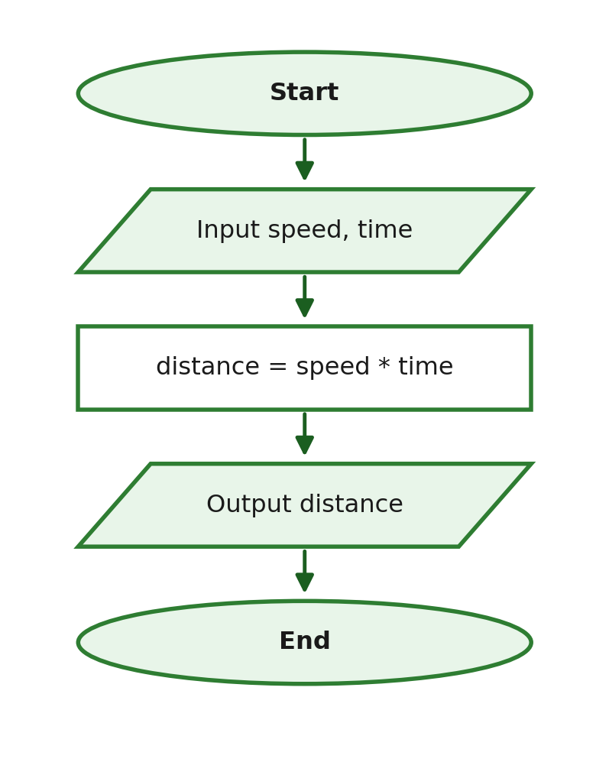
Suggested Python Program
speed = float(input("Enter average speed (km/h): "))
time = float(input("Enter jogging time (hours): "))

distance = speed * time

print(f"Distance: {distance:.2f} km")
Expected Output Using the Given Values
Distance: 7.80 km

G9: Simple Interest on a Time Deposit
IPO Table
Input | Process | Output
Principal amount, interest rate, and time in years | Compute interest (principal * rate * time), then total amount (principal + interest) | Interest earned and total amount

Suggested Algorithm
1. Start.
2. Input the principal amount.
3. Input the interest rate.
4. Input the time in years.
5. Compute the interest earned.
6. Compute the total amount.
7. Display the interest earned and the total amount.
8. End.

Suggested Pseudocode
START
INPUT principal
INPUT rate
INPUT time
interest = principal * rate * time
total_amount = principal + interest
OUTPUT interest, total_amount
END
Suggested Flowchart
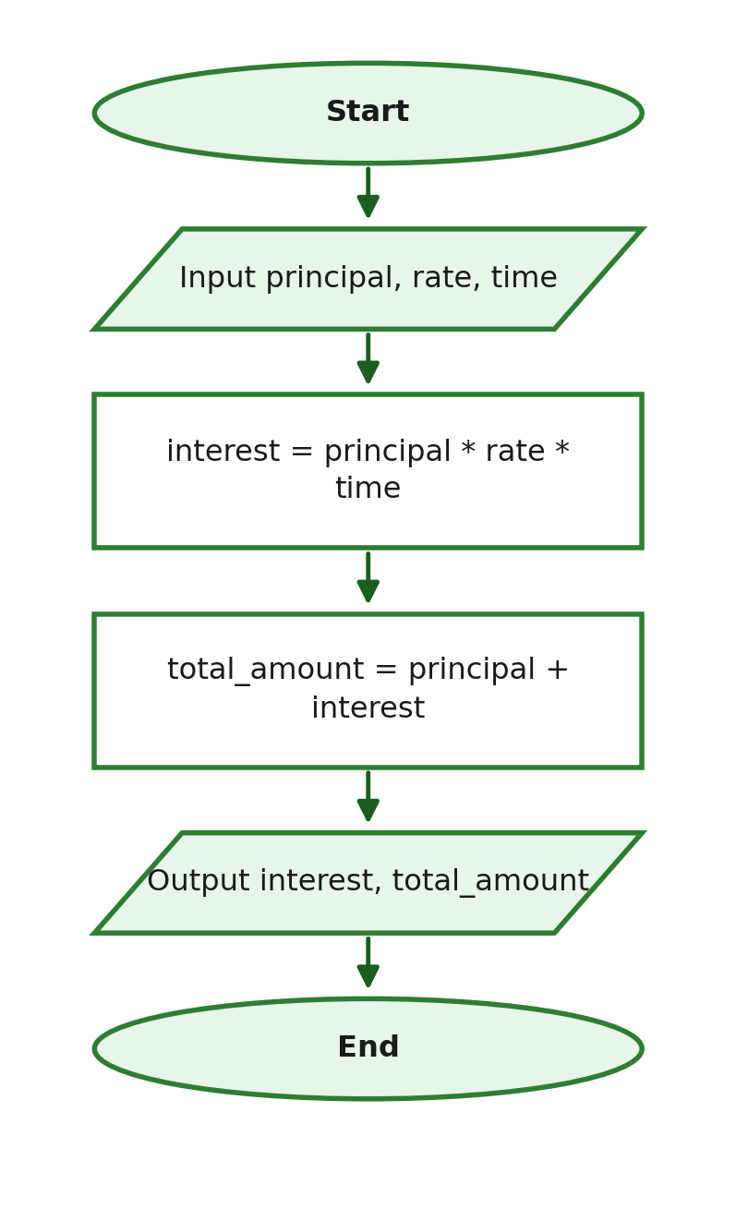
Suggested Python Program
principal = float(input("Enter the principal amount: "))
rate = float(input("Enter the interest rate (decimal form): "))
time = float(input("Enter the time in years: "))

interest = principal * rate * time
total_amount = principal + interest

print(f"Interest: ₱{interest:.2f}")
print(f"Total Amount: ₱{total_amount:.2f}")
Expected Output Using the Given Values
Interest: ₱3000.00
Total Amount: ₱28000.00

G10: Monthly Electricity Consumption Cost
IPO Table
Input | Process | Output
Kilowatt-hours consumed and rate per kilowatt-hour | Multiply consumption by the rate | Total electricity cost

Suggested Algorithm
1. Start.
2. Input the kilowatt-hours consumed.
3. Input the rate per kilowatt-hour.
4. Compute the total electricity cost.
5. Display the total electricity cost.
6. End.

Suggested Pseudocode
START
INPUT kwh_used
INPUT rate_per_kwh
total_cost = kwh_used * rate_per_kwh
OUTPUT total_cost
END
Suggested Flowchart
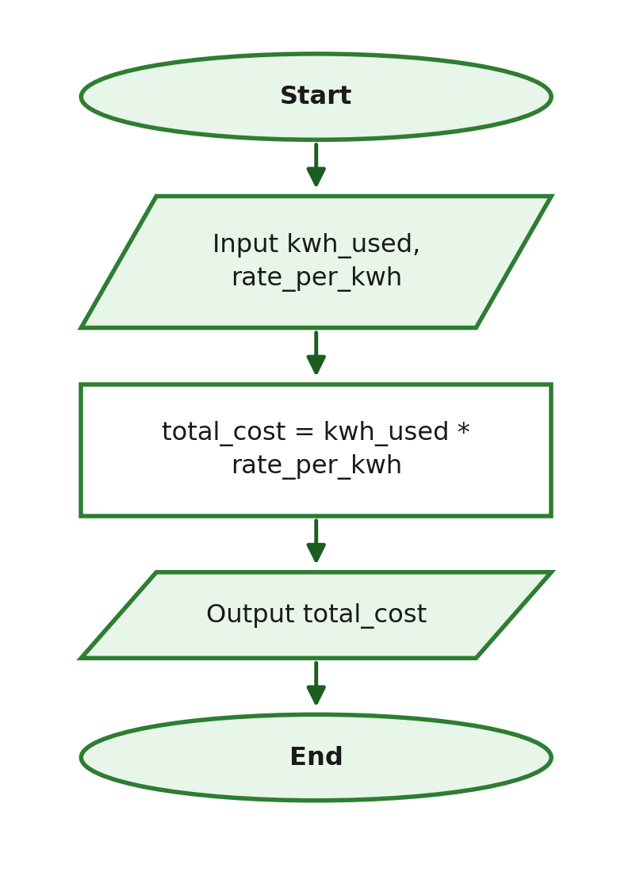
Suggested Python Program
kwh_used = float(input("Enter kilowatt-hours used: "))
rate_per_kwh = float(input("Enter rate per kilowatt-hour: "))

total_cost = kwh_used * rate_per_kwh

print(f"Electricity Cost: ₱{total_cost:.2f}")
Expected Output Using the Given Values
Electricity Cost: ₱3010.00

G11: Total Cost of Computer Peripherals
IPO Table
Input | Process | Output
Prices of the keyboard, mouse, webcam, and headset | Add the four peripheral prices together | Total cost

Suggested Algorithm
1. Start.
2. Input the keyboard price.
3. Input the mouse price.
4. Input the webcam price.
5. Input the headset price.
6. Compute the total cost.
7. Display the total cost.
8. End.

Suggested Pseudocode
START
INPUT keyboard_price
INPUT mouse_price
INPUT webcam_price
INPUT headset_price
total_cost = keyboard_price + mouse_price + webcam_price + headset_price
OUTPUT total_cost
END
Suggested Flowchart
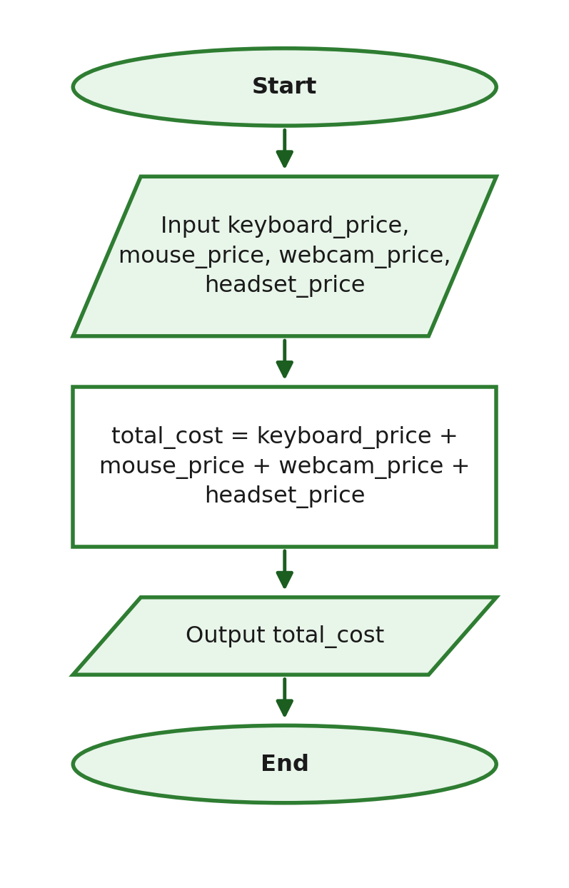
Suggested Python Program
keyboard_price = float(input("Enter keyboard price: "))
mouse_price = float(input("Enter mouse price: "))
webcam_price = float(input("Enter webcam price: "))
headset_price = float(input("Enter headset price: "))

total_cost = keyboard_price + mouse_price + webcam_price + headset_price

print(f"Total Cost: ₱{total_cost:.2f}")
Expected Output Using the Given Values
Total Cost: ₱4600.00

G12: Converting Total Minutes into Hours and Minutes
IPO Table
Input | Process | Output
Total number of minutes | Use floor division to get whole hours; use modulo to get remaining minutes | Hours and remaining minutes

Suggested Algorithm
1. Start.
2. Input the total number of minutes.
3. Compute the number of whole hours.
4. Compute the remaining minutes.
5. Display the hours and remaining minutes.
6. End.

Suggested Pseudocode
START
INPUT total_minutes
hours = total_minutes // 60
remaining_minutes = total_minutes % 60
OUTPUT hours, remaining_minutes
END
Suggested Flowchart
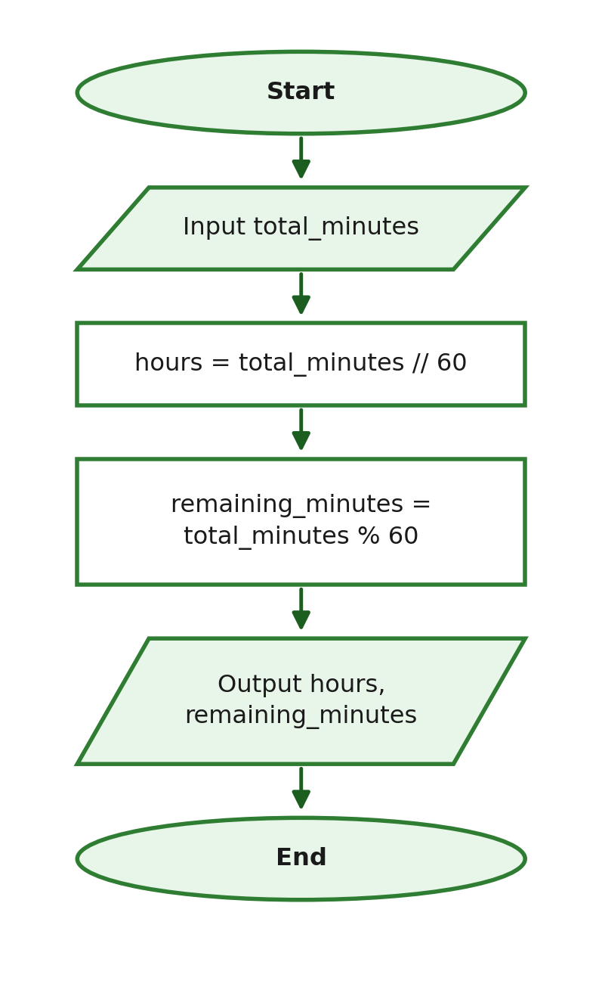
Suggested Python Program
total_minutes = int(input("Enter total minutes: "))

hours = total_minutes // 60
remaining_minutes = total_minutes % 60

print(f"Hours: {hours}")
print(f"Minutes: {remaining_minutes}")
Expected Output Using the Given Values
Hours: 5
Minutes: 19

Suggested Test Combinations
The item numbers below refer to the problems in the question bank above. Each version draws from different items so instructors can prepare parallel test forms for different sections.

Suggested Version A — Appropriate for Beginners (Approx. 40–50 points)
Mixture of short problems and one full programming problem.
Part | Selected Item Numbers | Points
Identifier Analysis | A1–A5 | 5
Data Types / Conversion | B1–B4, B9 | 5
Expression Evaluation | C1–C5, C10 | 6
Program Output | D1, D2, D3 | 6
Code Correction | E2, E3 | 4
Complete the Code | F1, F5 | 4
Full Problem Solving | G3 | 10
Full Problem Solving | G8 | 10
Total |  | 50

Suggested Version B — Moderate Difficulty (Approx. 40–50 points)
Different items from Version A.
Part | Selected Item Numbers | Points
Identifier Analysis | A6, A7, A9 | 6
Data Types / Conversion | B5, B6, B7 | 6
Expression Evaluation | C6, C7, C8, C9 | 8
Program Output | D4, D5, D6, D7 | 8
Code Correction | E1, E5, E6 | 6
Complete the Code | F3, F6 | 5
Full Problem Solving | G6 | 10
Total |  | 49

Suggested Version C — Moderate to Challenging (Approx. 40–50 points)
Different items from Versions A and B.
Part | Selected Item Numbers | Points
Identifier Analysis | A8, A10 | 5
Data Types / Conversion | B8 | 3
Expression Evaluation | C11, C12, C13 | 8
Program Output | D8, D9, D10 | 8
Code Correction | E4, E7 | 4
Complete the Code | F4, F8 | 4
Full Problem Solving | G9 | 18
Total |  | 50

