Preliminary Examination | Midterm Examination | Final Examination

CPP102 – Programming Logic and Design

1st | Semester, AY | 2026-2027

Student’s Name: |  | Date: |  | Score:

Year and Section: |  | Instructor: | Engr. Aldrin J. Soriano

GENERAL INSTRUCTIONS:
- Strictly no erasures (use of a pencil, friction pen, correction tape, and the like is prohibited). Write your answers clearly in the spaces provided in this questionnaire.
- Once the examination starts, no one will be allowed to go out of the classroom until the examination period is over.
- Cheating in any form is strictly prohibited. Anyone caught will automatically get a grade of 5.0 for this examination.
- Use permanent blue or black ink only.
- Do not detach the assessment set.

REMINDER: Our classroom policy states that failure to comply with instructions will mean a zero score for the particular assessment.
SET D — INSTRUCTOR'S ANSWER KEY
CPP102 — Programming Logic and Design | Preliminary Examination | Department of Computer Engineering
Mode: Pen and Paper Time Allotment: 1 hour and 30 minutes Total Points: 100
Coverage: Weeks 1–5 — Introduction to Programming and Python; Input–Process–Output; Git and GitHub Fundamentals; Algorithms, Pseudocode, and Flowcharts; Variables, Identifiers, Data Types, and Type Conversion; Operators and Operator Precedence; Conditional Statements and Python Indentation
This answer key follows the exact order and numbering of the finalized student examination (Part I: Items 1–30). The Table of Specifications is provided as a separate official .xlsx file.
PART I. MULTIPLE CHOICE — 30 points (30 items × 1 point)
Direction: Choose the letter of the best answer. Write the CAPITAL letter on the blank before each number.
_____ 1. In the Input–Process–Output model, showing the computed result to the user belongs to:
A. Input
B. Process
C. Storage
D. Output
ANSWER: D — Output | Displaying results is the output stage of IPO.
_____ 2. Programmers write comments in their code mainly to:
A. Make the program run faster
B. Explain the code to human readers, since Python ignores comments when running
C. Display messages on the screen
D. Store data permanently
ANSWER: B — Explain the code to human readers, since Python ignores comments when running | Comments document the code; the interpreter skips them.
_____ 3. Which Python function is used to ask the user to type a value?
A. input()
B. print()
C. type()
D. value()
ANSWER: A — input() | input() reads a value typed by the user.
_____ 4. A programming language is necessary because:
A. Computers can understand English directly
B. Programs cannot run without the internet
C. It provides a precise form in which instructions can be written for a computer
D. It replaces the need for algorithms
ANSWER: C — It provides a precise form in which instructions can be written for a computer | Languages give a precise, unambiguous way to express instructions.
_____ 5. Which command creates a new Git repository in the current folder?
A. git new
B. git start
C. git init
D. git create
ANSWER: C — git init | git init initializes a repository.
_____ 6. Immediately after git commit, the recorded changes are:
A. Saved in the local repository history but not yet on GitHub
B. Uploaded automatically to GitHub
C. Deleted from the folder
D. Visible to all GitHub users
ANSWER: A — Saved in the local repository history but not yet on GitHub | Commits are local; git push is needed to upload them.
_____ 7. Which command fetches changes from the remote repository and merges them into the local copy?
A. git push
B. git status
C. git commit
D. git pull
ANSWER: D — git pull | git pull downloads and merges remote changes.
_____ 8. A team of students wants all members to access the same repository over the internet. Which tool directly provides this service?
A. GitHub
B. VS Code
C. The Python interpreter
D. A flowchart editor
ANSWER: A — GitHub | GitHub hosts shared repositories online.
_____ 9. The text written inside a decision diamond must be:
A. A computation formula
B. The name of the program
C. A question or condition answerable by Yes or No
D. The final output message
ANSWER: C — A question or condition answerable by Yes or No | Diamonds hold conditions with two possible branches.
_____ 10. Which step belongs inside a parallelogram symbol?
A. Compute the total cost
B. Check if the total is greater than 100
C. End the program
D. Display the total cost
ANSWER: D — Display the total cost | Parallelograms represent input and output operations.
_____ 11. The main difference between an algorithm and a program is that an algorithm:
A. Is a language-independent list of steps, while a program is written in a programming language
B. Always runs faster than a program
C. Can only be drawn, never written
D. Requires a computer to be valid
ANSWER: A — Is a language-independent list of steps, while a program is written in a programming language | Algorithms are logical steps; programs are their coded form.
_____ 12. In an IPO table for computing the area of a rectangle, which entry belongs under Process?
A. Read the length and width
B. Multiply the length by the width
C. Display the area
D. The ruler used for measuring
ANSWER: B — Multiply the length by the width | The computation is the process; reading is input, displaying is output.
_____ 13. Which line follows standard pseudocode style for reading a value?
A. age = input()
B. scanf("%d", age)
C. INPUT age
D. type age here
ANSWER: C — INPUT age | Pseudocode uses plain keywords such as INPUT.
_____ 14. A variable will store a student's average grade. Which name follows Python naming conventions?
A. average_grade
B. AverageGrade!
C. 1average
D. average grade
ANSWER: A — average_grade | snake_case, no spaces, no symbols, cannot start with a digit.
_____ 15. Which of the following is a reserved keyword in Python?
A. total
B. Grade
C. value
D. elif
ANSWER: D — elif | elif is part of Python's conditional syntax.
_____ 16. What is the data type of the value 12.0?
A. int
B. str
C. float
D. bool
ANSWER: C — float | A number with a decimal point is a float.
_____ 17. The expression "5" + "3" results in "53" because:
A. Python adds the numbers incorrectly
B. Both values are strings, so + joins them together
C. The quotation marks are ignored
D. 53 is the sum of 5 and 3
ANSWER: B — Both values are strings, so + joins them together | + concatenates strings instead of adding numbers.
_____ 18. What is the result of str(20)?
A. 20
B. 20.0
C. An error occurs
D. "20"
ANSWER: D — "20" | str() converts the number into the text "20".
_____ 19. A value from input() must be converted before it is used in arithmetic because input() returns:
A. A string, and arithmetic requires numeric types
B. A float that is too small
C. A negative number
D. A Boolean value
ANSWER: A — A string, and arithmetic requires numeric types | input() always returns str.
_____ 20. What is the value of 40 - 3 * 5?
A. 185
B. 25
C. 37
D. 22
ANSWER: B — 25 | Multiplication first: 40 − 15 = 25.
_____ 21. Which operator raises a number to a power?
A. ^
B. x
C. //
D. **
ANSWER: D — ** | ** is the exponentiation operator.
_____ 22. Which group contains comparison operators only?
A. +, -, *
B. and, or, not
C. =, +=, -=
D. >, <=, ==
ANSWER: D — >, <=, == | These compare values and produce Booleans.
_____ 23. The condition (x > 5) or (y > 5) evaluates to True when:
A. Both conditions must be False
B. At least one of the two conditions is True
C. x and y are equal
D. The word or is capitalized
ANSWER: B — At least one of the two conditions is True | or needs only one True operand.
_____ 24. After the statements score = 10 and score += 3, the value of score is:
A. 13
B. 10
C. 3
D. 103
ANSWER: A — 13 | += adds 3 to the current value: 10 + 3 = 13.
_____ 25. The statements indented under an if header execute only when:
A. The program has an else
B. The condition evaluates to True
C. The condition evaluates to False
D. The user presses Enter
ANSWER: B — The condition evaluates to True | The indented block runs on a True condition.
_____ 26. A store offers free delivery when the distance is at most 5 kilometers. Which condition is correct?
A. distance < 5
B. distance == 5
C. distance <= 5
D. distance >= 5
ANSWER: C — distance <= 5 | "At most 5" includes 5, so <= is required.
_____ 27. An if-elif-else chain is more appropriate than several independent if statements when:
A. Every block must always run
B. Exactly one of several branches should run
C. No condition is needed
D. The program has no output
ANSWER: B — Exactly one of several branches should run | A chain guarantees only the first True branch executes.
_____ 28. Given the condition if x > 10:, which value of x makes the condition False?
A. 10
B. 11
C. 12
D. 100
ANSWER: A — 10 | 10 > 10 is False; > excludes the boundary value.
_____ 29. The spaces at the beginning of the statements inside an if block are called:
A. Margins
B. Bullets
C. Indentation
D. Alignment errors
ANSWER: C — Indentation | Indentation defines the block in Python.
_____ 30. Which line correctly begins an if statement?
A. if grade => 75:
B. if grade >= 75:
C. if grade >= 75
D. if (grade >= 75) then:
ANSWER: B — if grade >= 75: | >= is the correct operator and the header needs a colon.
Part I Checking Strip (Items 1–30):
1-D, 2-B, 3-A, 4-C, 5-C, 6-A, 7-D, 8-A, 9-C, 10-D, 11-A, 12-B, 13-C, 14-A, 15-D, 16-C, 17-B, 18-D, 19-A, 20-B, 21-D, 22-D, 23-B, 24-A, 25-B, 26-C, 27-B, 28-A, 29-C, 30-B
PART II. EVALUATION AND OUTPUT TRACING — 30 points
Part II-A. Expression Evaluation — 10 points (Items 1–10, 1 point each)
Direction: Evaluate each Python expression and write the exact result. Boolean answers must be written exactly as True or False.
Item | Expression | Exact Answer | Brief Computation
1 | 18 + 5 * 4 | 38 | Multiplication first: 18 + 20 = 38
2 | (18 + 5) * 4 | 92 | Parentheses first: 23 × 4 = 92
3 | 50 - 20 / 5 | 46.0 | Division first: 50 − 4.0 = 46.0 (/ gives a float)
4 | 41 // 7 | 5 | Floor division keeps the whole quotient
5 | 41 % 7 | 6 | 41 = 7 × 5 + 6; the remainder is 6
6 | 88 > 88 | False | > excludes equality (boundary value)
7 | 34 <= 40 | True | —
8 | (55 < 60) and (12 > 3) | True | True and True → True
9 | not (8 >= 8) | False | 8 >= 8 is True; not True → False
10 | float("6.25") * 2 | 12.5 | The string becomes 6.25 before multiplying
Part II-B. Program Output Tracing — 20 points (Programs 1–5, 4 points each)
Direction: Trace each Python program and write the exact output that appears in the terminal. Observe capitalization, punctuation, spacing, line order, Boolean capitalization, and decimal formatting.
Program 1:
base_fare = 45.0
distance = 6
fare = base_fare + distance * 8.75
print(f"Fare: PHP {fare:.2f}")
Exact output:
Fare: PHP 97.50
Explanation: 45.0 + 6 × 8.75 = 45.0 + 52.5 = 97.5; the format :.2f prints two decimal places: 97.50.
Program 2:
units = "115"
consumption = int(units) - 15
print(consumption)
print(consumption > 100)
Exact output:
100
False
Explanation: int("115") − 15 = 100; the strict comparison 100 > 100 is False at the boundary. Boolean must be capitalized: False.
Program 3:
balance = 500
withdraw = 500
if withdraw <= balance:
print("Transaction approved")
else:
print("Insufficient funds")
print("Session ended")
Exact output:
Transaction approved
Session ended
Explanation: 500 <= 500 is True (<= includes the boundary), so the if branch runs. The last print is not indented, so it always executes.
Program 4:
temp = 24
if temp >= 33:
print("Hot day")
elif temp >= 25:
print("Warm day")
else:
print("Cool day")
Exact output:
Cool day
Explanation: 24 >= 33 is False and 24 >= 25 is False (one below the boundary), so the else branch runs.
Program 5:
pin = 1234
attempts = 1
if pin == 1234:
if attempts < 3:
print("Access granted")
print("Checking done")
else:
print("Access denied")
Exact output:
Access granted
Checking done
Explanation: The outer condition is True; the inner condition 1 < 3 is also True, so both prints inside the outer block execute in order.
Part II-B Scoring Guide (apply per program):
Score | Description
4 | The complete output is exact.
3 | Values and logic are correct, with one minor capitalization, punctuation, spacing, or formatting error.
2 | At least half of the required output is correct.
1 | A relevant partial result is shown, but major errors remain.
0 | Blank, unrelated, or completely incorrect.
PART III. PROGRAM LOGIC AND DESIGN — 30 points (one integrated problem)
Direction: Read the problem carefully, then complete the four tasks. Use the required variable names and the standard flowchart symbols discussed in class. Do NOT write a complete Python program.
Problem: Electricity Consumption Evaluation
A household records its previous and current electricity-meter readings. The program computes the electricity consumption and the total electricity cost. If the electricity consumption is greater than 100 kilowatt-hours, the program assigns the category "High Consumption". Otherwise, it assigns the category "Normal Consumption". The program then displays the electricity consumption, the total cost, and the category.
Required variable names: previous_reading, current_reading, rate_per_kwh, consumption, total_cost, category
Task 1 — IPO Table (6 points)
Direction: Complete the IPO table for the problem.
Input | Process | Output
previous_reading, current_reading, rate_per_kwh | Compute consumption = current_reading - previous_reading; compute total_cost = consumption * rate_per_kwh; if consumption > 100, category = "High Consumption", otherwise category = "Normal Consumption" | consumption, total_cost, category
Scoring: 2 pts correct inputs; 2 pts correct formulas and condition; 2 pts correct outputs. Per criterion: 2 = complete and correct, 1 = partially correct, 0 = missing or incorrect.
Task 2 — Algorithm (6 points)
Direction: Write a complete numbered algorithm. Include Start and End.
Step 1: Start.
Step 2: Input previous_reading.
Step 3: Input current_reading.
Step 4: Input rate_per_kwh.
Step 5: Compute consumption = current_reading - previous_reading.
Step 6: Compute total_cost = consumption * rate_per_kwh.
Step 7: If consumption is greater than 100, set category = "High Consumption". Otherwise, set category = "Normal Consumption".
Step 8: Display consumption, total_cost, and category.
Step 9: End.
Acceptable equivalents: Steps 2–4 may be combined into one input step. Accept logically equivalent wording when the sequence and logic are correct.
Task 3 — Pseudocode (8 points)
Direction: Write the pseudocode using the required variable names.
START
INPUT previous_reading
INPUT current_reading
INPUT rate_per_kwh
consumption = current_reading - previous_reading
total_cost = consumption * rate_per_kwh
IF consumption > 100 THEN
category = "High Consumption"
ELSE
category = "Normal Consumption"
END IF
OUTPUT consumption
OUTPUT total_cost
OUTPUT category
END
Acceptable equivalents: READ instead of INPUT; DISPLAY or PRINT instead of OUTPUT; ENDIF instead of END IF. Do not accept Python source code alone as a complete pseudocode answer. Deduct only for errors that affect the logic or required structure; do not deduct repeatedly for the same single error.
Task 4 — Flowchart (10 points)
Direction: Draw the complete flowchart using the standard symbols discussed in class. Label the decision branches as Yes and No (or True and False).
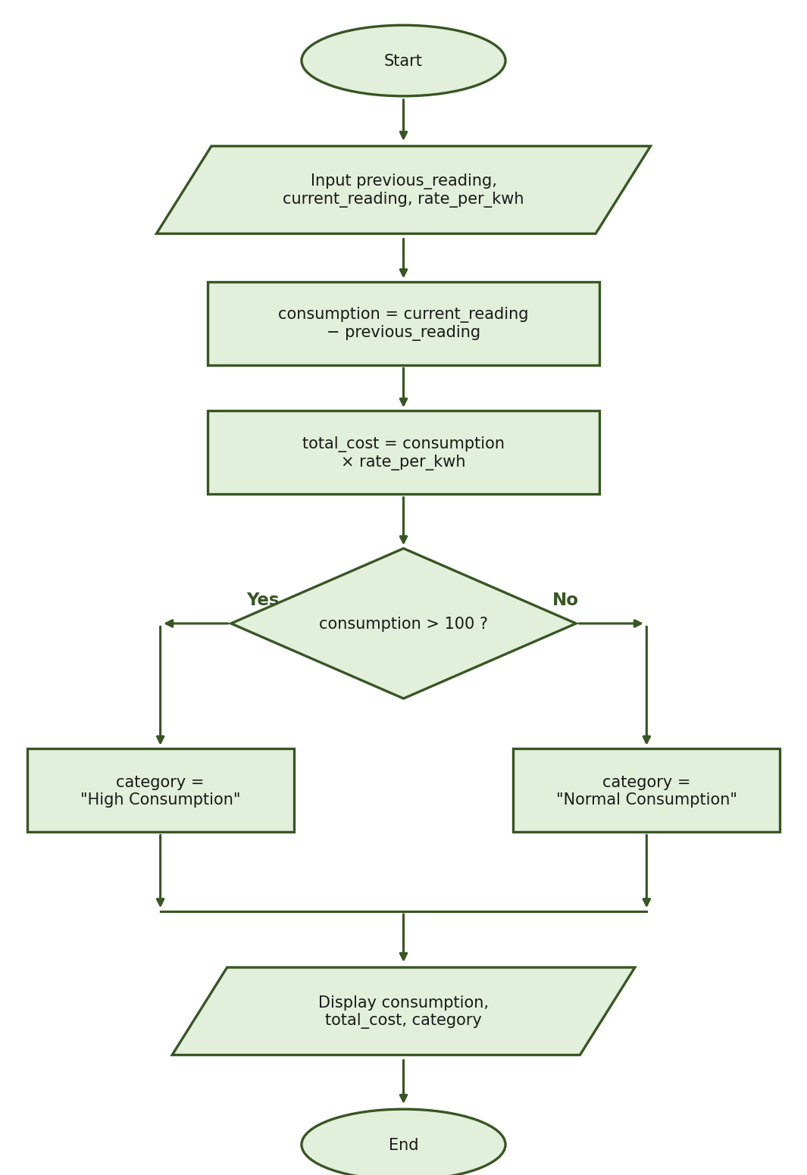
Expected computed results (using previous_reading = 1250, current_reading = 1365, rate_per_kwh = 12.50): consumption = 1365 - 1250 = 115; total_cost = 115 × 12.50 = 1437.50; since 115 > 100, category = "High Consumption". The condition must be consumption > 100 (strictly greater than), not >= 100.
Part III Detailed Rubric — 30 points
Task 1 — IPO Table (6 points)
Criterion | Points
Correct inputs: previous_reading, current_reading, and rate_per_kwh | 2
Correct formulas and condition | 2
Correct outputs: consumption, total_cost, and category | 2
Partial scoring per criterion: 2 = complete and correct; 1 = partially correct; 0 = missing or incorrect | —
Task 2 — Algorithm (6 points)
Criterion | Points
Includes Start and End | 1
Inputs all required values | 1
Computes consumption correctly | 1
Computes total cost correctly | 1
Includes the correct decision and both categories | 1
Displays all required outputs in logical sequence | 1
Accept different wording when the sequence and logic are correct. Do not deduct repeatedly for the same single mistake.
Task 3 — Pseudocode (8 points)
Criterion | Points
Correct START and END structure | 1
Correct input statements | 1
Correct consumption formula | 1
Correct total-cost formula | 1
Correct condition: consumption > 100 | 1
Correct High Consumption branch | 1
Correct Normal Consumption branch | 1
Correct output statements | 1
Task 4 — Flowchart (10 points)
Criterion | Points
Correct Start and End symbols (ovals) | 1
Correct input symbol and values (parallelogram) | 1
Correct consumption-process symbol and formula (rectangle) | 1
Correct total-cost process symbol and formula (rectangle) | 1
Correct decision diamond and condition (consumption > 100?) | 2
Correct High and Normal Consumption branches (rectangles) | 2
Correct output symbol and entries (parallelogram) | 1
Correct arrows, branch labels, and merging of paths | 1
Flowchart Partial-Score Guide (checking guide only — apply the analytic criteria first):
Performance Level | Score
Complete, correct, and properly connected | 9–10
Minor symbol, label, or arrow error; logic remains correct | 7–8
Basic structure is present, but several errors exist | 5–6
Partial flowchart with major logic errors | 2–4
No meaningful flowchart | 0–1
PART IV. DEFINITION OF A COMPUTER — 10 POINTS
Direction: Write the definition of a computer exactly as discussed and memorized in class. Your answer must be complete and nearly word-for-word.
1. What is a computer?
EXACT REQUIRED ANSWER: Computer is a machine that processes data into information under by control of stored program.
Preserve this exact wording. Do not correct its grammar, replace "under by control", add the word "the", remove or add required words, paraphrase the definition, or replace it with a standard textbook definition.
Part IV Scoring Rubric:
Required Phrase | Points
Computer is a machine | 2
that processes data | 2
into information | 2
under by control | 2
of stored program | 2
Total | 10
Checking Rules:
1. 10 points for a complete and nearly word-for-word answer.
2. Differences in capitalization, punctuation, or spacing may be accepted.
3. Deduct 2 points for each missing, incorrect, or substantially changed phrase.
4. Minor spelling errors may be accepted when the intended word remains unmistakable.
5. A paraphrased answer must not receive full credit.
6. A materially different, unrelated, or very distant answer receives 0 points.
SUGGESTED TIME ALLOCATION (90 MINUTES)
Part | Suggested Time
Part I — Multiple Choice | 25 minutes
Part II-A — Expression Evaluation | 10 minutes
Part II-B — Output Tracing | 15 minutes
Part III — Program Logic and Design | 33 minutes
Part IV — Definition of a Computer | 2 minutes
Final Review | 5 minutes
Total | 90 minutes
— END OF EXAMINATION —

