CPP102: PROGRAMMING LOGIC AND DESIGN
Week 7 Lecture and Laboratory Module
Fundamental Iteration and Loop-Control Structures
Department of Computer Engineering

PART A. LECTURE MODULE

1. Week Number and Topic
Week: 7
Course Title: CPP102 — Programming Logic and Design (2 units, Lecture-Laboratory)
Topic: Fundamental Iteration and Loop-Control Structures
Subtopics: the purpose of iteration, repetition in programming, counter-controlled and condition-controlled repetition, counters and accumulators, the while loop, the for loop, the range() function, the do-while logic concept and its equivalent Python implementation using a while loop, loop initialization, loop condition, loop update, the break statement, the continue statement, sentinel-controlled repetition, input validation using loops, basic loop tracing, common infinite-loop errors, and testing single-level loops.
Scope note: this module covers single-level loops only. Nested loops and multi-level iteration are taken up separately in the Week 8 module.

2. Intended Learning Outcomes
At the end of the module, students should be able to:
- Trace and evaluate Python programs that use while loops, for loops, counters, accumulators, break, and continue.
- Construct algorithms, pseudocode, and flowcharts for counter-controlled, condition-controlled, and sentinel-controlled repetition, including the do-while logic concept.
- Develop and test Python programs using appropriate single-level iteration and loop-control structures.

3. Week 7 Overview
In the previous weeks, your programs executed their statements from top to bottom, and conditional statements allowed them to choose between alternative paths. However, every statement was still executed at most once. Many practical problems require a program to repeat the same instructions several times: counting the students in a classroom, repeating an exercise ten times, adding daily expenses one after another, asking again until a valid grade is entered, or printing the numbers from 1 to 10. A looping statement allows a program to repeat a group of instructions without rewriting the same code many times.
This module builds directly on the earlier topics: variables, data types, type conversion, arithmetic operators, comparison operators, logical operators, conditional statements, and input and output. Every loop you will write uses a Boolean condition exactly like the ones you studied in Week 5, and the loop body may contain any statement you have already learned, including if statements.
Consider a program that must display the numbers 1 to 5. Without a loop, the same instruction must be typed five times:
print(1)
print(2)
print(3)
print(4)
print(5)

Output:
1
2
3
4
5

The same result can be produced by a loop with only two lines of code:
for number in range(1, 6):
print(number)

Output:
1
2
3
4
5

Both programs produce exactly the same output, but the loop version is shorter, easier to read, and much easier to modify. If the numbers 1 to 1000 were required instead, the first program would need 1000 lines, while the loop version would only need one small change: range(1, 1001). Repetition controlled by a loop is one of the most powerful ideas in programming, and this week you will learn the two looping statements of Python: the for loop and the while loop.
This module is limited to single-level loops — that is, one loop at a time. Placing one loop inside another, which is required for row-and-column processing and table generation, is the subject of the Week 8 module. Master the single-level structures first, because every nested loop is built from them.

4. Fundamental Parts of a Loop
Most loops are built from three important parts. If any one of these parts is missing or incorrect, the loop may repeat the wrong number of times or may never stop.
- Initialization — establishes the starting value of the loop-control variable before the loop begins.
- Condition — a Boolean expression checked before every repetition; the loop continues only while the condition is True.
- Update — changes the loop-control variable so that the condition can eventually become False.
Part | Purpose | Example
Initialization | Sets the beginning value | count = 1
Condition | Checks whether the loop continues | count <= 5
Update | Changes the loop-control variable | count += 1

Study how the three parts appear in a simple while loop:
count = 1
while count <= 5:
print(count)
count += 1

Output:
1
2
3
4
5

The program executes step by step as follows. First, the initialization count = 1 stores the starting value. Second, Python checks the condition count <= 5. Since 1 <= 5 is True, the body executes: it displays 1 and then the update count += 1 changes count to 2. Python returns to the condition and checks it again. This cycle repeats for the values 2, 3, 4, and 5. When count becomes 6, the condition 6 <= 5 is False, so the loop stops and the program continues with the statement after the loop. One complete execution of the loop body is called an iteration; this loop performed exactly five iterations.

5. Counter-Controlled and Condition-Controlled Loops
Loops are classified according to how the repetition is controlled.
Counter-controlled repetition is used when the number of repetitions is known before the loop starts. A counter variable moves from a starting value to an ending value. The for loop is the natural choice:
for count in range(5):
print("Hello")

Output:
Hello
Hello
Hello
Hello
Hello

Condition-controlled repetition is used when the repetition must continue until some condition changes, and the number of repetitions is not known in advance — for example, asking for input again until a valid grade is entered. The while loop is the natural choice:
number = 1
while number <= 5:
print(number)
number += 1

Output:
1
2
3
4
5

Feature | Counter-Controlled | Condition-Controlled
Typical Python structure | for | while
Number of repetitions | Usually known in advance | Usually unknown
Control | Sequence produced by range() | Boolean condition
Common use | Repeating a fixed number of times | Input validation or sentinel-controlled repetition

6. Counters and Accumulators
A counter keeps track of how many times something occurs. It usually starts at 0 and increases by exactly 1 each time the event happens.
count = 0
for number in range(1, 6):
count += 1
print("Count:", count)

Output:
Count: 5

An accumulator stores a running total. It also starts at 0, but instead of adding 1, it adds the current value being processed.
total = 0
for number in range(1, 6):
total += number
print("Total:", total)

Output:
Total: 15

A trace table records the value of every important variable during each iteration. Study how the accumulator grows while the loop above executes:
Iteration | number | total before | total after
1 | 1 | 0 | 1
2 | 2 | 1 | 3
3 | 3 | 3 | 6
4 | 4 | 6 | 10
5 | 5 | 10 | 15

Both the counter and the accumulator must be initialized before the loop begins. If the initialization is written inside the loop body, the variable is reset during every iteration and the final result will be wrong. This common error is discussed again in the section on common looping errors.
An accumulator does not always add. Computing a factorial uses an accumulator that multiplies. Because any number multiplied by 0 is 0, the accumulator must start at 1 instead of 0:
number = int(input("Enter a positive integer: "))
factorial = 1
for value in range(1, number + 1):
factorial *= value
print(f"The factorial of {number} is {factorial}")

Sample Run:
Enter a positive integer: 5
The factorial of 5 is 120

The program computes 5! = 5 × 4 × 3 × 2 × 1 = 120. Choosing the correct starting value — 0 for a sum, 1 for a product — is part of initializing an accumulator properly.

7. The Python range() Function
The range() function produces a sequence of integers and is most often used together with a for loop. It has three forms:
range(stop)
range(start, stop)
range(start, stop, step)

- range(stop) — starts at 0 and counts up to, but not including, stop.
- range(start, stop) — starts at start and counts up to, but not including, stop.
- range(start, stop, step) — starts at start, moves by step, and stops before reaching stop. A negative step counts downward.
Important: the stop value is always excluded. range(1, 5) produces 1, 2, 3, 4 — the value 5 is never included. To count from 1 to 5, write range(1, 6).
Expression | Values Produced
range(5) | 0, 1, 2, 3, 4
range(1, 6) | 1, 2, 3, 4, 5
range(2, 11, 2) | 2, 4, 6, 8, 10
range(10, 0, -2) | 10, 8, 6, 4, 2
range(1, 10, 2) | 1, 3, 5, 7, 9
range(5, 26, 5) | 5, 10, 15, 20, 25

Counting upward from 1 to 5:
for number in range(1, 6):
print(number)

Output:
1
2
3
4
5

Counting downward from 5 to 1 using a negative step:
for number in range(5, 0, -1):
print(number)

Output:
5
4
3
2
1

Even numbers from 2 to 10 using a step of 2:
for number in range(2, 11, 2):
print(number)

Output:
2
4
6
8
10

Odd numbers from 1 to 9:
for number in range(1, 10, 2):
print(number)

Output:
1
3
5
7
9

Skipping values using a step of 5:
for number in range(5, 26, 5):
print(number)

Output:
5
10
15
20
25

Common mistake — the excluded stopping value. A programmer who wants to display the numbers 1 to 5 but writes range(1, 5) will only see 1 to 4:
for number in range(1, 5):
print(number)

Output:
1
2
3
4

Producing one repetition too many or too few because of a wrong boundary is called an off-by-one error. Always check the first value, the last value, and the total number of repetitions of every loop you write.

Checkpoint A: Determine the Values Produced by range()
Write the exact sequence of values produced by each expression. Write “no values” if the expression produces an empty sequence.
Item | Expression
1 | range(5)
2 | range(1, 6)
3 | range(2, 11, 2)
4 | range(10, 0, -1)
5 | range(5, 20, 5)
6 | range(0, 10, 3)
7 | range(3, 4)
8 | range(8, 2, -2)
9 | range(1, 10, 4)
10 | range(6, 0, -1)

8. The for Loop
The for loop repeats a block of statements once for every value in a sequence. Its syntax is:
for variable in range(...):
statement
statement

The loop variable automatically receives each value produced by range(), one value per iteration. The statements inside the loop must be indented by four spaces, exactly like the body of an if statement. A for loop is appropriate whenever the number of repetitions is known before the loop starts.

Example 8.1: Display the Numbers from 1 to 10
Problem Statement: Display the whole numbers from 1 to 10, one number per line.
IPO Table:
Input | Process | Output
None | Repeat for the values 1 to 10 | The numbers 1 to 10

Algorithm:
Step 1: Start.
Step 2: For each number from 1 to 10, display the number.
Step 3: End.

Pseudocode:
START
FOR number = 1 TO 10
DISPLAY number
END FOR
END

Flowchart:
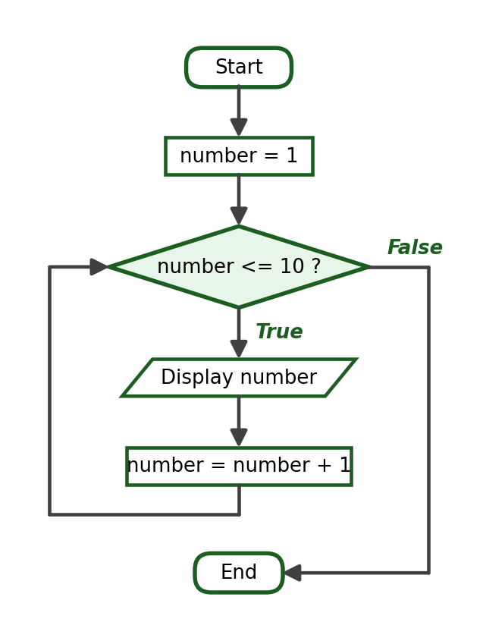
Python Program:
for number in range(1, 11):
print(number)

Sample Run:
1
2
3
4
5
6
7
8
9
10

Explanation: range(1, 11) produces the values 1 to 10 because the stop value 11 is excluded. The loop performs exactly ten iterations.

Example 8.2: Display the Even Numbers from 2 to 20
Problem Statement: Display all even numbers from 2 to 20.
IPO Table:
Input | Process | Output
None | Repeat for the values 2, 4, 6, …, 20 | The even numbers from 2 to 20

Algorithm:
Step 1: Start.
Step 2: For each number from 2 to 20 counting by 2, display the number.
Step 3: End.

Pseudocode:
START
FOR number = 2 TO 20 STEP 2
DISPLAY number
END FOR
END

Flowchart:
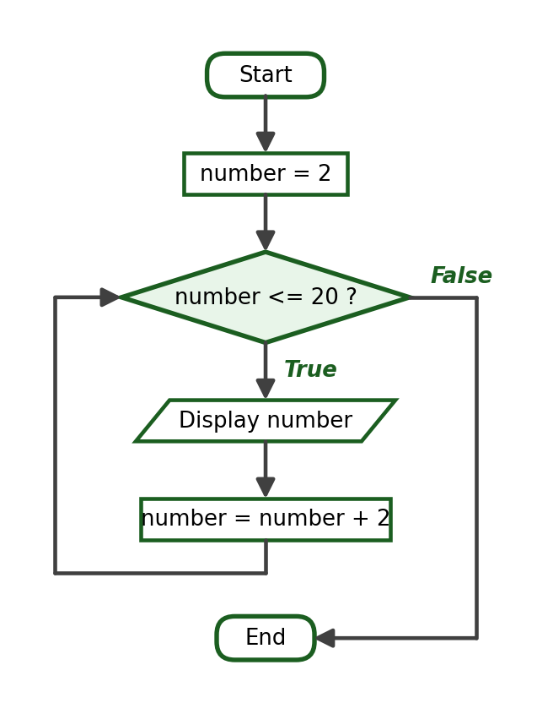
Python Program:
for number in range(2, 21, 2):
print(number)

Sample Run:
2
4
6
8
10
12
14
16
18
20

Explanation: The step value 2 makes the sequence skip every odd number. The stop value 21 allows 20 to be included.

Example 8.3: Display the Numbers from 10 Down to 1
Problem Statement: Display the numbers from 10 down to 1 in decreasing order.
IPO Table:
Input | Process | Output
None | Repeat for the values 10, 9, 8, …, 1 | The numbers 10 down to 1

Algorithm:
Step 1: Start.
Step 2: For each number from 10 down to 1, display the number.
Step 3: End.

Pseudocode:
START
FOR number = 10 DOWNTO 1
DISPLAY number
END FOR
END

Flowchart:
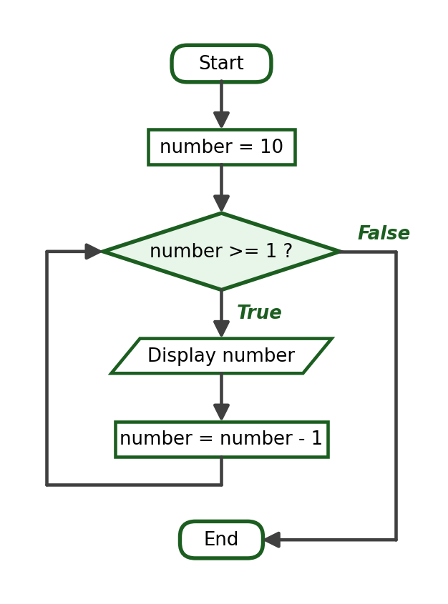
Python Program:
for number in range(10, 0, -1):
print(number)

Sample Run:
10
9
8
7
6
5
4
3
2
1

Explanation: A negative step of -1 counts downward. The stop value 0 is excluded, so the last value produced is 1.

Example 8.4: Sum of the Numbers from 1 to N
Problem Statement: Ask the user for a positive integer N and compute the sum 1 + 2 + … + N.
Problem Analysis: The program needs one input (the limit), an accumulator initialized to 0 before the loop, and a loop that adds each value from 1 to the limit.
IPO Table:
Input | Process | Output
limit | Add every number from 1 to limit into total | The sum total

Required Variables: limit (int), number (int), total (int).
Algorithm:
Step 1: Start.
Step 2: Ask the user for a positive integer. Store it as limit.
Step 3: Set total to 0.
Step 4: For each number from 1 to limit, add number to total.
Step 5: Display total.
Step 6: End.

Pseudocode:
START
INPUT limit
total = 0
FOR number = 1 TO limit
total = total + number
END FOR
DISPLAY total
END

Flowchart:
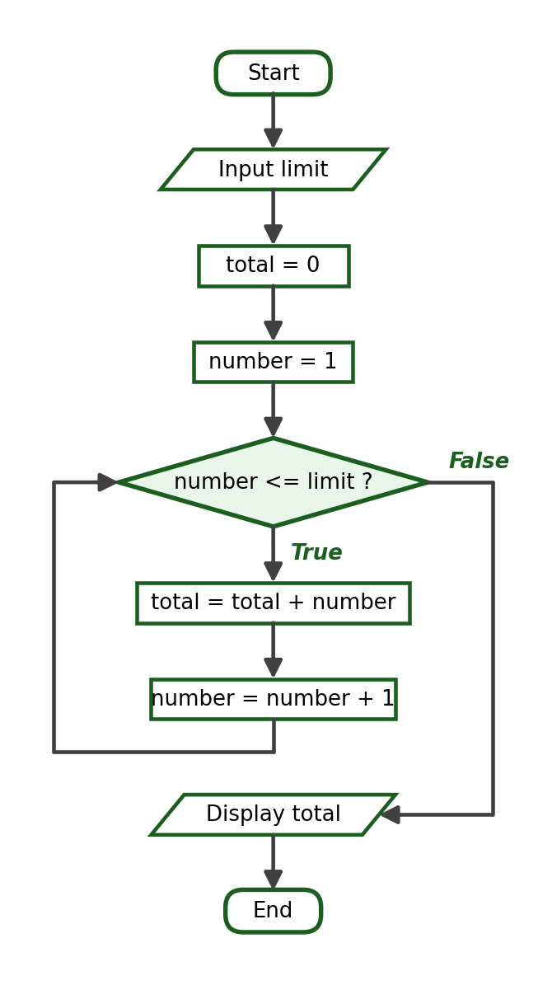
Python Program:
limit = int(input("Enter a positive integer: "))
total = 0
for number in range(1, limit + 1):
total += number
print("The sum of numbers from 1 to", limit, "is", total)

Trace Table:
Iteration | number | total before | total after
1 | 1 | 0 | 1
2 | 2 | 1 | 3
3 | 3 | 3 | 6
4 | 4 | 6 | 10
5 | 5 | 10 | 15

Sample Run 1:
Enter a positive integer: 5
The sum of numbers from 1 to 5 is 15

Sample Run 2:
Enter a positive integer: 1
The sum of numbers from 1 to 1 is 1

Sample Run 3:
Enter a positive integer: 10
The sum of numbers from 1 to 10 is 55

Explanation: The accumulator total is initialized to 0 exactly once, before the loop. Sample Run 2 tests the boundary value N = 1, whose sum is simply 1.

Example 8.5: Multiplication Table of a Given Number
Problem Statement: Ask the user for an integer and display its multiplication table from 1 to 10.
IPO Table:
Input | Process | Output
number | Multiply number by every value from 1 to 10 | Ten multiplication lines

Required Variables: number (int), multiplier (int), product (int).
Algorithm:
Step 1: Start.
Step 2: Ask the user for an integer. Store it as number.
Step 3: For each multiplier from 1 to 10, compute product = number × multiplier and display the line.
Step 4: End.

Pseudocode:
START
INPUT number
FOR multiplier = 1 TO 10
product = number * multiplier
DISPLAY number, " x ", multiplier, " = ", product
END FOR
END

Flowchart:
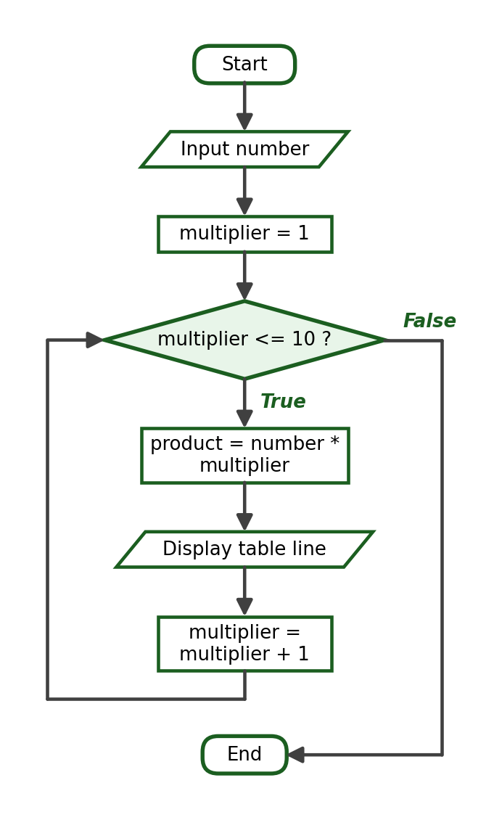
Python Program:
number = int(input("Enter an integer: "))
for multiplier in range(1, 11):
product = number * multiplier
print(f"{number} x {multiplier} = {product}")

Sample Run:
Enter an integer: 7
7 x 1 = 7
7 x 2 = 14
7 x 3 = 21
7 x 4 = 28
7 x 5 = 35
7 x 6 = 42
7 x 7 = 49
7 x 8 = 56
7 x 9 = 63
7 x 10 = 70

Explanation: The loop variable multiplier moves from 1 to 10 while number stays the same. The f-string produces readable formatted output.

9. The while Loop
The while loop repeats a block of statements for as long as its condition remains True. Its syntax is:
while condition:
statement
statement

The condition is checked before every iteration. If the condition is False the very first time, the body is never executed. A while loop is appropriate when the number of repetitions is not known in advance — for example, when the repetition depends on the values the user enters. Because the update must be written by the programmer, always verify that some statement inside the body can eventually make the condition False.

Example 9.1: Display the Numbers from 1 to 10
Problem Statement: Display the whole numbers from 1 to 10 using a while loop.
IPO Table:
Input | Process | Output
None | Repeat while number <= 10 | The numbers 1 to 10

Algorithm:
Step 1: Start.
Step 2: Set number to 1.
Step 3: While number <= 10, display number and then add 1 to number.
Step 4: End.

Pseudocode:
START
number = 1
WHILE number <= 10
DISPLAY number
number = number + 1
END WHILE
END

Flowchart:
Python Program:
number = 1
while number <= 10:
print(number)
number += 1

Sample Run:
1
2
3
4
5
6
7
8
9
10

Explanation: The three parts of the loop are all visible: the initialization number = 1, the condition number <= 10, and the update number += 1.

Example 9.2: Sum of Five Entered Numbers
Problem Statement: Accept five numbers from the user and display their total.
IPO Table:
Input | Process | Output
Five numbers | Add each entered value into total | The total of the five numbers

Required Variables: count (int), value (float), total (float).
Algorithm:
Step 1: Start.
Step 2: Set count to 1 and total to 0.
Step 3: While count <= 5, ask for a number, add it to total, and add 1 to count.
Step 4: Display total.
Step 5: End.

Pseudocode:
START
count = 1
total = 0
WHILE count <= 5
INPUT value
total = total + value
count = count + 1
END WHILE
DISPLAY total
END

Flowchart:
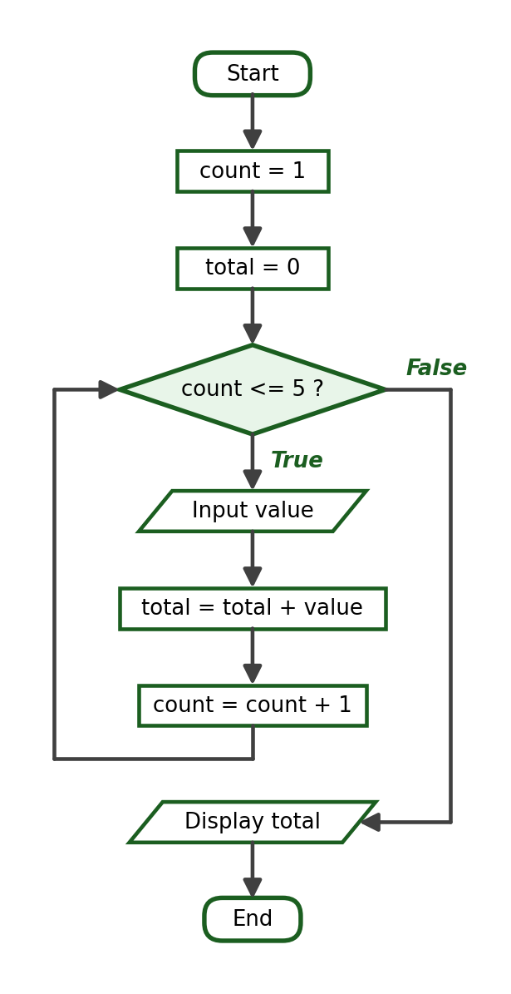
Python Program:
count = 1
total = 0
while count <= 5:
value = float(input("Enter a number: "))
total += value
count += 1
print(f"Total: {total:.2f}")

Trace Table:
Iteration | value | total after | count after
1 | 10.0 | 10.0 | 2
2 | 20.0 | 30.0 | 3
3 | 30.0 | 60.0 | 4
4 | 40.0 | 100.0 | 5
5 | 50.0 | 150.0 | 6

Sample Run:
Enter a number: 10
Enter a number: 20
Enter a number: 30
Enter a number: 40
Enter a number: 50
Total: 150.00

Explanation: The counter count controls the number of repetitions while the accumulator total collects the running sum. When count becomes 6, the condition is False and the total is displayed.

Example 9.3: Repeatedly Ask for a Positive Number
Problem Statement: Ask the user for a positive number. If the value is zero or negative, display a reminder and ask again until a positive number is entered.
IPO Table:
Input | Process | Output
One or more numbers | Repeat the input while the value is not positive | The accepted positive number

Algorithm:
Step 1: Start.
Step 2: Ask the user for a positive number. Store it as number.
Step 3: While number <= 0, display a reminder and ask again.
Step 4: Display the accepted number.
Step 5: End.

Pseudocode:
START
INPUT number
WHILE number <= 0
DISPLAY "The number must be positive."
INPUT number
END WHILE
DISPLAY number
END

Flowchart:
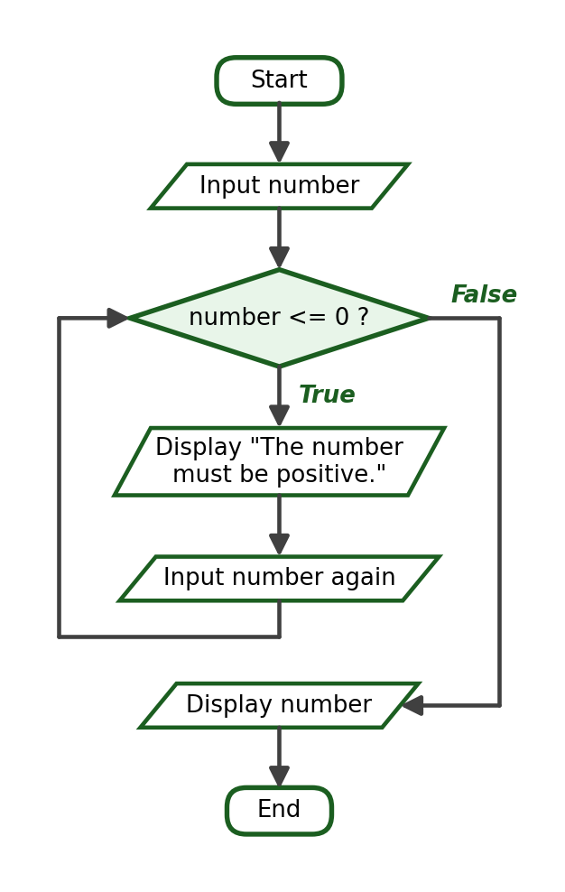
Python Program:
number = float(input("Enter a positive number: "))
while number <= 0:
print("The number must be positive.")
number = float(input("Enter a positive number: "))
print("You entered:", number)

Sample Run:
Enter a positive number: -8
The number must be positive.
Enter a positive number: 0
The number must be positive.
Enter a positive number: 12
You entered: 12.0

Explanation: This is an input-validation loop: the body executes only while the entered value is invalid. A valid first entry skips the loop entirely.

Example 9.4: Count Down from a Given Number
Problem Statement: Ask the user for a starting number and count down from that number to 1, then display “Done!”.
IPO Table:
Input | Process | Output
start | Repeat while count >= 1, decreasing count | The countdown and “Done!”

Algorithm:
Step 1: Start.
Step 2: Ask the user for the starting number. Store it as start and copy it to count.
Step 3: While count >= 1, display count and subtract 1 from count.
Step 4: Display “Done!”.
Step 5: End.

Pseudocode:
START
INPUT start
count = start
WHILE count >= 1
DISPLAY count
count = count - 1
END WHILE
DISPLAY "Done!"
END

Flowchart:
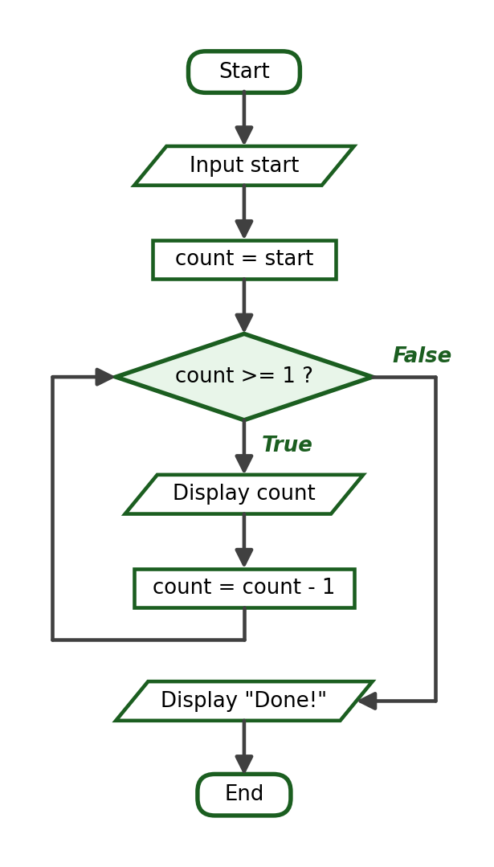
Python Program:
start = int(input("Enter the starting number: "))
count = start
while count >= 1:
print(count)
count -= 1
print("Done!")

Sample Run:
Enter the starting number: 5
5
4
3
2
1
Done!

Explanation: The update subtracts instead of adds, so the loop counts downward. When count reaches 0, the condition 0 >= 1 is False and the loop ends.

Example 9.5: Sentinel-Controlled Repetition
Problem Statement: Accept positive numbers from the user and display each one. Stop when the user enters -1.
Problem Analysis: A sentinel value is a special value that signals the end of the input. The sentinel here is -1. The first input before the loop is called the priming input; it gives the condition its first value to test. Inside the loop, the last statement asks for the next value — this is the update of a sentinel-controlled loop.
IPO Table:
Input | Process | Output
Numbers ending with -1 | Repeat while the value is not the sentinel | Each entered number and an end message

Algorithm:
Step 1: Start.
Step 2: Ask the user for a number (priming input). Store it as number.
Step 3: While number is not -1, display the number and ask for the next number.
Step 4: Display the end message.
Step 5: End.

Pseudocode:
START
INPUT number
WHILE number <> -1
DISPLAY number
INPUT number
END WHILE
DISPLAY "The loop has ended."
END

Flowchart:
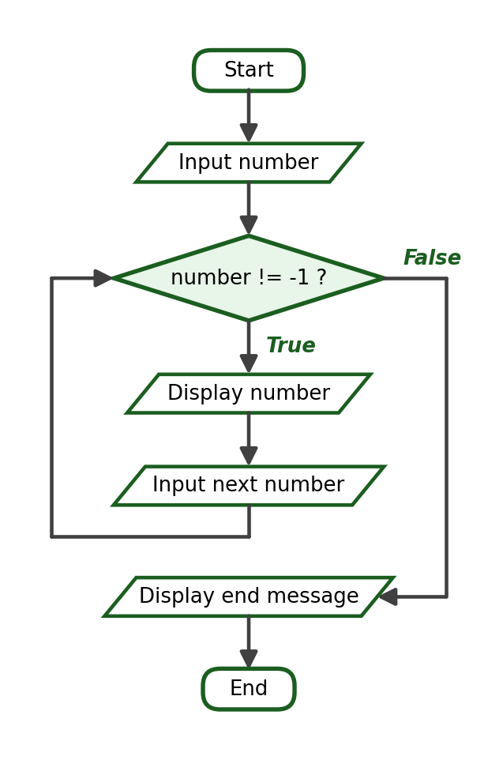
Python Program:
number = int(input("Enter a positive number or -1 to stop: "))
while number != -1:
print("You entered:", number)
number = int(input("Enter a positive number or -1 to stop: "))
print("Sentinel received. The loop has ended.")

Sample Run:
Enter a positive number or -1 to stop: 5
You entered: 5
Enter a positive number or -1 to stop: 8
You entered: 8
Enter a positive number or -1 to stop: 3
You entered: 3
Enter a positive number or -1 to stop: -1
Sentinel received. The loop has ended.

Explanation: The sentinel -1 is tested by the condition but is never processed by the body, so it is not displayed. Sentinel-controlled loops are the standard way to accept input when the number of entries is unknown.

Checkpoint B: Trace the Loop
For each program, complete a trace table showing the iteration number, the value of every variable after the iteration, and the output produced. Then write the final output of the program.
Program 1:
for number in range(1, 5):
print(number)

Program 2:
count = 10
while count >= 4:
print(count)
count -= 2

Program 3:
total = 0
for number in range(1, 5):
total += number
print(total)

Program 4:
count = 0
for number in range(3, 16, 4):
count += 1
print(count)

Program 5:
value = 1
while value < 20:
print(value)
value = value * 2

Program 6:
total = 0
count = 1
while count <= 4:
total += count * 2
count += 1
print(total)

Program 7:
result = 1
for number in range(1, 5):
result *= number
print(result)

Program 8:
number = 7
count = 0
while number > 0:
number -= 3
count += 1
print(number, count)

10. The do-while Logic Concept and Its Python Equivalent
The while loop you have just studied is a pre-test loop: the condition is tested before the body executes. If the condition is False at the very start, the body never runs even once. The following program demonstrates this:
count = 10
while count <= 5:
print("This line never executes.")
count += 1
print("The loop body was skipped entirely.")

Output:
The loop body was skipped entirely.

Some problems require the opposite behaviour. A program that asks for a password must ask at least once before it can possibly know whether the password is correct. A menu must be displayed at least once before the user can choose to exit. This pattern — execute the body first, then test the condition — is known in program design as do-while logic, or a post-test loop. In pseudocode it is written as:
DO
statement
statement
WHILE condition

Important: Python has no native do-while statement. The keywords do and do...while are not part of the Python language, and writing them produces a SyntaxError. Python provides only two looping statements: for and while. The do-while logic concept must therefore be implemented using an equivalent while-loop structure.
There are two standard ways to express do-while logic in Python.
Method 1 — while True with a break. The body executes first; the test is written at the end of the body, and break provides the exit:
correct_password = "cpe2026"
while True:
password = input("Enter the password: ")
if password == correct_password:
break
print("Incorrect password. Please try again.")
print("Access granted.")

Sample Run:
Enter the password: python
Incorrect password. Please try again.
Enter the password: cpp102
Incorrect password. Please try again.
Enter the password: cpe2026
Access granted.

The prompt is displayed before any test is possible, which is exactly the behaviour do-while logic requires. The loop repeats until the entered password matches, and break ends it.
Method 2 — a flag variable. A Boolean variable records whether the loop should continue. The flag is initialized so that the first test is always True, guaranteeing at least one execution of the body:
number = 0
finished = False
while not finished:
number = int(input("Enter a number greater than 100: "))
if number > 100:
finished = True
else:
print("The number must be greater than 100.")
print("Accepted number:", number)

Sample Run:
Enter a number greater than 100: 45
The number must be greater than 100.
Enter a number greater than 100: 100
The number must be greater than 100.
Enter a number greater than 100: 250
Accepted number: 250

A third common form uses a control variable whose initial value cannot satisfy the exit condition. The menu below repeats until the user chooses option 4, and the menu is always displayed at least once because choice is initialized to 0:
choice = 0
while choice != 4:
print("[1] Add [2] View [3] Report [4] Exit")
choice = int(input("Enter your choice: "))
if choice == 1:
print("Adding a record.")
elif choice == 2:
print("Viewing the records.")
elif choice == 3:
print("Printing the report.")
elif choice == 4:
print("Exiting the program.")
else:
print("Invalid choice.")

Sample Run:
[1] Add [2] View [3] Report [4] Exit
Enter your choice: 1
Adding a record.
[1] Add [2] View [3] Report [4] Exit
Enter your choice: 3
Printing the report.
[1] Add [2] View [3] Report [4] Exit
Enter your choice: 7
Invalid choice.
[1] Add [2] View [3] Report [4] Exit
Enter your choice: 4
Exiting the program.

Loop Form | When the Condition Is Tested | Minimum Number of Executions | Python Implementation
Pre-test loop | Before the body | 0 | while condition:
Post-test loop (do-while logic) | After the body | 1 | while True: … if …: break, or a flag variable

Use do-while logic whenever the problem statement contains the words “ask at least once”, “repeat until”, “display the menu until the user exits”, or “keep asking until the entry is correct”. Note that a plain input-validation loop, which reads a value before the loop and re-reads it inside, achieves a similar effect; both structures are acceptable, and Section 15 examines input validation in detail.

11. for Loop Versus while Loop
Both loops repeat statements, but each one is more natural in particular situations. Use the following guide:
Situation | Recommended Loop
Repeat exactly 10 times | for
Display all values in a range | for
Continue until a valid input is entered | while
Continue until the user enters a sentinel | while
Repeat while a condition remains true | while
Execute the body at least once (do-while logic) | while

The two programs below are equivalent — both display a greeting five times:
Using a for loop:
for number in range(1, 6):
print("Welcome to CPP102!")

Using a while loop:
number = 1
while number <= 5:
print("Welcome to CPP102!")
number += 1

Output of both programs:
Welcome to CPP102!
Welcome to CPP102!
Welcome to CPP102!
Welcome to CPP102!
Welcome to CPP102!

The for version is shorter and keeps all three loop parts in one line, so it is harder to forget the update. The while version needs three separate statements, but it becomes the better choice the moment the number of repetitions depends on the data — a for loop cannot easily say “repeat until the user enters a valid grade.” As a rule of thumb: if you can count the repetitions before the loop starts, use for; if the repetitions depend on a condition discovered while the loop runs, use while.

12. Infinite Loops
An infinite loop is a loop whose condition never becomes False. The program repeats forever and appears frozen. The most common cause is a missing update. Study this incorrect program:
count = 1
while count <= 5:
print(count)

The variable count starts at 1 and is never changed inside the body, so the condition 1 <= 5 remains True forever and the program prints 1 endlessly. The corrected version adds the update:
count = 1
while count <= 5:
print(count)
count += 1

Output:
1
2
3
4
5

Some programs use an intentional infinite loop:
while True:
print("Running")

Because the condition is the constant True, this loop can never end on its own. An intentional infinite loop is acceptable only when the body contains a valid exit mechanism such as a break statement, which you will study in the next section. Do not run an uncontrolled infinite loop on purpose; if a program becomes stuck, press Ctrl+C in the terminal to interrupt it.
Warning: before running a while loop, verify that at least one statement inside the loop can eventually make the condition false.

13. The break Statement
The break statement immediately terminates the nearest enclosing loop. Execution continues with the first statement after the loop. break is normally placed inside an if statement so that the loop stops only when a particular situation occurs.
Example 13.1 — stop when a particular number is reached. The loop below is written to count from 1 to 10, but it stops as soon as the value 6 appears:
for number in range(1, 11):
if number == 6:
break
print(number)

Output:
1
2
3
4
5

The number 6 is not printed because break executes before the print statement: when number equals 6, the condition of the if statement is True, the loop terminates immediately, and the remaining values 6 to 10 are never displayed.
Example 13.2 — stop when the user enters a sentinel. An intentional infinite loop combined with break is a common pattern for sentinel-controlled input:
while True:
number = int(input("Enter a number (0 to stop): "))
if number == 0:
break
print("You entered:", number)
print("The loop has ended.")

Sample Run:
Enter a number (0 to stop): 4
You entered: 4
Enter a number (0 to stop): 7
You entered: 7
Enter a number (0 to stop): 0
The loop has ended.

Example 13.3 — stop when a correct input is entered. The loop repeats until the user guesses the secret code:
secret_code = 4
while True:
guess = int(input("Guess the secret code (1 to 9): "))
if guess == secret_code:
print("Correct! The loop stops here.")
break
print("Wrong code. Try again.")

Sample Run:
Guess the secret code (1 to 9): 2
Wrong code. Try again.
Guess the secret code (1 to 9): 9
Wrong code. Try again.
Guess the secret code (1 to 9): 4
Correct! The loop stops here.

14. The continue Statement
The continue statement skips the remaining statements of the current iteration and jumps immediately to the next iteration of the loop. Unlike break, the loop itself does not stop.
Example 14.1 — skip a specific number:
for number in range(1, 6):
if number == 3:
continue
print(number)

Output:
1
2
4
5

When number equals 3, continue skips the print statement for that iteration only; the loop then proceeds normally with 4 and 5.
Example 14.2 — display only the odd numbers:
for number in range(1, 11):
if number % 2 == 0:
continue
print(number)

Output:
1
3
5
7
9

Example 14.3 — ignore negative values while accumulating positive values:
total = 0
for count in range(1, 6):
value = int(input("Enter a number: "))
if value < 0:
continue
total += value
print("Total of the positive values:", total)

Sample Run:
Enter a number: 10
Enter a number: -4
Enter a number: 25
Enter a number: -7
Enter a number: 5
Total of the positive values: 40

The values -4 and -7 are skipped by continue, so only 10 + 25 + 5 = 40 is accumulated.
Statement | Effect
break | Terminates the loop completely
continue | Skips only the current iteration and proceeds to the next one

Checkpoint C: Predict the Output
Write the exact terminal output of each program.
Program 1:
for number in range(1, 6):
print(number)

Program 2:
for number in range(5, 0, -1):
print(number)

Program 3:
total = 0
for number in range(1, 4):
total += number
print("Total:", total)

Program 4:
for number in range(1, 8):
if number == 4:
break
print(number)

Program 5:
for number in range(1, 6):
if number % 2 == 0:
continue
print(number)

Program 6:
total = 0
for number in range(1, 11):
if number % 4 == 0:
total += number
print("Total:", total)

Program 7:
for number in range(1, 4):
print(f"Line {number}")

Program 8:
number = 10
while number >= 4:
print(number)
number -= 3

Program 9:
for number in range(1, 11):
if number % 3 == 0:
print(number)

Program 10:
total = 0
count = 0
for number in range(2, 9, 2):
total += number
count += 1
print("Count:", count)
print("Total:", total)

15. Input Validation Using Loops
A program should not accept values that make no sense, such as a grade of 150 or a quantity of -3. An input-validation loop repeatedly requests input until the user supplies an acceptable value. The pattern is: read the first value, then loop while the value is invalid, warning the user and reading again. These examples assume the user enters a numeric value of the expected type; handling wrongly typed input requires exception handling, which is beyond the scope of this course.
Example 15.1 — grade from 0 to 100:
grade = float(input("Enter a grade from 0 to 100: "))
while grade < 0 or grade > 100:
print("Invalid grade.")
grade = float(input("Enter a grade from 0 to 100: "))
print("Accepted grade:", grade)

Sample Run:
Enter a grade from 0 to 100: 150
Invalid grade.
Enter a grade from 0 to 100: -5
Invalid grade.
Enter a grade from 0 to 100: 88
Accepted grade: 88.0

Example 15.2 — positive quantity:
quantity = int(input("Enter a positive quantity: "))
while quantity <= 0:
print("The quantity must be greater than zero.")
quantity = int(input("Enter a positive quantity: "))
print("Accepted quantity:", quantity)

Sample Run:
Enter a positive quantity: -3
The quantity must be greater than zero.
Enter a positive quantity: 0
The quantity must be greater than zero.
Enter a positive quantity: 7
Accepted quantity: 7

Example 15.3 — menu choice from 1 to 3:
choice = int(input("Enter your choice (1, 2, or 3): "))
while choice < 1 or choice > 3:
print("Invalid choice.")
choice = int(input("Enter your choice (1, 2, or 3): "))
print("You selected option", choice)

Sample Run:
Enter your choice (1, 2, or 3): 5
Invalid choice.
Enter your choice (1, 2, or 3): 0
Invalid choice.
Enter your choice (1, 2, or 3): 2
You selected option 2

In each program the loop condition describes the invalid values, so the body executes only while the input is unacceptable. Study the condition of Example 15.1: a grade is invalid when it is less than 0 or greater than 100, which is exactly the Boolean expression grade < 0 or grade > 100 from Week 5.

16. Flowcharts for Looping Structures
Loops are drawn with the same standard flowchart symbols used in the previous weeks. The decision diamond holds the loop condition, and an arrow returns from the update step back to the condition — this returning arrow is what makes the diagram a loop.
Symbol | Purpose
Oval | Start or End
Parallelogram | Input or Output
Rectangle | Processing
Diamond | Condition or decision
Arrow | Direction of flow

Every loop flowchart must clearly show the initialization before the loop, the condition inside a decision diamond with its True and False paths labeled, the repeated process, the update, the return arrow going back to the condition, and the exit path leading to the next part of the program.

a. Flowchart of a Counter-Controlled Loop (for)
The diagram below shows a loop that displays the values 1 to 5. The initialization, condition, body, and update of a for loop are drawn explicitly:
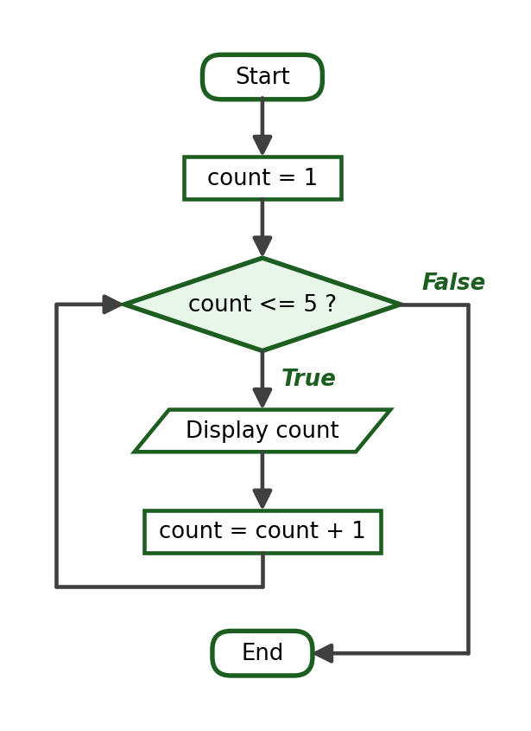

b. Flowchart of a Condition-Controlled Loop (while)
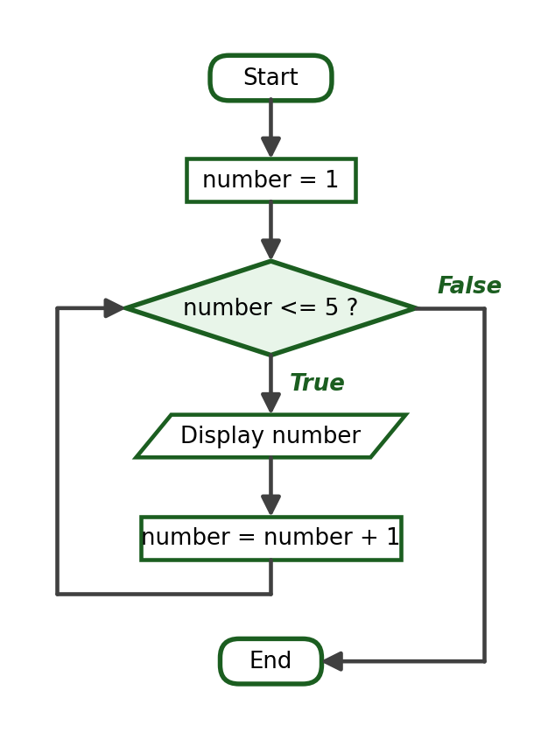

c. Flowchart of a Sentinel-Controlled Loop
The priming input appears before the condition, and the next input is requested at the end of the body:
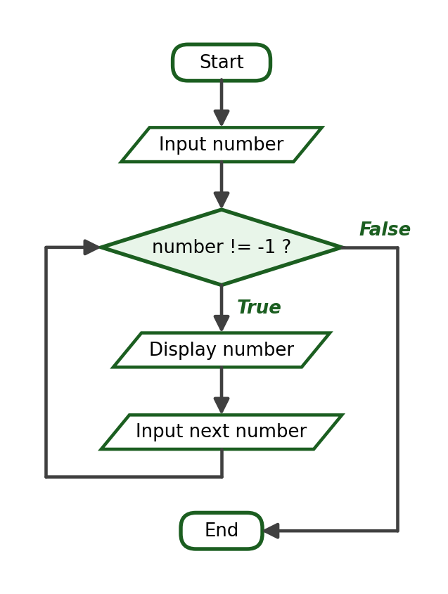

d. Flowchart of an Input-Validation Loop
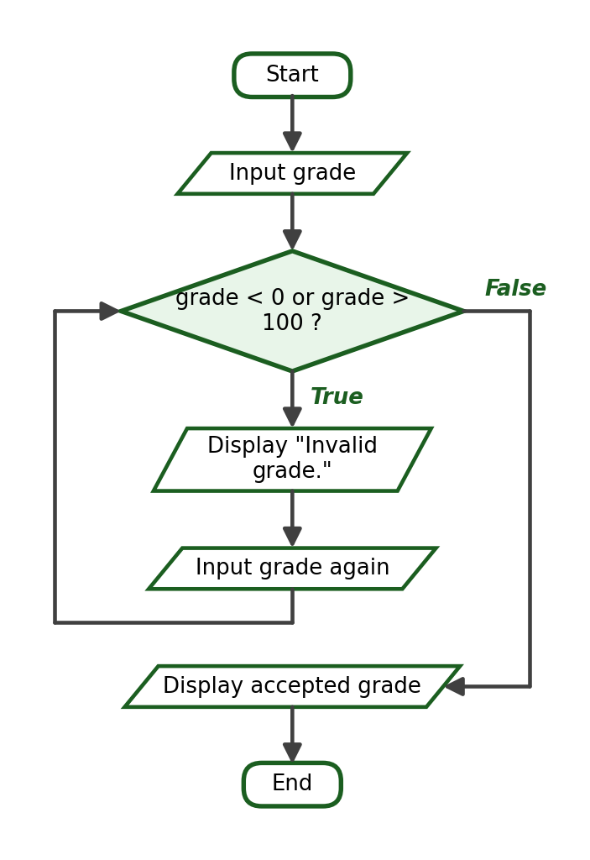

e. Flowchart of a Loop with break
The second decision inside the body represents the break test. Its True path exits the loop immediately:
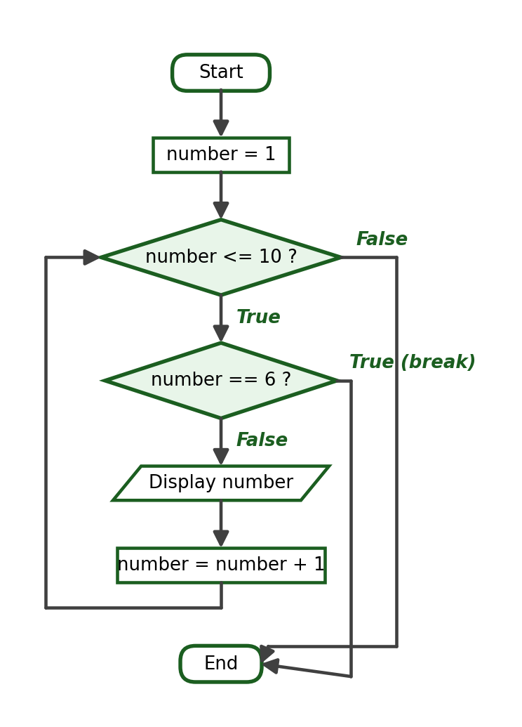

f. Flowchart of the do-while Logic Concept
In a post-test structure the process executes before the decision is reached, and the False path returns to the process rather than to a test placed above it. Compare this diagram with the pre-test flowcharts above:
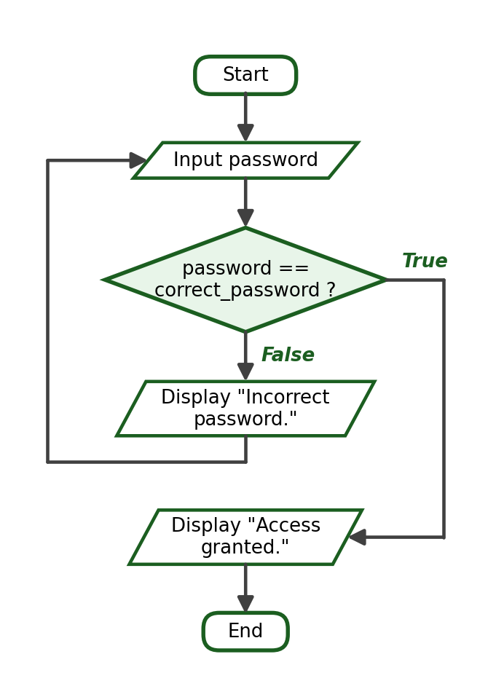

g. Flowchart of a Menu Loop Using do-while Logic
The control variable is initialized to a value that cannot satisfy the exit condition, so the menu is always displayed at least once:
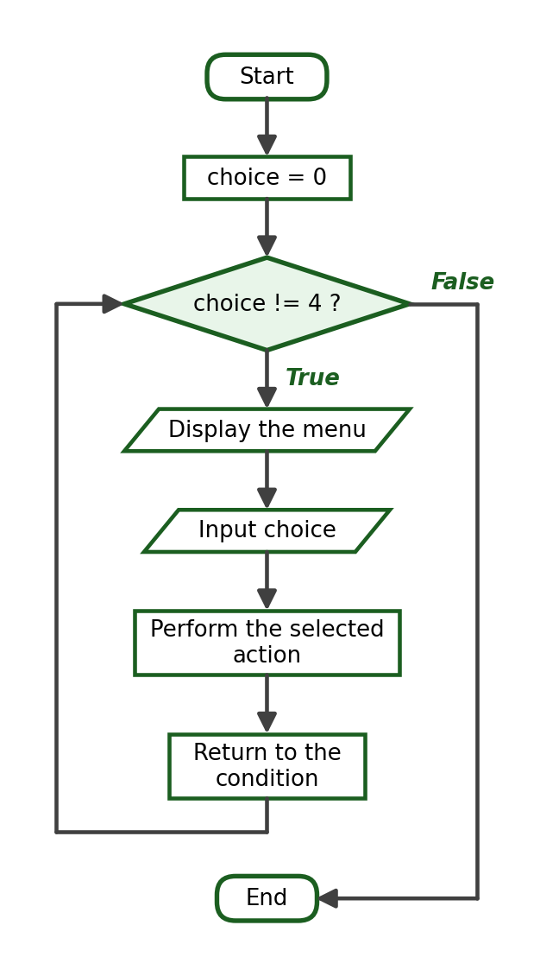

17. Common Looping Errors
The table below lists the errors that beginning programmers most often make when writing loops. Study each one carefully — several of them will appear in Checkpoint D.
Error | Explanation | Correction
Forgetting to update a while loop variable | The condition never becomes False, producing an infinite loop | Add an update statement such as count += 1 inside the body
Incorrect indentation | Statements meant to repeat are outside the loop, or Python reports an IndentationError | Indent the loop body consistently by four spaces
Using the wrong comparison operator | The loop repeats too many times, too few times, or not at all | Check whether <, <=, >, or >= matches the problem
Off-by-one error | The loop runs one time too many or one time too few | Verify the first value, the last value, and the number of iterations
Incorrect range() stop value | The final value is missing because stop is excluded | Use range(1, n + 1) to include n
Incorrect positive or negative step | The sequence is empty because the step moves away from stop | Use a negative step to count downward, positive to count upward
Placing initialization inside the loop | The variable is reset during every iteration | Initialize counters and accumulators before the loop
Resetting an accumulator during every iteration | The total only remembers the last value | Move total = 0 above the loop
Placing break outside a loop | Python reports SyntaxError: 'break' outside loop | Use break only inside a for or while body
Placing continue outside a loop | Python reports SyntaxError: 'continue' not properly in loop | Use continue only inside a for or while body
Unreachable statements after break | Code placed after break in the same block never executes | Put break after the statements that must run
Using = instead of == | Python reports a SyntaxError inside a condition | Use == for comparison and = for assignment
Missing colon | Python reports a SyntaxError at the loop header | End every for and while header with a colon
Writing do or do...while in Python | Python has no do-while statement; the keywords produce a SyntaxError | Implement do-while logic with while True plus break, or with a flag variable
Mixing tabs and spaces | Python reports TabError: inconsistent use of tabs and spaces | Use four spaces only; configure the editor to insert spaces

The accumulator-reset error deserves special attention. Study this incorrect program, which is intended to compute 1 + 2 + 3 + 4 + 5:
for number in range(1, 6):
total = 0
total += number
print("Total:", total)

Because total = 0 is inside the loop, the accumulator is wiped out at the start of every iteration, and after the loop it holds only the last value, 5. The initialization must occur exactly once, before the repetition begins:
total = 0
for number in range(1, 6):
total += number
print("Total:", total)

Output:
Total: 15

Checkpoint D: Correct the Code
Each program contains at least one error. Identify the error, rewrite the program correctly, and state the expected output of the corrected program when applicable.
Program 1 (intended to display "Hello" three times):
count = 1
while count <= 3:
print("Hello")

Program 2 (intended to display the numbers 1 to 5):
for number in range(1, 6):
print(number)

Program 3 (intended to display the numbers 1 to 10):
for number in range(1, 10):
print(number)

Program 4 (intended to display the even numbers from 10 to 20):
for number in range(10, 21, -2):
print(number)

Program 5 (intended to compute 1 + 2 + 3):
for number in range(1, 4):
total = 0
total += number
print(total)

Program 6 (intended to count down from 5 to 1):
count = 5
while count <= 1:
print(count)
count -= 1

Program 7 (intended to skip the number 3):
for number in range(1, 6)
if number == 3:
continue
print(number)

Program 8 (intended to stop the loop when the number 5 is reached):
for number in range(1, 8):
if number == 5:
print(number)
break

Checkpoint E: Choose the Appropriate Loop
For each situation, choose the more appropriate loop (for or while) and briefly explain your choice.
- Repeat a message exactly 10 times.
- Continue asking until a valid grade from 0 to 100 is entered.
- Display all numbers from 1 to 100.
- Accept expense amounts until zero is entered.
- Display a menu repeatedly until the user chooses Exit.
- Display the multiplication table of a number from 1 to 10.
- Keep asking for a menu choice until the user selects a valid option.
- Accept quiz scores until the sentinel value -1 is entered.

18. Guided Problem-Solving Examples
Each guided example below follows the complete problem-solving process of this course: problem analysis, IPO table, variables, condition or formula, algorithm, pseudocode, flowchart, Python program, trace table, and verified sample runs. Study every step — the laboratory activities require the same process.

Guided Example 1: Display the Numbers from 1 to N
Problem Statement: Ask the user for a positive integer and display the numbers from 1 up to that value.
Problem Analysis: The number of repetitions equals the entered value, which is known once the input is read, so a counter-controlled for loop is appropriate. The boundary requires range(1, limit + 1) so that the limit itself is included.
IPO Table:
Input | Process | Output
limit | Repeat for each number from 1 to limit | The numbers 1 to limit

Required Variables: limit (int), number (int).
Formula / Condition: number = 1, 2, 3, …, limit
Algorithm:
Step 1: Start.
Step 2: Ask the user for a positive integer. Store it as limit.
Step 3: For each number from 1 to limit, display the number.
Step 4: End.

Pseudocode:
START
INPUT limit
FOR number = 1 TO limit
DISPLAY number
END FOR
END

Flowchart:
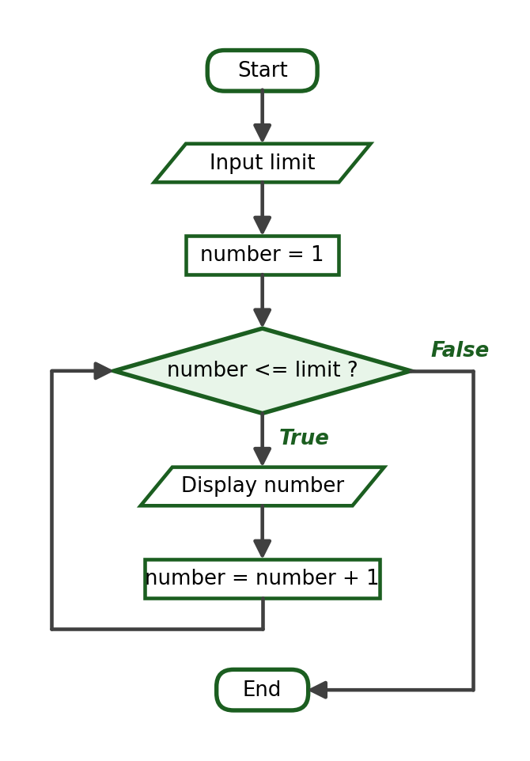
Python Program:
limit = int(input("Enter a positive integer: "))
for number in range(1, limit + 1):
print(number)

Trace Table:
Iteration | number | Output
1 | 1 | 1
2 | 2 | 2
3 | 3 | 3
4 | 4 | 4
5 | 5 | 5
6 | 6 | 6
7 | 7 | 7

Sample Run:
Enter a positive integer: 7
1
2
3
4
5
6
7

Explanation: With the input 7, range(1, 8) produces exactly the values 1 to 7. The loop ends when the sequence is exhausted.

Guided Example 2: Sum of the Numbers from 1 to N
Problem Statement: Ask the user for a positive integer and calculate the total of all integers from 1 through that value.
Problem Analysis: An accumulator must be initialized to 0 before the loop. Each iteration adds the current number. The expected result for N = 10 is 1 + 2 + … + 10 = 55.
IPO Table:
Input | Process | Output
limit | Add each number from 1 to limit into total | The sum total

Required Variables: limit (int), number (int), total (int).
Formula / Condition: total = total + number, repeated for number = 1 to limit
Algorithm:
Step 1: Start.
Step 2: Ask the user for a positive integer. Store it as limit.
Step 3: Set total to 0.
Step 4: For each number from 1 to limit, add number to total.
Step 5: Display total.
Step 6: End.

Pseudocode:
START
INPUT limit
total = 0
FOR number = 1 TO limit
total = total + number
END FOR
DISPLAY total
END

Flowchart:
Python Program:
limit = int(input("Enter a positive integer: "))
total = 0
for number in range(1, limit + 1):
total += number
print("The sum of numbers from 1 to", limit, "is", total)

Trace Table:
Iteration | number | total before | total after
1 | 1 | 0 | 1
2 | 2 | 1 | 3
3 | 3 | 3 | 6
4 | 4 | 6 | 10
5 | 5 | 10 | 15
6 | 6 | 15 | 21
7 | 7 | 21 | 28
8 | 8 | 28 | 36
9 | 9 | 36 | 45
10 | 10 | 45 | 55

Sample Run 1:
Enter a positive integer: 10
The sum of numbers from 1 to 10 is 55

Sample Run 2:
Enter a positive integer: 1
The sum of numbers from 1 to 1 is 1

Sample Run 3:
Enter a positive integer: 100
The sum of numbers from 1 to 100 is 5050

Explanation: Sample Run 2 tests the smallest valid input, N = 1. Sample Run 3 confirms the well-known result that the numbers 1 to 100 add up to 5050.

Guided Example 3: Multiplication Table
Problem Statement: Ask the user for an integer and display its multiplication table from 1 to 10.
Problem Analysis: The number of lines is fixed at 10, so a for loop over the multiplier is appropriate. The entered number never changes inside the loop.
IPO Table:
Input | Process | Output
number | Compute product = number × multiplier for multiplier = 1 to 10 | Ten formatted table lines

Required Variables: number (int), multiplier (int), product (int).
Formula / Condition: product = number * multiplier
Algorithm:
Step 1: Start.
Step 2: Ask the user for an integer. Store it as number.
Step 3: For each multiplier from 1 to 10, compute the product and display the formatted line.
Step 4: End.

Pseudocode:
START
INPUT number
FOR multiplier = 1 TO 10
product = number * multiplier
DISPLAY number, " x ", multiplier, " = ", product
END FOR
END

Flowchart:
Python Program:
number = int(input("Enter an integer: "))
for multiplier in range(1, 11):
product = number * multiplier
print(f"{number} x {multiplier} = {product}")

Trace Table:
Iteration | multiplier | product | Output
1 | 1 | 6 | 6 x 1 = 6
2 | 2 | 12 | 6 x 2 = 12
3 | 3 | 18 | 6 x 3 = 18
… | … | … | …
10 | 10 | 60 | 6 x 10 = 60

Sample Run:
Enter an integer: 6
6 x 1 = 6
6 x 2 = 12
6 x 3 = 18
6 x 4 = 24
6 x 5 = 30
6 x 6 = 36
6 x 7 = 42
6 x 8 = 48
6 x 9 = 54
6 x 10 = 60

Explanation: The f-string inserts the three values into a readable sentence. The loop performs exactly ten iterations regardless of the number entered.

Guided Example 4: Average of Several Scores
Problem Statement: Ask how many scores will be entered, accept the scores one at a time, calculate their total, and display the average with two decimal places. Do not use a list.
Problem Analysis: The count is entered first, so the loop is counter-controlled. The accumulator collects the scores, and the average is computed after the loop by dividing the total by the count.
IPO Table:
Input | Process | Output
count, then count scores | Accumulate every score into total; average = total / count | The average of the scores

Required Variables: count (int), entry (int), score (float), total (float), average (float).
Formula / Condition: average = total / count
Algorithm:
Step 1: Start.
Step 2: Ask how many scores will be entered. Store it as count.
Step 3: Set total to 0.
Step 4: For each entry from 1 to count, ask for a score and add it to total.
Step 5: Compute average = total / count.
Step 6: Display the average with two decimal places.
Step 7: End.

Pseudocode:
START
INPUT count
total = 0
FOR entry = 1 TO count
INPUT score
total = total + score
END FOR
average = total / count
DISPLAY average
END

Flowchart:
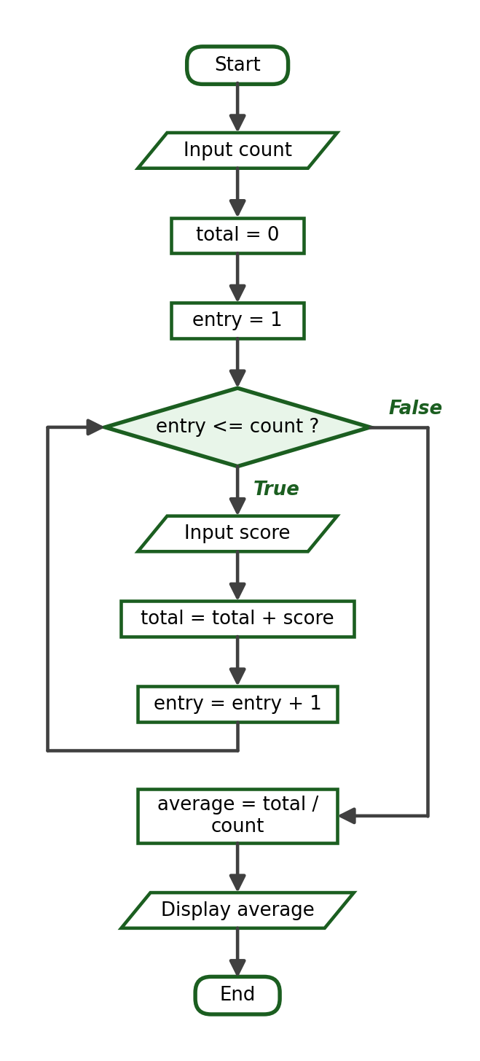
Python Program:
count = int(input("How many scores will be entered? "))
total = 0
for entry in range(1, count + 1):
score = float(input(f"Enter score {entry}: "))
total += score
average = total / count
print(f"Average: {average:.2f}")

Trace Table:
Iteration | score | total after
1 | 85.0 | 85.0
2 | 90.0 | 175.0
3 | 78.0 | 253.0

Sample Run:
How many scores will be entered? 3
Enter score 1: 85
Enter score 2: 90
Enter score 3: 78
Average: 84.33

Explanation: After the loop, 253.0 / 3 = 84.333…, which the format specifier :.2f rounds to 84.33. The average is computed once, after the loop — computing it inside the loop would waste work and risk using an incomplete total.

Guided Example 5: Count the Even and Odd Numbers
Problem Statement: Ask the user to enter five integers. Count how many are even and how many are odd.
Problem Analysis: Two counters are needed, both initialized to 0 before the loop. The decision inside the body uses the modulo operator: a number is even when number % 2 == 0.
IPO Table:
Input | Process | Output
Five integers | Classify each number as even or odd and count each kind | The number of even and odd values

Required Variables: entry (int), number (int), even_count (int), odd_count (int).
Formula / Condition: number % 2 == 0
Algorithm:
Step 1: Start.
Step 2: Set even_count to 0 and odd_count to 0.
Step 3: For each entry from 1 to 5, ask for an integer; if it is even, add 1 to even_count, otherwise add 1 to odd_count.
Step 4: Display both counters.
Step 5: End.

Pseudocode:
START
even_count = 0
odd_count = 0
FOR entry = 1 TO 5
INPUT number
IF number MOD 2 = 0 THEN
even_count = even_count + 1
ELSE
odd_count = odd_count + 1
END IF
END FOR
DISPLAY even_count, odd_count
END

Flowchart:
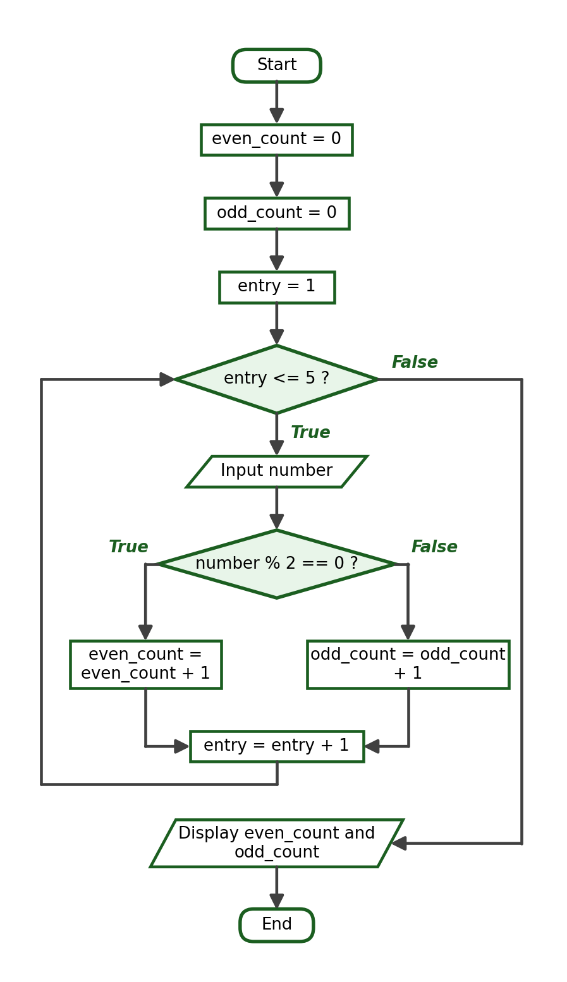
Python Program:
even_count = 0
odd_count = 0
for entry in range(1, 6):
number = int(input(f"Enter integer {entry}: "))
if number % 2 == 0:
even_count += 1
else:
odd_count += 1
print("Even numbers:", even_count)
print("Odd numbers:", odd_count)

Trace Table:
Iteration | number | even_count | odd_count
1 | 12 | 1 | 0
2 | 7 | 1 | 1
3 | 4 | 2 | 1
4 | 9 | 2 | 2
5 | 10 | 3 | 2

Sample Run:
Enter integer 1: 12
Enter integer 2: 7
Enter integer 3: 4
Enter integer 4: 9
Enter integer 5: 10
Even numbers: 3
Odd numbers: 2

Explanation: The two counters split the five inputs between them, so their final values always add up to 5. This combination of a loop, a decision, and counters appears in many real problems, such as counting passed and failed students.

Guided Example 6: Input Validation for a Grade
Problem Statement: Repeatedly ask for a grade until the user enters a value from 0 to 100, then display the accepted grade.
Problem Analysis: The loop condition describes the invalid values: grade < 0 or grade > 100. The body warns the user and reads a replacement value. The loop is condition-controlled because nobody knows how many attempts the user will need.
IPO Table:
Input | Process | Output
One or more grades | Repeat the input while the grade is outside 0 to 100 | The accepted grade

Required Variables: grade (float).
Formula / Condition: grade < 0 or grade > 100
Algorithm:
Step 1: Start.
Step 2: Ask the user for a grade. Store it as grade.
Step 3: While grade is less than 0 or greater than 100, display “Invalid grade.” and ask again.
Step 4: Display the accepted grade.
Step 5: End.

Pseudocode:
START
INPUT grade
WHILE grade < 0 OR grade > 100
DISPLAY "Invalid grade."
INPUT grade
END WHILE
DISPLAY grade
END

Flowchart:
Python Program:
grade = float(input("Enter a grade from 0 to 100: "))
while grade < 0 or grade > 100:
print("Invalid grade.")
grade = float(input("Enter a grade from 0 to 100: "))
print("Accepted grade:", grade)

Trace Table:
Attempt | grade | grade < 0 or grade > 100 | Action
1 | 105.0 | True | Warn and ask again
2 | -2.0 | True | Warn and ask again
3 | 92.0 | False | Exit the loop and accept

Sample Run:
Enter a grade from 0 to 100: 105
Invalid grade.
Enter a grade from 0 to 100: -2
Invalid grade.
Enter a grade from 0 to 100: 92
Accepted grade: 92.0

Explanation: The boundary values 0 and 100 are both valid: for grade = 100, the condition 100 < 0 or 100 > 100 evaluates to False, so the value is accepted.

Guided Example 7: Sentinel-Controlled Expense Total
Problem Statement: Accept expense amounts one at a time and stop when the user enters 0. Display the total of the expenses entered before the sentinel.
Problem Analysis: The sentinel is 0. A priming input is read before the loop; the condition tests the sentinel; the body accumulates and then reads the next amount. The sentinel itself must not be added to the total — which is naturally guaranteed because the condition is checked before the body executes.
IPO Table:
Input | Process | Output
Expense amounts ending with 0 | Accumulate each amount while it is not the sentinel | The total expenses

Required Variables: expense (float), total_expenses (float).
Formula / Condition: expense != 0
Algorithm:
Step 1: Start.
Step 2: Set total_expenses to 0.
Step 3: Ask the user for an expense amount (priming input). Store it as expense.
Step 4: While expense is not 0, add expense to total_expenses and ask for the next amount.
Step 5: Display total_expenses with two decimal places.
Step 6: End.

Pseudocode:
START
total_expenses = 0
INPUT expense
WHILE expense <> 0
total_expenses = total_expenses + expense
INPUT expense
END WHILE
DISPLAY total_expenses
END

Flowchart:
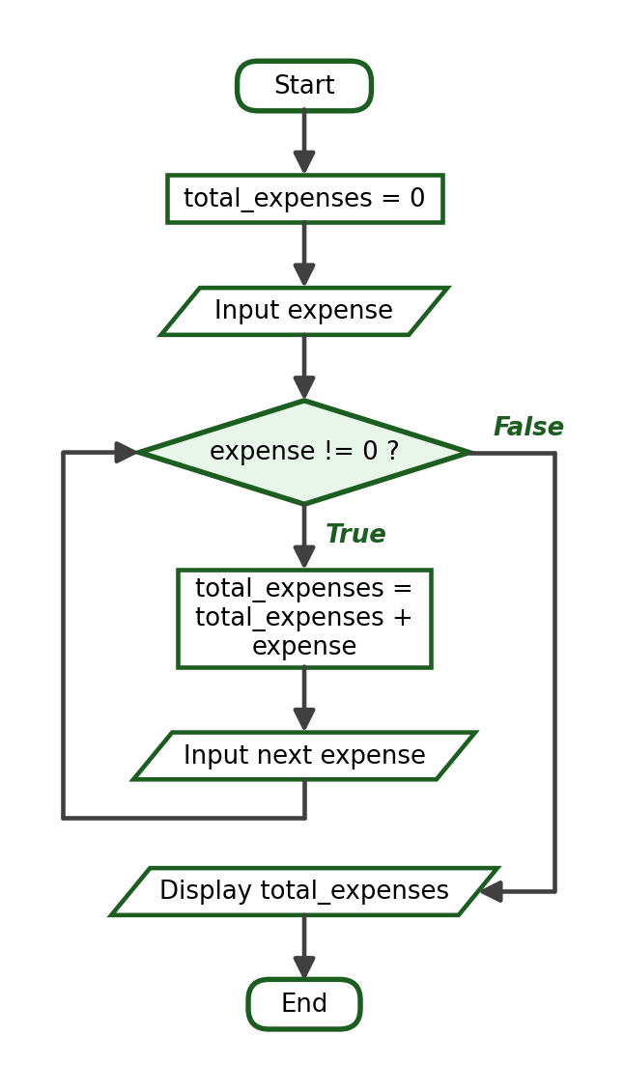
Python Program:
total_expenses = 0.0
expense = float(input("Enter an expense amount (0 to stop): "))
while expense != 0:
total_expenses += expense
expense = float(input("Enter an expense amount (0 to stop): "))
print(f"Total Expenses: ₱{total_expenses:.2f}")

Trace Table:
Iteration | expense | total_expenses after
1 | 120.0 | 120.0
2 | 85.5 | 205.5
3 | 200.0 | 405.5
— | 0.0 (sentinel) | loop ends, total stays 405.5

Sample Run:
Enter an expense amount (0 to stop): 120
Enter an expense amount (0 to stop): 85.50
Enter an expense amount (0 to stop): 200
Enter an expense amount (0 to stop): 0
Total Expenses: ₱405.50

Explanation: The sentinel 0 stops the loop without being accumulated. The formatted output ₱405.50 uses the :.2f specifier, which always shows two decimal places for amounts of money.

Guided Example 8: Counting Sensor Readings Above a Threshold
Problem Statement: A laboratory records several temperature readings. Ask how many readings will be entered, accept each reading, count how many exceed 30.0 degrees, and display that count together with the average of all readings.
Problem Analysis: This problem needs one counter and one accumulator working in the same single-level loop. The counter above_count increases only when the decision inside the body is True, while the accumulator total collects every reading. The average is computed after the loop.
IPO Table:
Input | Process | Output
count, then count readings | Accumulate every reading; count only those greater than 30.0 | The number of readings above the threshold and the average reading

Required Variables: count (int), reading_number (int), reading (float), above_count (int), total (float), average (float).
Formula / Condition: reading > 30.0 and average = total / count
Algorithm:
Step 1: Start.
Step 2: Ask how many readings will be entered. Store it as count.
Step 3: Set above_count to 0 and total to 0.
Step 4: For each reading_number from 1 to count: ask for a reading, add it to total, and if the reading is greater than 30.0, add 1 to above_count.
Step 5: Compute average = total / count.
Step 6: Display above_count and the average.
Step 7: End.

Pseudocode:
START
INPUT count
above_count = 0
total = 0
FOR reading_number = 1 TO count
INPUT reading
total = total + reading
IF reading > 30.0 THEN
above_count = above_count + 1
END IF
END FOR
average = total / count
DISPLAY above_count, average
END

Flowchart:
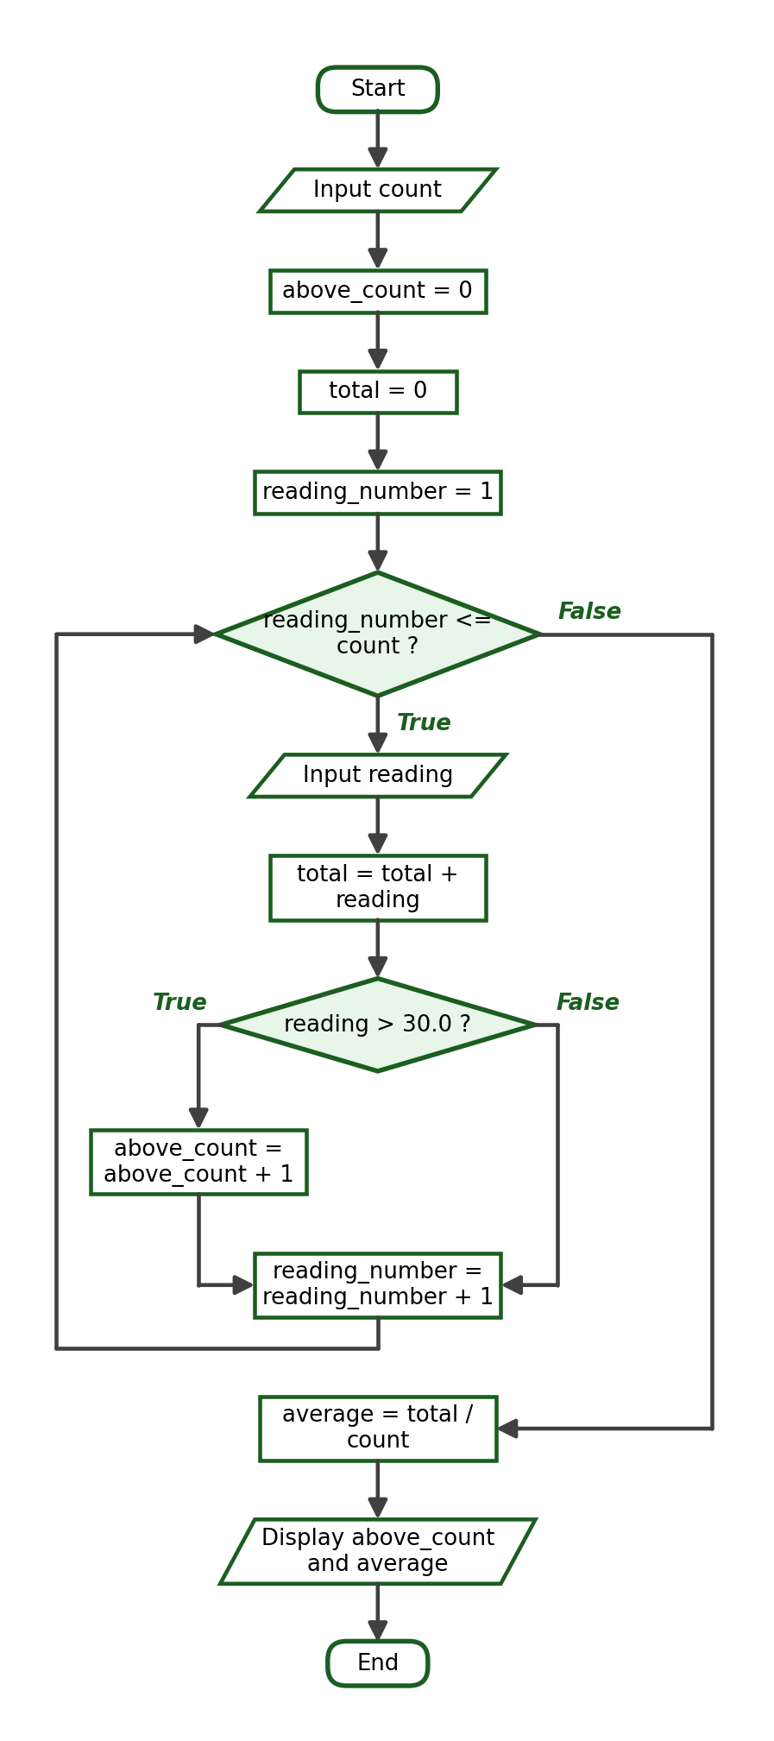
Python Program:
count = int(input("How many sensor readings will be entered? "))
above_count = 0
total = 0.0
for reading_number in range(1, count + 1):
reading = float(input(f"Enter reading {reading_number}: "))
total += reading
if reading > 30.0:
above_count += 1
average = total / count
print("Readings above 30.0:", above_count)
print(f"Average reading: {average:.2f}")

Trace Table:
Iteration | reading | reading > 30.0 | above_count | total after
1 | 28.4 | False | 0 | 28.4
2 | 31.2 | True | 1 | 59.6
3 | 35.0 | True | 2 | 94.6
4 | 29.9 | False | 2 | 124.5
5 | 30.1 | True | 3 | 154.6

Sample Run 1:
How many sensor readings will be entered? 5
Enter reading 1: 28.4
Enter reading 2: 31.2
Enter reading 3: 35.0
Enter reading 4: 29.9
Enter reading 5: 30.1
Readings above 30.0: 3
Average reading: 30.92

Sample Run 2:
How many sensor readings will be entered? 1
Enter reading 1: 30.0
Readings above 30.0: 0
Average reading: 30.00

Sample Run 3:
How many sensor readings will be entered? 4
Enter reading 1: 40
Enter reading 2: 41
Enter reading 3: 42
Enter reading 4: 43
Readings above 30.0: 4
Average reading: 41.50

Explanation: Sample Run 2 tests the boundary: a reading of exactly 30.0 is not greater than 30.0, so it is not counted. Sample Run 3 shows every reading exceeding the threshold. This counting-and-averaging pattern is used later in the course for processing simulated sensor data.

PART B. WEEK 7 LABORATORY MANUAL

1. Laboratory Title
Laboratory Exercise 6 — Fundamental Iteration and Loop-Control Structures
Developing Python Programs Using Single-Level Loops

2. Laboratory Objectives
At the end of the laboratory session, students should be able to:
- Trace and test Python programs that use for and while loops.
- Construct algorithms, pseudocode, and flowcharts for repetitive programming processes.
- Develop Python programs using counters, accumulators, break, continue, sentinel-controlled repetition, and input validation.

3. Required Tools
- Desktop or laptop computer
- Python 3
- Visual Studio Code
- Terminal
- Git
- GitHub account

4. Laboratory Rules
- Perform all activities using Visual Studio Code and the terminal.
- Run and test every Python program before submitting it.
- Use meaningful variable names.
- Follow proper Python indentation (four spaces).
- Initialize counters and accumulators correctly, before the loop begins.
- Verify that every while loop has a valid exit condition before running it.
- Do not edit or upload Python files directly through the GitHub website.
- Save all source-code files in the required Week 7 repository folder.
- Submit original work. Copying another student's code is an academic-integrity violation.
- Be prepared to explain your algorithm and source code when asked.

5. Laboratory Preparation: Review Activity
Loops combine everything you have learned so far: variables, numeric input with int() and float(), type conversion, comparison operators, logical operators, conditional statements, the modulo operator, assignment operators such as += and -=, and formatted output with f-strings. Answer the following readiness items before starting the activities. Write your answers on paper or in a text file; your instructor will check them.
- Evaluate: 17 % 5 and 17 // 5
- Evaluate: 8 >= 8 and 3 < 1
- If count = 4, what is the value of count after count += 1 executes?
- What is displayed by print(f"Result: {7 * 3}")?
- What is displayed by the following program if the user enters 14?
number = int(input("Enter an integer: "))
if number % 2 == 0:
print("Even")
else:
print("Odd")

6. Laboratory Activity 1 — Basic for Loops
For every problem, prepare the complete requirements: IPO table, algorithm, pseudocode, flowchart, Python source code, a test run, and the exact output. Save each program in the activity1 folder of your Week 7 repository.
- Display the numbers from 1 to 20.
- Display all even numbers from 2 to 50.
- Display the numbers from 20 down to 1.
- Display the squares of the numbers from 1 to 10, using the format “The square of 3 is 9”.
- Ask the user for an integer and display its multiplication table from 1 to 10.

7. Laboratory Activity 2 — Counters and Accumulators
Each problem requires a correctly initialized counter or accumulator. Provide the same complete requirements as in Activity 1. Save each program in the activity2 folder.
- Ask the user for a positive integer N and compute the sum of the numbers from 1 to N.
- Ask the user for a positive integer and compute its factorial using a loop. Keep the input small (10 or less). Remember that 5! = 5 × 4 × 3 × 2 × 1 = 120. Do not use recursion or any library factorial function.
- Accept five numbers from the user and display their total.
- Ask how many scores will be entered, accept the scores, and compute their average without using a list.
- Accept six integers and count how many are positive, how many are negative, and how many are zero.

8. Laboratory Activity 3 — while Loops and Input Validation
Use while loops for every problem. Do not use exception handling; assume the user always enters a numeric value of the expected type. Save each program in the activity3 folder.
- Repeatedly ask for a grade until the user enters a value from 0 to 100, then display the accepted grade.
- Repeatedly ask for a quantity until the user enters a positive value, then display the accepted quantity.
- Repeatedly ask for a menu choice until the user enters a value from 1 to 4, then display the selected option.
- Accept numbers until zero is entered and display their total.
- Accept values until the sentinel -99 is entered, then display how many values were entered before the sentinel.

9. Laboratory Activity 4 — break and continue
Each problem states which statement to use. Save each program in the activity4 folder.
- Use break: display the numbers from 1 to 15, but ask the user for a stopping number first and stop the loop the moment that number is reached. Display a message stating where the loop stopped.
- Use continue: display the numbers from 1 to 15, skipping every multiple of 3.
- Use continue: accept six integers and compute the total of the non-negative values, ignoring every negative entry.
- Use break: accept amounts inside a while True loop and stop when 0 is entered, then display the total using the peso format ₱0.00.

10. Laboratory Activity 5 — do-while Logic and Sentinel-Controlled Repetition
Each problem in this activity requires a loop whose body must execute at least once, or a loop that ends only when a sentinel value is entered. Remember that Python has no do-while statement: implement the logic with while True and break, with a flag variable, or with a control variable initialized to a value that cannot satisfy the exit condition. Save each program in the activity5 folder.
- Password check. Ask for a password and keep asking until the user enters cpe2026. Display “Access granted.” once the password is correct. The prompt must appear at least once.
- Menu loop. Display a four-option menu ([1] Deposit, [2] Withdraw, [3] Balance, [4] Exit) and perform the matching message until the user selects option 4. Reject invalid choices without ending the loop.
- Sentinel-controlled readings. Accept temperature readings until the user enters -1, then display how many readings were entered and their average. Display a suitable message when no reading is entered before the sentinel.
- Repeat-until-declined encoding. Accept the price of an item, then ask whether another item will be encoded (y/n). Repeat while the answer is y, then display the number of items and the total cost in the format ₱0.00.
For every problem, submit the IPO table, algorithm, pseudocode, flowchart, Python source code, a test run, and the exact output. State clearly in your README which of the three do-while implementations you used and why.

11. Laboratory Activity 6 — Complete Problem-Solving Tasks
Your instructor will announce which of the following problems are assigned to your section or batch. For every assigned problem, submit the complete requirements: problem analysis, IPO table, required variables, formula or condition, algorithm, pseudocode, flowchart, Python program, trace table, at least three test cases, and the expected outputs. Save each program in the activity6 folder. Do not use functions, lists, dictionaries, or file handling.
- Student Savings. Ask how many weeks will be recorded, accept the savings for each week, and display the total savings in the format ₱0.00.
- Daily Transportation Expense. Accept the transportation expense for each of 5 days and display the total in the format ₱0.00.
- Quiz Average. Ask how many quiz scores will be entered, accept the scores, and display their average with two decimal places. Do not use a list.
- Passed and Failed. Ask how many students are in the class, accept each student's grade, and count how many passed (grade of at least 75) and how many failed.
- Total Purchase Cost. Ask how many items were purchased, accept the price of each item, and display the total cost in the format ₱0.00.
- Largest Value. Ask how many values will be entered, accept the values one at a time, and display the largest without using a list.
- Product Inventory. Accept delivery quantities until the sentinel -1 is entered, then display the total number of items received.
- Grade Validation. Repeatedly ask for a grade until a value from 0 to 100 is entered, then display the accepted grade.
- Multiplication-Table Generator. Ask for an integer from 1 to 10, validating the input with a loop, then display the multiplication table of the accepted number from 1 to 10.
- Sum of Even Numbers. Ask for a positive integer N and compute the sum of all even numbers from 1 to N.

12. Required Test Cases
Every Activity 6 problem must be verified with at least three test cases: a normal case, a boundary-value case, and a case that makes the loop repeat several times. Add a sentinel-value case when the problem uses a sentinel, and an invalid-value case when the problem validates input. Record the test cases in a table like this:
Test Case | Input | Expected Result
1 | N = 5 | Sum is 15
2 | N = 1 | Sum is 1
3 | N = 10 | Sum is 55

Test cases must deliberately check the starting value, the ending value, the loop boundaries, the exit condition, and the final accumulator result. Most looping errors are off-by-one errors, and they are caught precisely by boundary test cases such as N = 1 or a grade of exactly 100 — a program that looks correct for N = 5 can still be wrong at the edges.

13. Flowchart Requirements for Laboratory Problems
Every complete problem-solving activity requires a flowchart drawn with standard symbols. Your flowchart must:
- Show the initialization before the loop.
- Place the loop condition inside a decision diamond.
- Label the True and False branches clearly (True/False or Yes/No).
- Show the loop body and the update statement.
- Return the update path to the condition with a clear arrow.
- Show the correct exit path and the End symbol.
- Fit within the page margins and remain readable when printed.
Draw the flowchart with a diagramming tool (such as diagrams.net) or neatly by hand, then export or scan it as a high-resolution image. The flowcharts in Part A, Section 16 of this module show the exact expected form for every loop structure.

14. Git and GitHub Submission Workflow
Create your Week 7 repository using the structure below. Use Visual Studio Code and the terminal for creating, testing, committing, and pushing the Python files. Do not directly upload or edit source-code files through the GitHub website.
cpp102-week7-surname/
├── activity1/
│ ├── problem1.py
│ ├── problem2.py
│ └── problem3.py
├── activity2/
├── activity3/
├── activity4/
├── activity5/
├── activity6/
└── README.md

After finishing and testing your programs, run the following commands inside the repository folder:
git status
git add .
git commit -m "Complete CPP102 Week 7 looping statement activities"
git push

If Git reports that the repository is locked by a leftover index file, remove the lock and try again:
rm .git/index.lock

README Requirement
The README.md file of your repository must contain:
- Your full name and section.
- The week number (Week 7).
- The list of completed activities.
- A short explanation of the loop used in each program (for, while, sentinel, validation, do-while logic) and why it was chosen.
- A short reflection (three to five sentences) on what you learned.

15. Reflection Questions
Answer the following questions in your README reflection or on the answer sheet provided by your instructor:
- What is the main difference between a for loop and a while loop?
- Why must a while loop contain a statement that can change its condition?
- What is the difference between a counter and an accumulator?
- How are break and continue different?
- How did the flowchart help you identify the initialization, condition, process, and update parts of the loop?
- Python has no do-while statement. How did you guarantee that a loop body executed at least once, and why was that necessary in your program?

PART C. CLOSING

1. Summary
Looping statements allow a program to repeat instructions without duplicating code. Most loops are built from an initialization, a condition, and an update; when any of these parts is wrong, the loop repeats the wrong number of times or never stops. The for loop, usually combined with range(), is the natural choice for counter-controlled repetition, in which the number of iterations is known in advance. The while loop handles condition-controlled repetition, including input validation and sentinel-controlled input. Counters track how many times something happens, and accumulators keep running totals; both must be initialized before the loop. The break statement terminates a loop immediately, while continue skips only the current iteration. Python has no native do-while statement, so a loop that must execute at least once is written with while True and break, with a flag variable, or with a control variable initialized outside the exit condition. Every structure studied this week is a single-level loop. Next week, in the Week 8 module, one loop will be placed inside another to handle row-and-column processing, table generation, and multi-level iteration.

2. References

Textbooks and Library References
- Gaddis, T. (2021). Starting Out with Python (5th ed.). Pearson. — Chapter 4: Repetition Structures.
- Deitel, P., & Deitel, H. (2020). Intro to Python for Computer Science and Data Science. Pearson.
- Lambert, K. A. (2019). Fundamentals of Python: First Programs (2nd ed.). Cengage Learning.

Online References
- Python Software Foundation. The Python Tutorial — More Control Flow Tools. https://docs.python.org/3/tutorial/controlflow.html
- Python Software Foundation. Built-in Functions — range. https://docs.python.org/3/library/functions.html#func-range
- W3Schools. Python For Loops and Python While Loops. https://www.w3schools.com/python/

PART D. INSTRUCTOR'S COMPLETE ANSWER KEY
This section contains the complete answers to every checkpoint, guided-example verification, laboratory activity, and reflection question. The section, activity, and problem numbers match the student portion of the module. All Python programs were executed and the outputs shown are exact terminal transcripts.

1. Checkpoint A Answer Key — Values Produced by range()
Item | Expression | Values Produced
1 | range(5) | 0, 1, 2, 3, 4
2 | range(1, 6) | 1, 2, 3, 4, 5
3 | range(2, 11, 2) | 2, 4, 6, 8, 10
4 | range(10, 0, -1) | 10, 9, 8, 7, 6, 5, 4, 3, 2, 1
5 | range(5, 20, 5) | 5, 10, 15
6 | range(0, 10, 3) | 0, 3, 6, 9
7 | range(3, 4) | 3
8 | range(8, 2, -2) | 8, 6, 4
9 | range(1, 10, 4) | 1, 5, 9
10 | range(6, 0, -1) | 6, 5, 4, 3, 2, 1

2. Checkpoint B Answer Key — Trace the Loop
Program 1:
Iteration | number | Output
1 | 1 | 1
2 | 2 | 2
3 | 3 | 3
4 | 4 | 4

Exact Output:
1
2
3
4

range(1, 5) produces 1 to 4; the loop performs four iterations.
Program 2:
Iteration | count at test | Output | count after update
1 | 10 | 10 | 8
2 | 8 | 8 | 6
3 | 6 | 6 | 4
4 | 4 | 4 | 2

Exact Output:
10
8
6
4

When count becomes 2, the condition 2 >= 4 is False and the loop stops.
Program 3:
Iteration | number | total after | Output
1 | 1 | 1 | 1
2 | 2 | 3 | 3
3 | 3 | 6 | 6
4 | 4 | 10 | 10

Exact Output:
1
3
6
10

The running total is printed inside the loop, so each partial sum appears.
Program 4:
Iteration | number | count after
1 | 3 | 1
2 | 7 | 2
3 | 11 | 3
4 | 15 | 4

Exact Output:
4

range(3, 16, 4) produces 3, 7, 11, 15. Only the final count is printed.
Program 5:
Iteration | value at test | Output | value after update
1 | 1 | 1 | 2
2 | 2 | 2 | 4
3 | 4 | 4 | 8
4 | 8 | 8 | 16
5 | 16 | 16 | 32

Exact Output:
1
2
4
8
16

The value doubles each iteration; 32 fails the condition 32 < 20 and is not printed.
Program 6:
Iteration | count | total after
1 | 1 | 2
2 | 2 | 6
3 | 3 | 12
4 | 4 | 20

Exact Output:
20

Each iteration adds count × 2: 2 + 4 + 6 + 8 = 20.
Program 7:
Iteration | number | result after
1 | 1 | 1
2 | 2 | 2
3 | 3 | 6
4 | 4 | 24

Exact Output:
24

The accumulator multiplies instead of adds, computing 4! = 24. Note that result is initialized to 1, not 0.
Program 8:
Iteration | number after | count after
1 | 4 | 1
2 | 1 | 2
3 | -2 | 3

Exact Output:
-2 3

The loop subtracts 3 while number is positive. After the third iteration number is -2, the condition fails, and both values are printed.

3. Checkpoint C Answer Key — Predict the Output
Program 1 — exact output:
1
2
3
4
5

Program 2 — exact output:
5
4
3
2
1

Program 3 — exact output:
Total: 6

Program 4 — exact output:
1
2
3

Program 5 — exact output:
1
3
5

Program 6 — exact output:
Total: 12

Program 7 — exact output:
Line 1
Line 2
Line 3

Program 8 — exact output:
10
7
4

Program 9 — exact output:
3
6
9

Program 10 — exact output:
Count: 4
Total: 20

Notes for checking: Program 4 stops before printing 4 because break executes first. Program 5 skips every even number. Program 6 adds only the multiples of 4 within 1 to 10, that is 4 + 8 = 12. Program 8 prints 10, 7, 4 — the next value, 1, fails the condition 1 >= 4. Program 9 prints only the multiples of 3. Program 10 counts four even values whose total is 20.

4. Checkpoint D Answer Key — Correct the Code
Program 1:
Error: Missing update statement. The variable count never changes, so the condition count <= 3 stays True forever and the program prints "Hello" endlessly (an infinite loop).
Correction: Add count += 1 inside the loop body.
Corrected Program:
count = 1
while count <= 3:
print("Hello")
count += 1

Expected Output of the Corrected Program:
Hello
Hello
Hello

Program 2:
Error: Incorrect indentation. The print statement is not indented, so Python reports IndentationError: expected an indented block after the for header.
Correction: Indent print(number) by four spaces.
Corrected Program:
for number in range(1, 6):
print(number)

Expected Output of the Corrected Program:
1
2
3
4
5

Program 3:
Error: Off-by-one error in the range() stop value. range(1, 10) produces only 1 to 9 because the stop value is excluded.
Correction: Change the range to range(1, 11).
Corrected Program:
for number in range(1, 11):
print(number)

Expected Output of the Corrected Program:
1
2
3
4
5
6
7
8
9
10

Program 4:
Error: Incorrect step direction. range(10, 21, -2) produces no values because a negative step cannot move from 10 up toward 21; the loop body never executes.
Correction: Use a positive step: range(10, 21, 2).
Corrected Program:
for number in range(10, 21, 2):
print(number)

Expected Output of the Corrected Program:
10
12
14
16
18
20

Program 5:
Error: Accumulator reset inside the loop. total = 0 executes during every iteration, so after the loop total holds only the last value, 3, instead of 6.
Correction: Move total = 0 above the loop.
Corrected Program:
total = 0
for number in range(1, 4):
total += number
print(total)

Expected Output of the Corrected Program:
6

Program 6:
Error: Wrong comparison operator. The condition count <= 1 is False when count is 5, so the loop body never executes.
Correction: Change the condition to count >= 1.
Corrected Program:
count = 5
while count >= 1:
print(count)
count -= 1

Expected Output of the Corrected Program:
5
4
3
2
1

Program 7:
Error: Missing colon at the end of the for header. Python reports a SyntaxError.
Correction: Add a colon: for number in range(1, 6):
Corrected Program:
for number in range(1, 6):
if number == 3:
continue
print(number)

Expected Output of the Corrected Program:
1
2
4
5

Program 8:
Error: Misplaced break. The break is outside the if block, so it executes during the first iteration and the loop ends before printing anything.
Correction: Move break inside the if block and print before testing, so the loop displays 1 to 4 and stops when 5 is reached.
Corrected Program:
for number in range(1, 8):
if number == 5:
break
print(number)

Expected Output of the Corrected Program:
1
2
3
4

5. Checkpoint E Answer Key — Choose the Appropriate Loop
Item | Situation | Loop | Reason
1 | Repeat a message exactly 10 times | for | The number of repetitions is known in advance
2 | Continue asking until a valid grade is entered | while | The number of attempts is unknown; repetition depends on a condition
3 | Display all numbers from 1 to 100 | for | A fixed, known range of values
4 | Accept expense amounts until zero is entered | while | Sentinel-controlled repetition; the count of entries is unknown
5 | Display a menu repeatedly until the user chooses Exit | while | Post-test (do-while) logic; the menu must appear at least once and the count of repetitions is unknown
6 | Display the multiplication table of a number | for | Exactly ten lines are always produced
7 | Keep asking for a valid menu choice | while | Input validation continues while the entry is invalid
8 | Accept quiz scores until -1 is entered | while | Sentinel-controlled repetition

6. Guided Examples — Verification Notes
All eight guided examples in Part A, Section 18 were executed, and every sample run shown in the module is an exact transcript. Key checking points:
- Guided Example 1 (N = 7): range(1, limit + 1) is required; range(1, limit) is the expected student off-by-one error.
- Guided Example 2: verified sums 55 (N = 10), 1 (N = 1), and 5050 (N = 100).
- Guided Example 3 (input 6): ten lines from 6 x 1 = 6 to 6 x 10 = 60.
- Guided Example 4 (3 scores: 85, 90, 78): total 253.0, average 84.33 after :.2f rounding.
- Guided Example 5 (12, 7, 4, 9, 10): 3 even, 2 odd; the two counters must add up to 5.
- Guided Example 6 (105, -2, 92): two rejections, then 92.0 accepted; grades 0 and 100 must both be accepted.
- Guided Example 7 (120, 85.50, 200, 0): total ₱405.50; the sentinel 0 must not be accumulated.
- Guided Example 8 (5 readings: 28.4, 31.2, 35.0, 29.9, 30.1): 3 readings above 30.0, average 30.92. A reading of exactly 30.0 must NOT be counted, since the condition is strictly greater than.

7. Laboratory Preparation Answer Key
Item | Answer | Explanation
1 | 17 % 5 = 2 | 17 // 5 = 3 | Modulo gives the remainder; floor division gives the whole-number quotient
2 | False | 8 >= 8 is True but 3 < 1 is False, and True and False is False
3 | 5 | count += 1 adds 1 to the current value 4
4 | Result: 21 | The f-string evaluates 7 * 3 and inserts the result
5 | Even | 14 % 2 equals 0, so the if branch executes

8. Laboratory Activity 1 Answer Key — Basic for Loops

Activity 1, Problem 1: Numbers from 1 to 20
IPO Table:
Input | Process | Output
None | Repeat for the values 1 to 20 | The numbers 1 to 20

Algorithm:
Step 1: Start.
Step 2: For each number from 1 to 20, display the number.
Step 3: End.

Pseudocode:
START
FOR number = 1 TO 20
DISPLAY number
END FOR
END

Flowchart:
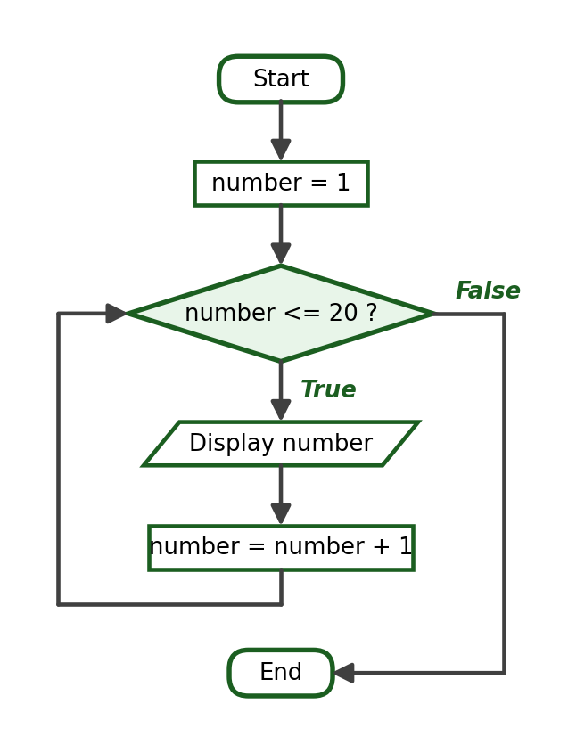
Python Program:
for number in range(1, 21):
print(number)

Verified Output:
1
2
3
4
5
6
7
8
9
10
11
12
13
14
15
16
17
18
19
20

Explanation: range(1, 21) is required; the stop value 21 is excluded.

Activity 1, Problem 2: Even Numbers from 2 to 50
IPO Table:
Input | Process | Output
None | Repeat for the values 2, 4, …, 50 | The even numbers from 2 to 50

Algorithm:
Step 1: Start.
Step 2: For each number from 2 to 50 counting by 2, display the number.
Step 3: End.

Pseudocode:
START
FOR number = 2 TO 50 STEP 2
DISPLAY number
END FOR
END

Flowchart:
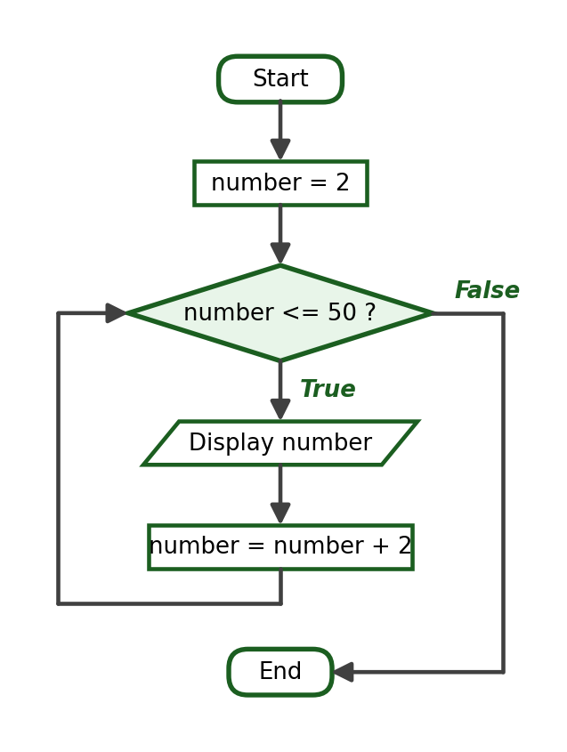
Python Program:
for number in range(2, 51, 2):
print(number)

Verified Output:
2
4
6
8
10
12
14
16
18
20
22
24
26
28
30
32
34
36
38
40
42
44
46
48
50

Explanation: range(2, 51, 2) produces 25 even values ending at 50.

Activity 1, Problem 3: Numbers from 20 Down to 1
IPO Table:
Input | Process | Output
None | Repeat for the values 20 down to 1 | The numbers 20 down to 1

Algorithm:
Step 1: Start.
Step 2: For each number from 20 down to 1, display the number.
Step 3: End.

Pseudocode:
START
FOR number = 20 DOWNTO 1
DISPLAY number
END FOR
END

Flowchart:
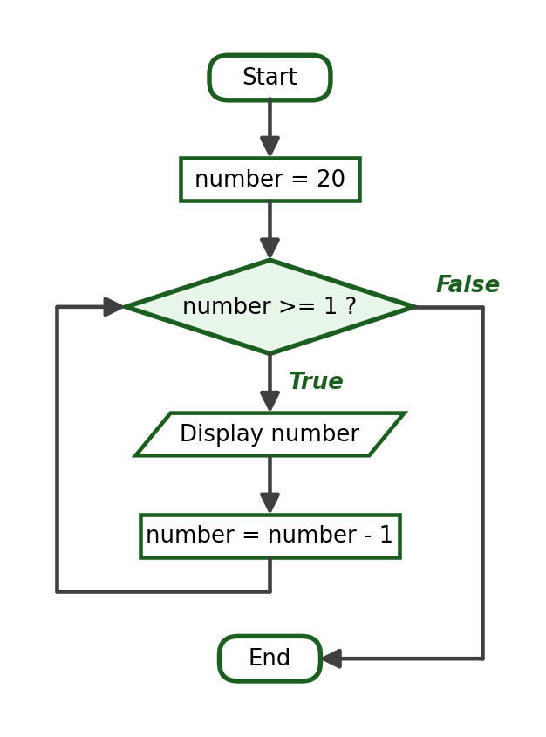
Python Program:
for number in range(20, 0, -1):
print(number)

Verified Output:
20
19
18
17
16
15
14
13
12
11
10
9
8
7
6
5
4
3
2
1

Explanation: range(20, 0, -1) uses a negative step; the stop value 0 is excluded so the last value is 1.

Activity 1, Problem 4: Squares of the Numbers from 1 to 10
IPO Table:
Input | Process | Output
None | Compute square = number × number for 1 to 10 | Ten formatted square lines

Algorithm:
Step 1: Start.
Step 2: For each number from 1 to 10, compute its square and display the formatted line.
Step 3: End.

Pseudocode:
START
FOR number = 1 TO 10
square = number * number
DISPLAY "The square of ", number, " is ", square
END FOR
END

Flowchart:
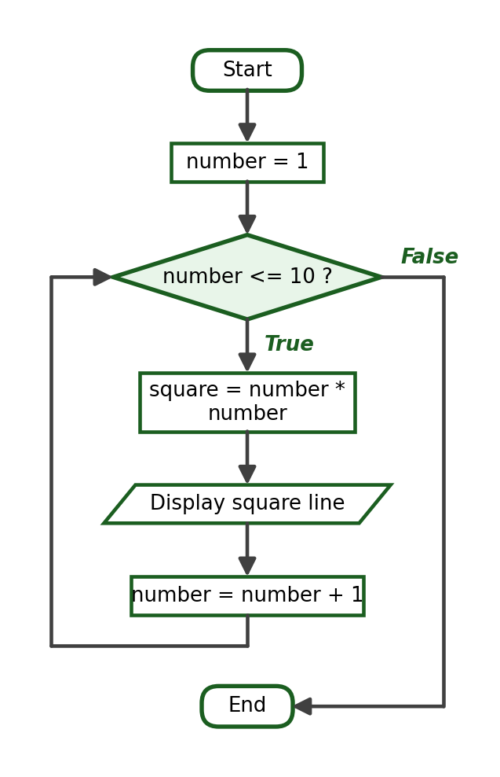
Python Program:
for number in range(1, 11):
square = number * number
print(f"The square of {number} is {square}")

Verified Output:
The square of 1 is 1
The square of 2 is 4
The square of 3 is 9
The square of 4 is 16
The square of 5 is 25
The square of 6 is 36
The square of 7 is 49
The square of 8 is 64
The square of 9 is 81
The square of 10 is 100

Explanation: number * number avoids introducing the exponent operator; number ** 2 is also acceptable.

Activity 1, Problem 5: Multiplication Table of a Given Integer
IPO Table:
Input | Process | Output
number | Multiply number by 1 to 10 | Ten multiplication lines

Required Variables: number (int), multiplier (int), product (int).
Algorithm:
Step 1: Start.
Step 2: Ask the user for an integer. Store it as number.
Step 3: For each multiplier from 1 to 10, compute the product and display the line.
Step 4: End.

Pseudocode:
START
INPUT number
FOR multiplier = 1 TO 10
product = number * multiplier
DISPLAY number, " x ", multiplier, " = ", product
END FOR
END

Flowchart:
Python Program:
number = int(input("Enter an integer: "))
for multiplier in range(1, 11):
product = number * multiplier
print(f"{number} x {multiplier} = {product}")

Verified Sample Run (input 9):
Enter an integer: 9
9 x 1 = 9
9 x 2 = 18
9 x 3 = 27
9 x 4 = 36
9 x 5 = 45
9 x 6 = 54
9 x 7 = 63
9 x 8 = 72
9 x 9 = 81
9 x 10 = 90

Explanation: Any integer input is acceptable in the test run; the loop structure is what is being graded.

9. Laboratory Activity 2 Answer Key — Counters and Accumulators

Activity 2, Problem 1: Sum of the Numbers from 1 to N
IPO Table:
Input | Process | Output
limit | Add every number from 1 to limit into total | The sum total

Required Variables: limit (int), number (int), total (int).
Formula / Condition: total = total + number
Algorithm:
Step 1: Start.
Step 2: Ask for a positive integer. Store it as limit.
Step 3: Set total to 0.
Step 4: For each number from 1 to limit, add number to total.
Step 5: Display total.
Step 6: End.

Pseudocode:
START
INPUT limit
total = 0
FOR number = 1 TO limit
total = total + number
END FOR
DISPLAY total
END

Flowchart:
Python Program:
limit = int(input("Enter a positive integer: "))
total = 0
for number in range(1, limit + 1):
total += number
print("The sum of numbers from 1 to", limit, "is", total)

Test Cases and Verified Outputs:
Test Case | Input | Expected / Verified Result
1 | N = 10 | Sum is 55
2 | N = 1 | Sum is 1 (boundary)
3 | N = 100 | Sum is 5050

Verified Sample Run (Test Case 1):
Enter a positive integer: 10
The sum of numbers from 1 to 10 is 55

Explanation: The accumulator must be initialized before the loop; students who initialize it inside the loop will display only the last value.

Activity 2, Problem 2: Factorial of a Positive Integer
IPO Table:
Input | Process | Output
number | Multiply factorial by every value from 1 to number | The factorial

Required Variables: number (int), value (int), factorial (int).
Formula / Condition: factorial = factorial * value
Algorithm:
Step 1: Start.
Step 2: Ask for a positive integer. Store it as number.
Step 3: Set factorial to 1.
Step 4: For each value from 1 to number, multiply factorial by value.
Step 5: Display factorial.
Step 6: End.

Pseudocode:
START
INPUT number
factorial = 1
FOR value = 1 TO number
factorial = factorial * value
END FOR
DISPLAY factorial
END

Flowchart:
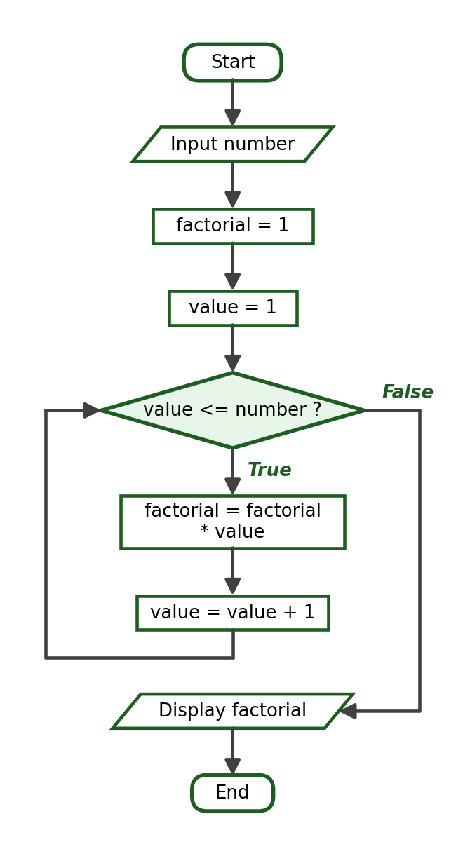
Python Program:
number = int(input("Enter a positive integer: "))
factorial = 1
for value in range(1, number + 1):
factorial *= value
print(f"The factorial of {number} is {factorial}")

Trace Table (using the inputs of Test Case 1):
Iteration | value | factorial after
1 | 1 | 1
2 | 2 | 2
3 | 3 | 6
4 | 4 | 24
5 | 5 | 120

Test Cases and Verified Outputs:
Test Case | Input | Expected / Verified Result
1 | 5 | The factorial of 5 is 120
2 | 1 | The factorial of 1 is 1 (boundary)
3 | 7 | The factorial of 7 is 5040

Verified Sample Run (Test Case 1):
Enter a positive integer: 5
The factorial of 5 is 120

Explanation: The accumulator starts at 1 because it multiplies. Starting at 0 would make every product 0 — the most common student error in this problem.

Activity 2, Problem 3: Add Five Entered Numbers
IPO Table:
Input | Process | Output
Five numbers | Add each entered value into total | The total

Required Variables: count (int), value (float), total (float).
Algorithm:
Step 1: Start.
Step 2: Set total to 0.
Step 3: For each count from 1 to 5, ask for a number and add it to total.
Step 4: Display total.
Step 5: End.

Pseudocode:
START
total = 0
FOR count = 1 TO 5
INPUT value
total = total + value
END FOR
DISPLAY total
END

Flowchart:
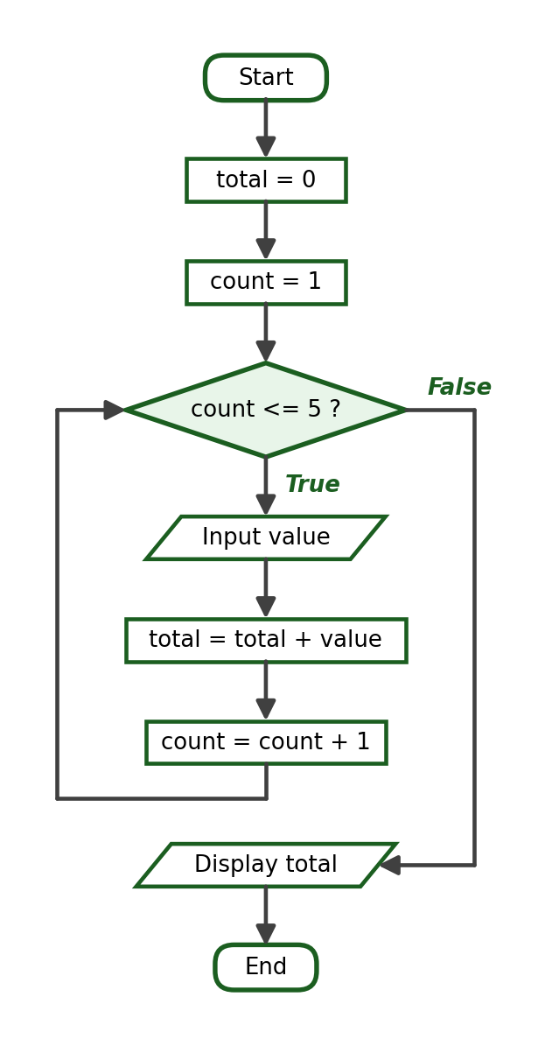
Python Program:
total = 0
for count in range(1, 6):
value = float(input(f"Enter number {count}: "))
total += value
print(f"Total: {total:.2f}")

Test Cases and Verified Outputs:
Test Case | Input | Expected / Verified Result
1 | 11, 22, 33, 44, 55 | Total: 165.00
2 | 0, 0, 0, 0, 0 | Total: 0.00 (boundary)
3 | 1.5, 2.5, 3, 4, 5 | Total: 16.00

Verified Sample Run (Test Case 1):
Enter number 1: 11
Enter number 2: 22
Enter number 3: 33
Enter number 4: 44
Enter number 5: 55
Total: 165.00

Explanation: A while loop with a counter is an equally valid solution.

Activity 2, Problem 4: Average of a Specified Number of Scores
IPO Table:
Input | Process | Output
count, then count scores | Accumulate the scores; average = total / count | The average

Required Variables: count (int), entry (int), score (float), total (float), average (float).
Formula / Condition: average = total / count
Algorithm:
Step 1: Start.
Step 2: Ask how many scores will be entered. Store it as count.
Step 3: Set total to 0.
Step 4: For each entry from 1 to count, ask for a score and add it to total.
Step 5: Compute average = total / count and display it.
Step 6: End.

Pseudocode:
START
INPUT count
total = 0
FOR entry = 1 TO count
INPUT score
total = total + score
END FOR
average = total / count
DISPLAY average
END

Flowchart:
Python Program:
count = int(input("How many scores will be entered? "))
total = 0
for entry in range(1, count + 1):
score = float(input(f"Enter score {entry}: "))
total += score
average = total / count
print(f"Average: {average:.2f}")

Test Cases and Verified Outputs:
Test Case | Input | Expected / Verified Result
1 | 4 scores: 80, 85, 90, 95 | Average: 87.50
2 | 1 score: 75 | Average: 75.00 (boundary)
3 | 3 scores: 70, 80, 90 | Average: 80.00

Verified Sample Run (Test Case 1):
How many scores will be entered? 4
Enter score 1: 80
Enter score 2: 85
Enter score 3: 90
Enter score 4: 95
Average: 87.50

Explanation: The average must be computed after the loop. No list is needed because only the running total matters.

Activity 2, Problem 5: Count Positive, Negative, and Zero
IPO Table:
Input | Process | Output
Six integers | Classify each value and count each kind | The three counts

Required Variables: entry (int), number (int), positive_count (int), negative_count (int), zero_count (int).
Algorithm:
Step 1: Start.
Step 2: Set the three counters to 0.
Step 3: For each entry from 1 to 6, ask for an integer and add 1 to the matching counter using if-elif-else.
Step 4: Display the three counters.
Step 5: End.

Pseudocode:
START
positive_count = 0
negative_count = 0
zero_count = 0
FOR entry = 1 TO 6
INPUT number
IF number > 0 THEN positive_count = positive_count + 1
ELSE IF number < 0 THEN negative_count = negative_count + 1
ELSE zero_count = zero_count + 1
END IF
END FOR
DISPLAY the three counts
END

Flowchart:
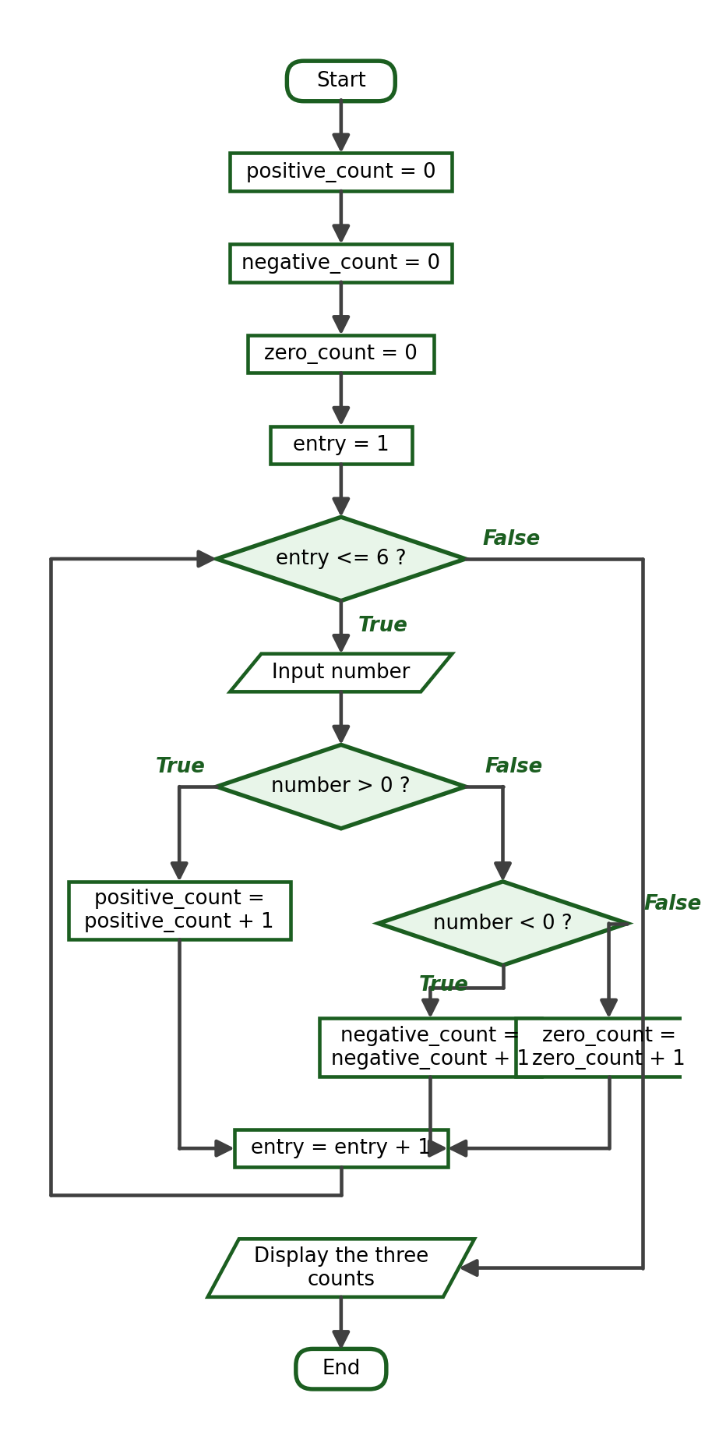
Python Program:
positive_count = 0
negative_count = 0
zero_count = 0
for entry in range(1, 7):
number = int(input(f"Enter integer {entry}: "))
if number > 0:
positive_count += 1
elif number < 0:
negative_count += 1
else:
zero_count += 1
print("Positive numbers:", positive_count)
print("Negative numbers:", negative_count)
print("Zeros:", zero_count)

Test Cases and Verified Outputs:
Test Case | Input | Expected / Verified Result
1 | 5, -3, 0, 8, -1, 0 | 2 positive, 2 negative, 2 zeros
2 | 1, 2, 3, 4, 5, 6 | 6 positive, 0 negative, 0 zeros
3 | 0, 0, 0, 0, 0, 0 | 0 positive, 0 negative, 6 zeros (boundary)

Verified Sample Run (Test Case 1):
Enter integer 1: 5
Enter integer 2: -3
Enter integer 3: 0
Enter integer 4: 8
Enter integer 5: -1
Enter integer 6: 0
Positive numbers: 2
Negative numbers: 2
Zeros: 2

Explanation: The three counters must add up to 6 in every run — an easy consistency check while grading.

10. Laboratory Activity 3 Answer Key — while Loops and Input Validation

Activity 3, Problem 1: Grade from 0 to 100
IPO Table:
Input | Process | Output
One or more grades | Repeat the input while the grade is invalid | The accepted grade

Required Variables: grade (float).
Formula / Condition: grade < 0 or grade > 100
Algorithm:
Step 1: Start.
Step 2: Ask for a grade.
Step 3: While the grade is less than 0 or greater than 100, warn the user and ask again.
Step 4: Display the accepted grade.
Step 5: End.

Pseudocode:
START
INPUT grade
WHILE grade < 0 OR grade > 100
DISPLAY "Invalid grade."
INPUT grade
END WHILE
DISPLAY grade
END

Flowchart:
Python Program:
grade = float(input("Enter a grade from 0 to 100: "))
while grade < 0 or grade > 100:
print("Invalid grade.")
grade = float(input("Enter a grade from 0 to 100: "))
print("Accepted grade:", grade)

Test Cases and Verified Outputs:
Test Case | Input | Expected / Verified Result
1 | 120, -10, 95 | Two rejections, then 95.0 accepted
2 | 0 | Accepted immediately (boundary)
3 | 100 | Accepted immediately (boundary)

Verified Sample Run (Test Case 1):
Enter a grade from 0 to 100: 120
Invalid grade.
Enter a grade from 0 to 100: -10
Invalid grade.
Enter a grade from 0 to 100: 95
Accepted grade: 95.0

Explanation: Both boundary values 0 and 100 must be accepted; a student who writes <= or >= in the condition rejects them incorrectly.

Activity 3, Problem 2: Positive Quantity
IPO Table:
Input | Process | Output
One or more quantities | Repeat the input while quantity <= 0 | The accepted quantity

Required Variables: quantity (int).
Formula / Condition: quantity <= 0
Algorithm:
Step 1: Start.
Step 2: Ask for a quantity.
Step 3: While the quantity is zero or negative, warn the user and ask again.
Step 4: Display the accepted quantity.
Step 5: End.

Pseudocode:
START
INPUT quantity
WHILE quantity <= 0
DISPLAY "Must be greater than zero."
INPUT quantity
END WHILE
DISPLAY quantity
END

Flowchart:
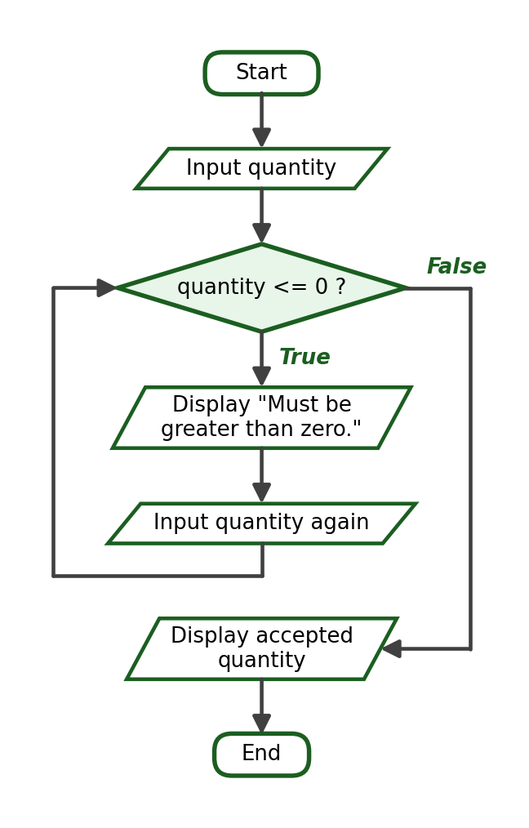
Python Program:
quantity = int(input("Enter a positive quantity: "))
while quantity <= 0:
print("The quantity must be greater than zero.")
quantity = int(input("Enter a positive quantity: "))
print("Accepted quantity:", quantity)

Test Cases and Verified Outputs:
Test Case | Input | Expected / Verified Result
1 | 0, -4, 12 | Two rejections, then 12 accepted
2 | 1 | Accepted immediately (boundary)
3 | -1, 5 | One rejection, then 5 accepted

Verified Sample Run (Test Case 1):
Enter a positive quantity: 0
The quantity must be greater than zero.
Enter a positive quantity: -4
The quantity must be greater than zero.
Enter a positive quantity: 12
Accepted quantity: 12

Explanation: Zero is not a positive quantity, so the condition must be quantity <= 0, not quantity < 0.

Activity 3, Problem 3: Menu Choice from 1 to 4
IPO Table:
Input | Process | Output
One or more choices | Repeat the input while the choice is outside 1 to 4 | The selected option

Required Variables: choice (int).
Formula / Condition: choice < 1 or choice > 4
Algorithm:
Step 1: Start.
Step 2: Ask for a choice.
Step 3: While the choice is less than 1 or greater than 4, warn the user and ask again.
Step 4: Display the selected option.
Step 5: End.

Pseudocode:
START
INPUT choice
WHILE choice < 1 OR choice > 4
DISPLAY "Invalid choice."
INPUT choice
END WHILE
DISPLAY choice
END

Flowchart:
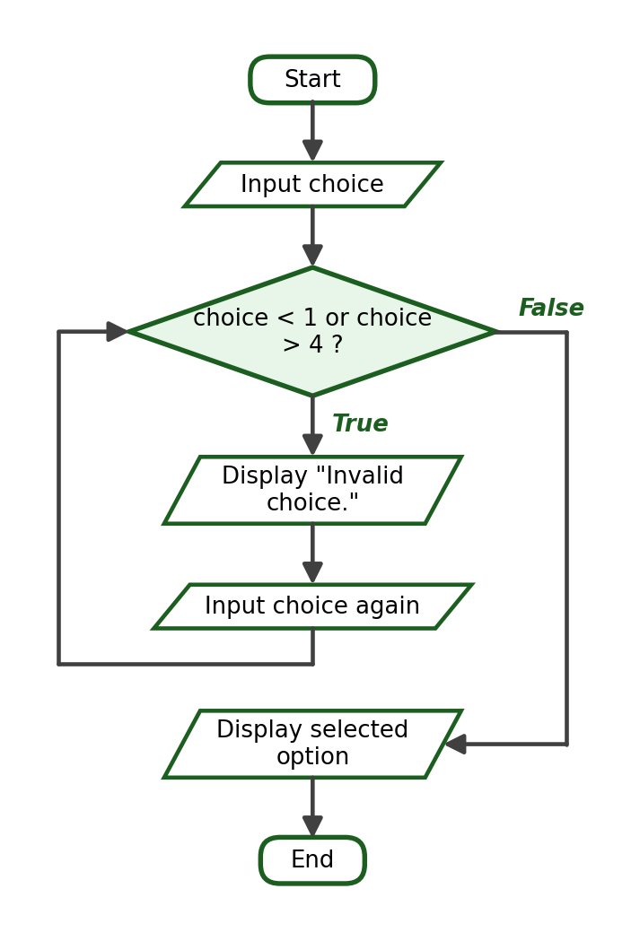
Python Program:
choice = int(input("Enter your choice (1 to 4): "))
while choice < 1 or choice > 4:
print("Invalid choice.")
choice = int(input("Enter your choice (1 to 4): "))
print("You selected option", choice)

Test Cases and Verified Outputs:
Test Case | Input | Expected / Verified Result
1 | 9, 0, 3 | Two rejections, then option 3 selected
2 | 1 | Accepted immediately (boundary)
3 | 4 | Accepted immediately (boundary)

Verified Sample Run (Test Case 1):
Enter your choice (1 to 4): 9
Invalid choice.
Enter your choice (1 to 4): 0
Invalid choice.
Enter your choice (1 to 4): 3
You selected option 3

Explanation: The validation logic mirrors Problem 1 with different boundaries.

Activity 3, Problem 4: Total Until Zero Is Entered
IPO Table:
Input | Process | Output
Numbers ending with 0 | Accumulate each value while it is not 0 | The total

Required Variables: number (float), total (float).
Formula / Condition: number != 0
Algorithm:
Step 1: Start.
Step 2: Set total to 0.
Step 3: Ask for a number (priming input).
Step 4: While the number is not 0, add it to total and ask for the next number.
Step 5: Display total.
Step 6: End.

Pseudocode:
START
total = 0
INPUT number
WHILE number <> 0
total = total + number
INPUT number
END WHILE
DISPLAY total
END

Flowchart:
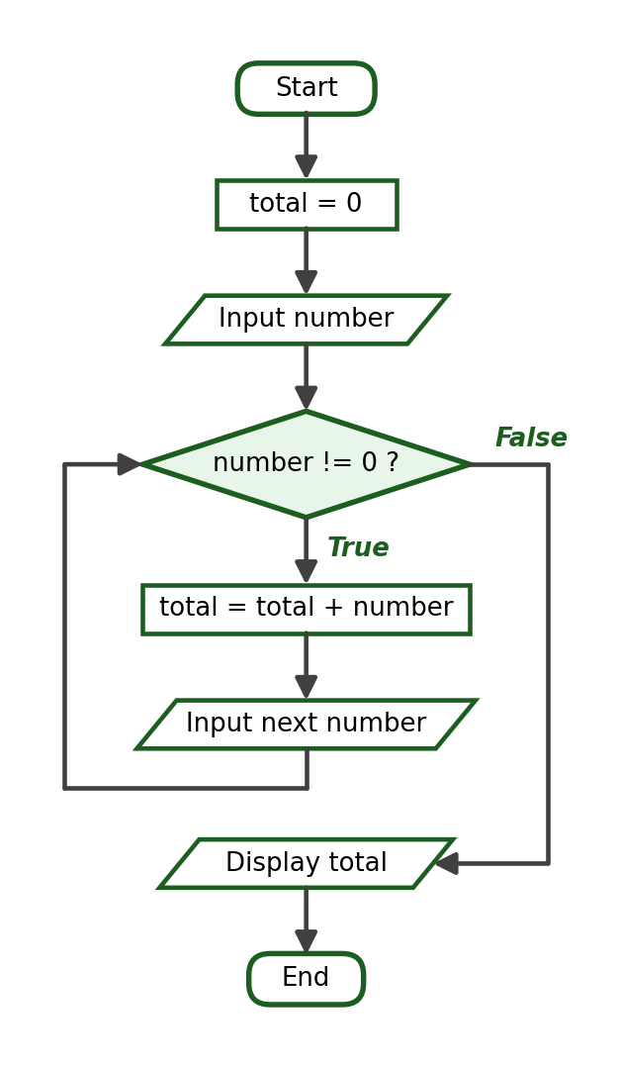
Python Program:
total = 0.0
number = float(input("Enter a number (0 to stop): "))
while number != 0:
total += number
number = float(input("Enter a number (0 to stop): "))
print(f"Total: {total:.2f}")

Test Cases and Verified Outputs:
Test Case | Input | Expected / Verified Result
1 | 12, 8, 5, 0 | Total: 25.00
2 | 0 | Total: 0.00 (immediate sentinel)
3 | 2.5, 2.5, 0 | Total: 5.00

Verified Sample Run (Test Case 1):
Enter a number (0 to stop): 12
Enter a number (0 to stop): 8
Enter a number (0 to stop): 5
Enter a number (0 to stop): 0
Total: 25.00

Explanation: The sentinel 0 must not be added — automatic here because the condition is tested before the body.

Activity 3, Problem 5: Count Values Until the Sentinel -99
IPO Table:
Input | Process | Output
Values ending with -99 | Count each value while it is not -99 | The number of values

Required Variables: value (int), count (int).
Formula / Condition: value != -99
Algorithm:
Step 1: Start.
Step 2: Set count to 0.
Step 3: Ask for a value (priming input).
Step 4: While the value is not -99, add 1 to count and ask for the next value.
Step 5: Display count.
Step 6: End.

Pseudocode:
START
count = 0
INPUT value
WHILE value <> -99
count = count + 1
INPUT value
END WHILE
DISPLAY count
END

Flowchart:
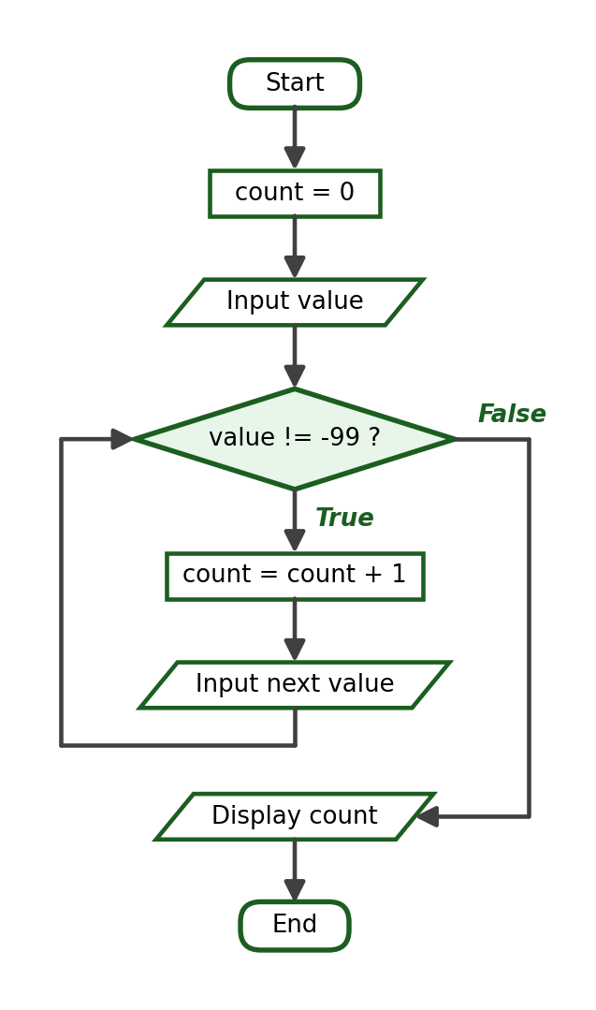
Python Program:
count = 0
value = int(input("Enter a value (-99 to stop): "))
while value != -99:
count += 1
value = int(input("Enter a value (-99 to stop): "))
print("Number of values entered:", count)

Test Cases and Verified Outputs:
Test Case | Input | Expected / Verified Result
1 | 4, 9, 2, -99 | Number of values entered: 3
2 | -99 | Number of values entered: 0 (immediate sentinel)
3 | 1, -99 | Number of values entered: 1

Verified Sample Run (Test Case 1):
Enter a value (-99 to stop): 4
Enter a value (-99 to stop): 9
Enter a value (-99 to stop): 2
Enter a value (-99 to stop): -99
Number of values entered: 3

Explanation: This problem uses a counter instead of an accumulator; the sentinel is not counted.

11. Laboratory Activity 4 Answer Key — break and continue

Activity 4, Problem 1: Stop at a Target Number (break)
IPO Table:
Input | Process | Output
target | Display 1 to 15 but break when target is reached | Numbers before target, then a message

Required Variables: target (int), number (int).
Formula / Condition: number == target
Algorithm:
Step 1: Start.
Step 2: Ask for the stopping number. Store it as target.
Step 3: For each number from 1 to 15: if number equals target, exit the loop; otherwise display the number.
Step 4: Display where the loop stopped.
Step 5: End.

Pseudocode:
START
INPUT target
FOR number = 1 TO 15
IF number = target THEN EXIT LOOP
DISPLAY number
END FOR
DISPLAY "The loop stopped at ", target
END

Flowchart:
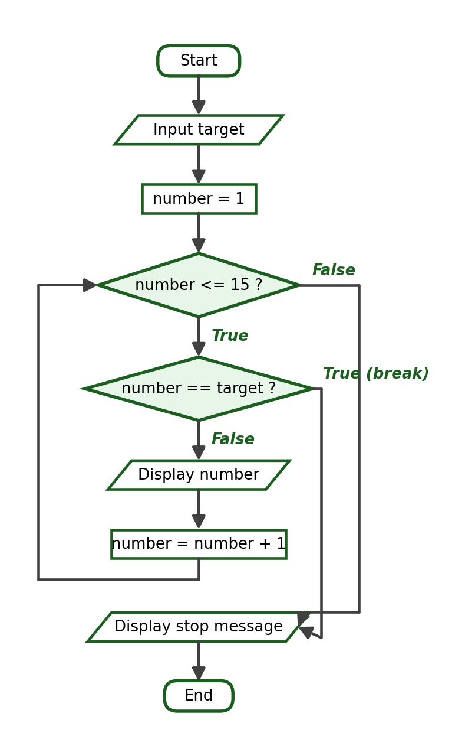
Python Program:
target = int(input("Enter the stopping number: "))
for number in range(1, 16):
if number == target:
break
print(number)
print("The loop stopped at", target)

Test Cases and Verified Outputs:
Test Case | Input | Expected / Verified Result
1 | target = 10 | Displays 1 to 9, then the stop message
2 | target = 1 | Displays nothing before the message (boundary)
3 | target = 20 | Displays 1 to 15; the target is never reached

Verified Sample Run (Test Case 1):
Enter the stopping number: 10
1
2
3
4
5
6
7
8
9
The loop stopped at 10

Explanation: Because break executes before the print, the target itself is not displayed. Test Case 3 shows that break is not guaranteed to execute.

Activity 4, Problem 2: Skip Multiples of Three (continue)
IPO Table:
Input | Process | Output
None | Display 1 to 15, skipping multiples of 3 | The numbers that are not multiples of 3

Formula / Condition: number % 3 == 0
Algorithm:
Step 1: Start.
Step 2: For each number from 1 to 15: if the number is a multiple of 3, skip it; otherwise display it.
Step 3: End.

Pseudocode:
START
FOR number = 1 TO 15
IF number MOD 3 = 0 THEN CONTINUE
DISPLAY number
END FOR
END

Flowchart:
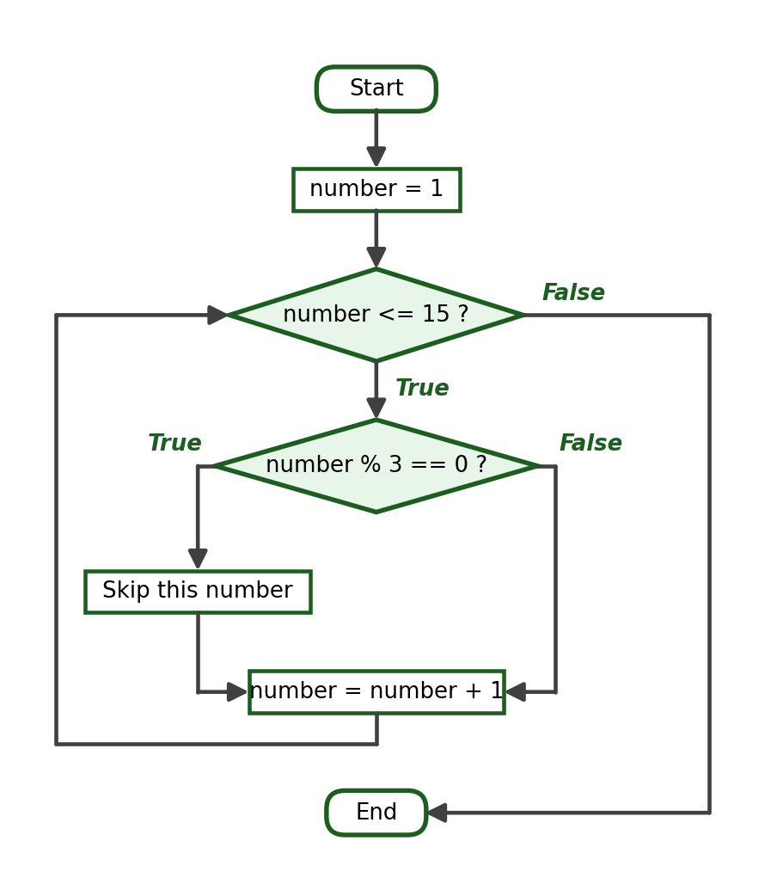
Python Program:
for number in range(1, 16):
if number % 3 == 0:
continue
print(number)

Verified Output:
1
2
4
5
7
8
10
11
13
14

Explanation: The multiples 3, 6, 9, 12, 15 are skipped; the loop itself never stops early.

Activity 4, Problem 3: Ignore Negative Values (continue)
IPO Table:
Input | Process | Output
Six integers | Add only the non-negative values into total | The total of the non-negative values

Required Variables: count (int), value (int), total (int).
Formula / Condition: value < 0
Algorithm:
Step 1: Start.
Step 2: Set total to 0.
Step 3: For each count from 1 to 6: ask for a value; if it is negative, skip it; otherwise add it to total.
Step 4: Display total.
Step 5: End.

Pseudocode:
START
total = 0
FOR count = 1 TO 6
INPUT value
IF value < 0 THEN CONTINUE
total = total + value
END FOR
DISPLAY total
END

Flowchart:
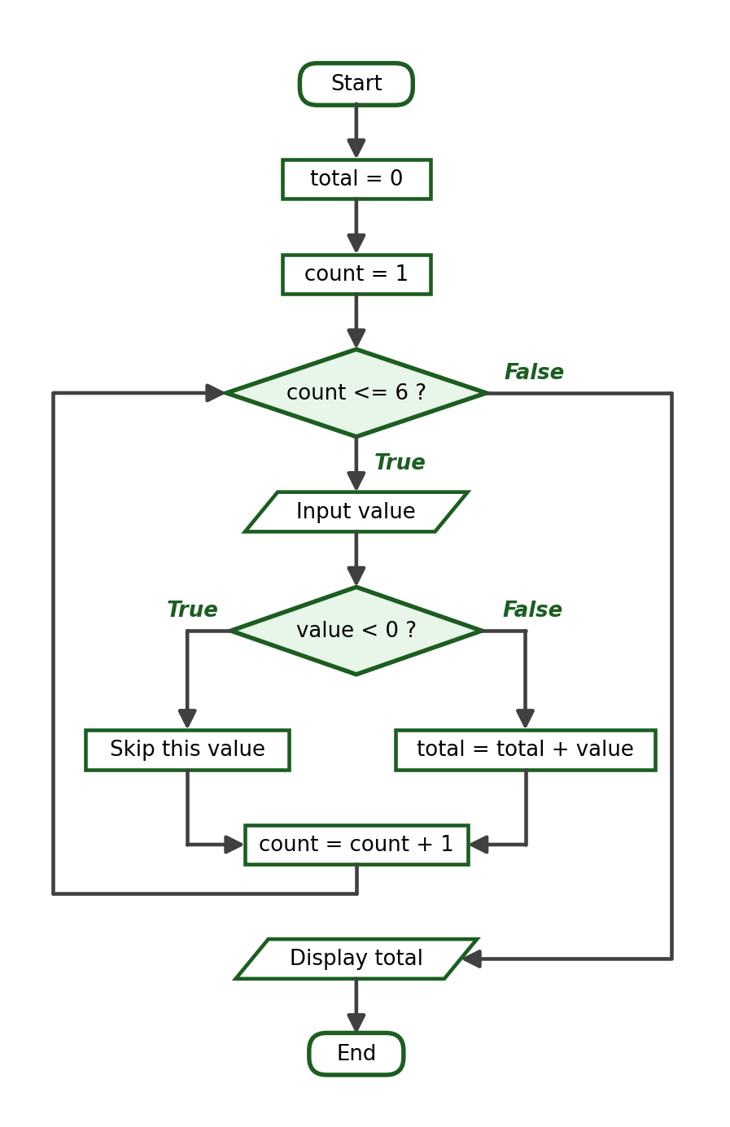
Python Program:
total = 0
for count in range(1, 7):
value = int(input(f"Enter number {count}: "))
if value < 0:
continue
total += value
print("Total of the non-negative values:", total)

Test Cases and Verified Outputs:
Test Case | Input | Expected / Verified Result
1 | 15, -6, 20, -3, 10, 5 | Total: 50
2 | -1, -2, -3, -4, -5, -6 | Total: 0 (all skipped)
3 | 1, 2, 3, 4, 5, 6 | Total: 21 (none skipped)

Verified Sample Run (Test Case 1):
Enter number 1: 15
Enter number 2: -6
Enter number 3: 20
Enter number 4: -3
Enter number 5: 10
Enter number 6: 5
Total of the non-negative values: 50

Explanation: continue skips only the accumulation statement; the loop still performs all six iterations, so all six values are requested.

Activity 4, Problem 4: Sentinel with break in a while True Loop
IPO Table:
Input | Process | Output
Amounts ending with 0 | Accumulate amounts until 0 is entered | The total amount

Required Variables: amount (float), total (float).
Formula / Condition: amount == 0
Algorithm:
Step 1: Start.
Step 2: Set total to 0.
Step 3: Repeat forever: ask for an amount; if it is 0, exit the loop; otherwise add it to total.
Step 4: Display the total in peso format.
Step 5: End.

Pseudocode:
START
total = 0
LOOP
INPUT amount
IF amount = 0 THEN EXIT LOOP
total = total + amount
END LOOP
DISPLAY total
END

Flowchart:
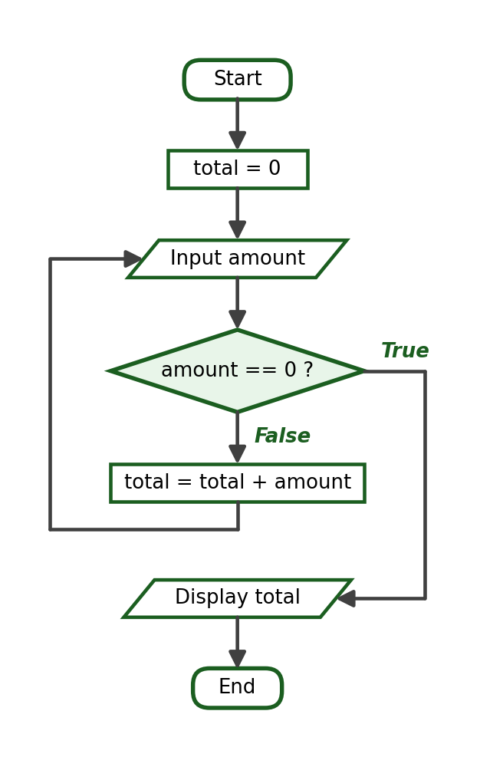
Python Program:
total = 0.0
while True:
amount = float(input("Enter an amount (0 to stop): "))
if amount == 0:
break
total += amount
print(f"Total Amount: ₱{total:.2f}")

Test Cases and Verified Outputs:
Test Case | Input | Expected / Verified Result
1 | 7, 3, 0 | Total Amount: ₱10.00
2 | 0 | Total Amount: ₱0.00 (immediate sentinel)
3 | 100.50, 0 | Total Amount: ₱100.50

Verified Sample Run (Test Case 1):
Enter an amount (0 to stop): 7
Enter an amount (0 to stop): 3
Enter an amount (0 to stop): 0
Total Amount: ₱10.00

Explanation: This is the intentional-infinite-loop pattern from the lecture: while True is acceptable only because break provides a guaranteed exit when the sentinel arrives.

12. Laboratory Activity 5 Answer Key — do-while Logic and Sentinel-Controlled Repetition
Accept any of the three valid implementations of do-while logic: while True with break, a flag variable, or a control variable initialized outside the exit condition. The essential requirement is that the loop body executes at least once.

Activity 5, Problem 1: Password Check
IPO Table:
Input | Process | Output
One or more password entries | Repeat the prompt until the entry matches the correct password | An access-granted message

Required Variables: password (str), correct_password (str).
Formula / Condition: password == correct_password
Algorithm:
Step 1: Start.
Step 2: Set correct_password to cpe2026.
Step 3: Repeat: ask for the password; if it matches, exit the loop; otherwise display an error message.
Step 4: Display “Access granted.”
Step 5: End.

Pseudocode:
START
correct_password = "cpe2026"
DO
INPUT password
IF password <> correct_password THEN
DISPLAY "Incorrect password. Please try again."
END IF
WHILE password <> correct_password
DISPLAY "Access granted."
END

Flowchart:
Python Program:
correct_password = "cpe2026"
while True:
password = input("Enter the password: ")
if password == correct_password:
break
print("Incorrect password. Please try again.")
print("Access granted.")

Test Cases and Verified Outputs:
Test Case | Input | Expected / Verified Result
1 | abc123, then cpe2026 | One rejection, then access granted
2 | cpe2026 | Access granted on the first attempt (boundary: exactly one execution)
3 | 1, 2, then cpe2026 | Two rejections, then access granted

Verified Sample Run (Test Case 1):
Enter the password: abc123
Incorrect password. Please try again.
Enter the password: cpe2026
Access granted.

Verified Sample Run (Test Case 2):
Enter the password: cpe2026
Access granted.

Explanation: Test Case 2 is the critical one: it proves the body executes at least once. A pre-test loop written as while password != correct_password before any input would fail because password would not yet exist.

Activity 5, Problem 2: Menu Loop
IPO Table:
Input | Process | Output
One or more menu choices | Display the menu and act on the choice until option 4 is selected | The matching message for each choice

Required Variables: choice (int).
Formula / Condition: choice != 4
Algorithm:
Step 1: Start.
Step 2: Set choice to 0 so that the loop is entered at least once.
Step 3: While choice is not 4: display the menu, ask for a choice, and display the matching message; reject invalid choices.
Step 4: End.

Pseudocode:
START
choice = 0
WHILE choice <> 4
DISPLAY the menu
INPUT choice
IF choice = 1 THEN DISPLAY "Deposit selected."
ELSE IF choice = 2 THEN DISPLAY "Withdraw selected."
ELSE IF choice = 3 THEN DISPLAY "Balance selected."
ELSE IF choice = 4 THEN DISPLAY the closing message
ELSE DISPLAY "Invalid choice. Please select 1 to 4."
END IF
END WHILE
END

Flowchart:
Python Program:
choice = 0
while choice != 4:
print("[1] Deposit [2] Withdraw [3] Balance [4] Exit")
choice = int(input("Enter your choice: "))
if choice == 1:
print("Deposit selected.")
elif choice == 2:
print("Withdraw selected.")
elif choice == 3:
print("Balance selected.")
elif choice == 4:
print("Thank you for using the system.")
else:
print("Invalid choice. Please select 1 to 4.")

Test Cases and Verified Outputs:
Test Case | Input | Expected / Verified Result
1 | 2, 9, 3, 4 | Withdraw, invalid warning, Balance, then exit
2 | 4 | Menu shown once, then exit (boundary)
3 | 0, 5, 4 | Two invalid warnings, then exit

Verified Sample Run (Test Case 1):
[1] Deposit [2] Withdraw [3] Balance [4] Exit
Enter your choice: 2
Withdraw selected.
[1] Deposit [2] Withdraw [3] Balance [4] Exit
Enter your choice: 9
Invalid choice. Please select 1 to 4.
[1] Deposit [2] Withdraw [3] Balance [4] Exit
Enter your choice: 3
Balance selected.
[1] Deposit [2] Withdraw [3] Balance [4] Exit
Enter your choice: 4
Thank you for using the system.

Explanation: Initializing choice to 0 guarantees the first test is True. An invalid entry must not terminate the loop — a common student error is using break for the invalid branch.

Activity 5, Problem 3: Sentinel-Controlled Readings
IPO Table:
Input | Process | Output
Readings ending with -1 | Count and accumulate each reading while it is not the sentinel | The number of readings and their average

Required Variables: reading (float), count (int), total (float), average (float).
Formula / Condition: reading != -1 and average = total / count
Algorithm:
Step 1: Start.
Step 2: Set count to 0 and total to 0.
Step 3: Ask for a reading (priming input).
Step 4: While the reading is not -1, add 1 to count, add the reading to total, and ask for the next reading.
Step 5: If count is greater than 0, compute and display the average; otherwise display a no-readings message.
Step 6: End.

Pseudocode:
START
count = 0
total = 0
INPUT reading
WHILE reading <> -1
count = count + 1
total = total + reading
INPUT reading
END WHILE
IF count > 0 THEN
average = total / count
DISPLAY count, average
ELSE
DISPLAY "No readings were entered."
END IF
END

Flowchart:
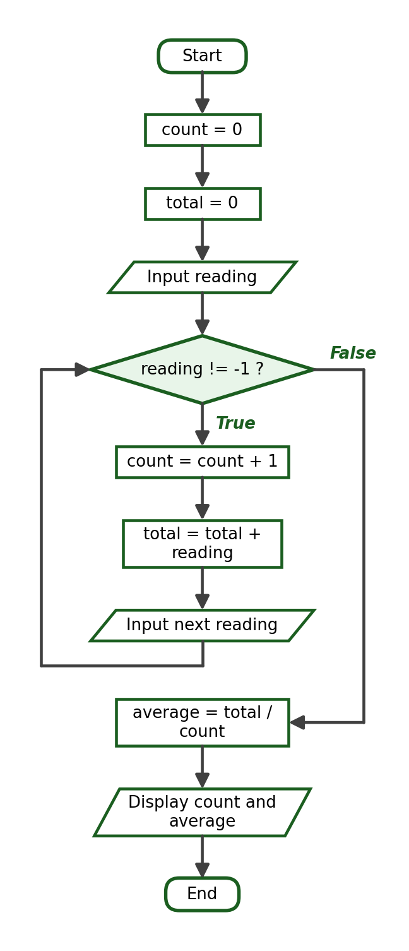
Python Program:
count = 0
total = 0.0
reading = float(input("Enter a reading (-1 to stop): "))
while reading != -1:
count += 1
total += reading
reading = float(input("Enter a reading (-1 to stop): "))
if count > 0:
average = total / count
print("Number of readings:", count)
print(f"Average reading: {average:.2f}")
else:
print("No readings were entered.")

Trace Table (using the inputs of Test Case 1):
Iteration | reading | count after | total after
1 | 12.5 | 1 | 12.5
2 | 18.0 | 2 | 30.5
3 | 21.5 | 3 | 52.0
— | -1 (sentinel) | 3 | 52.0

Test Cases and Verified Outputs:
Test Case | Input | Expected / Verified Result
1 | 12.5, 18.0, 21.5, -1 | 3 readings, average 17.33
2 | -1 immediately | No readings were entered (boundary)
3 | 100, -1 | 1 reading, average 100.00

Verified Sample Run (Test Case 1):
Enter a reading (-1 to stop): 12.5
Enter a reading (-1 to stop): 18.0
Enter a reading (-1 to stop): 21.5
Enter a reading (-1 to stop): -1
Number of readings: 3
Average reading: 17.33

Verified Sample Run (Test Case 2):
Enter a reading (-1 to stop): -1
No readings were entered.

Explanation: The guard if count > 0 prevents a division-by-zero error when the sentinel is entered immediately. Programs that omit this guard crash on Test Case 2 and must lose points.

Activity 5, Problem 4: Repeat-Until-Declined Encoding
IPO Table:
Input | Process | Output
Prices and y/n answers | Accumulate each price while the answer remains y | The item count and total cost

Required Variables: answer (str), price (float), item_count (int), total_cost (float).
Formula / Condition: answer == "y"
Algorithm:
Step 1: Start.
Step 2: Set answer to y, item_count to 0, and total_cost to 0.
Step 3: While answer is y: ask for a price, add it to total_cost, add 1 to item_count, and ask whether another item will be encoded.
Step 4: Display item_count and total_cost.
Step 5: End.

Pseudocode:
START
answer = "y"
item_count = 0
total_cost = 0
WHILE answer = "y"
INPUT price
total_cost = total_cost + price
item_count = item_count + 1
INPUT answer
END WHILE
DISPLAY item_count, total_cost
END

Flowchart:
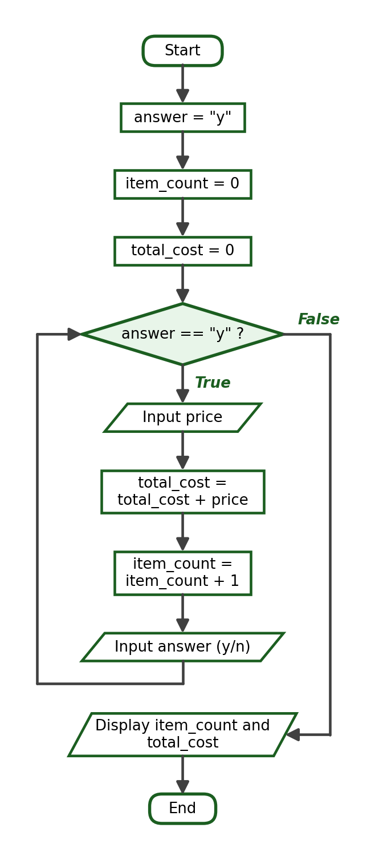
Python Program:
answer = "y"
item_count = 0
total_cost = 0.0
while answer == "y":
price = float(input("Enter the price of the item: "))
total_cost += price
item_count += 1
answer = input("Enter another item? (y/n): ")
print("Items encoded:", item_count)
print(f"Total Cost: ₱{total_cost:.2f}")

Test Cases and Verified Outputs:
Test Case | Input | Expected / Verified Result
1 | 120.50 y, 79.50 n | 2 items, Total Cost: ₱200.00
2 | 500 n | 1 item, Total Cost: ₱500.00 (boundary: one execution)
3 | 10 y, 20 y, 30 n | 3 items, Total Cost: ₱60.00

Verified Sample Run (Test Case 1):
Enter the price of the item: 120.50
Enter another item? (y/n): y
Enter the price of the item: 79.50
Enter another item? (y/n): n
Items encoded: 2
Total Cost: ₱200.00

Explanation: Initializing answer to y before the loop is what makes the body run at least once — the same technique as initializing choice to 0 in Problem 2.

13. Laboratory Activity 6 Answer Key — Complete Problem-Solving Tasks

Activity 6, Problem 1: Student Savings
IPO Table:
Input | Process | Output
weeks, then an amount per week | Accumulate each weekly amount | The total savings

Required Variables: weeks (int), week (int), amount (float), total_savings (float).
Formula / Condition: total_savings = total_savings + amount
Algorithm:
Step 1: Start.
Step 2: Ask how many weeks will be recorded. Store it as weeks.
Step 3: Set total_savings to 0.
Step 4: For each week from 1 to weeks, ask for the amount and add it to total_savings.
Step 5: Display total_savings in peso format.
Step 6: End.

Pseudocode:
START
INPUT weeks
total_savings = 0
FOR week = 1 TO weeks
INPUT amount
total_savings = total_savings + amount
END FOR
DISPLAY total_savings
END

Flowchart:
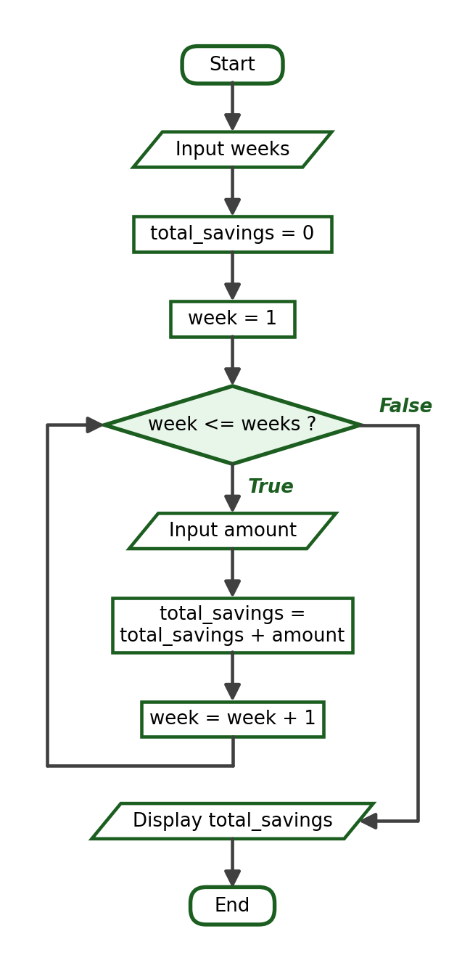
Python Program:
weeks = int(input("How many weeks will be recorded? "))
total_savings = 0.0
for week in range(1, weeks + 1):
amount = float(input(f"Enter savings for week {week}: "))
total_savings += amount
print(f"Total Savings: ₱{total_savings:.2f}")

Trace Table (using the inputs of Test Case 1):
Iteration | amount | total_savings after
1 | 100.0 | 100.0
2 | 150.0 | 250.0
3 | 200.0 | 450.0
4 | 50.0 | 500.0

Test Cases and Verified Outputs:
Test Case | Input | Expected / Verified Result
1 | 4 weeks: 100, 150, 200, 50 | Total Savings: ₱500.00
2 | 1 week: 500 | Total Savings: ₱500.00 (boundary)
3 | 3 weeks: 0, 250.50, 100 | Total Savings: ₱350.50

Verified Sample Run (Test Case 1):
How many weeks will be recorded? 4
Enter savings for week 1: 100
Enter savings for week 2: 150
Enter savings for week 3: 200
Enter savings for week 4: 50
Total Savings: ₱500.00

Explanation: A counter-controlled loop with an accumulator; the peso format requires :.2f.

Activity 6, Problem 2: Daily Transportation Expense
IPO Table:
Input | Process | Output
Five daily amounts | Accumulate the amount for each of 5 days | The total expense

Required Variables: day (int), amount (float), total_expense (float).
Formula / Condition: total_expense = total_expense + amount
Algorithm:
Step 1: Start.
Step 2: Set total_expense to 0.
Step 3: For each day from 1 to 5, ask for the amount and add it to total_expense.
Step 4: Display total_expense in peso format.
Step 5: End.

Pseudocode:
START
total_expense = 0
FOR day = 1 TO 5
INPUT amount
total_expense = total_expense + amount
END FOR
DISPLAY total_expense
END

Flowchart:
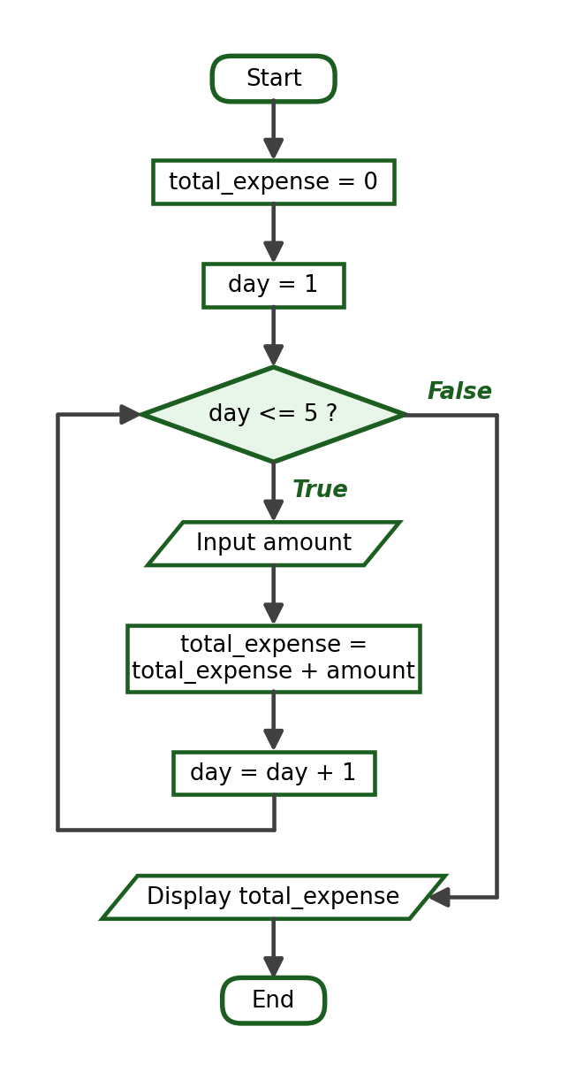
Python Program:
total_expense = 0.0
for day in range(1, 6):
amount = float(input(f"Enter transportation expense for day {day}: "))
total_expense += amount
print(f"Total Transportation Expense: ₱{total_expense:.2f}")

Trace Table (using the inputs of Test Case 1):
Iteration | amount | total_expense after
1 | 45.5 | 45.5
2 | 50.0 | 95.5
3 | 38.75 | 134.25
4 | 60.0 | 194.25
5 | 42.0 | 236.25

Test Cases and Verified Outputs:
Test Case | Input | Expected / Verified Result
1 | 45.50, 50, 38.75, 60, 42 | Total Transportation Expense: ₱236.25
2 | 10, 10, 10, 10, 10 | Total Transportation Expense: ₱50.00
3 | 0, 0, 0, 0, 0 | Total Transportation Expense: ₱0.00 (boundary)

Verified Sample Run (Test Case 1):
Enter transportation expense for day 1: 45.50
Enter transportation expense for day 2: 50
Enter transportation expense for day 3: 38.75
Enter transportation expense for day 4: 60
Enter transportation expense for day 5: 42
Total Transportation Expense: ₱236.25

Explanation: The number of days is fixed at 5, so no count input is needed.

Activity 6, Problem 3: Quiz Average
IPO Table:
Input | Process | Output
count, then count scores | Accumulate the scores; average = total / count | The average

Required Variables: count (int), entry (int), score (float), total (float), average (float).
Formula / Condition: average = total / count
Algorithm:
Step 1: Start.
Step 2: Ask how many quiz scores will be entered. Store it as count.
Step 3: Set total to 0.
Step 4: For each entry from 1 to count, ask for a score and add it to total.
Step 5: Compute and display average = total / count.
Step 6: End.

Pseudocode:
START
INPUT count
total = 0
FOR entry = 1 TO count
INPUT score
total = total + score
END FOR
average = total / count
DISPLAY average
END

Flowchart:
Python Program:
count = int(input("How many quiz scores will be entered? "))
total = 0
for entry in range(1, count + 1):
score = float(input(f"Enter quiz score {entry}: "))
total += score
average = total / count
print(f"Average: {average:.2f}")

Trace Table (using the inputs of Test Case 1):
Iteration | score | total after
1 | 88.0 | 88.0
2 | 92.0 | 180.0
3 | 79.0 | 259.0

Test Cases and Verified Outputs:
Test Case | Input | Expected / Verified Result
1 | 3 scores: 88, 92, 79 | Average: 86.33
2 | 1 score: 75 | Average: 75.00 (boundary)
3 | 4 scores: 70, 80, 90, 100 | Average: 85.00

Verified Sample Run (Test Case 1):
How many quiz scores will be entered? 3
Enter quiz score 1: 88
Enter quiz score 2: 92
Enter quiz score 3: 79
Average: 86.33

Explanation: 259.0 / 3 = 86.333…, displayed as 86.33 by the :.2f specifier.

Activity 6, Problem 4: Passed and Failed Students
IPO Table:
Input | Process | Output
students, then a grade per student | Count grades of at least 75 as passed, the rest as failed | The two counts

Required Variables: students (int), entry (int), grade (float), passed_count (int), failed_count (int).
Formula / Condition: grade >= 75
Algorithm:
Step 1: Start.
Step 2: Ask how many students are in the class. Store it as students.
Step 3: Set passed_count and failed_count to 0.
Step 4: For each entry from 1 to students: ask for the grade; if it is at least 75, add 1 to passed_count, otherwise add 1 to failed_count.
Step 5: Display both counts.
Step 6: End.

Pseudocode:
START
INPUT students
passed_count = 0
failed_count = 0
FOR entry = 1 TO students
INPUT grade
IF grade >= 75 THEN
passed_count = passed_count + 1
ELSE
failed_count = failed_count + 1
END IF
END FOR
DISPLAY passed_count, failed_count
END

Flowchart:
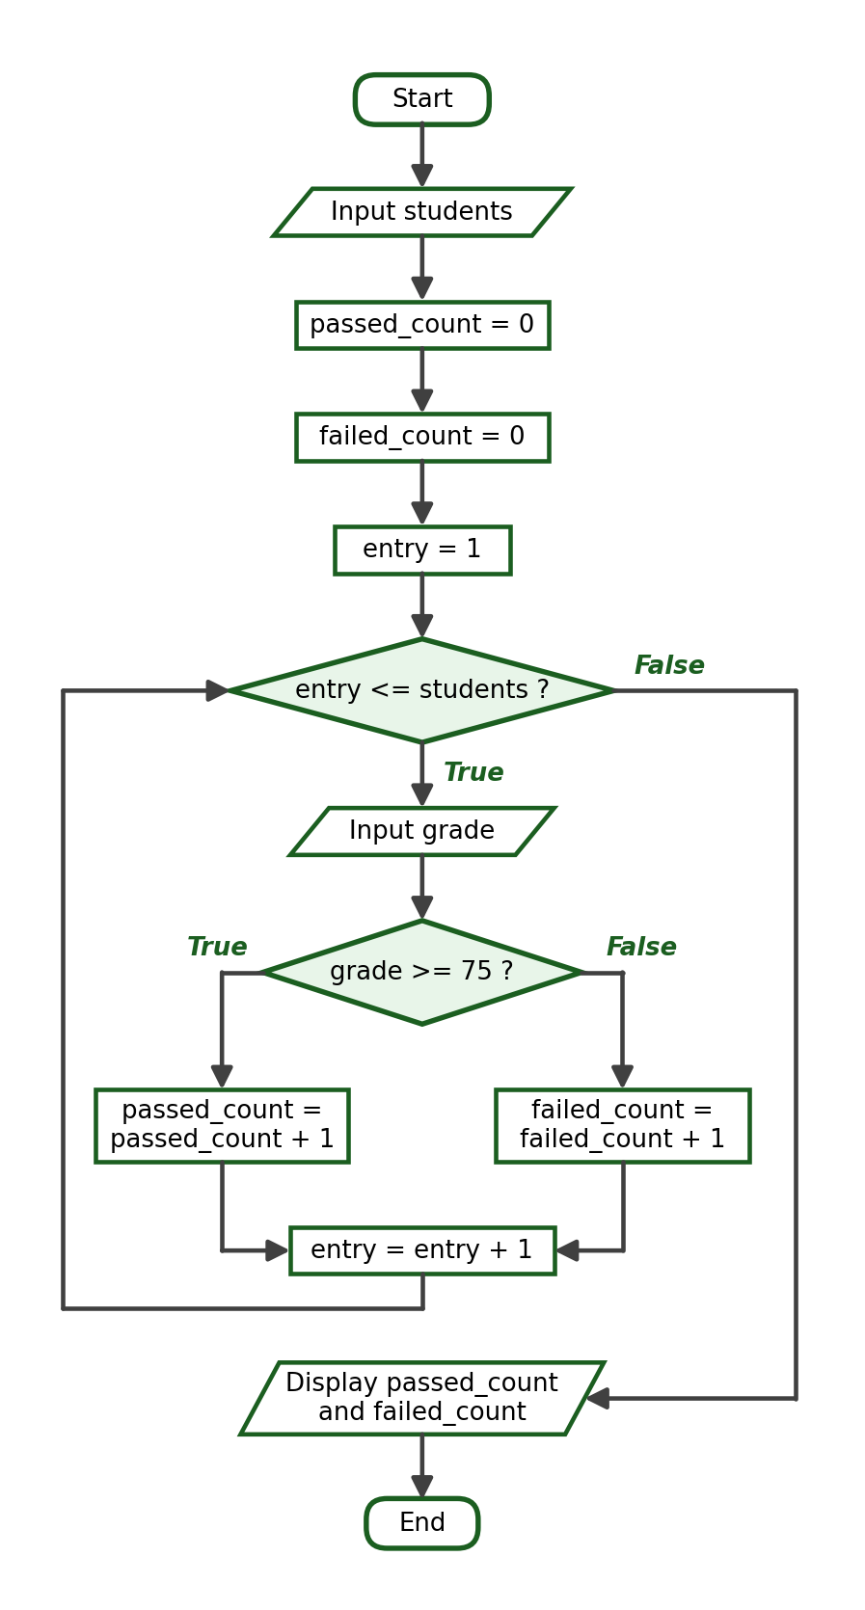
Python Program:
students = int(input("How many students are in the class? "))
passed_count = 0
failed_count = 0
for entry in range(1, students + 1):
grade = float(input(f"Enter the grade of student {entry}: "))
if grade >= 75:
passed_count += 1
else:
failed_count += 1
print("Passed students:", passed_count)
print("Failed students:", failed_count)

Trace Table (using the inputs of Test Case 1):
Iteration | grade | passed_count | failed_count
1 | 80.0 | 1 | 0
2 | 74.0 | 1 | 1
3 | 90.0 | 2 | 1
4 | 75.0 | 3 | 1
5 | 60.0 | 3 | 2

Test Cases and Verified Outputs:
Test Case | Input | Expected / Verified Result
1 | 5 grades: 80, 74, 90, 75, 60 | Passed: 3, Failed: 2
2 | 3 grades: 75, 75, 75 | Passed: 3, Failed: 0 (boundary 75 passes)
3 | 4 grades: 60, 65, 70, 74 | Passed: 0, Failed: 4

Verified Sample Run (Test Case 1):
How many students are in the class? 5
Enter the grade of student 1: 80
Enter the grade of student 2: 74
Enter the grade of student 3: 90
Enter the grade of student 4: 75
Enter the grade of student 5: 60
Passed students: 3
Failed students: 2

Explanation: The boundary grade of exactly 75 must be counted as passed. The two counters always add up to the number of students.

Activity 6, Problem 5: Total Purchase Cost
IPO Table:
Input | Process | Output
items, then a price per item | Accumulate each price | The total cost

Required Variables: items (int), item (int), price (float), total_cost (float).
Formula / Condition: total_cost = total_cost + price
Algorithm:
Step 1: Start.
Step 2: Ask how many items were purchased. Store it as items.
Step 3: Set total_cost to 0.
Step 4: For each item from 1 to items, ask for the price and add it to total_cost.
Step 5: Display total_cost in peso format.
Step 6: End.

Pseudocode:
START
INPUT items
total_cost = 0
FOR item = 1 TO items
INPUT price
total_cost = total_cost + price
END FOR
DISPLAY total_cost
END

Flowchart:
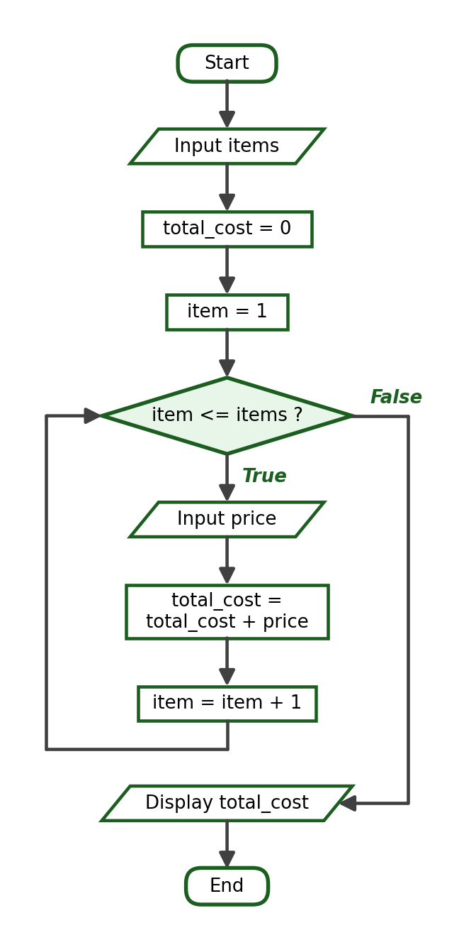
Python Program:
items = int(input("How many items were purchased? "))
total_cost = 0.0
for item in range(1, items + 1):
price = float(input(f"Enter the price of item {item}: "))
total_cost += price
print(f"Total Cost: ₱{total_cost:.2f}")

Trace Table (using the inputs of Test Case 1):
Iteration | price | total_cost after
1 | 199.75 | 199.75
2 | 45.25 | 245.0
3 | 300.0 | 545.0

Test Cases and Verified Outputs:
Test Case | Input | Expected / Verified Result
1 | 3 items: 199.75, 45.25, 300 | Total Cost: ₱545.00
2 | 1 item: 99.99 | Total Cost: ₱99.99 (boundary)
3 | 5 items: 10, 20, 30, 40, 50 | Total Cost: ₱150.00

Verified Sample Run (Test Case 1):
How many items were purchased? 3
Enter the price of item 1: 199.75
Enter the price of item 2: 45.25
Enter the price of item 3: 300
Total Cost: ₱545.00

Explanation: Structurally identical to Problem 1; the accumulator idea transfers across many money problems.

Activity 6, Problem 6: Largest Value Without a List
IPO Table:
Input | Process | Output
count, then count values | Keep the largest value seen so far | The largest value

Required Variables: count (int), entry (int), value (float), largest (float).
Formula / Condition: value > largest
Algorithm:
Step 1: Start.
Step 2: Ask how many values will be entered. Store it as count.
Step 3: Ask for the first value and store it as largest.
Step 4: For each entry from 2 to count: ask for a value; if it is greater than largest, replace largest with it.
Step 5: Display largest.
Step 6: End.

Pseudocode:
START
INPUT count
INPUT value
largest = value
FOR entry = 2 TO count
INPUT value
IF value > largest THEN
largest = value
END IF
END FOR
DISPLAY largest
END

Flowchart:
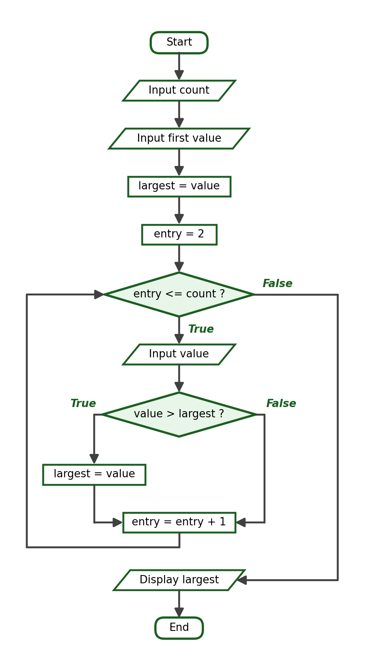
Python Program:
count = int(input("How many values will be entered? "))
largest = float(input("Enter value 1: "))
for entry in range(2, count + 1):
value = float(input(f"Enter value {entry}: "))
if value > largest:
largest = value
print("The largest value is", largest)

Trace Table (using the inputs of Test Case 1):
Iteration | value | value > largest | largest after
— | 18.0 (first value) | — | 18.0
1 | 42.0 | True | 42.0
2 | 7.0 | False | 42.0
3 | 33.0 | False | 42.0

Test Cases and Verified Outputs:
Test Case | Input | Expected / Verified Result
1 | 4 values: 18, 42, 7, 33 | The largest value is 42.0
2 | 3 values: 5, 5, 5 | The largest value is 5.0 (all equal, boundary)
3 | 2 values: -8, -3 | The largest value is -3.0 (all negative)

Verified Sample Run (Test Case 1):
How many values will be entered? 4
Enter value 1: 18
Enter value 2: 42
Enter value 3: 7
Enter value 4: 33
The largest value is 42.0

Explanation: Initializing largest with the first entered value (instead of 0) makes the program correct even when every value is negative — the point of Test Case 3.

Activity 6, Problem 7: Product Inventory with a Sentinel
IPO Table:
Input | Process | Output
Quantities ending with -1 | Accumulate each quantity while it is not the sentinel | The total items

Required Variables: quantity (int), total_items (int).
Formula / Condition: quantity != -1
Algorithm:
Step 1: Start.
Step 2: Set total_items to 0.
Step 3: Ask for a quantity (priming input).
Step 4: While the quantity is not -1, add it to total_items and ask for the next quantity.
Step 5: Display total_items.
Step 6: End.

Pseudocode:
START
total_items = 0
INPUT quantity
WHILE quantity <> -1
total_items = total_items + quantity
INPUT quantity
END WHILE
DISPLAY total_items
END

Flowchart:
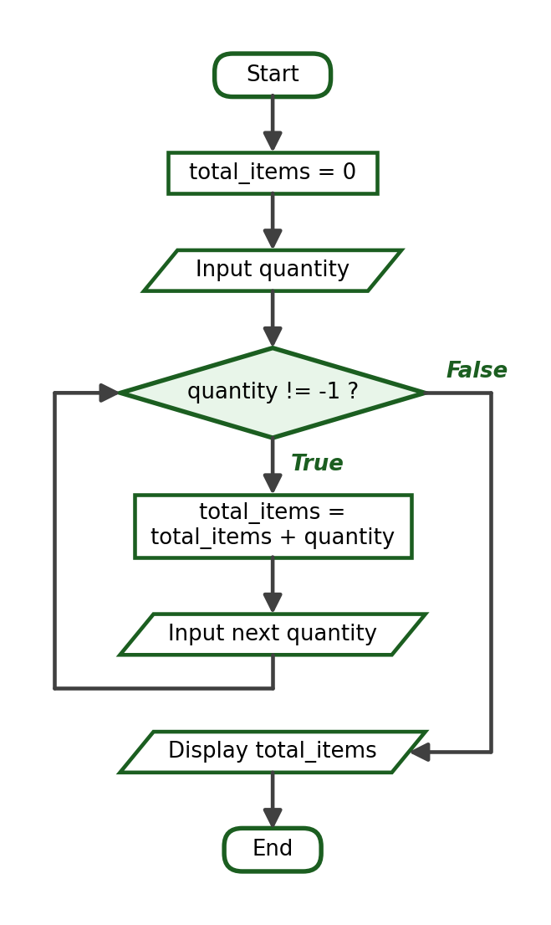
Python Program:
total_items = 0
quantity = int(input("Enter a delivery quantity (-1 to stop): "))
while quantity != -1:
total_items += quantity
quantity = int(input("Enter a delivery quantity (-1 to stop): "))
print("Total items received:", total_items)

Trace Table (using the inputs of Test Case 1):
Iteration | quantity | total_items after
1 | 24 | 24
2 | 36 | 60
3 | 15 | 75
— | -1 (sentinel) | loop ends, total stays 75

Test Cases and Verified Outputs:
Test Case | Input | Expected / Verified Result
1 | 24, 36, 15, -1 | Total items received: 75
2 | -1 | Total items received: 0 (immediate sentinel)
3 | 100, -1 | Total items received: 100

Verified Sample Run (Test Case 1):
Enter a delivery quantity (-1 to stop): 24
Enter a delivery quantity (-1 to stop): 36
Enter a delivery quantity (-1 to stop): 15
Enter a delivery quantity (-1 to stop): -1
Total items received: 75

Explanation: The sentinel -1 is chosen because a real quantity of -1 items is impossible; the sentinel is never accumulated.

Activity 6, Problem 8: Repeated Grade Validation
IPO Table:
Input | Process | Output
One or more grades | Repeat the input while the grade is outside 0 to 100 | The accepted grade

Required Variables: grade (float).
Formula / Condition: grade < 0 or grade > 100
Algorithm:
Step 1: Start.
Step 2: Ask for a grade.
Step 3: While the grade is less than 0 or greater than 100, warn the user and ask again.
Step 4: Display the accepted grade.
Step 5: End.

Pseudocode:
START
INPUT grade
WHILE grade < 0 OR grade > 100
DISPLAY "Invalid grade. Please try again."
INPUT grade
END WHILE
DISPLAY grade
END

Flowchart:
Python Program:
grade = float(input("Enter a grade from 0 to 100: "))
while grade < 0 or grade > 100:
print("Invalid grade. Please try again.")
grade = float(input("Enter a grade from 0 to 100: "))
print("Accepted grade:", grade)

Trace Table (using the inputs of Test Case 1):
Attempt | grade | Invalid? | Action
1 | 130.0 | True | Warn and ask again
2 | -20.0 | True | Warn and ask again
3 | 87.0 | False | Accept and display

Test Cases and Verified Outputs:
Test Case | Input | Expected / Verified Result
1 | 130, -20, 87 | Accepted grade: 87.0
2 | 0 | Accepted grade: 0.0 (boundary)
3 | 100 | Accepted grade: 100.0 (boundary)

Verified Sample Run (Test Case 1):
Enter a grade from 0 to 100: 130
Invalid grade. Please try again.
Enter a grade from 0 to 100: -20
Invalid grade. Please try again.
Enter a grade from 0 to 100: 87
Accepted grade: 87.0

Explanation: The condition describes the invalid region, so the body runs only for invalid grades.

Activity 6, Problem 9: Multiplication-Table Generator with Validation
IPO Table:
Input | Process | Output
An integer from 1 to 10 (validated) | Validate the input, then multiply it by 1 to 10 | Ten multiplication lines

Required Variables: number (int), multiplier (int), product (int).
Formula / Condition: number < 1 or number > 10
Algorithm:
Step 1: Start.
Step 2: Ask for an integer from 1 to 10.
Step 3: While the number is outside 1 to 10, warn the user and ask again.
Step 4: For each multiplier from 1 to 10, compute the product and display the line.
Step 5: End.

Pseudocode:
START
INPUT number
WHILE number < 1 OR number > 10
DISPLAY "Invalid number."
INPUT number
END WHILE
FOR multiplier = 1 TO 10
product = number * multiplier
DISPLAY number, " x ", multiplier, " = ", product
END FOR
END

Flowchart:
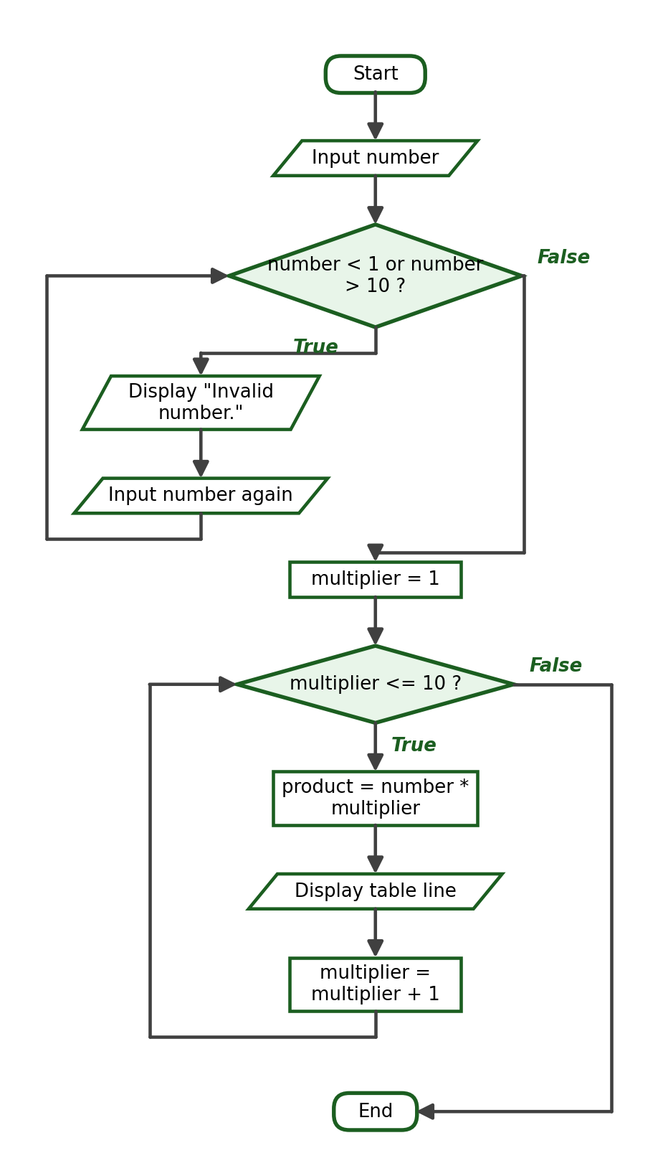
Python Program:
number = int(input("Enter an integer from 1 to 10: "))
while number < 1 or number > 10:
print("Invalid number.")
number = int(input("Enter an integer from 1 to 10: "))
for multiplier in range(1, 11):
product = number * multiplier
print(f"{number} x {multiplier} = {product}")

Trace Table (using the inputs of Test Case 1):
Phase | Value | Result
Validation attempt 1 | 15 | Invalid — ask again
Validation attempt 2 | 8 | Accepted
Table loop | multiplier = 1 to 10 | Displays 8 x 1 = 8 up to 8 x 10 = 80

Test Cases and Verified Outputs:
Test Case | Input | Expected / Verified Result
1 | 15, then 8 | One rejection, then the table of 8
2 | 1 | Accepted immediately; table of 1 (boundary)
3 | 0, 11, then 10 | Two rejections, then the table of 10 (boundary)

Verified Sample Run (Test Case 1):
Enter an integer from 1 to 10: 15
Invalid number.
Enter an integer from 1 to 10: 8
8 x 1 = 8
8 x 2 = 16
8 x 3 = 24
8 x 4 = 32
8 x 5 = 40
8 x 6 = 48
8 x 7 = 56
8 x 8 = 64
8 x 9 = 72
8 x 10 = 80

Explanation: This problem combines the two loop types sequentially: a while loop for validation runs to completion first, and only then does the for loop build the table. The second loop begins after the first one ends.

Activity 6, Problem 10: Sum of Even Numbers from 1 to N
IPO Table:
Input | Process | Output
limit | Add the even values 2, 4, … up to limit | The sum of the even numbers

Required Variables: limit (int), number (int), total (int).
Formula / Condition: total = total + number, for number = 2, 4, 6, … <= limit
Algorithm:
Step 1: Start.
Step 2: Ask for a positive integer. Store it as limit.
Step 3: Set total to 0.
Step 4: For each number from 2 to limit counting by 2, add number to total.
Step 5: Display total.
Step 6: End.

Pseudocode:
START
INPUT limit
total = 0
FOR number = 2 TO limit STEP 2
total = total + number
END FOR
DISPLAY total
END

Flowchart:
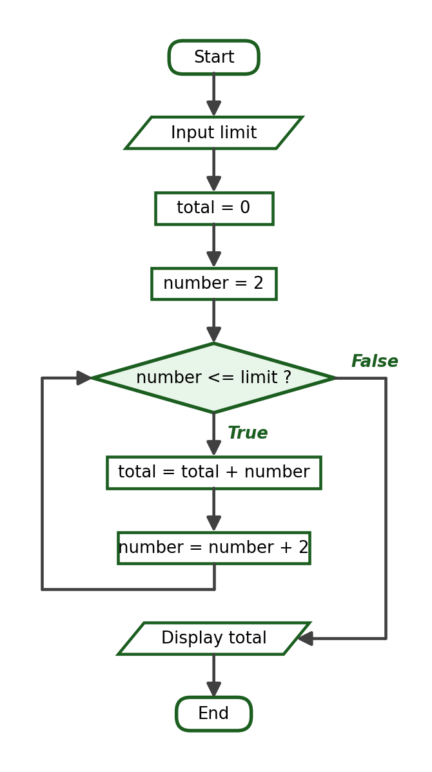
Python Program:
limit = int(input("Enter a positive integer: "))
total = 0
for number in range(2, limit + 1, 2):
total += number
print("The sum of even numbers from 1 to", limit, "is", total)

Trace Table (using the inputs of Test Case 1):
Iteration | number | total after
1 | 2 | 2
2 | 4 | 6
3 | 6 | 12
4 | 8 | 20
5 | 10 | 30

Test Cases and Verified Outputs:
Test Case | Input | Expected / Verified Result
1 | N = 10 | The sum of even numbers from 1 to 10 is 30
2 | N = 1 | The sum is 0 — the loop body never executes (boundary)
3 | N = 20 | The sum of even numbers from 1 to 20 is 110

Verified Sample Run (Test Case 1):
Enter a positive integer: 10
The sum of even numbers from 1 to 10 is 30

Explanation: Starting the range at 2 with a step of 2 visits only even values. An equally valid solution loops over every number and adds only those with number % 2 == 0.

14. Reflection Questions — Guide Answers
- 1. for versus while: a for loop iterates over a known sequence of values, so it suits counter-controlled repetition; a while loop repeats as long as a condition holds, so it suits repetition whose count is unknown, such as validation and sentinel input.
- 2. Changing the while condition: if no statement in the body can make the condition False, the loop never ends — an infinite loop. Every while loop needs an update, a sentinel input, or a break.
- 3. Counter versus accumulator: a counter adds exactly 1 to record how many times something happened; an accumulator adds the current value to keep a running total. Both must be initialized before the loop.
- 4. break versus continue: break terminates the entire loop immediately; continue abandons only the current iteration and returns to the condition or the next sequence value.
- 5. Flowcharts: acceptable answers should mention that the diamond isolates the condition, the return arrow makes the repetition visible, and the separate initialization and update boxes show exactly where those parts belong — before the loop and at the end of the body, respectively.
- 6. do-while logic: Python provides only for and while, and a plain while loop is a pre-test loop whose body may never execute. To guarantee at least one execution, students should describe while True with break, a flag variable, or a control variable initialized to a value that cannot satisfy the exit condition. Writing do or do...while in Python is a SyntaxError.

15. Grading Reminders
- Compare student outputs against the exact transcripts in this answer key; formatting differences (missing peso sign, wrong decimal places) lose points under output correctness.
- Check boundary behavior deliberately: N = 1, grade = 0, grade = 100, an immediate sentinel, and all-negative inputs for the largest-value problem.
- Accept equivalent correct solutions (for versus while, number * number versus number ** 2, modulo-based even sums) as long as the required statement (break, continue) is used where the problem demands it.
- Verify that counters and accumulators are initialized before the loop; a correct-looking output from a single test case can hide this error.
- Confirm the GitHub repository structure, commit history, and README contents; work uploaded through the website editor instead of a local commit does not meet the workflow requirement.
- If copying or fake authorship is suspected, flag the submission for follow-up and continue grading the rest of the batch.

