CPP102: PROGRAMMING LOGIC AND DESIGN
Week 8 Lecture and Laboratory Module
Functions Fundamentals
Department of Computer Engineering

PART A. LECTURE MODULE

Module Information
Course Code: CPP102
Course Title: Programming Logic and Design (2 units, Lecture-Laboratory)
Week: Week 8
Main Topic: Functions Fundamentals
Subtopics: purpose and benefits of functions, modular programming, program decomposition, built-in versus user-defined functions, defining a function using def, function naming, the function body and indentation, calling a function, functions with and without parameters, parameters versus arguments, functions with and without return values, the return statement, tracing function calls, testing individual functions, and the basic function-call flow.

Intended Learning Outcomes
At the end of the module, the students should be able to:
1. Differentiate built-in functions from user-defined functions and explain the role of functions in modular programming;
2. Define and call Python functions with and without parameters and return values; and
3. Trace, test, and organize individual functions within a single Python program.

1. Week 8 Overview
A function is a reusable block of instructions designed to perform one specific task. Instead of writing the same instructions again and again, a programmer writes them once inside a function and then uses that function whenever the task is needed. Functions are one of the most important tools for keeping a program organized, readable, and easy to maintain.
Functions help programmers in many practical ways. In particular, functions:
- avoid repeated code by writing an instruction only once;
- divide a large problem into smaller, manageable parts;
- improve the readability of a program;
- simplify testing because each function can be checked on its own;
- simplify debugging because errors can be traced to a single function;
- improve program maintenance since a change is made in only one place; and
- support teamwork and modular programming when a task is shared among members.
This lesson builds directly on the topics already studied in the previous weeks. Inside a function, we will continue to use variables, data types, type conversion, operators, input and output, conditional statements, and loops. We will also continue to design solutions using algorithms, pseudocode, and flowcharts before writing the Python program.
Analogy. A large school event is easier to organize when the work is divided among smaller teams, such as registration, documentation, food, and technical support. Each team is responsible for one clear job. In the same way, a program becomes easier to manage when it is divided into functions, where each function is responsible for one clear task.

2. Repetitive Code Versus Functions
Consider a program that must display the same two lines several times. Without a function, the same instructions are typed repeatedly:
Without a Function:
print("Welcome to CPP102")
print("Programming Logic and Design")
print("Welcome to CPP102")
print("Programming Logic and Design")
The function-based version writes the instructions only once and then reuses them by calling the function:
With a Function:
def display_message():
print("Welcome to CPP102")
print("Programming Logic and Design")

display_message()
display_message()
The example above shows the essential parts of working with a function:
- the function definition begins with the keyword def;
- display_message is the function name;
- the parentheses ( ) follow the name;
- the colon : ends the function header;
- the indented lines form the function body;
- display_message() is a function call that runs the body; and
- reusability means the same function can be called many times.
Without a Function | With a Function
Instructions may be repeated | Instructions are written once
Difficult to update repeated code | Changes are made in one function
Longer program | More organized program
Harder to test sections separately | Functions can be tested individually

3. Modular Programming and Program Decomposition
Modular programming is a way of building a program by dividing it into smaller functions, where each function handles one part of the whole task. Program decomposition is the thinking process of breaking a large problem into these smaller tasks before any code is written.
For example, a simple student-grade program can be divided into three clear tasks, each handled by its own function:
- get_scores() to obtain the three scores;
- calculate_average() to compute the average of the scores; and
- display_result() to show the final result.
At this stage we keep the design simple. We do not yet require multiple return values or advanced data structures. The decomposition diagram below shows how the one big problem is divided into three smaller tasks:
Decomposition Diagram:
Student Grade Program
|__ Input scores (get_scores)
|__ Calculate average (calculate_average)
|__ Display result (display_result)
A Function-Decomposition Worksheet is a helpful planning tool. It lists the main problem, the smaller tasks, the suggested function name for each task, the input needed, and the result produced. Three completed examples are shown, followed by one activity for the students to complete.
Main Problem | Smaller Task | Suggested Function Name | Input Needed | Result Produced
Student grade | Get three scores | get_scores() | None (fixed values) | Three scores
Student grade | Compute the average | calculate_average(a, b, c) | Three scores | The average
Student grade | Show the result | display_result(average) | The average | Printed remark
Purchase total | Compute total price | compute_total(qty, price) | Quantity, price | Total amount
Student Practice. For a program that converts a temperature from Celsius to Fahrenheit, complete one row of the worksheet: identify the smaller task, a suggested function name, the input needed, and the result produced. (The suggested answer is given in the answer key.)

4. Built-In Functions
Built-in functions are functions that Python already provides. They are ready to use and do not have to be defined by the programmer. Many of them have already been used in the previous weeks, including print(), input(), int(), float(), str(), bool(), type(), len(), round(), abs(), min(), max(), and pow().
The following program uses two built-in functions, max() and min(), to find the highest and lowest of three separate scores. Notice that separate numerical arguments are passed, not a list:
Python Program:
score1 = 82
score2 = 91
score3 = 76

highest = max(score1, score2, score3)
lowest = min(score1, score2, score3)

print("Highest:", highest)
print("Lowest:", lowest)
Output:
Highest: 91
Lowest: 76
The table below summarizes common beginner-level built-in functions, their purpose, a short example, and the result of that example.
Built-In Function | Purpose | Example | Result
print() | Displays output on the screen | print("Hi") | Hi
input() | Reads text typed by the user | input("Name: ") | Typed text
int() | Converts a value to an integer | int("25") | 25
float() | Converts a value to a decimal | float("3.5") | 3.5
str() | Converts a value to text | str(10) | "10"
len() | Counts characters in a string | len("CPP") | 3
round() | Rounds a number | round(3.146, 2) | 3.15
abs() | Gives the absolute value | abs(-8) | 8
max() | Returns the largest value | max(4, 9, 2) | 9
min() | Returns the smallest value | min(4, 9, 2) | 2
pow() | Raises a number to a power | pow(2, 3) | 8
It is important to understand the difference between using and defining a function. Using a built-in function such as round() means calling a function that already exists. Defining a new function, discussed next, means creating a function that did not exist before.

5. User-Defined Functions
A user-defined function is a function that the programmer creates. It is written using the keyword def, followed by the function name, parentheses, and a colon. The instructions of the function are placed in the indented body. The general syntax is shown below:
General Syntax:
def function_name():
statements
Part | Meaning
def | Begins a function definition
Function name | Identifies the function
Parentheses ( ) | Contain parameters when needed
Colon : | Ends the function header
Indented body | Contains the instructions to run
Function call | Executes the function
The three short examples below each define and then call a simple function. The first displays a welcome message, the second displays class information, and the third displays a separator line built with the multiplication of a string.
Python Program (three definitions):
def display_welcome():
print("Welcome to the class!")

def display_class_info():
print("CPP102 - Programming Logic and Design")
print("First Year, Computer Engineering")

def display_separator():
print("-" * 40)
Sample Calls:
display_separator()
print("CPP102: Programming Logic and Design")
display_separator()
Output:
----------------------------------------
CPP102: Programming Logic and Design
----------------------------------------

6. Function Naming Rules
Function names follow the same rules as Python identifiers. A clear, consistent naming style makes a program easier to read and maintain. The recommended style is described below.
- Use lowercase letters.
- Separate words using underscores (snake_case).
- Use meaningful, action-oriented names such as calculate_total.
- Avoid Python keywords such as if, for, or return.
- Avoid spaces and hyphens.
- Do not begin a name with a digit.
Recommended | Not Recommended | Reason
calculate_total | calculate-total | A hyphen is not allowed
display_result | display result | A space is not allowed
get_score | 2get_score | A name cannot begin with a digit
compute_average | if | if is a Python keyword
show_menu | x | The meaning is unclear
Naming Activity. Decide whether each of the following names is a good function name, and give a reason if it is not: print_receipt, 3rd_score, total amount, get_average, display-total, compute_tax, while, and show_summary. (Answers are provided in the answer key.)

7. Defining and Calling a Function
When Python reads a function definition, it does not immediately run the instructions in the body. The body is executed only when the function is called. The following program shows this clearly:
Python Program:
def greet_student():
print("Welcome, student!")

print("Program started")
greet_student()
print("Program ended")
Output:
Program started
Welcome, student!
Program ended
The execution proceeds step by step. First, Python reads the definition of greet_student but does not run it yet. Next, it runs the line that prints "Program started". When it reaches the call greet_student(), control jumps into the function body and prints the welcome message. After the function finishes, control returns to the next line, which prints "Program ended".
Execution Step | Statement | Action or Output
1 | def greet_student(): ... | Definition is read, not executed
2 | print("Program started") | Displays: Program started
3 | greet_student() | Jumps into the function body
4 | print("Welcome, student!") | Displays: Welcome, student!
5 | (function ends) | Returns to the caller
6 | print("Program ended") | Displays: Program ended
As a general rule, a function should be defined before it is called so that Python already knows the function when the call is reached.

8. Functions Without Parameters and Without Return Values
The simplest kind of user-defined function receives no value through its parentheses, performs a task, and does not send any value back to the caller. Its syntax is:
Syntax:
def function_name():
statements
Four worked examples follow. Each one is presented with its purpose, algorithm, pseudocode, flowchart, Python code, a function-call trace, the exact output, and a short explanation.

8.1 Display Course Information
Purpose: Display the course code, title, and number of units.
Function Name: display_course_info()
Algorithm:
1. Define the function display_course_info().
2. Execute: print("CPP102")
3. Execute: print("Programming Logic and Design")
4. Execute: print("2 units")
5. End the function; control returns to the caller (no value returned).
6. Call display_course_info() from the main program.
Pseudocode:
FUNCTION display_course_info()
print("CPP102")
print("Programming Logic and Design")
print("2 units")
END FUNCTION
Flowchart:
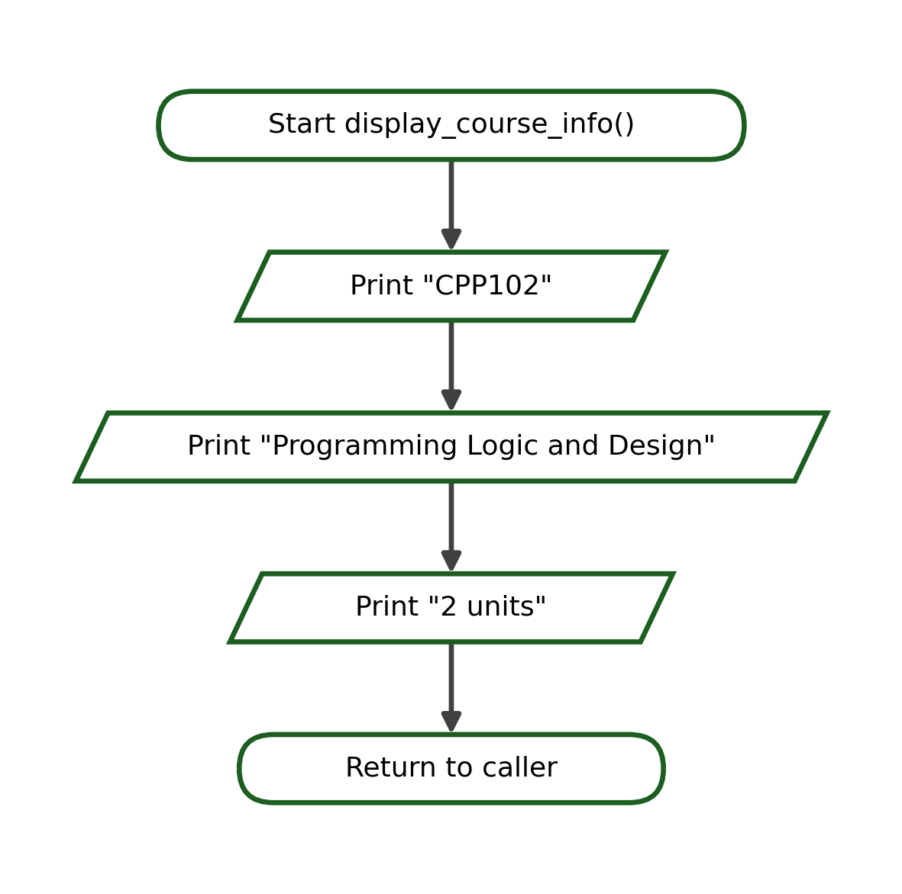
Python Program:
def display_course_info():
print("CPP102")
print("Programming Logic and Design")
print("2 units")

display_course_info()
Call | Action | Output
display_course_info() | Runs the function body | CPP102 / Programming Logic and Design / 2 units
Output:
CPP102
Programming Logic and Design
2 units
Explanation. display_course_info() receives no value and returns no value; it simply performs an output task and then control returns to the caller.

8.2 Display a Simple Menu
Purpose: Display a fixed three-option text menu.
Function Name: display_menu()
Algorithm:
1. Define the function display_menu().
2. Execute: print("1. Add")
3. Execute: print("2. Subtract")
4. Execute: print("3. Exit")
5. End the function; control returns to the caller (no value returned).
6. Call display_menu() from the main program.
Pseudocode:
FUNCTION display_menu()
print("1. Add")
print("2. Subtract")
print("3. Exit")
END FUNCTION
Flowchart:
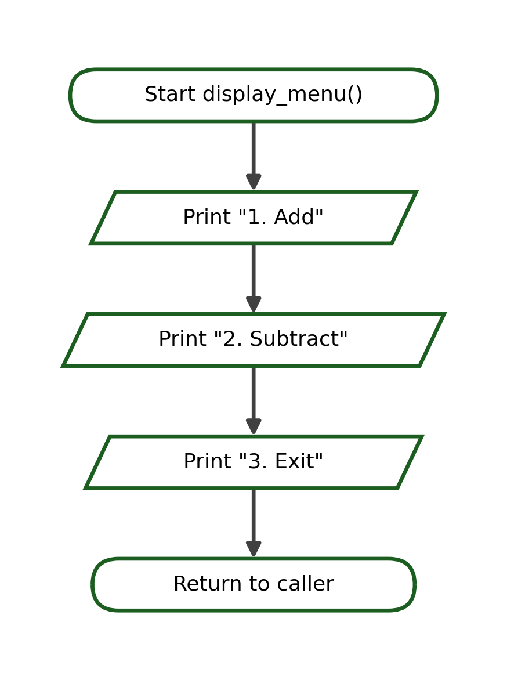
Python Program:
def display_menu():
print("1. Add")
print("2. Subtract")
print("3. Exit")

display_menu()
Call | Action | Output
display_menu() | Runs the function body | 1. Add / 2. Subtract / 3. Exit
Output:
1. Add
2. Subtract
3. Exit
Explanation. display_menu() receives no value and returns no value; it simply performs an output task and then control returns to the caller.

8.3 Print a Fixed Pattern
Purpose: Display three rows of five asterisks.
Function Name: display_pattern()
Algorithm:
1. Define the function display_pattern().
2. Execute: print("*****")
3. Execute: print("*****")
4. Execute: print("*****")
5. End the function; control returns to the caller (no value returned).
6. Call display_pattern() from the main program.
Pseudocode:
FUNCTION display_pattern()
print("*****")
print("*****")
print("*****")
END FUNCTION
Flowchart:
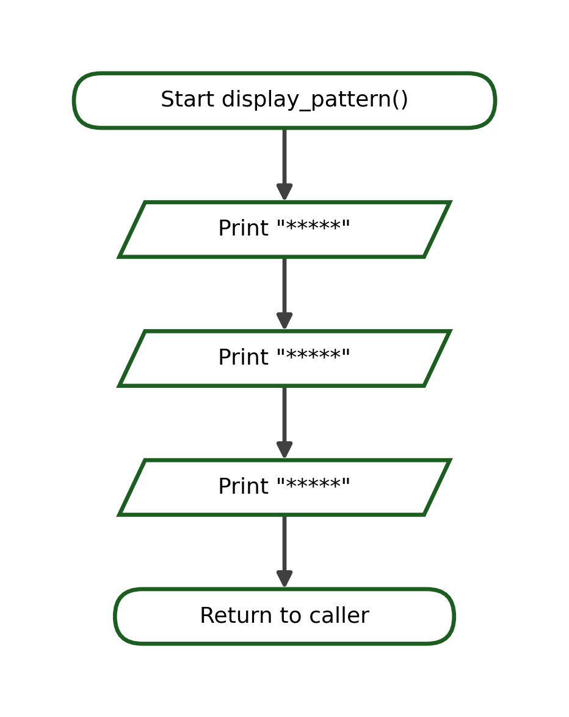
Python Program:
def display_pattern():
print("*****")
print("*****")
print("*****")

display_pattern()
Call | Action | Output
display_pattern() | Runs the function body | ***** / ***** / *****
Output:
*****
*****
*****
Explanation. display_pattern() receives no value and returns no value; it simply performs an output task and then control returns to the caller.

8.4 Display a Classroom Reminder
Purpose: Display two short classroom reminders.
Function Name: display_reminder()
Algorithm:
1. Define the function display_reminder().
2. Execute: print("Submit your work on time.")
3. Execute: print("Follow snake_case naming.")
4. End the function; control returns to the caller (no value returned).
5. Call display_reminder() from the main program.
Pseudocode:
FUNCTION display_reminder()
print("Submit your work on time.")
print("Follow snake_case naming.")
END FUNCTION
Flowchart:
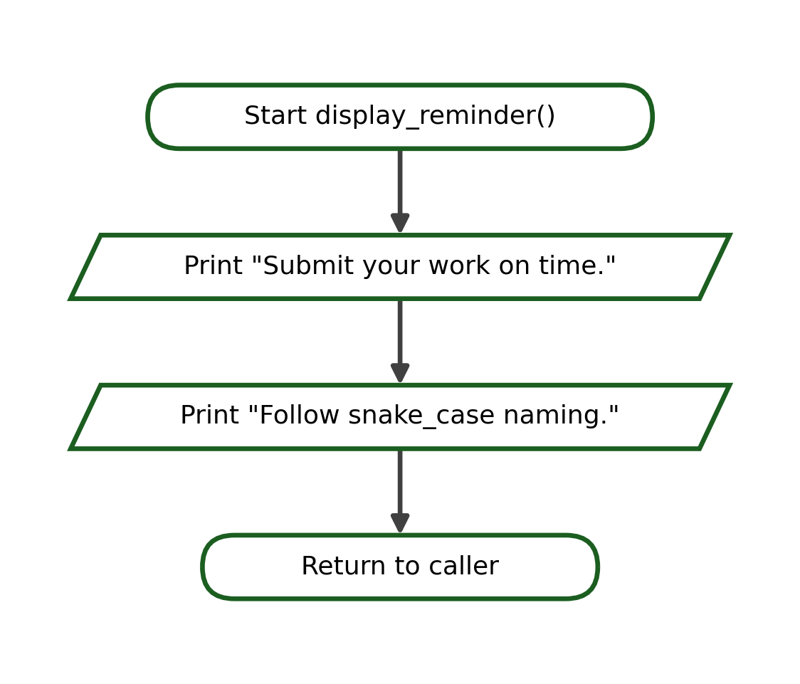
Python Program:
def display_reminder():
print("Submit your work on time.")
print("Follow snake_case naming.")

display_reminder()
Call | Action | Output
display_reminder() | Runs the function body | Submit your work on time. / Follow snake_case naming.
Output:
Submit your work on time.
Follow snake_case naming.
Explanation. display_reminder() receives no value and returns no value; it simply performs an output task and then control returns to the caller.

9. Functions With Parameters and Without Return Values
A parameter allows a function to receive data from the function call. The value that is actually sent during the call is called an argument. The syntax includes the parameter name inside the parentheses:
Syntax:
def function_name(parameter):
statements
Example:
def greet_student(name):
print(f"Welcome, {name}!")

greet_student("Ana")
greet_student("Marco")
In this example, name is a parameter, while "Ana" and "Marco" are the arguments passed during the two calls.
Output:
Welcome, Ana!
Welcome, Marco!
Five worked examples follow. Conditionals and loops that were studied in the previous weeks may be used inside these functions.

9.1 Personalized Greeting
Purpose: Display a greeting that includes the given name.
Function: greet_student(name)
Flowchart:
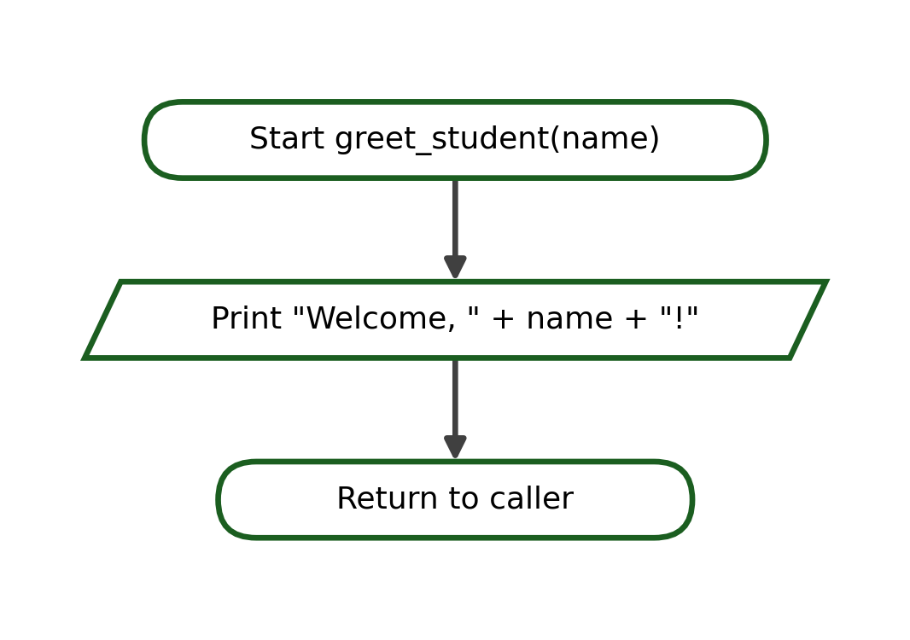
Python Program:
def greet_student(name):
print(f"Welcome, {name}!")

greet_student("Ana")
Sample Call | Parameter Value(s) | Output
greet_student("Ana") | name = "Ana" | Welcome, Ana!
Output (first call):
Welcome, Ana!
Explanation. The argument in each call is copied into the parameter and used inside the function; the function performs a task but returns no value.

9.2 Square of a Number
Purpose: Display the square of the given number.
Function: display_square(number)
Flowchart:
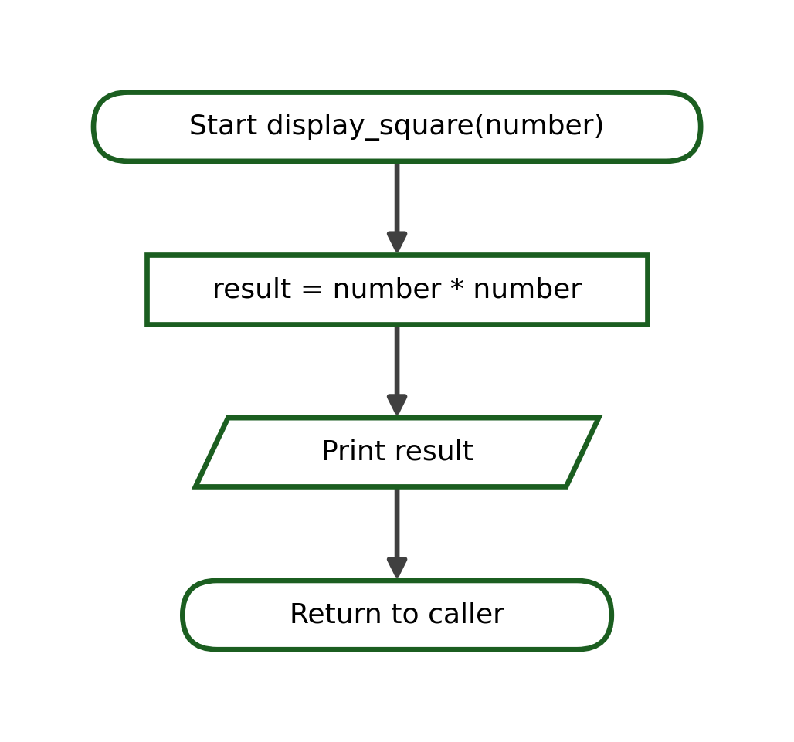
Python Program:
def display_square(number):
result = number * number
print(result)

display_square(6)
Sample Call | Parameter Value(s) | Output
display_square(6) | number = 6 | 36
Output (first call):
36
Explanation. The argument in each call is copied into the parameter and used inside the function; the function performs a task but returns no value.

9.3 Even or Odd Display
Purpose: Display whether the given number is even or odd.
Function: display_number_type(number)
Flowchart:
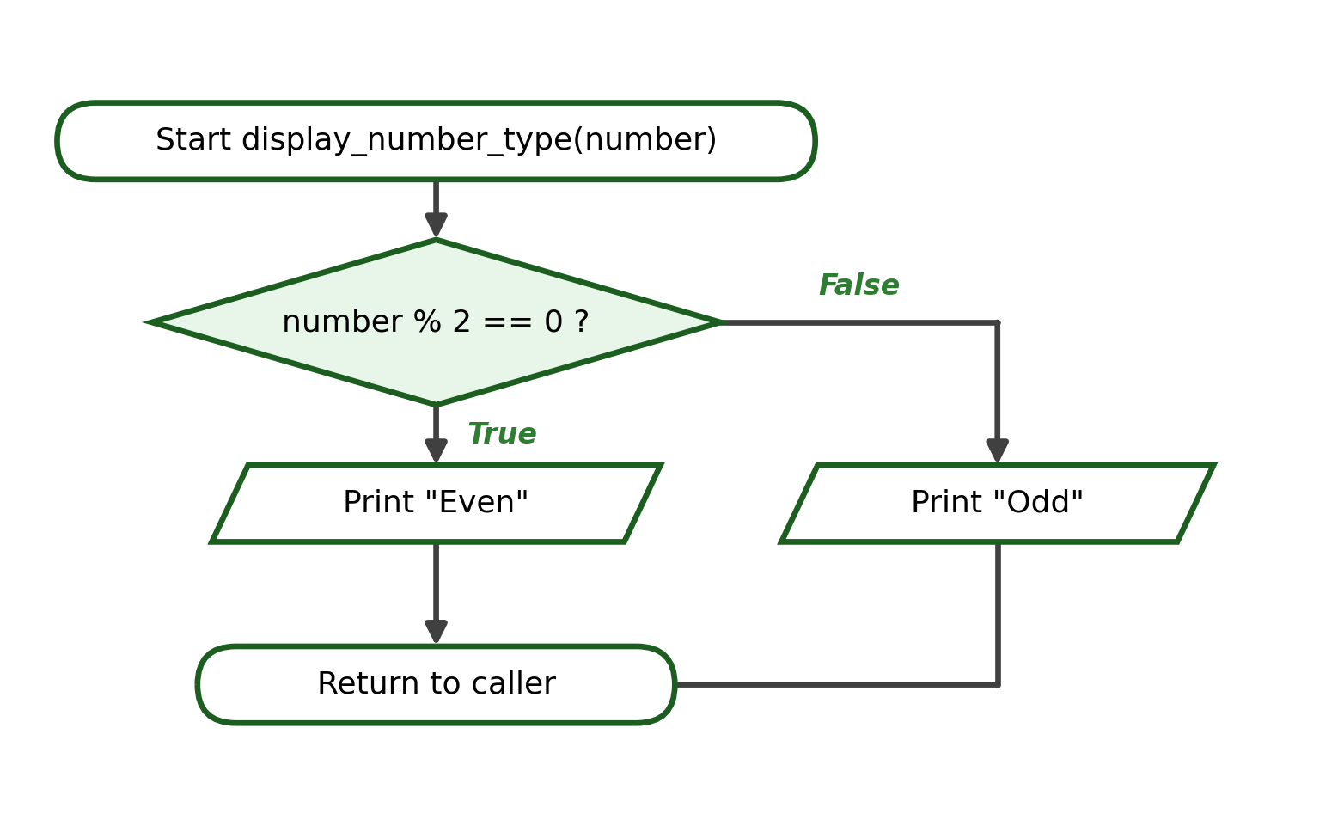
Python Program:
def display_number_type(number):
if number % 2 == 0:
print("Even")
else:
print("Odd")

display_number_type(14)
Sample Call | Parameter Value(s) | Output
display_number_type(14) | number = 14 | Even
display_number_type(7) | number = 7 | Odd
Output (first call):
Even
Explanation. The argument in each call is copied into the parameter and used inside the function; the function performs a task but returns no value.

9.4 Multiplication Table
Purpose: Display the multiplication table of the given number from 1 to 10.
Function: display_table(number)
Flowchart:
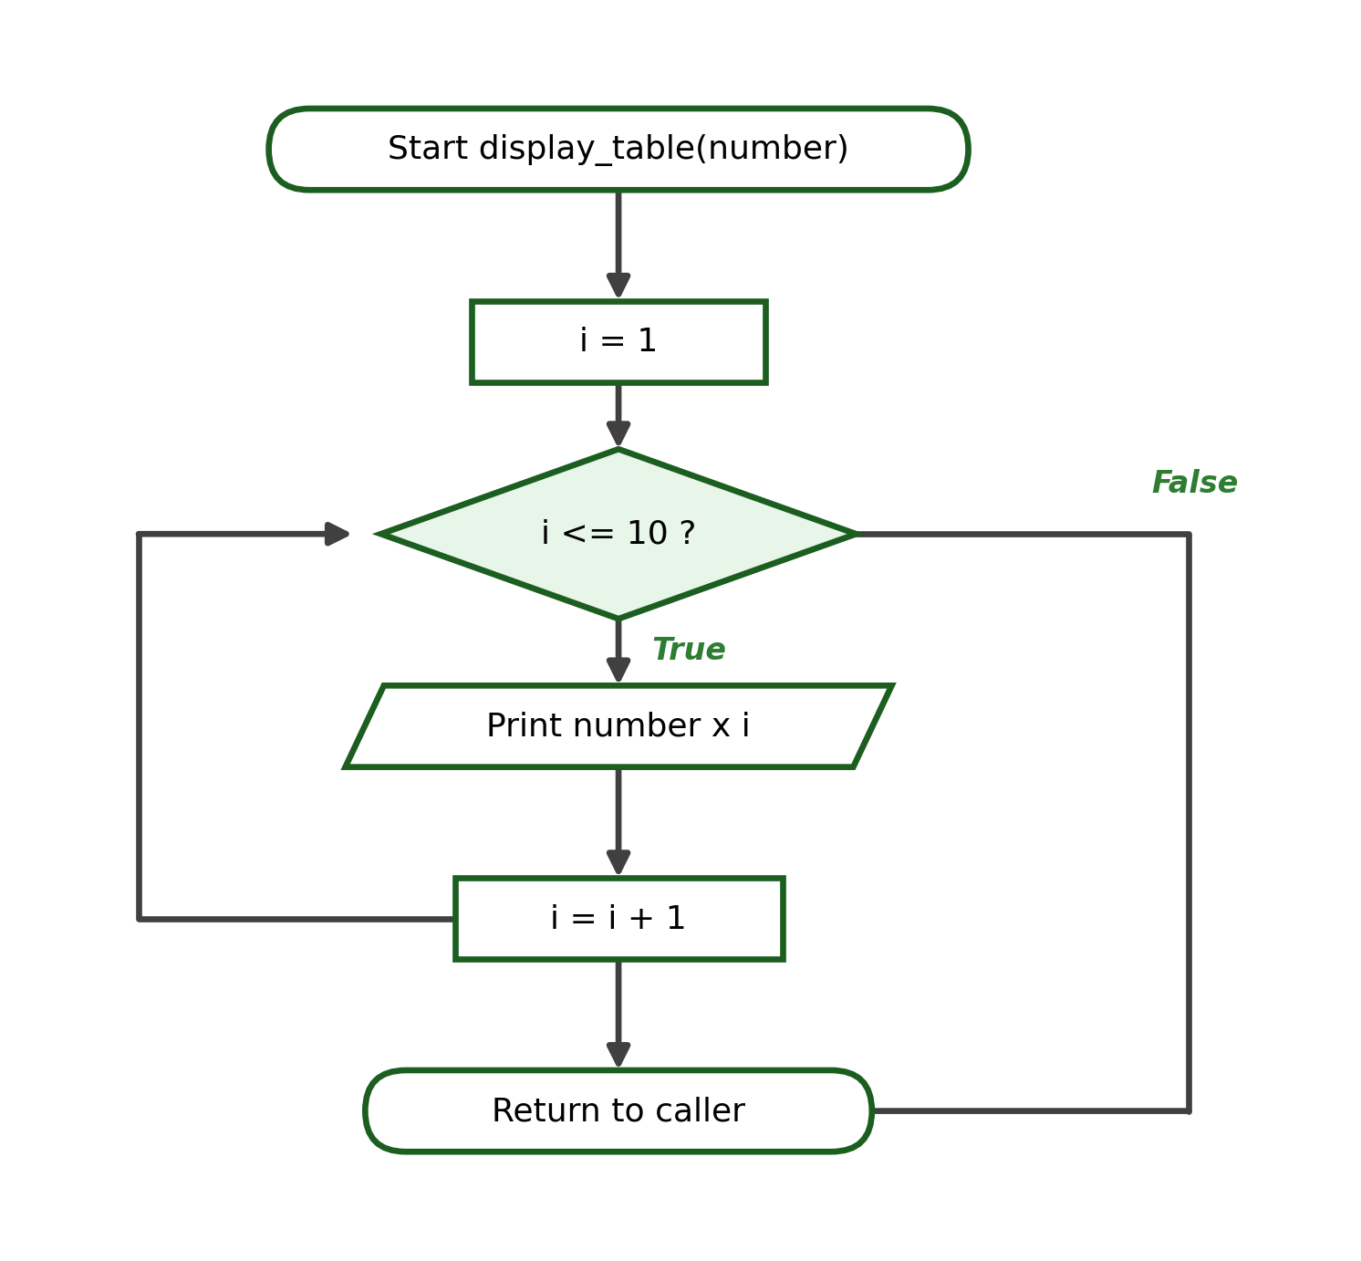
Python Program:
def display_table(number):
for i in range(1, 11):
print(f"{number} x {i} = {number * i}")

display_table(3)
Sample Call | Parameter Value(s) | Output
display_table(3) | number = 3, i = 1..10 | 3 x 1 = 3 ... 3 x 10 = 30
Output (first call):
3 x 1 = 3
3 x 2 = 6
...
3 x 10 = 30
Explanation. The argument in each call is copied into the parameter and used inside the function; the function performs a task but returns no value.

9.5 Student Grade Remark
Purpose: Display "Passed" if the grade is at least 75; otherwise display "Failed".
Function: display_remark(grade)
Flowchart:
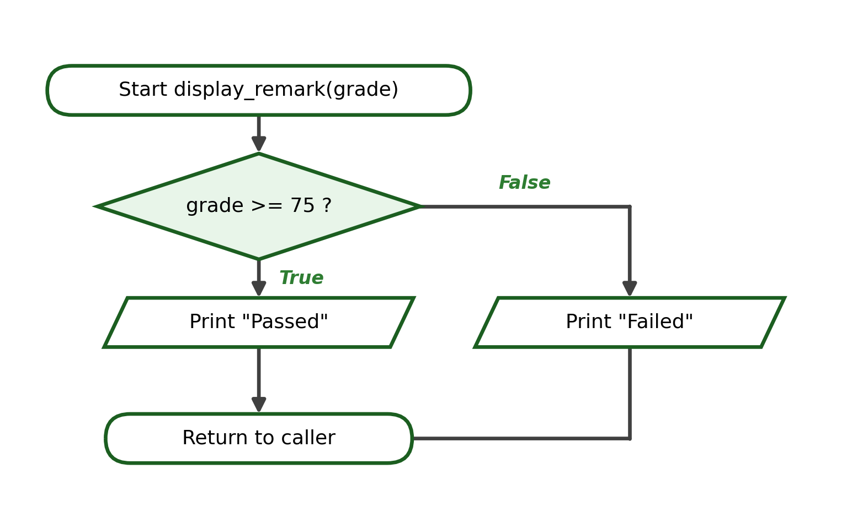
Python Program:
def display_remark(grade):
if grade >= 75:
print("Passed")
else:
print("Failed")

display_remark(80)
Sample Call | Parameter Value(s) | Output
display_remark(80) | grade = 80 | Passed
display_remark(70) | grade = 70 | Failed
Output (first call):
Passed
Explanation. The argument in each call is copied into the parameter and used inside the function; the function performs a task but returns no value.

10. Parameters Versus Arguments
It is important to distinguish a parameter from an argument. A parameter is the variable written inside the parentheses of the function definition. An argument is the actual value that is sent to the function when it is called.
Example:
def display_total(quantity, unit_price):
total = quantity * unit_price
print(f"Total: ₱{total:.2f}")

display_total(4, 35.50)
Term | Example | Meaning
Parameter | quantity, unit_price | Variable written in the function definition
Argument | 4, 35.50 | Actual value sent during the function call
Identification Activity. For each item, state whether the highlighted term is a parameter or an argument. (1) def area(base, height) -> base; (2) area(10, 5) -> 10; (3) def greet(name) -> name; (4) greet("Liza") -> "Liza"; (5) def total(price, qty) -> qty; (6) total(20, 3) -> 3; (7) def show(message) -> message; (8) show("Done") -> "Done". Answers are provided in the answer key.

11. Functions Without Parameters but With a Return Value
Some functions receive no parameters yet still send a value back to the caller using the return statement. The returned value may then be stored in a variable and used later in the program.
Example 1:
def get_school_name():
return "Pamantasan ng Cabuyao"

school = get_school_name()
print(school)
Output:
Pamantasan ng Cabuyao
In this example, the function receives no parameters, it returns exactly one value, and the returned value is assigned to the variable school. A second simple example returns a fixed passing grade:
Example 2:
def get_passing_grade():
return 75

passing = get_passing_grade()
print("Passing grade is", passing)
Output:
Passing grade is 75

12. Functions With Parameters and Return Values
The most flexible functions both receive parameters and return a value. The parameters receive the input, the function performs a calculation, and the return statement sends the result back to the caller, where it may be stored or used. The general syntax is:
General Syntax:
def function_name(parameters):
result = expression
return result
Example:
def calculate_total(quantity, unit_price):
total = quantity * unit_price
return total

amount = calculate_total(4, 35.50)
print(f"Total: ₱{amount:.2f}")
Output:
Total: ₱142.00
Five guided examples follow. Each one includes the problem statement, the function purpose, its parameters and returned value, an IPO table, the algorithm, the pseudocode, the flowchart, the Python program, a trace table, a sample call, the exact output, and a short explanation.

12.1 Add Two Numbers
Problem Statement: Compute and return the sum of two numbers.
Function: add_numbers(a, b)
Parameters: a, b
Returned Value: The sum a + b
Input | Process | Output
a, b | total = a + b | The sum
Algorithm:
1. Receive the two numbers a and b.
2. Add a and b and store the result in total.
3. Return total to the caller.
Pseudocode:
FUNCTION add_numbers(a, b)
total = a + b
RETURN total
END FUNCTION
Flowchart:
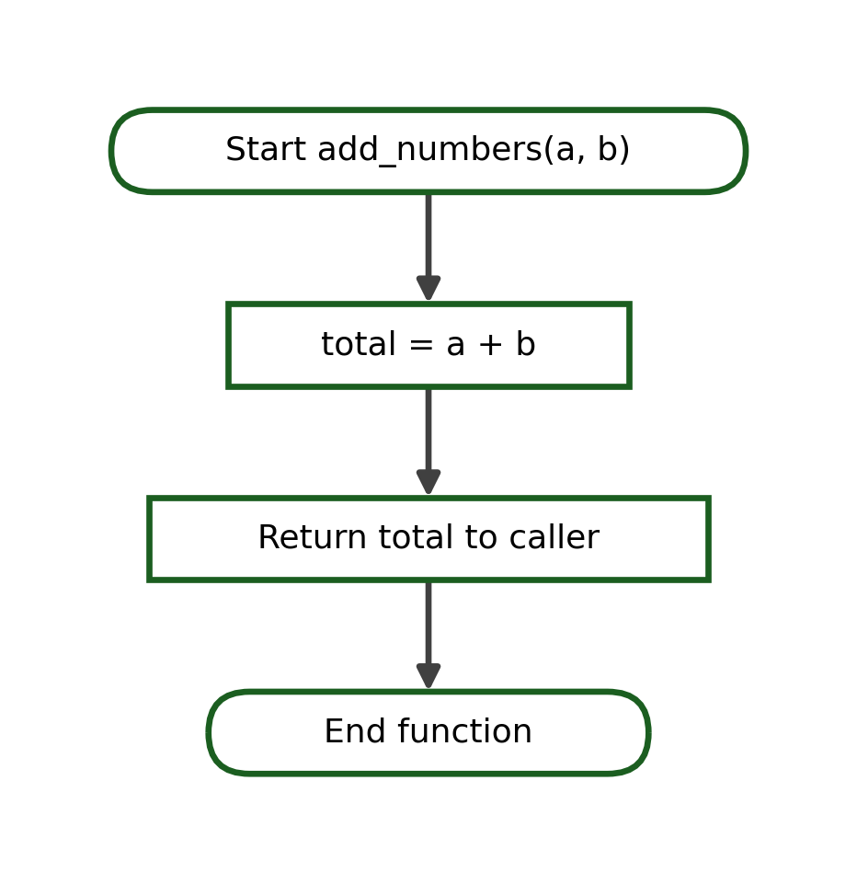
Python Program:
def add_numbers(a, b):
total = a + b
return total

result = add_numbers(8, 5)
print("Sum:", result)
Step | Statement | Values / Returned
1 | add_numbers(8, 5) | a = 8, b = 5
2 | total = a + b | total = 13
3 | return total | returns 13
Output:
Sum: 13

12.2 Area of a Rectangle
Problem Statement: Compute and return the area of a rectangle.
Function: rectangle_area(length, width)
Parameters: length, width
Returned Value: The area length * width
Input | Process | Output
length, width | area = length * width | The area
Algorithm:
1. Receive the length and the width.
2. Multiply length by width and store the result in area.
3. Return area to the caller.
Pseudocode:
FUNCTION rectangle_area(length, width)
area = length * width
RETURN area
END FUNCTION
Flowchart:
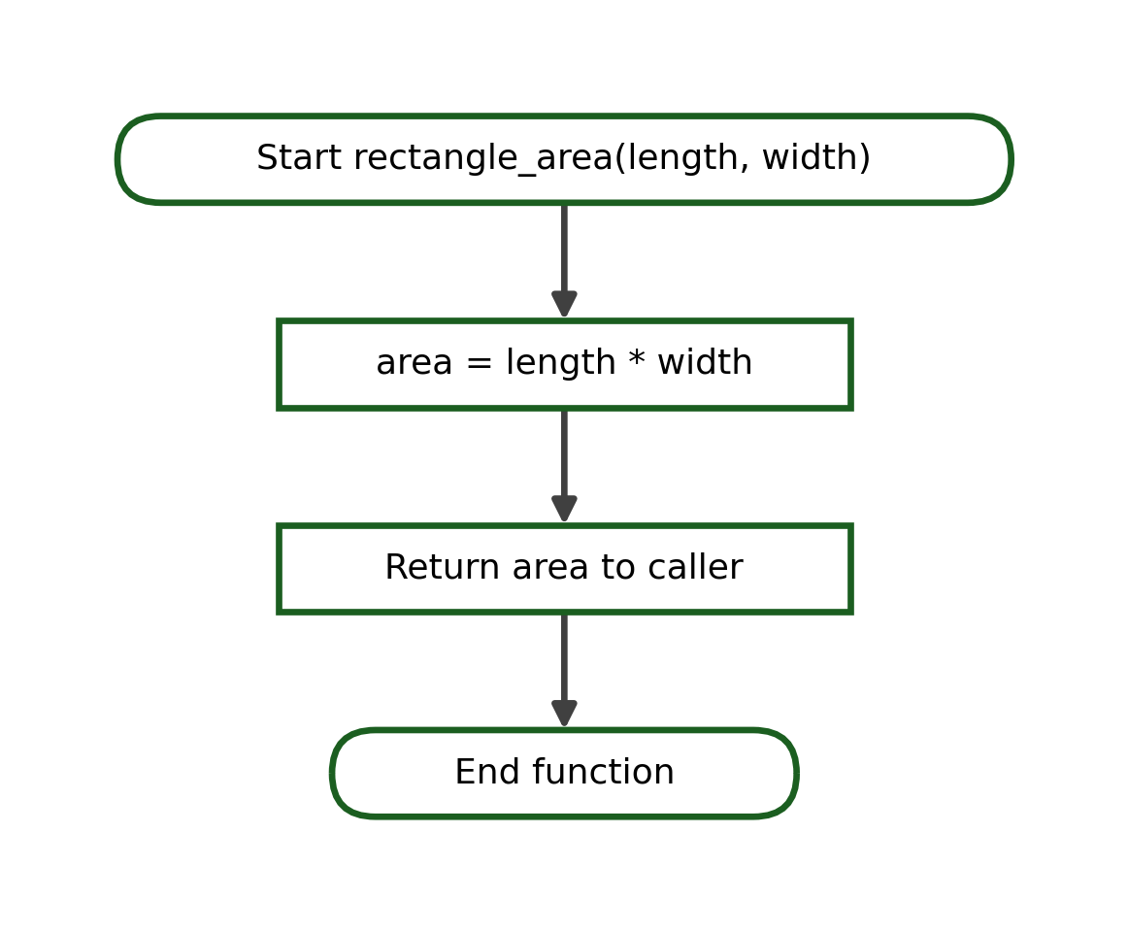
Python Program:
def rectangle_area(length, width):
area = length * width
return area

a = rectangle_area(6, 4)
print("Area:", a)
Step | Statement | Values / Returned
1 | rectangle_area(6, 4) | length = 6, width = 4
2 | area = length * width | area = 24
3 | return area | returns 24
Output:
Area: 24

12.3 Average of Three Scores
Problem Statement: Compute and return the average of three scores.
Function: average_of_three(a, b, c)
Parameters: a, b, c
Returned Value: The average (a + b + c) / 3
Input | Process | Output
a, b, c | average = (a + b + c) / 3 | The average
Algorithm:
1. Receive the three scores a, b, and c.
2. Add the three scores and divide the sum by 3.
3. Return the average to the caller.
Pseudocode:
FUNCTION average_of_three(a, b, c)
average = (a + b + c) / 3
RETURN average
END FUNCTION
Flowchart:
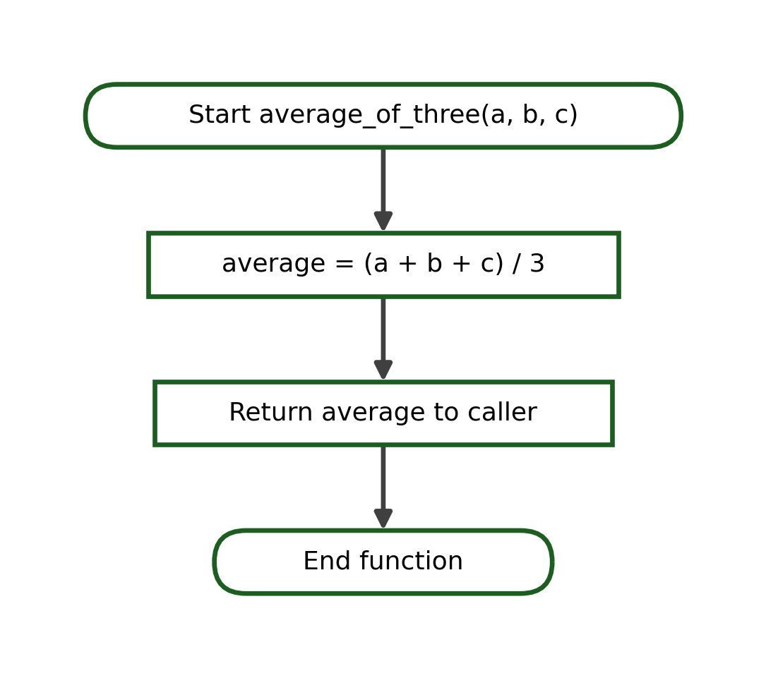
Python Program:
def average_of_three(a, b, c):
average = (a + b + c) / 3
return average

avg = average_of_three(80, 75, 85)
print(f"Average: {avg:.2f}")
Step | Statement | Values / Returned
1 | average_of_three(80, 75, 85) | a=80, b=75, c=85
2 | average = (a + b + c) / 3 | average = 80.0
3 | return average | returns 80.0
Output:
Average: 80.00

12.4 Total Price
Problem Statement: Compute and return the total price of a purchase.
Function: compute_total(quantity, price)
Parameters: quantity, price
Returned Value: The total quantity * price
Input | Process | Output
quantity, price | total = quantity * price | The total price
Algorithm:
1. Receive the quantity and the unit price.
2. Multiply quantity by price and store the result in total.
3. Return total to the caller.
Pseudocode:
FUNCTION compute_total(quantity, price)
total = quantity * price
RETURN total
END FUNCTION
Flowchart:
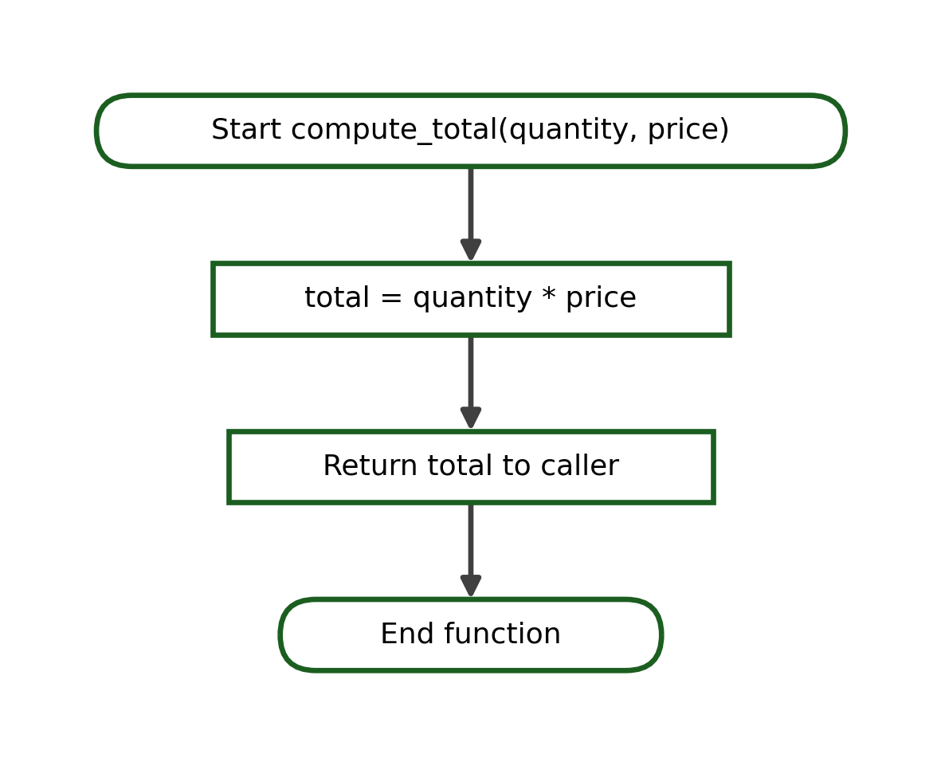
Python Program:
def compute_total(quantity, price):
total = quantity * price
return total

amount = compute_total(3, 12.50)
print(f"Total Amount: ₱{amount:.2f}")
Step | Statement | Values / Returned
1 | compute_total(3, 12.50) | quantity = 3, price = 12.50
2 | total = quantity * price | total = 37.5
3 | return total | returns 37.5
Output:
Total Amount: ₱37.50

12.5 Convert Celsius to Fahrenheit
Problem Statement: Convert a Celsius temperature to Fahrenheit and return it.
Function: to_fahrenheit(celsius)
Parameters: celsius
Returned Value: The temperature celsius * 9 / 5 + 32
Input | Process | Output
celsius | f = celsius * 9 / 5 + 32 | The Fahrenheit value
Algorithm:
1. Receive the Celsius temperature.
2. Apply the formula f = celsius * 9 / 5 + 32.
3. Return f to the caller.
Pseudocode:
FUNCTION to_fahrenheit(celsius)
f = celsius * 9 / 5 + 32
RETURN f
END FUNCTION
Flowchart:
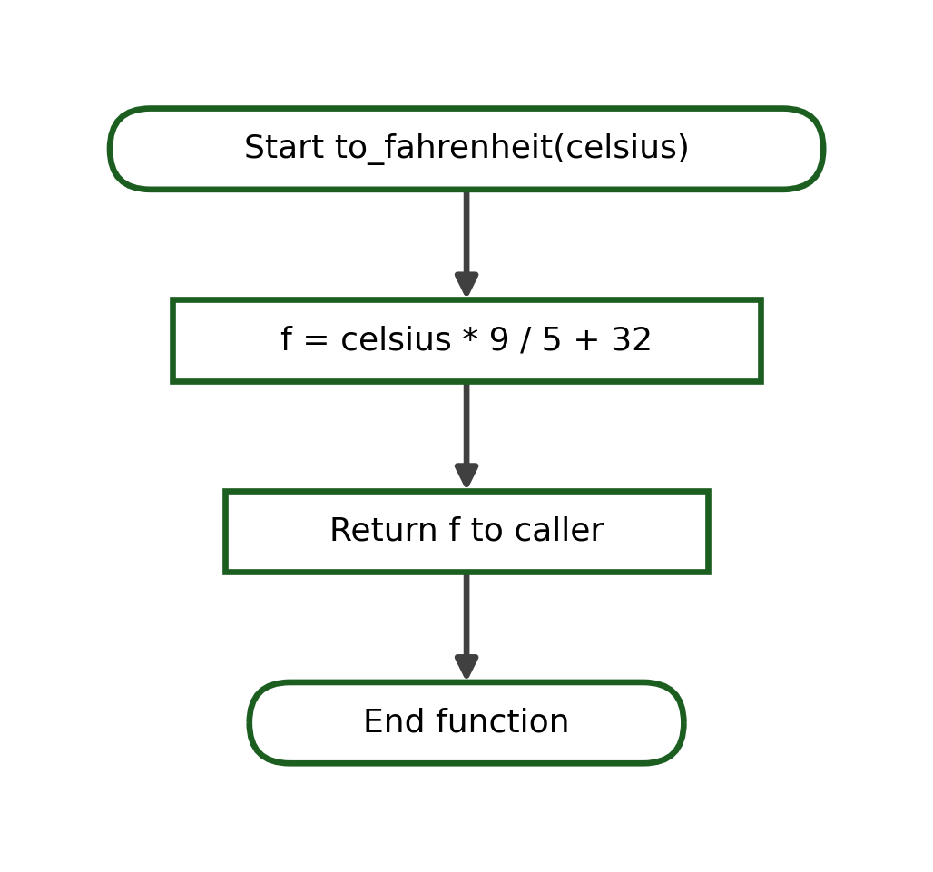
Python Program:
def to_fahrenheit(celsius):
f = celsius * 9 / 5 + 32
return f

temp = to_fahrenheit(37)
print(f"Fahrenheit: {temp:.1f}")
Step | Statement | Values / Returned
1 | to_fahrenheit(37) | celsius = 37
2 | f = celsius * 9 / 5 + 32 | f = 98.6
3 | return f | returns 98.6
Output:
Fahrenheit: 98.6

13. The return Statement
The return statement plays a central role in functions. It ends the execution of the function, sends a result back to the calling statement, and produces a value that may be assigned to a variable or used inside a larger expression. The return statement is different from print(), which only displays a value on the screen.
print() | return
Displays a value on the screen | Sends a value back to the caller
Primarily produces output | Produces a reusable result
Does not normally provide a value for later computation | The returned value may be stored or reused
Comparison Example:
def show_total(a, b):
print(a + b)

def get_total(a, b):
return a + b

show_total(8, 2) # displays 10 but gives back nothing usable
answer = get_total(8, 2) # gives back 10, which is stored
print(answer * 3) # 30, because the result can be reused
Output:
10
30
The difference is practical. The value printed by show_total cannot be used again, while the value returned by get_total is stored in answer and reused in a later computation. Finally, note briefly that any statements placed after an executed return are not processed, because return immediately ends the function.

14. Main Program and Function Calls
A well-organized program often separates the function definitions from the main sequence of statements that uses them. The function-definition section is placed first, and the main-program section follows. The main program calls the functions in the required order and may pass a value returned by one function into another.
Python Program:
def calculate_average(score1, score2, score3):
return (score1 + score2 + score3) / 3

def display_remark(average):
if average >= 75:
print("Passed")
else:
print("Failed")

# ---- main program ----
quiz1 = 80
quiz2 = 75
quiz3 = 85

average = calculate_average(quiz1, quiz2, quiz3)
print(f"Average: {average:.2f}")
display_remark(average)
Output:
Average: 80.00
Passed
The program has two clear parts. The function-definition section defines calculate_average and display_remark. The main-program section prepares the three quiz scores, calls calculate_average to obtain the average, and then passes that returned average into display_remark. All of this is kept in one Python file, and no module importing is used.

15. Function Flowcharts
Flowcharts can also represent functions and function calls. A function call is drawn using the predefined process symbol, which is a rectangle with two extra vertical bars on its sides. The table below reviews the flowchart symbols used in this module.
Symbol | Purpose
Oval (terminator) | Start or End of a function or program
Parallelogram | Input or Output
Rectangle | Process such as a calculation or assignment
Diamond | Decision (a condition that is True or False)
Predefined process | A function or subroutine call
Arrow | Direction of the flow
The six flowcharts below illustrate the common function patterns used in this week's lessons. Each diagram shows the flow of control, and the last terminator marks the point where the function returns to its caller.
(a) Function without parameters. The function performs a task and returns to the caller with no value.
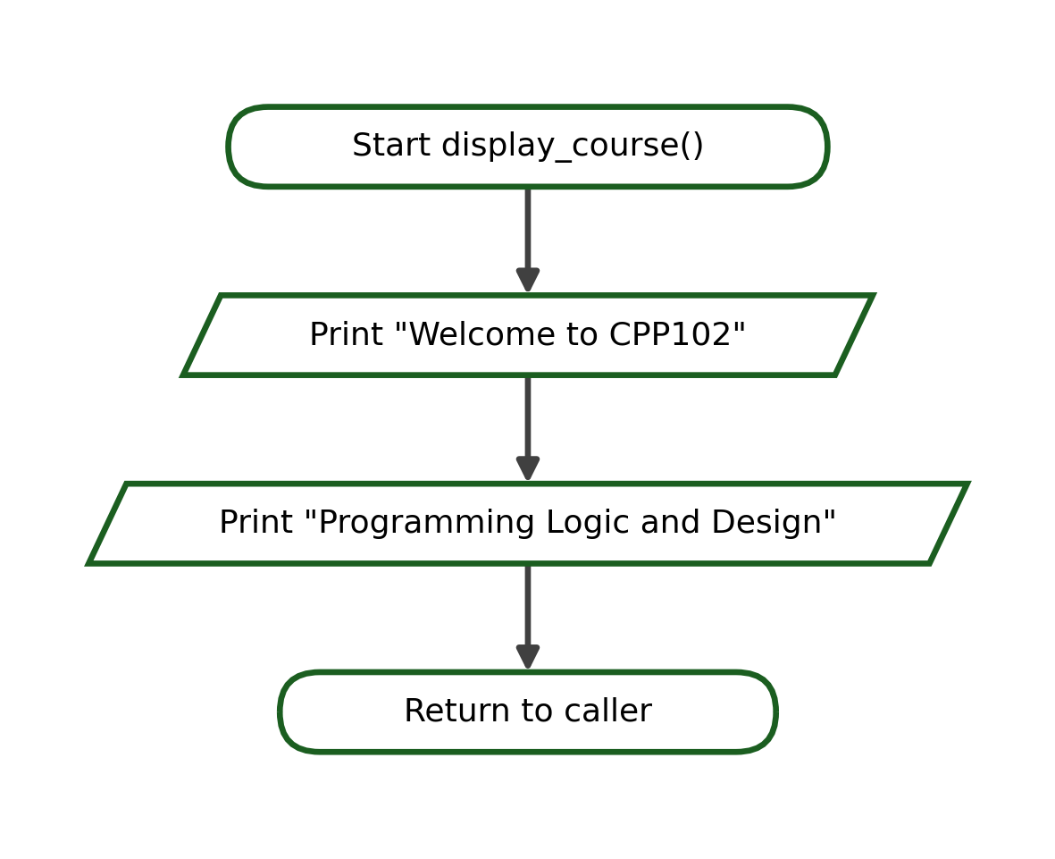
(b) Function with one parameter. A value received through the parameter is used inside the function.
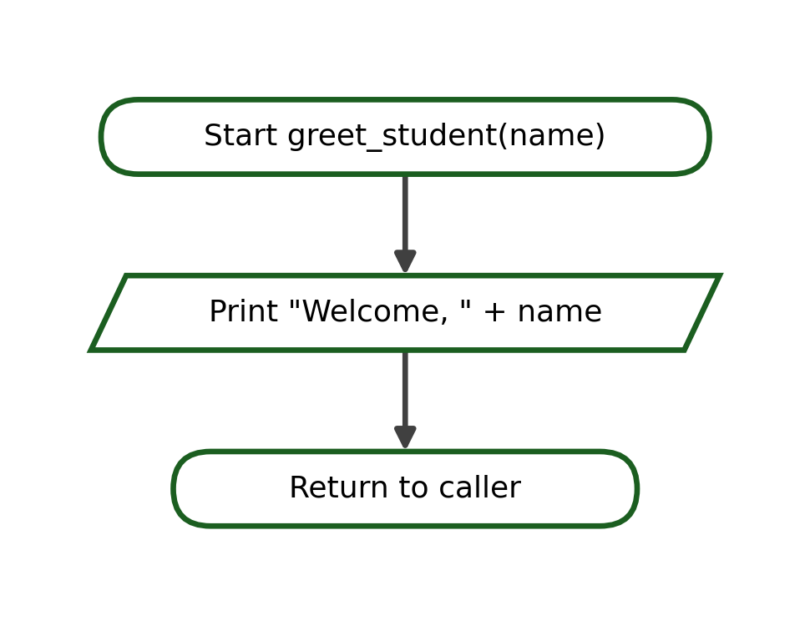
(c) Function returning a value. The function computes a result and returns it to the caller.
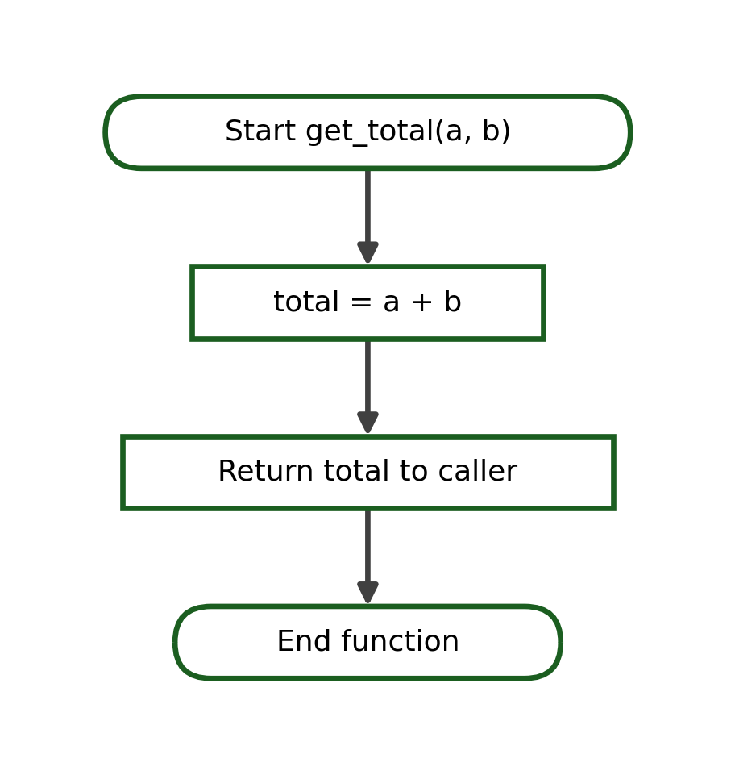
(d) Main program calling two functions. Each predefined process symbol represents a call; control returns to the main program after each call.
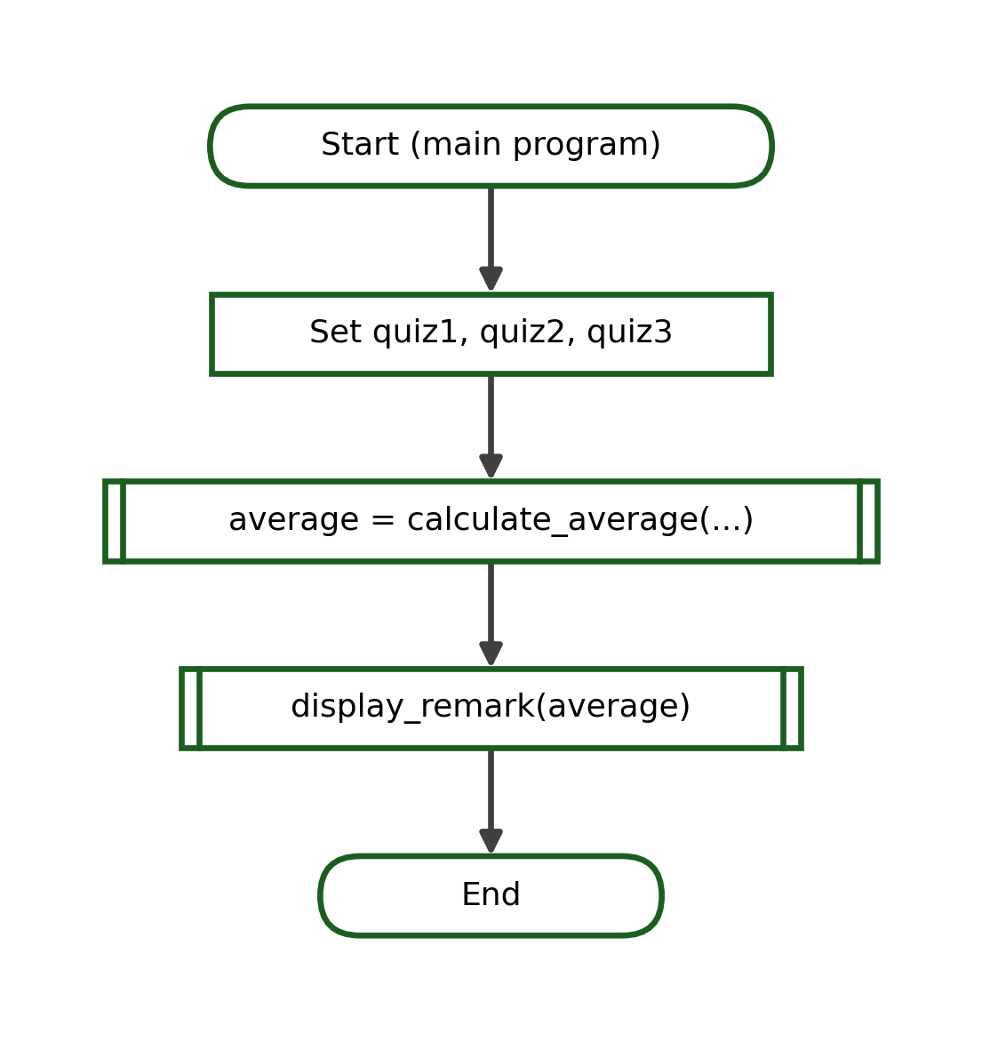
(e) Function containing a conditional statement. A decision inside the function chooses between two outputs.
(f) Function containing a simple loop. The body repeats while the condition is True, then the function returns to the caller.
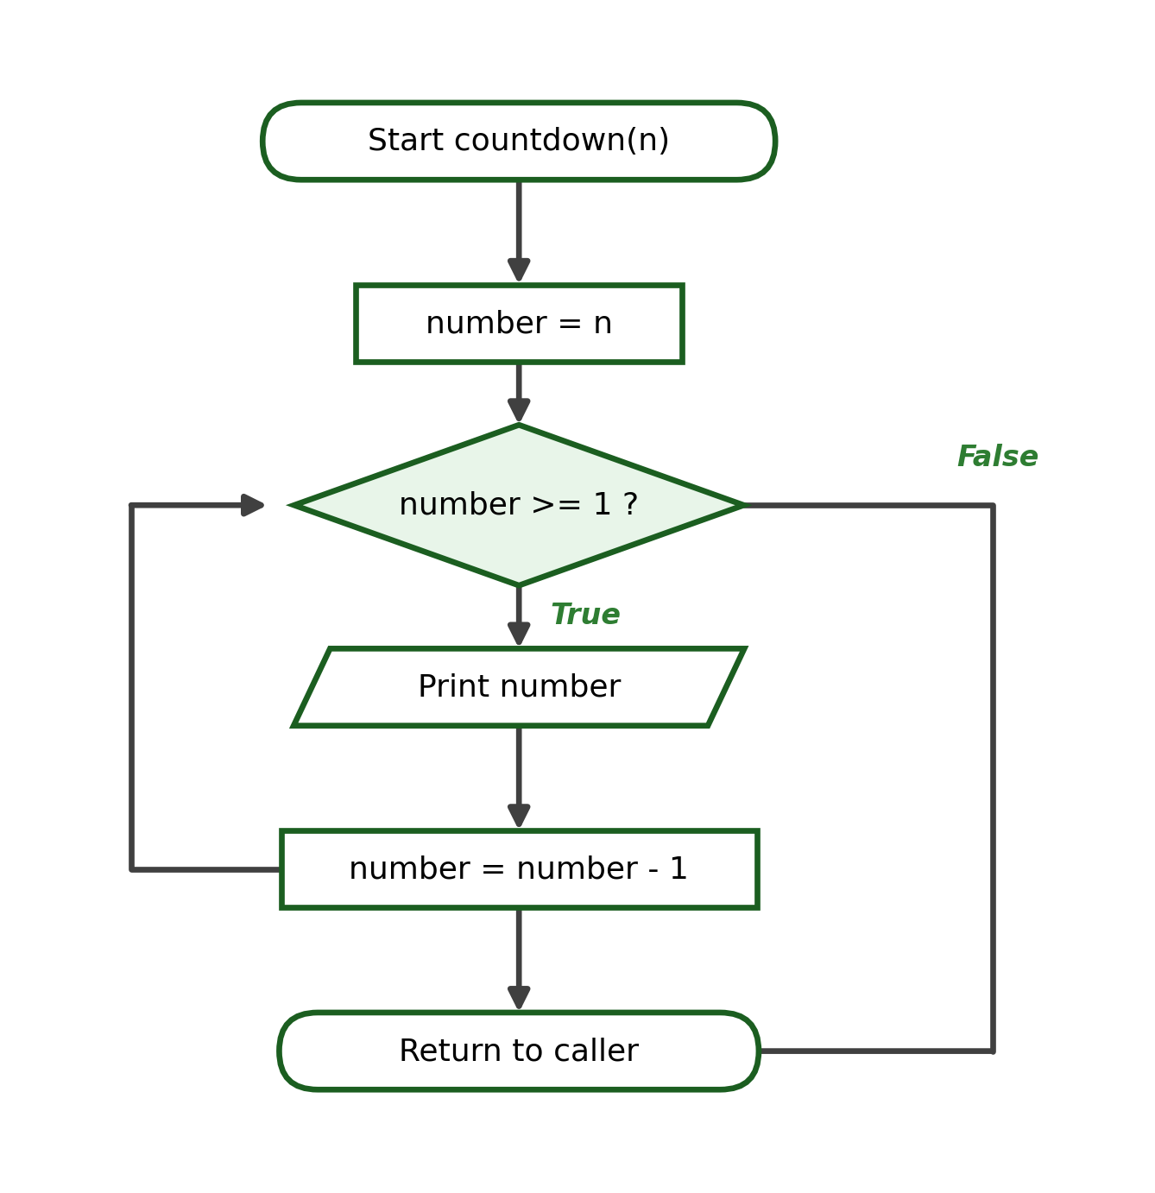

16. Tracing Function Calls
Tracing a function call means following the program step by step to see what happens. A good trace records the function call, the argument that was passed, the matching parameter value, the statements executed inside the function, the value that was returned, and the next statement executed in the caller. The five short examples below use a simple trace table.

16.1 No Parameter and No Return
Program:
def show_line():
print("======")

show_line()
Step | Location | Values | Output or Returned
1 | main: show_line() | none | jump into function
2 | print("======") | none | ======
3 | function ends | none | return to caller

16.2 One Parameter
Program:
def greet(name):
print("Hi", name)

greet("Ana")
Step | Location | Values | Output or Returned
1 | main: greet("Ana") | name = "Ana" | jump into function
2 | print("Hi", name) | name = "Ana" | Hi Ana
3 | function ends | - | return to caller

16.3 Two Parameters
Program:
def show_sum(a, b):
print(a + b)

show_sum(4, 6)
Step | Location | Values | Output or Returned
1 | main: show_sum(4, 6) | a = 4, b = 6 | jump into function
2 | print(a + b) | a = 4, b = 6 | 10
3 | function ends | - | return to caller

16.4 One Return Value
Program:
def square(n):
return n * n

result = square(5)
print(result)
Step | Location | Values | Output or Returned
1 | main: square(5) | n = 5 | jump into function
2 | return n * n | n = 5 | returns 25
3 | result = 25 | result = 25 | -
4 | print(result) | result = 25 | 25

16.5 Two Functions Called in Sequence
Program:
def double(n):
return n * 2

def add_one(n):
return n + 1

x = double(5)
y = add_one(x)
print(y)
Step | Location | Values | Output or Returned
1 | main: double(5) | n = 5 | returns 10
2 | x = 10 | x = 10 | -
3 | main: add_one(x) | n = 10 | returns 11
4 | y = 11 | y = 11 | -
5 | print(y) | y = 11 | 11

17. Testing Individual Functions
A function should be tested with different values to make sure it behaves correctly. Useful test values include a normal value, a boundary value, zero, and a negative value when it is relevant to the problem. Consider the following function that returns a remark based on a grade:
Function Under Test:
def determine_remark(grade):
if grade >= 75:
return "Passed"
return "Failed"
Test Case | Argument | Expected Return
1 | 80 | "Passed"
2 | 75 | "Passed"
3 | 74 | "Failed"
Test case 2 is especially important because 75 is the boundary value. Testing exactly at the boundary confirms that the condition grade >= 75 correctly treats 75 as a passing grade. At this stage, testing is done by hand and by trying different arguments; automated testing frameworks are not used.

18. Common Function Errors
Beginners often meet a small number of recurring mistakes when writing functions. The table below lists these common errors together with a short explanation and how to correct each one.
Common Error | Explanation | Correction
Missing parentheses | def greet: is invalid | Write def greet():
Missing colon | The header must end with a colon | Add : at the end
Incorrect indentation | The body must be indented | Indent the body by 4 spaces
Calling before defining | The function is unknown yet | Define the function first
Misspelled function name | greet() vs gret() | Match the defined name exactly
Wrong number of arguments | area(5) needs two values | Pass the correct count
Incorrect argument order | Values map by position | Send arguments in the right order
Confusing parameter and argument | Mixing definition and call | Parameter defines; argument calls
Forgetting to call | The body never runs | Add a call such as greet()
Forgetting return | No value is sent back | Add a return statement
Using print instead of return | The value cannot be reused | Use return to send a result
Ignoring the returned value | get_total(2, 3) alone | Assign or display the result
Statements after return | They are never processed | Place code before return
Invalid function name | 2get() is invalid | Do not start with a digit
Keyword as a name | def if(): is invalid | Avoid Python keywords
A very common example combines two of these errors, a missing colon and a missing return:
Incorrect:
def calculate_total(quantity, price)
quantity * price
Correct:
def calculate_total(quantity, price):
return quantity * price

19. Guided Problem-Solving Examples
This section brings the ideas together in eight complete guided examples. Each example moves from the problem to the solution using decomposition, an IPO table, an algorithm, pseudocode, a flowchart, the Python program, a function-call trace, test cases, the exact output, and a short explanation.

Example 1: Display a Welcome Message
Problem Statement. Display a fixed welcome message using a function.
Problem Decomposition:
Smaller Task | Function Name | Input Needed | Result Produced
Show a welcome message | display_welcome() | None | None
Function Name: display_welcome()
Parameters: None
Returned Value: None
Input | Process | Output
None | Print a welcome message | The message on screen
Algorithm:
1. Define display_welcome().
2. Print "Welcome to CPP102!".
3. End the function.
4. Call display_welcome().
Pseudocode:
FUNCTION display_welcome()
PRINT "Welcome to CPP102!"
END FUNCTION

display_welcome()
Flowchart:
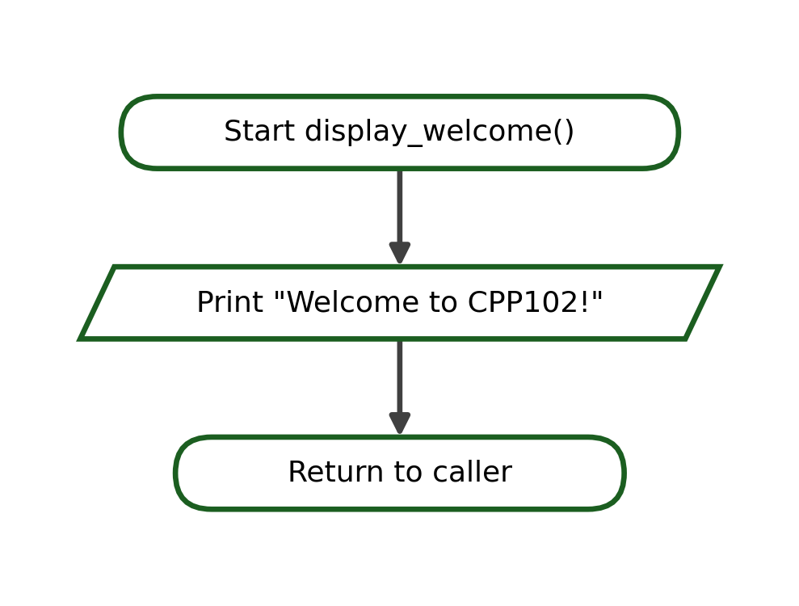
Python Program:
def display_welcome():
print("Welcome to CPP102!")

display_welcome()
Step | Statement / Call | Values | Output or Returned
1 | display_welcome() | none | jump into function
2 | print("Welcome to CPP102!") | none | Welcome to CPP102!
Test Cases:
Test Case | Argument(s) | Expected Output
1 | no argument | Welcome to CPP102!
Exact Output:
Welcome to CPP102!
Explanation. The function has no parameters and no return value; it only performs an output task.

Example 2: Personalized Greeting
Problem Statement. Display a greeting that includes a name passed to the function.
Problem Decomposition:
Smaller Task | Function Name | Input Needed | Result Produced
Greet a named person | greet(name) | name | Printed greeting
Function Name: greet(name)
Parameters: name
Returned Value: None
Input | Process | Output
name | Print "Hello, " + name + "!" | The greeting on screen
Algorithm:
1. Define greet(name).
2. Print "Hello, {name}!".
3. End the function.
4. Call greet("Marco").
Pseudocode:
FUNCTION greet(name)
PRINT "Hello, " + name + "!"
END FUNCTION

greet("Marco")
Flowchart:
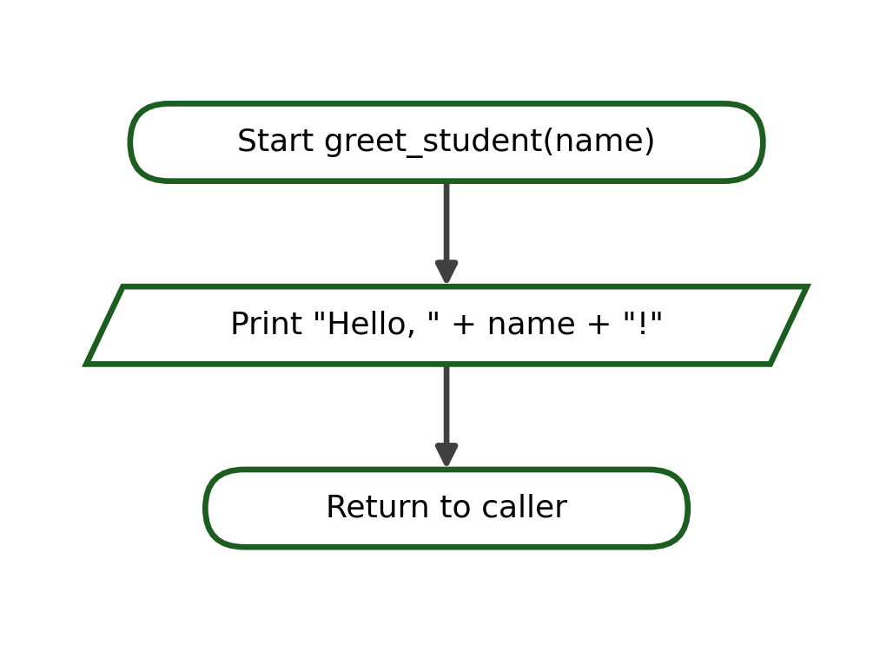
Python Program:
def greet(name):
print(f"Hello, {name}!")

greet("Marco")
Step | Statement / Call | Values | Output or Returned
1 | greet("Marco") | name = "Marco" | jump into function
2 | print(f"Hello, {name}!") | name = "Marco" | Hello, Marco!
Test Cases:
Test Case | Argument(s) | Expected Output
1 | "Marco" | Hello, Marco!
2 | "Ana" | Hello, Ana!
Exact Output:
Hello, Marco!
Explanation. The parameter name receives the argument and is used inside the output; no value is returned.

Example 3: Add Two Numbers
Problem Statement. Compute and return the sum of two numbers.
Problem Decomposition:
Smaller Task | Function Name | Input Needed | Result Produced
Add two numbers | add_numbers(a, b) | a, b | The sum
Function Name: add_numbers(a, b)
Parameters: a, b
Returned Value: The sum a + b
Input | Process | Output
a, b | total = a + b | The sum
Algorithm:
1. Define add_numbers(a, b).
2. Compute total = a + b.
3. Return total.
4. Store and display the returned value.
Pseudocode:
FUNCTION add_numbers(a, b)
total = a + b
RETURN total
END FUNCTION
Flowchart:
Python Program:
def add_numbers(a, b):
total = a + b
return total

result = add_numbers(8, 5)
print("Sum:", result)
Step | Statement / Call | Values | Output or Returned
1 | add_numbers(8, 5) | a = 8, b = 5 | -
2 | total = a + b | total = 13 | -
3 | return total | - | returns 13
4 | print("Sum:", result) | result = 13 | Sum: 13
Test Cases:
Test Case | Argument(s) | Expected Output
1 | 8, 5 | 13
2 | 0, 0 | 0
3 | -4, 10 | 6
Exact Output:
Sum: 13
Explanation. The function returns the sum, which the caller stores in result and then displays.

Example 4: Rectangle Area
Problem Statement. Compute and return the area of a rectangle from its length and width.
Problem Decomposition:
Smaller Task | Function Name | Input Needed | Result Produced
Compute area | rectangle_area(length, width) | length, width | The area
Function Name: rectangle_area(length, width)
Parameters: length, width
Returned Value: The area length * width
Input | Process | Output
length, width | area = length * width | The area
Algorithm:
1. Define rectangle_area(length, width).
2. Compute area = length * width.
3. Return area.
4. Store and display the returned value.
Pseudocode:
FUNCTION rectangle_area(length, width)
area = length * width
RETURN area
END FUNCTION
Flowchart:
Python Program:
def rectangle_area(length, width):
area = length * width
return area

a = rectangle_area(6, 4)
print("Area:", a)
Step | Statement / Call | Values | Output or Returned
1 | rectangle_area(6, 4) | length = 6, width = 4 | -
2 | area = length * width | area = 24 | -
3 | return area | - | returns 24
4 | print("Area:", a) | a = 24 | Area: 24
Test Cases:
Test Case | Argument(s) | Expected Output
1 | 6, 4 | 24
2 | 10, 1 | 10
3 | 0, 5 | 0
Exact Output:
Area: 24
Explanation. Two parameters are multiplied and the product is returned to the caller.

Example 5: Average of Three Scores
Problem Statement. Compute and return the average of three scores.
Problem Decomposition:
Smaller Task | Function Name | Input Needed | Result Produced
Compute average | average_of_three(a, b, c) | a, b, c | The average
Function Name: average_of_three(a, b, c)
Parameters: a, b, c
Returned Value: The average (a + b + c) / 3
Input | Process | Output
a, b, c | average = (a + b + c) / 3 | The average
Algorithm:
1. Define average_of_three(a, b, c).
2. Compute average = (a + b + c) / 3.
3. Return average.
4. Store and display the returned value.
Pseudocode:
FUNCTION average_of_three(a, b, c)
average = (a + b + c) / 3
RETURN average
END FUNCTION
Flowchart:
Python Program:
def average_of_three(a, b, c):
average = (a + b + c) / 3
return average

avg = average_of_three(80, 75, 85)
print(f"Average: {avg:.2f}")
Step | Statement / Call | Values | Output or Returned
1 | average_of_three(80, 75, 85) | a=80, b=75, c=85 | -
2 | average = (a+b+c)/3 | average = 80.0 | -
3 | return average | - | returns 80.0
4 | print(f"Average: {avg:.2f}") | avg = 80.0 | Average: 80.00
Test Cases:
Test Case | Argument(s) | Expected Output
1 | 80, 75, 85 | 80.00
2 | 90, 90, 90 | 90.00
3 | 70, 80, 90 | 80.00
Exact Output:
Average: 80.00
Explanation. Three parameters are averaged and the result is returned as a decimal number.

Example 6: Pass or Fail Remark
Problem Statement. Accept an average and return "Passed" or "Failed".
Problem Decomposition:
Smaller Task | Function Name | Input Needed | Result Produced
Decide the remark | pass_or_fail(average) | average | "Passed" or "Failed"
Function Name: pass_or_fail(average)
Parameters: average
Returned Value: "Passed" if average >= 75, else "Failed"
Input | Process | Output
average | Compare with 75 | A remark string
Algorithm:
1. Define pass_or_fail(average).
2. If average >= 75, return "Passed".
3. Otherwise return "Failed".
4. Store and display the returned value.
Pseudocode:
FUNCTION pass_or_fail(average)
IF average >= 75 THEN
RETURN "Passed"
ELSE
RETURN "Failed"
ENDIF
END FUNCTION
Flowchart:
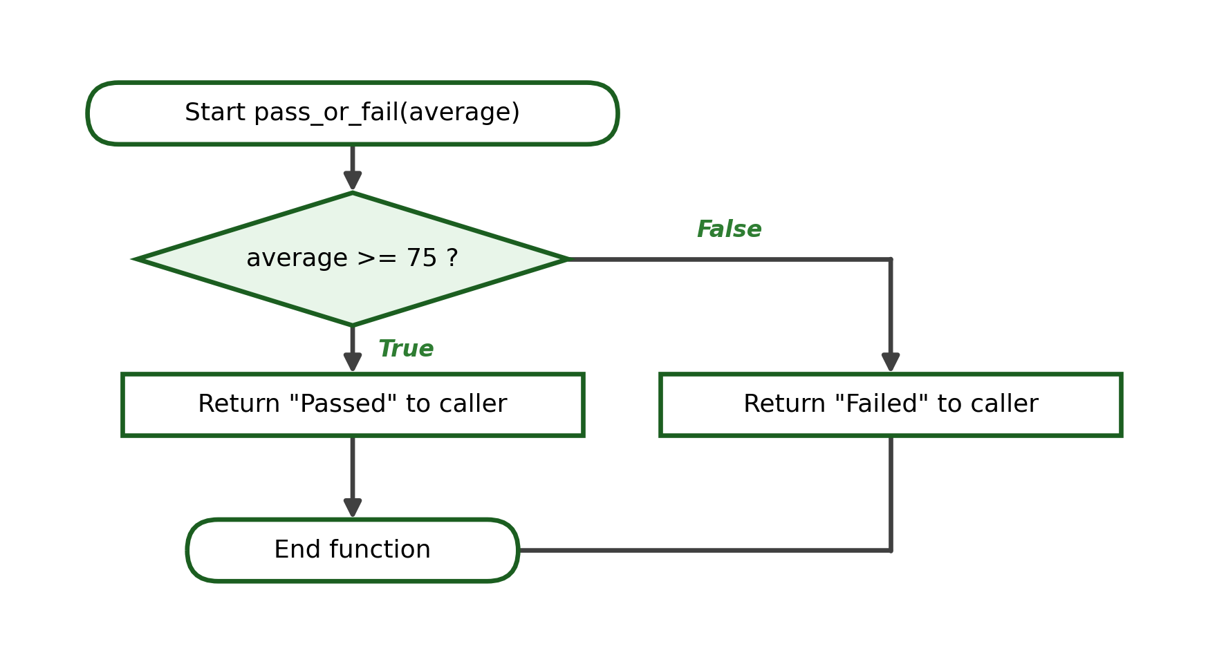
Python Program:
def pass_or_fail(average):
if average >= 75:
return "Passed"
else:
return "Failed"

remark = pass_or_fail(80)
print(remark)
Step | Statement / Call | Values | Output or Returned
1 | pass_or_fail(80) | average = 80 | -
2 | average >= 75 ? | True | -
3 | return "Passed" | - | returns "Passed"
4 | print(remark) | remark = "Passed" | Passed
Test Cases:
Test Case | Argument(s) | Expected Output
1 | 80 | Passed
2 | 75 | Passed
3 | 74 | Failed
Exact Output:
Passed
Explanation. A decision inside the function chooses which value to return; the boundary 75 returns Passed.

Example 7: Multiplication Table
Problem Statement. Accept a number and display its multiplication table using a loop.
Problem Decomposition:
Smaller Task | Function Name | Input Needed | Result Produced
Show the table | multiplication_table(number) | number | Printed rows
Function Name: multiplication_table(number)
Parameters: number
Returned Value: None
Input | Process | Output
number | Loop i from 1 to 10 | Ten printed rows
Algorithm:
1. Define multiplication_table(number).
2. Repeat i from 1 to 10.
3. Print number x i = product.
4. End the loop and the function.
Pseudocode:
FUNCTION multiplication_table(number)
FOR i = 1 TO 10
PRINT number, "x", i, "=", number * i
ENDFOR
END FUNCTION
Flowchart:
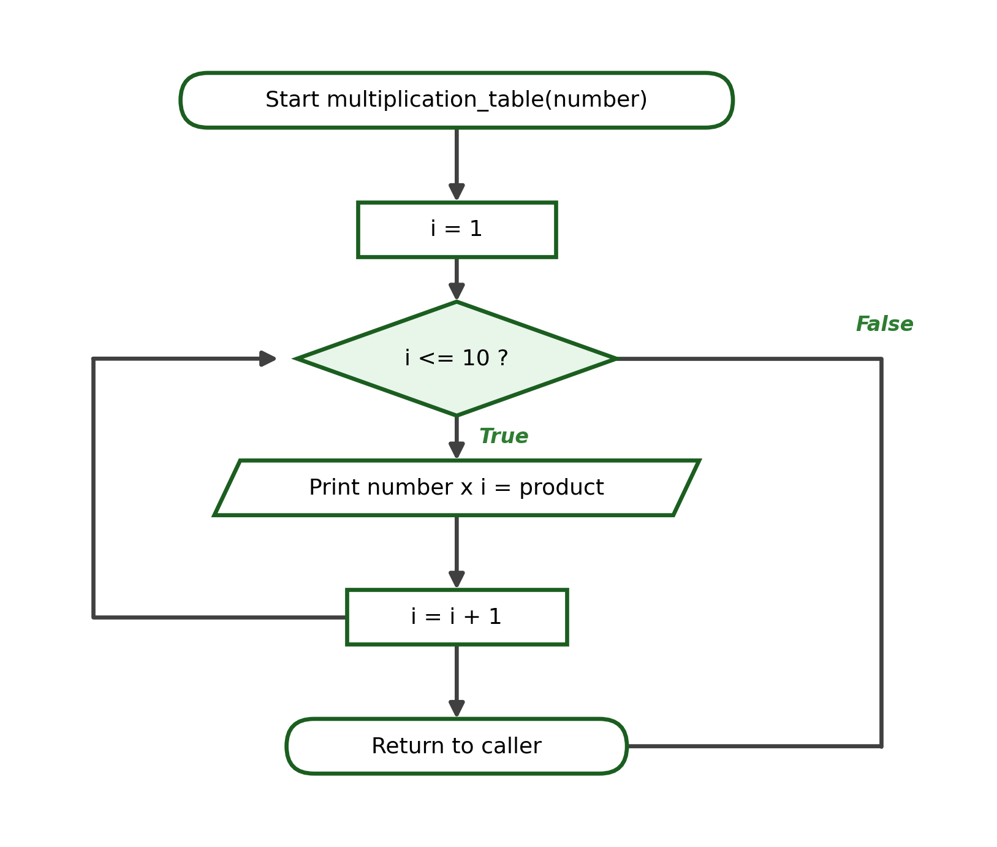
Python Program:
def multiplication_table(number):
for i in range(1, 11):
print(f"{number} x {i} = {number * i}")

multiplication_table(3)
Step | Statement / Call | Values | Output or Returned
1 | multiplication_table(3) | number = 3 | jump into function
2 | i = 1 | 3 x 1 | 3 x 1 = 3
3 | i = 2 | 3 x 2 | 3 x 2 = 6
... | ... | ... | ...
11 | i = 10 | 3 x 10 | 3 x 10 = 30
Test Cases:
Test Case | Argument(s) | Expected Output
1 | 3 | 3 x 1 = 3 ... 3 x 10 = 30
2 | 5 | 5 x 1 = 5 ...
Exact Output:
3 x 1 = 3
3 x 2 = 6
...
3 x 10 = 30
Explanation. A previously learned for loop repeats inside the function; no value is returned.

Example 8: Student Grade Program
Problem Statement. Use separate functions to compute the average, determine the remark, and display the result, all in one Python file.
Problem Decomposition:
Smaller Task | Function Name | Input Needed | Result Produced
Compute the average | compute_average(a, b, c) | a, b, c | The average
Determine the remark | get_remark(average) | average | A remark
Display the result | display_result(average, remark) | average, remark | Printed result
Function Name: compute_average / get_remark / display_result
Parameters: see decomposition
Returned Value: average and remark
Input | Process | Output
Three scores | Average, then compare with 75, then print | Average and remark shown
Algorithm:
1. Define compute_average(a, b, c) that returns the average.
2. Define get_remark(average) that returns Passed or Failed.
3. Define display_result(average, remark) that prints both.
4. In the main program, call the three functions in order.
Pseudocode:
FUNCTION compute_average(a, b, c)
RETURN (a + b + c) / 3
END FUNCTION

FUNCTION get_remark(average)
IF average >= 75 THEN
RETURN "Passed"
ELSE
RETURN "Failed"
ENDIF
END FUNCTION

FUNCTION display_result(average, remark)
PRINT average, remark
END FUNCTION
Flowchart:
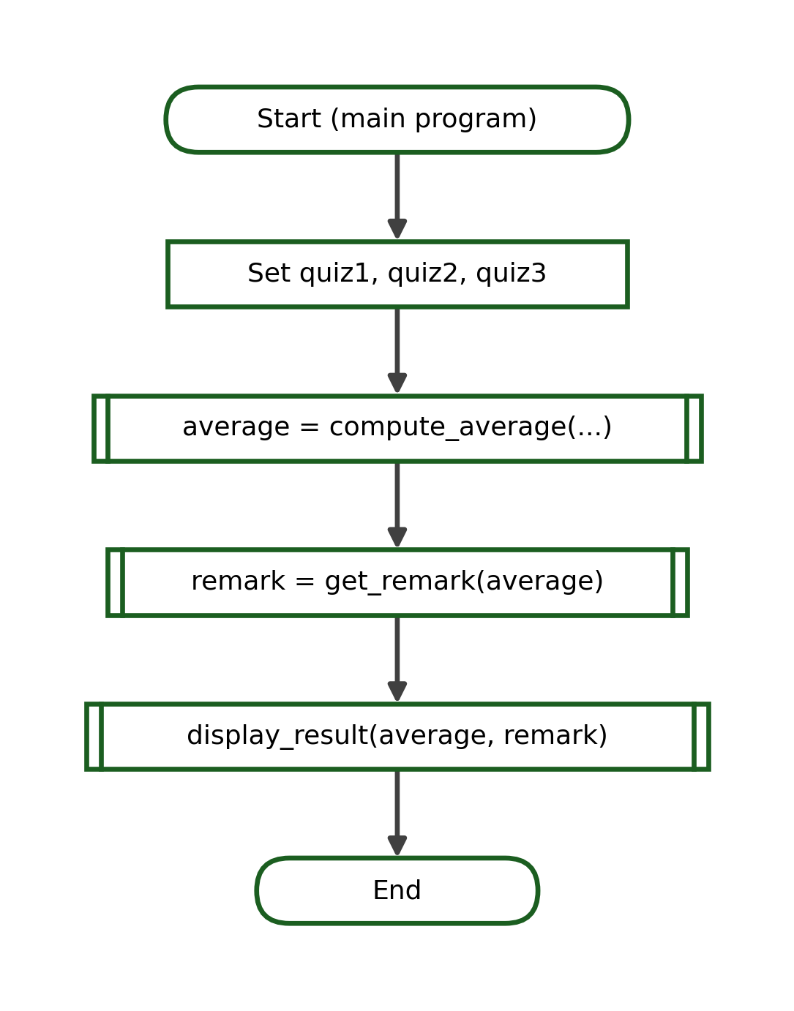
Python Program:
def compute_average(a, b, c):
return (a + b + c) / 3

def get_remark(average):
if average >= 75:
return "Passed"
else:
return "Failed"

def display_result(average, remark):
print(f"Average: {average:.2f}")
print(f"Remark: {remark}")

# ---- main program ----
q1 = 80
q2 = 75
q3 = 85
average = compute_average(q1, q2, q3)
remark = get_remark(average)
display_result(average, remark)
Step | Statement / Call | Values | Output or Returned
1 | compute_average(80, 75, 85) | returns 80.0 | -
2 | get_remark(80.0) | 80.0 >= 75 True | returns "Passed"
3 | display_result(80.0, "Passed") | - | Average: 80.00 / Passed
Test Cases:
Test Case | Argument(s) | Expected Output
1 | 80, 75, 85 | Average: 80.00 / Passed
2 | 70, 60, 80 | Average: 70.00 / Failed
Exact Output:
Average: 80.00
Remark: Passed
Explanation. The program is decomposed into three focused functions; the main program calls them in order and passes returned values between them.

20. Lecture Checkpoint Activities
The following short checkpoint activities may be answered after the related lecture sections. Complete answers appear in the Instructor's Complete Answer Key.

Checkpoint A - Built-In or User-Defined
Classify each of the following as a built-in function or a user-defined function.
1. print()
2. greet_student()
3. len()
4. compute_total()
5. round()
6. display_menu()
7. max()
8. get_average()
9. input()
10. show_result()

Checkpoint B - Valid Function Name
For each proposed function name, write Valid or Invalid, and give a reason when it is invalid.
1. compute_tax
2. 2nd_score
3. display result
4. get_total
5. show-menu
6. average_grade
7. return
8. print_receipt
9. TotalAmount
10. for

Checkpoint C - Parameter or Argument
State whether the highlighted term is a parameter or an argument.
1. def area(base, height) -> base
2. area(10, 5) -> 10
3. def greet(name) -> name
4. greet("Liza") -> "Liza"
5. def total(price, qty) -> qty
6. total(20, 3) -> 3
7. def show(message) -> message
8. show("Done") -> "Done"
9. def power(base, exp) -> exp
10. power(2, 4) -> 4

Checkpoint D - Predict the Output
Predict the exact output of each short program.
1.
def a():
print("Hi")
a()
a()
2.
def b(x):
print(x + 1)
b(9)
3.
def c(n):
return n * 2
print(c(5))
4.
def d():
print("Start")
print("End")
d()
5.
def e(name):
print("Hello", name)
e("Sam")
6.
def f(a, b):
return a - b
print(f(10, 4))
7.
def g(n):
for i in range(n):
print(i)
g(3)
8.
def h(x):
if x > 0:
return "Positive"
return "Not positive"
print(h(-2))
9.
def k(a, b):
print(a * b)
k(3, 4)
10.
def m(n):
return n + 10
result = m(5)
print(result)

Checkpoint E - Trace the Function
Complete a trace table for each program, showing the call, the parameter values, and the output or returned value.
1.
def sq(n):
return n * n
print(sq(6))
2.
def greet(name):
print("Hi", name)
greet("Ana")
3.
def add(a, b):
return a + b
x = add(2, 3)
print(x)
4.
def show(a, b):
print(a, b)
show(7, 8)
5.
def twice(n):
return n * 2
y = twice(twice(3))
print(y)
6.
def label(g):
if g >= 75:
return "Pass"
return "Fail"
print(label(75))

Checkpoint F - Complete the Missing Code
Fill in the missing part shown by the blank (____) so that each program works as described.
1.
# define a function that prints "Welcome"
____ welcome():
print("Welcome")
welcome()
2.
# call the function
def show():
print("Shown")
____
3.
# add a parameter named value
def display(____):
print(value)
display(10)
4.
# return the sum
def total(a, b):
____ a + b
print(total(4, 5))
5.
# store the returned value
def area(l, w):
return l * w
result = ____
print(result)
6.
# complete the header colon
def square(n)____
return n * n
print(square(3))
7.
# pass the correct arguments
def greet(first, last):
print(first, last)
greet(____)
8.
# print "Even" or "Odd"
def kind(n):
if n % 2 == 0:
print("Even")
____:
print("Odd")
kind(5)

Checkpoint G - Correct the Function
Each program contains one error. Identify the error and write the corrected version.
1.
def greet()
print("Hi")
greet()
2.
def show():
print("Shown")
show()
3.
def total(a, b):
return a + b
print(total(5))
4.
def area(l, w):
area = l * w
print(area(4, 3))
5.
def greet(name):
print("Hi", name)
gret("Ana")
6.
def add(a, b):
return a + b
print("done")
print(add(2, 3))
7.
def square(n):
return n * n
square(5)
print(result)
8.
def if(n):
return n
print(if(3))

WEEK 8 LABORATORY MANUAL

Laboratory Title
Designing Modular Python Programs Using Functions

Laboratory Objectives
At the end of the laboratory session, the students should be able to:
1. Differentiate built-in functions from user-defined functions;
2. Define and call functions with appropriate parameters and return values; and
3. Trace, test, and organize functions within a single Python program.

Required Tools
- Desktop or laptop computer
- Python 3.x
- Visual Studio Code
- Terminal or command-line interface
- Git
- GitHub account
- Projector (when needed)
- Learning Management System (LMS)

Laboratory Rules
- Perform the activities using Visual Studio Code and the terminal.
- Run and test every Python file before submitting it.
- Use meaningful function and variable names.
- Follow snake_case naming for functions and variables.
- Use proper four-space indentation.
- Write each function for one clear purpose.
- Do not directly upload or edit Python files through the GitHub website.
- Use Git commands through the terminal only.
- Save all files inside the required Week 8 repository structure.
- Submit original work.
- Be prepared to explain your functions and test cases.
- Copying another student's source code is an academic-integrity violation.

Laboratory Preparation
Before starting, answer this short readiness activity that reviews the concepts needed for this laboratory. Write your answers on your worksheet; the correct answers are provided in the Instructor's Complete Answer Key.
1. Write a Python statement that stores the integer 25 in a variable named age.
2. Convert the string "12" into an integer using a built-in function.
3. Write the operator used to obtain the remainder of a division.
4. Write a conditional statement that prints "Passed" if grade is at least 75.
5. Write a for loop that prints the numbers 1 to 5.
6. State whether student_score is a valid identifier and why.
7. State whether 2nd_score is a valid function name and why.
8. Write a single line that reads a number from the user and stores it as a float.

Laboratory Activity 1 - Built-In Functions
For each expression below, identify the built-in function used, the argument(s), the returned result, and the exact output when it is printed. Do not use lists as the central topic.
No. | Expression | Function | Argument(s) | Returned Result
1 | print(round(9.876, 1)) | ____ | ____ | ____
2 | print(abs(-15)) | ____ | ____ | ____
3 | print(min(7, 3, 9)) | ____ | ____ | ____
4 | print(max(7, 3, 9)) | ____ | ____ | ____
5 | print(pow(3, 2)) | ____ | ____ | ____
6 | print(len("Engineering")) | ____ | ____ | ____
7 | print(int("48")) | ____ | ____ | ____

Laboratory Activity 2 - Functions Without Parameters
Write a function for each task below. The function must receive no parameters and return no value. For every task provide the function name, algorithm, pseudocode, flowchart, Python code, a test run, and the exact output.
1. Write display_student_info() that prints your name, section, and student number.
2. Write display_classroom_reminder() that prints two laboratory reminders.
3. Write display_text_menu() that prints a simple four-line menu.
4. Write display_symbol_pattern() that prints a fixed pattern of symbols (for example, a small triangle of asterisks).

Laboratory Activity 3 - Functions With Parameters
Write a function for each task below. Each function must use one or more parameters and return no value. For each function, identify the parameters, the arguments used in each test call, and the output for at least three calls.
1. Write greet_person(name) that prints a personalized greeting.
2. Write display_number_square(number) that prints the square of the number.
3. Write display_even_odd(number) that prints whether the number is even or odd.
4. Write display_grade_remark(grade) that prints "Passed" or "Failed".
5. Write display_multiplication_table(number) that prints the table of the number from 1 to 10.

Laboratory Activity 4 - Functions With Return Values
Write a function for each task below. Each function must use parameters and return a value. For each function, provide the function definition, its parameters, the return expression, a function call, a variable that receives the returned value, and the exact output.
1. Write add_two_numbers(a, b) that returns the sum of two numbers.
2. Write rectangle_area(length, width) that returns the area of a rectangle.
3. Write compute_total(quantity, price) that returns the total purchase amount.
4. Write average_of_three(a, b, c) that returns the average of three grades.
5. Write to_fahrenheit(celsius) that returns the Fahrenheit equivalent.

Laboratory Activity 5 - Function Decomposition
For each larger problem below, divide the solution into smaller functions. Complete a decomposition table for each problem. All functions must remain inside one Python program file; multiple files are not required.
Decomposition Table (to complete for each problem):
Required Task | Function Name | Parameters | Return Value
____ | ____ | ____ | ____
1. Student-grade evaluator: read three scores, compute the average, and decide the remark.
2. School-supply purchase calculator: compute the total cost of an item and show the amount due.
3. Transportation-fare calculator: compute a fare from a base fare and a per-kilometer rate.
4. Employee salary calculator: compute the gross salary from an hourly rate and the number of hours worked.

Laboratory Activity 6 - Function Tracing and Testing
Trace each program below and complete a trace table showing the argument values, the parameter values, the function output, the returned value, and the final program output. Then run at least three test cases for each selected programming problem.
1.
def triple(n):
return n * 3
print(triple(4))
2.
def greet(name):
print("Hello", name)
greet("Bea")
3.
def total(a, b):
return a + b
x = total(6, 9)
print(x)
4.
def is_even(n):
if n % 2 == 0:
return "Even"
return "Odd"
print(is_even(11))
5.
def fee(base, km):
return base + km * 2
print(fee(10, 5))
6.
def bigger(a, b):
if a >= b:
return a
return b
print(bigger(12, 20))

Laboratory Activity 7 - Complete Problem-Solving Tasks
Choose problems assigned by your instructor from the list below. For each chosen problem, provide a complete solution consisting of a problem analysis, function decomposition, IPO table, algorithm, pseudocode, flowchart, function definitions, main program, a function-call trace, at least three test cases, and the exact expected output. Use only Week 1 to Week 8 concepts.
1. Total cost of school supplies (quantity and unit price).
2. Average of three quiz scores.
3. Rectangle area and perimeter.
4. Temperature conversion (Celsius to Fahrenheit).
5. Pass-or-fail evaluation from an average.
6. Largest of two numbers.
7. Even-or-odd checker.
8. Employee gross salary (hourly rate and hours worked).
9. Student allowance balance (allowance minus amount spent).
10. Electricity-consumption cost (kilowatt-hours and rate).
11. Simple-interest calculator (principal, rate, and time).
12. Multiplication-table generator for a given number.
Model solutions for these problems are provided in the Instructor's Complete Answer Key.

Git and GitHub Workflow
Use Visual Studio Code and the terminal to create, test, commit, and push your files. Do not directly edit or upload source-code files through the GitHub website. Organize your work using the repository structure below.
Suggested Folder Structure:
cpp102-week8-surname/
|__ activity1/
| |__ built_in_functions.py
| |__ README.md
|__ activity2/
| |__ no_parameter_functions.py
| |__ README.md
|__ activity3/
| |__ parameter_functions.py
| |__ README.md
|__ activity4/
| |__ return_value_functions.py
| |__ README.md
|__ activity5/
| |__ function_decomposition.py
|__ activity6/
| |__ function_tracing.md
|__ README.md
After completing and testing your files, save your work using the following Git commands in the terminal:
Terminal Commands:
git status
git add .
git commit -m "Complete CPP102 Week 8 functions fundamentals activities"
git push
If Git reports that the index is locked (for example, an "index.lock" error), remove the lock file and try again:
Troubleshooting:
rm .git/index.lock
The main README.md file of your repository must contain the following information:
- Student name
- Section
- Week number
- List of completed activities
- Names and purposes of the functions you created
- Test cases used
- A short reflection

Reflection Questions
Answer the following questions briefly and honestly on your worksheet.
1. What problem does modular programming solve?
2. What is the difference between a built-in function and a user-defined function?
3. What is the difference between a parameter and an argument?
4. What is the difference between print() and return?
5. How did function decomposition make your program easier to design and test?

INSTRUCTOR'S COMPLETE ANSWER KEY
This section contains the complete answers to every lecture checkpoint and laboratory activity in this module. The answers are organized using the same section numbers, checkpoint labels, and activity numbers used earlier.

Section 3 - Function-Decomposition Worksheet (Student Practice)
Suggested answer for the Celsius-to-Fahrenheit row:
Main Problem | Smaller Task | Suggested Function Name | Input Needed | Result Produced
Temperature conversion | Convert Celsius to Fahrenheit | to_fahrenheit(celsius) | A Celsius value | The Fahrenheit value

Section 6 - Naming Activity
1. print_receipt - Valid (lowercase, snake_case, meaningful).
2. 3rd_score - Invalid (a name cannot begin with a digit).
3. total amount - Invalid (a space is not allowed).
4. get_average - Valid (clear, action-oriented, snake_case).
5. display-total - Invalid (a hyphen is not allowed).
6. compute_tax - Valid.
7. while - Invalid (while is a Python keyword).
8. show_summary - Valid.

Section 10 - Parameter or Argument
The same items appear again as Checkpoint C; see the answers there.

Checkpoint A - Built-In or User-Defined
1. print() - Built-in.
2. greet_student() - User-defined.
3. len() - Built-in.
4. compute_total() - User-defined.
5. round() - Built-in.
6. display_menu() - User-defined.
7. max() - Built-in.
8. get_average() - User-defined.
9. input() - Built-in.
10. show_result() - User-defined.

Checkpoint B - Valid Function Name
1. compute_tax - Valid.
2. 2nd_score - Invalid (begins with a digit).
3. display result - Invalid (contains a space).
4. get_total - Valid.
5. show-menu - Invalid (contains a hyphen).
6. average_grade - Valid.
7. return - Invalid (Python keyword).
8. print_receipt - Valid.
9. TotalAmount - Valid syntactically, but snake_case (total_amount) is recommended.
10. for - Invalid (Python keyword).

Checkpoint C - Parameter or Argument
1. base - Parameter.
2. 10 - Argument.
3. name - Parameter.
4. "Liza" - Argument.
5. qty - Parameter.
6. 3 - Argument.
7. message - Parameter.
8. "Done" - Argument.
9. exp - Parameter.
10. 4 - Argument.

Checkpoint D - Predict the Output
1. Hi (printed twice, on two lines).
2. 10.
3. 10.
4. End then Start (the definition runs only when d() is called).
5. Hello Sam.
6. 6.
7. 0, 1, 2 (each on its own line).
8. Not positive.
9. 12.
10. 15.

Checkpoint E - Trace the Function
1. sq(6): n = 6, returns 36 -> output 36.
2. greet("Ana"): name = "Ana" -> output Hi Ana.
3. add(2, 3): a = 2, b = 3, returns 5; x = 5 -> output 5.
4. show(7, 8): a = 7, b = 8 -> output 7 8.
5. twice(3) returns 6, then twice(6) returns 12 -> output 12.
6. label(75): 75 >= 75 is True, returns "Pass" -> output Pass.

Checkpoint F - Complete the Missing Code
1. def welcome(): (the missing keyword is def) -> output Welcome.
2. show() (call the function) -> output Shown.
3. def display(value): (add the parameter value) -> output 10.
4. return a + b (the missing keyword is return) -> output 9.
5. result = area(4, 3) (call with arguments) -> output 12.
6. def square(n): (add the colon) -> output 9.
7. greet("Ana", "Cruz") (pass two arguments) -> output Ana Cruz.
8. else: (the missing keyword is else) -> output Odd.

Checkpoint G - Correct the Function
Each item shows the error and the corrected program.
1. Missing colon on the header.
Corrected:
def greet():
print("Hi")

greet()
2. The function body must be indented.
Corrected:
def show():
print("Shown")

show()
3. total() needs two arguments.
Corrected:
def total(a, b):
return a + b

print(total(5, 3))
4. The function must return the result (return was missing).
Corrected:
def area(l, w):
return l * w

print(area(4, 3))
5. The function name is misspelled in the call.
Corrected:
def greet(name):
print("Hi", name)

greet("Ana")
6. Statements after return are never processed; remove or reorder them.
Corrected:
def add(a, b):
return a + b

print(add(2, 3))
7. The returned value must be stored and printed.
Corrected:
def square(n):
return n * n

result = square(5)
print(result)
8. A keyword cannot be used as a function name; rename it.
Corrected:
def keep(n):
return n

print(keep(3))

Laboratory Preparation - Answers
1. age = 25
2. int("12")
3. The modulo operator %.
4. if grade >= 75:
print("Passed")
5. for i in range(1, 6):
print(i)
6. student_score - Valid (letters and an underscore, does not start with a digit).
7. 2nd_score - Invalid (a name cannot begin with a digit).
8. number = float(input("Enter a number: "))

Laboratory Activity 1 - Built-In Functions (Answers)
No. | Expression | Function | Argument(s) | Returned Result | Output
1 | round(9.876, 1) | round() | 9.876, 1 | 9.9 | 9.9
2 | abs(-15) | abs() | -15 | 15 | 15
3 | min(7, 3, 9) | min() | 7, 3, 9 | 3 | 3
4 | max(7, 3, 9) | max() | 7, 3, 9 | 9 | 9
5 | pow(3, 2) | pow() | 3, 2 | 9 | 9
6 | len("Engineering") | len() | "Engineering" | 11 | 11
7 | int("48") | int() | "48" | 48 | 48

Laboratory Activity 2 - Functions Without Parameters (Model Solutions)
1. display_student_info():
def display_student_info():
print("Name: Juan Dela Cruz")
print("Section: 1CPE-A")
print("Student Number: 2026-00123")

display_student_info()
Output:
Name: Juan Dela Cruz
Section: 1CPE-A
Student Number: 2026-00123
2. display_classroom_reminder():
def display_classroom_reminder():
print("Save your files inside the Week 8 repository.")
print("Use the terminal for all Git commands.")

display_classroom_reminder()
Output:
Save your files inside the Week 8 repository.
Use the terminal for all Git commands.
3. display_text_menu():
def display_text_menu():
print("1. Add")
print("2. Subtract")
print("3. Multiply")
print("4. Exit")

display_text_menu()
Output:
1. Add
2. Subtract
3. Multiply
4. Exit
4. display_symbol_pattern():
def display_symbol_pattern():
print("*")
print("**")
print("***")

display_symbol_pattern()
Output:
*
**
***

Laboratory Activity 3 - Functions With Parameters (Model Solutions)
1. greet_person(name): parameter = name
def greet_person(name):
print(f"Hello, {name}!")

greet_person("Ana")
greet_person("Marco")
greet_person("Liza")
Output (three calls):
Hello, Ana!
Hello, Marco!
Hello, Liza!
2. display_number_square(number): parameter = number
def display_number_square(number):
print(number * number)

display_number_square(4)
display_number_square(7)
display_number_square(10)
Output (three calls):
16
49
100
3. display_even_odd(number): parameter = number
def display_even_odd(number):
if number % 2 == 0:
print("Even")
else:
print("Odd")

display_even_odd(4)
display_even_odd(7)
display_even_odd(0)
Output (three calls):
Even
Odd
Even
4. display_grade_remark(grade): parameter = grade
def display_grade_remark(grade):
if grade >= 75:
print("Passed")
else:
print("Failed")

display_grade_remark(90)
display_grade_remark(75)
display_grade_remark(60)
Output (three calls):
Passed
Passed
Failed
5. display_multiplication_table(number): parameter = number
def display_multiplication_table(number):
for i in range(1, 11):
print(f"{number} x {i} = {number * i}")

display_multiplication_table(2)
Output (call with 2):
2 x 1 = 2
2 x 2 = 4
2 x 3 = 6
...
2 x 10 = 20

Laboratory Activity 4 - Functions With Return Values (Model Solutions)
1. add_two_numbers(a, b):
def add_two_numbers(a, b):
return a + b

result = add_two_numbers(8, 5)
print("Sum:", result)
Output:
Sum: 13
2. rectangle_area(length, width):
def rectangle_area(length, width):
return length * width

a = rectangle_area(6, 4)
print("Area:", a)
Output:
Area: 24
3. compute_total(quantity, price):
def compute_total(quantity, price):
return quantity * price

amount = compute_total(3, 12.50)
print(f"Total: ₱{amount:.2f}")
Output:
Total: ₱37.50
4. average_of_three(a, b, c):
def average_of_three(a, b, c):
return (a + b + c) / 3

avg = average_of_three(80, 75, 85)
print(f"Average: {avg:.2f}")
Output:
Average: 80.00
5. to_fahrenheit(celsius):
def to_fahrenheit(celsius):
return celsius * 9 / 5 + 32

temp = to_fahrenheit(37)
print(f"Fahrenheit: {temp:.1f}")
Output:
Fahrenheit: 98.6

Laboratory Activity 5 - Function Decomposition (Answers)
1. Student-grade evaluator:
Required Task | Function Name | Parameters | Return Value
Read three scores | get_scores() | None | Three scores
Compute the average | compute_average(a, b, c) | a, b, c | The average
Decide the remark | get_remark(average) | average | "Passed"/"Failed"
2. School-supply purchase calculator:
Required Task | Function Name | Parameters | Return Value
Compute total cost | compute_total(quantity, price) | quantity, price | The total
Show the amount due | display_amount(total) | total | None (prints)
3. Transportation-fare calculator:
Required Task | Function Name | Parameters | Return Value
Compute the fare | compute_fare(base, km) | base, km | The fare
Show the fare | display_fare(fare) | fare | None (prints)
4. Employee salary calculator:
Required Task | Function Name | Parameters | Return Value
Compute gross salary | gross_salary(rate, hours) | rate, hours | The salary
Show the salary | display_salary(salary) | salary | None (prints)

Laboratory Activity 6 - Function Tracing and Testing (Answers)
No. | Call | Parameter Values | Returned | Final Output
1 | triple(4) | n = 4 | 12 | 12
2 | greet("Bea") | name = "Bea" | None | Hello Bea
3 | total(6, 9) | a = 6, b = 9 | 15 | 15
4 | is_even(11) | n = 11 | "Odd" | Odd
5 | fee(10, 5) | base = 10, km = 5 | 20 | 20
6 | bigger(12, 20) | a = 12, b = 20 | 20 | 20
Suggested additional test cases: for is_even try 4 (Even), 7 (Odd), and 0 (Even); for bigger try (3, 9) -> 9, (9, 3) -> 9, and (5, 5) -> 5.

Laboratory Activity 7 - Complete Problem-Solving Tasks (Model Solutions)

Problem 1: Total Cost of School Supplies
Function: total_cost(quantity, price)
Parameters: quantity, price
Returned Value: The total quantity * price
Decomposition Table:
Required Task | Function Name | Parameters | Return Value
Compute total cost | total_cost(quantity, price) | quantity, price | The total
IPO Table:
Input | Process | Output
quantity, price | total = quantity * price | The total cost
Algorithm:
1. Define total_cost(quantity, price).
2. Compute total = quantity * price.
3. Return total.
4. Display the returned value with two decimals.
Pseudocode:
FUNCTION total_cost(quantity, price)
total = quantity * price
RETURN total
END FUNCTION
Flowchart:
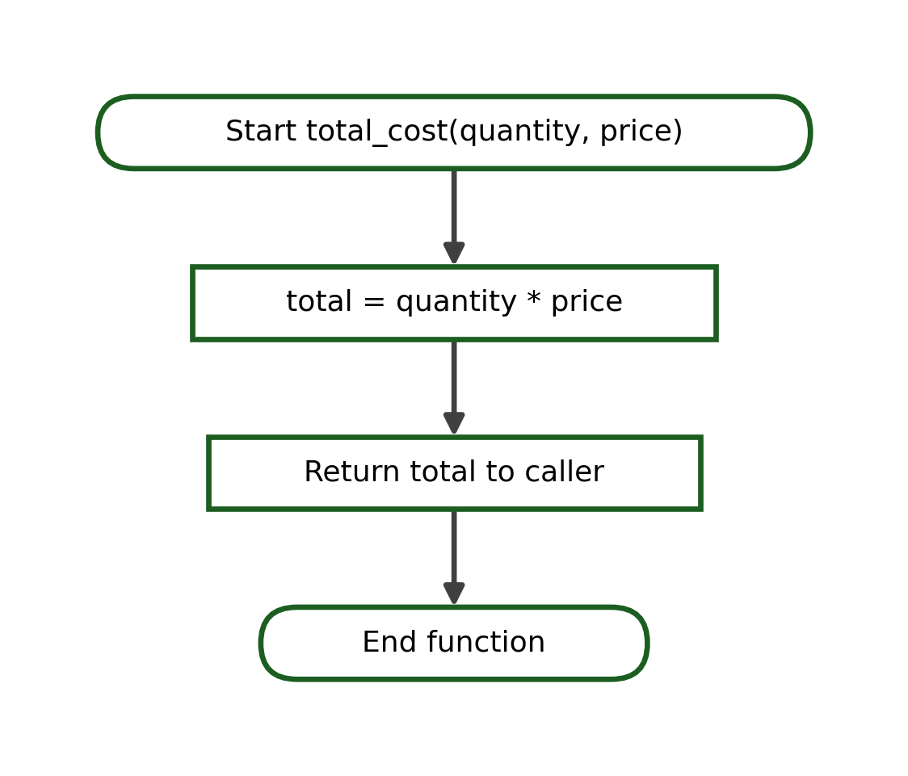
Complete Python Program:
def total_cost(quantity, price):
return quantity * price

amount = total_cost(3, 25.50)
print(f"Total Cost: ₱{amount:.2f}")
Step | Statement / Call | Values / Returned
1 | total_cost(3, 25.50) | quantity = 3, price = 25.50
2 | return quantity * price | returns 76.5
3 | print(...) | Total Cost: ₱76.50
Test Cases:
Test Case | Argument(s) | Expected Output
1 | 3, 25.50 | Total Cost: ₱76.50
2 | 5, 12 | Total Cost: ₱60.00
3 | 2, 100 | Total Cost: ₱200.00
Exact Output:
Total Cost: ₱76.50
Explanation. The function multiplies quantity by price and returns the total, which the caller formats as currency.

Problem 2: Average of Three Quiz Scores
Function: average_of_three(a, b, c)
Parameters: a, b, c
Returned Value: The average (a + b + c) / 3
Decomposition Table:
Required Task | Function Name | Parameters | Return Value
Compute the average | average_of_three(a, b, c) | a, b, c | The average
IPO Table:
Input | Process | Output
a, b, c | average = (a + b + c) / 3 | The average
Algorithm:
1. Define average_of_three(a, b, c).
2. Compute the sum and divide by 3.
3. Return the average.
4. Display the returned value with two decimals.
Pseudocode:
FUNCTION average_of_three(a, b, c)
average = (a + b + c) / 3
RETURN average
END FUNCTION
Flowchart:
Complete Python Program:
def average_of_three(a, b, c):
return (a + b + c) / 3

avg = average_of_three(80, 75, 85)
print(f"Average: {avg:.2f}")
Step | Statement / Call | Values / Returned
1 | average_of_three(80, 75, 85) | a=80, b=75, c=85
2 | return (a + b + c) / 3 | returns 80.0
3 | print(...) | Average: 80.00
Test Cases:
Test Case | Argument(s) | Expected Output
1 | 80, 75, 85 | Average: 80.00
2 | 90, 90, 90 | Average: 90.00
3 | 70, 80, 90 | Average: 80.00
Exact Output:
Average: 80.00
Explanation. Three parameters are averaged; the returned decimal is displayed with two decimal places.

Problem 3: Rectangle Area and Perimeter
Function: rectangle_area(length, width) and rectangle_perimeter(length, width)
Parameters: length, width
Returned Value: The area and the perimeter
Decomposition Table:
Required Task | Function Name | Parameters | Return Value
Compute the area | rectangle_area(length, width) | length, width | The area
Compute the perimeter | rectangle_perimeter(length, width) | length, width | The perimeter
IPO Table:
Input | Process | Output
length, width | area = l * w; perimeter = 2 * (l + w) | The area and perimeter
Algorithm:
1. Define rectangle_area(length, width) that returns length * width.
2. Define rectangle_perimeter(length, width) that returns 2 * (length + width).
3. Call both functions and display the results.
Pseudocode:
FUNCTION rectangle_area(length, width)
RETURN length * width
END FUNCTION

FUNCTION rectangle_perimeter(length, width)
RETURN 2 * (length + width)
END FUNCTION
Flowchart:
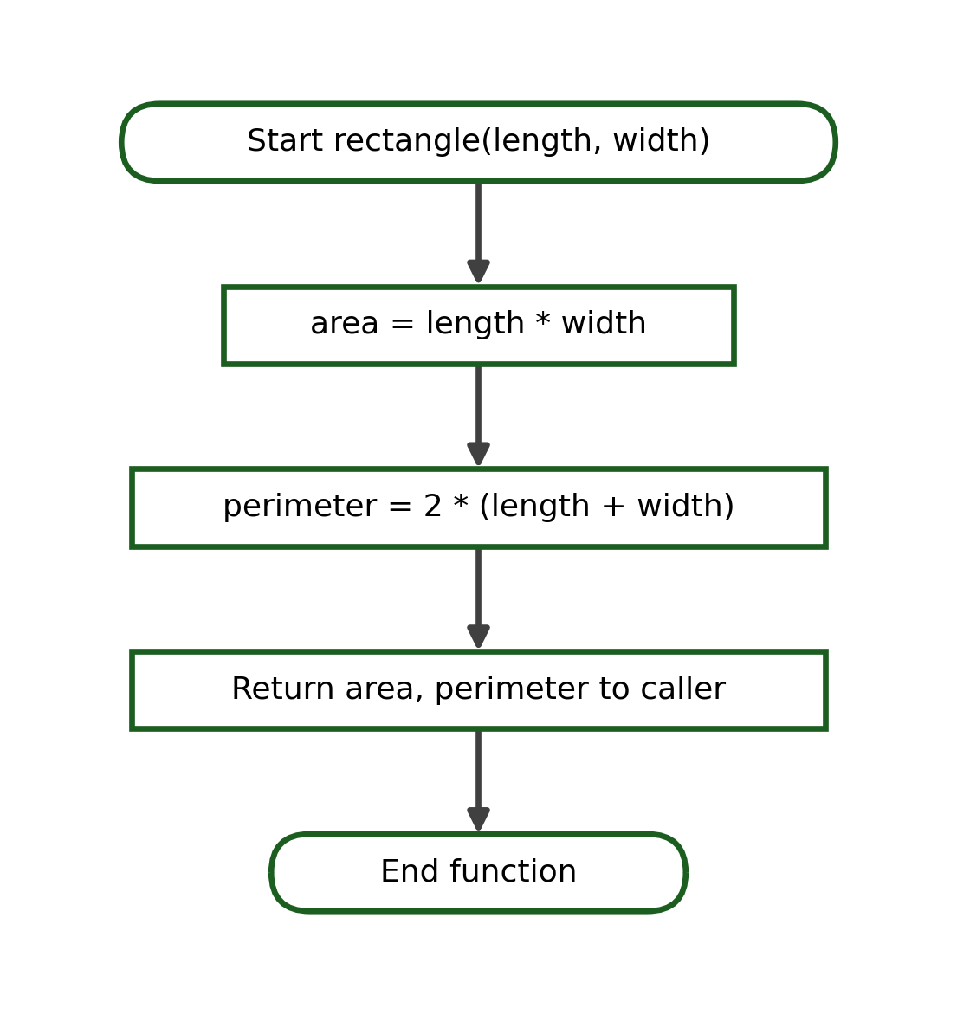
Complete Python Program:
def rectangle_area(length, width):
return length * width

def rectangle_perimeter(length, width):
return 2 * (length + width)

a = rectangle_area(6, 4)
p = rectangle_perimeter(6, 4)
print("Area:", a)
print("Perimeter:", p)
Step | Statement / Call | Values / Returned
1 | rectangle_area(6, 4) | returns 24
2 | rectangle_perimeter(6, 4) | returns 20
3 | print(...) | Area: 24 / Perimeter: 20
Test Cases:
Test Case | Argument(s) | Expected Output
1 | 6, 4 | Area: 24 / Perimeter: 20
2 | 10, 2 | Area: 20 / Perimeter: 24
3 | 5, 5 | Area: 25 / Perimeter: 20
Exact Output:
Area: 24
Perimeter: 20
Explanation. The problem is decomposed into two functions, each returning one value that the main program displays.

Problem 4: Temperature Conversion (Celsius to Fahrenheit)
Function: to_fahrenheit(celsius)
Parameters: celsius
Returned Value: celsius * 9 / 5 + 32
Decomposition Table:
Required Task | Function Name | Parameters | Return Value
Convert temperature | to_fahrenheit(celsius) | celsius | The Fahrenheit value
IPO Table:
Input | Process | Output
celsius | f = celsius * 9 / 5 + 32 | The Fahrenheit value
Algorithm:
1. Define to_fahrenheit(celsius).
2. Apply f = celsius * 9 / 5 + 32.
3. Return f.
4. Display the returned value with one decimal.
Pseudocode:
FUNCTION to_fahrenheit(celsius)
f = celsius * 9 / 5 + 32
RETURN f
END FUNCTION
Flowchart:
Complete Python Program:
def to_fahrenheit(celsius):
return celsius * 9 / 5 + 32

temp = to_fahrenheit(37)
print(f"Fahrenheit: {temp:.1f}")
Step | Statement / Call | Values / Returned
1 | to_fahrenheit(37) | celsius = 37
2 | return celsius * 9 / 5 + 32 | returns 98.6
3 | print(...) | Fahrenheit: 98.6
Test Cases:
Test Case | Argument(s) | Expected Output
1 | 37 | Fahrenheit: 98.6
2 | 0 | Fahrenheit: 32.0
3 | 100 | Fahrenheit: 212.0
Exact Output:
Fahrenheit: 98.6
Explanation. The conversion formula is applied to the parameter and the result is returned.

Problem 5: Pass-or-Fail Evaluation
Function: pass_or_fail(average)
Parameters: average
Returned Value: "Passed" if average >= 75, else "Failed"
Decomposition Table:
Required Task | Function Name | Parameters | Return Value
Decide the remark | pass_or_fail(average) | average | A remark
IPO Table:
Input | Process | Output
average | Compare average with 75 | A remark string
Algorithm:
1. Define pass_or_fail(average).
2. If average >= 75, return "Passed".
3. Otherwise return "Failed".
4. Display the returned value.
Pseudocode:
FUNCTION pass_or_fail(average)
IF average >= 75 THEN
RETURN "Passed"
ELSE
RETURN "Failed"
ENDIF
END FUNCTION
Flowchart:
Complete Python Program:
def pass_or_fail(average):
if average >= 75:
return "Passed"
else:
return "Failed"

print(pass_or_fail(80))
Step | Statement / Call | Values / Returned
1 | pass_or_fail(80) | average = 80
2 | 80 >= 75 ? | True
3 | return "Passed" | returns "Passed"
Test Cases:
Test Case | Argument(s) | Expected Output
1 | 80 | Passed
2 | 75 | Passed
3 | 74 | Failed
Exact Output:
Passed
Explanation. The boundary value 75 returns Passed because the condition uses >=.

Problem 6: Largest of Two Numbers
Function: larger(a, b)
Parameters: a, b
Returned Value: The larger of a and b
Decomposition Table:
Required Task | Function Name | Parameters | Return Value
Find the larger value | larger(a, b) | a, b | The larger value
IPO Table:
Input | Process | Output
a, b | Compare a and b | The larger value
Algorithm:
1. Define larger(a, b).
2. If a >= b, return a.
3. Otherwise return b.
4. Display the returned value.
Pseudocode:
FUNCTION larger(a, b)
IF a >= b THEN
RETURN a
ELSE
RETURN b
ENDIF
END FUNCTION
Flowchart:
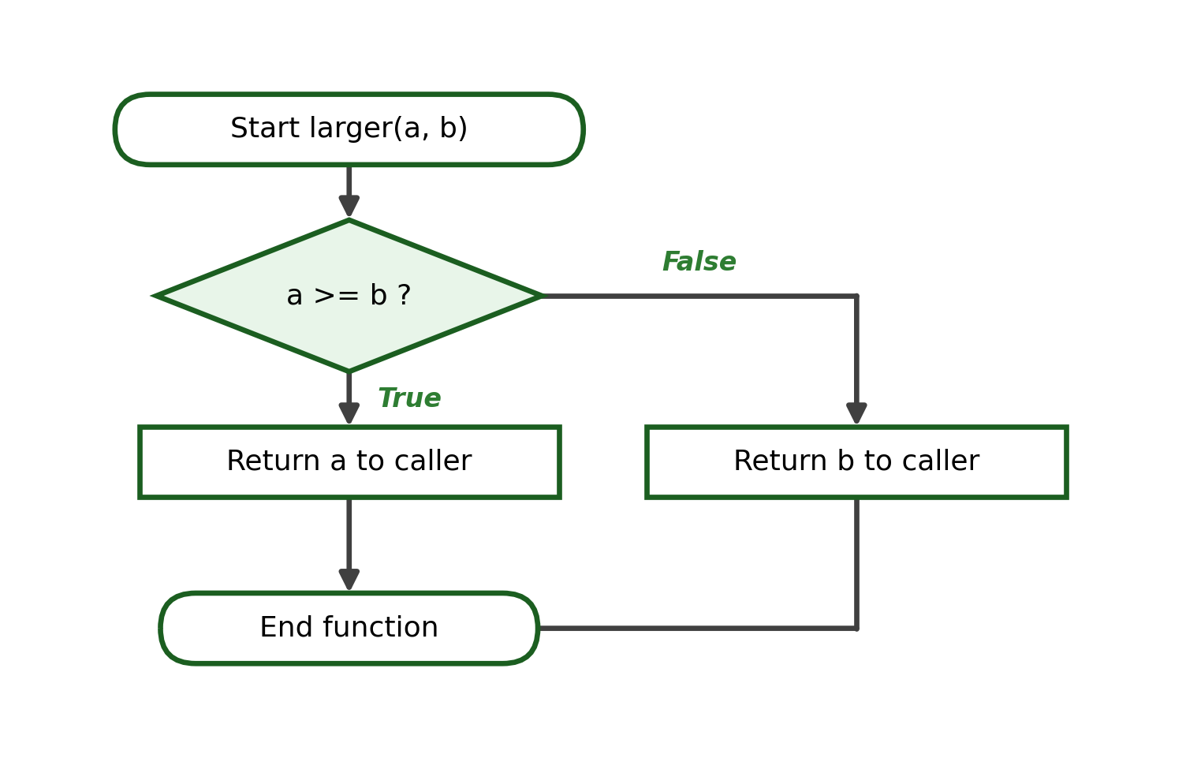
Complete Python Program:
def larger(a, b):
if a >= b:
return a
else:
return b

print(larger(12, 20))
Step | Statement / Call | Values / Returned
1 | larger(12, 20) | a = 12, b = 20
2 | 12 >= 20 ? | False
3 | return b | returns 20
Test Cases:
Test Case | Argument(s) | Expected Output
1 | 12, 20 | 20
2 | 9, 3 | 9
3 | 5, 5 | 5
Exact Output:
20
Explanation. A single decision returns the larger value; equal values return a (which equals b).

Problem 7: Even-or-Odd Checker
Function: even_or_odd(number)
Parameters: number
Returned Value: "Even" or "Odd"
Decomposition Table:
Required Task | Function Name | Parameters | Return Value
Classify the number | even_or_odd(number) | number | A remark
IPO Table:
Input | Process | Output
number | Test number % 2 == 0 | A remark string
Algorithm:
1. Define even_or_odd(number).
2. If number % 2 == 0, return "Even".
3. Otherwise return "Odd".
4. Display the returned value.
Pseudocode:
FUNCTION even_or_odd(number)
IF number % 2 == 0 THEN
RETURN "Even"
ELSE
RETURN "Odd"
ENDIF
END FUNCTION
Flowchart:
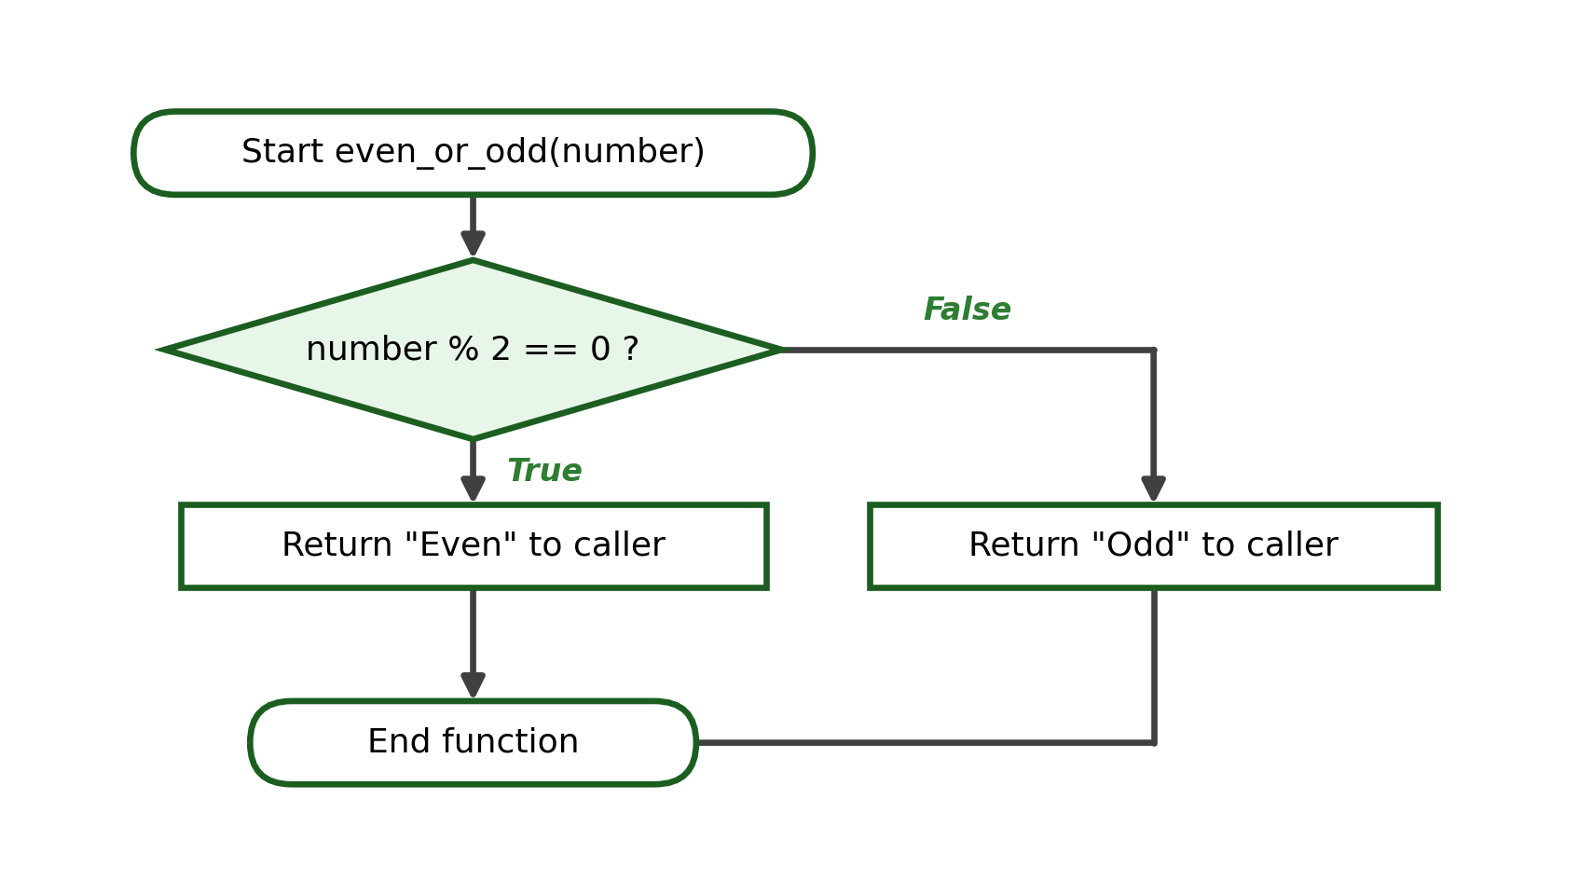
Complete Python Program:
def even_or_odd(number):
if number % 2 == 0:
return "Even"
else:
return "Odd"

print(even_or_odd(4))
Step | Statement / Call | Values / Returned
1 | even_or_odd(4) | number = 4
2 | 4 % 2 == 0 ? | True
3 | return "Even" | returns "Even"
Test Cases:
Test Case | Argument(s) | Expected Output
1 | 4 | Even
2 | 7 | Odd
3 | 0 | Even
Exact Output:
Even
Explanation. The modulo operator tests divisibility by 2 to classify the number.

Problem 8: Employee Gross Salary
Function: gross_salary(rate, hours)
Parameters: rate, hours
Returned Value: rate * hours
Decomposition Table:
Required Task | Function Name | Parameters | Return Value
Compute gross salary | gross_salary(rate, hours) | rate, hours | The salary
IPO Table:
Input | Process | Output
rate, hours | salary = rate * hours | The gross salary
Algorithm:
1. Define gross_salary(rate, hours).
2. Compute salary = rate * hours.
3. Return salary.
4. Display the returned value with two decimals.
Pseudocode:
FUNCTION gross_salary(rate, hours)
salary = rate * hours
RETURN salary
END FUNCTION
Flowchart:
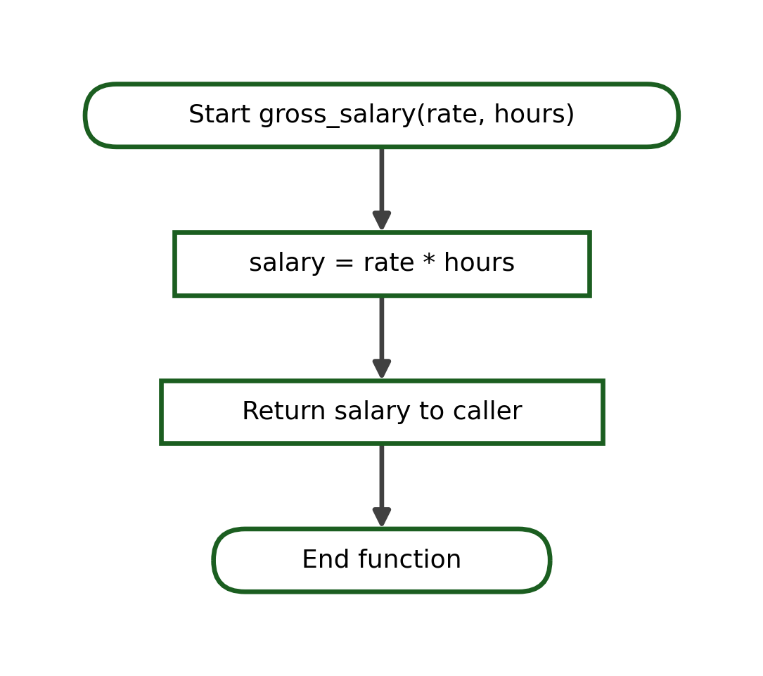
Complete Python Program:
def gross_salary(rate, hours):
return rate * hours

pay = gross_salary(120, 8)
print(f"Gross Salary: ₱{pay:.2f}")
Step | Statement / Call | Values / Returned
1 | gross_salary(120, 8) | rate = 120, hours = 8
2 | return rate * hours | returns 960
3 | print(...) | Gross Salary: ₱960.00
Test Cases:
Test Case | Argument(s) | Expected Output
1 | 120, 8 | Gross Salary: ₱960.00
2 | 150, 40 | Gross Salary: ₱6000.00
3 | 100, 0 | Gross Salary: ₱0.00
Exact Output:
Gross Salary: ₱960.00
Explanation. The hourly rate is multiplied by the number of hours to produce the gross salary.

Problem 9: Student Allowance Balance
Function: balance(allowance, spent)
Parameters: allowance, spent
Returned Value: allowance - spent
Decomposition Table:
Required Task | Function Name | Parameters | Return Value
Compute the balance | balance(allowance, spent) | allowance, spent | The remaining amount
IPO Table:
Input | Process | Output
allowance, spent | remaining = allowance - spent | The balance
Algorithm:
1. Define balance(allowance, spent).
2. Compute remaining = allowance - spent.
3. Return remaining.
4. Display the returned value with two decimals.
Pseudocode:
FUNCTION balance(allowance, spent)
remaining = allowance - spent
RETURN remaining
END FUNCTION
Flowchart:
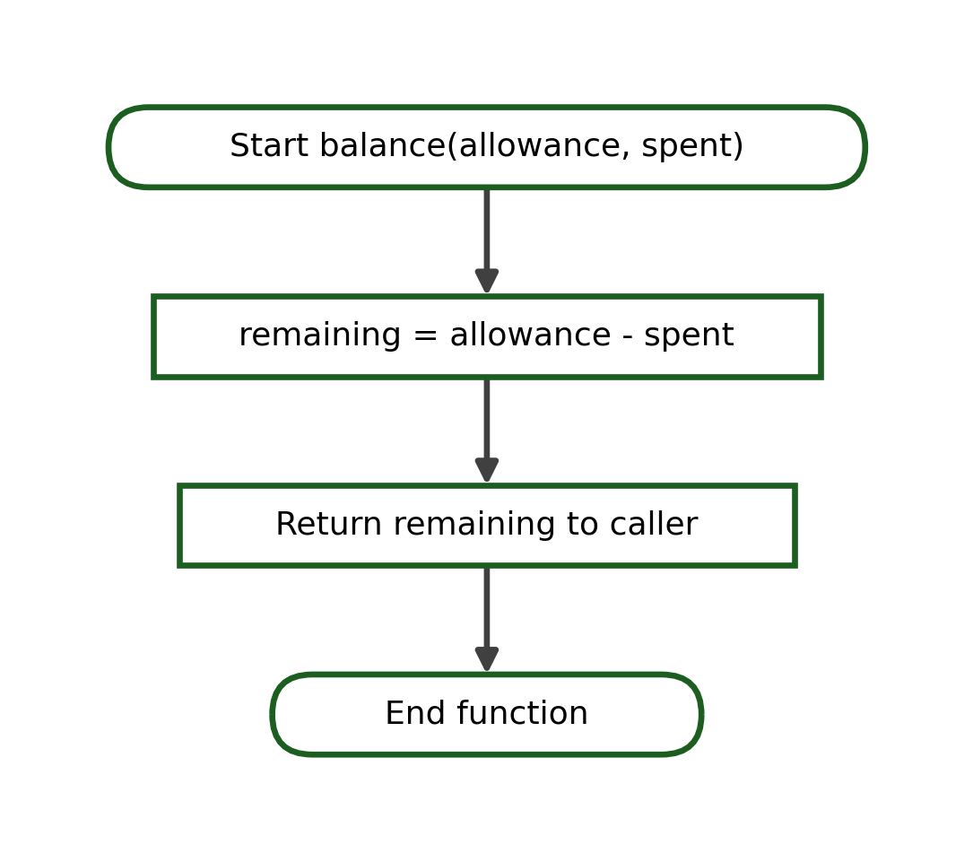
Complete Python Program:
def balance(allowance, spent):
return allowance - spent

left = balance(500, 120)
print(f"Balance: ₱{left:.2f}")
Step | Statement / Call | Values / Returned
1 | balance(500, 120) | allowance = 500, spent = 120
2 | return allowance - spent | returns 380
3 | print(...) | Balance: ₱380.00
Test Cases:
Test Case | Argument(s) | Expected Output
1 | 500, 120 | Balance: ₱380.00
2 | 1000, 1000 | Balance: ₱0.00
3 | 300, 50 | Balance: ₱250.00
Exact Output:
Balance: ₱380.00
Explanation. The amount spent is subtracted from the allowance to give the remaining balance.

Problem 10: Electricity-Consumption Cost
Function: electricity_bill(kwh, rate)
Parameters: kwh, rate
Returned Value: kwh * rate
Decomposition Table:
Required Task | Function Name | Parameters | Return Value
Compute the bill | electricity_bill(kwh, rate) | kwh, rate | The cost
IPO Table:
Input | Process | Output
kwh, rate | cost = kwh * rate | The electricity cost
Algorithm:
1. Define electricity_bill(kwh, rate).
2. Compute cost = kwh * rate.
3. Return cost.
4. Display the returned value with two decimals.
Pseudocode:
FUNCTION electricity_bill(kwh, rate)
cost = kwh * rate
RETURN cost
END FUNCTION
Flowchart:
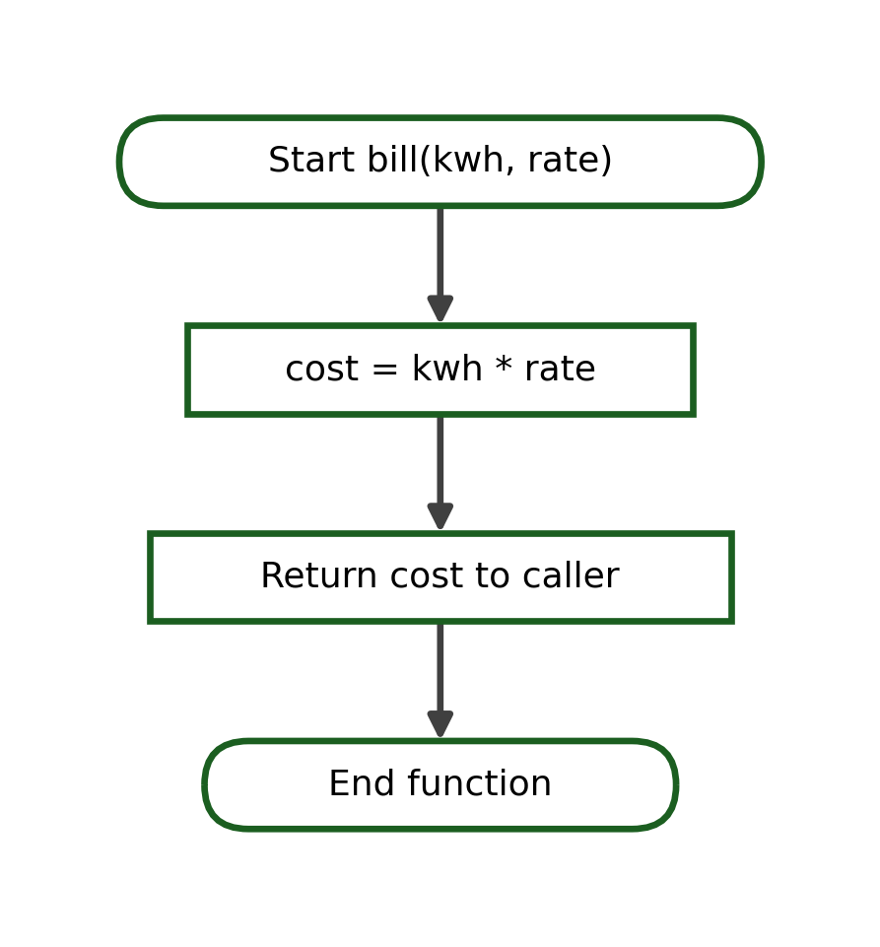
Complete Python Program:
def electricity_bill(kwh, rate):
return kwh * rate

bill = electricity_bill(150, 11.50)
print(f"Electric Bill: ₱{bill:.2f}")
Step | Statement / Call | Values / Returned
1 | electricity_bill(150, 11.50) | kwh = 150, rate = 11.50
2 | return kwh * rate | returns 1725.0
3 | print(...) | Electric Bill: ₱1725.00
Test Cases:
Test Case | Argument(s) | Expected Output
1 | 150, 11.50 | Electric Bill: ₱1725.00
2 | 100, 10 | Electric Bill: ₱1000.00
3 | 0, 10 | Electric Bill: ₱0.00
Exact Output:
Electric Bill: ₱1725.00
Explanation. Kilowatt-hours are multiplied by the rate to compute the cost.

Problem 11: Simple-Interest Calculator
Function: simple_interest(principal, rate, time)
Parameters: principal, rate, time
Returned Value: principal * rate * time
Decomposition Table:
Required Task | Function Name | Parameters | Return Value
Compute the interest | simple_interest(principal, rate, time) | principal, rate, time | The interest
IPO Table:
Input | Process | Output
principal, rate, time | interest = principal * rate * time | The interest
Algorithm:
1. Define simple_interest(principal, rate, time).
2. Compute interest = principal * rate * time.
3. Return interest.
4. Display the returned value with two decimals.
Pseudocode:
FUNCTION simple_interest(principal, rate, time)
interest = principal * rate * time
RETURN interest
END FUNCTION
Flowchart:
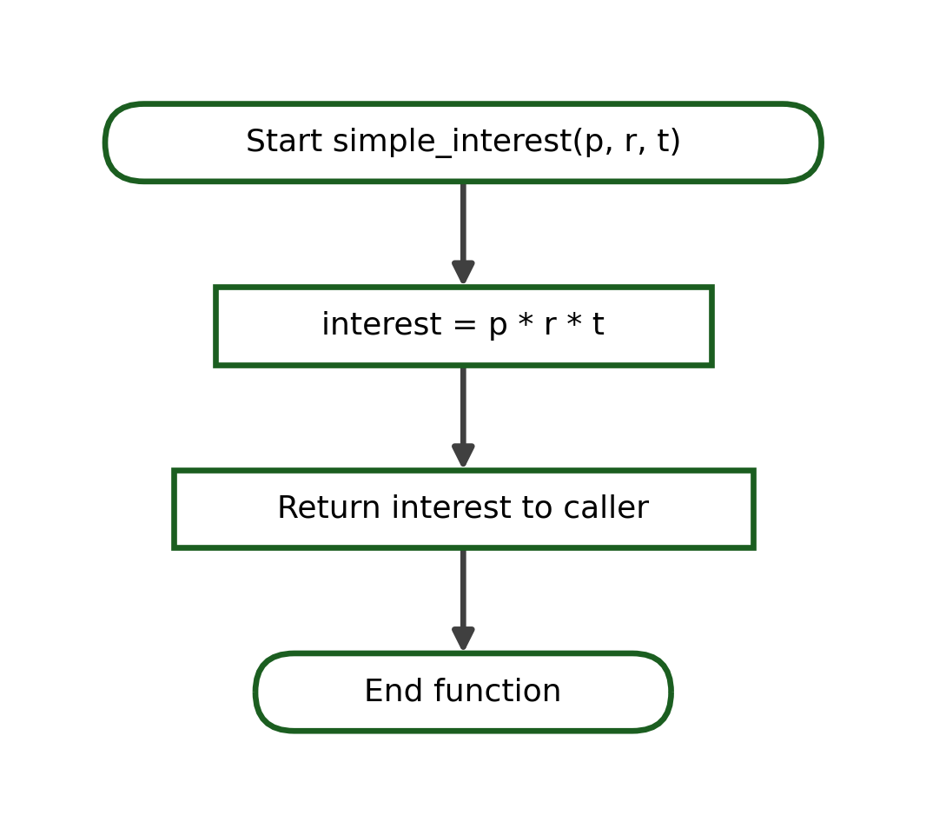
Complete Python Program:
def simple_interest(principal, rate, time):
return principal * rate * time

interest = simple_interest(1000, 0.05, 2)
print(f"Interest: ₱{interest:.2f}")
Step | Statement / Call | Values / Returned
1 | simple_interest(1000, 0.05, 2) | p = 1000, r = 0.05, t = 2
2 | return p * r * t | returns 100.0
3 | print(...) | Interest: ₱100.00
Test Cases:
Test Case | Argument(s) | Expected Output
1 | 1000, 0.05, 2 | Interest: ₱100.00
2 | 5000, 0.03, 1 | Interest: ₱150.00
3 | 2000, 0.10, 3 | Interest: ₱600.00
Exact Output:
Interest: ₱100.00
Explanation. The simple-interest formula multiplies the three parameters and returns the result.

Problem 12: Multiplication-Table Generator
Function: multiplication_table(number)
Parameters: number
Returned Value: None (prints ten rows)
Decomposition Table:
Required Task | Function Name | Parameters | Return Value
Display the table | multiplication_table(number) | number | None (prints)
IPO Table:
Input | Process | Output
number | Loop i from 1 to 10 | Ten printed rows
Algorithm:
1. Define multiplication_table(number).
2. Repeat i from 1 to 10.
3. Print number x i = product.
4. End the loop and the function.
Pseudocode:
FUNCTION multiplication_table(number)
FOR i = 1 TO 10
PRINT number, "x", i, "=", number * i
ENDFOR
END FUNCTION
Flowchart:
Complete Python Program:
def multiplication_table(number):
for i in range(1, 11):
print(f"{number} x {i} = {number * i}")

multiplication_table(4)
Step | Statement / Call | Values / Returned
1 | multiplication_table(4) | number = 4
2 | loop i = 1..10 | prints 4 x 1 = 4 ... 4 x 10 = 40
3 | function ends | return to caller
Test Cases:
Test Case | Argument(s) | Expected Output
1 | 4 | 4 x 1 = 4 ... 4 x 10 = 40
2 | 6 | 6 x 1 = 6 ... 6 x 10 = 60
3 | 9 | 9 x 1 = 9 ... 9 x 10 = 90
Exact Output:
4 x 1 = 4
4 x 2 = 8
4 x 3 = 12
...
4 x 10 = 40
Explanation. A for loop repeats inside the function to print the ten rows; the function returns no value.

