CPP102: PROGRAMMING LOGIC AND DESIGN
Week 10 Lecture and Laboratory Module
Function Behavior and Data Flow
Department of Computer Engineering

PART A. LECTURE MODULE

Module Information
Course Code: CPP102
Course Title: Programming Logic and Design (2 units, Lecture-Laboratory)
Week: Week 10
Main Topic: Function Behavior and Data Flow
Subtopics: passing values to functions, returning processed results, multiple parameters, positional arguments, default parameters, keyword arguments, local variables, global variables, variable scope, data flow among functions, function-call tracing, common function-related errors, testing functions independently, and debugging functions that produce incorrect results.

Intended Learning Outcomes
At the end of the module, the students should be able to:
1. Implement Python functions that exchange data through multiple parameters, positional arguments, default parameters, keyword arguments, and return values;
2. Analyze variable scope and data flow among functions through systematic function-call tracing; and
3. Test and debug individual Python functions to identify and correct errors that produce incorrect results.

1. Week 10 Overview
In the previous week the function was introduced as a named block of instructions that performs one clear task. A function becomes far more useful, however, once it can exchange data with the rest of the program. Week 10 studies that exchange. A well-designed function is able to:
- receive several pieces of data through its parameters;
- process those values using the operators, conditions and loops already studied;
- return a single processed result to the statement that called it;
- pass that result to another function for further processing;
- keep its own local variables, which do not disturb the rest of the program; and
- be tested on its own before it is joined to a larger program.
Every topic studied since Week 1 is used here. Variables store the values a function receives and produces; operators perform the computation; conditional statements decide which value a function returns; loops repeat work inside a function; and the algorithm, pseudocode and flowchart remain the planning tools used before any code is written. Week 9 supplied the mechanics of def, the function call, the parameter and the return statement. Week 10 concentrates on the behaviour of those parts when data travels through several functions.
Data-Flow Illustration:
Main Program -> Function A -> returned value -> Function B -> Final Output

The illustration is read from left to right. The main program supplies the starting values; Function A processes them and returns a result; that returned value becomes the argument of Function B; and the value returned by Function B is finally displayed. No function needs to know how the others work internally. Each one only needs to know what it receives and what it returns.
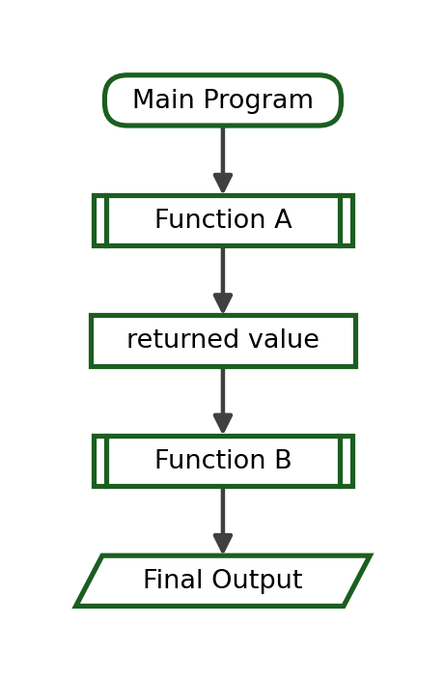
Note. Week 10 therefore has two goals. The first is to write functions that receive and return data correctly. The second, which is just as important, is to understand how data moves through a modular program, so that a wrong result can be traced to the exact function that produced it.

2. Passing Values to Functions
An argument is a value written inside the parentheses of a function call. A parameter is the variable written inside the parentheses of the function definition. When the call is executed, each argument is copied into the matching parameter, and the function body then works with those copies.
Python Program:
def calculate_total(quantity, unit_price):
return quantity * unit_price

qty = 4
price = 35.50
total = calculate_total(qty, price)
print(f"Total: ₱{total:.2f}")

Output:
Total: ₱142.00

The vocabulary used from this point onward is summarised below.
Term | In the Example | Meaning
Caller | the main program | The statement that runs the function.
Argument | qty, price | The values sent by the caller.
Parameter | quantity, unit_price | The variables that receive those values.
Received value | quantity = 4  unit_price = 35.5 | The copies stored inside the function.
Processed result | quantity * unit_price | The computation performed by the function.
Returned value | 142.0 | The value sent back to the caller.

A function may receive one value, two values, or three values. The number of arguments in the call must match the number of parameters in the definition.
One Parameter:
def square(number):
return number * number

print(square(7))

Output:
49

Two Parameters:
def rectangle_area(length, width):
return length * width

print(rectangle_area(12, 5))

Output:
60

Three Parameters:
def average_of_three(a, b, c):
return (a + b + c) / 3

print(average_of_three(80, 75, 85))

Output:
80.0

The values that are sent may take several forms. They may be written directly as numbers or as strings, they may be variables, or they may be expressions that Python evaluates before the call is made.
Numeric, String, Variable and Expression Arguments:
def compute_total(quantity, price):
return quantity * price

def greet(name):
return "Welcome, " + name + "!"

print(compute_total(3, 120))
print(greet("Ana"))

boxes = 5
unit = 45.00
print(compute_total(boxes, unit))

print(compute_total(2 + 3, unit * 2))

Output:
360
Welcome, Ana!
225.0
450.0

Explanation. In the last call the expressions 2 + 3 and unit * 2 are evaluated first. The function therefore receives 5 and 90.0; it never sees the expressions themselves. This is an important habit: Python always evaluates the arguments before the function begins.
Trace Table:
Step | Call | Arguments Evaluated | Parameters Inside the Function | Returned
1 | compute_total(3, 120) | 3, 120 | quantity = 3, price = 120 | 360
2 | greet("Ana") | "Ana" | name = "Ana" | Welcome, Ana!
3 | compute_total(boxes, unit) | 5, 45.0 | quantity = 5, price = 45.0 | 225.0
4 | compute_total(2 + 3, unit * 2) | 5, 90.0 | quantity = 5, price = 90.0 | 450.0

3. Multiple Parameters
A function with two or more parameters can solve richer problems, but it also introduces a responsibility: the caller must supply the values in the right order and in the right number. Four rules apply.
- Parameter order matters. The first argument is assigned to the first parameter, the second argument to the second parameter, and so on.
- Data is assigned by position, not by meaning. Python does not check whether a length was placed where a width was expected.
- Parameter names should describe the data they receive, such as quantity, unit_price or hours_worked.
- The number of arguments must match the number of parameters, unless a default value has been provided.
The five worked examples below each follow the complete problem-solving format used throughout CPP102: problem statement, IPO table, algorithm, pseudocode, flowchart, Python program, trace table and exact output.

3.1 Average of Three Scores
Problem Statement. Compute and display the average of a student's three quiz scores.
IPO Table:
Input | Process | Output
Three scores: 88, 91, 79 | average = (a + b + c) / 3 | The average, shown to two decimal places

Algorithm:
1. Define average_of_three(a, b, c) with three parameters.
2. Add the three values and divide the sum by 3.
3. Return the computed average to the caller.
4. In the main program, call the function with 88, 91 and 79.
5. Display the returned value with two decimal places.
Pseudocode:
FUNCTION average_of_three(a, b, c)
SET average = (a + b + c) / 3
RETURN average
END FUNCTION

MAIN
SET result = average_of_three(88, 91, 79)
DISPLAY "Average: ", result
END MAIN

Flowchart:
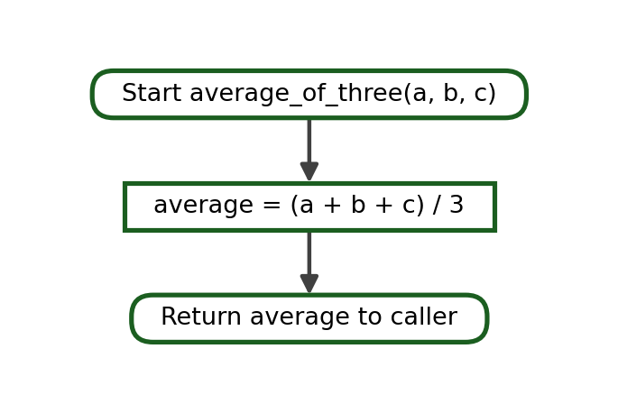
Python Program:
def average_of_three(a, b, c):
average = (a + b + c) / 3
return average

result = average_of_three(88, 91, 79)
print(f"Average: {result:.2f}")

Trace Table:
Step | Statement | a | b | c | average | Returned
1 | result = average_of_three(88, 91, 79) | 88 | 91 | 79 | - | -
2 | average = (a + b + c) / 3 | 88 | 91 | 79 | 86.0 | -
3 | return average | 88 | 91 | 79 | 86.0 | 86.0
4 | print(...) | - | - | - | - | Average: 86.00

Exact Output:
Average: 86.00

Explanation. The three arguments are matched by position, the average is computed inside the function, and only the finished number is returned. The formatting to two decimal places is done by the caller, which keeps the function reusable.

3.2 Area of a Rectangle
Problem Statement. Compute and display the area of a rectangle from its length and width.
IPO Table:
Input | Process | Output
length = 12, width = 7 | area = length * width | The area of the rectangle

Algorithm:
1. Define rectangle_area(length, width) with two parameters.
2. Multiply length by width and store the product in area.
3. Return area to the caller.
4. In the main program, call the function with 12 and 7.
5. Display the returned value.
Pseudocode:
FUNCTION rectangle_area(length, width)
SET area = length * width
RETURN area
END FUNCTION

MAIN
SET result = rectangle_area(12, 7)
DISPLAY "Area: ", result
END MAIN

Flowchart:
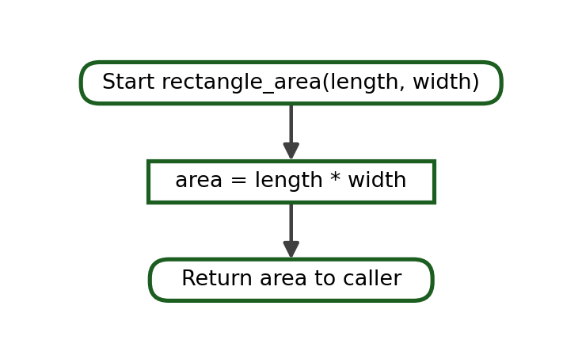
Python Program:
def rectangle_area(length, width):
area = length * width
return area

result = rectangle_area(12, 7)
print("Area:", result)

Trace Table:
Step | Statement | length | width | area | Returned
1 | result = rectangle_area(12, 7) | 12 | 7 | - | -
2 | area = length * width | 12 | 7 | 84 | -
3 | return area | 12 | 7 | 84 | 84
4 | print("Area:", result) | - | - | - | Area: 84

Exact Output:
Area: 84

Explanation. Both parameters hold numbers, so a reversed call would still run and would even give the same area. The habit of writing the arguments in the declared order should still be kept, because most formulas are not reversible.

3.3 Purchase Total
Problem Statement. Compute the amount due for a purchase from the quantity bought and the unit price.
IPO Table:
Input | Process | Output
quantity = 6, unit_price = 45.75 | total = quantity * unit_price | The amount due in pesos

Algorithm:
1. Define compute_total(quantity, unit_price) with two parameters.
2. Multiply quantity by unit_price and store the product in total.
3. Return total to the caller.
4. In the main program, call the function with 6 and 45.75.
5. Display the returned value with two decimal places.
Pseudocode:
FUNCTION compute_total(quantity, unit_price)
SET total = quantity * unit_price
RETURN total
END FUNCTION

MAIN
SET amount = compute_total(6, 45.75)
DISPLAY "Total: ", amount
END MAIN

Flowchart:
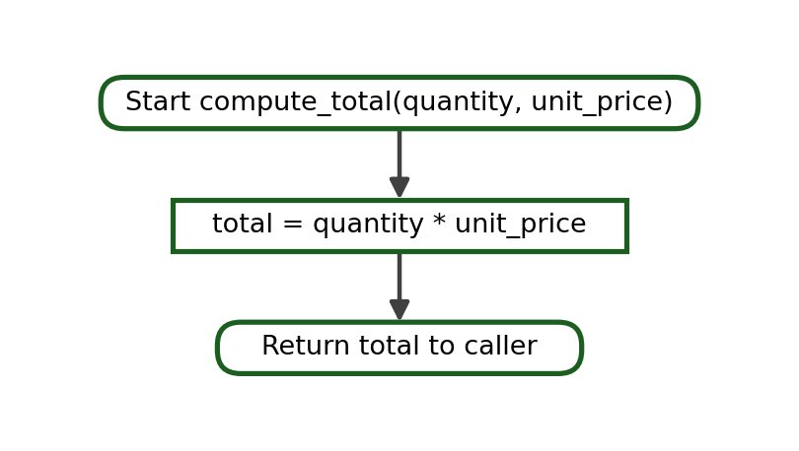
Python Program:
def compute_total(quantity, unit_price):
total = quantity * unit_price
return total

amount = compute_total(6, 45.75)
print(f"Total: ₱{amount:.2f}")

Trace Table:
Step | Statement | quantity | unit_price | total | Returned
1 | amount = compute_total(6, 45.75) | 6 | 45.75 | - | -
2 | total = quantity * unit_price | 6 | 45.75 | 274.5 | -
3 | return total | 6 | 45.75 | 274.5 | 274.5
4 | print(...) | - | - | - | Total: ₱274.50

Exact Output:
Total: ₱274.50

Explanation. The function returns the plain number 274.5. The peso sign and the two decimal places are added by the caller during display. Keeping formatting out of the function allows the same function to be reused wherever a total is needed.

3.4 Employee Gross Salary
Problem Statement. Compute an employee's gross salary from the hourly rate and the number of hours worked.
IPO Table:
Input | Process | Output
rate = 110.50, hours = 160 | gross = rate * hours | The gross salary in pesos

Algorithm:
1. Define compute_gross(rate, hours) with two parameters.
2. Multiply rate by hours and store the product in gross.
3. Return gross to the caller.
4. In the main program, call the function with 110.50 and 160.
5. Display the returned value with two decimal places.
Pseudocode:
FUNCTION compute_gross(rate, hours)
SET gross = rate * hours
RETURN gross
END FUNCTION

MAIN
SET salary = compute_gross(110.50, 160)
DISPLAY "Gross Salary: ", salary
END MAIN

Flowchart:
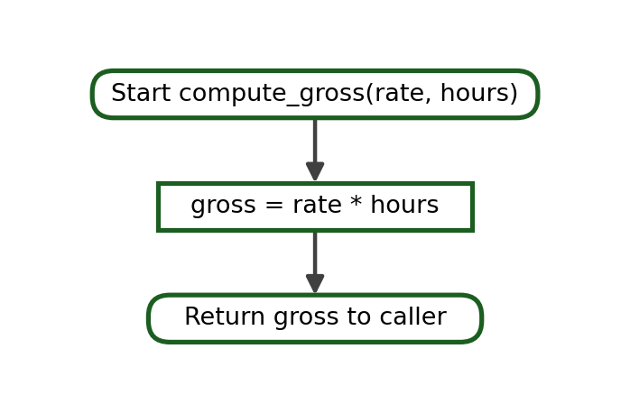
Python Program:
def compute_gross(rate, hours):
gross = rate * hours
return gross

salary = compute_gross(110.50, 160)
print(f"Gross Salary: ₱{salary:.2f}")

Trace Table:
Step | Statement | rate | hours | gross | Returned
1 | salary = compute_gross(110.50, 160) | 110.5 | 160 | - | -
2 | gross = rate * hours | 110.5 | 160 | 17680.0 | -
3 | return gross | 110.5 | 160 | 17680.0 | 17680.0
4 | print(...) | - | - | - | Gross Salary: ₱17680.00

Exact Output:
Gross Salary: ₱17680.00

Explanation. Meaningful parameter names make the call easy to read. If the parameters had been named a and b, a reader would have to open the function body to learn which value comes first.

3.5 Distance Travelled
Problem Statement. Compute the distance travelled from a constant speed and a travel time.
IPO Table:
Input | Process | Output
speed = 60, time = 2.5 | distance = speed * time | The distance in kilometres

Algorithm:
1. Define compute_distance(speed, time) with two parameters.
2. Multiply speed by time and store the product in distance.
3. Return distance to the caller.
4. In the main program, call the function with 60 and 2.5.
5. Display the returned value with the unit km.
Pseudocode:
FUNCTION compute_distance(speed, time)
SET distance = speed * time
RETURN distance
END FUNCTION

MAIN
SET travelled = compute_distance(60, 2.5)
DISPLAY "Distance: ", travelled, " km"
END MAIN

Flowchart:
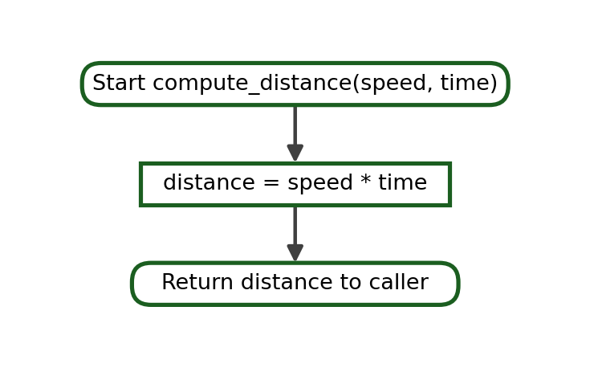
Python Program:
def compute_distance(speed, time):
distance = speed * time
return distance

travelled = compute_distance(60, 2.5)
print("Distance:", travelled, "km")

Trace Table:
Step | Statement | speed | time | distance | Returned
1 | travelled = compute_distance(60, 2.5) | 60 | 2.5 | - | -
2 | distance = speed * time | 60 | 2.5 | 150.0 | -
3 | return distance | 60 | 2.5 | 150.0 | 150.0
4 | print(...) | - | - | - | Distance: 150.0 km

Exact Output:
Distance: 150.0 km

Explanation. Because one argument is a whole number and the other is a decimal, the product is a decimal. Understanding the type of the returned value matters when the result is formatted or compared later.

4. Positional Arguments
A positional argument is matched to a parameter by its position in the call. The first value goes to the first parameter, the second value to the second parameter, and so on. The names of the variables used by the caller are irrelevant; only the order counts.
Correct Order:
def display_student(name, age):
print("Name:", name)
print("Age:", age)

display_student("Ana", 18)

Output:
Name: Ana
Age: 18

Reversed Order:
def display_student(name, age):
print("Name:", name)
print("Age:", age)

display_student(18, "Ana")

Output:
Name: 18
Age: Ana

Why the program still runs. The second program still runs, because Python only checks that two values were supplied. It does not know that a name should be a word and that an age should be a number. The parameter name therefore receives 18 and the parameter age receives "Ana". The result is a logical error: the program produces an answer, but the answer is wrong. Errors of this kind are not reported by Python and can only be found by reading the output carefully or by tracing the call.
A practical warning. The danger is greatest when the arguments have the same data type. In fare(base, distance), both values are numbers, so reversing them produces a fare that looks reasonable but is incorrect.

Tracing Exercises - Positional Arguments
For each program, state which value each parameter receives and write the exact output. Answers are in the Instructor's Complete Answer Key.
1.
def show_pair(first, second):
print(first, second)

show_pair("Ana", 18)

2.
def show_pair(first, second):
print(first, second)

show_pair(18, "Ana")

3.
def divide(a, b):
return a / b

print(divide(10, 2))

4.
def divide(a, b):
return a / b

print(divide(2, 10))

5.
def rectangle_area(length, width):
return length * width

print(rectangle_area(8, 3))

6.
def subtract(a, b):
return a - b

print(subtract(8, 3))
print(subtract(3, 8))

7.
def fare(base, distance):
return base + (distance * 2)

print(fare(13, 5))

8.
def fare(base, distance):
return base + (distance * 2)

print(fare(5, 13))

5. Default Parameters
A default parameter is a parameter that already has a value written in the function definition. If the caller does not supply an argument for it, the default value is used. If the caller does supply one, the supplied value replaces the default for that call only.
def greet(name="Student"):
print(f"Welcome, {name}!")

greet()
greet("Marco")

Output:
Welcome, Student!
Welcome, Marco!

Term | Meaning | In the Example
Default value | The value written in the definition after the equals sign. | "Student"
Omitted argument | A call that does not supply a value for that parameter. | greet()
Overriding the default | A call that supplies its own value instead. | greet("Marco")
Required parameter | A parameter with no default; the caller must supply a value. | name in def greet(name):
Optional parameter | A parameter with a default; the caller may omit it. | name in def greet(name="Student"):

A function may mix required and optional parameters. In the next example the amount must always be supplied, while the rate is optional and defaults to ten percent.
def compute_discount(amount, rate=0.10):
return amount * rate

print(compute_discount(500))
print(compute_discount(500, 0.20))
print(compute_discount(1200))

Output:
50.0
100.0
120.0

Rule. Parameters without default values must be written before parameters with default values. Python needs every required parameter to have a definite position, and that is only possible when the optional ones come last.
Definition | Valid? | Reason
def compute_discount(amount, rate=0.10): | Valid | The required parameter comes first.
def compute_discount(rate=0.10, amount): | Invalid | A required parameter follows an optional one.
def fare(distance, base=13.00, rate=2.00): | Valid | One required parameter, then two optional ones.
def fare(base=13.00, distance, rate=2.00): | Invalid | The required parameter distance is in the middle.

Choosing a good default. A sensible default should be the value that is used most often. In a jeepney-fare program the base fare rarely changes, so it is a good candidate for a default; the distance changes on every trip, so it must stay required.
Practice. Ten short programs for practising default parameters are provided as Checkpoint B in Section 21, and their complete answers appear in the Instructor's Complete Answer Key.

6. Keyword Arguments
A keyword argument names the parameter that is to receive the value, using the form parameter=value. Because the name is stated explicitly, the order of the arguments no longer matters.
def student_info(name, age, section):
print(name, age, section)

student_info(section="1CPE-A", name="Ana", age=18)

Output:
Ana 18 1CPE-A

Positional Form:
student_info("Ana", 18, "1CPE-A")

Keyword Form:
student_info(name="Ana", age=18, section="1CPE-A")

Both calls send exactly the same values to exactly the same parameters. They differ only in how the match is made.
Positional Arguments | Keyword Arguments
Match by position | Match by parameter name
Order is important | Order may differ
Shorter calls | More descriptive calls
Easier to misplace similar values | Often easier to read
Best for one or two obvious values | Best for several values of the same type

Spelling matters. A keyword argument must use the exact spelling of the parameter. Writing nmae="Ana" when the parameter is name produces an error, because Python cannot find a parameter with that name.

Keyword-Argument Exercises
For each program, state whether the arguments are positional, keyword or mixed, and write the exact output.
1.
def student_info(name, age, section):
print(name, age, section)

student_info(name="Ana", age=18, section="1CPE-A")

2.
def student_info(name, age, section):
print(name, age, section)

student_info(section="1CPE-B", age=19, name="Leo")

3.
def compute_bill(quantity, price):
return quantity * price

print(compute_bill(price=75, quantity=4))

4.
def label(text, symbol):
print(symbol + " " + text)

label(text="Total", symbol="->")

5.
def compute_discount(amount, rate):
return amount * rate

print(compute_discount(amount=500, rate=0.15))

6.
def to_fahrenheit(celsius):
return celsius * 9 / 5 + 32

print(to_fahrenheit(celsius=37))

7.
def show_grades(prelim, midterm, final):
print(prelim, midterm, final)

show_grades(88, final=91, midterm=85)

8.
def net_pay(gross, deduction):
return gross - deduction

print(net_pay(gross=12000, deduction=1500))

7. Combining Positional, Default and Keyword Arguments
The three forms may be combined in one call. Positional arguments are written first, and keyword arguments follow them. Any parameter that is not supplied keeps its default value.
def compute_bill(quantity, price, discount=0):
subtotal = quantity * price
return subtotal - discount

print(compute_bill(3, 100))
print(compute_bill(3, 100, 25))
print(compute_bill(quantity=3, price=100, discount=25))
print(compute_bill(3, price=100, discount=25))

Output:
300
275
275
275

Call | quantity | price | discount | Returned
compute_bill(3, 100) | 3 | 100 | 0 (default) | 300
compute_bill(3, 100, 25) | 3 | 100 | 25 | 275
compute_bill(quantity=3, price=100, discount=25) | 3 | 100 | 25 | 275
compute_bill(3, price=100, discount=25) | 3 | 100 | 25 | 275

Rule. One simple rule prevents almost every mistake at this level: write the positional arguments first, then the keyword arguments, and never supply the same parameter twice.
Call | Valid? | Reason
compute_bill(3, 100, discount=25) | Valid | Positional arguments first, keyword argument last.
compute_bill(quantity=3, 100) | Invalid | A positional argument follows a keyword argument.
compute_bill(3, 100, quantity=3) | Invalid | quantity would receive a value twice.
compute_bill(price=100, quantity=3) | Valid | All arguments are keyword arguments, so the order is free.

Output Tracing:
def fare(distance, base=13.00, rate=2.00):
return base + distance * rate

print(fare(5))
print(fare(5, 15.00))
print(fare(5, rate=2.50))
print(fare(distance=5, base=15.00, rate=2.50))

Output:
23.0
25.0
25.5
27.5

Explanation. In the third call only the rate is replaced. The base fare keeps its default value of 13.00 because no value was supplied for it. This is the practical advantage of keyword arguments: a single optional value can be changed without repeating the others.

8. Returning Processed Results
The return statement ends a function and sends one value back to the caller. A function that only prints a result gives the value to the screen; a function that returns a result gives the value to the program, which can then do anything it wishes with it.
def show_total(a, b):
print(a + b)

def get_total(a, b):
return a + b

show_total(4, 6)
answer = get_total(4, 6)
print(answer)
print(answer * 2)

Output:
10
10
20

Explanation. show_total displays 10 and gives nothing back, so its result cannot be reused. get_total gives 10 back to the caller, which stores it in answer and then uses it again. A returned value may be:
- assigned to a variable, as in average = compute_average(80, 75, 85);
- used inside another computation, as in total = get_total(4, 6) * 12;
- passed directly to another function, as in get_remark(compute_average(80, 75, 85)); and
- displayed later, once the rest of the processing has finished.
Two Functions Working Together:
def compute_average(a, b, c):
return (a + b + c) / 3

def get_remark(average):
if average >= 75:
return "Passed"
return "Failed"

avg = compute_average(80, 75, 85)
remark = get_remark(avg)
print(f"Average: {avg:.2f}")
print("Remark:", remark)

Output:
Average: 80.00
Remark: Passed

Explanation. compute_average returns the number 80.0. That number is stored in avg and is then sent as the argument of get_remark, which returns the text "Passed". Neither function displays anything; the main program does all the displaying. This separation makes each function easy to test on its own.
`print()` Inside a Function | `return` Inside a Function
Sends the value to the screen | Sends the value back to the caller
The value cannot be reused | The value can be stored and reused
The function gives back None | The function gives back the stated value
Suitable for display-only tasks | Suitable for computation tasks
Cannot feed another function | Can be passed to another function

9. Local Variables
A local variable is a variable created inside a function. It is created when the function starts, it exists only while the function is running, and it disappears when the function ends. Parameters are local variables too, because they are created inside the function when the call is made.
def compute_total():
total = 500
print(total)

compute_total()

Output:
500

Explanation. The name total belongs to compute_total(). It is created when the function starts and is removed when the function ends. Nothing outside the function can see it.
Using a Local Variable Outside Its Function:
def compute_total():
total = 500

compute_total()
print(total)

Result:
NameError: name 'total' is not defined

Explanation. The function ran and did create total, but by the time print(total) is reached the function has already ended and the name no longer exists. The correct solution is not to force the variable outward, but to return it.
Correct Version:
def compute_total():
total = 500
return total

result = compute_total()
print(result)

Output:
500

Scope Diagram:
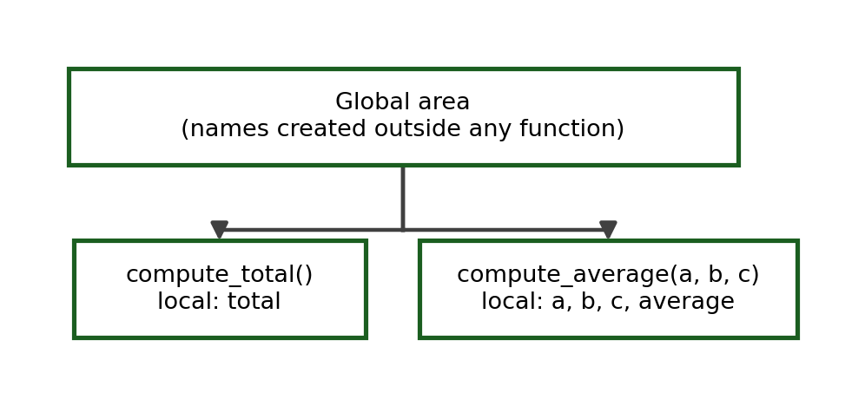
Reading the diagram. Each function owns a private area of names. A function can read the names in the global area, but no function can read the private names of another function. Data crosses these boundaries only through arguments and returned values.
Why locals are useful. Local variables are an advantage, not a restriction. Because they are private, two functions may safely use the same variable name without interfering with each other, and a function can be tested on its own without disturbing the rest of the program.

10. Global Variables
A global variable is created outside every function, at the main level of the program. It exists for as long as the program runs, and any function may read it.
school_name = "Pamantasan ng Cabuyao"

def display_school():
print(school_name)

display_school()

Output:
Pamantasan ng Cabuyao

Explanation. display_school() has no parameter, yet it can still read school_name, because that name exists in the global area. Reading a global value in this way is acceptable for a fixed value that never changes, such as the name of the school or the passing grade.
A Reasonable Use of a Global Value:
PASSING_GRADE = 75

def get_remark(grade):
if grade >= PASSING_GRADE:
return "Passed"
return "Failed"

print(get_remark(80))
print(get_remark(70))

Output:
Passed
Failed

Depending heavily on global variables, however, creates real problems in larger programs:
- the program becomes harder to trace, because a value may be changed anywhere;
- a function becomes harder to test, because it no longer works from its arguments alone;
- maintenance becomes harder, because a change in one place may affect distant functions; and
- unintended changes become more likely, since two functions may use the same global name for different purposes.
An important detail. Python also treats assignment inside a function as the creation of a new local variable. In the program below the assignment inside the function does not change the global counter at all.
counter = 0

def add_items(items):
counter = items
return counter

print(add_items(7))
print(counter)

Output:
7
0

Explanation. The function created its own local counter, used it, and then discarded it. The global counter still holds 0. Python does provide a global keyword that would allow a function to modify a global variable, but at this stage of the course modifying global variables from inside functions should generally be avoided. The clearer and safer practice is to pass values in through parameters and to send results back through return.
Preferred Practice:
def add_items(current, items):
return current + items

counter = 0
counter = add_items(counter, 7)
print(counter)

Output:
7

Explanation. The function receives the current value, computes a new value, and returns it. The main program decides what to do with the result. Nothing is hidden and the function can be tested with any pair of values.

11. Local Variables Versus Global Variables
Local Variable | Global Variable
Defined inside a function | Defined outside every function
Usually accessible only in that function | May be read by several functions
Exists only during function execution | Exists for the whole program's execution
Easier to isolate during testing | Can create hidden dependencies
Preferred for temporary calculations | Use only when truly appropriate
Removed when the function ends | Removed only when the program ends
Two functions may reuse the same name safely | One name is shared by the whole program

Identification and Tracing Items
For each program, state whether the named variable is local or global, and write the exact output. Answers appear in the Instructor's Complete Answer Key.
1.
total = 100

def show():
print(total)

show()

Variable in question: total
2.
def show():
message = "Hello"
print(message)

show()

Variable in question: message
3.
rate = 0.10

def compute(amount):
return amount * rate

print(compute(500))

Variable in question: rate
4.
def compute(amount):
tax = amount * 0.12
return tax

print(compute(1000))

Variable in question: tax
5.
school = "PnC"

def display():
school = "CpE"
print(school)

display()
print(school)

Variable in question: school inside display()
6.
def first():
value = 5
return value

def second(number):
return number * 2

print(second(first()))

Variable in question: value
7.
counter = 0

def report(items):
counter = items
return counter

print(report(7))
print(counter)

Variable in question: counter inside report()
8.
PASSING = 75

def remark(grade):
if grade >= PASSING:
return "Passed"
return "Failed"

print(remark(80))

Variable in question: PASSING
9.
def area(length, width):
result = length * width
return result

print(area(6, 4))

Variable in question: result
10.
name = "Ana"

def greet(name):
return "Hello, " + name

print(greet("Leo"))
print(name)

Variable in question: name inside greet()

12. Variable Scope
Variable scope is the part of a program in which a variable can be accessed. A local variable has function scope: it can be used only inside the function that created it. A global variable has program scope: it can be read anywhere in the program.
Case 1 - The Same Name Used Globally and Locally:
score = 90

def show_score():
score = 75
print("Inside:", score)

show_score()
print("Outside:", score)

Predict the Output:
Inside: 75
Outside: 90

Exact Output:
Inside: 75
Outside: 90

Step | Statement | Global score | Local score | Output
1 | score = 90 | 90 | does not exist | -
2 | show_score() starts | 90 | created | -
3 | score = 75 (inside) | 90 | 75 | -
4 | print("Inside:", score) | 90 | 75 | Inside: 75
5 | function ends | 90 | removed | -
6 | print("Outside:", score) | 90 | - | Outside: 90

Explanation. The assignment inside the function created a second, separate variable that happens to have the same name. Inside the function that local name hides the global one; outside the function the global value is untouched.
Case 2 - A Local Variable Is Not Available to Another Function:
def first_function():
message = "Hello from the first function"
return message

def second_function():
return message.upper()

print(first_function())
print(second_function())

Result:
Hello from the first function
NameError: name 'message' is not defined

Explanation. message belongs to first_function(). second_function() cannot see it, so the program stops with a NameError as soon as the second call is made.
Case 3 - The Value Must Be Returned Before Another Function Can Use It:
def first_function():
message = "Hello from the first function"
return message

def second_function(text):
return text.upper()

result = first_function()
print(result)
print(second_function(result))

Output:
Hello from the first function
HELLO FROM THE FIRST FUNCTION

Explanation. The corrected version does not try to reach inside the first function. It returns the value, stores it in the main program, and passes it as an argument to the second function. This is the standard way data travels between functions.
Question | Answer
Where was the variable created? | Inside a function means local; outside every function means global.
Can another function read it directly? | Only if it is global; a local variable must be returned first.
What happens when the function ends? | Local variables are removed; global variables remain.
Two variables share a name. Which one is used inside the function? | The local one, for as long as the function is running.

13. Data Flow Among Functions
Data flow describes the path a value takes as it moves through a program. In a modular program the path is easy to state in one line:
Input -> Function 1 -> Return -> Function 2 -> Return -> Main Program -> Output

Each function is a stage. It receives values, processes them, and returns one result. The main program is the coordinator: it holds the returned values in variables and decides which function is called next.
Complete Program:
def calculate_subtotal(quantity, price):
return quantity * price

def calculate_discount(subtotal):
if subtotal >= 1000:
return subtotal * 0.10
return 0

def calculate_final(subtotal, discount):
return subtotal - discount

subtotal = calculate_subtotal(5, 250)
discount = calculate_discount(subtotal)
final_amount = calculate_final(subtotal, discount)
print(f"Final Amount: ₱{final_amount:.2f}")

Output:
Final Amount: ₱1125.00

Data-Flow Diagram:
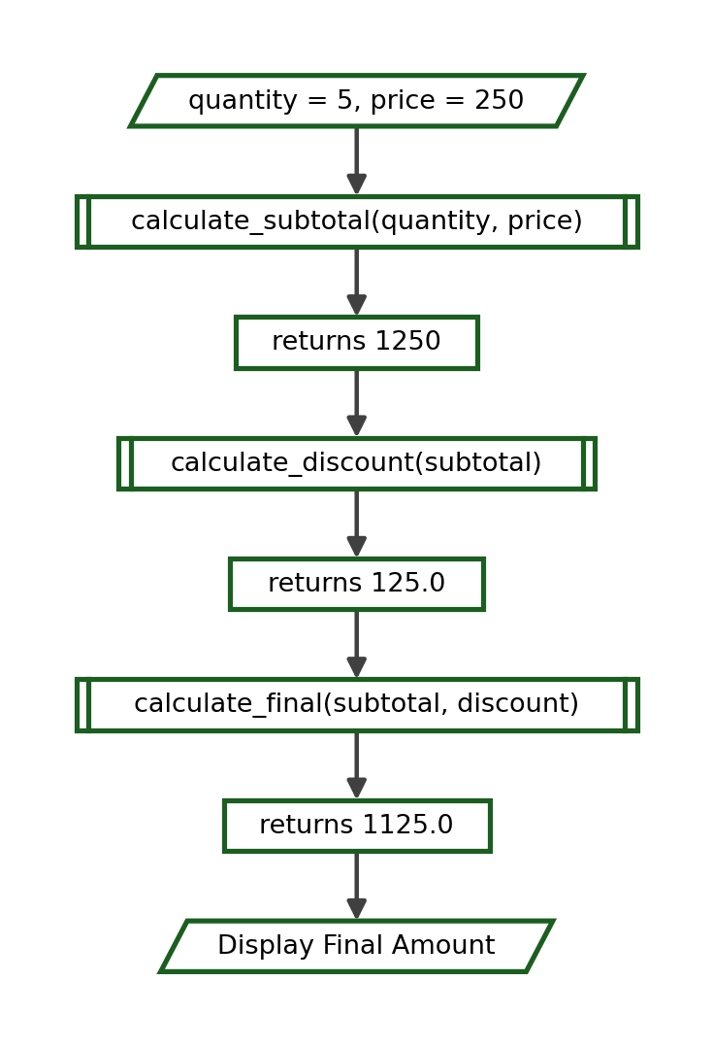
Movement of Each Value:
Stage | Value Entering | Work Done | Value Leaving | Stored In
calculate_subtotal | 5 and 250 | 5 * 250 | 1250 | subtotal
calculate_discount | 1250 | 1250 >= 1000 is True, so 1250 * 0.10 | 125.0 | discount
calculate_final | 1250 and 125.0 | 1250 - 125.0 | 1125.0 | final_amount
main program | 1125.0 | formats to two decimals | - | displayed

Explanation. Notice that no function calls another function. Each one receives what it needs and returns one value; the main program joins them together. This is the simplest and clearest arrangement for a beginner, and it makes every function independently testable.

14. Function-to-Function Data Flow
In the four programs below, the value returned by one function becomes the argument of the next. Each program is followed by a complete trace of the data as it moves from one function to the other.

14.1 Grade Program: compute_average() to get_remark()
def compute_average(a, b, c):
return (a + b + c) / 3

def get_remark(average):
if average >= 75:
return "Passed"
return "Failed"

average = compute_average(82, 76, 91)
remark = get_remark(average)
print(f"Average: {average:.2f}")
print("Remark:", remark)

Output:
Average: 83.00
Remark: Passed

Complete Trace:
Step | Current Function | Arguments | Parameters / Local Values | Returned Value | Output
1 | main | - | - | - | -
2 | compute_average | 82, 76, 91 | a = 82, b = 76, c = 91 | 83.0 | -
3 | main | - | average = 83.0 | - | -
4 | get_remark | 83.0 | average = 83.0; 83.0 >= 75 is True | "Passed" | -
5 | main | - | remark = "Passed" | - | -
6 | main | - | - | - | Average: 83.00  Remark: Passed

Flowchart:
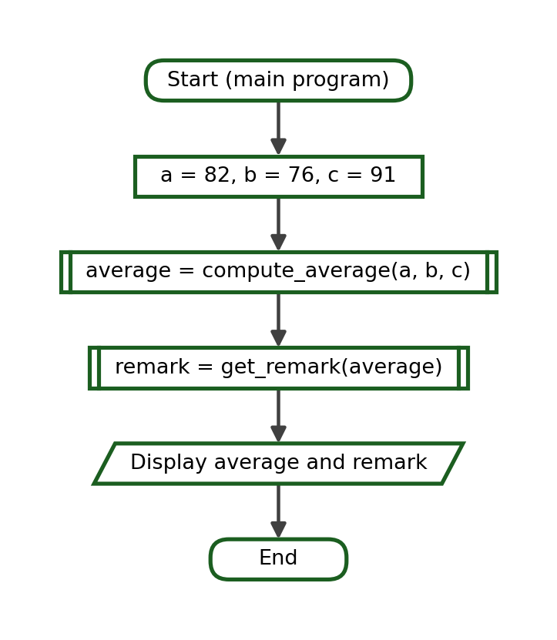

14.2 Purchase Program: compute_subtotal() to compute_discount() to compute_final()
def compute_subtotal(quantity, price):
return quantity * price

def compute_discount(subtotal):
if subtotal >= 1000:
return subtotal * 0.10
return 0

def compute_final(subtotal, discount):
return subtotal - discount

subtotal = compute_subtotal(8, 175)
discount = compute_discount(subtotal)
final_amount = compute_final(subtotal, discount)
print(f"Subtotal: ₱{subtotal:.2f}")
print(f"Discount: ₱{discount:.2f}")
print(f"Final Amount: ₱{final_amount:.2f}")

Output:
Subtotal: ₱1400.00
Discount: ₱140.00
Final Amount: ₱1260.00

Complete Trace:
Step | Current Function | Arguments | Parameters / Local Values | Returned Value | Output
1 | main | - | - | - | -
2 | compute_subtotal | 8, 175 | quantity = 8, price = 175 | 1400 | -
3 | main | - | subtotal = 1400 | - | -
4 | compute_discount | 1400 | subtotal = 1400; 1400 >= 1000 is True | 140.0 | -
5 | main | - | discount = 140.0 | - | -
6 | compute_final | 1400, 140.0 | subtotal = 1400, discount = 140.0 | 1260.0 | -
7 | main | - | final_amount = 1260.0 | - | Subtotal: ₱1400.00  Discount: ₱140.00  Final Amount: ₱1260.00

14.3 Salary Program: compute_gross() to compute_deduction() to compute_net()
def compute_gross(rate, hours):
return rate * hours

def compute_deduction(gross):
return gross * 0.10

def compute_net(gross, deduction):
return gross - deduction

gross = compute_gross(125, 160)
deduction = compute_deduction(gross)
net = compute_net(gross, deduction)
print(f"Gross: ₱{gross:.2f}")
print(f"Deduction: ₱{deduction:.2f}")
print(f"Net Pay: ₱{net:.2f}")

Output:
Gross: ₱20000.00
Deduction: ₱2000.00
Net Pay: ₱18000.00

Complete Trace:
Step | Current Function | Arguments | Parameters / Local Values | Returned Value | Output
1 | main | - | - | - | -
2 | compute_gross | 125, 160 | rate = 125, hours = 160 | 20000 | -
3 | main | - | gross = 20000 | - | -
4 | compute_deduction | 20000 | gross = 20000 | 2000.0 | -
5 | main | - | deduction = 2000.0 | - | -
6 | compute_net | 20000, 2000.0 | gross = 20000, deduction = 2000.0 | 18000.0 | -
7 | main | - | net = 18000.0 | - | Gross: ₱20000.00  Deduction: ₱2000.00  Net Pay: ₱18000.00

Flowchart:
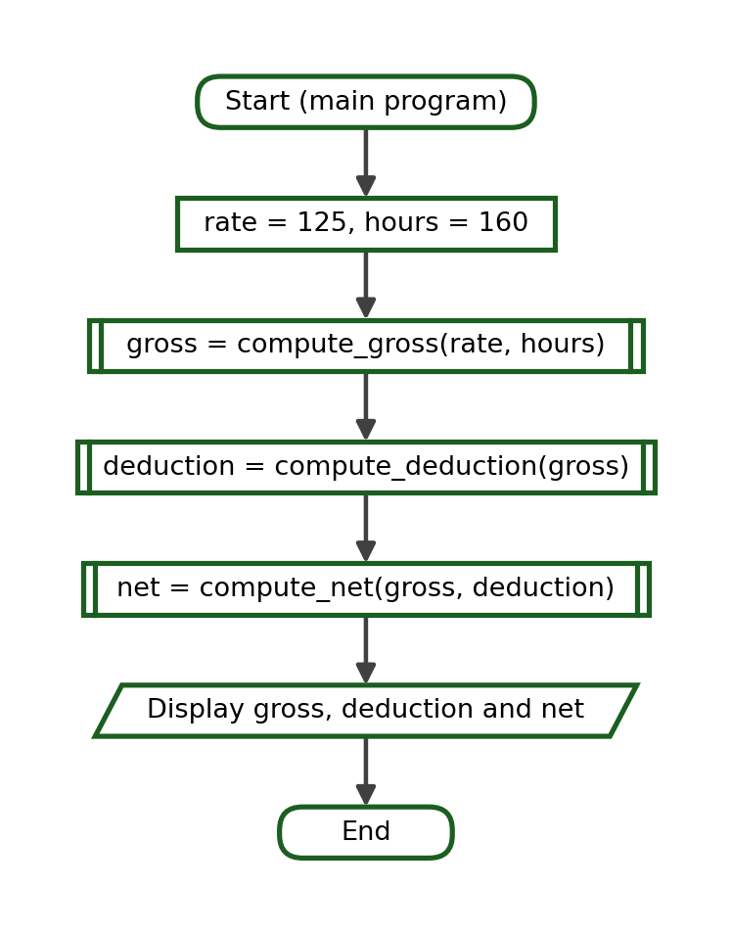

14.4 Temperature Program: to_fahrenheit() to temperature_label()
def to_fahrenheit(celsius):
return celsius * 9 / 5 + 32

def temperature_label(fahrenheit):
if fahrenheit >= 100:
return "Very Hot"
if fahrenheit >= 86:
return "Hot"
return "Normal"

fahrenheit = to_fahrenheit(38)
label = temperature_label(fahrenheit)
print(f"Fahrenheit: {fahrenheit:.1f}")
print("Label:", label)

Output:
Fahrenheit: 100.4
Label: Very Hot

Complete Trace:
Step | Current Function | Arguments | Parameters / Local Values | Returned Value | Output
1 | main | - | - | - | -
2 | to_fahrenheit | 38 | celsius = 38; 38 * 9 / 5 + 32 | 100.4 | -
3 | main | - | fahrenheit = 100.4 | - | -
4 | temperature_label | 100.4 | fahrenheit = 100.4; 100.4 >= 100 is True | "Very Hot" | -
5 | main | - | label = "Very Hot" | - | Fahrenheit: 100.4  Label: Very Hot

Explanation. The value returned by the first function is the only thing the second function receives. If the wrong value is passed - for example the Celsius reading instead of the Fahrenheit one - the program still runs but the label is wrong. This is one of the most common data-flow errors and is studied again in Section 19.

15. Function-Call Tracing
Function-call tracing is the skill of following a program step by step, recording what each function receives, what its local variables hold, what it returns, and what is displayed. The trace table used in this module has six columns.
Step | Current Function | Arguments | Parameters / Local Values | Returned Value | Output
1 | main | - | - | - | -

The fifteen traces below move from a single call with two parameters to programs in which two functions work in sequence. Recursion is not used anywhere in this module.

Trace 1 - Two Parameters
def add(a, b):
return a + b

print(add(12, 8))

Output:
20

Trace Table:
Step | Current Function | Arguments | Parameters / Local Values | Returned Value | Output
1 | main | - | - | - | -
2 | add | 12, 8 | a = 12, b = 8 | 20 | -
3 | main | - | - | - | 20

Trace 2 - Three Parameters
def total_of_three(a, b, c):
total = a + b + c
return total

print(total_of_three(10, 25, 40))

Output:
75

Trace Table:
Step | Current Function | Arguments | Parameters / Local Values | Returned Value | Output
1 | main | - | - | - | -
2 | total_of_three | 10, 25, 40 | a = 10, b = 25, c = 40; total = 75 | 75 | -
3 | main | - | - | - | 75

Trace 3 - A Variable Passed as an Argument
def compute_total(quantity, price):
return quantity * price

qty = 7
unit = 24.50
amount = compute_total(qty, unit)
print(amount)

Output:
171.5

Trace Table:
Step | Current Function | Arguments | Parameters / Local Values | Returned Value | Output
1 | main | - | qty = 7, unit = 24.5 | - | -
2 | compute_total | 7, 24.5 | quantity = 7, price = 24.5 | 171.5 | -
3 | main | - | amount = 171.5 | - | -
4 | main | - | - | - | 171.5

Trace 4 - An Expression Passed as an Argument
def square(number):
return number * number

print(square(3 + 4))

Output:
49

Trace Table:
Step | Current Function | Arguments | Parameters / Local Values | Returned Value | Output
1 | main | - | 3 + 4 is evaluated first | - | -
2 | square | 7 | number = 7 | 49 | -
3 | main | - | - | - | 49

Explanation. Python evaluates every argument before the function starts, so the function receives 7 and never sees the expression 3 + 4.

Trace 5 - A Default Parameter Used
def compute_discount(amount, rate=0.10):
return amount * rate

print(compute_discount(800))

Output:
80.0

Trace Table:
Step | Current Function | Arguments | Parameters / Local Values | Returned Value | Output
1 | main | - | - | - | -
2 | compute_discount | 800 | amount = 800, rate = 0.10 (default) | 80.0 | -
3 | main | - | - | - | 80.0

Trace 6 - A Default Parameter Replaced
def compute_discount(amount, rate=0.10):
return amount * rate

print(compute_discount(800, 0.25))

Output:
200.0

Trace Table:
Step | Current Function | Arguments | Parameters / Local Values | Returned Value | Output
1 | main | - | - | - | -
2 | compute_discount | 800, 0.25 | amount = 800, rate = 0.25 (supplied) | 200.0 | -
3 | main | - | - | - | 200.0

Trace 7 - Keyword Arguments in a Different Order
def student_info(name, age, section):
return f"{name} ({age}) - {section}"

print(student_info(section="1CPE-A", name="Ana", age=18))

Output:
Ana (18) - 1CPE-A

Trace Table:
Step | Current Function | Arguments | Parameters / Local Values | Returned Value | Output
1 | main | - | - | - | -
2 | student_info | section="1CPE-A",  name="Ana",  age=18 | name = "Ana", age = 18,  section = "1CPE-A" | "Ana (18) - 1CPE-A" | -
3 | main | - | - | - | Ana (18) - 1CPE-A

Trace 8 - Positional and Keyword Arguments Combined
def compute_bill(quantity, price, discount=0):
subtotal = quantity * price
return subtotal - discount

print(compute_bill(4, 250, discount=150))

Output:
850

Trace Table:
Step | Current Function | Arguments | Parameters / Local Values | Returned Value | Output
1 | main | - | - | - | -
2 | compute_bill | 4, 250,  discount=150 | quantity = 4, price = 250,  discount = 150; subtotal = 1000 | 850 | -
3 | main | - | - | - | 850

Trace 9 - A Local Variable Inside the Function
def compute_net(gross):
deduction = gross * 0.12
net = gross - deduction
return net

print(compute_net(15000))

Output:
13200.0

Trace Table:
Step | Current Function | Arguments | Parameters / Local Values | Returned Value | Output
1 | main | - | - | - | -
2 | compute_net | 15000 | gross = 15000; deduction = 1800.0;  net = 13200.0 | 13200.0 | -
3 | main | - | deduction and net are removed | - | 13200.0

Explanation. deduction and net exist only while compute_net() is running. Only the returned value survives.

Trace 10 - A Returned Value Stored and Reused
def double(number):
return number * 2

first = double(6)
second = double(first)
print(first, second)

Output:
12 24

Trace Table:
Step | Current Function | Arguments | Parameters / Local Values | Returned Value | Output
1 | main | - | - | - | -
2 | double | 6 | number = 6 | 12 | -
3 | main | - | first = 12 | - | -
4 | double | 12 | number = 12 | 24 | -
5 | main | - | second = 24 | - | 12 24

Trace 11 - One Function Feeding Another Directly
def double(number):
return number * 2

def add_five(number):
return number + 5

print(add_five(double(9)))

Output:
23

Trace Table:
Step | Current Function | Arguments | Parameters / Local Values | Returned Value | Output
1 | main | - | the inner call runs first | - | -
2 | double | 9 | number = 9 | 18 | -
3 | add_five | 18 | number = 18 | 23 | -
4 | main | - | - | - | 23

Explanation. The returned value of double() becomes the argument of add_five() without ever being stored in a variable.

Trace 12 - Two Functions Called in Sequence
def compute_area(length, width):
return length * width

def paint_cost(area, rate=35):
return area * rate

area = compute_area(6, 4)
cost = paint_cost(area)
print(area, cost)

Output:
24 840

Trace Table:
Step | Current Function | Arguments | Parameters / Local Values | Returned Value | Output
1 | main | - | - | - | -
2 | compute_area | 6, 4 | length = 6, width = 4 | 24 | -
3 | main | - | area = 24 | - | -
4 | paint_cost | 24 | area = 24, rate = 35 (default) | 840 | -
5 | main | - | cost = 840 | - | 24 840

Trace 13 - A Conditional Return Value
def get_remark(average):
if average >= 75:
return "Passed"
return "Failed"

print(get_remark(75))
print(get_remark(74))

Output:
Passed
Failed

Trace Table:
Step | Current Function | Arguments | Parameters / Local Values | Returned Value | Output
1 | main | - | - | - | -
2 | get_remark | 75 | average = 75; 75 >= 75 is True | "Passed" | -
3 | main | - | - | - | Passed
4 | get_remark | 74 | average = 74; 74 >= 75 is False | "Failed" | -
5 | main | - | - | - | Failed

Explanation. The boundary value 75 returns Passed because the condition uses the >= operator.

Trace 14 - A Loop Inside a Function
def sum_to(limit):
total = 0
for number in range(1, limit + 1):
total = total + number
return total

print(sum_to(5))

Output:
15

Trace Table:
Step | Current Function | Arguments | Parameters / Local Values | Returned Value | Output
1 | main | - | - | - | -
2 | sum_to | 5 | limit = 5, total = 0 | - | -
3 | sum_to | - | number = 1, total = 1 | - | -
4 | sum_to | - | number = 2, total = 3 | - | -
5 | sum_to | - | number = 3, total = 6 | - | -
6 | sum_to | - | number = 4, total = 10 | - | -
7 | sum_to | - | number = 5, total = 15 | 15 | -
8 | main | - | - | - | 15

Explanation. The loop was studied in Weeks 7 and 8. Inside a function it behaves in exactly the same way; only the returned total leaves the function.

Trace 15 - Three Functions in Sequence
def compute_subtotal(quantity, price):
return quantity * price

def compute_discount(subtotal):
if subtotal >= 1000:
return subtotal * 0.10
return 0

def compute_final(subtotal, discount):
return subtotal - discount

subtotal = compute_subtotal(3, 260)
discount = compute_discount(subtotal)
final_amount = compute_final(subtotal, discount)
print(f"₱{final_amount:.2f}")

Output:
₱780.00

Trace Table:
Step | Current Function | Arguments | Parameters / Local Values | Returned Value | Output
1 | main | - | - | - | -
2 | compute_subtotal | 3, 260 | quantity = 3, price = 260 | 780 | -
3 | main | - | subtotal = 780 | - | -
4 | compute_discount | 780 | subtotal = 780; 780 >= 1000 is False | 0 | -
5 | main | - | discount = 0 | - | -
6 | compute_final | 780, 0 | subtotal = 780, discount = 0 | 780 | -
7 | main | - | final_amount = 780 | - | ₱780.00

Explanation. The subtotal did not reach 1000, so the second function returned 0 and the final amount equals the subtotal.

16. Flowcharts for Function Data Flow
A flowchart shows the movement of control and data in graphical form. The standard symbols used in CPP102 are listed below and are used consistently in every flowchart in this module.
Symbol | Shape | Used For
Terminator | Rounded rectangle | Start of a function or program; End; Return to caller
Data (Input/Output) | Parallelogram | An actual input from the user or a value displayed on the screen
Process | Rectangle | A computation or an assignment
Decision | Diamond | A condition with a True branch and a False branch
Predefined Process | Rectangle with double side bars | A call to another function
Flow line | Arrow | The direction in which control moves

Two rules worth repeating. The parallelogram is drawn in its standard orientation, with the top edge offset to the right. It is used only for an actual input or for a value that is displayed. It is never used for an ordinary calculation and never mirrored. A return statement is not a screen output, so it is drawn as a process-style note, Return result to caller, inside a terminator that ends the function.

16.1 A Function With Multiple Parameters
Reading the flowchart. Both parameters are received at the Start terminator. The single process symbol performs the computation, and the function ends by returning one value. No parallelogram appears, because nothing is displayed inside the function.

16.2 A Function With a Default Parameter
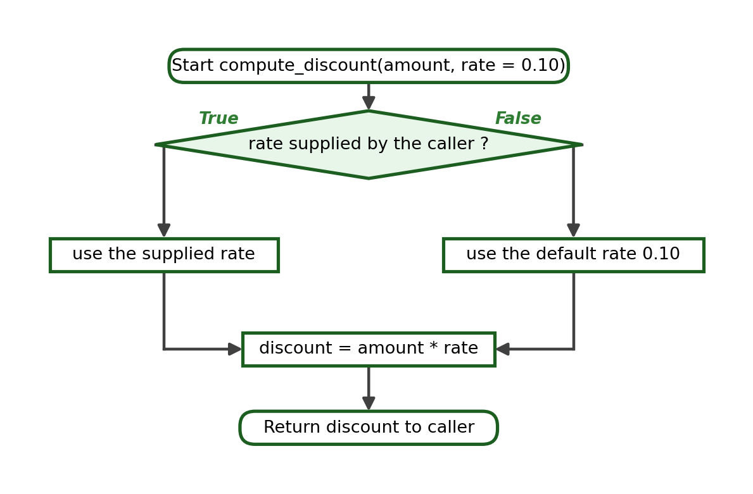
Reading the flowchart. The decision symbol is used here only to explain the behaviour of the default value. In the Python code no if statement is written: Python performs this choice automatically when the call is made.

16.3 A Main Program Calling One Function
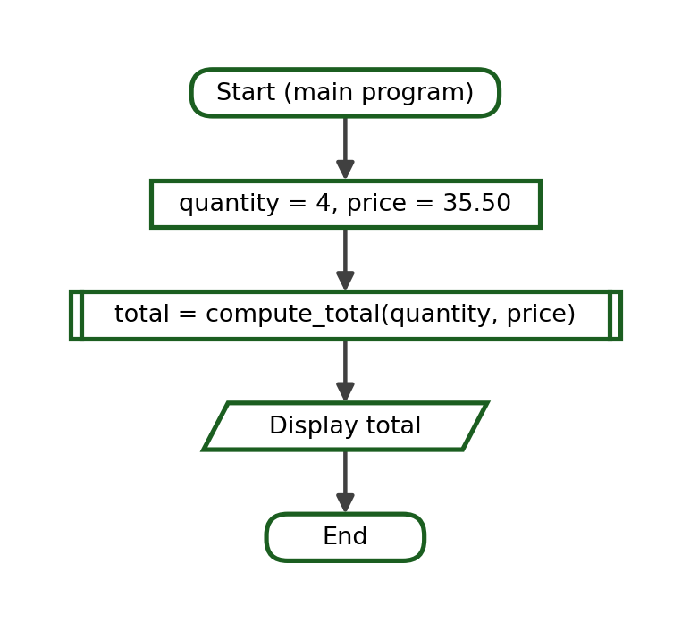
Reading the flowchart. The predefined-process symbol represents the call. Control leaves the main program, the function runs, and control returns with the value that is stored in total.

16.4 A Main Program Calling Two Functions
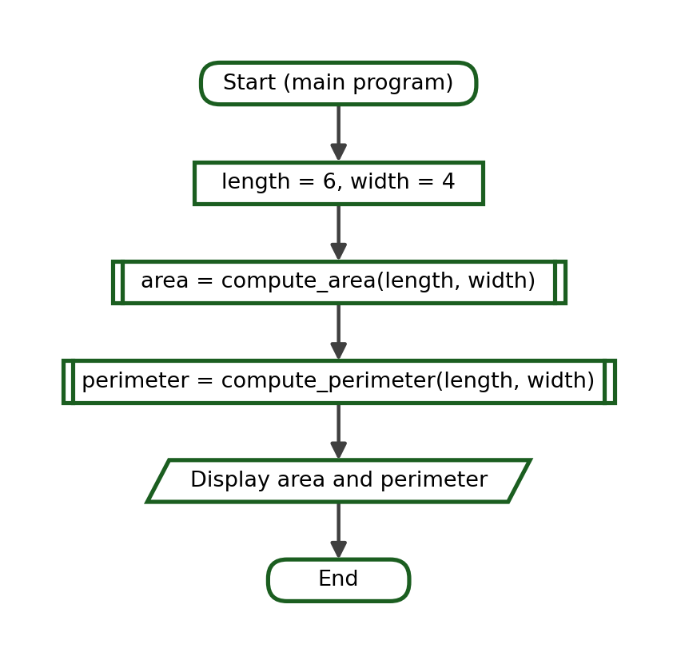
Reading the flowchart. Each call is a separate predefined-process symbol. The two functions do not communicate with each other; both receive their values from the main program.

16.5 A Returned Value Passed to Another Function
Reading the flowchart. The value returned by the first call becomes the argument of the second call. The arrow between the two predefined-process symbols therefore carries data as well as control.

16.6 A Function Containing a Decision
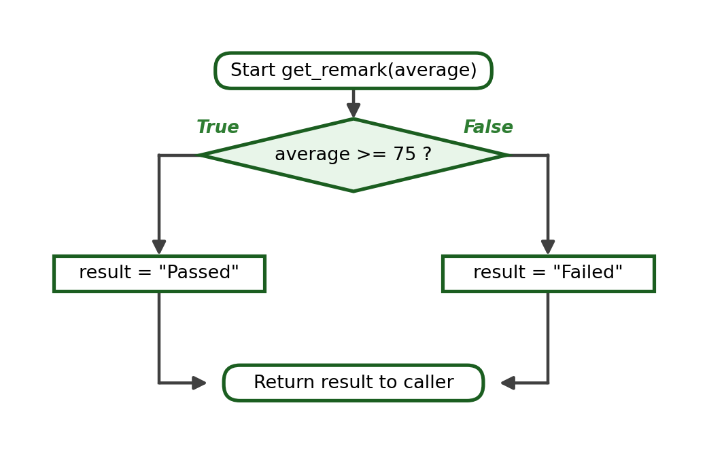
Reading the flowchart. Both branches reconnect at the terminator, so the function always returns exactly one value.

16.7 A Function Containing a Loop
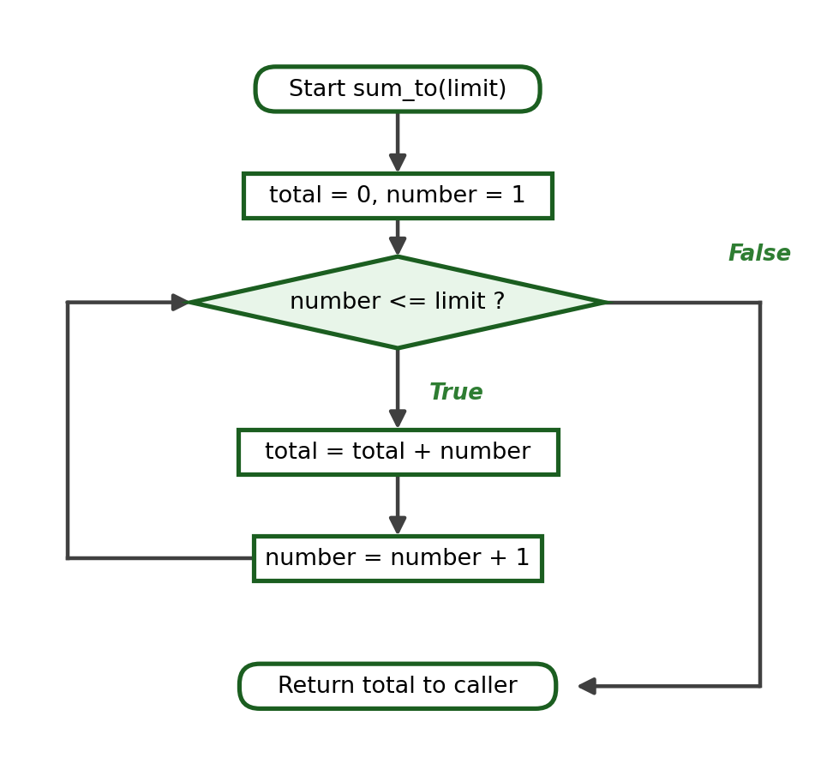
Reading the flowchart. The loop returns to the decision symbol, exactly as in the Week 7 and Week 8 flowcharts. When the condition becomes False, control leaves the loop and the function returns the accumulated total.

16.8 A Complete Three-Function Data-Flow Example
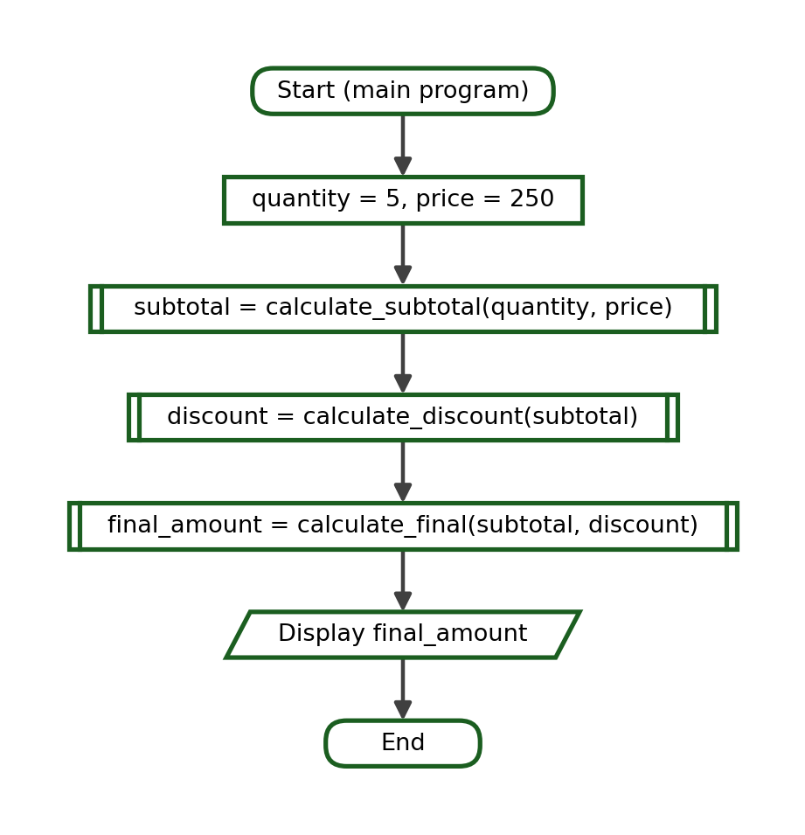
Reading the flowchart. The three calls appear in the order in which they must run. Each predefined-process symbol both calls a function and stores the value that the function returns, which is why the data flows downward from one symbol to the next.

17. Common Function-Related Errors
The errors below account for most of the difficulties beginners meet when functions begin to exchange data. Some of them stop the program; others are worse, because the program runs and produces a wrong answer without any warning.
Error | Why It Happens | Correction
Wrong number of arguments | The call supplies fewer or more values than there are parameters. | Count the parameters and supply exactly that many arguments.
Incorrect positional argument order | The values are correct but are written in the wrong order. | Follow the order in the definition, or use keyword arguments.
Misspelled keyword argument | The name used in the call does not match any parameter. | Copy the parameter name exactly as it is written in the definition.
Missing required argument | A parameter without a default receives no value. | Supply the value, or give the parameter a sensible default.
Invalid default-parameter order | A parameter without a default is written after one with a default. | Move every parameter that has a default to the end.
Forgetting return | The function computes a value but never sends it back, so None is given. | Add a return statement for the finished value.
Returning the wrong variable | A different local variable is returned instead of the result. | Return the variable that actually holds the answer.
Using print() instead of return | The value is displayed but cannot be reused by the caller. | Return the value and let the caller display it.
Ignoring the returned value | The function is called but the result is not stored or used. | Assign the call to a variable or use it inside an expression.
Using a local variable outside its function | The name no longer exists once the function has ended. | Return the value and store it in the caller.
Assuming a local variable is global | An assignment inside a function creates a new local variable. | Pass the value in as a parameter and return the new value.
Unexpected global-variable dependency | The function silently relies on a name defined elsewhere. | Add a parameter so that the function receives the value it needs.
Incorrect indentation | The body is not indented, or the indentation is uneven. | Indent every line of the body by exactly four spaces.
Misspelled function name | The name in the call differs from the name in the definition. | Use the same spelling, in lowercase snake_case, in both places.
Function call before definition | The call is executed before Python has read the def block. | Place every function definition above the main program.
Wrong comparison inside a function | An operator such as > is used where >= is required. | Check the boundary value and choose the correct operator.
Wrong formula | The program runs but the computation itself is incorrect. | Recheck the formula and the order of operations, and test the result by hand.

Three of these errors are shown in full below, because they are the ones most often mistaken for something else.

17.1 Forgetting return
Incorrect:
def compute_total(quantity, price):
total = quantity * price

result = compute_total(4, 35.50)
print(result)

Reason. The function computes total but never sends it back, so the call gives back None. The program runs, so nothing looks wrong until the output is read.
Output of the Incorrect Program:
None

Corrected:
def compute_total(quantity, price):
total = quantity * price
return total

result = compute_total(4, 35.50)
print(result)

Output:
142.0

17.2 Using a Local Variable Outside Its Function
Incorrect:
def compute_area(length, width):
area = length * width

compute_area(8, 3)
print(area)

Reason. area belongs to compute_area(). Once the function ends the name is removed, so the print statement fails with NameError: name 'area' is not defined.
Corrected:
def compute_area(length, width):
area = length * width
return area

area = compute_area(8, 3)
print(area)

Output:
24

17.3 Invalid Default-Parameter Order
Incorrect:
def compute_bill(discount=0, quantity, price):
return quantity * price - discount

Reason. A parameter without a default follows one that has a default. Python reports SyntaxError: parameter without a default follows parameter with a default, and the file will not run at all.
Corrected:
def compute_bill(quantity, price, discount=0):
return quantity * price - discount

print(compute_bill(4, 250))
print(compute_bill(4, 250, 150))

Output:
1000
850

18. Testing Functions Independently
A function should be tested on its own before it is joined to a larger program. Independent testing is simple: call the function directly with chosen values, compare the returned value with the value expected by hand, and record whether the test passed. If every function is known to be correct, then any remaining fault in the program must be in the way the functions are joined together.
Scope. The testing done in this course is manual. No testing library is used. The value of the method lies in choosing the arguments carefully.
Category of Test | What It Checks | Example Argument
Normal input | The ordinary case the function was written for | 85
Boundary input | The exact value at which the answer changes | 75
Just outside the boundary | The first value on the other side | 74
Zero | Whether a zero value is handled sensibly | 0
Negative value, when meaningful | Whether an invalid case is detected | -5
Default argument | The result when the optional value is omitted | compute_discount(500)
Explicitly supplied argument | The result when the default is replaced | compute_discount(500, 0.25)

Function Under Test:
def get_remark(grade):
if grade >= 75:
return "Passed"
return "Failed"

Test Cases:
Test | Argument | Expected Return
Normal passing | 85 | Passed
Boundary | 75 | Passed
Below boundary | 74 | Failed
Normal failing | 60 | Failed
Zero | 0 | Failed

Running the Tests:
def get_remark(grade):
if grade >= 75:
return "Passed"
return "Failed"

print(get_remark(85))
print(get_remark(75))
print(get_remark(74))
print(get_remark(60))
print(get_remark(0))

Actual Output:
Passed
Passed
Failed
Failed
Failed

Why boundary values matter. A boundary value is the exact point at which the answer changes. In this function the boundary is 75. A program written with > instead of >= produces the correct answer for 85 and for 74, and is wrong only for 75 itself. Testing only ordinary values would never reveal the fault, which is why the boundary and the value just below it must always be tested.
Testing a Function That Has a Default Parameter:
def compute_discount(amount, rate=0.10):
return amount * rate

print(compute_discount(500))
print(compute_discount(500, 0.25))
print(compute_discount(0))

Actual Output:
50.0
125.0
0.0

Test | Call | Expected Return | Actual Return | Pass/Fail
Default used | compute_discount(500) | 50.0 | 50.0 | Pass
Default replaced | compute_discount(500, 0.25) | 125.0 | 125.0 | Pass
Zero amount | compute_discount(0) | 0.0 | 0.0 | Pass

19. Debugging Functions That Produce Incorrect Results
Debugging is not only the removal of syntax errors. The more dangerous fault is the logical error: the program runs, produces an answer, and the answer is wrong. Such faults are found by tracing the function, by testing it with values whose answers are already known, and by checking the formula by hand.
Each of the twelve cases below shows the incorrect program, the problem, the corrected program, an explanation and the correct output.

19.1 Wrong Formula
Incorrect Program:
def calculate_average(a, b, c):
return a + b + c / 3

print(calculate_average(90, 84, 78))

Problem. The program runs, but only c is divided by 3. The order of operations makes the division happen before the addition, so the returned value is not the average.
Corrected Program:
def calculate_average(a, b, c):
return (a + b + c) / 3

print(calculate_average(90, 84, 78))

Explanation. Parentheses force the addition to be completed first, and the sum is then divided by 3.
Correct Output:
84.0

19.2 Wrong Comparison
Incorrect Program:
def get_remark(average):
if average > 75:
return "Passed"
return "Failed"

print(get_remark(75))

Problem. A student whose average is exactly 75 should pass, but the operator > excludes the boundary value.
Corrected Program:
def get_remark(average):
if average >= 75:
return "Passed"
return "Failed"

print(get_remark(75))

Explanation. The operator >= includes the boundary, so 75 now returns Passed.
Correct Output:
Passed

19.3 Wrong Argument Order
Incorrect Program:
def compute_fare(base, distance):
return base + distance * 2.00

print(compute_fare(8, 13.00))

Problem. The values are correct but reversed: 8 is used as the base fare and 13.00 as the distance. The program runs and prints a plausible but wrong fare.
Corrected Program:
def compute_fare(base, distance):
return base + distance * 2.00

print(compute_fare(13.00, 8))

Explanation. Writing the arguments in the declared order gives the correct fare. Using compute_fare(base=13.00, distance=8) would prevent the mistake entirely.
Correct Output:
29.0

19.4 Wrong Parameter Used in the Formula
Incorrect Program:
def compute_net(gross, deduction):
return gross - gross

print(compute_net(18000, 1500))

Problem. The formula subtracts gross from itself, so the function always returns 0 and the parameter deduction is never used.
Corrected Program:
def compute_net(gross, deduction):
return gross - deduction

print(compute_net(18000, 1500))

Explanation. Every parameter that a function declares should appear in the computation, otherwise it serves no purpose.
Correct Output:
16500

19.5 Missing return
Incorrect Program:
def compute_total(quantity, price):
total = quantity * price

amount = compute_total(6, 45.00)
print(amount)

Problem. The total is computed but never sent back, so the call gives None.
Corrected Program:
def compute_total(quantity, price):
total = quantity * price
return total

amount = compute_total(6, 45.00)
print(amount)

Explanation. A function that is meant to produce a value must end with a return statement for that value.
Correct Output:
270.0

19.6 Misplaced return
Incorrect Program:
def compute_bill(units, rate):
bill = units * rate
return bill
bill = bill + 50

print(compute_bill(100, 11.50))

Problem. The service fee is added after the return statement, so that line is never reached and the fee is silently lost.
Corrected Program:
def compute_bill(units, rate):
bill = units * rate
bill = bill + 50
return bill

print(compute_bill(100, 11.50))

Explanation. return must be the last step of the computation, not the middle of it.
Correct Output:
1200.0

19.7 Incorrect Local Variable Returned
Incorrect Program:
def compute_area_and_perimeter(length, width):
area = length * width
perimeter = 2 * (length + width)
return area

print("Perimeter:", compute_area_and_perimeter(9, 5))

Problem. The function computes both values but returns the area, which is then displayed under the label Perimeter.
Corrected Program:
def compute_perimeter(length, width):
perimeter = 2 * (length + width)
return perimeter

print("Perimeter:", compute_perimeter(9, 5))

Explanation. One function should produce one result. Splitting the two computations removes the confusion completely.
Correct Output:
Perimeter: 28

19.8 Incorrect Default Value
Incorrect Program:
def compute_discount(amount, rate=10):
return amount * rate

print(compute_discount(500))

Problem. The rate is meant to be ten percent, but 10 means ten times the amount. The program produces a discount that is larger than the purchase.
Corrected Program:
def compute_discount(amount, rate=0.10):
return amount * rate

print(compute_discount(500))

Explanation. A percentage used in a multiplication must be written as a decimal fraction.
Correct Output:
50.0

19.9 Keyword-Argument Mismatch
Incorrect Program:
def student_info(name, age, section):
print(name, age, section)

student_info(name="Ana", ag=18, section="1CPE-A")

Problem. The keyword ag does not match the parameter age, so Python reports TypeError: student_info() got an unexpected keyword argument 'ag'.
Corrected Program:
def student_info(name, age, section):
print(name, age, section)

student_info(name="Ana", age=18, section="1CPE-A")

Explanation. Keyword arguments must repeat the parameter name exactly.
Correct Output:
Ana 18 1CPE-A

19.10 Incorrect Function-Call Sequence
Incorrect Program:
def compute_subtotal(quantity, price):
return quantity * price

def compute_final(subtotal, discount):
return subtotal - discount

final = compute_final(subtotal, 100)
subtotal = compute_subtotal(4, 300)
print(final)

Problem. compute_final() is called before subtotal exists, so Python reports NameError: name 'subtotal' is not defined.
Corrected Program:
def compute_subtotal(quantity, price):
return quantity * price

def compute_final(subtotal, discount):
return subtotal - discount

subtotal = compute_subtotal(4, 300)
final = compute_final(subtotal, 100)
print(final)

Explanation. In a data-flow program the calls must follow the order in which the values become available.
Correct Output:
1100

19.11 Using the Wrong Function's Returned Value
Incorrect Program:
def compute_area(length, width):
return length * width

def compute_perimeter(length, width):
return 2 * (length + width)

area = compute_area(7, 4)
perimeter = compute_area(7, 4)
print("Area:", area)
print("Perimeter:", perimeter)

Problem. compute_area() is called twice, so the perimeter shown is really the area. The program runs and both numbers look reasonable.
Corrected Program:
def compute_area(length, width):
return length * width

def compute_perimeter(length, width):
return 2 * (length + width)

area = compute_area(7, 4)
perimeter = compute_perimeter(7, 4)
print("Area:", area)
print("Perimeter:", perimeter)

Explanation. Each variable must be filled by the function that actually produces that value.
Correct Output:
Area: 28
Perimeter: 22

19.12 Incorrect Data Passed to Another Function
Incorrect Program:
def to_fahrenheit(celsius):
return celsius * 9 / 5 + 32

def temperature_label(celsius):
if celsius >= 38:
return "Hot"
return "Normal"

fahrenheit = to_fahrenheit(30)
print(temperature_label(fahrenheit))

Problem. temperature_label() expects a Celsius value, but a Fahrenheit value is passed to it. 86.0 is greater than 38, so a mild 30 degree Celsius reading is reported as Hot.
Corrected Program:
def to_fahrenheit(celsius):
return celsius * 9 / 5 + 32

def temperature_label(celsius):
if celsius >= 38:
return "Hot"
return "Normal"

celsius = 30
fahrenheit = to_fahrenheit(celsius)
print(temperature_label(celsius))

Explanation. When a value travels from one function to another, its unit and its meaning must match what the receiving function expects.
Correct Output:
Normal

20. Guided Problem-Solving Examples
The twelve guided examples below bring together every idea in this module. Each one is solved completely, from the problem statement to the exact output, and each one uses at least two functions that exchange data.

Example 1: Student Average and Remark
Problem Statement. A student has three quiz scores. Compute the average and decide whether the student passed or failed, using one function for each task.
Problem Decomposition:
Smaller Task | Function Name | Input Needed | Result Produced
Compute the average of three scores | compute_average | Three scores | The average
Decide the remark from the average | get_remark | The average | "Passed" or "Failed"
Display the results | main program | Average and remark | Two printed lines

Functions Needed: compute_average(a, b, c) and get_remark(average)
Parameters: a, b, c for the first function; average for the second
Returned Values: a decimal average, then the text "Passed" or "Failed"
IPO Table:
Input | Process | Output
Three scores: 84, 79, 92 | average = (a + b + c) / 3, then compare the average with 75 | The average and the remark

Algorithm:
1. Define compute_average(a, b, c) that returns the average of the three scores.
2. Define get_remark(average) that returns "Passed" when the average reaches 75 and "Failed" otherwise.
3. In the main program, call compute_average with 84, 79 and 92 and store the returned value.
4. Pass the stored average to get_remark and store the returned text.
5. Display the average with two decimal places and the remark.
Pseudocode:
FUNCTION compute_average(a, b, c)
RETURN (a + b + c) / 3
END FUNCTION

FUNCTION get_remark(average)
IF average >= 75 THEN
RETURN "Passed"
ELSE
RETURN "Failed"
END IF
END FUNCTION

MAIN
SET average = compute_average(84, 79, 92)
SET remark = get_remark(average)
DISPLAY "Average: ", average
DISPLAY "Remark: ", remark
END MAIN

Flowchart:
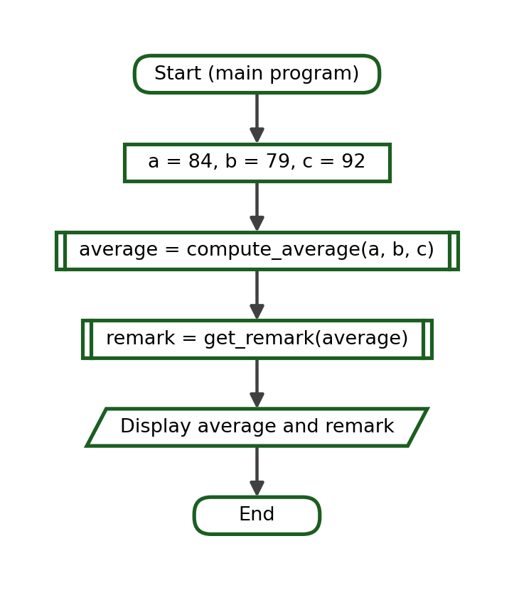
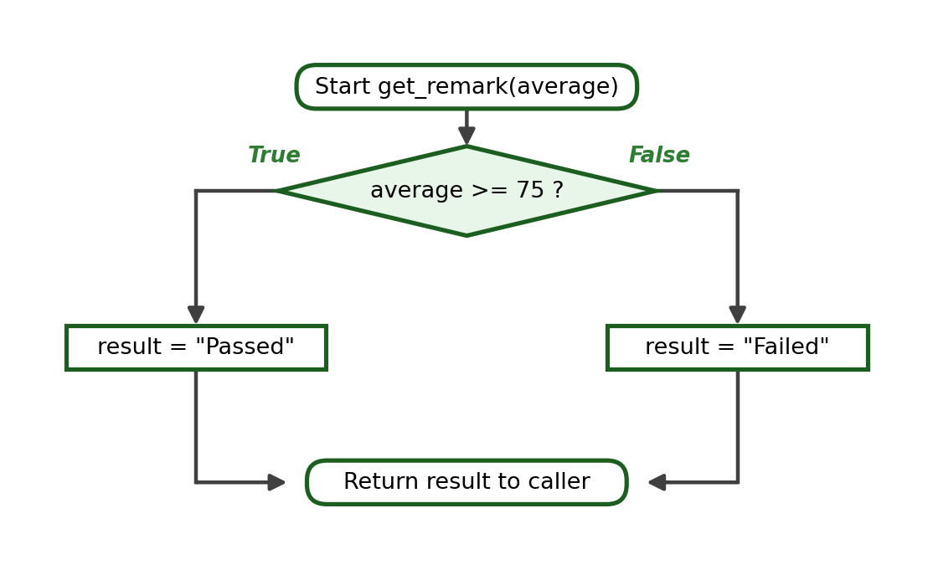
Python Program:
def compute_average(a, b, c):
return (a + b + c) / 3

def get_remark(average):
if average >= 75:
return "Passed"
return "Failed"

average = compute_average(84, 79, 92)
remark = get_remark(average)
print(f"Average: {average:.2f}")
print("Remark:", remark)

Function-Call Trace:
Step | Current Function | Arguments | Parameters / Local Values | Returned Value | Output
1 | main | - | - | - | -
2 | compute_average | 84, 79, 92 | a = 84, b = 79, c = 92 | 85.0 | -
3 | main | - | average = 85.0 | - | -
4 | get_remark | 85.0 | average = 85.0; 85.0 >= 75 is True | "Passed" | -
5 | main | - | remark = "Passed" | - | Average: 85.00  Remark: Passed

Test Cases:
Test Case | Arguments | Expected Return
Normal passing | 84, 79, 92 | 85.0 then Passed
Boundary average | 75, 75, 75 | 75.0 then Passed
Below boundary | 70, 74, 78 | 74.0 then Failed

Exact Output:
Average: 85.00
Remark: Passed

Explanation. Each function performs one task and returns one value. The main program is the only place where the two results are displayed, so both functions can be tested on their own.

Example 2: Purchase Subtotal, Discount and Final Amount
Problem Statement. A customer buys several units of one item. Compute the subtotal, apply a ten-percent discount when the subtotal reaches 1000, and compute the final amount due.
Problem Decomposition:
Smaller Task | Function Name | Input Needed | Result Produced
Compute the subtotal | compute_subtotal | Quantity and price | The subtotal
Compute the discount | compute_discount | The subtotal | The discount amount
Compute the final amount | compute_final | Subtotal and discount | The amount due

Functions Needed: compute_subtotal, compute_discount and compute_final
Parameters: quantity and price; subtotal; subtotal and discount
Returned Values: the subtotal, the discount and the final amount
IPO Table:
Input | Process | Output
quantity = 6, price = 220 | subtotal = quantity * price; discount if subtotal >= 1000; final = subtotal - discount | The final amount due

Algorithm:
1. Define compute_subtotal(quantity, price) that returns the product.
2. Define compute_discount(subtotal) that returns ten percent of the subtotal when it reaches 1000, and 0 otherwise.
3. Define compute_final(subtotal, discount) that returns the difference.
4. In the main program, call the three functions in that order, storing each returned value.
5. Display the subtotal, the discount and the final amount with two decimal places.
Pseudocode:
FUNCTION compute_subtotal(quantity, price)
RETURN quantity * price
END FUNCTION

FUNCTION compute_discount(subtotal)
IF subtotal >= 1000 THEN
RETURN subtotal * 0.10
ELSE
RETURN 0
END IF
END FUNCTION

FUNCTION compute_final(subtotal, discount)
RETURN subtotal - discount
END FUNCTION

MAIN
SET subtotal = compute_subtotal(6, 220)
SET discount = compute_discount(subtotal)
SET final_amount = compute_final(subtotal, discount)
DISPLAY subtotal, discount, final_amount
END MAIN

Flowchart:
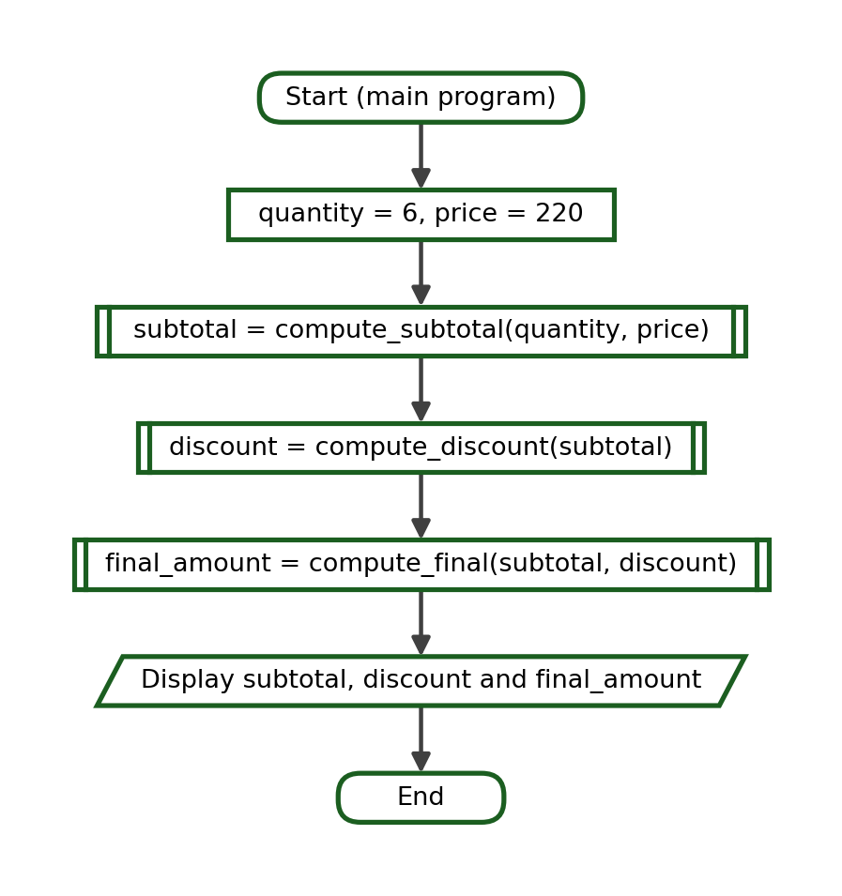
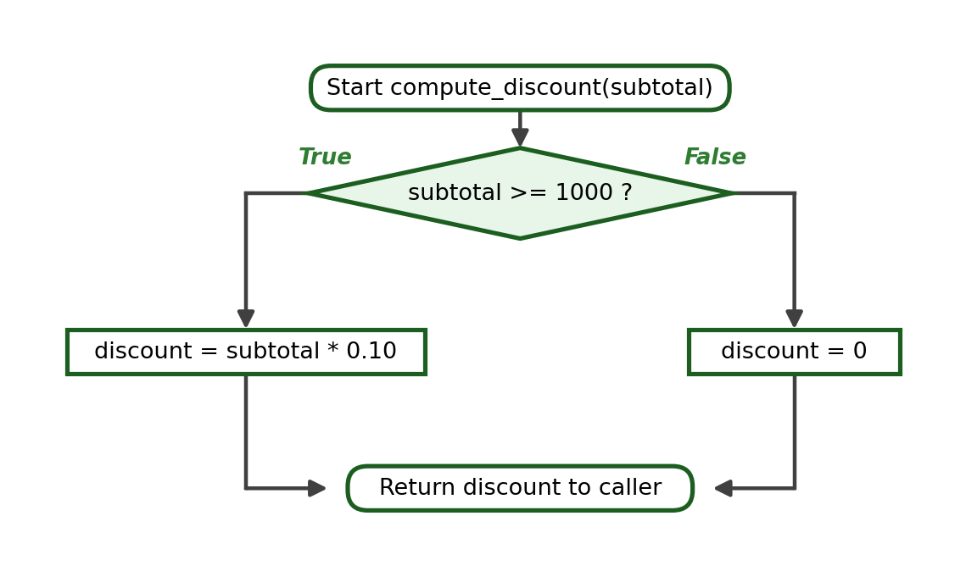
Python Program:
def compute_subtotal(quantity, price):
return quantity * price

def compute_discount(subtotal):
if subtotal >= 1000:
return subtotal * 0.10
return 0

def compute_final(subtotal, discount):
return subtotal - discount

subtotal = compute_subtotal(6, 220)
discount = compute_discount(subtotal)
final_amount = compute_final(subtotal, discount)
print(f"Subtotal: ₱{subtotal:.2f}")
print(f"Discount: ₱{discount:.2f}")
print(f"Final Amount: ₱{final_amount:.2f}")

Function-Call Trace:
Step | Current Function | Arguments | Parameters / Local Values | Returned Value | Output
1 | main | - | - | - | -
2 | compute_subtotal | 6, 220 | quantity = 6, price = 220 | 1320 | -
3 | main | - | subtotal = 1320 | - | -
4 | compute_discount | 1320 | subtotal = 1320; 1320 >= 1000 is True | 132.0 | -
5 | main | - | discount = 132.0 | - | -
6 | compute_final | 1320, 132.0 | subtotal = 1320, discount = 132.0 | 1188.0 | -
7 | main | - | final_amount = 1188.0 | - | Subtotal: ₱1320.00  Discount: ₱132.00  Final Amount: ₱1188.00

Test Cases:
Test Case | Arguments | Expected Return
Discount applies | 6, 220 | 1188.0
Boundary subtotal | 4, 250 | 900.0
No discount | 3, 220 | 660

Exact Output:
Subtotal: ₱1320.00
Discount: ₱132.00
Final Amount: ₱1188.00

Explanation. The returned value of each function becomes an argument of the next. Because the discount rule lives in one function only, a change in store policy is made in a single place.

Example 3: Employee Gross and Net Salary
Problem Statement. Compute an employee's gross pay from the hourly rate and the hours worked, deduct eight percent, and show the net pay.
Problem Decomposition:
Smaller Task | Function Name | Input Needed | Result Produced
Compute the gross pay | compute_gross | Rate and hours | The gross pay
Compute the deduction | compute_deduction | The gross pay | The deduction
Compute the net pay | compute_net | Gross and deduction | The net pay

Functions Needed: compute_gross, compute_deduction and compute_net
Parameters: rate and hours; gross and an optional percent; gross and deduction
Returned Values: the gross pay, the deduction and the net pay
IPO Table:
Input | Process | Output
rate = 115.00, hours = 160 | gross = rate * hours; deduction = gross * 0.08; net = gross - deduction | The net pay

Algorithm:
1. Define compute_gross(rate, hours) that returns the product.
2. Define compute_deduction(gross, percent=0.08) that returns the deduction.
3. Define compute_net(gross, deduction) that returns the difference.
4. In the main program, call the three functions in order.
5. Display the gross pay, the deduction and the net pay with two decimal places.
Pseudocode:
FUNCTION compute_gross(rate, hours)
RETURN rate * hours
END FUNCTION

FUNCTION compute_deduction(gross, percent = 0.08)
RETURN gross * percent
END FUNCTION

FUNCTION compute_net(gross, deduction)
RETURN gross - deduction
END FUNCTION

MAIN
SET gross = compute_gross(115.00, 160)
SET deduction = compute_deduction(gross)
SET net = compute_net(gross, deduction)
DISPLAY gross, deduction, net
END MAIN

Flowchart:
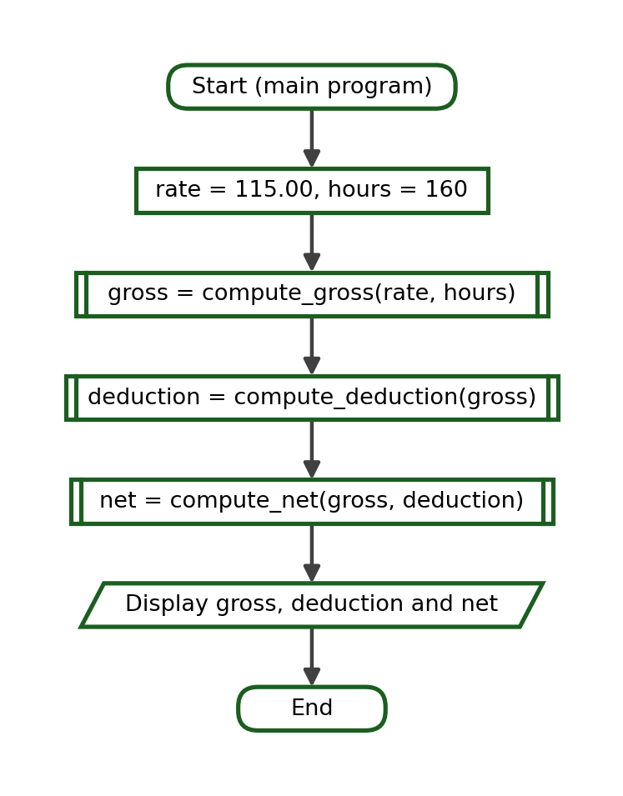
Python Program:
def compute_gross(rate, hours):
return rate * hours

def compute_deduction(gross, percent=0.08):
return gross * percent

def compute_net(gross, deduction):
return gross - deduction

gross = compute_gross(115.00, 160)
deduction = compute_deduction(gross)
net = compute_net(gross, deduction)
print(f"Gross Pay: ₱{gross:.2f}")
print(f"Deduction: ₱{deduction:.2f}")
print(f"Net Pay: ₱{net:.2f}")

Function-Call Trace:
Step | Current Function | Arguments | Parameters / Local Values | Returned Value | Output
1 | main | - | - | - | -
2 | compute_gross | 115.0, 160 | rate = 115.0, hours = 160 | 18400.0 | -
3 | main | - | gross = 18400.0 | - | -
4 | compute_deduction | 18400.0 | gross = 18400.0, percent = 0.08 (default) | 1472.0 | -
5 | main | - | deduction = 1472.0 | - | -
6 | compute_net | 18400.0, 1472.0 | gross = 18400.0, deduction = 1472.0 | 16928.0 | -
7 | main | - | net = 16928.0 | - | Gross Pay: ₱18400.00  Deduction: ₱1472.00  Net Pay: ₱16928.00

Test Cases:
Test Case | Arguments | Expected Return
Default deduction | 115.00, 160 | 16928.0
Zero hours | 115.00, 0 | 0.0
Higher deduction rate | 115.00, 160 with percent = 0.12 | 16192.0

Exact Output:
Gross Pay: ₱18400.00
Deduction: ₱1472.00
Net Pay: ₱16928.00

Explanation. compute_deduction has a default percentage, so the ordinary case needs no third argument. Supplying percent=0.12 changes the rate for one call without editing the function.

Example 4: Rectangle Area and Perimeter
Problem Statement. Compute both the area and the perimeter of a rectangle using one function for each measurement.
Problem Decomposition:
Smaller Task | Function Name | Input Needed | Result Produced
Compute the area | compute_area | Length and width | The area
Compute the perimeter | compute_perimeter | Length and width | The perimeter
Display both results | main program | Area and perimeter | Two printed lines

Functions Needed: compute_area(length, width) and compute_perimeter(length, width)
Parameters: length and width for both functions
Returned Values: the area and the perimeter
IPO Table:
Input | Process | Output
length = 9, width = 5 | area = length * width; perimeter = 2 * (length + width) | The area and the perimeter

Algorithm:
1. Define compute_area(length, width) that returns the product.
2. Define compute_perimeter(length, width) that returns 2 * (length + width).
3. In the main program, call both functions with 9 and 5.
4. Store each returned value in its own variable.
5. Display the area and the perimeter.
Pseudocode:
FUNCTION compute_area(length, width)
RETURN length * width
END FUNCTION

FUNCTION compute_perimeter(length, width)
RETURN 2 * (length + width)
END FUNCTION

MAIN
SET area = compute_area(9, 5)
SET perimeter = compute_perimeter(9, 5)
DISPLAY "Area: ", area
DISPLAY "Perimeter: ", perimeter
END MAIN

Flowchart:
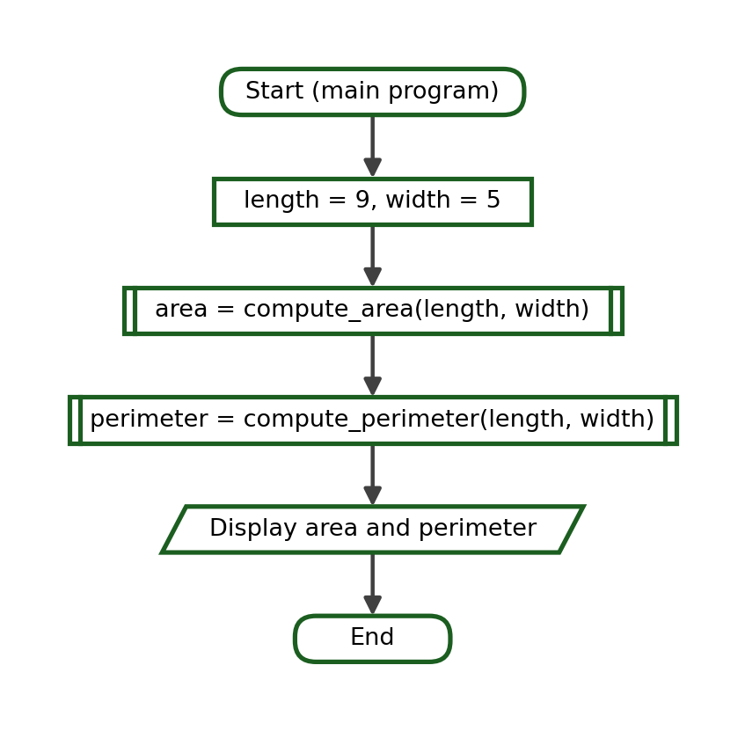
Python Program:
def compute_area(length, width):
return length * width

def compute_perimeter(length, width):
return 2 * (length + width)

area = compute_area(9, 5)
perimeter = compute_perimeter(9, 5)
print("Area:", area)
print("Perimeter:", perimeter)

Function-Call Trace:
Step | Current Function | Arguments | Parameters / Local Values | Returned Value | Output
1 | main | - | - | - | -
2 | compute_area | 9, 5 | length = 9, width = 5 | 45 | -
3 | main | - | area = 45 | - | -
4 | compute_perimeter | 9, 5 | length = 9, width = 5 | 28 | -
5 | main | - | perimeter = 28 | - | Area: 45  Perimeter: 28

Test Cases:
Test Case | Arguments | Expected Return
Normal rectangle | 9, 5 | 45 and 28
Square | 6, 6 | 36 and 24
Unit rectangle | 1, 1 | 1 and 4

Exact Output:
Area: 45
Perimeter: 28

Explanation. The two functions receive the same arguments but return different results. Storing each returned value in a clearly named variable prevents the common mistake of displaying the area under the label Perimeter.

Example 5: Celsius Conversion and Temperature Label
Problem Statement. Convert a Celsius reading to Fahrenheit and describe the result with a short label.
Problem Decomposition:
Smaller Task | Function Name | Input Needed | Result Produced
Convert Celsius to Fahrenheit | to_fahrenheit | Celsius value | Fahrenheit value
Describe the temperature | temperature_label | Fahrenheit value | A short label
Display both values | main program | Fahrenheit and label | Two printed lines

Functions Needed: to_fahrenheit(celsius) and temperature_label(fahrenheit)
Parameters: celsius; fahrenheit
Returned Values: the Fahrenheit value and the label
IPO Table:
Input | Process | Output
celsius = 36 | fahrenheit = celsius * 9 / 5 + 32, then compare with 86 and 100 | The Fahrenheit value and its label

Algorithm:
1. Define to_fahrenheit(celsius) that returns celsius * 9 / 5 + 32.
2. Define temperature_label(fahrenheit) that returns "Very Hot", "Hot" or "Normal".
3. In the main program, convert 36 degrees Celsius and store the result.
4. Pass the stored Fahrenheit value to temperature_label.
5. Display the Fahrenheit value with one decimal place and the label.
Pseudocode:
FUNCTION to_fahrenheit(celsius)
RETURN celsius * 9 / 5 + 32
END FUNCTION

FUNCTION temperature_label(fahrenheit)
IF fahrenheit >= 100 THEN
RETURN "Very Hot"
ELSE IF fahrenheit >= 86 THEN
RETURN "Hot"
ELSE
RETURN "Normal"
END IF
END FUNCTION

MAIN
SET fahrenheit = to_fahrenheit(36)
SET label = temperature_label(fahrenheit)
DISPLAY fahrenheit, label
END MAIN

Flowchart:
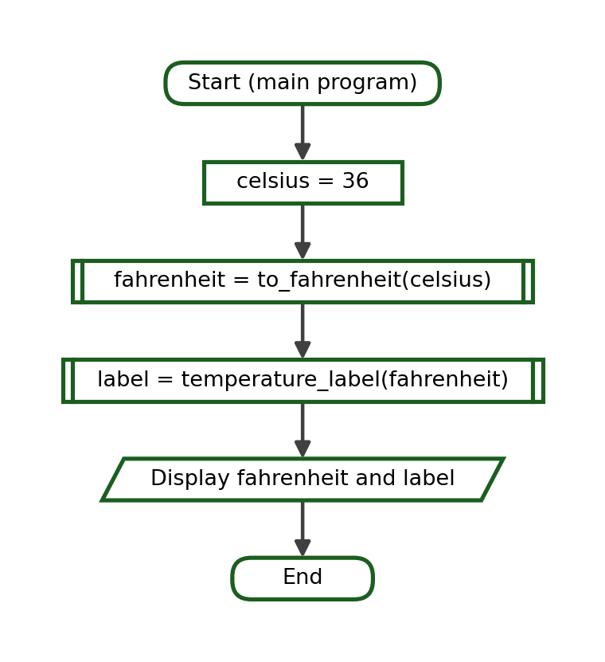
Python Program:
def to_fahrenheit(celsius):
return celsius * 9 / 5 + 32

def temperature_label(fahrenheit):
if fahrenheit >= 100:
return "Very Hot"
if fahrenheit >= 86:
return "Hot"
return "Normal"

fahrenheit = to_fahrenheit(36)
label = temperature_label(fahrenheit)
print(f"Fahrenheit: {fahrenheit:.1f}")
print("Label:", label)

Function-Call Trace:
Step | Current Function | Arguments | Parameters / Local Values | Returned Value | Output
1 | main | - | - | - | -
2 | to_fahrenheit | 36 | celsius = 36 | 96.8 | -
3 | main | - | fahrenheit = 96.8 | - | -
4 | temperature_label | 96.8 | fahrenheit = 96.8; 96.8 >= 100 is False;  96.8 >= 86 is True | "Hot" | -
5 | main | - | label = "Hot" | - | Fahrenheit: 96.8  Label: Hot

Test Cases:
Test Case | Arguments | Expected Return
Warm day | 36 | 96.8 and Hot
Boiling point | 100 | 212.0 and Very Hot
Cool day | 25 | 77.0 and Normal

Exact Output:
Fahrenheit: 96.8
Label: Hot

Explanation. The unit of the value that travels between the two functions matters. temperature_label expects Fahrenheit; passing the Celsius value instead would produce a wrong label without any error message.

Example 6: Tuition Computation
Problem Statement. Compute a student's tuition from the number of units enrolled and the cost per unit, then add the miscellaneous fee.
Problem Decomposition:
Smaller Task | Function Name | Input Needed | Result Produced
Compute the tuition for the units | compute_tuition | Units and cost per unit | The tuition
Add the miscellaneous fee | add_miscellaneous | Tuition and fee | The total assessment
Display the assessment | main program | The total | One printed line

Functions Needed: compute_tuition(units, cost_per_unit) and add_miscellaneous(tuition, misc)
Parameters: units and cost_per_unit; tuition and an optional misc
Returned Values: the tuition and the total assessment
IPO Table:
Input | Process | Output
units = 21, cost_per_unit = 780.00 | tuition = units * cost_per_unit; total = tuition + misc | The total assessment

Algorithm:
1. Define compute_tuition(units, cost_per_unit) that returns the product.
2. Define add_miscellaneous(tuition, misc=3500.00) that returns the sum.
3. In the main program, compute the tuition for 21 units at 780.00 each.
4. Pass the tuition to add_miscellaneous and store the total.
5. Display the tuition and the total assessment with two decimal places.
Pseudocode:
FUNCTION compute_tuition(units, cost_per_unit)
RETURN units * cost_per_unit
END FUNCTION

FUNCTION add_miscellaneous(tuition, misc = 3500.00)
RETURN tuition + misc
END FUNCTION

MAIN
SET tuition = compute_tuition(21, 780.00)
SET total = add_miscellaneous(tuition)
DISPLAY tuition, total
END MAIN

Flowchart:
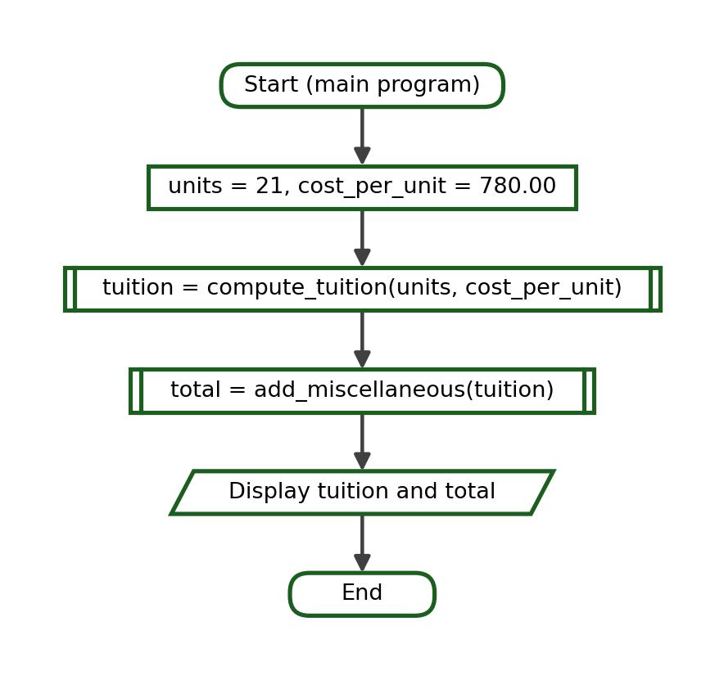
Python Program:
def compute_tuition(units, cost_per_unit):
return units * cost_per_unit

def add_miscellaneous(tuition, misc=3500.00):
return tuition + misc

tuition = compute_tuition(21, 780.00)
total = add_miscellaneous(tuition)
print(f"Tuition: ₱{tuition:.2f}")
print(f"Total Assessment: ₱{total:.2f}")

Function-Call Trace:
Step | Current Function | Arguments | Parameters / Local Values | Returned Value | Output
1 | main | - | - | - | -
2 | compute_tuition | 21, 780.0 | units = 21, cost_per_unit = 780.0 | 16380.0 | -
3 | main | - | tuition = 16380.0 | - | -
4 | add_miscellaneous | 16380.0 | tuition = 16380.0, misc = 3500.0 (default) | 19880.0 | -
5 | main | - | total = 19880.0 | - | Tuition: ₱16380.00  Total Assessment: ₱19880.00

Test Cases:
Test Case | Arguments | Expected Return
Default fee | 21, 780.00 | 19880.0
Fewer units | 15, 780.00 | 15200.0
Higher fee | 21, 780.00 with misc = 4200.00 | 20580.0

Exact Output:
Tuition: ₱16380.00
Total Assessment: ₱19880.00

Explanation. The miscellaneous fee rarely changes, which makes it a good default parameter. A different fee can still be supplied for a single call.

Example 7: Transportation Fare
Problem Statement. Compute a jeepney fare from a base fare and a per-kilometre rate, then apply a twenty-percent student discount.
Problem Decomposition:
Smaller Task | Function Name | Input Needed | Result Produced
Compute the regular fare | compute_fare | Distance, base fare, rate | The regular fare
Apply the student discount | apply_discount | The fare and a rate | The discounted fare
Display both fares | main program | Both fares | Two printed lines

Functions Needed: compute_fare(distance, base, rate) and apply_discount(fare, discount_rate)
Parameters: distance with optional base and rate; fare with an optional discount_rate
Returned Values: the regular fare and the discounted fare
IPO Table:
Input | Process | Output
distance = 12 kilometres | fare = base + distance * rate; discounted = fare - fare * 0.20 | The regular fare and the student fare

Algorithm:
1. Define compute_fare(distance, base=13.00, rate=2.25) that returns the fare.
2. Define apply_discount(fare, discount_rate=0.20) that returns the reduced fare.
3. In the main program, compute the fare for 12 kilometres.
4. Pass the fare to apply_discount and store the student fare.
5. Display the regular fare and the student fare with two decimal places.
Pseudocode:
FUNCTION compute_fare(distance, base = 13.00, rate = 2.25)
RETURN base + distance * rate
END FUNCTION

FUNCTION apply_discount(fare, discount_rate = 0.20)
RETURN fare - fare * discount_rate
END FUNCTION

MAIN
SET fare = compute_fare(12)
SET student_fare = apply_discount(fare)
DISPLAY fare, student_fare
END MAIN

Flowchart:
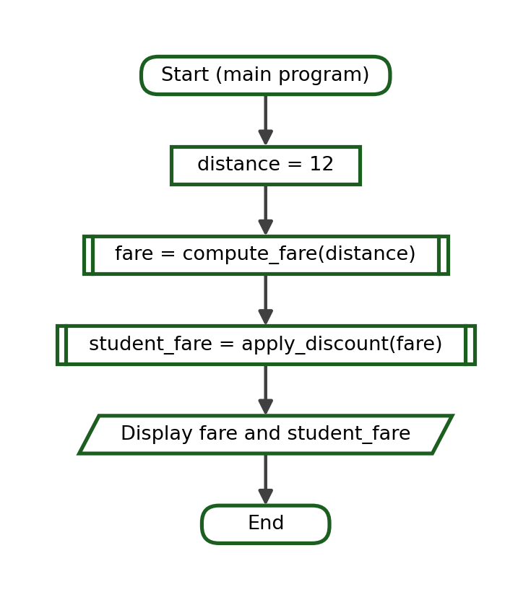
Python Program:
def compute_fare(distance, base=13.00, rate=2.25):
return base + distance * rate

def apply_discount(fare, discount_rate=0.20):
return fare - fare * discount_rate

fare = compute_fare(12)
student_fare = apply_discount(fare)
print(f"Regular Fare: ₱{fare:.2f}")
print(f"Student Fare: ₱{student_fare:.2f}")

Function-Call Trace:
Step | Current Function | Arguments | Parameters / Local Values | Returned Value | Output
1 | main | - | - | - | -
2 | compute_fare | 12 | distance = 12, base = 13.0,  rate = 2.25 (both default) | 40.0 | -
3 | main | - | fare = 40.0 | - | -
4 | apply_discount | 40.0 | fare = 40.0, discount_rate = 0.20 (default) | 32.0 | -
5 | main | - | student_fare = 32.0 | - | Regular Fare: ₱40.00  Student Fare: ₱32.00

Test Cases:
Test Case | Arguments | Expected Return
Default base and rate | 12 | 40.0 then 32.0
Zero distance | 0 | 13.0 then 10.4
Higher rate | 12 with rate = 2.50 | 43.0 then 34.4

Exact Output:
Regular Fare: ₱40.00
Student Fare: ₱32.00

Explanation. Two optional parameters keep the ordinary call short, while a keyword argument such as rate=2.50 allows one value to be changed without repeating the others.

Example 8: Sales Commission
Problem Statement. Compute the commission earned from total sales and add it to the basic pay.
Problem Decomposition:
Smaller Task | Function Name | Input Needed | Result Produced
Compute the commission | compute_commission | Sales and a rate | The commission
Add the commission to the basic pay | compute_total_pay | Basic pay and commission | The total pay
Display the pay | main program | Commission and total pay | Two printed lines

Functions Needed: compute_commission(sales, rate) and compute_total_pay(basic, commission)
Parameters: sales with an optional rate; basic and commission
Returned Values: the commission and the total pay
IPO Table:
Input | Process | Output
sales = 85000.00, basic pay = 12000.00 | commission = sales * rate; total = basic + commission | The commission and the total pay

Algorithm:
1. Define compute_commission(sales, rate=0.05) that returns the commission.
2. Define compute_total_pay(basic, commission) that returns their sum.
3. In the main program, compute the commission for 85000.00 in sales.
4. Add the commission to a basic pay of 12000.00.
5. Display the commission and the total pay with two decimal places.
Pseudocode:
FUNCTION compute_commission(sales, rate = 0.05)
RETURN sales * rate
END FUNCTION

FUNCTION compute_total_pay(basic, commission)
RETURN basic + commission
END FUNCTION

MAIN
SET commission = compute_commission(85000.00)
SET total_pay = compute_total_pay(12000.00, commission)
DISPLAY commission, total_pay
END MAIN

Flowchart:
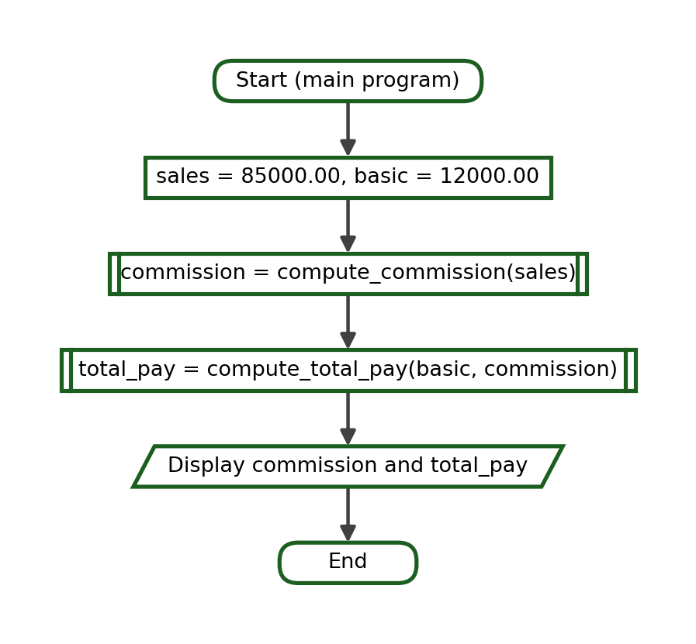
Python Program:
def compute_commission(sales, rate=0.05):
return sales * rate

def compute_total_pay(basic, commission):
return basic + commission

commission = compute_commission(85000.00)
total_pay = compute_total_pay(12000.00, commission)
print(f"Commission: ₱{commission:.2f}")
print(f"Total Pay: ₱{total_pay:.2f}")

Function-Call Trace:
Step | Current Function | Arguments | Parameters / Local Values | Returned Value | Output
1 | main | - | - | - | -
2 | compute_commission | 85000.0 | sales = 85000.0, rate = 0.05 (default) | 4250.0 | -
3 | main | - | commission = 4250.0 | - | -
4 | compute_total_pay | 12000.0, 4250.0 | basic = 12000.0, commission = 4250.0 | 16250.0 | -
5 | main | - | total_pay = 16250.0 | - | Commission: ₱4250.00  Total Pay: ₱16250.00

Test Cases:
Test Case | Arguments | Expected Return
Default rate | 85000.00 | 4250.0 then 16250.0
No sales | 0 | 0.0 then 12000.0
Higher rate | 85000.00 with rate = 0.08 | 6800.0 then 18800.0

Exact Output:
Commission: ₱4250.00
Total Pay: ₱16250.00

Explanation. The commission rate is stored once, as a default value. If the company changes the standard rate, only the function header needs to be edited.

Example 9: Electricity Bill
Problem Statement. Compute an electricity bill from the kilowatt-hours consumed, add a service fee, and add the twelve-percent tax.
Problem Decomposition:
Smaller Task | Function Name | Input Needed | Result Produced
Compute the energy charge | compute_energy_charge | Units and rate | The energy charge
Add the service fee | add_service_fee | Charge and fee | The amount before tax
Add the tax | add_tax | Amount and tax rate | The total bill

Functions Needed: compute_energy_charge, add_service_fee and add_tax
Parameters: units with an optional rate; amount with an optional fee; amount with an optional tax_rate
Returned Values: the energy charge, the amount before tax and the total bill
IPO Table:
Input | Process | Output
units = 180 kWh | charge = units * rate; charge + fee; then add twelve percent tax | The total electricity bill

Algorithm:
1. Define compute_energy_charge(units, rate=11.50) that returns the charge.
2. Define add_service_fee(amount, fee=65.00) that returns the sum.
3. Define add_tax(amount, tax_rate=0.12) that returns the amount plus the tax.
4. In the main program, call the three functions in order for 180 units.
5. Display the total bill with two decimal places.
Pseudocode:
FUNCTION compute_energy_charge(units, rate = 11.50)
RETURN units * rate
END FUNCTION

FUNCTION add_service_fee(amount, fee = 65.00)
RETURN amount + fee
END FUNCTION

FUNCTION add_tax(amount, tax_rate = 0.12)
RETURN amount + amount * tax_rate
END FUNCTION

MAIN
SET charge = compute_energy_charge(180)
SET before_tax = add_service_fee(charge)
SET total = add_tax(before_tax)
DISPLAY total
END MAIN

Flowchart:
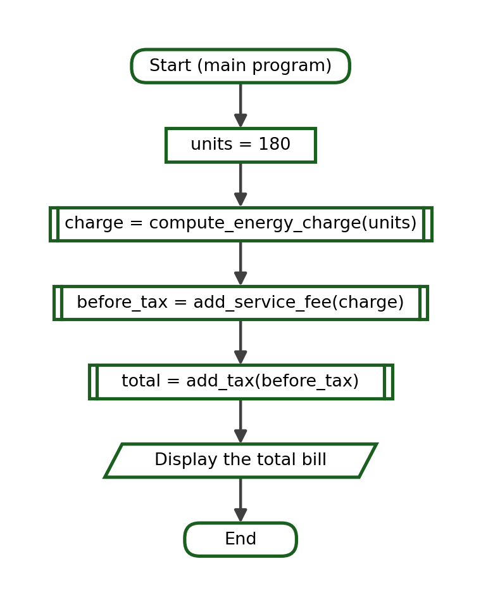
Python Program:
def compute_energy_charge(units, rate=11.50):
return units * rate

def add_service_fee(amount, fee=65.00):
return amount + fee

def add_tax(amount, tax_rate=0.12):
return amount + amount * tax_rate

charge = compute_energy_charge(180)
before_tax = add_service_fee(charge)
total = add_tax(before_tax)
print(f"Energy Charge: ₱{charge:.2f}")
print(f"Before Tax: ₱{before_tax:.2f}")
print(f"Total Bill: ₱{total:.2f}")

Function-Call Trace:
Step | Current Function | Arguments | Parameters / Local Values | Returned Value | Output
1 | main | - | - | - | -
2 | compute_energy_charge | 180 | units = 180, rate = 11.5 (default) | 2070.0 | -
3 | main | - | charge = 2070.0 | - | -
4 | add_service_fee | 2070.0 | amount = 2070.0, fee = 65.0 (default) | 2135.0 | -
5 | main | - | before_tax = 2135.0 | - | -
6 | add_tax | 2135.0 | amount = 2135.0, tax_rate = 0.12 (default) | 2391.2 | -
7 | main | - | total = 2391.2 | - | Energy Charge: ₱2070.00  Before Tax: ₱2135.00  Total Bill: ₱2391.20

Test Cases:
Test Case | Arguments | Expected Return
Normal consumption | 180 | 2391.2
No consumption | 0 | 72.8
Higher rate | 180 with rate = 12.75 | 2642.6

Exact Output:
Energy Charge: ₱2070.00
Before Tax: ₱2135.00
Total Bill: ₱2391.20

Explanation. Three small functions are easier to check than one long formula. Each stage can be printed on its own while the program is being tested.

Example 10: School Supplies Purchase
Problem Statement. Compute the amount due for a quantity of one school supply item, add a fixed packaging fee, and show the change from the amount paid.
Problem Decomposition:
Smaller Task | Function Name | Input Needed | Result Produced
Compute the amount due | compute_amount | Quantity and price | The amount due
Add the packaging fee | add_packaging | Amount and fee | The total due
Compute the change | compute_change | Payment and total | The change

Functions Needed: compute_amount, add_packaging and compute_change
Parameters: quantity and price; amount with an optional fee; payment and total
Returned Values: the amount due, the total due and the change
IPO Table:
Input | Process | Output
quantity = 12, price = 18.75, payment = 300.00 | amount = quantity * price; total = amount + fee; change = payment - total | The total due and the change

Algorithm:
1. Define compute_amount(quantity, price) that returns the product.
2. Define add_packaging(amount, fee=15.00) that returns the sum.
3. Define compute_change(payment, total) that returns the difference.
4. In the main program, call the three functions in order.
5. Display the total due and the change with two decimal places.
Pseudocode:
FUNCTION compute_amount(quantity, price)
RETURN quantity * price
END FUNCTION

FUNCTION add_packaging(amount, fee = 15.00)
RETURN amount + fee
END FUNCTION

FUNCTION compute_change(payment, total)
RETURN payment - total
END FUNCTION

MAIN
SET amount = compute_amount(12, 18.75)
SET total = add_packaging(amount)
SET change = compute_change(300.00, total)
DISPLAY total, change
END MAIN

Flowchart:
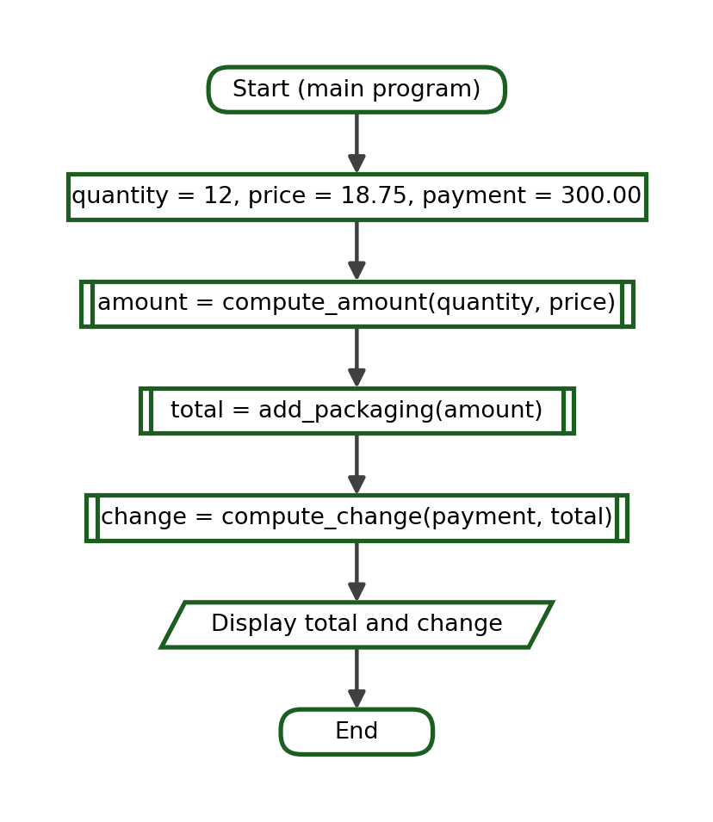
Python Program:
def compute_amount(quantity, price):
return quantity * price

def add_packaging(amount, fee=15.00):
return amount + fee

def compute_change(payment, total):
return payment - total

amount = compute_amount(12, 18.75)
total = add_packaging(amount)
change = compute_change(300.00, total)
print(f"Amount Due: ₱{amount:.2f}")
print(f"Total Due: ₱{total:.2f}")
print(f"Change: ₱{change:.2f}")

Function-Call Trace:
Step | Current Function | Arguments | Parameters / Local Values | Returned Value | Output
1 | main | - | - | - | -
2 | compute_amount | 12, 18.75 | quantity = 12, price = 18.75 | 225.0 | -
3 | main | - | amount = 225.0 | - | -
4 | add_packaging | 225.0 | amount = 225.0, fee = 15.0 (default) | 240.0 | -
5 | main | - | total = 240.0 | - | -
6 | compute_change | 300.0, 240.0 | payment = 300.0, total = 240.0 | 60.0 | -
7 | main | - | change = 60.0 | - | Amount Due: ₱225.00  Total Due: ₱240.00  Change: ₱60.00

Test Cases:
Test Case | Arguments | Expected Return
Normal purchase | 12, 18.75 with 300.00 paid | 60.0
Exact payment | 12, 18.75 with 240.00 paid | 0.0
Single item | 1, 18.75 with 50.00 paid | 16.25

Exact Output:
Amount Due: ₱225.00
Total Due: ₱240.00
Change: ₱60.00

Explanation. compute_change receives two values that were produced at different stages: one from the caller and one from an earlier function. The order of the arguments therefore matters.

Example 11: Simple Interest Computation
Problem Statement. Compute the simple interest earned on a deposit and the maturity value at the end of the term.
Problem Decomposition:
Smaller Task | Function Name | Input Needed | Result Produced
Compute the interest | compute_interest | Principal, rate and time | The interest earned
Compute the maturity value | compute_maturity | Principal and interest | The maturity value
Display both amounts | main program | Interest and maturity | Two printed lines

Functions Needed: compute_interest(principal, rate, time) and compute_maturity(principal, interest)
Parameters: principal, rate and time; principal and interest
Returned Values: the interest earned and the maturity value
IPO Table:
Input | Process | Output
principal = 25000.00, rate = 0.045, time = 3 years | interest = principal * rate * time; maturity = principal + interest | The interest and the maturity value

Algorithm:
1. Define compute_interest(principal, rate, time) that returns their product.
2. Define compute_maturity(principal, interest) that returns their sum.
3. In the main program, compute the interest on 25000.00 at 4.5 percent for 3 years.
4. Pass the principal and the interest to compute_maturity.
5. Display the interest and the maturity value with two decimal places.
Pseudocode:
FUNCTION compute_interest(principal, rate, time)
RETURN principal * rate * time
END FUNCTION

FUNCTION compute_maturity(principal, interest)
RETURN principal + interest
END FUNCTION

MAIN
SET interest = compute_interest(25000.00, 0.045, 3)
SET maturity = compute_maturity(25000.00, interest)
DISPLAY interest, maturity
END MAIN

Flowchart:
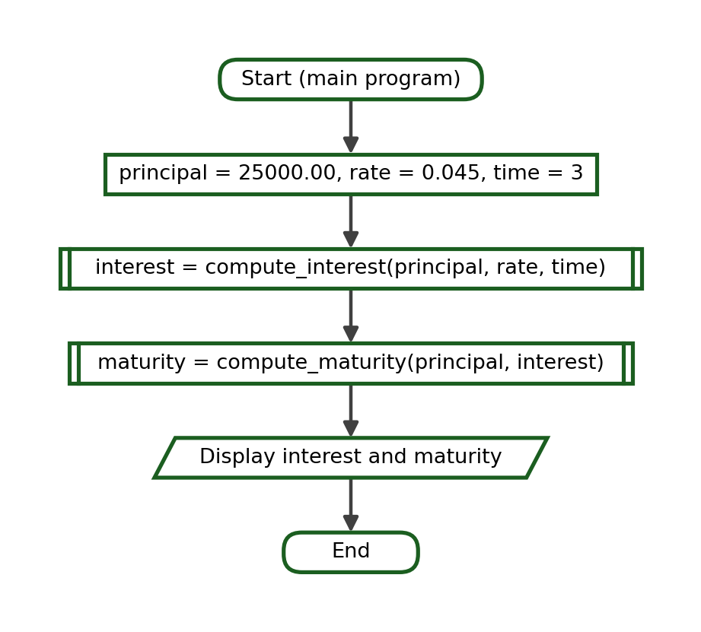
Python Program:
def compute_interest(principal, rate, time):
return principal * rate * time

def compute_maturity(principal, interest):
return principal + interest

interest = compute_interest(25000.00, 0.045, 3)
maturity = compute_maturity(25000.00, interest)
print(f"Interest: ₱{interest:.2f}")
print(f"Maturity Value: ₱{maturity:.2f}")

Function-Call Trace:
Step | Current Function | Arguments | Parameters / Local Values | Returned Value | Output
1 | main | - | - | - | -
2 | compute_interest | 25000.0, 0.045, 3 | principal = 25000.0, rate = 0.045,  time = 3 | 3375.0 | -
3 | main | - | interest = 3375.0 | - | -
4 | compute_maturity | 25000.0, 3375.0 | principal = 25000.0, interest = 3375.0 | 28375.0 | -
5 | main | - | maturity = 28375.0 | - | Interest: ₱3375.00  Maturity Value: ₱28375.00

Test Cases:
Test Case | Arguments | Expected Return
Three-year term | 25000.00, 0.045, 3 | 3375.0 then 28375.0
One-year term | 25000.00, 0.045, 1 | 1125.0 then 26125.0
Zero time | 25000.00, 0.045, 0 | 0.0 then 25000.0

Exact Output:
Interest: ₱3375.00
Maturity Value: ₱28375.00

Explanation. Three parameters must be supplied in the declared order. Writing compute_interest(0.045, 25000.00, 3) would still run and would even give the same answer here, because multiplication is commutative; with a different formula the result would be wrong.

Example 12: Employee Bonus
Problem Statement. Compute an employee's bonus from the monthly salary and the number of years in service. Employees with at least five years of service receive a higher rate.
Problem Decomposition:
Smaller Task | Function Name | Input Needed | Result Produced
Choose the bonus rate | get_bonus_rate | Years of service | The bonus rate
Compute the bonus | compute_bonus | Salary and rate | The bonus amount
Display the bonus | main program | Rate and bonus | Two printed lines

Functions Needed: get_bonus_rate(years) and compute_bonus(salary, rate)
Parameters: years; salary and rate
Returned Values: the bonus rate and the bonus amount
IPO Table:
Input | Process | Output
salary = 18500.00, years = 6 | rate = 0.20 when years >= 5, otherwise 0.10; bonus = salary * rate | The bonus rate and the bonus amount

Algorithm:
1. Define get_bonus_rate(years) that returns 0.20 when years reaches 5 and 0.10 otherwise.
2. Define compute_bonus(salary, rate) that returns the product.
3. In the main program, obtain the rate for 6 years of service.
4. Pass the salary and the returned rate to compute_bonus.
5. Display the rate as a percentage and the bonus with two decimal places.
Pseudocode:
FUNCTION get_bonus_rate(years)
IF years >= 5 THEN
RETURN 0.20
ELSE
RETURN 0.10
END IF
END FUNCTION

FUNCTION compute_bonus(salary, rate)
RETURN salary * rate
END FUNCTION

MAIN
SET rate = get_bonus_rate(6)
SET bonus = compute_bonus(18500.00, rate)
DISPLAY rate, bonus
END MAIN

Flowchart:
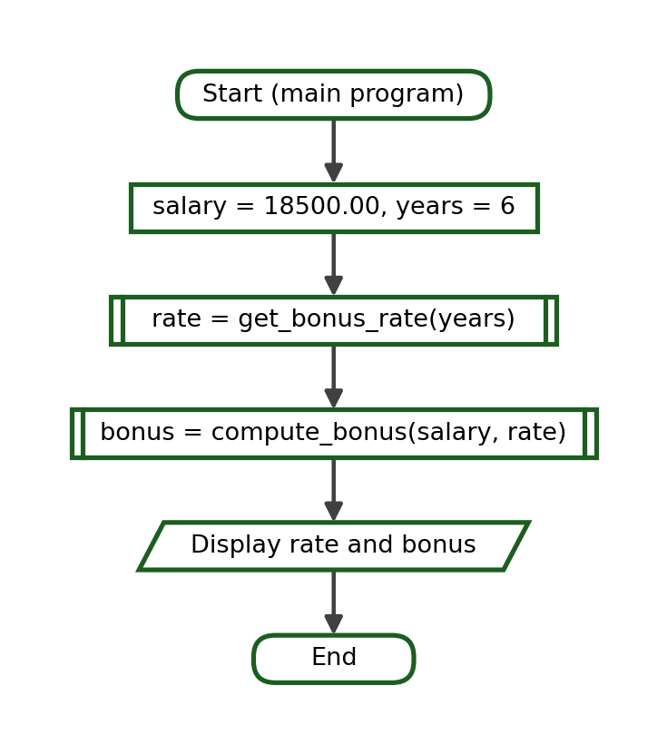
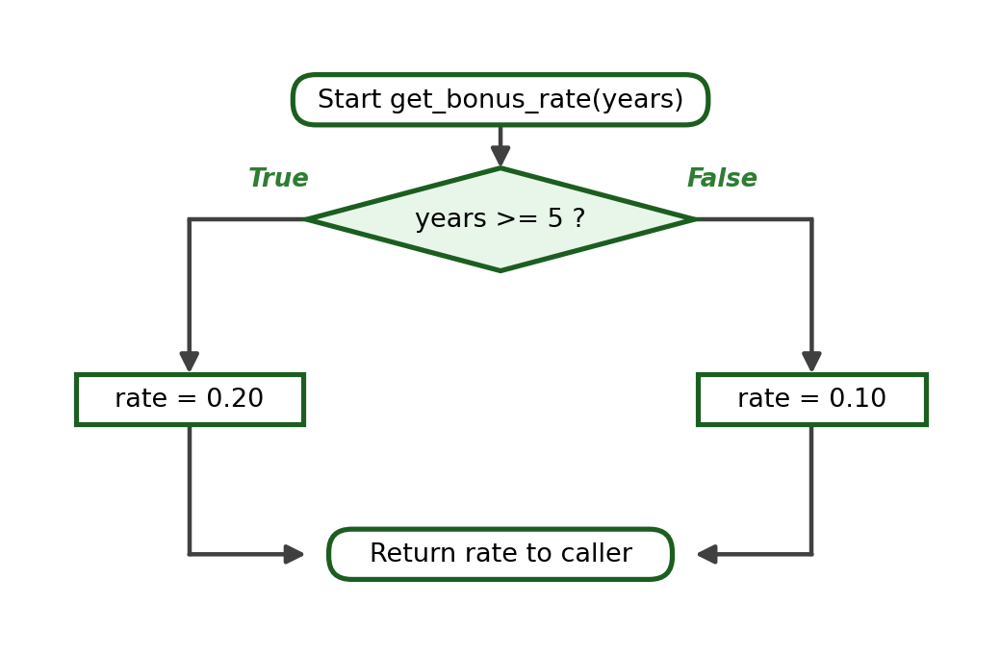
Python Program:
def get_bonus_rate(years):
if years >= 5:
return 0.20
return 0.10

def compute_bonus(salary, rate):
return salary * rate

rate = get_bonus_rate(6)
bonus = compute_bonus(18500.00, rate)
print(f"Bonus Rate: {rate * 100:.0f}%")
print(f"Bonus: ₱{bonus:.2f}")

Function-Call Trace:
Step | Current Function | Arguments | Parameters / Local Values | Returned Value | Output
1 | main | - | - | - | -
2 | get_bonus_rate | 6 | years = 6; 6 >= 5 is True | 0.2 | -
3 | main | - | rate = 0.2 | - | -
4 | compute_bonus | 18500.0, 0.2 | salary = 18500.0, rate = 0.2 | 3700.0 | -
5 | main | - | bonus = 3700.0 | - | Bonus Rate: 20%  Bonus: ₱3700.00

Test Cases:
Test Case | Arguments | Expected Return
Long service | 18500.00, 6 years | 0.2 then 3700.0
Boundary | 18500.00, 5 years | 0.2 then 3700.0
Short service | 18500.00, 4 years | 0.1 then 1850.0

Exact Output:
Bonus Rate: 20%
Bonus: ₱3700.00

Explanation. The decision is placed inside get_bonus_rate, so compute_bonus stays a plain multiplication. Separating the decision from the computation makes both functions easy to test.

21. Lecture Checkpoint Activities
The checkpoint activities below may be answered after the related lecture sections. Complete answers are provided in the Instructor's Complete Answer Key at the end of this module, not beside the exercises.

Checkpoint A - Positional or Keyword
State whether the arguments in each call are positional, keyword, mixed, or absent. Assume that each function has been defined correctly.
1.
student_info("Ana", 18, "1CPE-A")

2.
student_info(name="Ana", age=18, section="1CPE-A")

3.
compute_bill(3, 100, discount=25)

4.
greet()

5.
compute_discount(500, rate=0.15)

6.
display_student(18, "Ana")

7.
to_fahrenheit(celsius=37)

8.
rectangle_area(8, 3)

9.
student_info(section="1CPE-B", name="Leo", age=19)

10.
compute_bill(quantity=4, price=75)

Checkpoint B - Default-Parameter Tracing
Write the exact output of each program.
1.
def greet(name="Student"):
print("Welcome,", name)

greet()
greet("Marco")

2.
def compute_discount(amount, rate=0.10):
return amount * rate

print(compute_discount(500))
print(compute_discount(500, 0.20))

3.
def add_tax(price, tax=12):
return price + tax

print(add_tax(100))
print(add_tax(100, 25))

4.
def fare(distance, base=13):
return base + (distance * 2)

print(fare(5))
print(fare(5, 20))

5.
def show_line(symbol="-", count=10):
print(symbol * count)

show_line()
show_line("*")
show_line("=", 5)

6.
def total_price(quantity, price=25.00):
return quantity * price

print(total_price(4))
print(total_price(4, 10.50))

7.
def remark(grade, passing=75):
if grade >= passing:
return "Passed"
return "Failed"

print(remark(74))
print(remark(74, 70))

8.
def bonus(salary, rate=0.05):
return salary * rate

print(bonus(20000))
print(bonus(20000, rate=0.10))

9.
def label(text, prefix="Result:"):
print(prefix, text)

label(120)
label(120, "Total:")

10.
def allowance(days, daily=150):
return days * daily

print(allowance(5))
print(allowance(5, 200))

Checkpoint C - Local or Global
State whether the named variable is local or global.
1.
tax_rate = 0.12

def compute(amount):
return amount * tax_rate

Variable in question: tax_rate
2.
def compute(amount):
fee = 50
return amount + fee

Variable in question: fee
3.
def greet(name):
print("Hi,", name)

Variable in question: name
4.
school = "Pamantasan ng Cabuyao"

def show():
print(school)

Variable in question: school
5.
def average(a, b, c):
total = a + b + c
return total / 3

Variable in question: total
6.
PASSING = 75

def remark(grade):
return "Passed" if grade >= PASSING else "Failed"

Variable in question: PASSING
7.
def area(length, width):
return length * width

size = area(5, 4)

Variable in question: size
8.
def compute_net(gross):
deduction = gross * 0.10
return gross - deduction

Variable in question: deduction
9.
count = 0

def report(items):
count = items
return count

Variable in question: count inside report()
10.
def to_fahrenheit(celsius):
f = celsius * 9 / 5 + 32
return f

Variable in question: f
11.
rate = 0.05

def bonus(salary, rate):
return salary * rate

Variable in question: rate inside bonus()
12.
def show_total(a, b):
print(a + b)

result = 10

Variable in question: result

Checkpoint D - Predict the Output
Write the exact output of each short function program.
1.
def add(a, b):
return a + b

print(add(4, 6))

2.
def show(name, age):
print(name, age)

show("Ana", 18)

3.
def show(name, age):
print(name, age)

show(18, "Ana")

4.
def greet(name="Student"):
print("Welcome,", name)

greet()
greet("Liza")

5.
def compute(amount, rate=0.10):
return amount * rate

print(compute(800))

6.
def info(name, section):
print(name, "-", section)

info(section="1CPE-A", name="Marco")

7.
def double(n):
return n * 2

def add_five(n):
return n + 5

print(add_five(double(4)))

8.
def total(a, b, c):
return a + b + c

print(total(10, 20, 30) / 3)

9.
def show_total(a, b):
print(a + b)

result = show_total(3, 4)
print(result)

10.
score = 90

def show_score():
score = 75
print("Inside:", score)

show_score()
print("Outside:", score)

11.
def area(length, width=5):
return length * width

print(area(4))
print(area(4, 10))

12.
def fee(base, km):
return base + km * 12

print(fee(km=3, base=20))

13.
def grade_remark(average):
if average >= 75:
return "Passed"
return "Failed"

print(grade_remark(75))
print(grade_remark(74))

14.
def add_all(start, stop):
total = 0
for number in range(start, stop + 1):
total = total + number
return total

print(add_all(1, 5))

15.
def net(gross, deduction=500):
return gross - deduction

value = net(12000)
print(value)
print(net(12000, 1200))

Checkpoint E - Trace the Data Flow
For each program, list the value returned by every function call and write the exact output.
1.
def compute_subtotal(quantity, price):
return quantity * price

def add_delivery(subtotal):
return subtotal + 50

subtotal = compute_subtotal(3, 200)
final = add_delivery(subtotal)
print(final)

2.
def compute_average(a, b, c):
return (a + b + c) / 3

def get_remark(average):
if average >= 75:
return "Passed"
return "Failed"

avg = compute_average(80, 75, 85)
print(f"{avg:.2f}", get_remark(avg))

3.
def to_fahrenheit(celsius):
return celsius * 9 / 5 + 32

def temperature_label(fahrenheit):
if fahrenheit >= 100:
return "Hot"
return "Normal"

f = to_fahrenheit(40)
print(f, temperature_label(f))

4.
def compute_gross(rate, hours):
return rate * hours

def compute_deduction(gross):
return gross * 0.10

def compute_net(gross, deduction):
return gross - deduction

gross = compute_gross(120, 160)
deduction = compute_deduction(gross)
print(compute_net(gross, deduction))

5.
def double(n):
return n * 2

def triple(n):
return n * 3

print(triple(double(5)))

6.
def base_fare(distance):
return 13 + distance * 2

def student_fare(fare):
return fare * 0.80

print(round(student_fare(base_fare(10)), 2))

7.
def compute_area(length, width):
return length * width

def paint_cost(area, rate=25):
return area * rate

area = compute_area(6, 4)
print(paint_cost(area))

8.
def total_units(units, rate=11.50):
return units * rate

def with_tax(amount, tax_rate=0.12):
return amount + amount * tax_rate

bill = total_units(120)
print(round(with_tax(bill), 2))

9.
def get_total(a, b, c):
return a + b + c

def get_average(total, count=3):
return total / count

total = get_total(70, 80, 90)
print(get_average(total))

10.
def interest(principal, rate, time):
return principal * rate * time

def maturity(principal, earned):
return principal + earned

earned = interest(10000, 0.05, 2)
print(earned, maturity(10000, earned))

Checkpoint F - Find the Error
Each program contains one error. Identify the error and explain why it produces a wrong result or stops the program.
1.
def add(a, b):
return a + b

print(add(5))

2.
def greet(name="Student", section):
print(name, section)

3.
def area(length, width):
length * width

print(area(6, 4))

4.
def info(name, age):
print(name, age)

info(nmae="Ana", age=18)

5.
def total(a, b):
print(a + b)

result = total(4, 5)
print(result * 2)

6.
def compute_average(a, b, c):
return a + b + c / 3

print(compute_average(80, 75, 85))

7.
def bonus(salary, rate=0.05):
return salary * rate

print(bonus(rate=0.10))

8.
def show_area(length, width):
area = length * width

show_area(5, 4)
print(area)

9.
def compute_total(quantity, price):
return quantity * price

10.
def remark(grade):
if grade > 75:
return "Passed"
return "Failed"

print(remark(75))

11.
def fare(base, distance):
return base + distance * 2

print(fare(5, 13))

12.
print(square(4))

def square(n):
return n * n

Checkpoint G - Correct the Function
Each program runs without stopping, but the result is wrong. Correct the function and write the correct output.
1.
def compute_average(a, b, c):
total = a + b + c
return total

print(compute_average(80, 75, 85))

2.
def net_pay(gross, deduction):
return gross + deduction

print(net_pay(15000, 1200))

3.
def compute_final(subtotal, discount):
return subtotal
final = subtotal - discount

print(compute_final(1000, 100))

4.
def discount(amount, rate=1.10):
return amount * rate

print(discount(500))

5.
def perimeter(length, width):
return 2 * length + width

print(perimeter(6, 4))

6.
def gross_pay(rate, hours):
return rate + hours

print(gross_pay(120, 160))

7.
def to_celsius(fahrenheit):
return (fahrenheit - 32) * 9 / 5

print(to_celsius(212))

8.
def commission(sales, rate=0.05):
total = sales * rate

print(commission(50000))

9.
def compute_subtotal(quantity, price):
return quantity * price

def compute_discount(subtotal):
return subtotal * 0.10

discount = compute_discount(subtotal)
subtotal = compute_subtotal(5, 250)
print(subtotal - discount)

10.
def compute_area(length, width):
return length * width

def compute_perimeter(length, width):
return 2 * (length + width)

area = compute_area(6, 4)
print("Perimeter:", compute_area(6, 4))

WEEK 10 LABORATORY MANUAL

Laboratory Title
Laboratory Exercise 9 - Function Behavior and Data Flow

Laboratory Objectives
At the end of the laboratory session, the students should be able to:
1. Implement Python functions that exchange data through multiple parameters, positional arguments, default parameters, keyword arguments, and return values;
2. Analyze variable scope and data flow among functions through systematic function-call tracing; and
3. Test and debug individual Python functions to identify and correct errors that produce incorrect results.

Required Tools
- Desktop or laptop computer
- Python 3.x
- Visual Studio Code
- Terminal or command-line interface
- Git
- GitHub account
- Learning Management System (LMS)
- Projector (when needed)

Laboratory Rules
- Perform the activities using Visual Studio Code and the terminal.
- Run and test every Python file before submitting it.
- Follow snake_case naming for functions, parameters and variables.
- Use proper four-space indentation.
- Test each function on its own before joining it to a larger program.
- Use meaningful parameter names that describe the value received.
- Avoid unnecessary global variables; pass values through parameters and return results.
- Commit and push your work using Git commands in the terminal.
- Do not directly edit or upload source-code files through the GitHub website.
- Save all files inside the required Week 10 repository structure.
- Submit original work.
- Be prepared to explain the logic of every program you submit.
- Copying another student's source code is an academic-integrity violation.

Laboratory Preparation
Answer this short readiness activity before starting. It reviews the concepts needed for the Week 10 laboratory.
1. Write a function header for a function named compute_total that receives a quantity and a unit price.
2. Write a function call that sends 5 and 42.50 to that function.
3. Write the same call using keyword arguments.
4. Write a function header in which the parameter rate has a default value of 0.10.
5. State whether a variable created inside a function is local or global.
6. State what a function returns when it has no return statement.
7. Write the statement that stores the value returned by compute_total(5, 42.50) in a variable named amount.
8. State one reason why a function should be tested before it is joined to a larger program.

Laboratory Activity 1 - Multiple Parameters
For each program below, run the file and then identify the function name, the parameters, the arguments, the returned value and the exact output. Record your answers in the table that follows the programs.
1.
def compute_total(quantity, unit_price):
return quantity * unit_price

total = compute_total(4, 35.50)
print(f"Total: ₱{total:.2f}")

2.
def average_of_three(a, b, c):
return (a + b + c) / 3

print(f"Average: {average_of_three(88, 91, 79):.2f}")

3.
def rectangle_area(length, width):
return length * width

print("Area:", rectangle_area(12, 7))

4.
def gross_salary(rate, hours):
return rate * hours

print("Gross:", gross_salary(95, 160))

5.
def distance(speed, time):
return speed * time

print("Distance:", distance(60, 2.5), "km")

6.
def full_label(course, week, topic):
return course + " Week " + str(week) + ": " + topic

print(full_label("CPP102", 10, "Data Flow"))

7.
def simple_interest(principal, rate, time):
return principal * rate * time

print("Interest:", simple_interest(10000, 0.05, 3))

8.
def bill_amount(units, rate, service_fee):
return units * rate + service_fee

print(f"Bill: ₱{bill_amount(150, 11.25, 60):.2f}")

Answer Table (to complete for each program):
No. | Function Name | Parameters | Arguments | Returned Value | Exact Output
1
2
3
4
5
6
7
8

Laboratory Activity 2 - Positional, Default and Keyword Arguments
For each program, determine the value received by every parameter, the value returned by each call, and the exact output. State also whether each call uses positional arguments, keyword arguments, a default value, or a combination of these.
1.
def greet(name="Student"):
print("Welcome,", name)

greet()
greet("Ana")

2.
def compute_bill(quantity, price, discount=0):
subtotal = quantity * price
return subtotal - discount

print(compute_bill(3, 100))
print(compute_bill(3, 100, 25))

3.
def student_info(name, age, section):
print(name, age, section)

student_info(section="1CPE-A", name="Ana", age=18)

4.
def fare(distance, base=13.00, rate=2.00):
return base + distance * rate

print(fare(8))
print(fare(8, 15.00))
print(fare(8, rate=2.50))

5.
def commission(sales, rate=0.05):
return sales * rate

print(commission(80000))
print(commission(80000, 0.08))
print(commission(sales=80000, rate=0.10))

6.
def tuition(units, cost_per_unit=750, misc=3500):
return units * cost_per_unit + misc

print(tuition(21))
print(tuition(21, 800))
print(tuition(21, misc=4000))

7.
def show_line(symbol="=", count=20):
print(symbol * count)

show_line()
show_line("-")
show_line(count=5)

8.
def net_pay(gross, tax=0.10, other=200):
return gross - gross * tax - other

print(net_pay(20000))
print(net_pay(20000, 0.15))
print(net_pay(20000, other=500))

9.
def label_score(score, passing=75):
if score >= passing:
return "Passed"
return "Failed"

print(label_score(74))
print(label_score(74, 70))
print(label_score(score=90))

10.
def markup(cost, percent=0.20):
return cost + cost * percent

print(markup(250))
print(markup(250, 0.35))
print(markup(percent=0.50, cost=250))

11.
def savings(weekly, weeks=4, start=0):
return start + weekly * weeks

print(savings(500))
print(savings(500, 8))
print(savings(500, start=1000))

12.
def bmi(weight, height):
return weight / (height * height)

print(round(bmi(60, 1.65), 2))
print(round(bmi(height=1.70, weight=72), 2))

Answer Table (to complete for each program):
No. | Call | Parameter Values | Returned Value | Exact Output
1
2
3
4
5
6
7
8
9
10
11
12

Laboratory Activity 3 - Variable Scope
Trace each program. For every item, list the variables used, state whether each one is local or global, and write the exact output. Where the same name appears both inside and outside a function, explain which value is used in each place.
1.
total = 500

def show_total():
print(total)

show_total()

2.
def show_total():
total = 500
print(total)

show_total()

3.
score = 90

def show_score():
score = 75
print("Inside:", score)

show_score()
print("Outside:", score)

4.
rate = 0.12

def compute(amount):
return amount * rate

print(compute(1000))
print(rate)

5.
def compute(amount):
rate = 0.12
return amount * rate

print(compute(1000))

6.
name = "Ana"

def greet(name):
name = name.upper()
return name

print(greet("Leo"))
print(name)

7.
def first():
value = 10
return value

def second(number):
value = number * 3
return value

print(first())
print(second(first()))

8.
PASSING = 75

def remark(grade):
label = "Passed" if grade >= PASSING else "Failed"
return label

print(remark(80))
print(PASSING)

9.
counter = 0

def add_item(items):
counter = items + 1
return counter

print(add_item(4))
print(counter)

10.
def outer_value():
result = 7
return result

answer = outer_value()
print(answer)

Answer Table (to complete for each program):
No. | Variable | Local or Global | Value Inside the Function | Value Outside | Exact Output
1
2
3
4
5
6
7
8
9
10

Laboratory Activity 4 - Function Data Flow
Each program below uses two or more functions that pass data to one another. Complete a trace table for every program using the columns shown after the listings.
1.
def compute_subtotal(quantity, price):
return quantity * price

def compute_discount(subtotal):
if subtotal >= 1000:
return subtotal * 0.10
return 0

def compute_final(subtotal, discount):
return subtotal - discount

subtotal = compute_subtotal(5, 250)
discount = compute_discount(subtotal)
final_amount = compute_final(subtotal, discount)
print(f"Final Amount: ₱{final_amount:.2f}")

2.
def compute_average(a, b, c):
return (a + b + c) / 3

def get_remark(average):
if average >= 75:
return "Passed"
return "Failed"

avg = compute_average(78, 82, 71)
remark = get_remark(avg)
print(f"Average: {avg:.2f}")
print("Remark:", remark)

3.
def compute_gross(rate, hours):
return rate * hours

def compute_deduction(gross, percent=0.08):
return gross * percent

def compute_net(gross, deduction):
return gross - deduction

gross = compute_gross(110, 160)
deduction = compute_deduction(gross)
net = compute_net(gross, deduction)
print(f"Net Pay: ₱{net:.2f}")

4.
def to_fahrenheit(celsius):
return celsius * 9 / 5 + 32

def temperature_label(fahrenheit):
if fahrenheit >= 100:
return "Very Hot"
if fahrenheit >= 86:
return "Hot"
return "Normal"

f = to_fahrenheit(35)
label = temperature_label(f)
print(f"{f:.1f} F is {label}")

5.
def units_cost(units, rate=11.50):
return units * rate

def add_service_fee(amount, fee=65.00):
return amount + fee

def add_tax(amount, tax_rate=0.12):
return amount + amount * tax_rate

cost = units_cost(180)
with_fee = add_service_fee(cost)
total = add_tax(with_fee)
print(f"Electric Bill: ₱{total:.2f}")

6.
def compute_area(length, width):
return length * width

def compute_perimeter(length, width):
return 2 * (length + width)

def describe(area, perimeter):
return f"Area = {area}, Perimeter = {perimeter}"

a = compute_area(9, 5)
p = compute_perimeter(9, 5)
print(describe(a, p))

7.
def base_fare(distance, base=13.00, rate=2.25):
return base + distance * rate

def student_discount(fare, rate=0.20):
return fare - fare * rate

fare = base_fare(12)
final_fare = student_discount(fare)
print(f"Regular: ₱{fare:.2f}")
print(f"Student: ₱{final_fare:.2f}")

8.
def compute_interest(principal, rate, time):
return principal * rate * time

def maturity_value(principal, interest):
return principal + interest

earned = compute_interest(25000, 0.045, 3)
total = maturity_value(25000, earned)
print(f"Interest: ₱{earned:.2f}")
print(f"Maturity: ₱{total:.2f}")

Trace Table (to complete for each program):
Function | Arguments | Parameters | Local Values | Returned Value | Next Function | Final Output

Laboratory Activity 5 - Debugging Functions
Every program below runs, or almost runs, but does not produce the correct result. For each item: (1) identify the error, (2) explain why the result is incorrect, (3) correct the function, and (4) write the correct output. Most of these are logical errors rather than syntax errors, so read the formula and the order of the calls carefully.
1.
def compute_average(a, b, c):
return a + b + c / 3

print(compute_average(90, 84, 78))

2.
def remark(average):
if average > 75:
return "Passed"
return "Failed"

print(remark(75))

3.
def fare(base, distance):
return base + distance * 2.00

print(fare(9, 13.00))

4.
def net_pay(gross, deduction):
return gross - gross

print(net_pay(18000, 1500))

5.
def compute_total(quantity, price):
total = quantity * price

result = compute_total(6, 45.00)
print(result)

6.
def compute_bill(units, rate):
bill = units * rate
return bill
bill = bill + 50

print(compute_bill(100, 11.50))

7.
def compute_area(length, width):
area = length * width

compute_area(8, 3)
print(area)

8.
def discount(amount, rate=10):
return amount * rate

print(discount(500))

9.
def student_info(name, age, section):
print(name, age, section)

student_info(name="Ana", ag=18, section="1CPE-A")

10.
def compute_subtotal(quantity, price):
return quantity * price

def compute_final(subtotal, discount):
return subtotal - discount

final = compute_final(subtotal, 100)
subtotal = compute_subtotal(4, 300)
print(final)

11.
def compute_area(length, width):
return length * width

def compute_perimeter(length, width):
return 2 * (length + width)

print("Perimeter:", compute_area(7, 4))

12.
def to_fahrenheit(celsius):
return celsius * 9 / 5 + 32

def temperature_label(celsius):
if celsius >= 38:
return "Hot"
return "Normal"

f = to_fahrenheit(40)
print(temperature_label(f))

Laboratory Activity 6 - Independent Function Testing
Test each function below on its own. For every function, create a normal test case, a boundary test case and one additional test case of your own. Run each test, record the actual result, and mark the test as Pass or Fail.
1.
def get_remark(grade):
if grade >= 75:
return "Passed"
return "Failed"

Returns Passed when the grade reaches the passing mark of 75.
Test Case | Input / Argument | Expected | Actual | Pass/Fail
Normal
Boundary
Additional

2.
def compute_discount(subtotal):
if subtotal >= 1000:
return subtotal * 0.10
return 0

Returns a ten-percent discount only when the subtotal reaches 1000.
Test Case | Input / Argument | Expected | Actual | Pass/Fail
Normal
Boundary
Additional

3.
def compute_total(quantity, unit_price):
return quantity * unit_price

Returns the amount due for a purchase.
Test Case | Input / Argument | Expected | Actual | Pass/Fail
Normal
Boundary
Additional

4.
def compute_average(a, b, c):
return (a + b + c) / 3

Returns the average of three scores.
Test Case | Input / Argument | Expected | Actual | Pass/Fail
Normal
Boundary
Additional

5.
def net_pay(gross, deduction=500):
return gross - deduction

Returns the take-home pay after a deduction that defaults to 500.
Test Case | Input / Argument | Expected | Actual | Pass/Fail
Normal
Boundary
Additional

6.
def fare(distance, base=13.00, rate=2.00):
return base + distance * rate

Returns the fare for a trip, using a default base fare and rate.
Test Case | Input / Argument | Expected | Actual | Pass/Fail
Normal
Boundary
Additional

Laboratory Activity 7 - Complete Problem-Solving Tasks
Choose the problems assigned by your instructor from the list below. Every chosen problem must be solved completely and must use at least two functions that exchange data.
1. Student grade evaluator. Read three quiz scores, compute the average, and decide the remark.
2. Employee payroll. Compute the gross pay from an hourly rate and hours worked, deduct a percentage, and show the net pay.
3. Grocery discount. Compute the subtotal of a purchase, apply a discount when the subtotal reaches a set amount, and show the final amount.
4. School supply purchase. Compute the amount due for a quantity of one item and add a fixed packaging fee.
5. Electricity bill. Compute the cost of the kilowatt-hours consumed, add a service fee, and add the tax.
6. Water bill. Compute the cost of the cubic metres consumed using a minimum charge and a rate for the excess.
7. Transportation fare. Compute the fare from a base fare and a per-kilometre rate, then apply a student discount.
8. Tuition computation. Compute the tuition from the number of units and the cost per unit, then add the miscellaneous fee.
9. Sales commission. Compute the commission earned from total sales using a default commission rate.
10. Simple interest. Compute the interest earned from the principal, rate and time, then compute the maturity value.
11. Employee bonus. Compute a bonus from the monthly salary and the number of years in service.
12. Temperature conversion. Convert a Celsius reading to Fahrenheit and return a label that describes it.
13. BMI computation. Compute the body mass index from weight and height and return a category.
14. Rectangle calculator. Compute the area and the perimeter of a rectangle using two functions.
15. Allowance budget. Compute the total weekly allowance and the amount left after the daily expenses.
16. Product markup. Compute the selling price from the cost and a default markup rate, then compute the profit.
17. Savings goal. Compute the total amount saved after a number of weeks and the amount still needed to reach a goal.
Every complete problem requires:
1. Problem Analysis
2. Function Decomposition
3. IPO Table
4. Algorithm
5. Pseudocode
6. Flowchart drawn with the standard symbols
7. Python Program
8. Function-Call Trace
9. At least three test cases
10. Exact sample outputs
Model solutions for these problems are provided in the Instructor's Complete Answer Key.

Git and GitHub Workflow
Reminder. Create, test, commit and push all source files using Visual Studio Code and the terminal. Do not directly edit or upload source-code files through the GitHub website.
Suggested Repository Structure:
cpp102-week10-surname/
|__ activity1/
|__ activity2/
|__ activity3/
|__ activity4/
|__ activity5/
|__ activity6/
|__ activity7/
|__ README.md

Work inside the repository folder. After completing and testing your files, save your work with the following commands.
Terminal Commands:
git status
git add .
git commit -m "Complete CPP102 Week 10 Function Behavior and Data Flow activities"
git push

If Git reports that the index is locked, for example with an "index.lock" error, remove the lock file and repeat the command.
Troubleshooting:
rm .git/index.lock

The README.md file at the root of your repository must contain the following information.
- Student name
- Section
- Week number
- List of completed activities
- Names of the functions you created
- Parameters used by each function, including any default parameters
- Values returned by each function
- Test cases used and their results
- A short reflection on what you learned

Reflection Questions
Answer the following questions briefly and honestly on your worksheet.
1. Why is passing data through parameters better than depending excessively on global variables?
2. What is the difference between a positional argument and a keyword argument?
3. How do default parameters make a function more flexible?
4. How does a returned value move from one function to another?
5. Why is testing each function independently useful before combining functions into a larger program?
6. Which of the errors in Activity 5 was the hardest to find, and how did you finally locate it?

INSTRUCTOR'S COMPLETE ANSWER KEY
This section contains the complete answers to every lecture exercise, checkpoint activity and laboratory activity in this module. The twelve guided problem-solving examples in Section 20 and the twelve debugging cases in Section 19 are already presented with their full solutions in the lecture, and are not repeated here.

Section 4 - Positional-Argument Tracing Exercises
1.
def show_pair(first, second):
print(first, second)

show_pair("Ana", 18)

Output:
Ana 18

Answer. The first argument goes to first and the second to second.
2.
def show_pair(first, second):
print(first, second)

show_pair(18, "Ana")

Output:
18 Ana

Answer. The values are reversed because position, not meaning, decides the match.
3.
def divide(a, b):
return a / b

print(divide(10, 2))

Output:
5.0

Answer. a receives 10 and b receives 2, so the quotient is 5.0.
4.
def divide(a, b):
return a / b

print(divide(2, 10))

Output:
0.2

Answer. Swapping the arguments swaps the roles of a and b.
5.
def rectangle_area(length, width):
return length * width

print(rectangle_area(8, 3))

Output:
24

Answer. Multiplication is commutative, so the area is correct in both orders.
6.
def subtract(a, b):
return a - b

print(subtract(8, 3))
print(subtract(3, 8))

Output:
5
-5

Answer. Subtraction is not commutative, so the order changes the result.
7.
def fare(base, distance):
return base + (distance * 2)

print(fare(13, 5))

Output:
23

Answer. base receives 13 and distance receives 5.
8.
def fare(base, distance):
return base + (distance * 2)

print(fare(5, 13))

Output:
31

Answer. The program still runs, but the fare is logically wrong.

Section 6 - Keyword-Argument Exercises
1.
def student_info(name, age, section):
print(name, age, section)

student_info(name="Ana", age=18, section="1CPE-A")

Output:
Ana 18 1CPE-A

Answer. All three arguments are keyword arguments.
2.
def student_info(name, age, section):
print(name, age, section)

student_info(section="1CPE-B", age=19, name="Leo")

Output:
Leo 19 1CPE-B

Answer. Keyword arguments may be written in any order.
3.
def compute_bill(quantity, price):
return quantity * price

print(compute_bill(price=75, quantity=4))

Output:
300

Answer. The names decide the match, so the reversed order is still correct.
4.
def label(text, symbol):
print(symbol + " " + text)

label(text="Total", symbol="->")

Output:
-> Total

Answer. Keyword arguments make the meaning of each value clear.
5.
def compute_discount(amount, rate):
return amount * rate

print(compute_discount(amount=500, rate=0.15))

Output:
75.0

Answer. Both arguments are named, so no position is assumed.
6.
def to_fahrenheit(celsius):
return celsius * 9 / 5 + 32

print(to_fahrenheit(celsius=37))

Output:
98.6

Answer. A single keyword argument is also allowed.
7.
def show_grades(prelim, midterm, final):
print(prelim, midterm, final)

show_grades(88, final=91, midterm=85)

Output:
88 85 91

Answer. A positional argument may be followed by keyword arguments.
8.
def net_pay(gross, deduction):
return gross - deduction

print(net_pay(gross=12000, deduction=1500))

Output:
10500

Answer. The keyword form documents which value is which.

Section 11 - Local or Global Identification and Tracing
1.
total = 100

def show():
print(total)

show()

Output:
100

Answer. total - Global (the function only reads it).
2.
def show():
message = "Hello"
print(message)

show()

Output:
Hello

Answer. message - Local to show().
3.
rate = 0.10

def compute(amount):
return amount * rate

print(compute(500))

Output:
50.0

Answer. rate - Global; amount is local.
4.
def compute(amount):
tax = amount * 0.12
return tax

print(compute(1000))

Output:
120.0

Answer. tax - Local to compute().
5.
school = "PnC"

def display():
school = "CpE"
print(school)

display()
print(school)

Output:
CpE
PnC

Answer. school inside display() - Local; it hides the global name only inside the function.
6.
def first():
value = 5
return value

def second(number):
return number * 2

print(second(first()))

Output:
10

Answer. value - Local to first(); it reaches second() only through the returned value.
7.
counter = 0

def report(items):
counter = items
return counter

print(report(7))
print(counter)

Output:
7
0

Answer. counter inside report() - Local; the global counter is unchanged.
8.
PASSING = 75

def remark(grade):
if grade >= PASSING:
return "Passed"
return "Failed"

print(remark(80))

Output:
Passed

Answer. PASSING - Global constant read by the function.
9.
def area(length, width):
result = length * width
return result

print(area(6, 4))

Output:
24

Answer. result - Local to area().
10.
name = "Ana"

def greet(name):
return "Hello, " + name

print(greet("Leo"))
print(name)

Output:
Hello, Leo
Ana

Answer. name inside greet() - Local parameter; the global name is not affected.

Checkpoint A - Positional or Keyword
No. | Call | Answer
1 | student_info("Ana", 18, "1CPE-A") | Positional arguments only.
2 | student_info(name="Ana", age=18, section="1CPE-A") | Keyword arguments only.
3 | compute_bill(3, 100, discount=25) | Mixed: two positional arguments followed by one keyword argument.
4 | greet() | No arguments; the default parameter value is used.
5 | compute_discount(500, rate=0.15) | Mixed: one positional argument followed by one keyword argument.
6 | display_student(18, "Ana") | Positional arguments only (and, in this case, in the wrong order).
7 | to_fahrenheit(celsius=37) | Keyword argument only.
8 | rectangle_area(8, 3) | Positional arguments only.
9 | student_info(section="1CPE-B", name="Leo", age=19) | Keyword arguments only; the order differs from the definition.
10 | compute_bill(quantity=4, price=75) | Keyword arguments only.

Checkpoint B - Default-Parameter Tracing
1.
def greet(name="Student"):
print("Welcome,", name)

greet()
greet("Marco")

Output:
Welcome, Student
Welcome, Marco

2.
def compute_discount(amount, rate=0.10):
return amount * rate

print(compute_discount(500))
print(compute_discount(500, 0.20))

Output:
50.0
100.0

3.
def add_tax(price, tax=12):
return price + tax

print(add_tax(100))
print(add_tax(100, 25))

Output:
112
125

4.
def fare(distance, base=13):
return base + (distance * 2)

print(fare(5))
print(fare(5, 20))

Output:
23
30

5.
def show_line(symbol="-", count=10):
print(symbol * count)

show_line()
show_line("*")
show_line("=", 5)

Output:
----------
**********
=====

6.
def total_price(quantity, price=25.00):
return quantity * price

print(total_price(4))
print(total_price(4, 10.50))

Output:
100.0
42.0

7.
def remark(grade, passing=75):
if grade >= passing:
return "Passed"
return "Failed"

print(remark(74))
print(remark(74, 70))

Output:
Failed
Passed

8.
def bonus(salary, rate=0.05):
return salary * rate

print(bonus(20000))
print(bonus(20000, rate=0.10))

Output:
1000.0
2000.0

9.
def label(text, prefix="Result:"):
print(prefix, text)

label(120)
label(120, "Total:")

Output:
Result: 120
Total: 120

10.
def allowance(days, daily=150):
return days * daily

print(allowance(5))
print(allowance(5, 200))

Output:
750
1000

Checkpoint C - Local or Global
No. | Variable | Answer
1 | tax_rate | Global.
2 | fee | Local to compute().
3 | name | Local (it is a parameter).
4 | school | Global.
5 | total | Local to average().
6 | PASSING | Global.
7 | size | Global (it is created outside any function).
8 | deduction | Local to compute_net().
9 | count inside report() | Local; it hides the global name inside the function only.
10 | f | Local to to_fahrenheit().
11 | rate inside bonus() | Local parameter; it hides the global rate inside the function.
12 | result | Global.

Checkpoint D - Predict the Output
1.
def add(a, b):
return a + b

print(add(4, 6))

Output:
10

2.
def show(name, age):
print(name, age)

show("Ana", 18)

Output:
Ana 18

3.
def show(name, age):
print(name, age)

show(18, "Ana")

Output:
18 Ana

4.
def greet(name="Student"):
print("Welcome,", name)

greet()
greet("Liza")

Output:
Welcome, Student
Welcome, Liza

5.
def compute(amount, rate=0.10):
return amount * rate

print(compute(800))

Output:
80.0

6.
def info(name, section):
print(name, "-", section)

info(section="1CPE-A", name="Marco")

Output:
Marco - 1CPE-A

7.
def double(n):
return n * 2

def add_five(n):
return n + 5

print(add_five(double(4)))

Output:
13

8.
def total(a, b, c):
return a + b + c

print(total(10, 20, 30) / 3)

Output:
20.0

9.
def show_total(a, b):
print(a + b)

result = show_total(3, 4)
print(result)

Output:
7
None

10.
score = 90

def show_score():
score = 75
print("Inside:", score)

show_score()
print("Outside:", score)

Output:
Inside: 75
Outside: 90

11.
def area(length, width=5):
return length * width

print(area(4))
print(area(4, 10))

Output:
20
40

12.
def fee(base, km):
return base + km * 12

print(fee(km=3, base=20))

Output:
56

13.
def grade_remark(average):
if average >= 75:
return "Passed"
return "Failed"

print(grade_remark(75))
print(grade_remark(74))

Output:
Passed
Failed

14.
def add_all(start, stop):
total = 0
for number in range(start, stop + 1):
total = total + number
return total

print(add_all(1, 5))

Output:
15

15.
def net(gross, deduction=500):
return gross - deduction

value = net(12000)
print(value)
print(net(12000, 1200))

Output:
11500
10800

Checkpoint E - Trace the Data Flow
1.
def compute_subtotal(quantity, price):
return quantity * price

def add_delivery(subtotal):
return subtotal + 50

subtotal = compute_subtotal(3, 200)
final = add_delivery(subtotal)
print(final)

Function-Call Trace:
Step | Current Function | Arguments | Parameters / Local Values | Returned Value | Output
1 | main | - | - | - | -
2 | compute_subtotal | 3, 200 | quantity = 3, price = 200 | 600 | -
3 | add_delivery | 600 | subtotal = 600 | 650 | -
4 | main | - | - | - | 650

2.
def compute_average(a, b, c):
return (a + b + c) / 3

def get_remark(average):
if average >= 75:
return "Passed"
return "Failed"

avg = compute_average(80, 75, 85)
print(f"{avg:.2f}", get_remark(avg))

Function-Call Trace:
Step | Current Function | Arguments | Parameters / Local Values | Returned Value | Output
1 | main | - | - | - | -
2 | compute_average | 80, 75, 85 | a = 80, b = 75, c = 85 | 80.0 | -
3 | get_remark | 80.0 | average = 80.0 | "Passed" | -
4 | main | - | - | - | 80.00 Passed

3.
def to_fahrenheit(celsius):
return celsius * 9 / 5 + 32

def temperature_label(fahrenheit):
if fahrenheit >= 100:
return "Hot"
return "Normal"

f = to_fahrenheit(40)
print(f, temperature_label(f))

Function-Call Trace:
Step | Current Function | Arguments | Parameters / Local Values | Returned Value | Output
1 | main | - | - | - | -
2 | to_fahrenheit | 40 | celsius = 40 | 104.0 | -
3 | temperature_label | 104.0 | fahrenheit = 104.0 | "Hot" | -
4 | main | - | - | - | 104.0 Hot

4.
def compute_gross(rate, hours):
return rate * hours

def compute_deduction(gross):
return gross * 0.10

def compute_net(gross, deduction):
return gross - deduction

gross = compute_gross(120, 160)
deduction = compute_deduction(gross)
print(compute_net(gross, deduction))

Function-Call Trace:
Step | Current Function | Arguments | Parameters / Local Values | Returned Value | Output
1 | main | - | - | - | -
2 | compute_gross | 120, 160 | rate = 120, hours = 160 | 19200 | -
3 | compute_deduction | 19200 | gross = 19200 | 1920.0 | -
4 | compute_net | 19200, 1920.0 | gross = 19200, deduction = 1920.0 | 17280.0 | -
5 | main | - | - | - | 17280.0

5.
def double(n):
return n * 2

def triple(n):
return n * 3

print(triple(double(5)))

Function-Call Trace:
Step | Current Function | Arguments | Parameters / Local Values | Returned Value | Output
1 | main | - | - | - | -
2 | double | 5 | n = 5 | 10 | -
3 | triple | 10 | n = 10 | 30 | -
4 | main | - | - | - | 30

6.
def base_fare(distance):
return 13 + distance * 2

def student_fare(fare):
return fare * 0.80

print(round(student_fare(base_fare(10)), 2))

Function-Call Trace:
Step | Current Function | Arguments | Parameters / Local Values | Returned Value | Output
1 | main | - | - | - | -
2 | base_fare | 10 | distance = 10 | 33 | -
3 | student_fare | 33 | fare = 33 | 26.400000000000002 | -
4 | main | - | - | - | 26.4

7.
def compute_area(length, width):
return length * width

def paint_cost(area, rate=25):
return area * rate

area = compute_area(6, 4)
print(paint_cost(area))

Function-Call Trace:
Step | Current Function | Arguments | Parameters / Local Values | Returned Value | Output
1 | main | - | - | - | -
2 | compute_area | 6, 4 | length = 6, width = 4 | 24 | -
3 | paint_cost | 24, 25 | area = 24, rate = 25 | 600 | -
4 | main | - | - | - | 600

8.
def total_units(units, rate=11.50):
return units * rate

def with_tax(amount, tax_rate=0.12):
return amount + amount * tax_rate

bill = total_units(120)
print(round(with_tax(bill), 2))

Function-Call Trace:
Step | Current Function | Arguments | Parameters / Local Values | Returned Value | Output
1 | main | - | - | - | -
2 | total_units | 120, 11.5 | units = 120, rate = 11.5 | 1380.0 | -
3 | with_tax | 1380.0, 0.12 | amount = 1380.0, tax_rate = 0.12 | 1545.6 | -
4 | main | - | - | - | 1545.6

9.
def get_total(a, b, c):
return a + b + c

def get_average(total, count=3):
return total / count

total = get_total(70, 80, 90)
print(get_average(total))

Function-Call Trace:
Step | Current Function | Arguments | Parameters / Local Values | Returned Value | Output
1 | main | - | - | - | -
2 | get_total | 70, 80, 90 | a = 70, b = 80, c = 90 | 240 | -
3 | get_average | 240, 3 | total = 240, count = 3 | 80.0 | -
4 | main | - | - | - | 80.0

10.
def interest(principal, rate, time):
return principal * rate * time

def maturity(principal, earned):
return principal + earned

earned = interest(10000, 0.05, 2)
print(earned, maturity(10000, earned))

Function-Call Trace:
Step | Current Function | Arguments | Parameters / Local Values | Returned Value | Output
1 | main | - | - | - | -
2 | interest | 10000, 0.05, 2 | principal = 10000, rate = 0.05, time = 2 | 1000.0 | -
3 | maturity | 10000, 1000.0 | principal = 10000, earned = 1000.0 | 11000.0 | -
4 | main | - | - | - | 1000.0 11000.0

Checkpoint F - Find the Error
1.
Error. Missing required argument: add() needs two arguments but only one is given.
Correction. print(add(5, 3))
2.
Error. A parameter without a default is written after a parameter with a default.
Correction. def greet(section, name="Student"):
3.
Error. The function computes the area but never returns it, so None is printed.
Correction. return length * width
4.
Error. The keyword argument nmae is misspelled; the parameter is name.
Correction. info(name="Ana", age=18)
5.
Error. total() prints instead of returning, so result is None and cannot be multiplied.
Correction. return a + b
6.
Error. Missing parentheses: only c is divided by 3.
Correction. return (a + b + c) / 3
7.
Error. The required argument salary is missing.
Correction. print(bonus(20000, rate=0.10))
8.
Error. area is local to show_area() and cannot be used outside the function.
Correction. return area from the function and store it in the caller
9.
Error. The function body is not indented.
Correction. return quantity * price
10.
Error. Wrong comparison operator: a grade of exactly 75 should pass.
Correction. if grade >= 75:
11.
Error. Wrong argument order: 5 is used as the base fare and 13 as the distance.
Correction. print(fare(13, 5))
12.
Error. The function is called before it is defined.
Correction. Move the def block above the call.

Checkpoint G - Correct the Function
1.
Problem. The function returns the sum instead of the average.
Corrected Program:
def compute_average(a, b, c):
total = a + b + c
return total / 3

print(compute_average(80, 75, 85))

Correct Output:
80.0

2.
Problem. The deduction must be subtracted, not added.
Corrected Program:
def net_pay(gross, deduction):
return gross - deduction

print(net_pay(15000, 1200))

Correct Output:
13800

3.
Problem. The statement after return is never reached.
Corrected Program:
def compute_final(subtotal, discount):
final = subtotal - discount
return final

print(compute_final(1000, 100))

Correct Output:
900

4.
Problem. The default rate should be 0.10, not 1.10.
Corrected Program:
def discount(amount, rate=0.10):
return amount * rate

print(discount(500))

Correct Output:
50.0

5.
Problem. The formula is wrong; both dimensions must be doubled.
Corrected Program:
def perimeter(length, width):
return 2 * (length + width)

print(perimeter(6, 4))

Correct Output:
20

6.
Problem. The pay is the product of the rate and the hours, not their sum.
Corrected Program:
def gross_pay(rate, hours):
return rate * hours

print(gross_pay(120, 160))

Correct Output:
19200

7.
Problem. The conversion factor is inverted; it must be 5 / 9.
Corrected Program:
def to_celsius(fahrenheit):
return (fahrenheit - 32) * 5 / 9

print(to_celsius(212))

Correct Output:
100.0

8.
Problem. The computed commission is never returned.
Corrected Program:
def commission(sales, rate=0.05):
total = sales * rate
return total

print(commission(50000))

Correct Output:
2500.0

9.
Problem. The functions are called in the wrong sequence: the discount is computed before the subtotal exists.
Corrected Program:
def compute_subtotal(quantity, price):
return quantity * price

def compute_discount(subtotal):
return subtotal * 0.10

subtotal = compute_subtotal(5, 250)
discount = compute_discount(subtotal)
print(subtotal - discount)

Correct Output:
1125.0

10.
Problem. The wrong function's returned value is displayed as the perimeter.
Corrected Program:
def compute_area(length, width):
return length * width

def compute_perimeter(length, width):
return 2 * (length + width)

area = compute_area(6, 4)
print("Perimeter:", compute_perimeter(6, 4))

Correct Output:
Perimeter: 20

Laboratory Preparation - Answers
No. | Answer
1 | def compute_total(quantity, unit_price):
2 | compute_total(5, 42.50)
3 | compute_total(quantity=5, unit_price=42.50)
4 | def compute_discount(amount, rate=0.10):
5 | It is local; it exists only while the function is running.
6 | It returns None.
7 | amount = compute_total(5, 42.50)
8 | Testing a function on its own proves that the function itself is correct, so any remaining fault must be in the way the functions are joined.

Laboratory Activity 1 - Multiple Parameters (Answers)
No. | Function | Parameters | Arguments | Exact Output
1 | compute_total | quantity, unit_price | 4 and 35.50 | Total: ₱142.00
2 | average_of_three | a, b, c | 88, 91 and 79 | Average: 86.00
3 | rectangle_area | length, width | 12 and 7 | Area: 84
4 | gross_salary | rate, hours | 95 and 160 | Gross: 15200
5 | distance | speed, time | 60 and 2.5 | Distance: 150.0 km
6 | full_label | course, week, topic | "CPP102", 10 and "Data Flow" | CPP102 Week 10: Data Flow
7 | simple_interest | principal, rate, time | 10000, 0.05 and 3 | Interest: 1500.0
8 | bill_amount | units, rate, service_fee | 150, 11.25 and 60 | Bill: ₱1747.50

Note. The returned value of each function is the value that appears in the output line, before any formatting is applied by the caller.

Laboratory Activity 2 - Positional, Default and Keyword Arguments (Answers)
1.
def greet(name="Student"):
print("Welcome,", name)

greet()
greet("Ana")

Output:
Welcome, Student
Welcome, Ana

2.
def compute_bill(quantity, price, discount=0):
subtotal = quantity * price
return subtotal - discount

print(compute_bill(3, 100))
print(compute_bill(3, 100, 25))

Output:
300
275

3.
def student_info(name, age, section):
print(name, age, section)

student_info(section="1CPE-A", name="Ana", age=18)

Output:
Ana 18 1CPE-A

4.
def fare(distance, base=13.00, rate=2.00):
return base + distance * rate

print(fare(8))
print(fare(8, 15.00))
print(fare(8, rate=2.50))

Output:
29.0
31.0
33.0

5.
def commission(sales, rate=0.05):
return sales * rate

print(commission(80000))
print(commission(80000, 0.08))
print(commission(sales=80000, rate=0.10))

Output:
4000.0
6400.0
8000.0

6.
def tuition(units, cost_per_unit=750, misc=3500):
return units * cost_per_unit + misc

print(tuition(21))
print(tuition(21, 800))
print(tuition(21, misc=4000))

Output:
19250
20300
19750

7.
def show_line(symbol="=", count=20):
print(symbol * count)

show_line()
show_line("-")
show_line(count=5)

Output:
====================
--------------------
=====

8.
def net_pay(gross, tax=0.10, other=200):
return gross - gross * tax - other

print(net_pay(20000))
print(net_pay(20000, 0.15))
print(net_pay(20000, other=500))

Output:
17800.0
16800.0
17500.0

9.
def label_score(score, passing=75):
if score >= passing:
return "Passed"
return "Failed"

print(label_score(74))
print(label_score(74, 70))
print(label_score(score=90))

Output:
Failed
Passed
Passed

10.
def markup(cost, percent=0.20):
return cost + cost * percent

print(markup(250))
print(markup(250, 0.35))
print(markup(percent=0.50, cost=250))

Output:
300.0
337.5
375.0

11.
def savings(weekly, weeks=4, start=0):
return start + weekly * weeks

print(savings(500))
print(savings(500, 8))
print(savings(500, start=1000))

Output:
2000
4000
3000

12.
def bmi(weight, height):
return weight / (height * height)

print(round(bmi(60, 1.65), 2))
print(round(bmi(height=1.70, weight=72), 2))

Output:
22.04
24.91

Laboratory Activity 3 - Variable Scope (Answers)
1.
total = 500

def show_total():
print(total)

show_total()

Output:
500

Answer. total is global; the function only reads it.
2.
def show_total():
total = 500
print(total)

show_total()

Output:
500

Answer. total is local to show_total(); it does not exist outside the function.
3.
score = 90

def show_score():
score = 75
print("Inside:", score)

show_score()
print("Outside:", score)

Output:
Inside: 75
Outside: 90

Answer. The assignment inside the function creates a separate local score; the global score keeps its value of 90.
4.
rate = 0.12

def compute(amount):
return amount * rate

print(compute(1000))
print(rate)

Output:
120.0
0.12

Answer. rate is global and is read by compute(); amount is a local parameter.
5.
def compute(amount):
rate = 0.12
return amount * rate

print(compute(1000))

Output:
120.0

Answer. rate is local to compute(); no global rate exists.
6.
name = "Ana"

def greet(name):
name = name.upper()
return name

print(greet("Leo"))
print(name)

Output:
LEO
Ana

Answer. The parameter name is local and hides the global name inside greet(); the global name is unchanged.
7.
def first():
value = 10
return value

def second(number):
value = number * 3
return value

print(first())
print(second(first()))

Output:
10
30

Answer. Each function has its own local value; the two never interfere.
8.
PASSING = 75

def remark(grade):
label = "Passed" if grade >= PASSING else "Failed"
return label

print(remark(80))
print(PASSING)

Output:
Passed
75

Answer. PASSING is a global constant; label is local to remark().
9.
counter = 0

def add_item(items):
counter = items + 1
return counter

print(add_item(4))
print(counter)

Output:
5
0

Answer. counter inside add_item() is local, so the global counter still holds 0.
10.
def outer_value():
result = 7
return result

answer = outer_value()
print(answer)

Output:
7

Answer. result is local to outer_value(); the returned value is stored in the global variable answer.

Laboratory Activity 4 - Function Data Flow (Answers)
1.
def compute_subtotal(quantity, price):
return quantity * price

def compute_discount(subtotal):
if subtotal >= 1000:
return subtotal * 0.10
return 0

def compute_final(subtotal, discount):
return subtotal - discount

subtotal = compute_subtotal(5, 250)
discount = compute_discount(subtotal)
final_amount = compute_final(subtotal, discount)
print(f"Final Amount: ₱{final_amount:.2f}")

Complete Trace:
Step | Current Function | Arguments | Parameters / Local Values | Returned Value | Output
1 | main | - | - | - | -
2 | compute_subtotal | 5, 250 | quantity = 5, price = 250 | 1250 | -
3 | compute_discount | 1250 | subtotal = 1250 | 125.0 | -
4 | compute_final | 1250, 125.0 | subtotal = 1250, discount = 125.0 | 1125.0 | -
5 | main | - | - | - | Final Amount: ₱1125.00

2.
def compute_average(a, b, c):
return (a + b + c) / 3

def get_remark(average):
if average >= 75:
return "Passed"
return "Failed"

avg = compute_average(78, 82, 71)
remark = get_remark(avg)
print(f"Average: {avg:.2f}")
print("Remark:", remark)

Complete Trace:
Step | Current Function | Arguments | Parameters / Local Values | Returned Value | Output
1 | main | - | - | - | -
2 | compute_average | 78, 82, 71 | a = 78, b = 82, c = 71 | 77.0 | -
3 | get_remark | 77.0 | average = 77.0 | "Passed" | -
4 | main | - | - | - | Average: 77.00  Remark: Passed

3.
def compute_gross(rate, hours):
return rate * hours

def compute_deduction(gross, percent=0.08):
return gross * percent

def compute_net(gross, deduction):
return gross - deduction

gross = compute_gross(110, 160)
deduction = compute_deduction(gross)
net = compute_net(gross, deduction)
print(f"Net Pay: ₱{net:.2f}")

Complete Trace:
Step | Current Function | Arguments | Parameters / Local Values | Returned Value | Output
1 | main | - | - | - | -
2 | compute_gross | 110, 160 | rate = 110, hours = 160 | 17600 | -
3 | compute_deduction | 17600, 0.08 | gross = 17600, percent = 0.08 | 1408.0 | -
4 | compute_net | 17600, 1408.0 | gross = 17600, deduction = 1408.0 | 16192.0 | -
5 | main | - | - | - | Net Pay: ₱16192.00

4.
def to_fahrenheit(celsius):
return celsius * 9 / 5 + 32

def temperature_label(fahrenheit):
if fahrenheit >= 100:
return "Very Hot"
if fahrenheit >= 86:
return "Hot"
return "Normal"

f = to_fahrenheit(35)
label = temperature_label(f)
print(f"{f:.1f} F is {label}")

Complete Trace:
Step | Current Function | Arguments | Parameters / Local Values | Returned Value | Output
1 | main | - | - | - | -
2 | to_fahrenheit | 35 | celsius = 35 | 95.0 | -
3 | temperature_label | 95.0 | fahrenheit = 95.0 | "Hot" | -
4 | main | - | - | - | 95.0 F is Hot

5.
def units_cost(units, rate=11.50):
return units * rate

def add_service_fee(amount, fee=65.00):
return amount + fee

def add_tax(amount, tax_rate=0.12):
return amount + amount * tax_rate

cost = units_cost(180)
with_fee = add_service_fee(cost)
total = add_tax(with_fee)
print(f"Electric Bill: ₱{total:.2f}")

Complete Trace:
Step | Current Function | Arguments | Parameters / Local Values | Returned Value | Output
1 | main | - | - | - | -
2 | units_cost | 180, 11.5 | units = 180, rate = 11.5 | 2070.0 | -
3 | add_service_fee | 2070.0, 65.0 | amount = 2070.0, fee = 65.0 | 2135.0 | -
4 | add_tax | 2135.0, 0.12 | amount = 2135.0, tax_rate = 0.12 | 2391.2 | -
5 | main | - | - | - | Electric Bill: ₱2391.20

6.
def compute_area(length, width):
return length * width

def compute_perimeter(length, width):
return 2 * (length + width)

def describe(area, perimeter):
return f"Area = {area}, Perimeter = {perimeter}"

a = compute_area(9, 5)
p = compute_perimeter(9, 5)
print(describe(a, p))

Complete Trace:
Step | Current Function | Arguments | Parameters / Local Values | Returned Value | Output
1 | main | - | - | - | -
2 | compute_area | 9, 5 | length = 9, width = 5 | 45 | -
3 | compute_perimeter | 9, 5 | length = 9, width = 5 | 28 | -
4 | describe | 45, 28 | area = 45, perimeter = 28 | "Area = 45, Perimeter = 28" | -
5 | main | - | - | - | Area = 45, Perimeter = 28

7.
def base_fare(distance, base=13.00, rate=2.25):
return base + distance * rate

def student_discount(fare, rate=0.20):
return fare - fare * rate

fare = base_fare(12)
final_fare = student_discount(fare)
print(f"Regular: ₱{fare:.2f}")
print(f"Student: ₱{final_fare:.2f}")

Complete Trace:
Step | Current Function | Arguments | Parameters / Local Values | Returned Value | Output
1 | main | - | - | - | -
2 | base_fare | 12, 13.0, 2.25 | distance = 12, base = 13.0, rate = 2.25 | 40.0 | -
3 | student_discount | 40.0, 0.2 | fare = 40.0, rate = 0.2 | 32.0 | -
4 | main | - | - | - | Regular: ₱40.00  Student: ₱32.00

8.
def compute_interest(principal, rate, time):
return principal * rate * time

def maturity_value(principal, interest):
return principal + interest

earned = compute_interest(25000, 0.045, 3)
total = maturity_value(25000, earned)
print(f"Interest: ₱{earned:.2f}")
print(f"Maturity: ₱{total:.2f}")

Complete Trace:
Step | Current Function | Arguments | Parameters / Local Values | Returned Value | Output
1 | main | - | - | - | -
2 | compute_interest | 25000, 0.045, 3 | principal = 25000, rate = 0.045, time = 3 | 3375.0 | -
3 | maturity_value | 25000, 3375.0 | principal = 25000, interest = 3375.0 | 28375.0 | -
4 | main | - | - | - | Interest: ₱3375.00  Maturity: ₱28375.00

Laboratory Activity 5 - Debugging Functions (Answers)
1.
Error. Missing parentheses. Only c is divided by 3, so the returned value is not the average.
Corrected Program:
def compute_average(a, b, c):
return (a + b + c) / 3

print(compute_average(90, 84, 78))

Correct Output:
84.0

2.
Error. Wrong comparison operator. A student whose average is exactly 75 should pass.
Corrected Program:
def remark(average):
if average >= 75:
return "Passed"
return "Failed"

print(remark(75))

Correct Output:
Passed

3.
Error. Wrong argument order. 9 is used as the base fare and 13.00 as the distance.
Corrected Program:
def fare(base, distance):
return base + distance * 2.00

print(fare(13.00, 9))

Correct Output:
31.0

4.
Error. The wrong variable is used in the formula; deduction is ignored.
Corrected Program:
def net_pay(gross, deduction):
return gross - deduction

print(net_pay(18000, 1500))

Correct Output:
16500

5.
Error. The function never returns the total, so result is None.
Corrected Program:
def compute_total(quantity, price):
total = quantity * price
return total

result = compute_total(6, 45.00)
print(result)

Correct Output:
270.0

6.
Error. The service fee is added after return, so that line never runs.
Corrected Program:
def compute_bill(units, rate):
bill = units * rate
bill = bill + 50
return bill

print(compute_bill(100, 11.50))

Correct Output:
1200.0

7.
Error. area is a local variable and does not exist outside compute_area().
Corrected Program:
def compute_area(length, width):
area = length * width
return area

area = compute_area(8, 3)
print(area)

Correct Output:
24

8.
Error. The default value should be the decimal 0.10, not the whole number 10.
Corrected Program:
def discount(amount, rate=0.10):
return amount * rate

print(discount(500))

Correct Output:
50.0

9.
Error. The keyword argument ag does not match the parameter age.
Corrected Program:
def student_info(name, age, section):
print(name, age, section)

student_info(name="Ana", age=18, section="1CPE-A")

Correct Output:
Ana 18 1CPE-A

10.
Error. The functions are called in the wrong sequence; subtotal does not exist yet.
Corrected Program:
def compute_subtotal(quantity, price):
return quantity * price

def compute_final(subtotal, discount):
return subtotal - discount

subtotal = compute_subtotal(4, 300)
final = compute_final(subtotal, 100)
print(final)

Correct Output:
1100

11.
Error. The returned value of the wrong function is displayed.
Corrected Program:
def compute_area(length, width):
return length * width

def compute_perimeter(length, width):
return 2 * (length + width)

print("Perimeter:", compute_perimeter(7, 4))

Correct Output:
Perimeter: 22

12.
Error. The Fahrenheit value is passed to a function that expects a Celsius value.
Corrected Program:
def to_fahrenheit(celsius):
return celsius * 9 / 5 + 32

def temperature_label(celsius):
if celsius >= 38:
return "Hot"
return "Normal"

celsius = 40
f = to_fahrenheit(celsius)
print(temperature_label(celsius))

Correct Output:
Hot

Laboratory Activity 6 - Independent Function Testing (Answers)
1.
def get_remark(grade):
if grade >= 75:
return "Passed"
return "Failed"

Test Case | Input / Argument | Expected | Actual | Pass/Fail
Normal passing | get_remark(85) | Passed | Passed | Pass
Boundary | get_remark(75) | Passed | Passed | Pass
Below boundary | get_remark(74) | Failed | Failed | Pass

Verification Program:
def get_remark(grade):
if grade >= 75:
return "Passed"
return "Failed"

print(get_remark(85))
print(get_remark(75))
print(get_remark(74))

Actual Output:
Passed
Passed
Failed

2.
def compute_discount(subtotal):
if subtotal >= 1000:
return subtotal * 0.10
return 0

Test Case | Input / Argument | Expected | Actual | Pass/Fail
Normal | compute_discount(1500) | 150.0 | 150.0 | Pass
Boundary | compute_discount(1000) | 100.0 | 100.0 | Pass
Below boundary | compute_discount(999) | 0 | 0 | Pass

Verification Program:
def compute_discount(subtotal):
if subtotal >= 1000:
return subtotal * 0.10
return 0

print(compute_discount(1500))
print(compute_discount(1000))
print(compute_discount(999))

Actual Output:
150.0
100.0
0

3.
def compute_total(quantity, unit_price):
return quantity * unit_price

Test Case | Input / Argument | Expected | Actual | Pass/Fail
Normal | compute_total(4, 35.50) | 142.0 | 142.0 | Pass
Zero quantity | compute_total(0, 35.50) | 0.0 | 0.0 | Pass
Single item | compute_total(1, 35.50) | 35.5 | 35.5 | Pass

Verification Program:
def compute_total(quantity, unit_price):
return quantity * unit_price

print(compute_total(4, 35.50))
print(compute_total(0, 35.50))
print(compute_total(1, 35.50))

Actual Output:
142.0
0.0
35.5

4.
def compute_average(a, b, c):
return (a + b + c) / 3

Test Case | Input / Argument | Expected | Actual | Pass/Fail
Normal | compute_average(80, 75, 85) | 80.0 | 80.0 | Pass
All equal | compute_average(75, 75, 75) | 75.0 | 75.0 | Pass
With zero | compute_average(0, 75, 75) | 50.0 | 50.0 | Pass

Verification Program:
def compute_average(a, b, c):
return (a + b + c) / 3

print(compute_average(80, 75, 85))
print(compute_average(75, 75, 75))
print(compute_average(0, 75, 75))

Actual Output:
80.0
75.0
50.0

5.
def net_pay(gross, deduction=500):
return gross - deduction

Test Case | Input / Argument | Expected | Actual | Pass/Fail
Default used | net_pay(12000) | 11500 | 11500 | Pass
Default replaced | net_pay(12000, 1200) | 10800 | 10800 | Pass
No deduction | net_pay(12000, 0) | 12000 | 12000 | Pass

Verification Program:
def net_pay(gross, deduction=500):
return gross - deduction

print(net_pay(12000))
print(net_pay(12000, 1200))
print(net_pay(12000, 0))

Actual Output:
11500
10800
12000

6.
def fare(distance, base=13.00, rate=2.00):
return base + distance * rate

Test Case | Input / Argument | Expected | Actual | Pass/Fail
Default used | fare(5) | 23.0 | 23.0 | Pass
Zero distance | fare(0) | 13.0 | 13.0 | Pass
Rate replaced | fare(5, 13.00, 2.50) | 25.5 | 25.5 | Pass

Verification Program:
def fare(distance, base=13.00, rate=2.00):
return base + distance * rate

print(fare(5))
print(fare(0))
print(fare(5, 13.00, 2.50))

Actual Output:
23.0
13.0
25.5

Laboratory Activity 7 - Complete Problem-Solving Tasks (Model Solutions)
Each model solution below uses at least two functions that exchange data. The trace tables were produced by following the programs step by step, and every output shown is the exact output of the program as written.

Problem 1: Student Grade Evaluator
Problem Analysis. Read three quiz scores, compute the average, and decide the remark. One function computes the average and another decides the remark.
Function Decomposition:
Required Task | Function Name | Parameters | Return Value
Compute the average | compute_average | a, b, c | The average
Decide the remark | get_remark | average | "Passed" or "Failed"
Display the results | main program | - | Two printed lines

IPO Table:
Input | Process | Output
Three scores: 91, 68, 78 | average = (a + b + c) / 3; compare with 75 | The average and the remark

Algorithm:
1. Define compute_average(a, b, c) that returns the average.
2. Define get_remark(average) that returns Passed or Failed.
3. Call compute_average with the three scores.
4. Pass the returned average to get_remark.
5. Display the average and the remark.
Pseudocode:
FUNCTION compute_average(a, b, c)
RETURN (a + b + c) / 3
END FUNCTION

FUNCTION get_remark(average)
IF average >= 75 THEN
RETURN "Passed"
ELSE
RETURN "Failed"
END IF
END FUNCTION

MAIN
SET average = compute_average(91, 68, 78)
SET remark = get_remark(average)
DISPLAY average, remark
END MAIN

Flowchart:
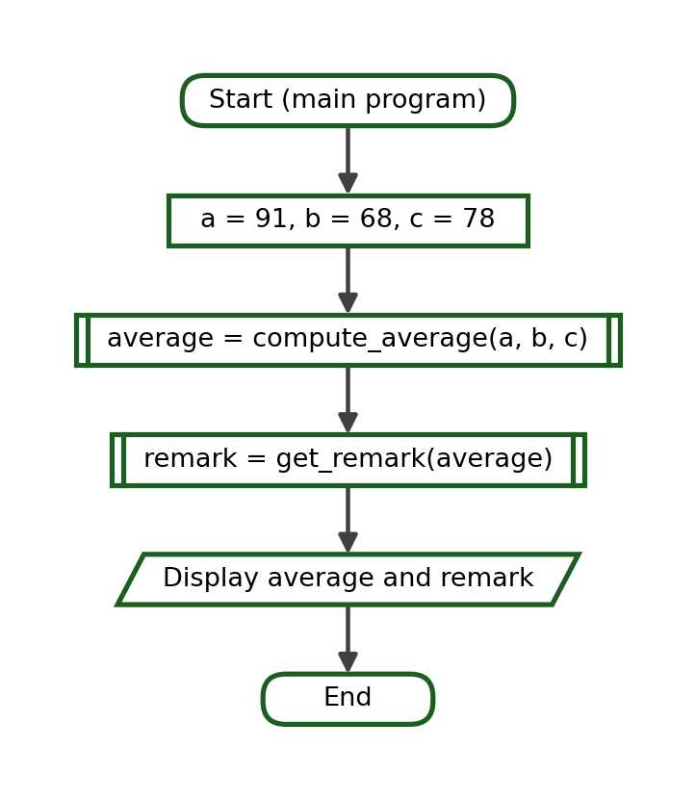
Complete Python Program:
def compute_average(a, b, c):
return (a + b + c) / 3

def get_remark(average):
if average >= 75:
return "Passed"
return "Failed"

average = compute_average(91, 68, 78)
remark = get_remark(average)
print(f"Average: {average:.2f}")
print("Remark:", remark)

Function-Call Trace:
Step | Current Function | Arguments | Parameters / Local Values | Returned Value | Output
1 | main | - | - | - | -
2 | compute_average | 91, 68, 78 | a = 91, b = 68, c = 78 | 79.0 | -
3 | get_remark | 79.0 | average = 79.0 | "Passed" | -
4 | main | - | - | - | Average: 79.00  Remark: Passed

Test Cases:
Test Case | Call | Returned Value
Normal passing | compute_average(91, 68, 78) | 79.0
Boundary remark | get_remark(75) | Passed
Below boundary | get_remark(74.99) | Failed

Exact Output:
Average: 79.00
Remark: Passed

Explanation. The average is returned as a decimal and is passed unchanged to get_remark. The boundary value 75 returns Passed because the condition uses >=.

Problem 2: Employee Payroll
Problem Analysis. Compute the gross pay from an hourly rate and the hours worked, deduct ten percent, and show the net pay.
Function Decomposition:
Required Task | Function Name | Parameters | Return Value
Compute the gross pay | compute_gross | rate, hours | The gross pay
Compute the deduction | compute_deduction | gross, rate | The deduction
Compute the net pay | compute_net | gross, deduction | The net pay

IPO Table:
Input | Process | Output
rate = 98.75, hours = 176 | gross = rate * hours; deduction = gross * 0.10; net = gross - deduction | The gross pay, the deduction and the net pay

Algorithm:
1. Define compute_gross(rate, hours) that returns the product.
2. Define compute_deduction(gross, rate=0.10) that returns the deduction.
3. Define compute_net(gross, deduction) that returns the difference.
4. Call the three functions in order, storing every returned value.
5. Display the three amounts with two decimal places.
Pseudocode:
FUNCTION compute_gross(rate, hours)
RETURN rate * hours
END FUNCTION

FUNCTION compute_deduction(gross, rate = 0.10)
RETURN gross * rate
END FUNCTION

FUNCTION compute_net(gross, deduction)
RETURN gross - deduction
END FUNCTION

MAIN
SET gross = compute_gross(98.75, 176)
SET deduction = compute_deduction(gross)
SET net = compute_net(gross, deduction)
DISPLAY gross, deduction, net
END MAIN

Flowchart:
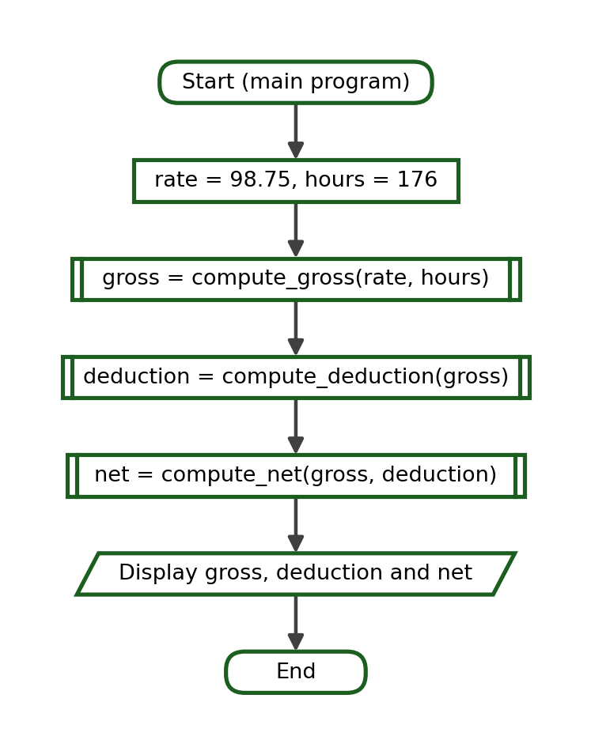
Complete Python Program:
def compute_gross(rate, hours):
return rate * hours

def compute_deduction(gross, rate=0.10):
return gross * rate

def compute_net(gross, deduction):
return gross - deduction

gross = compute_gross(98.75, 176)
deduction = compute_deduction(gross)
net = compute_net(gross, deduction)
print(f"Gross Pay: ₱{gross:.2f}")
print(f"Deduction: ₱{deduction:.2f}")
print(f"Net Pay: ₱{net:.2f}")

Function-Call Trace:
Step | Current Function | Arguments | Parameters / Local Values | Returned Value | Output
1 | main | - | - | - | -
2 | compute_gross | 98.75, 176 | rate = 98.75, hours = 176 | 17380.0 | -
3 | compute_deduction | 17380.0, 0.1 | gross = 17380.0, rate = 0.1 | 1738.0 | -
4 | compute_net | 17380.0, 1738.0 | gross = 17380.0, deduction = 1738.0 | 15642.0 | -
5 | main | - | - | - | Gross Pay: ₱17380.00  Deduction: ₱1738.00  Net Pay: ₱15642.00

Test Cases:
Test Case | Call | Returned Value
Normal payroll | compute_gross(98.75, 176) | 17380.0
Default deduction | compute_deduction(17380.0) | 1738.0
Higher deduction | compute_deduction(17380.0, 0.15) | 2607.0

Exact Output:
Gross Pay: ₱17380.00
Deduction: ₱1738.00
Net Pay: ₱15642.00

Explanation. compute_deduction has a default rate, so the ordinary call needs only one argument. A different rate can be supplied without editing the function.

Problem 3: Grocery Discount
Problem Analysis. Compute the subtotal of a grocery purchase, apply a five-percent discount when the subtotal reaches 500, and show the amount due.
Function Decomposition:
Required Task | Function Name | Parameters | Return Value
Compute the subtotal | compute_subtotal | quantity, price | The subtotal
Compute the discount | compute_discount | subtotal | The discount amount
Compute the amount due | compute_due | subtotal, discount | The amount due

IPO Table:
Input | Process | Output
quantity = 9, price = 74.50 | subtotal = quantity * price; discount when subtotal >= 500; due = subtotal - discount | The amount due

Algorithm:
1. Define compute_subtotal(quantity, price) that returns the product.
2. Define compute_discount(subtotal) that returns five percent of the subtotal when it reaches 500, and 0 otherwise.
3. Define compute_due(subtotal, discount) that returns the difference.
4. Call the three functions in order.
5. Display the subtotal, the discount and the amount due.
Pseudocode:
FUNCTION compute_subtotal(quantity, price)
RETURN quantity * price
END FUNCTION

FUNCTION compute_discount(subtotal)
IF subtotal >= 500 THEN
RETURN subtotal * 0.05
ELSE
RETURN 0
END IF
END FUNCTION

FUNCTION compute_due(subtotal, discount)
RETURN subtotal - discount
END FUNCTION

MAIN
SET subtotal = compute_subtotal(9, 74.50)
SET discount = compute_discount(subtotal)
SET due = compute_due(subtotal, discount)
DISPLAY subtotal, discount, due
END MAIN

Flowchart:
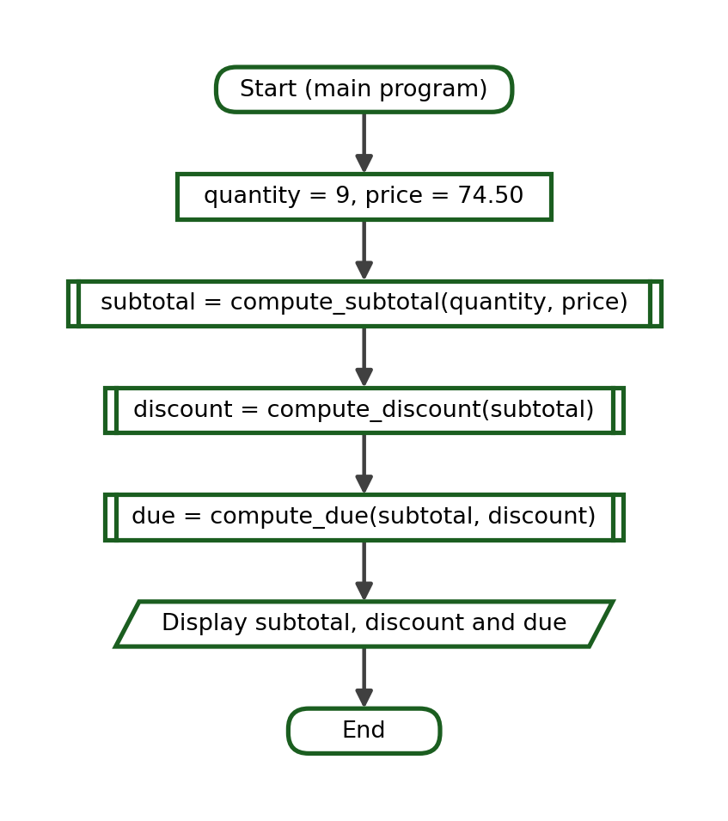
Complete Python Program:
def compute_subtotal(quantity, price):
return quantity * price

def compute_discount(subtotal):
if subtotal >= 500:
return subtotal * 0.05
return 0

def compute_due(subtotal, discount):
return subtotal - discount

subtotal = compute_subtotal(9, 74.50)
discount = compute_discount(subtotal)
due = compute_due(subtotal, discount)
print(f"Subtotal: ₱{subtotal:.2f}")
print(f"Discount: ₱{discount:.2f}")
print(f"Amount Due: ₱{due:.2f}")

Function-Call Trace:
Step | Current Function | Arguments | Parameters / Local Values | Returned Value | Output
1 | main | - | - | - | -
2 | compute_subtotal | 9, 74.5 | quantity = 9, price = 74.5 | 670.5 | -
3 | compute_discount | 670.5 | subtotal = 670.5 | 33.525 | -
4 | compute_due | 670.5, 33.525 | subtotal = 670.5, discount = 33.525 | 636.975 | -
5 | main | - | - | - | Subtotal: ₱670.50  Discount: ₱33.52  Amount Due: ₱636.98

Test Cases:
Test Case | Call | Returned Value
Discount applies | compute_discount(670.5) | 33.525
Boundary subtotal | compute_discount(500) | 25.0
No discount | compute_discount(499.99) | 0

Exact Output:
Subtotal: ₱670.50
Discount: ₱33.52
Amount Due: ₱636.98

Explanation. The discount rule is held in one function, so the store can change the threshold or the rate in a single place.

Problem 4: School Supply Purchase
Problem Analysis. Compute the amount due for a quantity of one item, add a fixed packaging fee, and compute the change from the payment.
Function Decomposition:
Required Task | Function Name | Parameters | Return Value
Compute the amount | compute_amount | quantity, price | The amount
Add the packaging fee | add_fee | amount, fee | The total due
Compute the change | compute_change | payment, total | The change

IPO Table:
Input | Process | Output
quantity = 15, price = 12.50, payment = 250.00 | amount = quantity * price; total = amount + fee; change = payment - total | The total due and the change

Algorithm:
1. Define compute_amount(quantity, price) that returns the product.
2. Define add_fee(amount, fee=20.00) that returns the sum.
3. Define compute_change(payment, total) that returns the difference.
4. Call the three functions in order.
5. Display the total due and the change.
Pseudocode:
FUNCTION compute_amount(quantity, price)
RETURN quantity * price
END FUNCTION

FUNCTION add_fee(amount, fee = 20.00)
RETURN amount + fee
END FUNCTION

FUNCTION compute_change(payment, total)
RETURN payment - total
END FUNCTION

MAIN
SET amount = compute_amount(15, 12.50)
SET total = add_fee(amount)
SET change = compute_change(250.00, total)
DISPLAY total, change
END MAIN

Flowchart:
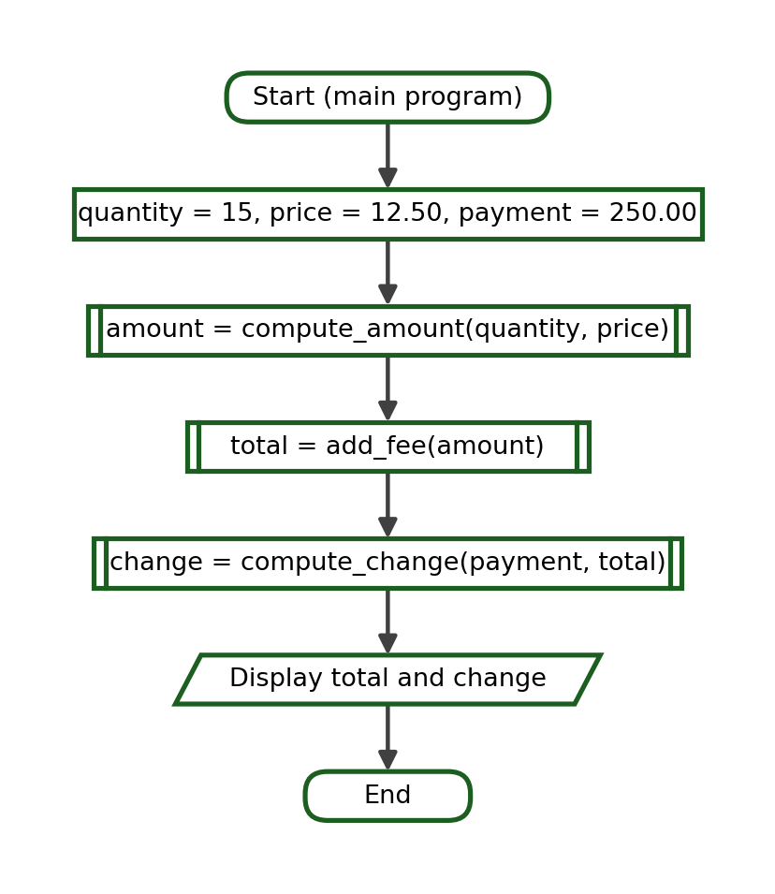
Complete Python Program:
def compute_amount(quantity, price):
return quantity * price

def add_fee(amount, fee=20.00):
return amount + fee

def compute_change(payment, total):
return payment - total

amount = compute_amount(15, 12.50)
total = add_fee(amount)
change = compute_change(250.00, total)
print(f"Amount: ₱{amount:.2f}")
print(f"Total Due: ₱{total:.2f}")
print(f"Change: ₱{change:.2f}")

Function-Call Trace:
Step | Current Function | Arguments | Parameters / Local Values | Returned Value | Output
1 | main | - | - | - | -
2 | compute_amount | 15, 12.5 | quantity = 15, price = 12.5 | 187.5 | -
3 | add_fee | 187.5, 20.0 | amount = 187.5, fee = 20.0 | 207.5 | -
4 | compute_change | 250.0, 207.5 | payment = 250.0, total = 207.5 | 42.5 | -
5 | main | - | - | - | Amount: ₱187.50  Total Due: ₱207.50  Change: ₱42.50

Test Cases:
Test Case | Call | Returned Value
Normal purchase | compute_amount(15, 12.50) | 187.5
Default fee | add_fee(187.5) | 207.5
Exact payment | compute_change(207.5, 207.5) | 0.0

Exact Output:
Amount: ₱187.50
Total Due: ₱207.50
Change: ₱42.50

Explanation. compute_change receives one value from the caller and one from an earlier function, so the order of its two arguments must be read carefully.

Problem 5: Electricity Bill
Problem Analysis. Compute the energy charge for the kilowatt-hours consumed, add a service fee, and add the twelve-percent tax.
Function Decomposition:
Required Task | Function Name | Parameters | Return Value
Compute the energy charge | energy_charge | units, rate | The energy charge
Add the service fee | add_service_fee | amount, fee | The amount before tax
Add the tax | add_tax | amount, tax_rate | The total bill

IPO Table:
Input | Process | Output
units = 235 kWh | charge = units * rate; add the fee; add twelve percent tax | The total electricity bill

Algorithm:
1. Define energy_charge(units, rate=11.75) that returns the charge.
2. Define add_service_fee(amount, fee=70.00) that returns the sum.
3. Define add_tax(amount, tax_rate=0.12) that returns the taxed amount.
4. Call the three functions in order.
5. Display each stage with two decimal places.
Pseudocode:
FUNCTION energy_charge(units, rate = 11.75)
RETURN units * rate
END FUNCTION

FUNCTION add_service_fee(amount, fee = 70.00)
RETURN amount + fee
END FUNCTION

FUNCTION add_tax(amount, tax_rate = 0.12)
RETURN amount + amount * tax_rate
END FUNCTION

MAIN
SET charge = energy_charge(235)
SET before_tax = add_service_fee(charge)
SET total = add_tax(before_tax)
DISPLAY charge, before_tax, total
END MAIN

Flowchart:
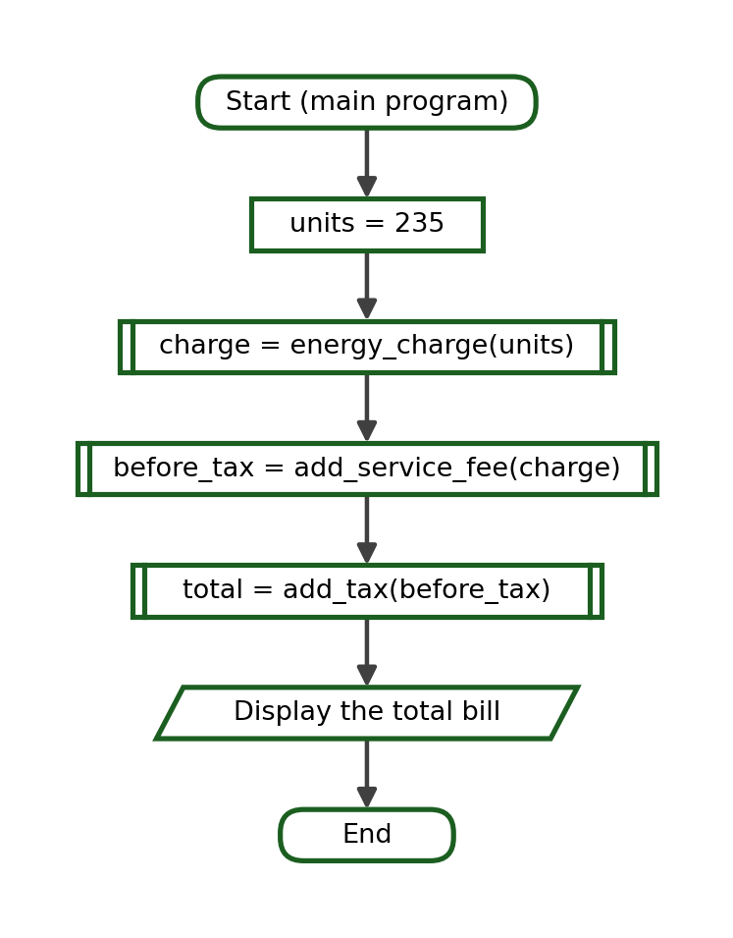
Complete Python Program:
def energy_charge(units, rate=11.75):
return units * rate

def add_service_fee(amount, fee=70.00):
return amount + fee

def add_tax(amount, tax_rate=0.12):
return amount + amount * tax_rate

charge = energy_charge(235)
before_tax = add_service_fee(charge)
total = add_tax(before_tax)
print(f"Energy Charge: ₱{charge:.2f}")
print(f"Before Tax: ₱{before_tax:.2f}")
print(f"Total Bill: ₱{total:.2f}")

Function-Call Trace:
Step | Current Function | Arguments | Parameters / Local Values | Returned Value | Output
1 | main | - | - | - | -
2 | energy_charge | 235, 11.75 | units = 235, rate = 11.75 | 2761.25 | -
3 | add_service_fee | 2761.25, 70.0 | amount = 2761.25, fee = 70.0 | 2831.25 | -
4 | add_tax | 2831.25, 0.12 | amount = 2831.25, tax_rate = 0.12 | 3171.0 | -
5 | main | - | - | - | Energy Charge: ₱2761.25  Before Tax: ₱2831.25  Total Bill: ₱3171.00

Test Cases:
Test Case | Call | Returned Value
Normal consumption | energy_charge(235) | 2761.25
Zero consumption | energy_charge(0) | 0.0
Tax on a fixed amount | add_tax(1000) | 1120.0

Exact Output:
Energy Charge: ₱2761.25
Before Tax: ₱2831.25
Total Bill: ₱3171.00

Explanation. Each stage of the bill is a separate function, so a wrong total can be traced immediately to the stage that produced it.

Problem 6: Water Bill
Problem Analysis. Compute a water bill using a minimum charge for the first ten cubic metres and a rate for every cubic metre beyond that.
Function Decomposition:
Required Task | Function Name | Parameters | Return Value
Compute the excess consumption | compute_excess | cubic_metres, free | The excess
Compute the excess charge | excess_charge | excess, rate | The excess charge
Compute the total bill | compute_bill | minimum, excess_amount | The total bill

IPO Table:
Input | Process | Output
cubic_metres = 24 | excess = cubic_metres - 10; excess_amount = excess * 18.50; bill = 165.00 + excess_amount | The total water bill

Algorithm:
1. Define compute_excess(cubic_metres, free=10) that returns the consumption beyond the free allowance, or 0.
2. Define excess_charge(excess, rate=18.50) that returns the charge.
3. Define compute_bill(minimum, excess_amount) that returns the sum.
4. Call the three functions in order for 24 cubic metres.
5. Display the excess, the excess charge and the total bill.
Pseudocode:
FUNCTION compute_excess(cubic_metres, free = 10)
IF cubic_metres > free THEN
RETURN cubic_metres - free
ELSE
RETURN 0
END IF
END FUNCTION

FUNCTION excess_charge(excess, rate = 18.50)
RETURN excess * rate
END FUNCTION

FUNCTION compute_bill(minimum, excess_amount)
RETURN minimum + excess_amount
END FUNCTION

MAIN
SET excess = compute_excess(24)
SET amount = excess_charge(excess)
SET bill = compute_bill(165.00, amount)
DISPLAY excess, amount, bill
END MAIN

Flowchart:
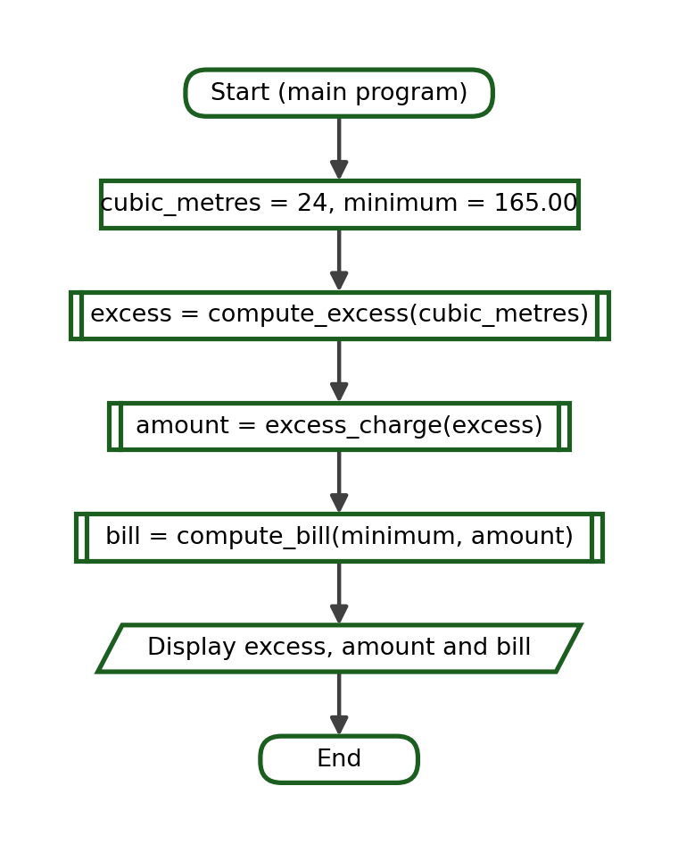
Complete Python Program:
def compute_excess(cubic_metres, free=10):
if cubic_metres > free:
return cubic_metres - free
return 0

def excess_charge(excess, rate=18.50):
return excess * rate

def compute_bill(minimum, excess_amount):
return minimum + excess_amount

excess = compute_excess(24)
amount = excess_charge(excess)
bill = compute_bill(165.00, amount)
print("Excess Cubic Metres:", excess)
print(f"Excess Charge: ₱{amount:.2f}")
print(f"Total Bill: ₱{bill:.2f}")

Function-Call Trace:
Step | Current Function | Arguments | Parameters / Local Values | Returned Value | Output
1 | main | - | - | - | -
2 | compute_excess | 24, 10 | cubic_metres = 24, free = 10 | 14 | -
3 | excess_charge | 14, 18.5 | excess = 14, rate = 18.5 | 259.0 | -
4 | compute_bill | 165.0, 259.0 | minimum = 165.0, excess_amount = 259.0 | 424.0 | -
5 | main | - | - | - | Excess Cubic Metres: 14  Excess Charge: ₱259.00  Total Bill: ₱424.00

Test Cases:
Test Case | Call | Returned Value
Above the allowance | compute_excess(24) | 14
At the allowance | compute_excess(10) | 0
Below the allowance | compute_excess(7) | 0

Exact Output:
Excess Cubic Metres: 14
Excess Charge: ₱259.00
Total Bill: ₱424.00

Explanation. compute_excess protects the rest of the program from negative values by returning 0 when the consumption is within the free allowance.

Problem 7: Transportation Fare
Problem Analysis. Compute a fare from a base fare and a per-kilometre rate, then apply a twenty-percent student discount.
Function Decomposition:
Required Task | Function Name | Parameters | Return Value
Compute the regular fare | compute_fare | distance, base, rate | The regular fare
Apply the discount | student_fare | fare, discount_rate | The student fare
Display both fares | main program | - | Two printed lines

IPO Table:
Input | Process | Output
distance = 17 kilometres | fare = base + distance * rate; student = fare - fare * 0.20 | The regular fare and the student fare

Algorithm:
1. Define compute_fare(distance, base=13.00, rate=2.25).
2. Define student_fare(fare, discount_rate=0.20).
3. Compute the regular fare for 17 kilometres.
4. Pass the returned fare to student_fare.
5. Display both fares with two decimal places.
Pseudocode:
FUNCTION compute_fare(distance, base = 13.00, rate = 2.25)
RETURN base + distance * rate
END FUNCTION

FUNCTION student_fare(fare, discount_rate = 0.20)
RETURN fare - fare * discount_rate
END FUNCTION

MAIN
SET fare = compute_fare(17)
SET discounted = student_fare(fare)
DISPLAY fare, discounted
END MAIN

Flowchart:
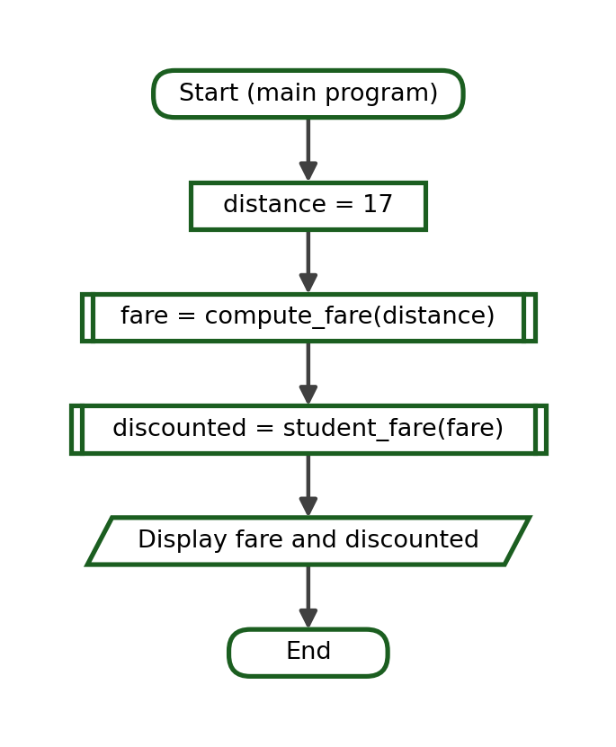
Complete Python Program:
def compute_fare(distance, base=13.00, rate=2.25):
return base + distance * rate

def student_fare(fare, discount_rate=0.20):
return fare - fare * discount_rate

fare = compute_fare(17)
discounted = student_fare(fare)
print(f"Regular Fare: ₱{fare:.2f}")
print(f"Student Fare: ₱{discounted:.2f}")

Function-Call Trace:
Step | Current Function | Arguments | Parameters / Local Values | Returned Value | Output
1 | main | - | - | - | -
2 | compute_fare | 17, 13.0, 2.25 | distance = 17, base = 13.0, rate = 2.25 | 51.25 | -
3 | student_fare | 51.25, 0.2 | fare = 51.25, discount_rate = 0.2 | 41.0 | -
4 | main | - | - | - | Regular Fare: ₱51.25  Student Fare: ₱41.00

Test Cases:
Test Case | Call | Returned Value
Default base and rate | compute_fare(17) | 51.25
Zero distance | compute_fare(0) | 13.0
Replaced rate | compute_fare(17, rate=2.50) | 55.5

Exact Output:
Regular Fare: ₱51.25
Student Fare: ₱41.00

Explanation. Only the distance changes on every trip, so it is the one required parameter; the base fare and the rate are sensible defaults.

Problem 8: Tuition Computation
Problem Analysis. Compute the tuition from the number of units and the cost per unit, then add the miscellaneous fee.
Function Decomposition:
Required Task | Function Name | Parameters | Return Value
Compute the tuition | compute_tuition | units, cost_per_unit | The tuition
Add the miscellaneous fee | add_misc | tuition, misc | The total assessment
Display the assessment | main program | - | Two printed lines

IPO Table:
Input | Process | Output
units = 24, cost_per_unit = 810.00 | tuition = units * cost_per_unit; total = tuition + misc | The tuition and the total assessment

Algorithm:
1. Define compute_tuition(units, cost_per_unit).
2. Define add_misc(tuition, misc=3800.00).
3. Compute the tuition for 24 units at 810.00 each.
4. Pass the tuition to add_misc.
5. Display the tuition and the total assessment.
Pseudocode:
FUNCTION compute_tuition(units, cost_per_unit)
RETURN units * cost_per_unit
END FUNCTION

FUNCTION add_misc(tuition, misc = 3800.00)
RETURN tuition + misc
END FUNCTION

MAIN
SET tuition = compute_tuition(24, 810.00)
SET total = add_misc(tuition)
DISPLAY tuition, total
END MAIN

Flowchart:
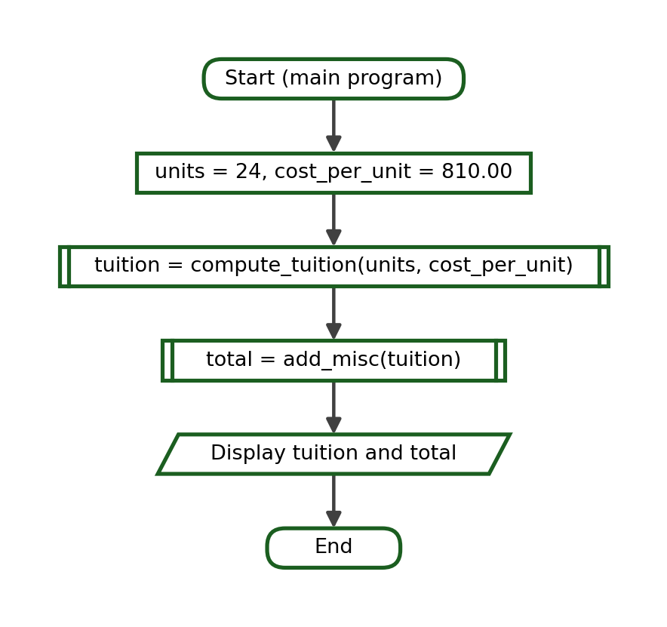
Complete Python Program:
def compute_tuition(units, cost_per_unit):
return units * cost_per_unit

def add_misc(tuition, misc=3800.00):
return tuition + misc

tuition = compute_tuition(24, 810.00)
total = add_misc(tuition)
print(f"Tuition: ₱{tuition:.2f}")
print(f"Total Assessment: ₱{total:.2f}")

Function-Call Trace:
Step | Current Function | Arguments | Parameters / Local Values | Returned Value | Output
1 | main | - | - | - | -
2 | compute_tuition | 24, 810.0 | units = 24, cost_per_unit = 810.0 | 19440.0 | -
3 | add_misc | 19440.0, 3800.0 | tuition = 19440.0, misc = 3800.0 | 23240.0 | -
4 | main | - | - | - | Tuition: ₱19440.00  Total Assessment: ₱23240.00

Test Cases:
Test Case | Call | Returned Value
Full load | compute_tuition(24, 810.00) | 19440.0
Default fee | add_misc(19440.0) | 23240.0
Higher fee | add_misc(19440.0, 4500.00) | 23940.0

Exact Output:
Tuition: ₱19440.00
Total Assessment: ₱23240.00

Explanation. The miscellaneous fee is the same for most students, so it is a good default value.

Problem 9: Sales Commission
Problem Analysis. Compute the commission earned from total sales using a default commission rate, then add it to the basic pay.
Function Decomposition:
Required Task | Function Name | Parameters | Return Value
Compute the commission | compute_commission | sales, rate | The commission
Compute the total pay | total_pay | basic, commission | The total pay
Display the amounts | main program | - | Two printed lines

IPO Table:
Input | Process | Output
sales = 128500.00, basic = 14000.00 | commission = sales * rate; total = basic + commission | The commission and the total pay

Algorithm:
1. Define compute_commission(sales, rate=0.04).
2. Define total_pay(basic, commission).
3. Compute the commission on 128500.00 in sales.
4. Add the commission to a basic pay of 14000.00.
5. Display both amounts with two decimal places.
Pseudocode:
FUNCTION compute_commission(sales, rate = 0.04)
RETURN sales * rate
END FUNCTION

FUNCTION total_pay(basic, commission)
RETURN basic + commission
END FUNCTION

MAIN
SET commission = compute_commission(128500.00)
SET pay = total_pay(14000.00, commission)
DISPLAY commission, pay
END MAIN

Flowchart:
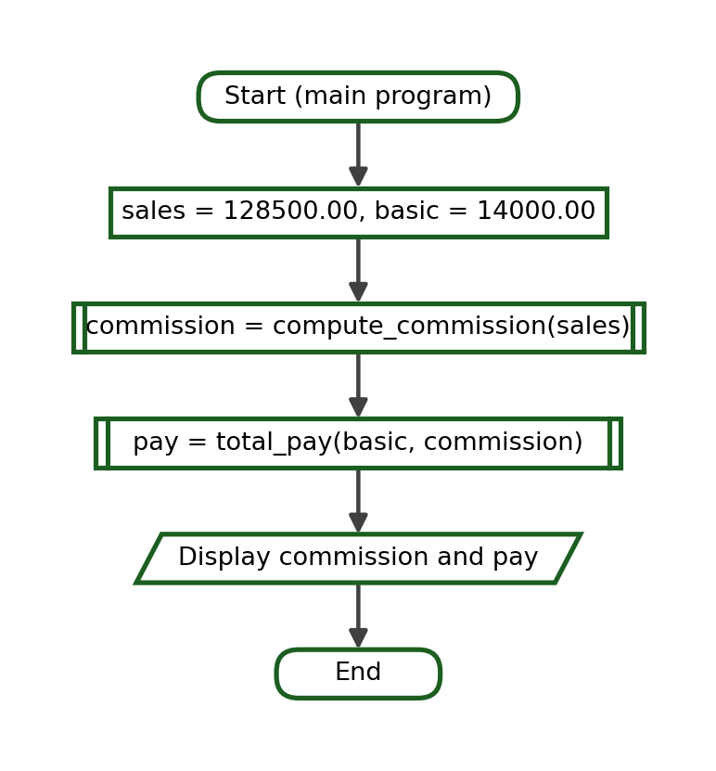
Complete Python Program:
def compute_commission(sales, rate=0.04):
return sales * rate

def total_pay(basic, commission):
return basic + commission

commission = compute_commission(128500.00)
pay = total_pay(14000.00, commission)
print(f"Commission: ₱{commission:.2f}")
print(f"Total Pay: ₱{pay:.2f}")

Function-Call Trace:
Step | Current Function | Arguments | Parameters / Local Values | Returned Value | Output
1 | main | - | - | - | -
2 | compute_commission | 128500.0, 0.04 | sales = 128500.0, rate = 0.04 | 5140.0 | -
3 | total_pay | 14000.0, 5140.0 | basic = 14000.0, commission = 5140.0 | 19140.0 | -
4 | main | - | - | - | Commission: ₱5140.00  Total Pay: ₱19140.00

Test Cases:
Test Case | Call | Returned Value
Default rate | compute_commission(128500.00) | 5140.0
No sales | compute_commission(0) | 0.0
Higher rate | compute_commission(128500.00, 0.06) | 7710.0

Exact Output:
Commission: ₱5140.00
Total Pay: ₱19140.00

Explanation. Storing the standard rate as a default keeps every ordinary call short and keeps the rate in one place.

Problem 10: Simple Interest
Problem Analysis. Compute the interest earned from the principal, the rate and the time, then compute the maturity value.
Function Decomposition:
Required Task | Function Name | Parameters | Return Value
Compute the interest | compute_interest | principal, rate, time | The interest
Compute the maturity value | compute_maturity | principal, interest | The maturity value
Display the amounts | main program | - | Two printed lines

IPO Table:
Input | Process | Output
principal = 42000.00, rate = 0.0375, time = 4 | interest = principal * rate * time; maturity = principal + interest | The interest and the maturity value

Algorithm:
1. Define compute_interest(principal, rate, time).
2. Define compute_maturity(principal, interest).
3. Compute the interest on 42000.00 at 3.75 percent for 4 years.
4. Compute the maturity value.
5. Display both amounts with two decimal places.
Pseudocode:
FUNCTION compute_interest(principal, rate, time)
RETURN principal * rate * time
END FUNCTION

FUNCTION compute_maturity(principal, interest)
RETURN principal + interest
END FUNCTION

MAIN
SET interest = compute_interest(42000.00, 0.0375, 4)
SET maturity = compute_maturity(42000.00, interest)
DISPLAY interest, maturity
END MAIN

Flowchart:
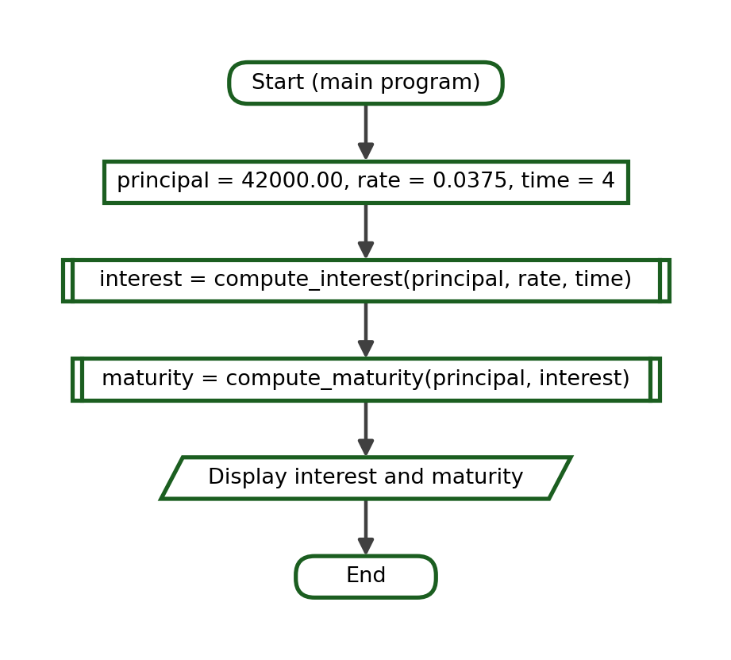
Complete Python Program:
def compute_interest(principal, rate, time):
return principal * rate * time

def compute_maturity(principal, interest):
return principal + interest

interest = compute_interest(42000.00, 0.0375, 4)
maturity = compute_maturity(42000.00, interest)
print(f"Interest: ₱{interest:.2f}")
print(f"Maturity Value: ₱{maturity:.2f}")

Function-Call Trace:
Step | Current Function | Arguments | Parameters / Local Values | Returned Value | Output
1 | main | - | - | - | -
2 | compute_interest | 42000.0, 0.0375, 4 | principal = 42000.0, rate = 0.0375, time = 4 | 6300.0 | -
3 | compute_maturity | 42000.0, 6300.0 | principal = 42000.0, interest = 6300.0 | 48300.0 | -
4 | main | - | - | - | Interest: ₱6300.00  Maturity Value: ₱48300.00

Test Cases:
Test Case | Call | Returned Value
Four-year term | compute_interest(42000.00, 0.0375, 4) | 6300.0
One-year term | compute_interest(42000.00, 0.0375, 1) | 1575.0
Zero time | compute_interest(42000.00, 0.0375, 0) | 0.0

Exact Output:
Interest: ₱6300.00
Maturity Value: ₱48300.00

Explanation. Three parameters must be supplied in the declared order. Using keyword arguments removes any doubt about which value is the rate and which is the time.

Problem 11: Employee Bonus
Problem Analysis. Compute a bonus from the monthly salary and the number of years in service, where employees with at least ten years receive a higher rate.
Function Decomposition:
Required Task | Function Name | Parameters | Return Value
Choose the bonus rate | get_rate | years | The bonus rate
Compute the bonus | compute_bonus | salary, rate | The bonus
Display the bonus | main program | - | Two printed lines

IPO Table:
Input | Process | Output
salary = 22400.00, years = 12 | rate = 0.25 when years >= 10, otherwise 0.15; bonus = salary * rate | The rate and the bonus

Algorithm:
1. Define get_rate(years) that returns 0.25 or 0.15.
2. Define compute_bonus(salary, rate) that returns the product.
3. Obtain the rate for 12 years of service.
4. Compute the bonus for a salary of 22400.00.
5. Display the rate as a percentage and the bonus.
Pseudocode:
FUNCTION get_rate(years)
IF years >= 10 THEN
RETURN 0.25
ELSE
RETURN 0.15
END IF
END FUNCTION

FUNCTION compute_bonus(salary, rate)
RETURN salary * rate
END FUNCTION

MAIN
SET rate = get_rate(12)
SET bonus = compute_bonus(22400.00, rate)
DISPLAY rate, bonus
END MAIN

Flowchart:
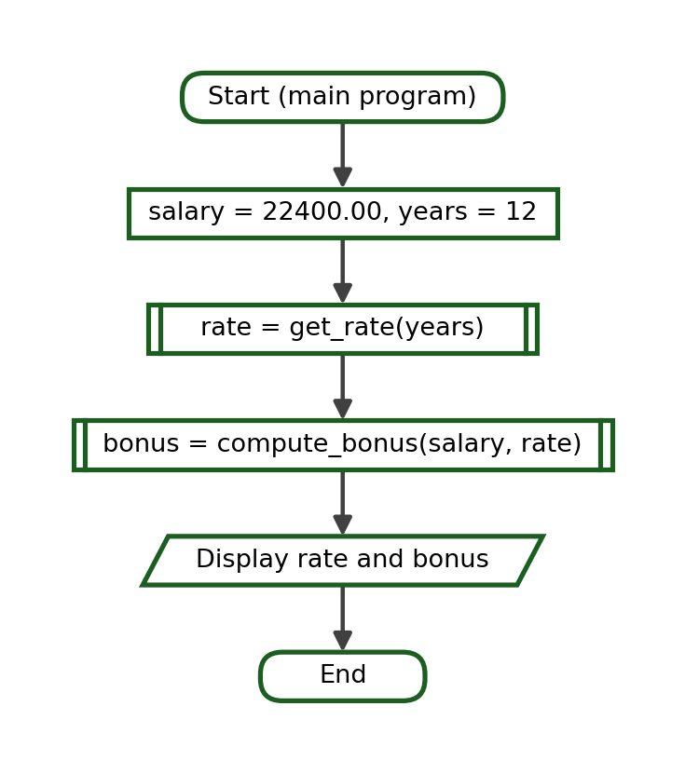
Complete Python Program:
def get_rate(years):
if years >= 10:
return 0.25
return 0.15

def compute_bonus(salary, rate):
return salary * rate

rate = get_rate(12)
bonus = compute_bonus(22400.00, rate)
print(f"Bonus Rate: {rate * 100:.0f}%")
print(f"Bonus: ₱{bonus:.2f}")

Function-Call Trace:
Step | Current Function | Arguments | Parameters / Local Values | Returned Value | Output
1 | main | - | - | - | -
2 | get_rate | 12 | years = 12 | 0.25 | -
3 | compute_bonus | 22400.0, 0.25 | salary = 22400.0, rate = 0.25 | 5600.0 | -
4 | main | - | - | - | Bonus Rate: 25%  Bonus: ₱5600.00

Test Cases:
Test Case | Call | Returned Value
Long service | get_rate(12) | 0.25
Boundary | get_rate(10) | 0.25
Short service | get_rate(9) | 0.15

Exact Output:
Bonus Rate: 25%
Bonus: ₱5600.00

Explanation. The decision lives in get_rate, so compute_bonus stays a plain multiplication that is easy to test.

Problem 12: Temperature Conversion
Problem Analysis. Convert a Celsius reading to Fahrenheit and return a label that describes the temperature.
Function Decomposition:
Required Task | Function Name | Parameters | Return Value
Convert to Fahrenheit | to_fahrenheit | celsius | The Fahrenheit value
Describe the reading | describe | celsius | A short label
Display both values | main program | - | Two printed lines

IPO Table:
Input | Process | Output
celsius = 41 | fahrenheit = celsius * 9 / 5 + 32; compare the Celsius value with 38 and 30 | The Fahrenheit value and the label

Algorithm:
1. Define to_fahrenheit(celsius) that returns the converted value.
2. Define describe(celsius) that returns Very Hot, Warm or Cool.
3. Convert 41 degrees Celsius.
4. Pass the original Celsius value to describe.
5. Display the Fahrenheit value and the label.
Pseudocode:
FUNCTION to_fahrenheit(celsius)
RETURN celsius * 9 / 5 + 32
END FUNCTION

FUNCTION describe(celsius)
IF celsius >= 38 THEN
RETURN "Very Hot"
ELSE IF celsius >= 30 THEN
RETURN "Warm"
ELSE
RETURN "Cool"
END IF
END FUNCTION

MAIN
SET celsius = 41
SET fahrenheit = to_fahrenheit(celsius)
SET label = describe(celsius)
DISPLAY fahrenheit, label
END MAIN

Flowchart:
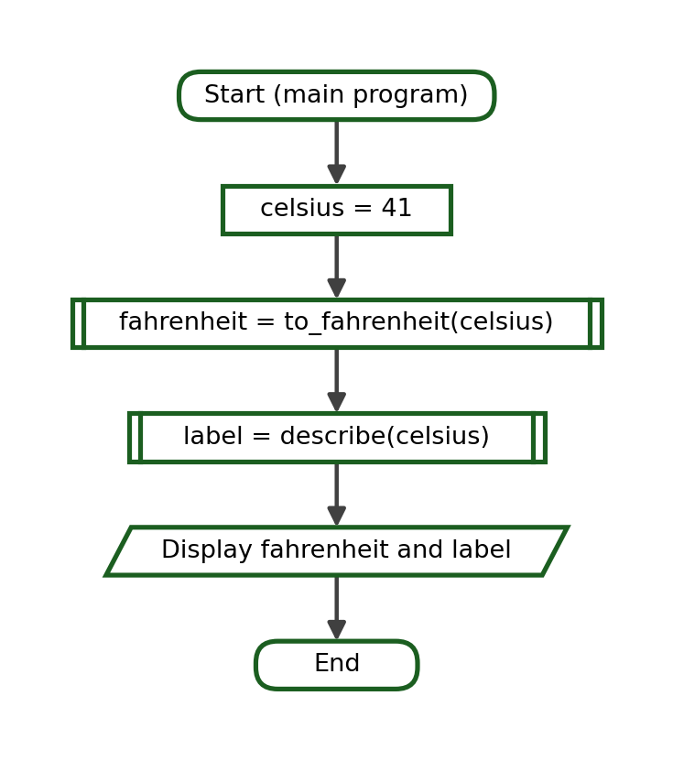
Complete Python Program:
def to_fahrenheit(celsius):
return celsius * 9 / 5 + 32

def describe(celsius):
if celsius >= 38:
return "Very Hot"
if celsius >= 30:
return "Warm"
return "Cool"

celsius = 41
fahrenheit = to_fahrenheit(celsius)
label = describe(celsius)
print(f"Fahrenheit: {fahrenheit:.1f}")
print("Label:", label)

Function-Call Trace:
Step | Current Function | Arguments | Parameters / Local Values | Returned Value | Output
1 | main | - | - | - | -
2 | to_fahrenheit | 41 | celsius = 41 | 105.8 | -
3 | describe | 41 | celsius = 41 | "Very Hot" | -
4 | main | - | - | - | Fahrenheit: 105.8  Label: Very Hot

Test Cases:
Test Case | Call | Returned Value
Very hot day | describe(41) | Very Hot
Boundary | describe(38) | Very Hot
Cool day | describe(24) | Cool

Exact Output:
Fahrenheit: 105.8
Label: Very Hot

Explanation. Both functions receive the Celsius value. Passing the Fahrenheit value to describe would produce a wrong label without any error message, which is exactly the data-flow mistake studied in Section 19.

Problem 13: BMI Computation
Problem Analysis. Compute the body mass index from weight and height, then return a category for the result.
Function Decomposition:
Required Task | Function Name | Parameters | Return Value
Compute the BMI | compute_bmi | weight, height | The BMI
Categorise the BMI | bmi_category | bmi | A category
Display both values | main program | - | Two printed lines

IPO Table:
Input | Process | Output
weight = 68 kg, height = 1.70 m | bmi = weight / (height * height); compare with 18.5, 25 and 30 | The BMI and its category

Algorithm:
1. Define compute_bmi(weight, height) that returns the index.
2. Define bmi_category(bmi) that returns the matching category.
3. Compute the BMI for 68 kilograms and 1.70 metres.
4. Pass the returned BMI to bmi_category.
5. Display the BMI with one decimal place and the category.
Pseudocode:
FUNCTION compute_bmi(weight, height)
RETURN weight / (height * height)
END FUNCTION

FUNCTION bmi_category(bmi)
IF bmi < 18.5 THEN
RETURN "Underweight"
ELSE IF bmi < 25 THEN
RETURN "Normal"
ELSE IF bmi < 30 THEN
RETURN "Overweight"
ELSE
RETURN "Obese"
END IF
END FUNCTION

MAIN
SET bmi = compute_bmi(68, 1.70)
SET category = bmi_category(bmi)
DISPLAY bmi, category
END MAIN

Flowchart:
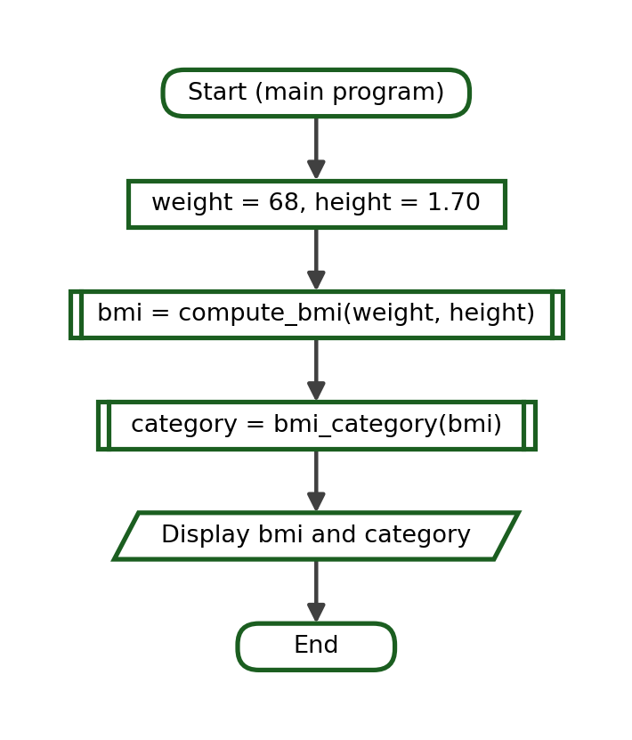
Complete Python Program:
def compute_bmi(weight, height):
return weight / (height * height)

def bmi_category(bmi):
if bmi < 18.5:
return "Underweight"
if bmi < 25:
return "Normal"
if bmi < 30:
return "Overweight"
return "Obese"

bmi = compute_bmi(68, 1.70)
category = bmi_category(bmi)
print(f"BMI: {bmi:.1f}")
print("Category:", category)

Function-Call Trace:
Step | Current Function | Arguments | Parameters / Local Values | Returned Value | Output
1 | main | - | - | - | -
2 | compute_bmi | 68, 1.7 | weight = 68, height = 1.7 | 23.529411764705884 | -
3 | bmi_category | 23.529411764705884 | bmi = 23.529411764705884 | "Normal" | -
4 | main | - | - | - | BMI: 23.5  Category: Normal

Test Cases:
Test Case | Call | Returned Value
Normal build | round(compute_bmi(68, 1.70), 2) | 23.53
Category boundary | bmi_category(25) | Overweight
Low index | bmi_category(17.9) | Underweight

Exact Output:
BMI: 23.5
Category: Normal

Explanation. The height is squared inside the function, so the caller supplies the plain height. Keeping the formula in one place prevents it from being written differently in two programs.

Problem 14: Rectangle Calculator
Problem Analysis. Compute the area and the perimeter of a rectangle using one function for each measurement.
Function Decomposition:
Required Task | Function Name | Parameters | Return Value
Compute the area | compute_area | length, width | The area
Compute the perimeter | compute_perimeter | length, width | The perimeter
Display both results | main program | - | Two printed lines

IPO Table:
Input | Process | Output
length = 14, width = 8 | area = length * width; perimeter = 2 * (length + width) | The area and the perimeter

Algorithm:
1. Define compute_area(length, width).
2. Define compute_perimeter(length, width).
3. Call both functions with 14 and 8.
4. Store each returned value in its own variable.
5. Display the area and the perimeter.
Pseudocode:
FUNCTION compute_area(length, width)
RETURN length * width
END FUNCTION

FUNCTION compute_perimeter(length, width)
RETURN 2 * (length + width)
END FUNCTION

MAIN
SET area = compute_area(14, 8)
SET perimeter = compute_perimeter(14, 8)
DISPLAY area, perimeter
END MAIN

Flowchart:
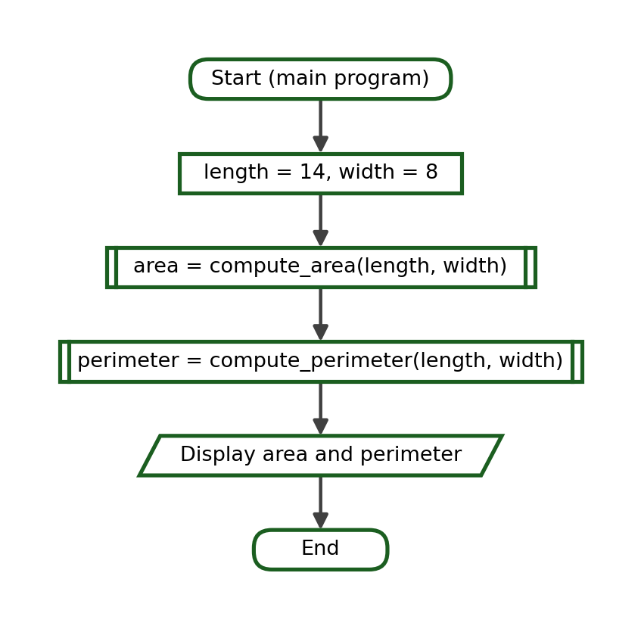
Complete Python Program:
def compute_area(length, width):
return length * width

def compute_perimeter(length, width):
return 2 * (length + width)

area = compute_area(14, 8)
perimeter = compute_perimeter(14, 8)
print("Area:", area)
print("Perimeter:", perimeter)

Function-Call Trace:
Step | Current Function | Arguments | Parameters / Local Values | Returned Value | Output
1 | main | - | - | - | -
2 | compute_area | 14, 8 | length = 14, width = 8 | 112 | -
3 | compute_perimeter | 14, 8 | length = 14, width = 8 | 44 | -
4 | main | - | - | - | Area: 112  Perimeter: 44

Test Cases:
Test Case | Call | Returned Value
Normal rectangle | compute_area(14, 8) | 112
Perimeter | compute_perimeter(14, 8) | 44
Square | compute_area(5, 5) | 25

Exact Output:
Area: 112
Perimeter: 44

Explanation. Two functions receive the same arguments but produce different results. Each returned value must be stored in a variable whose name matches the quantity it holds.

Problem 15: Allowance Budget
Problem Analysis. Compute the total weekly allowance and the amount left after the daily expenses.
Function Decomposition:
Required Task | Function Name | Parameters | Return Value
Compute the weekly allowance | weekly_allowance | daily, days | The total allowance
Compute the weekly expenses | weekly_expenses | daily_expense, days | The total expenses
Compute the balance | compute_balance | allowance, expenses | The remaining amount

IPO Table:
Input | Process | Output
daily allowance = 250.00, daily expense = 185.00, days = 5 | allowance = daily * days; expenses = daily_expense * days; balance = allowance - expenses | The allowance, the expenses and the balance

Algorithm:
1. Define weekly_allowance(daily, days=5).
2. Define weekly_expenses(daily_expense, days=5).
3. Define compute_balance(allowance, expenses).
4. Call the three functions in order.
5. Display the three amounts with two decimal places.
Pseudocode:
FUNCTION weekly_allowance(daily, days = 5)
RETURN daily * days
END FUNCTION

FUNCTION weekly_expenses(daily_expense, days = 5)
RETURN daily_expense * days
END FUNCTION

FUNCTION compute_balance(allowance, expenses)
RETURN allowance - expenses
END FUNCTION

MAIN
SET allowance = weekly_allowance(250.00)
SET expenses = weekly_expenses(185.00)
SET balance = compute_balance(allowance, expenses)
DISPLAY allowance, expenses, balance
END MAIN

Flowchart:
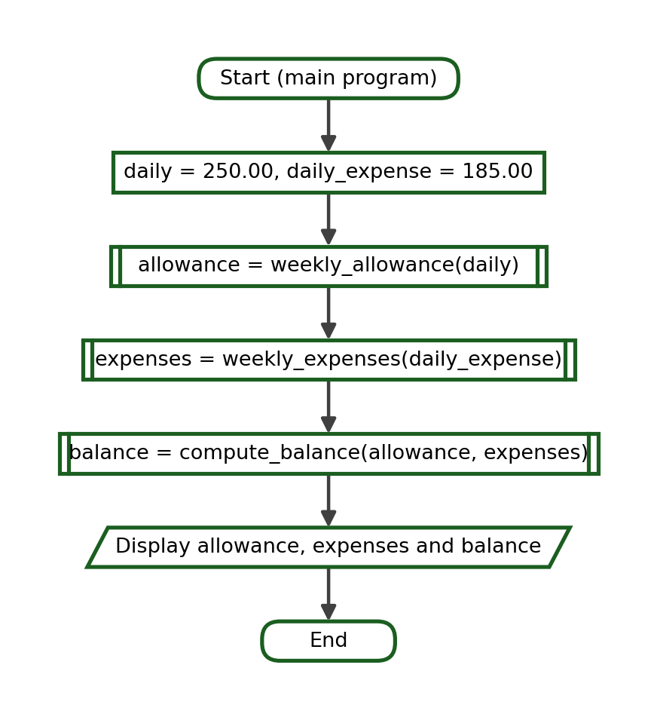
Complete Python Program:
def weekly_allowance(daily, days=5):
return daily * days

def weekly_expenses(daily_expense, days=5):
return daily_expense * days

def compute_balance(allowance, expenses):
return allowance - expenses

allowance = weekly_allowance(250.00)
expenses = weekly_expenses(185.00)
balance = compute_balance(allowance, expenses)
print(f"Allowance: ₱{allowance:.2f}")
print(f"Expenses: ₱{expenses:.2f}")
print(f"Balance: ₱{balance:.2f}")

Function-Call Trace:
Step | Current Function | Arguments | Parameters / Local Values | Returned Value | Output
1 | main | - | - | - | -
2 | weekly_allowance | 250.0, 5 | daily = 250.0, days = 5 | 1250.0 | -
3 | weekly_expenses | 185.0, 5 | daily_expense = 185.0, days = 5 | 925.0 | -
4 | compute_balance | 1250.0, 925.0 | allowance = 1250.0, expenses = 925.0 | 325.0 | -
5 | main | - | - | - | Allowance: ₱1250.00  Expenses: ₱925.00  Balance: ₱325.00

Test Cases:
Test Case | Call | Returned Value
Five school days | weekly_allowance(250.00) | 1250.0
Six school days | weekly_allowance(250.00, 6) | 1500.0
Balance | compute_balance(1250.0, 925.0) | 325.0

Exact Output:
Allowance: ₱1250.00
Expenses: ₱925.00
Balance: ₱325.00

Explanation. The number of school days is normally five, which makes it a good default. A six-day week is handled by supplying the second argument.

Problem 16: Product Markup
Problem Analysis. Compute the selling price from the cost and a default markup rate, then compute the profit.
Function Decomposition:
Required Task | Function Name | Parameters | Return Value
Compute the selling price | selling_price | cost, markup | The selling price
Compute the profit | compute_profit | price, cost | The profit
Display both amounts | main program | - | Two printed lines

IPO Table:
Input | Process | Output
cost = 340.00, markup = default 0.25 | price = cost + cost * markup; profit = price - cost | The selling price and the profit

Algorithm:
1. Define selling_price(cost, markup=0.25).
2. Define compute_profit(price, cost).
3. Compute the selling price of an item costing 340.00.
4. Compute the profit from the returned price.
5. Display both amounts with two decimal places.
Pseudocode:
FUNCTION selling_price(cost, markup = 0.25)
RETURN cost + cost * markup
END FUNCTION

FUNCTION compute_profit(price, cost)
RETURN price - cost
END FUNCTION

MAIN
SET price = selling_price(340.00)
SET profit = compute_profit(price, 340.00)
DISPLAY price, profit
END MAIN

Flowchart:
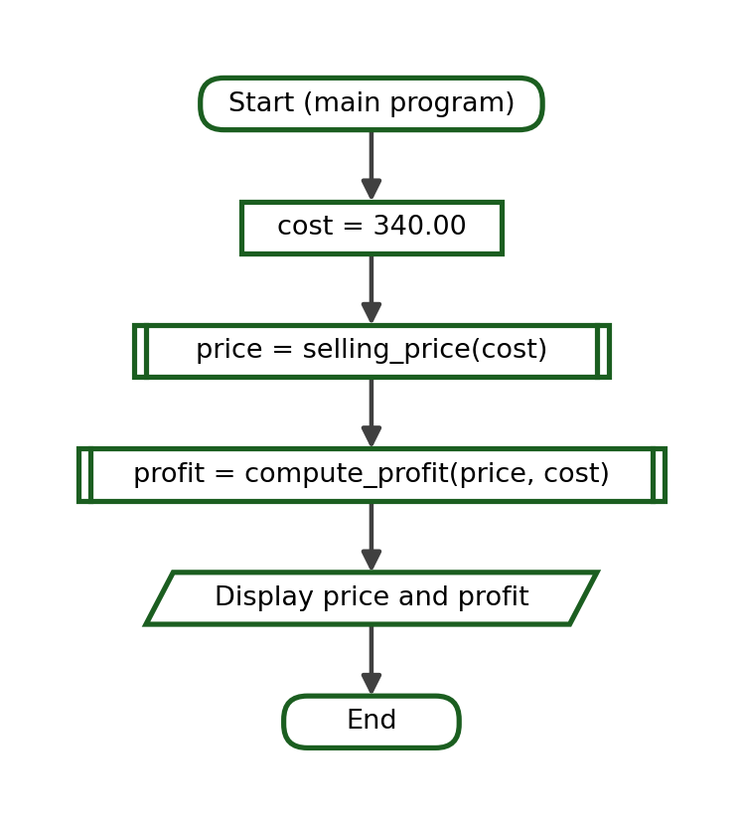
Complete Python Program:
def selling_price(cost, markup=0.25):
return cost + cost * markup

def compute_profit(price, cost):
return price - cost

price = selling_price(340.00)
profit = compute_profit(price, 340.00)
print(f"Selling Price: ₱{price:.2f}")
print(f"Profit: ₱{profit:.2f}")

Function-Call Trace:
Step | Current Function | Arguments | Parameters / Local Values | Returned Value | Output
1 | main | - | - | - | -
2 | selling_price | 340.0, 0.25 | cost = 340.0, markup = 0.25 | 425.0 | -
3 | compute_profit | 425.0, 340.0 | price = 425.0, cost = 340.0 | 85.0 | -
4 | main | - | - | - | Selling Price: ₱425.00  Profit: ₱85.00

Test Cases:
Test Case | Call | Returned Value
Default markup | selling_price(340.00) | 425.0
Higher markup | selling_price(340.00, 0.40) | 476.0
Profit | compute_profit(425.0, 340.00) | 85.0

Exact Output:
Selling Price: ₱425.00
Profit: ₱85.00

Explanation. compute_profit needs the original cost as well as the returned price, so the main program keeps the cost in a variable and passes it to both functions.

Problem 17: Savings Goal
Problem Analysis. Compute the total amount saved after a number of weeks and the amount still needed to reach a goal.
Function Decomposition:
Required Task | Function Name | Parameters | Return Value
Compute the total saved | total_saved | weekly, weeks | The amount saved
Compute the amount still needed | amount_needed | goal, saved | The remaining amount
Display both amounts | main program | - | Two printed lines

IPO Table:
Input | Process | Output
weekly = 450.00, weeks = 16, goal = 10000.00 | saved = weekly * weeks; needed = goal - saved, or 0 when the goal is reached | The amount saved and the amount still needed

Algorithm:
1. Define total_saved(weekly, weeks) that returns the product.
2. Define amount_needed(goal, saved) that returns the difference, or 0 when the goal has been reached.
3. Compute the amount saved after 16 weeks at 450.00 a week.
4. Compute the amount still needed for a goal of 10000.00.
5. Display both amounts with two decimal places.
Pseudocode:
FUNCTION total_saved(weekly, weeks)
RETURN weekly * weeks
END FUNCTION

FUNCTION amount_needed(goal, saved)
IF saved >= goal THEN
RETURN 0
ELSE
RETURN goal - saved
END IF
END FUNCTION

MAIN
SET saved = total_saved(450.00, 16)
SET needed = amount_needed(10000.00, saved)
DISPLAY saved, needed
END MAIN

Flowchart:
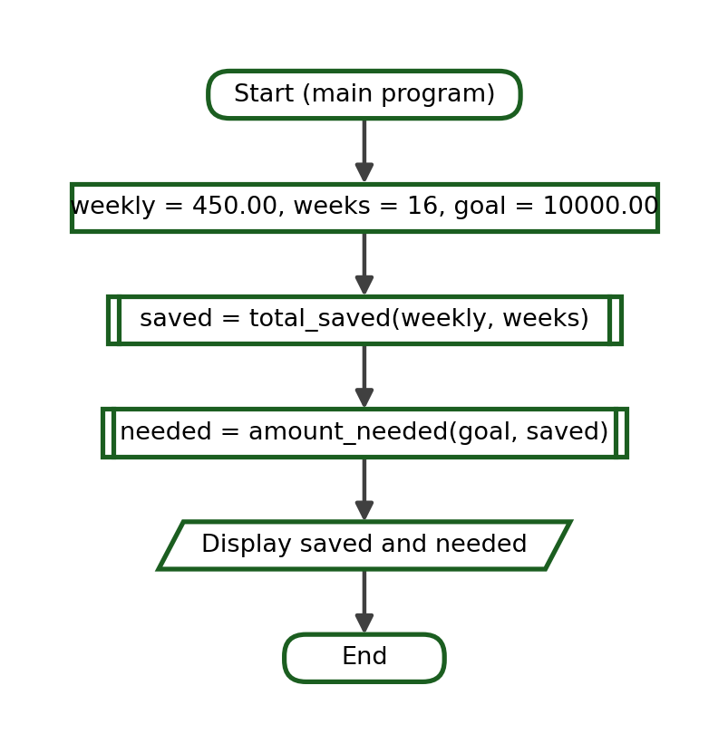
Complete Python Program:
def total_saved(weekly, weeks):
return weekly * weeks

def amount_needed(goal, saved):
if saved >= goal:
return 0
return goal - saved

saved = total_saved(450.00, 16)
needed = amount_needed(10000.00, saved)
print(f"Total Saved: ₱{saved:.2f}")
print(f"Still Needed: ₱{needed:.2f}")

Function-Call Trace:
Step | Current Function | Arguments | Parameters / Local Values | Returned Value | Output
1 | main | - | - | - | -
2 | total_saved | 450.0, 16 | weekly = 450.0, weeks = 16 | 7200.0 | -
3 | amount_needed | 10000.0, 7200.0 | goal = 10000.0, saved = 7200.0 | 2800.0 | -
4 | main | - | - | - | Total Saved: ₱7200.00  Still Needed: ₱2800.00

Test Cases:
Test Case | Call | Returned Value
Sixteen weeks | total_saved(450.00, 16) | 7200.0
Goal not yet reached | amount_needed(10000.00, 7200.0) | 2800.0
Goal reached | amount_needed(10000.00, 10800.0) | 0

Exact Output:
Total Saved: ₱7200.00
Still Needed: ₱2800.00

Explanation. amount_needed returns 0 instead of a negative number once the goal has been reached, so the displayed value always makes sense to the reader.

Reflection Questions - Suggested Answers
1. Parameters make the data a function needs visible in the function header. A function that receives its data through parameters can be read, traced and tested on its own, and it cannot be disturbed by changes made elsewhere in the program. A function that depends on global variables is harder to trace, because the value it uses may have been changed anywhere in the program.
2. A positional argument is matched to a parameter by its position in the call, so the order must follow the definition. A keyword argument names the parameter that is to receive the value, so the order may differ and the call documents itself.
3. A default parameter gives a value that is used when the caller supplies none. The ordinary call stays short, while a caller who needs a different value can still supply one for a single call without editing the function.
4. The value named in the return statement is sent back to the statement that made the call. The caller usually stores it in a variable, and that variable is then written as the argument of the next function. The value may also be passed directly, as in get_remark(compute_average(80, 75, 85)).
5. Testing a function on its own proves that the function itself is correct. If every function has been tested, any remaining fault must be in the way the functions are joined together, which makes the search far shorter. Testing boundary values during this stage catches the wrong-comparison errors that ordinary values never reveal.
6. Answers will vary. Look for a specific description of the method used, such as printing the returned value of each function in turn, checking the formula by hand, or testing the suspected function with a value whose answer was already known.

