WALL-E AND EVE
Autonomous Search and Signal Detection Agent
Final Project Report | Multi-Seed Evaluation

Prepared from the project implementation and aggregate test results shared by the developer

1. Abstract
WALL-E and EVE is a grid-based autonomous search project in which an agent explores an environment, uses local scans to gather clues and detect a signal, maintains a set of possible EVE locations, and plans movement while managing battery and mission time. The project was evaluated using repeated runs with different random seeds. After an agent decision-logic adjustment, the final 50-seed run completed 50 out of 50 missions successfully. A further test over seeds 101–200 completed 100 out of 100 missions successfully. These results indicate consistent success across the 150 tested runs after the adjustment; they do not prove success for every possible environment.

2. Project Objectives
- Explore a partially observed grid environment using movement and scanning actions.
- Use scan outcomes to update the possible locations of EVE.
- Select useful scan locations and navigate toward candidate locations using path planning.
- Manage battery by returning to the charger when required.
- Record mission activity and evaluate performance across multiple random seeds.

3. System Overview
The project is organized into separate Python modules. The main program runs a mission; the environment simulates the grid, obstacles, clues, battery, time, and EVE's hidden position; the agent chooses actions; the belief module tracks possible EVE locations; and the mission logger writes trace and report JSON files. A multi-seed test script automates repeated runs, collects reports, and summarizes success and resource metrics.
Core decision loop:
- Read the current observation (position, battery, remaining time, clues, and detection state).
- Update the belief set using scan results or confirmed arrival at EVE's location.
- Check mission completion and whether recharging is needed.
- Choose a scan or a movement target and plan a path.
- Execute the action, log the result, and repeat until success or a stopping condition.

4. Testing Methodology
The tests use different environment seeds so that the randomly generated EVE location and clue layout vary. The original 50-seed run exposed two unsuccessful missions (seeds 22 and 23). The agent's candidate-investigation logic was then adjusted so it would investigate candidate locations earlier instead of continuing an inefficient search pattern. The rerun of seeds 1–50 succeeded in all 50 missions. A separate run over seeds 101–200 then succeeded in all 100 missions.
Important reporting note: the figures below use the aggregate results reported in the conversation. The individual per-seed result rows were not available while generating this report, so the graphs show aggregate counts and averages rather than invented per-seed data. The testing script printed the path summary_50_seeds.json for the 100-seed run; therefore, the filename alone does not establish whether that file's name was updated to match its contents.

5. Results
Test run | Seeds tested | Successes | Failures | Success rate | Avg. steps* | Avg. battery left*
Initial run (before fix) | 1–50 (50) | 48 | 2 | 96% | 33.08 | 54.71
Final run (after fix) | 1–50 (50) | 50 | 0 | 100% | 41.12 | 58.88
New independent range | 101–200 (100) | 100 | 0 | 100% | 44.18 | 55.82
*Average steps, battery remaining, and time remaining are reported aggregate values for successful missions, as supplied. The initial run's averages are included for context; because it had failures, these averages should not be interpreted as a direct apples-to-apples efficiency comparison.

5.1 Mission success rate
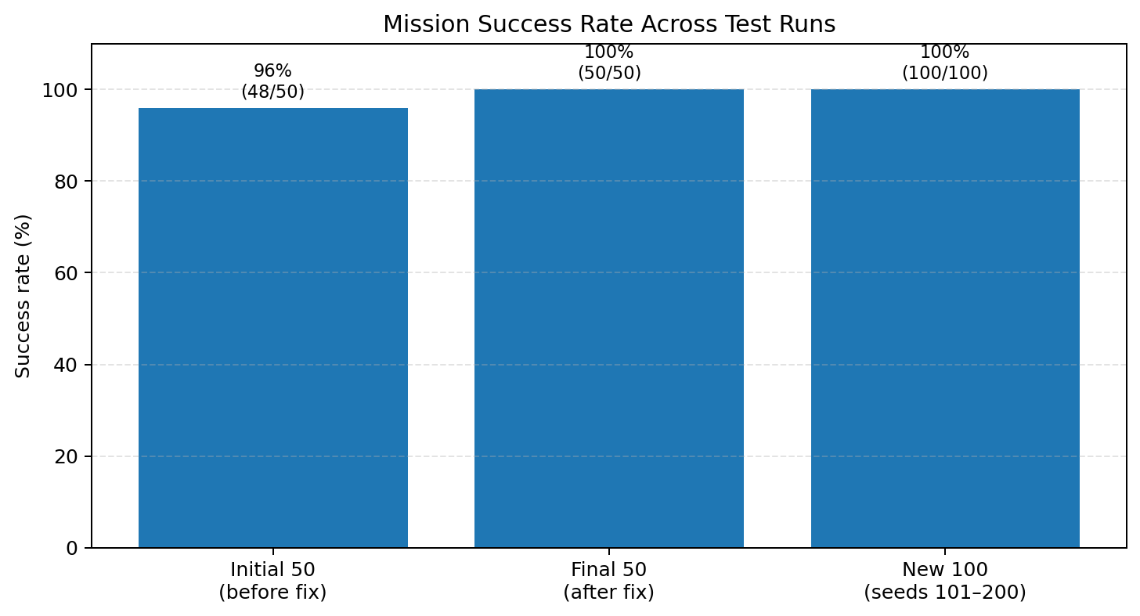
The initial agent completed 48/50 missions (96%). After the decision-logic adjustment, the 50-seed rerun completed 50/50 missions, and the additional seeds 101–200 completed 100/100 missions.

5.2 Successful and failed mission counts
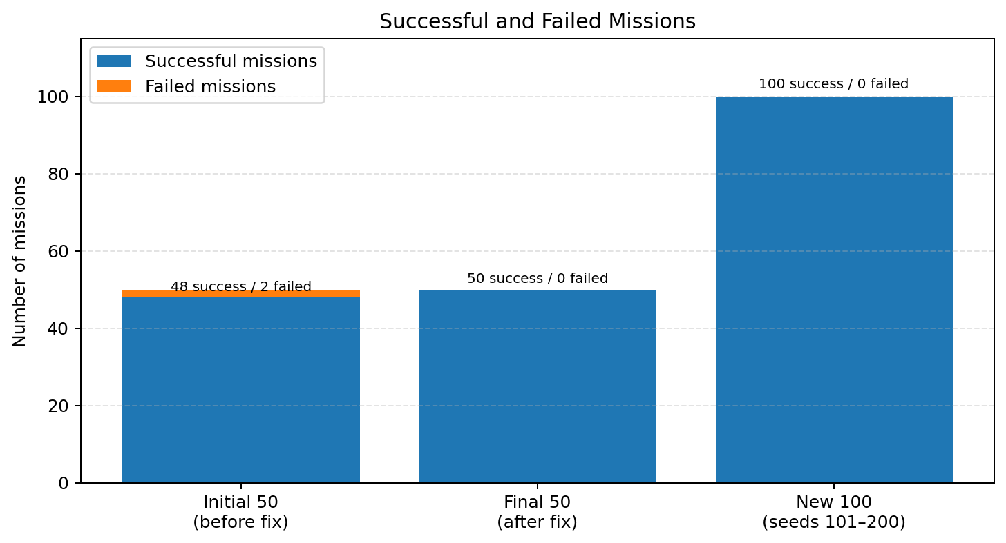

5.3 Average metrics across the two final test runs
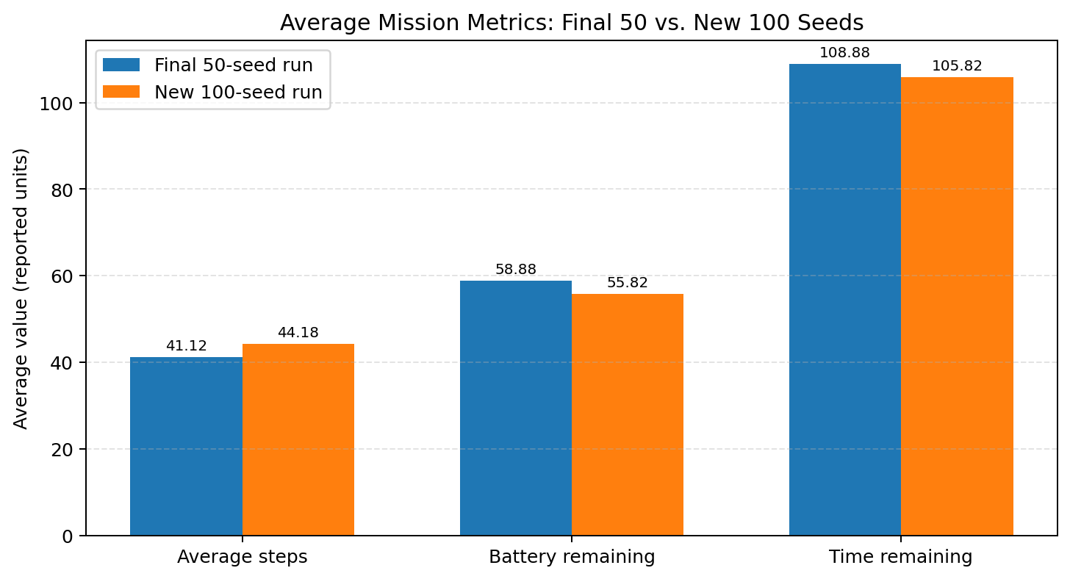
The 100-new-seed run used an average of 44.18 steps, compared with 41.12 in the final 50-seed run. Its reported average battery remaining was 55.82, compared with 58.88, and average time remaining was 105.82, compared with 108.88. The larger run therefore had slightly higher average steps and lower remaining battery/time, while maintaining a 100% observed success rate. These differences may reflect the randomly generated environments and are not, by themselves, evidence of a performance regression.

6. Agent Improvement
The original tests showed that seeds 22 and 23 could reach the action limit while investigating a small set of remaining candidate locations. The change increased the candidate-investigation threshold so that the agent would navigate toward likely locations sooner. After the change, both the 50-seed rerun and the new 100-seed range completed without a reported failed mission or run error.
This is an empirical improvement based on the tested seeds. It should be described as improved reliability in these test runs, rather than a guarantee that the agent cannot fail in other environments.

7. Strengths
- Modular code structure separates environment simulation, agent decisions, belief tracking, and logging.
- The belief set narrows candidate locations using positive and negative scan evidence.
- Path planning uses grid navigation rather than purely random movement.
- Battery-aware behavior includes returning to the charger and recharging.
- Multi-seed testing provides more evidence than demonstrating a single successful mission.
- JSON traces and reports support debugging and repeatable evaluation.

8. Limitations and Future Work
- The reported success rate applies only to the tested seed ranges; more seeds and edge cases should be tested.
- The aggregate results do not include per-seed distributions, confidence intervals, or a breakdown of failures by cause.
- The confidence value in the belief module is a simple candidate-count score (1 divided by the number of possible locations), not a calibrated probability.
- A future evaluation should save uniquely named summaries for each run, such as summary_seeds_1_50.json and summary_seeds_101_200.json, to avoid confusion.
- Add tests for low battery, no informative scan targets, depleted candidate sets, and near-limit time conditions.
- Compare against a simple baseline agent using the same seed ranges and report success rate, steps, battery, and time under identical conditions.

9. Conclusion
WALL-E and EVE demonstrates a modular autonomous search agent that combines sensing, belief updates, path planning, and resource management. The initial 50-seed evaluation achieved 96% success, with two failures. Following a candidate-investigation logic adjustment, the final 50-seed rerun achieved 100% success, and the additional 100-seed evaluation over seeds 101–200 also achieved 100% success. In total, the corrected version succeeded in 150 out of 150 reported test missions across these two test ranges. This is strong empirical evidence for the tested configurations, with broader validation and clearer per-run result archiving as recommended next steps.

Appendix A. Result summary
Reported post-adjustment evaluation: 150/150 successful missions across seeds 1–50 and 101–200.
Final 50-seed run: average steps 41.12; average battery remaining 58.88; average time remaining 108.88.
New 100-seed run: average steps 44.18; average battery remaining 55.82; average time remaining 105.82.
Original pre-adjustment run: 48/50 successes; 2 failures (seeds 22 and 23); 0 run errors.

