INTERNSHIP REPORT
Feature Engineering for Paneer Storage Study Data
Week 3 – Feature Engineering
Student | Rishikesh Deshmukh
Internship organization | Yuva Intern
Internship role | Junior Data Scientist Intern – Food Processing
Week and assignment | Week 3 – Feature Engineering
Technology | Python, pandas, NumPy, Matplotlib, Jupyter Notebook
Date of preparation | 10 October 2026

Dataset analysed: Storage study data for paneer in controlled RH and Temperature environment, Mendeley Data, Version 2, DOI: 10.17632/rd9dmr54xx.2 (CC BY 4.0).

Abstract
This report documents the Week 3 feature engineering task of the Junior Data Scientist Internship at Yuva Intern. Starting from the cleaned paneer storage-study dataset (70 rows × 24 columns, Day 0 to Day 13, five replicates per day), nine new features were created: one analyst-defined storage-phase category, three Day 0 baseline values for total plate count (TPC) log value, pH and moisture, three change-from-baseline measures, a Day 0 TPC count baseline and a TPC growth ratio. The engineered dataset has 70 rows × 33 columns and none of the nine new features has missing values.
In this dataset the mean TPC log change rises from 0.000 on Day 0 to 3.433 on Day 13, the mean pH change on Day 13 is −0.882, and the mean moisture change on Day 13 is −4.438 percentage points. Day shows a correlation of 0.99 with TPC log change, but only 0.18 with the TPC growth ratio, whose daily mean does not increase steadily. No machine-learning model was trained, so the report makes no claim of improved predictive accuracy; it describes the features, their rationale and how they might be validated in future work.

1. Introduction
Feature engineering is the process of deriving new variables from existing data so that patterns relevant to a problem are represented more directly. In a storage study, the quantity of interest is often how a measurement changes over time relative to its starting value, not its absolute level. Raw columns such as TPC_Log10, pH and Moisture_Percent record the current state of a sample, but they do not state how far it has moved from its Day 0 condition.
This report builds on the Week 2 preprocessing work, which produced a cleaned dataset from the paneer storage study. Week 3 adds features that express each observation relative to its own replicate’s Day 0 baseline, together with a coarse grouping of storage days. The features are intended as inputs for future exploratory analysis and machine-learning models.

2. Dataset Description and Source
Table 1. Dataset details
Item | Detail
Title | Storage study data for paneer in controlled RH and Temperature environment
Source | Mendeley Data
DOI | 10.17632/rd9dmr54xx.2
Version / published | Version 2, published 17 February 2026
License | CC BY 4.0
Cleaned input dataset | 70 rows × 24 columns
Observation period | Day 0 to Day 13, five replicates per day (14 × 5 = 70 rows)
Engineered dataset | 70 rows × 33 columns (24 + 9 new features)

The input to this task is the cleaned dataset from Week 2. Its measurements include the total plate count (TPC) and its log10 value (TPC_Log10), pH and moisture percentage (Moisture_Percent).

3. Objectives of Feature Engineering
- Create meaningful new features from the cleaned paneer storage-study data.
- Express microbial, pH and moisture measurements relative to each replicate’s Day 0 baseline.
- Provide an exploratory grouping of storage days into Early, Middle and Late phases.
- Explain the rationale for every feature and how it might be used in future machine-learning models.
- Evaluate the features descriptively and state clearly what cannot yet be concluded.

4. Methodology and Tools Used
The work was done in a Jupyter Notebook using Python. pandas handled data selection, per-replicate matching of Day 0 values, feature calculation and summaries; NumPy supported numerical operations; and Matplotlib produced the chart in this report. Features were evaluated descriptively, using daily means and pairwise correlations. No model was trained.

5. Feature Engineering Process
The process had three parts, applied to the 70-row cleaned dataset:
- Baseline extraction. For each replicate, the Day 0 values of TPC count, TPC_Log10, pH and Moisture_Percent were taken and attached to every row of that replicate. This produced the four baseline features (Baseline_TPC_Count, Baseline_TPC_Log10, Baseline_pH and Baseline_Moisture_Percent).
- Change and ratio calculation. The current value minus the same replicate’s baseline gave TPC_Log_Change, pH_Change_From_Baseline and Moisture_Change_From_Baseline. The current TPC count divided by the baseline count gave TPC_Growth_Ratio. On Day 0 the changes are therefore 0 and the ratio is 1 by construction.
- Phase labelling. Each row was assigned to Early (Days 0–3), Middle (Days 4–8) or Late (Days 9–13) from its storage day. These give 20, 25 and 25 rows respectively (20 + 25 + 25 = 70).
After these steps the dataset grew from 24 to 33 columns, with 70 rows retained. All nine new features have zero missing values. Because the baselines come from Day 0, the Day 0 observations of each replicate must be present for these features to be computable.

6. Engineered Features
Table 2 describes all nine features. Storage_Phase boundaries are analyst-defined groups for exploratory analysis and are not validated food-safety thresholds. The “potential ML use” column describes possible uses only; none has been tested.
Table 2. The nine engineered features
Feature | Definition | Rationale | Potential ML use
1. Storage_Phase | Early (Days 0–3), Middle (Days 4–8), Late (Days 9–13) | Groups the 14 days into broader stages for exploratory comparison. | Categorical input or grouping variable; stratified summaries.
2. Baseline_TPC_Log10 | Day 0 TPC_Log10 of the same replicate | Fixes each replicate’s starting microbial level. | Reference point for understanding microbial changes.
3. Baseline_pH | Day 0 pH of the same replicate | Fixes each replicate’s starting pH. | Allows pH to be compared with the initial observation.
4. Baseline_Moisture_Percent | Day 0 Moisture_Percent of the same replicate | Fixes each replicate’s starting moisture. | Baseline for examining moisture changes during storage.
5. TPC_Log_Change | TPC_Log10 − Baseline_TPC_Log10 | Log-scale change; a change of 1 is a ten-fold change in the logged quantity. | Represents change in microbial load on a logarithmic scale.
6. pH_Change_From_Baseline | pH − Baseline_pH | Removes between-replicate differences in starting pH. | Captures pH variation during storage.
7. Moisture_Change_From_Baseline | Moisture_Percent − Baseline_Moisture_Percent | Expresses moisture relative to start (percentage points). | Captures changes in moisture relative to baseline.
8. Baseline_TPC_Count | Day 0 TPC count of the same replicate | Supplies the denominator for the growth ratio. | Reference for comparing current microbial counts.
9. TPC_Growth_Ratio | Current TPC count ÷ Baseline_TPC_Count | Relative size of the current count versus the initial count. | Expresses current count relative to the initial count: >1 above baseline, <1 below.

7. Evaluation Results and Correlation Interpretation

7.1 Daily mean TPC log change
Table 3 and Figure 1 give the daily mean of TPC_Log_Change. By construction it is 0.000 on Day 0. It then increases on every successive day to 3.433 on Day 13.
Table 3. Daily mean TPC log change from Day 0
Day | Mean change | Day | Mean change | Day | Mean change | Day | Mean change
0 | 0.000 | 4 | 1.072 | 8 | 2.203 | 12 | 3.324
1 | 0.207 | 5 | 1.350 | 9 | 2.474 | 13 | 3.433
2 | 0.513 | 6 | 1.704 | 10 | 2.813
3 | 0.723 | 7 | 1.886 | 11 | 3.110

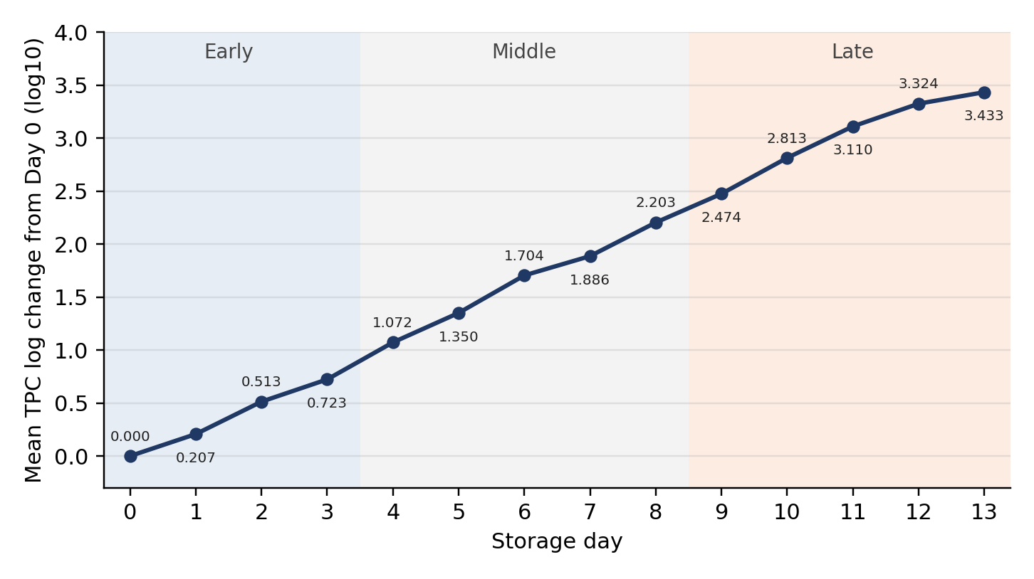
Figure 1. Average TPC log change from Day 0 over storage days 0–13. Shaded bands show the analyst-defined Early, Middle and Late phases.

7.2 pH and moisture at Day 13
Table 4. Mean change from baseline on Day 13
Feature | Day 13 mean | Unit
pH_Change_From_Baseline | −0.882 | pH units
Moisture_Change_From_Baseline | −4.438 | percentage points (assuming the source variable is a percentage)

7.3 Correlations
Table 5. Correlations between features
Variable pair | Correlation
Day and TPC_Log_Change | 0.99
Day and pH_Change_From_Baseline | −0.94
Day and Moisture_Change_From_Baseline | −0.93
TPC_Log_Change and pH_Change_From_Baseline | −0.94
TPC_Log_Change and Moisture_Change_From_Baseline | −0.91
pH_Change_From_Baseline and Moisture_Change_From_Baseline | 0.82
Day and TPC_Growth_Ratio | 0.18

Interpretation. Correlations describe association within this dataset and do not prove causation. TPC log change rises with storage day, while pH and moisture changes fall with it (−0.94 and −0.93). Because all of these quantities trend with time, their mutual correlations (for example −0.94 between TPC log change and pH change) largely reflect a shared time trend; they do not show that one variable drives another. For modelling, this also means the features are strongly interrelated, so redundancy between them should be checked.
TPC_Growth_Ratio. The mean TPC_Growth_Ratio is not consistently increasing from day to day, and its correlation with Day is only 0.18, in contrast to 0.99 for TPC_Log_Change. The ratio is affected by replicate-level variation and by the size of each replicate’s baseline count. A plausible reason for the difference is that the ratio is on the raw-count scale, where a few large values can dominate, whereas the log change compresses that range; this explanation has not been tested here. Differences in how counts and log values are treated, such as dilution adjustment, could also contribute; this was not examined here. The ratio should not be described as steadily increasing.

8. Potential Applications in Future Machine-Learning Models
The following uses are possibilities that would need validation through model training and testing:
- Relative-change inputs. TPC_Log_Change, pH_Change_From_Baseline and Moisture_Change_From_Baseline could represent how far each sample has moved from its start, which may be easier for a model to use than absolute values.
- Baseline context. Baseline features could allow a model to account for different starting conditions across replicates.
- Phase-based analysis. Storage_Phase could support grouped summaries, stratified evaluation or a categorical input.
- Alternative target or input. TPC_Log_Change could serve as a regression target or input in later exploratory models; the log scale may be preferable to TPC_Growth_Ratio given the ratio’s variability.
- Feature selection. The strong correlations in Table 5 suggest that some features carry overlapping information, so feature selection or regularisation may be useful.

9. Limitations and Responsible Interpretation
- No model was trained or validated. The report therefore makes no claim that predictive accuracy has improved. Feature usefulness is potential and must be tested in future work.
- Exploratory phase boundaries. Early, Middle and Late are analyst-defined groupings, not validated food-safety thresholds.
- Dependence on Day 0. Baseline features exist only where the Day 0 observation of the replicate is available.
- Possible data leakage. Baseline-derived features carry information from the same replicate’s Day 0 observation. If rows from one replicate are split carelessly between training and test sets, the test set can indirectly share information with training; splits should keep each replicate together.
- Correlation is not causation. Associations in Table 5 do not establish cause and effect, and mostly reflect shared time trends.
- Small, structured sample. The data consist of 70 rows (14 days × 5 replicates), and rows from the same replicate are not independent.
- No food-safety conclusion. This dataset alone does not establish food safety or shelf life.

10. Conclusion
Nine features were engineered from the cleaned paneer storage-study dataset, extending it from 70 × 24 to 70 × 33 with no missing values in the new columns. Descriptively, mean TPC log change increases from 0.000 to 3.433 across Days 0–13, and by Day 13 mean pH has changed by −0.882 and mean moisture by −4.438 percentage points. The strong correlations with Day indicate shared time trends, whereas TPC_Growth_Ratio behaves differently and does not rise steadily. The features are a basis for future modelling, but their value as model inputs remains to be demonstrated through properly split training and testing.

11. References
[1] Storage study data for paneer in controlled RH and Temperature environment, Mendeley Data, Version 2, DOI: 10.17632/rd9dmr54xx.2 (published 17 February 2026; licensed CC BY 4.0).
[2] McKinney, W. (2010). Data structures for statistical computing in Python. Proceedings of the 9th Python in Science Conference, 56–61.
[3] Harris, C. R., et al. (2020). Array programming with NumPy. Nature, 585, 357–362.
[4] Hunter, J. D. (2007). Matplotlib: A 2D graphics environment. Computing in Science & Engineering, 9(3), 90–95.

