YUVA INTERN
Food Processing Internship
Week 4: Predictive Modeling
Paneer Storage Study
Estimating log₁₀ total plate count (TPC_Log10) from storage-day, pH, moisture and replicate information using Linear Regression and Random Forest regression
Date of preparation
13 October 2026
Dataset
Mendeley Data, DOI 10.17632/rd9dmr54xx.2 (Version 2, CC BY 4.0)

Contents

1. Abstract
This report documents the Week 4 predictive-modeling task of the Yuva Intern Food Processing internship. The task investigates whether a small set of storage-related inputs can be used to estimate the base-10 logarithm of the total plate count (TPC_Log10) of paneer samples. The data come from a published paneer storage study and comprise 70 observations collected over 14 storage days (Day 0 to Day 13) with five replicates per day. The models use four inputs: Day, pH, Moisture_Percent and Replicate.
A temporal holdout was used: observations from Days 0–10 (55 samples) trained the models and observations from Days 11–13 (15 samples) tested them. Linear Regression and a Random Forest Regressor were compared using Mean Absolute Error (MAE), Root Mean Squared Error (RMSE) and R². On the held-out days, Linear Regression achieved MAE 0.1180, RMSE 0.1524 and R² 0.2208, whereas Random Forest achieved MAE 0.4679, RMSE 0.4968 and R² −7.2812.
Linear Regression therefore performed better in this experiment, but its R² shows only limited predictive ability, and the negative R² of the Random Forest means it did worse than simply predicting the test-set mean. The experiment is a small, initial modeling exercise using one study; it is not an external validation and its outputs must not be used to judge the safety or shelf life of paneer.

2. Introduction
Food-processing research frequently measures how product quality changes during storage. Microbial counts, pH and moisture content are routinely recorded, but microbiological counts require laboratory work and incubation time. Predictive modeling asks whether quantities that are easier to measure can help estimate a harder-to-measure quantity. Such models can also summarize how strongly the recorded variables are related and show where simple assumptions break down.
This report uses a published paneer storage dataset in which samples were stored under controlled relative humidity and temperature conditions and measured on successive days. The dataset contains microbiological counts (total plate count, coliform, yeast and mold, and psychrophilic counts), sensory scores, pH, moisture and production details. Earlier internship weeks prepared and explored this data; Week 4 applies supervised regression to it. No claim is made here about industrial use of such models.

3. Problem Statement
The problem is a supervised regression task: given a paneer sample’s storage day, replicate number, pH and moisture percentage, estimate its TPC_Log10. The target, TPC_Log10, is the base-10 logarithm of the total plate count as recorded in the dataset. A value of 5.0 therefore corresponds to a count of 10⁵ on the log scale, and a difference of 1.0 represents a ten-fold difference in count.
The question is deliberately framed over time: the models are trained on earlier storage days and asked to estimate later days, which is harder than predicting a randomly chosen sample from the middle of the study.

4. Objectives
- Load the existing feature-engineered paneer dataset and confirm its structure.
- Define a target (TPC_Log10) and a fixed predictor set (Day, pH, Moisture_Percent, Replicate).
- Split the data chronologically into a training period (Days 0–10) and a test period (Days 11–13).
- Train and evaluate two regression models, Linear Regression and Random Forest Regressor.
- Compare the models using MAE, RMSE and R² and examine their errors visually.
- Report the results honestly, including their limitations, and outline sensible next steps.

5. Dataset Description

5.1 Source and structure
The data are taken from the Mendeley Data record “Storage study data for paneer in controlled RH and Temperature environment”, Version 2, DOI 10.17632/rd9dmr54xx.2, released under the Creative Commons Attribution 4.0 (CC BY 4.0) licence. The feature-engineered file used in this project (paneer_feature_engineered.csv) was checked directly and contains 70 rows and 33 columns. Storage days run from Day 0 to Day 13 (14 days), with five replicates (1–5) on every day (14 × 5 = 70).

5.2 Complete dataset versus modeling features
The feature-engineered file holds many more columns than the models use. The columns fall into the groups below. Only the four predictor columns were supplied to the models, and TPC_Log10 is the target.
Table 1. Column groups in the feature-engineered dataset
Group | Columns | Used by models?
Identifiers | Day, Replicate | Yes (both)
Total plate count | TPC_CFU_ml, TPC_Dilution, TPC_Log10 | Target: TPC_Log10 only
Other microbiology | Coliform, Yeast_Mold and Psychrophilic counts, dilutions and log values | No
Sensory scores | Colour_Appearance, Body_Texture, Flavour, Overall_Acceptability | No
Physicochemical | pH, Moisture_Percent | Yes (both)
Production details | Milk_Quantity, Paneer_Quantity, Yield_Percent, Fat_Percent | No
Engineered columns | Storage_Phase, baseline values, change-from-baseline values, TPC_Growth_Ratio | No

The engineered columns derived from TPC (for example TPC_Log_Change and TPC_Growth_Ratio) were not among the inputs. Such columns are computed from the target and would leak its value into the inputs if used. The inputs actually used are summarized below, with descriptive statistics computed over all 70 observations.
Table 2. Predictors and target used in the experiment
Variable | Role and meaning | Mean | Range
Day | Predictor; storage day | 6.50 | 0–13
pH | Predictor; acidity of the sample | 5.394 | 4.93–5.98
Moisture_Percent | Predictor; moisture content (%) | 50.648 | 48.11–53.47
Replicate | Predictor; replicate number | 3.00 | 1–5
TPC_Log10 | Target; log₁₀ total plate count | 4.063 | 2.079–5.845

Mean TPC_Log10 rises from about 2.29 on Day 0 to about 5.72 on Day 13, so the target is strongly time-dependent. The daily increase is steady through most of the study and appears to slow over Days 11–13 (daily means of about 5.40, 5.62 and 5.72).

6. Data Preparation and Feature Selection
The existing feature-engineered CSV was loaded directly with pandas; no new cleaning step was introduced for the modeling task. A check of the four predictors and the target in the supplied file found no missing values in any of the five columns. (Some other columns of the dataset, such as the coliform log values, contain blanks, but they are not used here.)
The target is TPC_Log10 and the predictors are Day, pH, Moisture_Percent and Replicate, as fixed in the completed experiment. This report makes no claim that feature scaling, imputation, cross-validation or hyperparameter search were applied; none of them forms part of the documented experiment.

7. Methodology

7.1 Linear Regression
Linear Regression estimates the target as a weighted sum of the inputs plus a constant. The weights are chosen so that the sum of squared differences between observed and fitted values on the training data is as small as possible (ordinary least squares).
TPC_Log10 ≈ b₀ + b₁·Day + b₂·pH + b₃·Moisture_Percent + b₄·Replicate
The model is easy to interpret and continues a trend beyond the range of the training data, which is relevant here because the test days lie after the training days. Its limitation is that it can only represent relationships that are additive and straight-line in the inputs.

7.2 Random Forest Regression
A Random Forest Regressor builds many decision trees, each trained on a random resample of the training data, and averages their predictions. Each tree divides the input space into regions and predicts the average training target within a region. Averaging many trees reduces the variability of any single tree and allows non-linear relationships and interactions to be captured. The settings used are listed in Table 3.
Table 3. Random Forest configuration
Parameter | Value
Number of estimators (n_estimators) | 200
Maximum depth (max_depth) | 5
Minimum samples per leaf (min_samples_leaf) | 2
Random state (random_state) | 42

7.3 Why compare two models
A simple model gives a reference point against which a more flexible model must justify its added complexity. If the flexible model does not outperform the simple one on unseen data, the extra flexibility is not helping for that problem. Comparing the two also reveals different behaviors, for example how each handles later days that lie beyond the training period.

8. Experimental Setup
The experiment uses a temporal holdout taken from the same dataset. Data from earlier storage days were used for training and data from later days for testing, which mimics estimating later samples from earlier ones more closely than a random split would.
Table 4. Training and test partitions
Partition | Storage days | Observations | Share of data
Training | Day 0 – Day 10 | 55 | 78.6%
Test | Day 11 – Day 13 | 15 | 21.4%
Total | Day 0 – Day 13 | 70 | 100%

Both partitions come from the same study, the same storage conditions and the same production runs. The test set is therefore an internal holdout and not an independent validation set.

9. Evaluation Metrics
Let yᵢ be the observed TPC_Log10 of test observation i, ŷᵢ the model’s estimate, ȳ the mean of the observed test values and n the number of test observations (15).

9.1 Mean Absolute Error (MAE)
MAE = (1/n) Σ | yᵢ − ŷᵢ |
MAE is the average size of the errors, in the same units as the target (log₁₀ units). An MAE of 0.1180 means that, on average, the estimates were about 0.12 log units from the observed values. Lower is better.

9.2 Root Mean Squared Error (RMSE)
RMSE = √[ (1/n) Σ ( yᵢ − ŷᵢ )² ]
RMSE also uses the target’s units but squares the errors before averaging, so large errors are penalized more heavily than small ones. An RMSE well above the MAE suggests a few comparatively large errors. Lower is better.

9.3 R-squared (R²)
R² = 1 − Σ ( yᵢ − ŷᵢ )² / Σ ( yᵢ − ȳ )²
R² compares the model with a baseline that always predicts the test-set mean. A value of 1 is perfect, a value of 0 means the model is no better than the baseline, and a negative value means the model’s predictions are worse than the baseline. Because the denominator depends on the spread of the test targets, R² is sensitive to small test sets with little variation. The 15 test values here have a standard deviation of about 0.17 log units, which makes R² a demanding measure for this experiment.

10. Results
Both models were fitted on the 55 training observations and evaluated on the 15 test observations. Table 5 reports the recorded results of the completed experiment.
Table 5. Test-set performance (Days 11–13, n = 15)
Model | MAE | RMSE | R²
Linear Regression | 0.1180 | 0.1524 | 0.2208
Random Forest | 0.4679 | 0.4968 | −7.2812
Lower MAE and RMSE and higher R² indicate better performance. Linear Regression is better on all three measures.
An independent re-run of both models on the supplied CSV reproduced the Linear Regression metrics exactly. The Random Forest metrics differed marginally (MAE 0.4674, RMSE 0.4963, R² −7.2658), which is the kind of small difference that can arise between software versions or environments. The conclusions are identical; details are in Appendix B.

11. Results Interpretation
Linear Regression outperformed the Random Forest in this experiment: its MAE was about four times smaller (0.1180 against 0.4679) and its RMSE about three times smaller (0.1524 against 0.4968). Its R² of 0.2208 is, however, modest. The model explains only a small part of the variation among the 15 test values and should be described as limited rather than good.
A plausible reason Linear Regression did relatively better is that it can continue a trend: TPC_Log10 increases with storage day, and the fitted model assigns a positive weight to Day, so its estimates move upward on later days. The scatter plot shows its estimates fall within roughly 5.3–6.0 for observed values of about 5.2–5.85, but with noticeable scatter, and several points lie well above the diagonal.
For the Random Forest, the negative R² of −7.2812 means its errors were large relative to the small spread of the test values. A check of the training and test data shows a pattern that is consistent with these results without proving a cause: the training targets reach at most about 5.30, the test targets range from about 5.18 to 5.85 (mean about 5.58), and the Random Forest estimates in the re-run stayed in a narrow band of roughly 5.0–5.1. The forest therefore under-estimated the later days systematically. No further explanation is asserted, because the experiment did not include diagnostics to establish one.
These findings apply to this test set only. With 15 test observations drawn from three consecutive days, the ranking of the models could change with different data, and nothing here shows that either model would generalize to other paneer batches, storage temperatures or humidity conditions.

12. Visual Analysis
The three figures below were produced during the completed experiment and are embedded unchanged from the project’s visualizations folder.

12.1 Actual versus predicted values
Figure 1 plots observed against estimated TPC_Log10 for the 15 test observations. Points on the dashed diagonal would be perfect estimates. Several points are close to the line, but others, especially some observations with actual values between about 5.55 and 5.75, are over-estimated by roughly 0.2–0.35 log units.
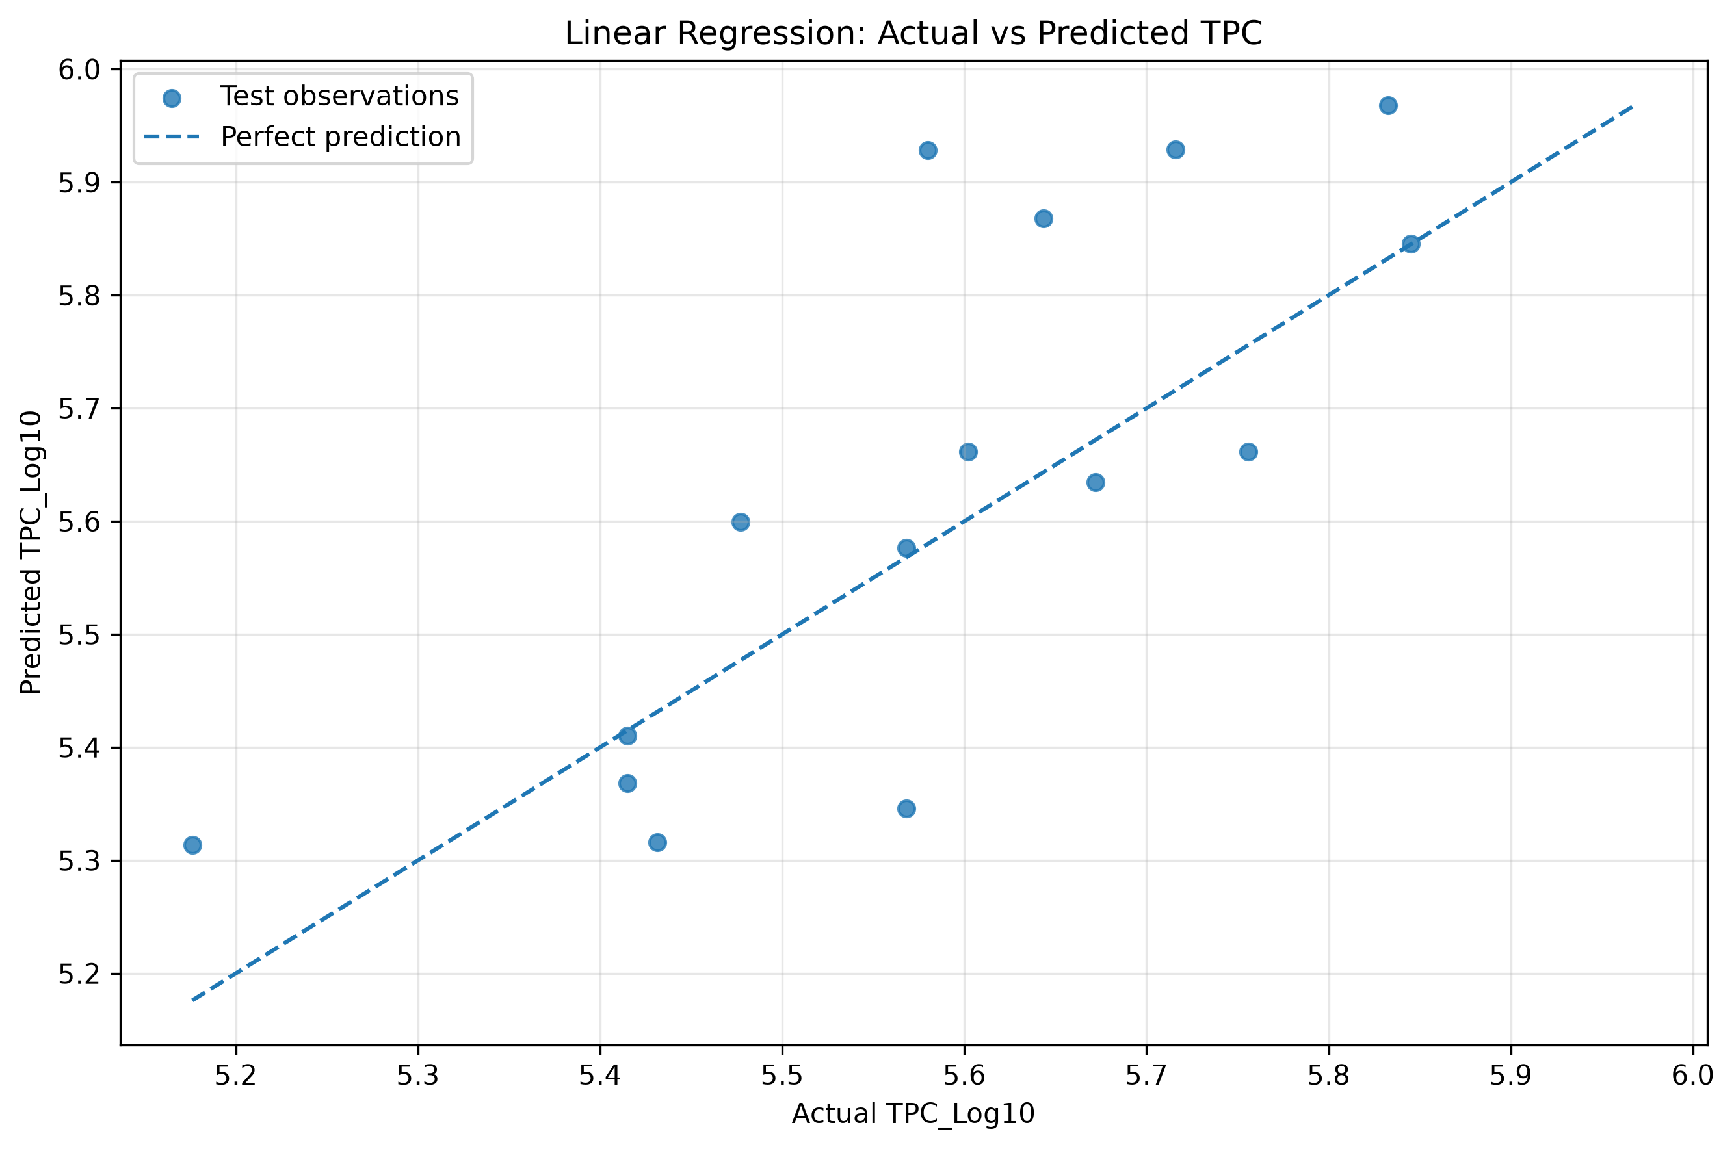
Figure 1. Linear Regression: actual versus predicted TPC_Log10 on the test set (Days 11–13).

12.2 Residual plot
Figure 2 shows residuals (actual minus predicted) against predicted values. Residuals fall both above and below zero, so there is no single direction of error, but they are not tightly clustered: the largest negative residual is about −0.35 and the largest positive about +0.22. The most negative residuals occur at the highest predicted values (about 5.87–5.93), indicating over-estimation there. With only 15 points, this is an observation and not a confirmed pattern.
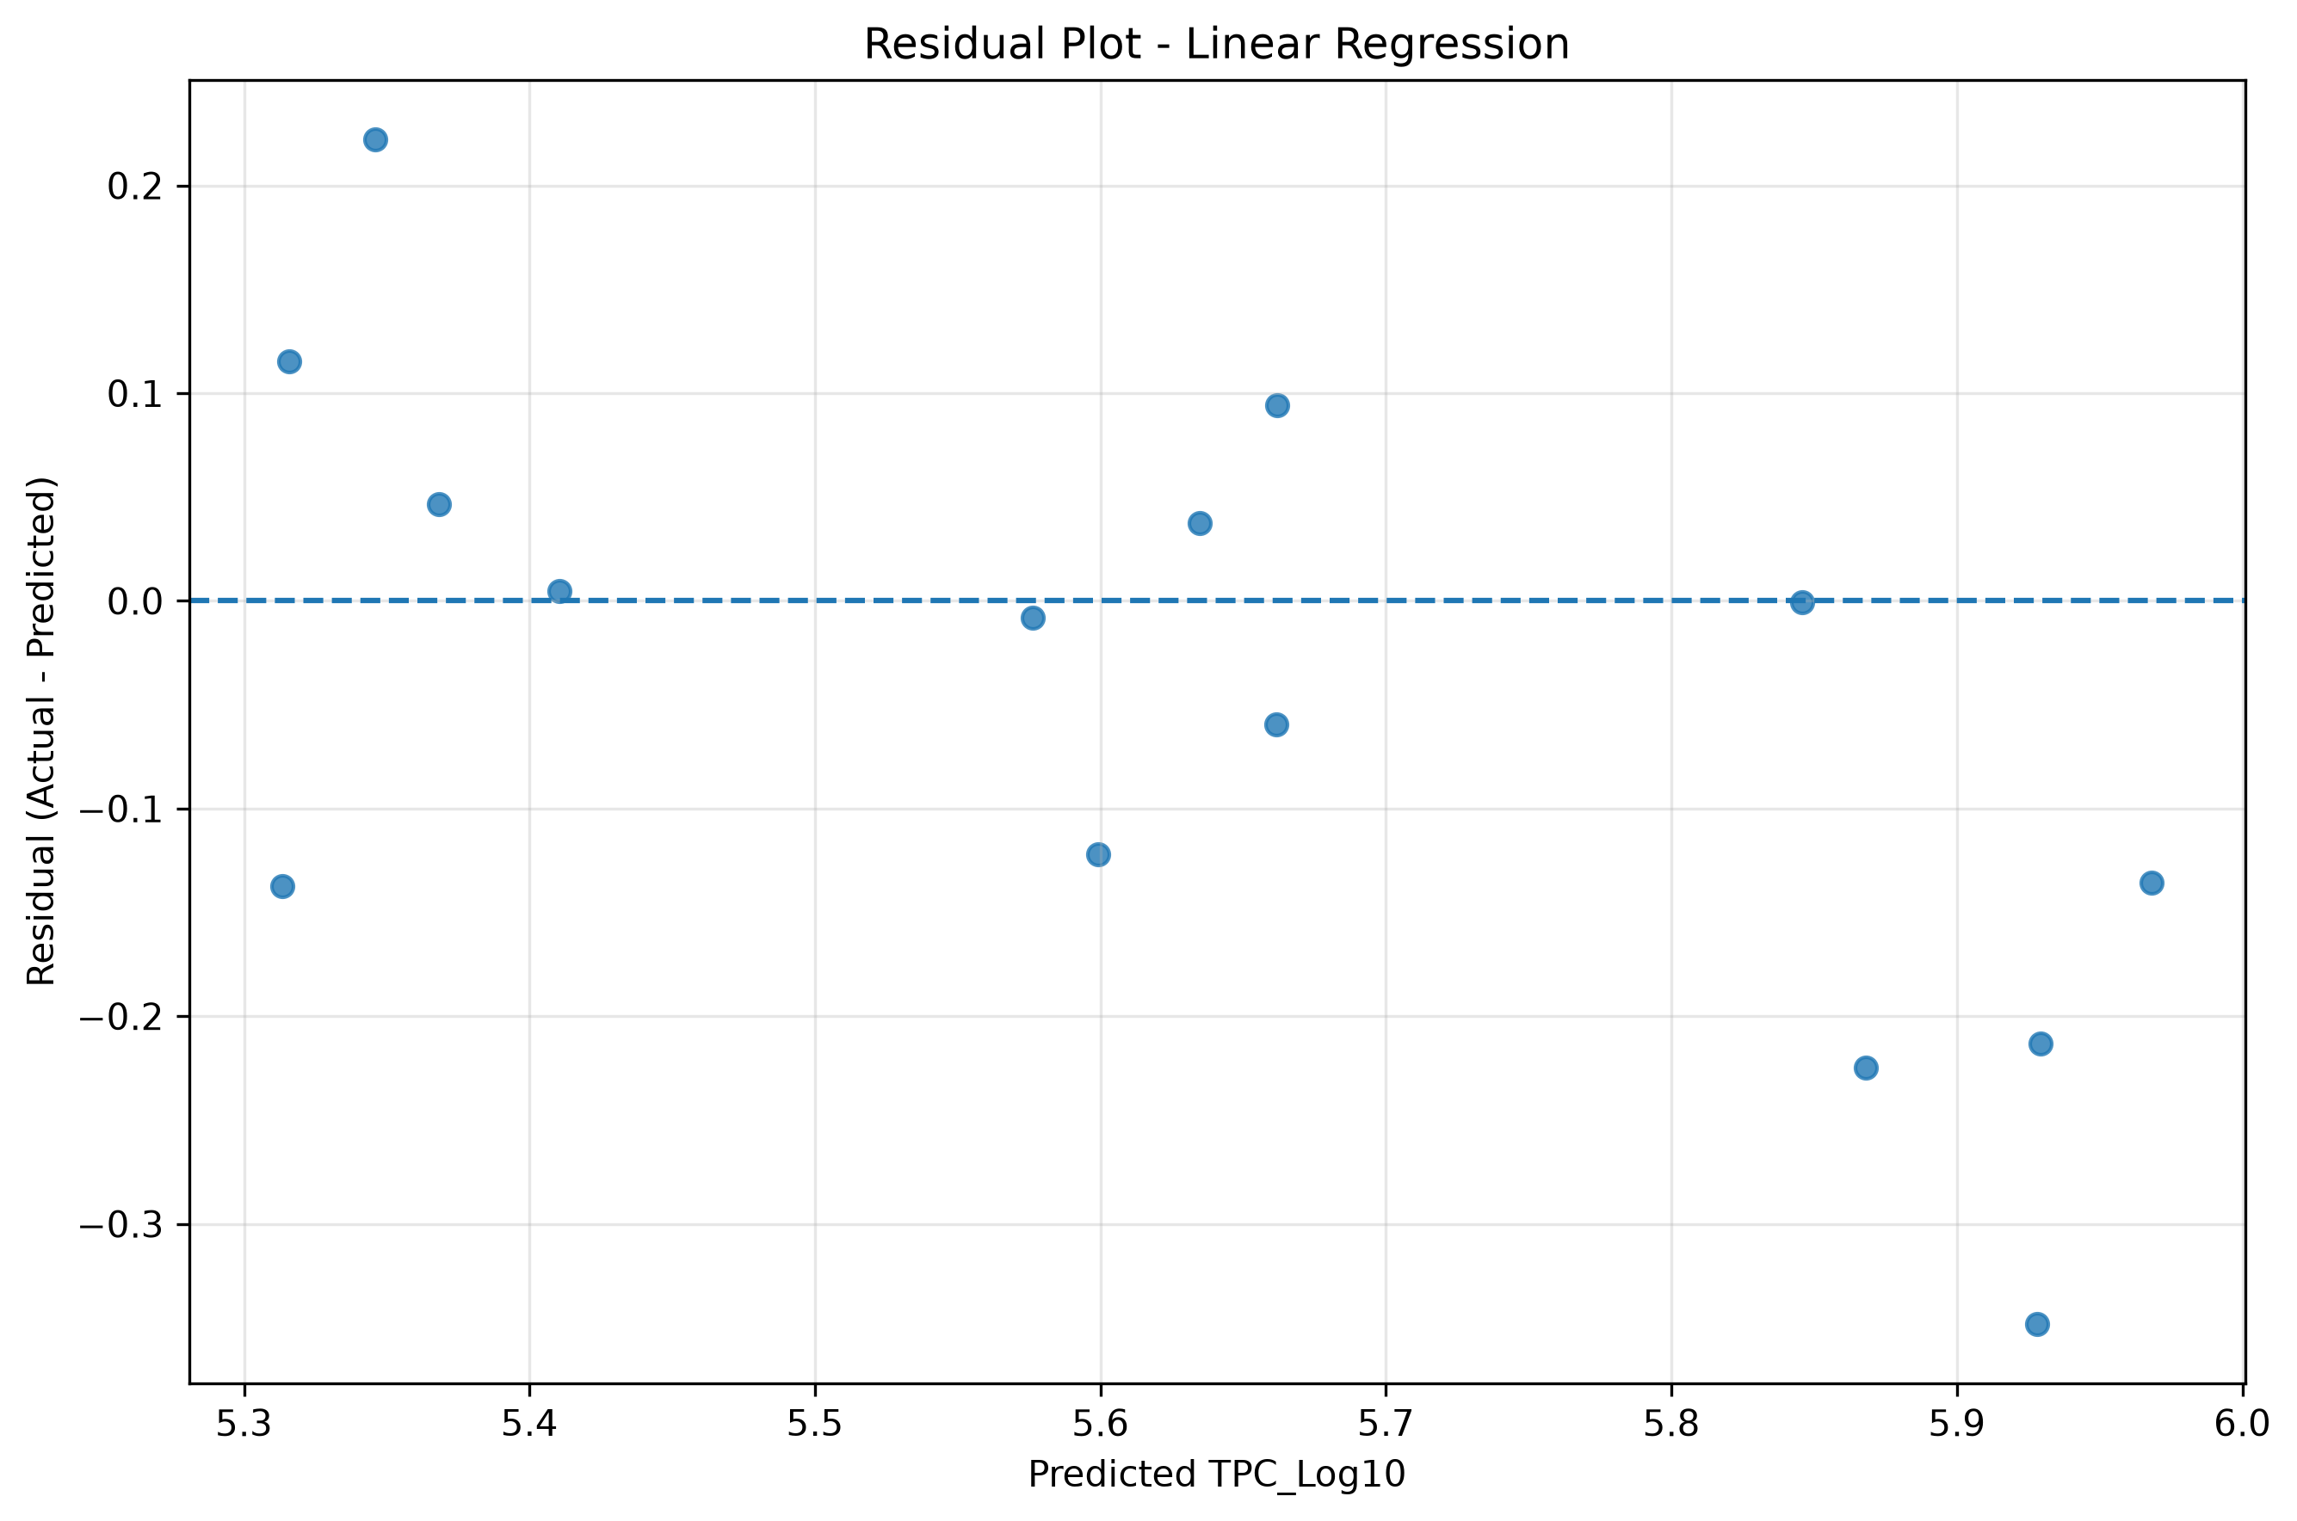
Figure 2. Residual plot for Linear Regression (residual = actual − predicted).

12.3 Model performance comparison
Figure 3 compares the two models by MAE and RMSE. The Random Forest bars are several times higher, in agreement with Table 5. R² is not shown in the figure.
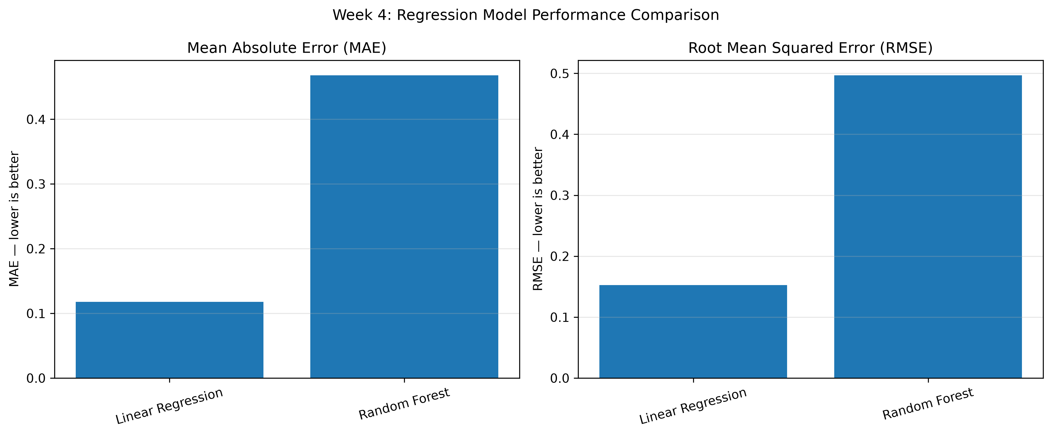
Figure 3. MAE and RMSE for Linear Regression and Random Forest on the test set (lower is better).

13. Limitations
- Small dataset and test set. Only 70 observations exist and just 15 were used for testing, so the metrics are uncertain and sensitive to individual points.
- Same-study evaluation. Training and test observations come from the same study, so the results do not show performance on new experiments or laboratories.
- Later days of one dataset only. Testing on Days 11–13 is a useful temporal check but covers a narrow part of the storage period, and later days may behave differently from earlier ones.
- Initial modeling exercise. The work is exploratory and has not been externally validated.
- Replicate as a numeric predictor. Replicate is an identifier-like variable; treating it as a number imposes an artificial ordering (replicate 5 is not “more” than replicate 1) that may introduce an artificial ordering effect.
- Same-day measurements assumed. pH and moisture are measured on the same day as the sample’s TPC, so the models assume those measurements are available at prediction time.
- No validated safety criteria. No validated food-safety classification threshold or independently verified shelf-life label was supplied, so the models estimate a count and cannot classify samples.

14. Ethical and Scientific Considerations
A predicted total plate count alone cannot establish whether a food product is safe to consume. Food safety depends on specific pathogens, toxins, handling, storage and regulatory limits that a regression on TPC_Log10 does not capture. Regression outputs in this report have deliberately not been converted into categories such as “safe” or “spoiled”, because no validated criteria were provided. The experiment must not be presented as a certified quality-control or shelf-life system.
The data used are openly licensed under CC BY 4.0 and are credited in the references. Because the metrics are modest and the test set is small, they should be reported with their uncertainty and not as evidence of reliable performance.

15. Conclusion
This work built and evaluated two regression models to estimate TPC_Log10 of stored paneer from Day, pH, Moisture_Percent and Replicate. Training on Days 0–10 (55 observations) and testing on Days 11–13 (15 observations), Linear Regression (MAE 0.1180, RMSE 0.1524, R² 0.2208) clearly outperformed the Random Forest (MAE 0.4679, RMSE 0.4968, R² −7.2812), whose estimates were worse than a mean-only baseline.
Even the better model has limited explanatory power, and the results come from a small internal temporal holdout of a single study. The outcome is best read as a baseline for further work and not as a deployable predictor.

16. Future Scope
- Collect more observations and include independent paneer batches and storage conditions.
- Adopt stronger validation, such as time-aware cross-validation or leave-one-batch-out evaluation.
- Handle replicate identifiers appropriately, for example by treating them as categories or removing them.
- Compare additional models, tune hyperparameters, and assess uncertainty with prediction intervals.
- Investigate whether the apparent slowing of growth on later days can be modeled, for instance with growth-curve models.
- Carry out external validation before any practical use, and add validated food-safety criteria if classification is ever required.

17. References
- Storage study data for paneer in controlled RH and Temperature environment (Version 2). Mendeley Data. https://doi.org/10.17632/rd9dmr54xx.2. Licensed under CC BY 4.0. (Author list not recorded in the project files.)
- Pedregosa, F., et al. (2011). Scikit-learn: Machine learning in Python. Journal of Machine Learning Research, 12, 2825–2830.
- Breiman, L. (2001). Random forests. Machine Learning, 45(1), 5–32. https://doi.org/10.1023/A:1010933404324

Appendix A. Project Structure and Configuration
Relevant project structure (the project folder may contain further files):
week 4 predictive modeling/
data/raw/
data/processed/paneer_feature_engineered.csv
notebooks/04_predictive_modeling.ipynb
visualizations/ (three PNG figures used in this report)
models/
report/ (this report, model_comparison.csv, summaries, checklist)
README.md

Table A1. Experiment configuration
Item | Setting
Target | TPC_Log10
Predictors | Day, pH, Moisture_Percent, Replicate
Training set | Days 0–10, 55 observations
Test set | Days 11–13, 15 observations
Linear Regression | Ordinary least squares, default settings
Random Forest | n_estimators 200, max_depth 5, min_samples_leaf 2, random_state 42

Appendix B. Reproduction Check
Because the saved notebook supplied with the project contained no recorded outputs, the metrics could not be compared with notebook output. Instead, both models were re-fitted on the supplied CSV with the stated split and settings (scikit-learn 1.8.0).
Table B1. Recorded results versus independent re-run
Model / source | MAE | RMSE | R² | Match
Linear Regression, recorded | 0.1180 | 0.1524 | 0.2208 | –
Linear Regression, re-run | 0.1180 | 0.1524 | 0.2208 | Exact
Random Forest, recorded | 0.4679 | 0.4968 | −7.2812 | –
Random Forest, re-run | 0.4674 | 0.4963 | −7.2658 | Close

The Random Forest differences are in the third decimal place for MAE and RMSE; the exact cause was not investigated. The report uses the recorded values, and neither set of figures changes any conclusion.

