Supermarket Sales Analysis
AI + Data: Make Data Intelligent — Masterclass 1 | Project Report

1. Introduction
This project analyses the supplied Practice Dataset to understand its structure, identify data-quality problems, prepare a reliable analysis copy, answer management questions and provide practical recommendations.

2. Dataset Structure
Column | Type | Business use
Order_ID | Identifier | Tracks an order.
Order_Date | Date | Supports time trends.
Customer_ID | Identifier | Supports customer and repeat-customer analysis.
Product | Categorical | Supports product performance.
Category | Categorical | Supports category comparison.
Region | Categorical | Supports regional comparison.
Quantity | Numerical | Supports sales volume.
Revenue | Numerical | Supports sales and order-value analysis.
Profit | Numerical | Supports profitability analysis.

3. Data Quality Findings
Issue | Finding | Recommendation
Missing values | Customer_ID 26; Product 7; Region 16; Quantity 23; Revenue 27; Profit 29. | Review missing records before using the affected metric.
Duplicate records | 23 exact duplicate rows. | Remove exact duplicates from analysis to avoid double counting.
Category inconsistency | 15 raw variants represent 5 logical categories. | Standardise capitalization/spelling.
Region inconsistency | 21 raw variants represent 7 logical regions. | Standardise capitalization/spelling.
Invalid dates | 24 invalid dates after exact duplicates are removed. | Exclude invalid dates from time analysis until verified.
Mixed revenue formats | Revenue contains numeric and currency/text formats; 27 values are missing. | Convert to numeric after cleaning currency/text.
Negative quantities | 38 records have negative quantity. | Review as possible returns/corrections; no return flag is supplied.
Negative profit | 15 records have negative profit. | Review loss-making transactions.
Outliers | Revenue/profit contain statistical outliers. | Investigate rather than automatically deleting them.

4. Cleaning Method
- Exact duplicate rows were removed from the analysis copy.
- Product, Category and Region text were trimmed and standardised.
- Revenue was converted to numeric after removing currency/text characters.
- Both ISO and day-month-year date formats were parsed; invalid dates remain missing.
- Negative quantities were excluded from core positive-sales analysis because the dataset has no transaction-type/return field.
- Rows with critical missing fields were excluded only from metrics that require those fields.

5. Key Findings
- Core analysis transactions: 1,816.
- Total revenue: ₹89,393,248.
- Total profit: ₹14,292,042.
- Highest-revenue product: Laptop — ₹18,551,719.
- Highest-revenue category: Electronics — ₹57,281,932.
- Highest-revenue region: Pune — ₹15,853,015.
- Repeat-customer revenue: ₹82,605,422; New-customer revenue: ₹4,886,881.

6. Visual Analysis
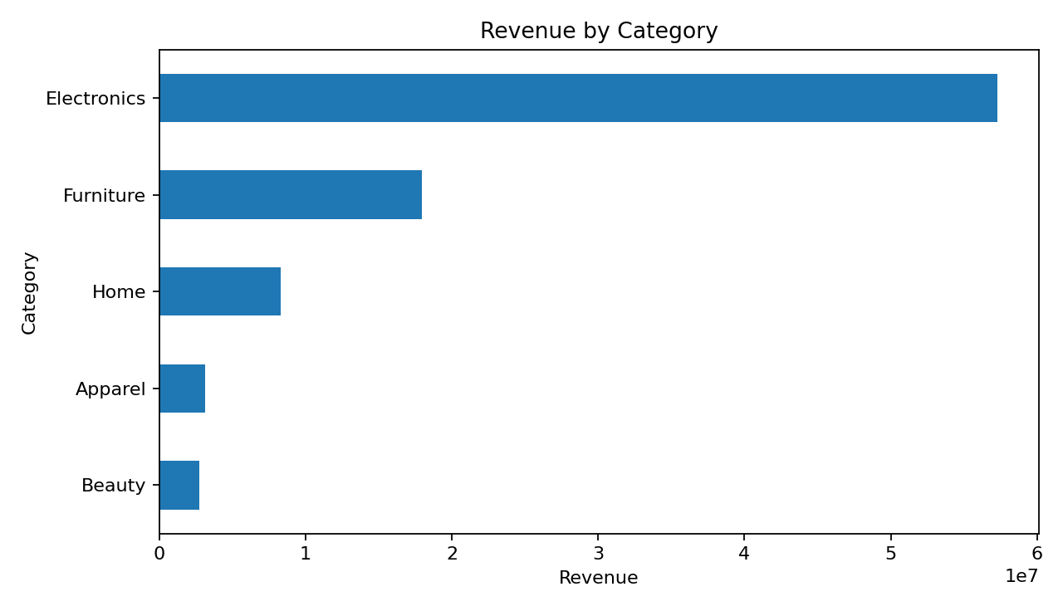
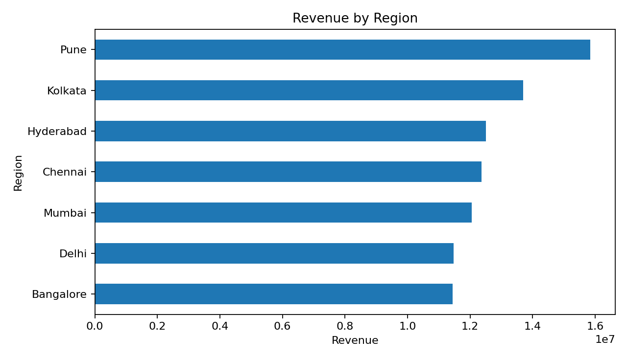
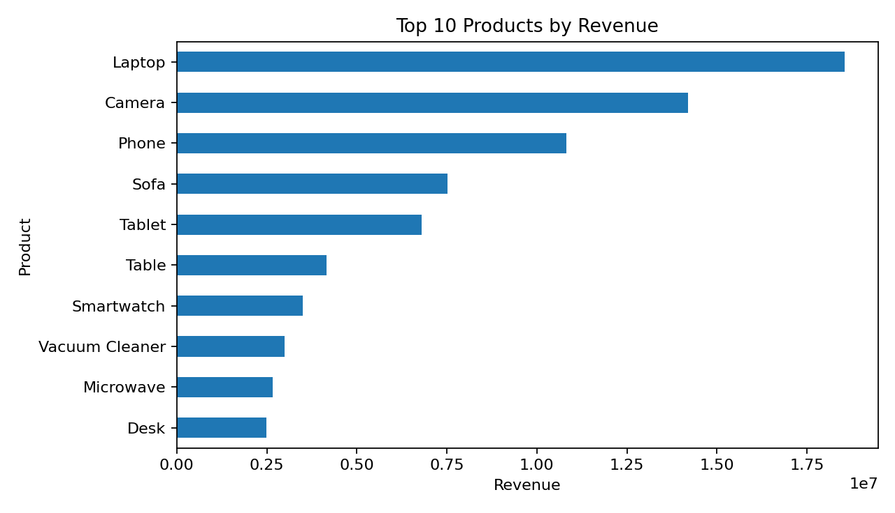
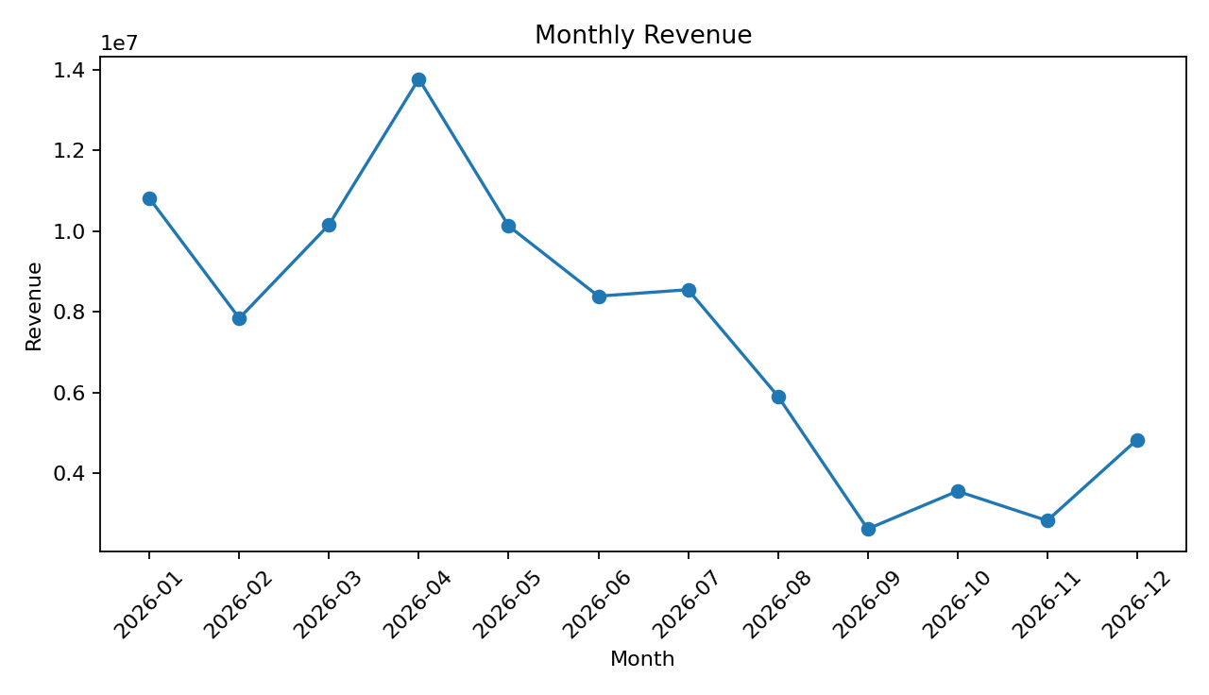

7. 12 Management Questions
- Which month generated the highest revenue?
- Which month generated the highest profit?
- What is the average revenue per valid order?
- Which product generated the highest revenue?
- Which product generated the highest profit?
- Which category generated the highest revenue?
- Do repeat customers contribute more revenue than new customers?
- Which customer segment has the highest average order value?
- What share of valid orders comes from repeat customers?
- Which region generated the highest revenue?
- Which region generated the highest profit?
- Which region has the highest average revenue per valid order?

8. Recommendations
- Prioritise inventory and promotions around high-revenue products.
- Protect Electronics availability and monitor profitability.
- Study Pune's product and customer mix and apply learnings to weaker regions.
- Use retention and repeat-purchase campaigns because repeat customers drive most revenue.
- Review negative quantities and negative-profit transactions to identify returns, corrections or loss-making orders.
- Add transaction type/return status, payment method and rating fields in future data collection if those metrics are required.

9. Conclusion
The cleaned analysis shows strong performance in Electronics, Laptop and the Pune region, while repeat customers are the major revenue contributor. The main limitation is data quality, so the cleaning rules and assumptions should be retained with the project for auditability.

