Problem Statement: There can be multiple customers, who can place multiple orders on the site. Now a sales person can handle these orders will distribute into multiple sales persons (One order will be assign to one salesperson only). So a sales person can have multiple orders of multiple customers

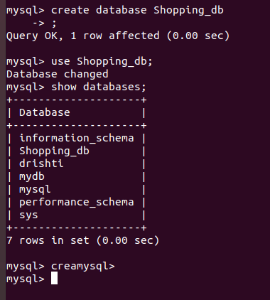
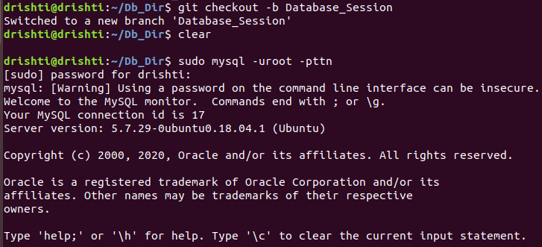
1.Create database.

2. Design Schema
Customer Schema
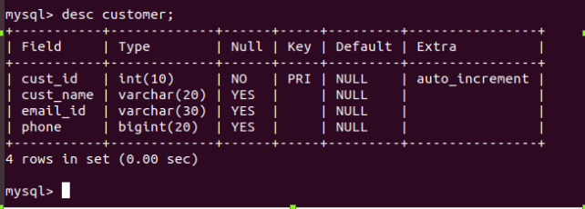

Salesman Schema
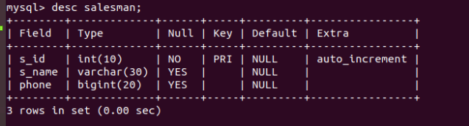

Order Schema
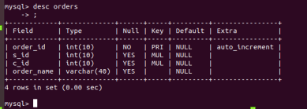

3. Create tables
a. Customer
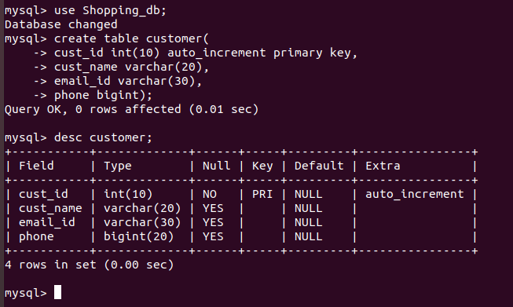
b. Salesman
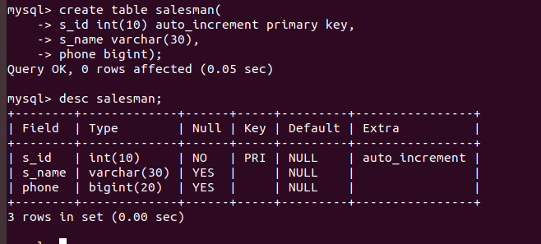

c. Order table
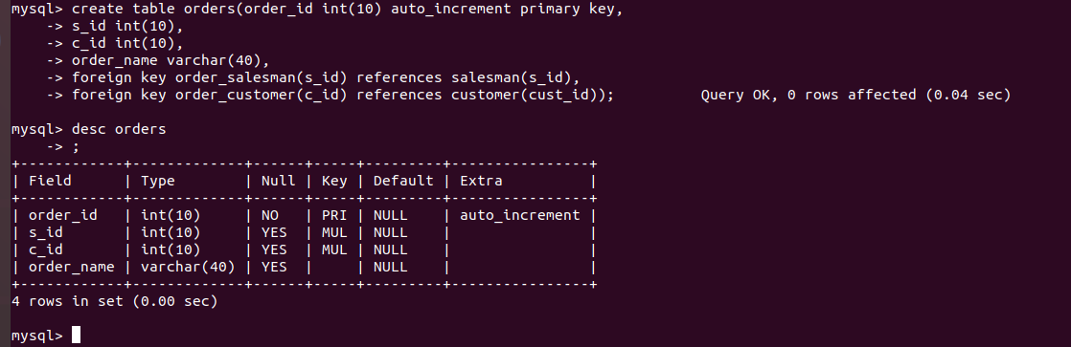

4. Insert sample data
a. Inserting values in Customer
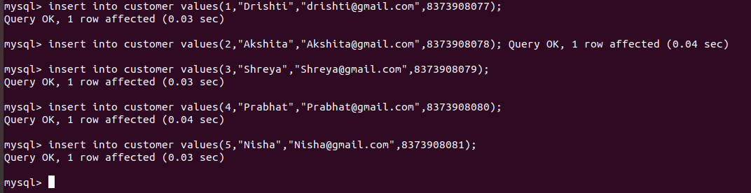
b. Inserting values in Salesman
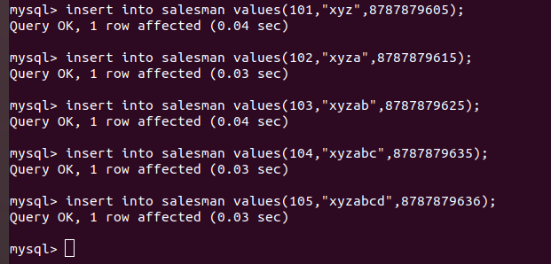

c. Inserting values in Order
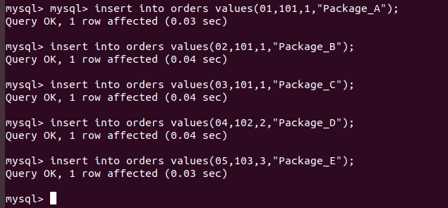

5. Find the sales person have multiple orders.
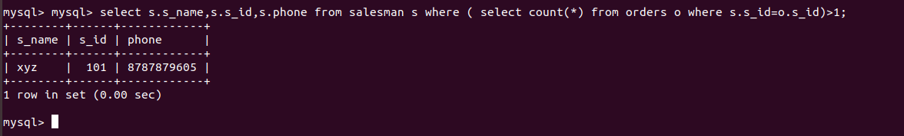
6. Find the all sales person details along with order details
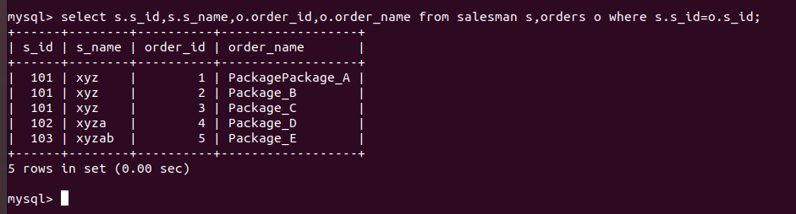
7. Create index
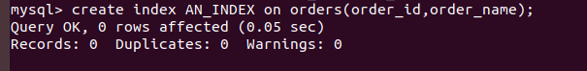

8. How to show index on a table
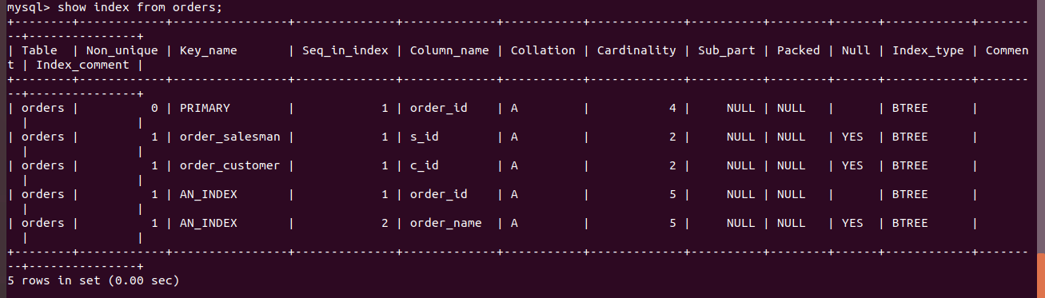

9. Find the order number, sale person name, along with the customer to whom that order belongs to
