Exercises: Introduction to Java 2

1. Create Java classes having suitable attributes for Library management system.Use OOPs concepts in your design.Also try to use interfaces and abstract classes.
Code:
/*
Create Java classes having suitable attributes for Library management system.
Use OOPs concepts in your design.Also try to use interfaces and abstract classes.
*/
interface permission {
public void add();
public void edit();
public void delete();
}
abstract class operation implements permission {
public abstract void display();
public abstract void search();
}
class Librarian extends operation {
public void add() {
}
public void edit() {
}
public void delete() {
}
public void display() {
System.out.println("Displaying customer details");
}
public void search() {
System.out.println("Searching customer");
}
}
class Book extends operation {
public void add() {
}
public void edit() {
}
public void delete() {
}
public void display() {
System.out.println("Displaying book details");
}
public void search() {
System.out.println("Searching book");
}
}
public class Ques1 {
public static void main(String[] args) {
}
}
2. WAP to sorting string without using string Methods?.
Code:
//WAP to sorting string without using string Methods?
package Java2;
public class Ques2 {
public static void main(String args[]) {
String str = "hello world";
char[] arr = str.toCharArray();
for (int i = 0; i < arr.length; i++) {
for (int j = i + 1; j < arr.length; j++) {
if (arr[j] < arr[i]) {
char temp;
temp = arr[i];
arr[i] = arr[j];
arr[j] = temp;
}
}
}
for (int i = 0; i < arr.length; i++) {
System.out.print(arr[i]);
}
}
}
Output:
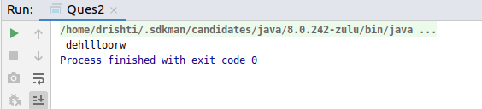
3. WAP to produce NoClassDefFoundError and ClassNotFoundException exception.
ClassNotFoundException
package Java2;
class Ques3 {
public static void main(String[] args) {
try {
Class.forName("Ques3");
System.out.println("Class found successfully");
} catch (ClassNotFoundException ex) {
System.out.println("Exception caught");
ex.printStackTrace();
}
}
}
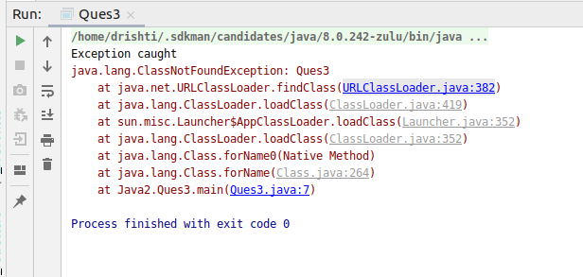
Output:

NoClassDefFoundError
class Ques3
public class Ques3 {
public static void main(String[] args) {
try {
Class.forName("Ques3");
System.out.println("Class found successfully");
} catch (ClassNotFoundException ex) {
System.out.println("Exception caught");
ex.printStackTrace();
}
A a = new A();
}
}
class A
public class A {
void display(){
System.out.println("Hello, this is class A ");
}
}
On Terminal:
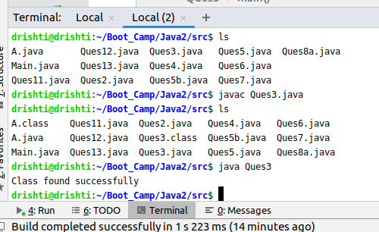
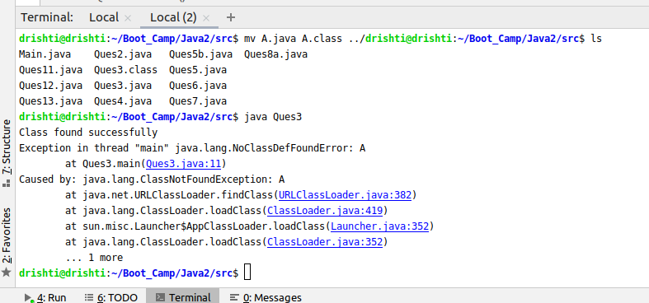
4. WAP to create singleton class.
Code:
//WAP to create singleton class.
//WAP to create singleton class.
class Ques4 {
public static Ques4 q = new Ques4();
public String str;
private Ques4() {
str = "This is a string";
}
public static Ques4 getObj() {
return q;
}
}
class Test {
public static void main(String[] args) {
Ques4 q1 = Ques4.getObj();
Ques4 q2 = Ques4.getObj();
q1.str = (q1.str).toUpperCase();
System.out.println("Object q1 " + q1.str);
q2.str = (q2.str).toUpperCase();
System.out.println("\n Object q2 " + q2.str);
}
}
Output:
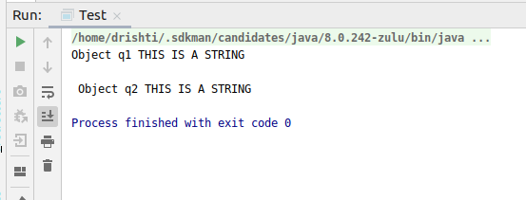

5. WAP to show object cloning in java using cloneable and copy constructor both.
Code: Using Clonable
class Ques5 implements Cloneable {
int eid;
String name;
Ques5(int eid, String name) {
this.eid = eid;
this.name = name;
}
public Object clone() throws CloneNotSupportedException {
return super.clone();
}
public static void main(String[] args) {
try {
Ques5 e1 = new Ques5(101, "Drishti");
Ques5 e2 = (Ques5) e1.clone();
System.out.println("Emp1: " + e1.eid + " " + e1.name);
System.out.println("Emp2: " + e2.eid + " " + e2.name);
} catch (CloneNotSupportedException c) {
System.out.println("Not Supported");
}
}
}

Output:
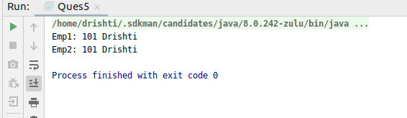

Code: Using Copy Constructor
public class Ques5b {
int eid;
String name;
Ques5b(int eid, String name) {
this.eid = eid;
this.name = name;
}
Ques5b(Ques5b q) {
eid = q.eid;
name = q.name;
}
public static void main(String[] args) {
Ques5b e1 = new Ques5b(101, "Drishti");
Ques5b e2 = new Ques5b(e1);
System.out.println("Emp1: " + e1.eid + " " + e1.name);
System.out.println("Emp2: " + e2.eid + " " + e2.name);
}
}
Output:
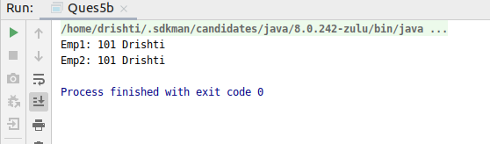
6. WAP showing try, multi-catch and finally blocks.
Code:
//WAP showing try, multi-catch and finally blocks.
package Java2;
public class Ques6 {
public static void main(String[] args) {
try {
/*
int a = 20, b = 0;
float result = a / b;
*/
int arr[] = {1, 2, 3, 4};
System.out.println(arr[5]);
} catch (ArithmeticException ae) {
System.out.println("Arithmentic Exception");
} catch (ArrayIndexOutOfBoundsException ex) {
System.out.println("Array Index Out of Bound");
} finally {
System.out.println("This is finally block");
}
}
}

Output:
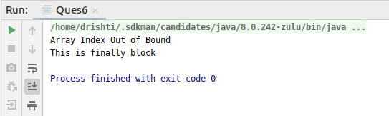

7. WAP to convert seconds into days, hours, minutes and seconds.
Code:
//WAP to convert seconds into days, hours, minutes and seconds.
public class Ques7 {
public static void main(String[] args){
int n=129600;
System.out.println(n + " seconds");
int days= n/(24*3600);
System.out.println("Days: "+days+" day(s)");
n=n%(24*3600);
int hour=n/3600;
System.out.println("Hours: "+hour+ " hour(s)");
n=n%3600;
int min=n/60;
System.out.println("Minutes: "+min+" min(s)");
n=n%60;
int sec=n;
System.out.println("Seconds: "+sec+" sec(s)");
}
}
Output:
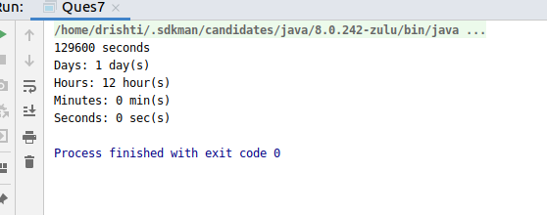

8. WAP to read words from the keyboard until the word done is entered. For each word except done, report whether its first character is equal to its last character. For the required loop, use a
a)while statement
b)do-while statement
a) Code: using while loop
import java.util.Scanner;
public class Ques8a {
public static void main(String[] args) {
Scanner keyboard = new Scanner(System.in);
System.out.println("Enter a word");
String word = keyboard.next();
while (!word.equals("done")) {
if (word.charAt(0) == word.charAt(word.length() - 1)) {
System.out.println("First and last character are equals for the word: " + word);
} else {
System.out.println("First and last character are NOT equals for the word: " + word);
}
word = keyboard.next();
}
}
}
b)Code: using while loop
import java.util.Scanner;
public class Ques8a {
public static void main(String[] args) {
Scanner keyboard = new Scanner(System.in);
System.out.println("Enter a word");
String word = keyboard.next();
do {
if (word.charAt(0) == word.charAt(word.length() - 1)) {
System.out.println("First and last character are equals for the word: " + word);
} else {
System.out.println("First and last character are NOT equals for the word: " + word);
}
word = keyboard.next();
} while (!word.equals("done"));
}
}
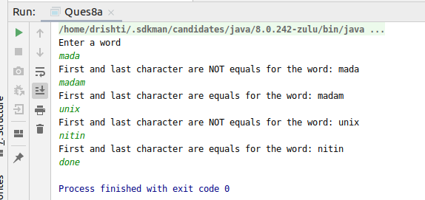
Output:

9. Design classes having attributes for furniture where there are wooden chairs and tables, metal chairs and tables. There are stress and fire tests for each products.
Code:
//Design classes having attributes for furniture where
// there are wooden chairs and tables,
// metal chairs and tables.
// There are stress and fire tests for each products.
interface Furniture {
void stressTest();
void fireTest();
}
abstract class Chair implements Furniture {
public abstract String chairType();
}
abstract class Table implements Furniture {
public abstract String tableType();
}
class metalChair extends Chair {
@Override
public void stressTest() {
System.out.println("passed in stress test");
}
@Override
public void fireTest() {
System.out.println("passed in fire test");
}
@Override
public String chairType() {
String s1 = "Metal Chair";
return s1;
}
}
class metalTable extends Table {
@Override
public void stressTest() {
System.out.println("passed in stress test");
}
@Override
public void fireTest() {
System.out.println("passed in fire test");
}
@Override
public String tableType() {
String s2 = "Metal Table";
return s2;
}
}
class woodenChair extends Chair {
@Override
public void stressTest() {
System.out.println("failed in stress test");
}
@Override
public void fireTest() {
System.out.println("failed in fire test ");
}
@Override
public String chairType() {
String s3 = "Wooden Chair";
return s3;
}
}
class woodenTable extends Table {
@Override
public void stressTest() {
System.out.println("passed in stress test ");
}
@Override
public void fireTest() {
System.out.println("failed in fire test");
}
@Override
public String tableType() {
String s4 = "Wooden Table";
return s4;
}
}
public class Ques9 {
public static void main(String[] args) {
//metal chair
metalChair m1 = new metalChair();
System.out.println(m1.chairType());
m1.fireTest();
m1.stressTest();
// metal table
metalTable m2 = new metalTable();
System.out.println(m2.tableType());
m2.fireTest();
m2.stressTest();
//wooden chair
woodenChair w1 = new woodenChair();
System.out.println(w1.chairType());
w1.fireTest();
w1.stressTest();
//wooden table
woodenTable w2 = new woodenTable();
System.out.println(w2.tableType());
w2.fireTest();
w2.stressTest();
}
}
Output:
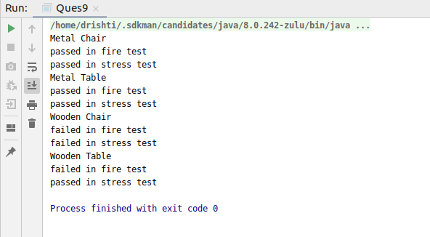

10. Design classes having attributes and method(only skeleton) for a coffee shop. There are three different actors in our scenario and i have listed the different actions they do also below
* Customer
- Pays the cash to the cashier and places his order, get a token number back
- Waits for the intimation that order for his token is ready
- Upon intimation/notification he collects the coffee and enjoys his drink
( Assumption: Customer waits till the coffee is done, he wont timeout and cancel the order. Customer always likes the drink served. Exceptions like he not liking his coffee, he getting wrong coffee are not considered to keep the design simple.)
* Cashier
- Takes an order and payment from the customer
- Upon payment, creates an order and places it into the order queue
- Intimates the customer that he has to wait for his token and gives him his token
( Assumption: Token returned to the customer is the order id. Order queue is unlimited. With a simple modification, we can design for a limited queue size)
* Barista
- Gets the next order from the queue
- Prepares the coffee
- Places the coffee in the completed order queue
- Places a notification that order for token is ready
Code:
import java.util.Queue;
class Customer {
public int tokenNumber;
public String order;
private int payment;
public void payCash() {
}
public void placeOrder() {
}

public int getTokenNumber() {
return 0;
}
public void getNotification() {
}
}
class Cashier {
private int orderid;

private String getOrder() {
return null;
}
public void receiveCash() {
}
public void notifyCustomer(Customer c1) {
}
public int issueToken(){
return orderid;
}
}
class Barista {

public void prepareCoffee() {
}
public void placeCoffee() {
}
public void notifyCustomer(Customer c1) {
}
}
public class Ques10 {
public static void main(String[] args) {
}
}

11. Convert the following code so that it uses nested while statements instead of for statements:
int s = 0;
int t = 1;
for (int i = 0; i < 10; i++)
{
s = s + i;
for (int j = i; j > 0; j−−)
{
t = t * (j - i);
}
s = s * t;
System.out.println("T is " + t);
}
System.out.println("S is " + s);
Code with while statements
public class Ques11 {
public static void main(String[] args) {
int s = 0;
int t = 1;
int i = 0;
while (i < 10) {
s = s + i;
int j = i;
while (j > 0) {
t = t * (j - i);
j--;
}
s = s * t;
System.out.println("T is " + t);
i++;
}
System.out.println("S is " + s);
}
}
12.What will be the output on new Child(); ?
class Parent extends Grandparent {
{
System.out.println("instance - parent");
}
public Parent() {
System.out.println("
}
static {
System.out.println("static - parent");
}
}
class Grandparent {
static {
System.out.println("static - grandparent");
}
{
System.out.println("instance - grandparent");
}
public Grandparent() {
System.out.println("
}
}
class Child extends Parent {
public Child() {
System.out.println("
}
static {
System.out.println("static - child");
}
{
System.out.println("instance - child");
}
}
Code: with new Child object.
class Parent extends Grandparent {
{
System.out.println("instance - parent");
}
public Parent() {
System.out.println(" ");
}
static {
System.out.println("static - parent");
}
}
class Grandparent {
static {
System.out.println("static - grandparent");
}
{
System.out.println("instance - grandparent");
}
public Grandparent() {
System.out.println(" ");
}
}
class Child extends Parent {
public Child() {
System.out.println(" ");
}
static {
System.out.println("static - child");
}
{
System.out.println("instance - child");
}
}
public class Ques12 {
public static void main(String[] args) {
Child c = new Child();
}
}
Output:
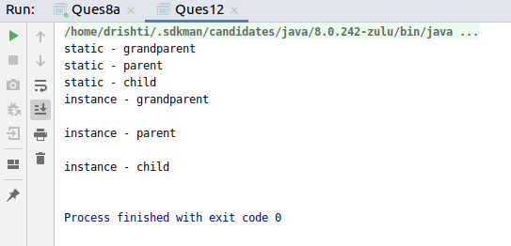
Q13. Create a custom exception that do not have any stack trace.
Code:
//Create a custom exception that do not have any stack trace.
class Person {
float height;
Person(float h) {
height = h;
}
float getHeight() {
return this.height;
}
}
class Park {
final float pheight = 1.2f;
public void check(Person p) throws HeightNotSuitableException {
float x = p.getHeight();
if (x < pheight) {
System.out.println("Not a suitable height");
throw new HeightNotSuitableException(x);
} else {
System.out.println("Entry Allowed");
}
}
}
class HeightNotSuitableException extends Exception {
float height;
HeightNotSuitableException(float x) {
height = x;
}
public synchronized Throwable fillInStackTrace() {
return this;
}
}
public class Ques13 {
public static void main(String[] args) {
Person p1 = new Person(1);
Park p = new Park();
try {
p.check(p1);
} catch (HeightNotSuitableException e) {
e.printStackTrace();
System.out.println();
}
}
}
Output:
