Exercise: Selenium Testing- Session 3
Q1-https://www.ultimateqa.
Fetch Quality Assurance Engineer Salary from the table under HTML Table with no id.
The code should be dynamic.
Code:
package abc;
import org.openqa.selenium.By;
import org.openqa.selenium.WebDriver;
import org.openqa.selenium.chrome.ChromeDriver;
public class q1{
public static void main(String[] args) throws InterruptedException {
// TODO Auto-generated method stub
String title="Quality Assurance Engineer";
System.setProperty("webdriver.chrome.driver","/home/drishti/Desktop/selenium/chromedriver");
WebDriver driver= new ChromeDriver();
driver.get("https://ultimateqa.com/simple-html-elements-for-automation/");
Thread.sleep(1000);
String qa=driver.findElement(By.xpath("(//*[@class='et_pb_text_inner'])[3]/table/tbody/tr[4]")).getText();
if(qa.contains(title)) {
String item=driver.findElement(By.xpath("(//*[@class='et_pb_text_inner'])[3]/table/tbody/tr[4]/td[3]")).getText();
System.out.println("Salary of "+title+" is: "+item);
}
}
}

Output:
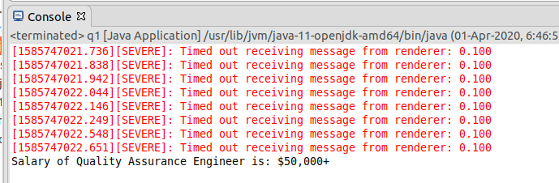

Q2- Write an automation script for filling all fields of the registration page. (Registration.html)
But make sure that test data should be provided from a properties file.
package selenium3;
import java.io.FileInputStream;
import java.io.IOException;
import java.util.Properties;
import org.openqa.selenium.By;
import org.openqa.selenium.WebDriver;
import org.openqa.selenium.chrome.ChromeDriver;
import org.openqa.selenium.support.ui.Select;
public class ques2 {
public static void main(String[] args) throws IOException {
// TODO Auto-generated method stub
Properties obj = new Properties();
FileInputStream fis =new FileInputStream("/home/drishti/eclipse-workspace/Selenium3/src/resources/dataFile.properties");
// Load the properties File
obj.load(fis);
System.setProperty("webdriver.chrome.driver","/home/drishti/Desktop/selenium/chromedriver");
WebDriver driver = new ChromeDriver();
driver.get(obj.getProperty("url"));
driver.findElement(By.xpath("//input[@placeholder='First Name']")).sendKeys(obj.getProperty("FirstName"));
driver.findElement(By.xpath("//input[@placeholder='Last Name']")).sendKeys(obj.getProperty("LastName"));
driver.findElement(By.xpath("//textarea[@class='form-control ng-pristine ng-untouched ng-valid']")).sendKeys(obj.getProperty("Address"));
driver.findElement(By.xpath("//input[@type='email']")).sendKeys(obj.getProperty("EmailAddress"));
driver.findElement(By.xpath("//input[@type='tel']")).sendKeys(obj.getProperty("Phone"));
driver.findElement(By.xpath("//input[@value='FeMale']")).click();
driver.findElement(By.id("checkbox2")).click();
driver.findElement(By.id("msdd")).click();
driver.findElement(By.linkText("Korean")).click();
driver.findElement(By.linkText("Malay")).click();
driver.findElement(By.linkText("Italian")).click();
driver.findElement(By.id("basicBootstrapForm")).click();
Select skills=new Select(driver.findElement(By.id("Skills")));
skills.selectByValue("C++");
Select country=new Select(driver.findElement(By.id("countries")));
country.selectByValue("India");
driver.findElement(By.xpath("//b[@role]")).click(); driver.findElement(By.xpath("/html/body/span/span/span[1]/input")).sendKeys("Denmark");
driver.findElement(By.xpath("/html/body/span/span/span[2]/ul/li")).click(); driver.findElement(By.xpath("//select[@placeholder='Year']")).sendKeys("2014");
driver.findElement(By.xpath("//select[@placeholder='Month']")).sendKeys("October"); driver.findElement(By.xpath("//select[@placeholder='Day']")).sendKeys("7"); driver.findElement(By.id("firstpassword")).sendKeys(obj.getProperty("Password"));
driver.findElement(By.id("secondpassword")).sendKeys(obj.getProperty("confirmPassword"));
}
}

Output:
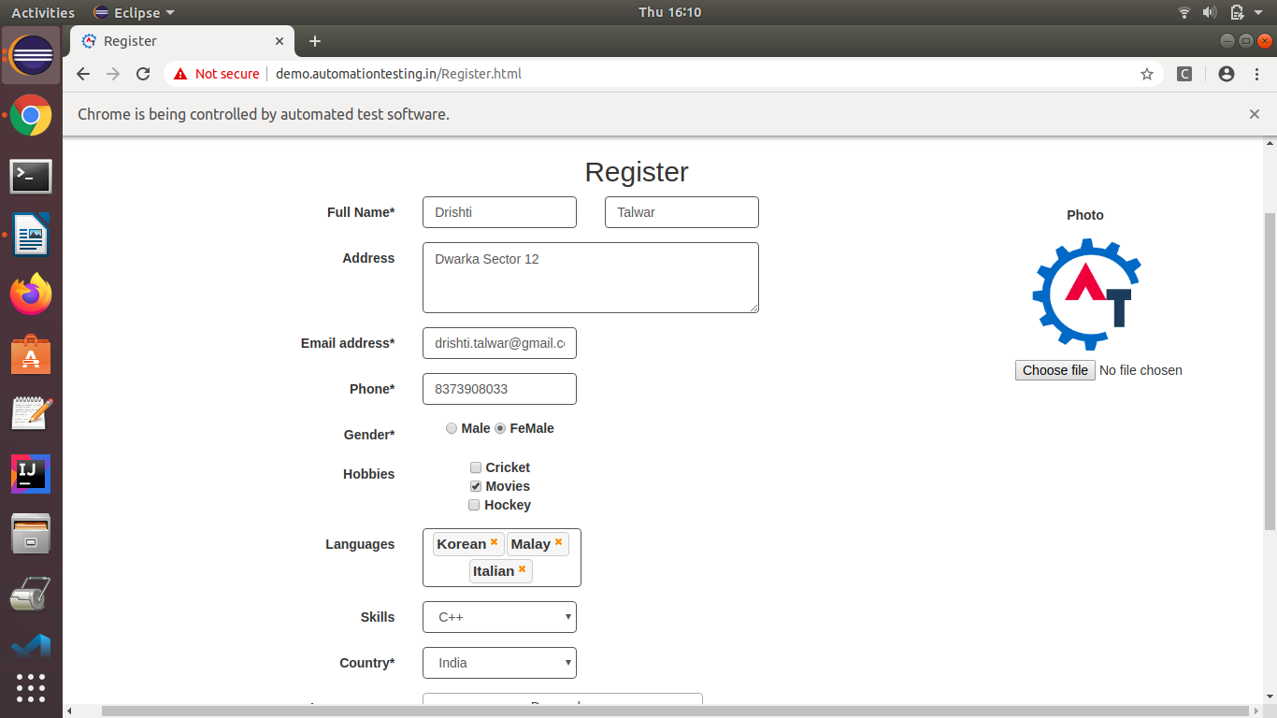
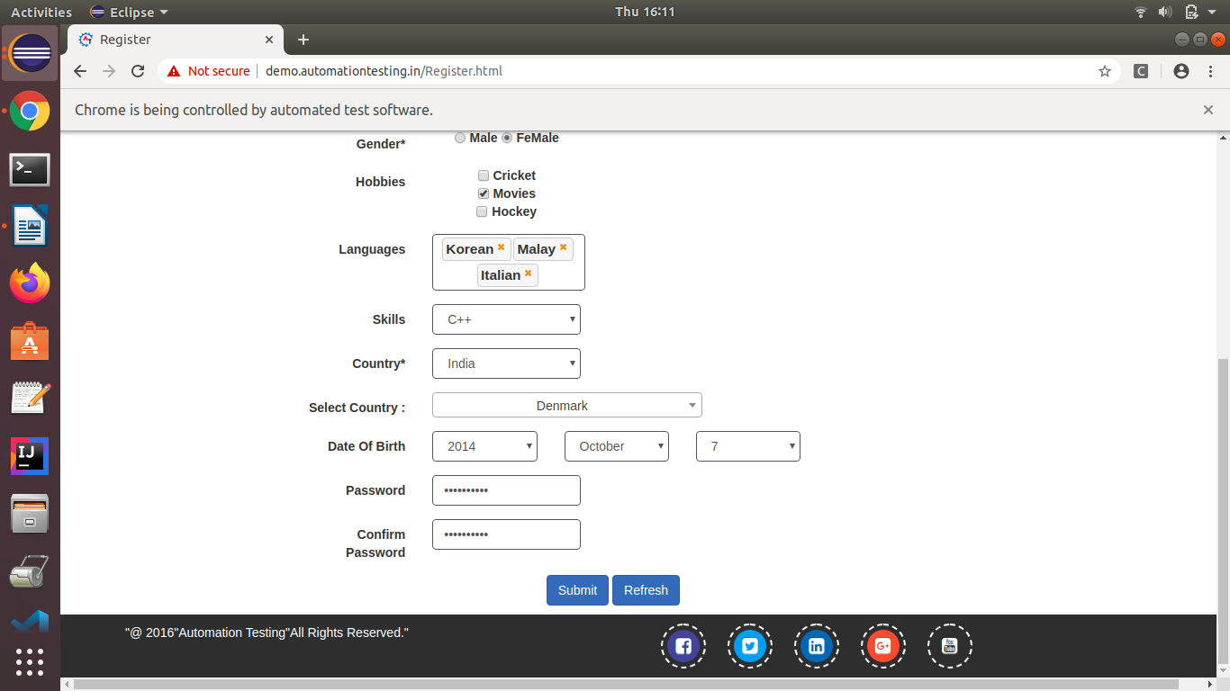

Q3- What are the advantages of TestNG & TestNG annotations?
TestNG is an automation testing Framework where NG stands for Next Generation.
Advantages of TestNG:
1. We can generate a proper report, to differentiate which all test cases have passes,failed and skipped.
2. It is easy to execute only the failed test cases separately using retry mechanism.
3. Annotations are easily understandable.
4. Test cases grouping is easy.
Advantages of TestNG Annotations :
1. Multiple @Test annotations can be used in a single TestNG file, the methods are executed alphabetically.
2. We can change the order in which the test methods should be executed by passing the parameter “priority” in @Test annotation.
3. @BeforeTest, methods under this annotation will be executed prior to the first test casae in the file and @AfterTest, method under this annotatins will be executed after all the test cases in the file are executed.

Q4- Print the order of TestNG annotations?
Code:
package selenium3;
import org.testng.annotations.AfterClass;
import org.testng.annotations.AfterMethod;
import org.testng.annotations.AfterSuite;
import org.testng.annotations.AfterTest;
import org.testng.annotations.BeforeClass;
import org.testng.annotations.BeforeMethod;
import org.testng.annotations.BeforeSuite;
import org.testng.annotations.BeforeTest;
import org.testng.annotations.Test;
public class ques4 {
// test case 1
@Test
public void testCase1() {
System.out.println("in test case 1");
}

// test case 2
@Test
public void testCase2() {
System.out.println("in test case 2");
}

@BeforeMethod
public void beforeMethod() {
System.out.println("in beforeMethod");
}

@AfterMethod
public void afterMethod() {
System.out.println("in afterMethod");
}

@BeforeClass
public void beforeClass() {
System.out.println("in beforeClass");
}

@AfterClass
public void afterClass() {
System.out.println("in afterClass");
}

@BeforeTest
public void beforeTest() {
System.out.println("in beforeTest");
}

@AfterTest
public void afterTest() {
System.out.println("in afterTest");
}

@BeforeSuite
public void beforeSuite() {
System.out.println("in beforeSuite");
}

@AfterSuite
public void afterSuite() {
System.out.println("in afterSuite");
}

}

testing.xml
<?xml version="1.0" encoding="UTF-8"?>
<!DOCTYPE suite SYSTEM "https://testng.org/testng-1.0.dtd">
<suite name="Suite">
<test thread-count="5" name="Test">
<classes>
<class name="selenium3.ques4"/>
</classes>
</test> <!-- Test -->
</suite> <!-- Suite -->

Output:
