Exercises: Introduction to Java 1

Q1. Write a program to replace a substring inside a string with other string ?
Code:

//Question: Write a program to replace a substring inside a string with other string
package CoreJava;
public class Ques1 {
public static void main(String[] args){
String str="Helo World";
System.out.println("Original String: "+str);
System.out.println("Replaced String: "+ str.replace("lo","llo"));
}
}
Output:
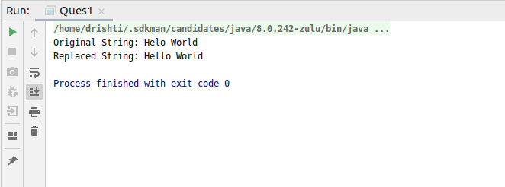

Q2. Write a program to find the number of occurrences of the duplicate words in a string and print them ?
Code:

//Write a program to find the number of occurrences of the duplicate words in a string and print them
package CoreJava;
public class Ques2 {
public static void main(String[] args) {
int count;
String str = "I am doing the program to calculate duplicate words.There are duplicate duplicate words in the statement";
System.out.println("String: " + str);
str = str.toLowerCase();
String tmp[] = str.split(" ");
System.out.println("Duplicate words are:");
for (int i = 0; i < tmp.length; i++) {
count = 1;
for (int j = i + 1; j < tmp.length; j++) {
if (tmp[i].equals(tmp[j])) {
count++;
tmp[j] = "0";
}
}
if (count > 1 && tmp[i] != "0") {
System.out.println("Count of " + tmp[i] + " is: " + count);
System.out.println(tmp[i]);
}
}
}
}

Output:

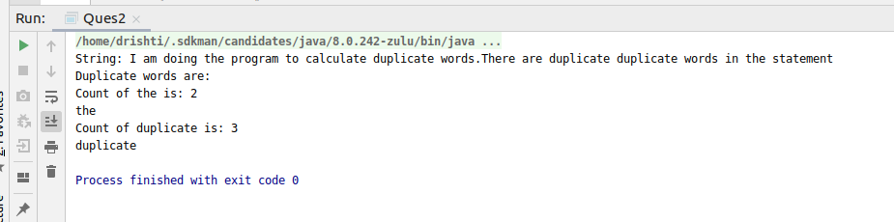

Q3. Write a program to find the number of occurrences of a character in a string without using loop?
Code:

//Write a program to find the number of occurrences of a character in a string without using loop
package CoreJava;
public class Ques3 {
public static void main(String[] args) {
String str = "Hello world";
System.out.println(str);
int count = str.length() - str.replace("l", "").length();
System.out.println("Number of occurances of 'l' in " + str + " is \n= " + count);
}
}
Output:

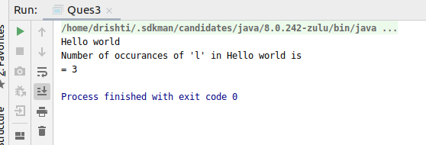

Q4. Calculate the number & Percentage Of Lowercase Letters,Uppercase Letters, Digits And Other Special Characters In A String

Code:
// Calculate the number & Percentage Of Lowercase Letters,Uppercase Letters, Digits And Other Special Characters In A String
package CoreJava;
public class Ques4 {
public static void main(String[] args) {
String str = "Hello World @ ttn123";
char[] ch = str.toCharArray();
int upper = 0;
int lower = 0;
int digit = 0;
int other = 0;
System.out.println("Number of LowerCase,UpperCase, Digits and other special characters: ");
for (int i = 0; i < str.length(); i++) {
if (Character.isLowerCase(ch[i])) {
lower++;
} else if (Character.isUpperCase(ch[i])) {
upper++;
} else if (Character.isDigit(ch[i])) {
digit++;
} else {
other++;
}
}
System.out.println("lower: " + lower);
System.out.println("upper: " + upper);
System.out.println("digit: " + digit);
System.out.println("other: " + other);
System.out.println("Percentage is: ");
System.out.println("% of lowerCase is:" + (lower * 100) / str.length());
System.out.println("% of upperCase is:" + (upper * 100) / str.length());
System.out.println("% of digits is:" + (digit * 100) / str.length());
System.out.println("% of others is:" + (other * 100) / str.length());
}
}
Output:
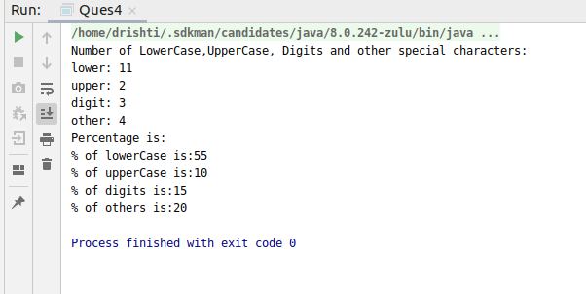

Q5. Find common elements between two arrays.
Code:

//Find common elements between two arrays.
package CoreJava;
public class Ques5 {
public static void main(String[] args) {
int arr1[] = {1, 2, 3, 4, 5};
int arr2[] = {2, 3, 7, 8, 9};
System.out.println("Array1");
for (int a1 = 0; a1 < arr1.length; a1++)
System.out.print(arr1[a1] + " ");
System.out.println("\nArray2");
for (int a2 = 0; a2 < arr2.length; a2++)
System.out.print(arr2[a2] + " ");
System.out.println("\nThe common elements between the arrays are: ");
for (int i = 0; i < arr1.length; i++) {
for (int j = 0; j < arr2.length; j++) {
if (arr1[i] == arr2[j]) {
System.out.println(arr1[i]);
}
}
}
}
}
Output:

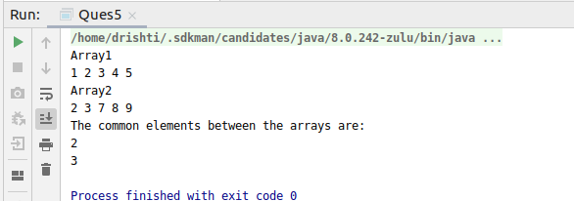

Q6. There is an array with every element repeated twice except one. Find that element.
Code:
//There is an array with every element repeated twice except one. Find that element.
package CoreJava;
public class Ques6 {
public static void main(String[] args) {
int arr1[] = {1,2,3,4,1,2,3};
//int count = 1;
System.out.println("Array elements are:");
for (int arr = 0; arr < arr1.length; arr++) {
System.out.print(arr1[arr] + " ");
}
int result=arr1[0];
for (int i=1;i<arr1.length;i++){
result=result^arr1[i];
}
System.out.println("Unique element is:"+result);
}
}
Output:
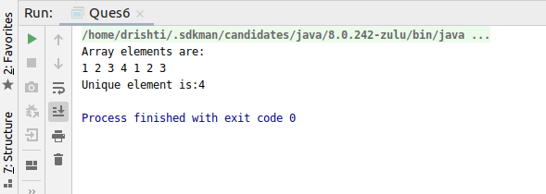
Q7. Write a program to print your Firstname,LastName & age using static block,static method & static variable respectively
Code:
Static Variable
//Write a program to print your Firstname,LastName & age using static block,static method & static variable respectively
package CoreJava;
public class Ques7 {
static String FirstName = "Drishti";
static String LastName = "Talwar";
static int age = 22;
public static void main(String[] args) {
System.out.println(Ques7.FirstName);
System.out.println(Ques7.LastName);
System.out.println(Ques7.age);
}
}

Output:
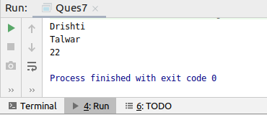

Static Function
Code:
//Write a program to print your Firstname,LastName & age using static block,static method & static variable respectively
package CoreJava;
public class Ques7 {
static String FirstName;
static String LastName;
static int age;
static void display() {
FirstName = "Drishti";
LastName = "Talwar";
age = 22;
System.out.println(FirstName + " " + LastName);
System.out.println("Age is: " + age);
}
public static void main(String[] args) {
Ques7.display();
}
}

Output:
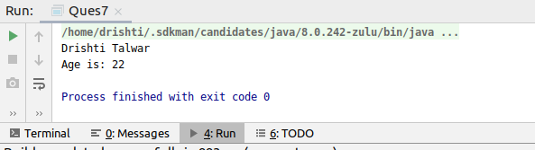
Static Block:
Code:
//Write a program to print your Firstname,LastName & age using static block,static method & static variable respectively
package CoreJava;
public class Ques7 {
static String FirstName;
static String LastName;
static int age;
static {
FirstName = "Drishti";
LastName = "Talwar";
age = 22;
}
public static void main(String[] args) {
System.out.println(FirstName + " " + LastName);
System.out.println("Age is: " + age);
}
}

Output:
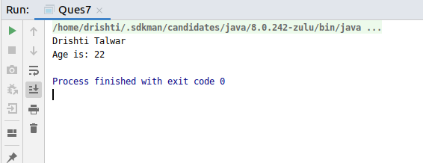

Q8. Write a program to reverse a string and remove character from index 4 to index 9 from the reversed string using String Buffer
Code:
//Write a program to reverse a string and remove character from index 4 to index 9 from the reversed string using String Buffer
package CoreJava;
public class Ques8 {
public static void main(String[] args) {
StringBuffer sb = new StringBuffer("Drishti Talwar");
System.out.println("Original String: " + sb);
sb.reverse();
System.out.println("Reversed String: " + sb);
System.out.println("\nRemoving characters from index 4 to 9");
sb.delete(4, 9);
System.out.println("After removing: " + sb);
}
}
Output:
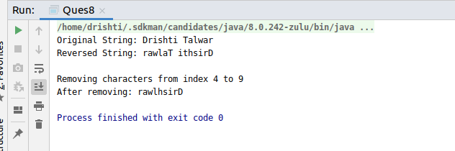

Q9.Write a program to display values of enums using a constructor & getPrice() method (Example display house & their prices)
Code:
//Write a program to display values of enums using a constructor & getPrice() method (Example display house & their prices)
package CoreJava;
enum House {
BHK1(20), BHK2(30), BHK3(50);
private int price;
House(int p) {
price = p;
}
int getPrice() {
return price;
}
public static void main(String args[]) {
System.out.println("All house prices:");
for (House h : House.values())
System.out.println("costs of " + h + " is: " + h.getPrice() + " thousand.");
}
}

Output:
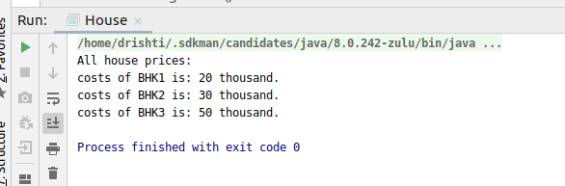
Q10.Write a single program for following operation using overloading
A) Adding 2 integer number
B) Adding 2 double
C) multiplying 2 float
D) multiplying 2 int
E) concate 2 string
F) Concate 3 String

Code:
/*
Write a single program for following operation using overloading
A) Adding 2 integer number
B) Adding 2 double
C) multiplying 2 float
D) multiplying 2 int
E) concate 2 string
F) Concate 3 String
*/
package CoreJava;
public class Ques10 {
public int addInt(int a, int b) {
return a + b;
}
public int addInt(int a, int b, int c) {
return a + b + c;
}
public double add_double(double a, double b, double c) {
return a + b + c;
}
public float mul_float(float a, float b) {
return a * b;
}
public int mul_int(int a, int b) {
return a * b;
}
public String concat(String a, String b) {
return (a + b);
}
public String concat(String a, String b, String c) {
return (a + b + c);
}
public static void main(String[] args) {
Ques10 q = new Ques10();
System.out.println("Adding 2 integer number: ");
System.out.println(q.addInt(10, 20));
System.out.println("Adding 3 integer number: ");
System.out.println(q.addInt(10, 20, 30));
System.out.println("Adding 2 double: ");
System.out.println(q.add_double(10.00, 20.00, 22.22));
System.out.println("multiplying 2 float: ");
System.out.println(q.mul_float(10.0f, 20.0f));
System.out.println("multiplying 2 int: ");
System.out.println(q.mul_int(10, 10));
System.out.println("concate 2 string: ");
System.out.println(q.concat("Hello ", "World"));
System.out.println("Concate 3 String: ");
System.out.println(q.concat("Hello ", "Drishti ", "Talwar"));
}
}
Output:
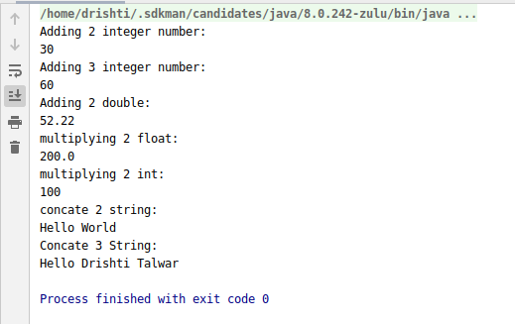

Q11.Create 3 sub class of bank SBI,BOI,ICICI all 4 should have method called getDetails which provide there specific details like rateofinterest etc,print details of every banks.
Code:
/*
Create 3 sub class of bank SBI,BOI,ICICI all
4 should have method called getDetails which provide there specific details like
rateofinterest etc,print details of every banks
*/
package CoreJava;
class Bank {
float rateOfInterest;
String bankName;
String accountType;
public Bank(String bn, float roi, String acc) {
rateOfInterest = roi;
bankName = bn;
accountType = acc;
}
void display() {
System.out.println("Bank Name is: " + bankName);
System.out.println("Rate of Interest is: " + rateOfInterest);
System.out.println("Account Type is: " + accountType);
System.out.println("");
}
}
class SBI extends Bank {
public SBI(String bn, float roi, String acc) {
super(bn, roi, acc);
}
}
class ICICI extends Bank {
public ICICI(String bn, float roi, String acc) {
super(bn, roi, acc);
}
}
class HDFC extends Bank {
public HDFC(String bn, float roi, String acc) {
super(bn, roi, acc);
}
}
public class Ques11 {
public static void main(String[] args) {
SBI sbi = new SBI("SBI", 2.1f, "Savings");
ICICI icici = new ICICI("ICICI", 3.1f, "Current");
HDFC hdfc = new HDFC("HDFC", 4.2f, "Salary");
sbi.display();
icici.display();
hdfc.display();
}
}
Output:

