Performance testing using Jmeter

1. What is Load/Stress/Performance testing.
Ans.
Performance Testing : It is a type of testing which determines various aspects such as speed of a computer, network or device. The performance is determined by passing different parameters in different load scenerios.
Load Testing : It is a type of testing which simulates the actual user load on any application or website. The application behaviour is tested during normal and high loads. In Load Testing the load limit is a threshold of a break.
Stress Testing : This is a type of testing which determines the stability and robustness of the system. It tests the system behaviour under extreme load and its ability to recover from the failure. In Stress testing the load limit is above the threshold of a break.

2. Why we do the Performance testing.
Ans.
Performance Testing is performed to:
- validate if the application performs properly.
- validate to conform the performance needs of the business.
- find, analyze and fix performance issues.
- do capacity planning for future demand of the application.

3. Different tools through which we can do the performance testing.
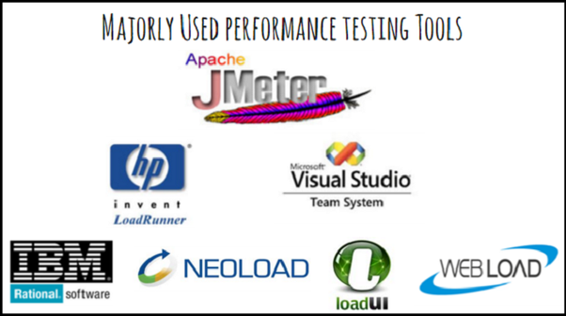
Ans.

--WebLOAD: It is an enterprise-scale load testing solution capable of generating reliable, real life scenerios.It is based on a flexible platform with built in support for hundreds of technologies and integration with many tools.
--NeoLoad: It is an innovative performance testing platform designed to automate test design, maintenance, and anaysis of Agile and DevOps team.
--Jmeter: It is an open source tool which can be used for performance and load testing for analyzing and measuring the performance of a variety of services. It is mainly used for web and web service applications.
Features of Jmeter:
1. Highly portable and supports 100% all the java based applications.
2. Less sccripting efforts as comapred to other tools as it has user friendly GUI.
3. Simple charts and graphs for analyzing load related statistics.
--HP Performance Tester LoadRunner : This is an enterprise performance testing version of LoadRunner. It lowers the cost of distributed load testing.
--Rational Performance Tester IBM : It is a performance and load testing tool developed by IBM. It is performance test creation, execution, and analysis tool that helps development team to validate the scalability and reliability of web applications before deplyment into production.

4. What are environments.
Ans.
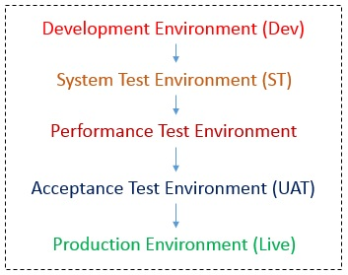

Development Environment: Where the actual development including defect fixes happens. Unit tests are done by developers in this environment.
After successful unit tests, the build is then promoted to the next environment for testing.
System Test Environment: It is also known as QA environment where the testing happens. All the test cases are executed, exploratory tests are performed, defect retesting and regression is performed. The Testing team then provides a sign-off for the build to be deplyed in the next higher environment for UAT.
Performance Test Environment: for performance testing.For effective performance measurement we need a replica of production environment with fewer servers, capacity, memory, etc.
Acceptance Test Environment(UAT): After successful System Testing, the build is deployed in UAT for User acceptance tests and is performed by Business Team. After the confirmation from the UAT team, the application is deploed in the next higher environment known as application Go-Live.
Production Environment: Also known as Live Environment. This is where the end-user access the application.

5. What is workload model.
Ans.
The distribution os load across all the identified scenerios of Application Under Test is called Workload. A workload model is designed to identify key test scenerios and load distribution across these scenerios.
Identification of key test scenerios and load distibution across thesse scenerios is one of the major parts of a performance test plan which lies under the workload modeling.

6. What is the use of we need workload model.
Ans.
Before running a performance test, we need to model the production workload accurately, we have to set up the test environment and establish a benchmark baseline fou all the tests. Having the right workload model is crucial for the reliable deployment of any system intended to support a large number of users in the production environment.

7. What is User’s journey.
Ans.
A user’s journey is the series of clicks and pages that the user takes to achieve a goal on a website. A failure or performance lag anywhere along the user journey will either block the user from achieving their goal or they will abandon the site for a competitor with a faster and better experience.

8. What is Thread.
Ans.
A Thread Group is a set of threads executing the same scenerio. Virtual user groups are represented by Thread Groups.
A number of Threads(users) can be defined in a Thread Group. Each thread simulates a real user requesting to the server under a test.
The controls provided by a thread group allows us to :
-- Set the number of threads.
-- Set the ramp-up period
-- Set the number of times to execute the test.

9. What are samplers
Ans.
Samplers tell Jmeter to send requests to a server and wait for a response.
Example: HTTP Request, FTP Request, JDBC Request, etc.
They are added as a child of Thread Groups. Once the sampler request is processed by the server, itss response is returned to Jmeter and the same can be viewed and analyzed in terms of different performance parameters like response time, throughput, etc.

10. What is listener.
Ans.
Listeners are the Jmeter components that displays test results.
Performance testing is all about analysing server responses in various forms and then presenting the same to the client.
Listeners provide pictorial representation of data gathered by Jmeter about the test cases as a sampler component of Jmeter is executed.There are around 15 listeners provided by Jmeter but mostly used ones are table,trees and graphs.

11. Why do we use Request Defaults.
Ans.
Main goal of using the HTTP Default Request is to:
- Avoid data duplication in tests.
- Make test scripts more maintainable.
For example:
We have a test script, which consists of 20-30 HTTP Requests, all these requests hit the same test server, but refer to different resources. In case we need to reconfigure your test scenerio to use with another server and we need to reconfigure these 20-30 HTTP Requests to the new domain. All the HTTP requests have the same Server name or IP. So we move this element to the HTTP Requests field.

12. Create a user journey using following details.
Load of 10 users.
Ramp up time 10 sec.
Hold time 10 sec.
Request defaults.
View result tree.

Jmeter screenshots:

