HTML/CSS EXERCISE

1.How are inline and block elements different from each other?
A block-level element always starts on a new line and takes up the full width available. Div element is a type of block element which always start from a new line and will cover the full width that is available.
An inline element does not start on a new line and only takes up as much width as necessary.
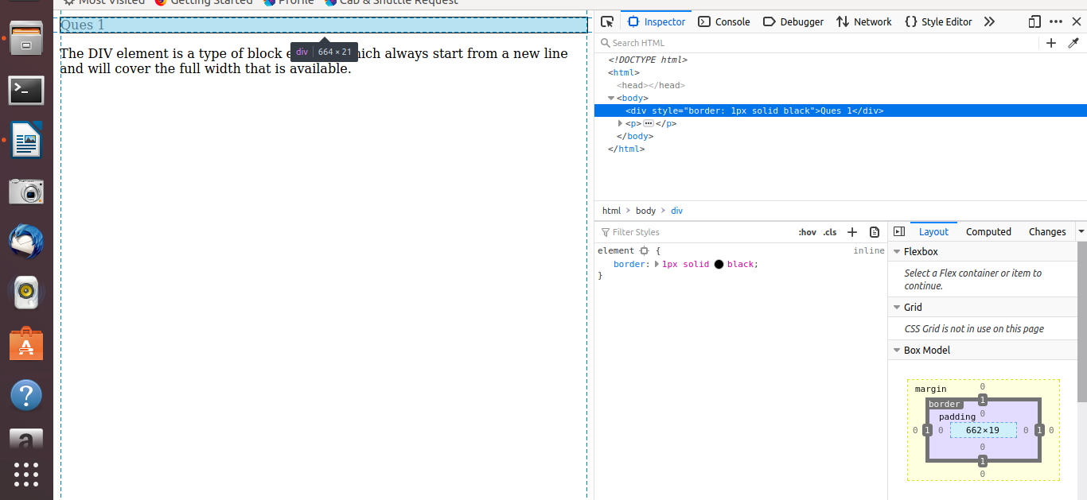
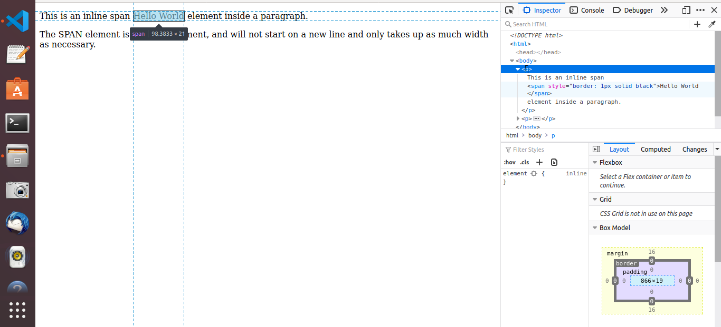

2.Explain the difference between visibility:hidden and display:none
The visibility property specifies whether or not an element is visible.
Hiding an element can be done by setting the display property to none. The element will be hidden, and the page will be displayed as if the element is not there.
However, the element will still take up the same space as before. The element will be hidden, but still affect the layout.
Visibility:hidden
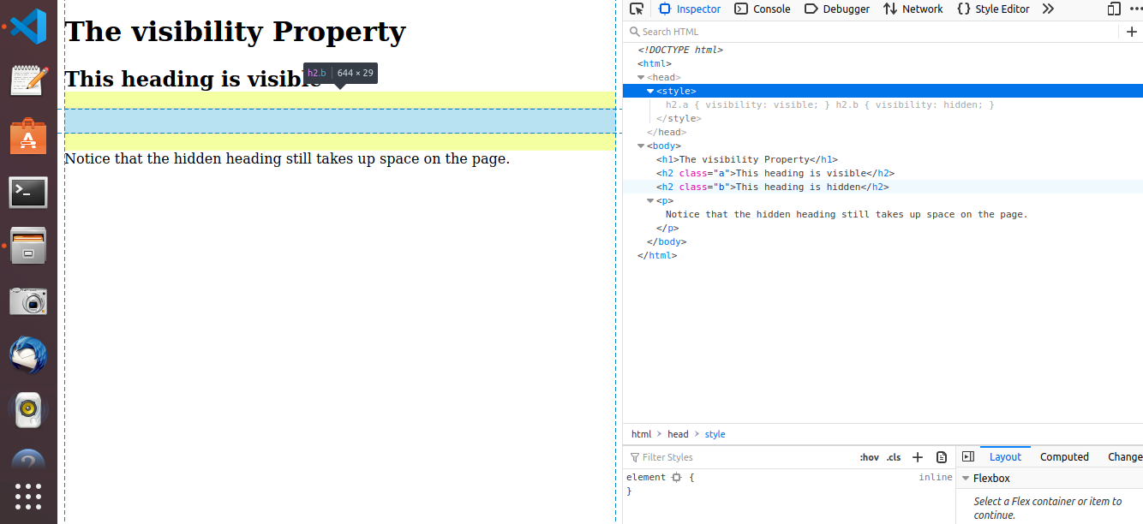
display:none
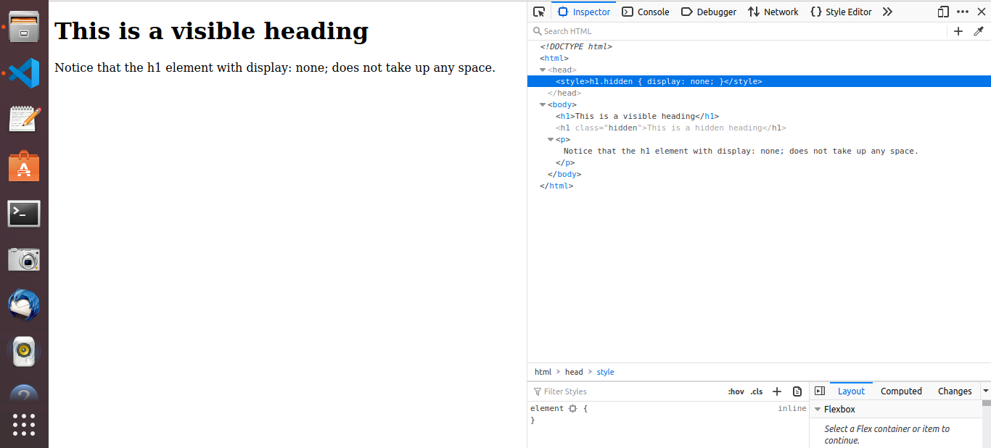

3. Explain the clear and float properties.
The clear property specifies what elements can float beside the cleared element and on which side.
- left - No floating elements allowed on the left side
- none - Allows floating elements on both sides. This is default
- right- No floating elements allowed on the right side
- both - No floating elements allowed on either the left or the right side
- inherit - The element inherits the clear value of its parent
The float property is used for positioning and formatting content e.g. let an image float left to the text in a container.
The float property can have one of the following values:
- left - The element floats to the left of its container
- right - The element floats to the right of its container
- none - The element does not float (will be displayed just where it occurs in the text). This is default
- inherit - The element inherits the float value of its parent
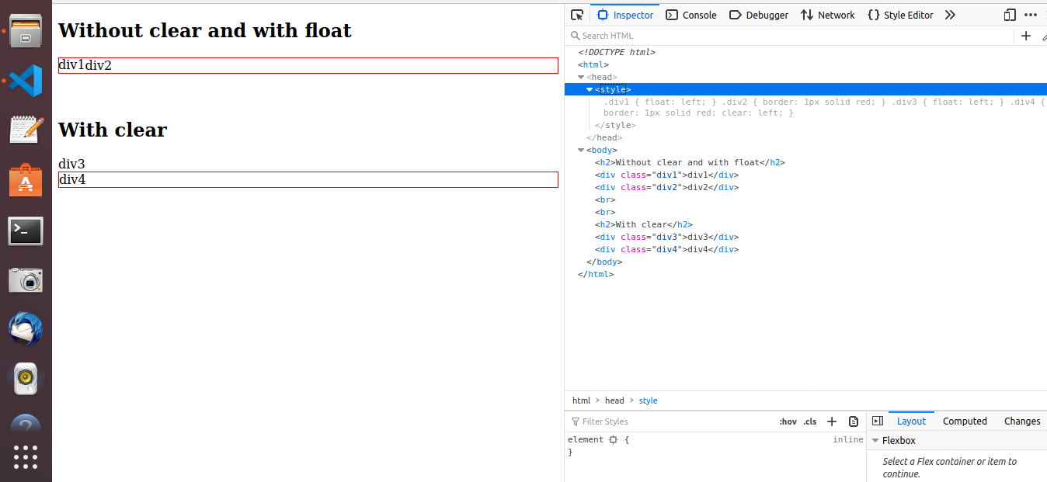

4. explain difference between absolute, relative,fixed and static.
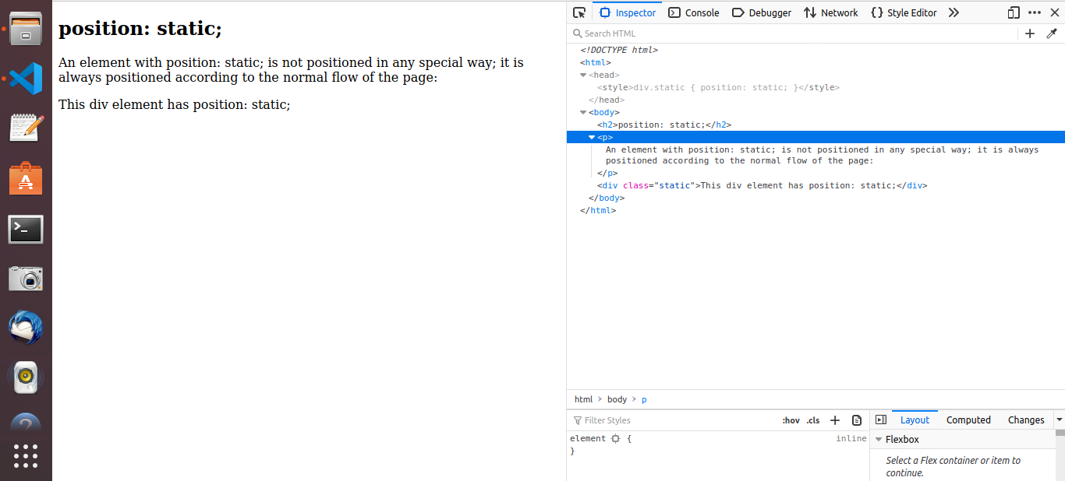
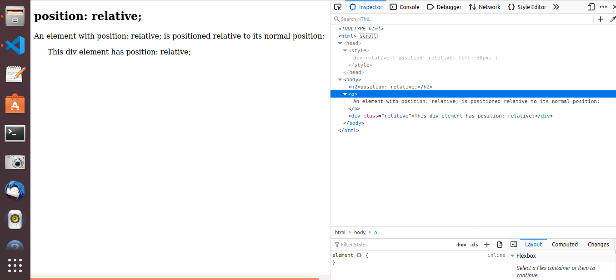
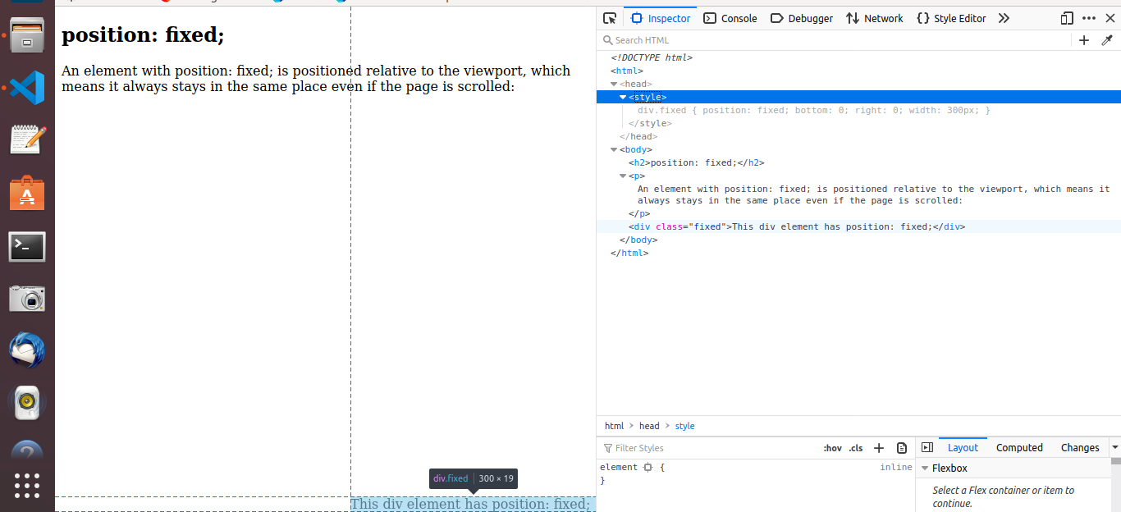
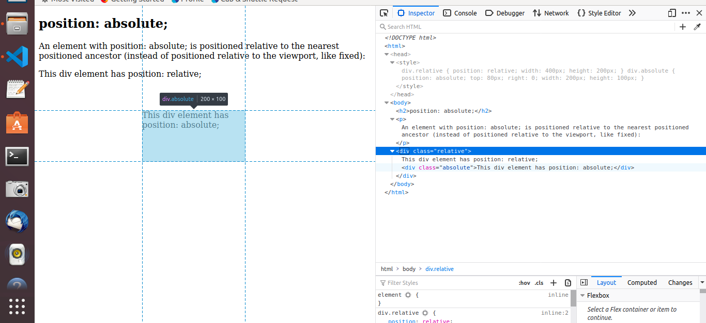
5. Write the HTML code to create a table in which there are 4 columns( ID , Employee Name, Designation, Department) and at least 6 rows. Also do some styling to it.
CODE.HTML
<!DOCTYPE html>
<html>
<head>
<style>
table {
font-family: arial, sans-serif;
border-collapse: collapse;
width: 100%;
}
td, th {
border: 1px solid #dddddd;
text-align: left;
padding: 8px;
}
tr:nth-child(even) {
background-color: #dddddd;
}
</style>
</head>
<body>
<h2>HTML Table</h2>
<table>
<tr>
<th>ID</th>
<th>Employee Name</th>
<th>Designation</th>
<th>Department</th>
</tr>
<tr>
<td>101</td>
<td>Drishti</td>
<td>Trainee</td>
<td>QE</td>
</tr>
<tr>
<td>102</td>
<td>Akshita</td>
<td>Trainee</td>
<td>JVM</td>
</tr>
<tr>
<td>103</td>
<td>Nisha</td>
<td>Trainee</td>
<td>QE</td>
</tr>
<tr>
<td>104</td>
<td>Prabhat</td>
<td>Trainee</td>
<td>QE</td>
</tr>
<tr>
<td>105</td>
<td>Shreya</td>
<td>Trainee</td>
<td>JVM</td>
</tr>
<tr>
<td>106</td>
<td>Udit</td>
<td>Trainee</td>
<td>MEAN</td>
</tr>
</table>
</body>
</html>

OUTPUT
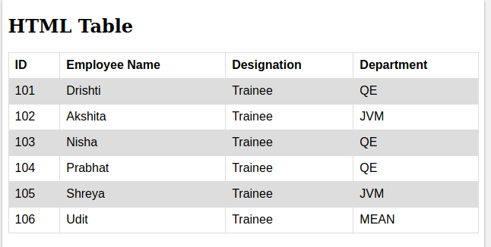

6. Why do we use meta tags?
Metadata is data (information) about data.
The <meta> tag provides metadata about the HTML document. Metadata will not be displayed on the page, but will be machine parsable.
Meta elements are typically used to specify page description, keywords, author of the document, last modified, and other metadata.
he metadata can be used by browsers (how to display content or reload page), search engines (keywords), or other web services.
HTML5 introduced a method to let web designers take control over the viewport (the user's visible area of a web page), through the <meta> tag .
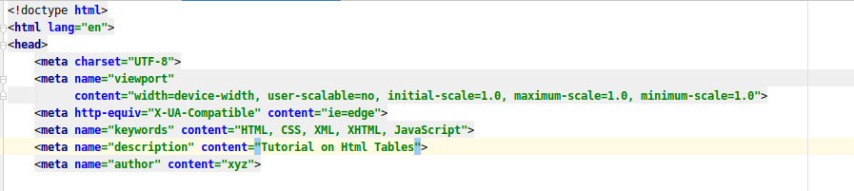
7. Explain box model.
The CSS box model is essentially a box that wraps around every HTML element. It consists of: margins, borders, padding, and the actual content.
- Content - The content of the box, where text and images appear
- Padding - Clears an area around the content. The padding is transparent
- Border - A border that goes around the padding and content
- Margin - Clears an area outside the border. The margin is transparent
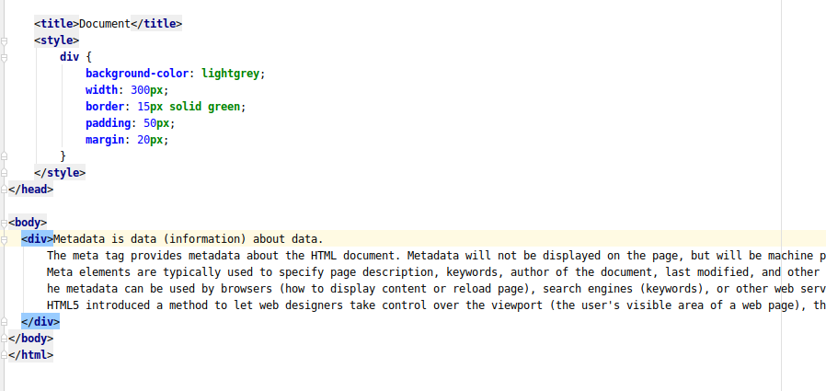
The box model allows us to add a border around elements, and to define space between elements.

8. What are the different types of CSS Selectors?
a) element selector: the element selector selects HTML elements based on the element name.
b) id selector: The id selector uses the id attribute of an HTML element to select a specific element.
c) class selector : The class selector selects HTML elements with a specific class attribute.
d) grouping selector : The grouping selector selects all the HTML elements with the same style definitions.
e)Universal Selector :The universal selector (*) selects all HTML elements on the page.
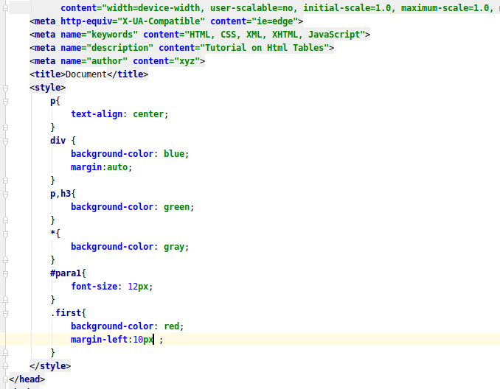
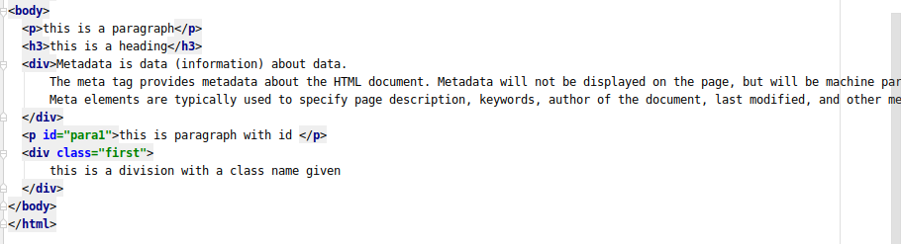
9. Define Doctype.
A doctype or document type declaration is an instruction which tells the web browser about the markup language in which the current page is written. The Doctype is not an element or tag, it lets the browser know about the version of or standard of HTML or any other markup language that is being used in the document.
Declaration of a Doctype: A DOCTYPE declaration appears at the top of a web page before all other elements. According to the HTML specification or standards, every HTML document requires a document type declaration to ensure that the pages are displayed in the way they are intended to be displayed.
In the version, HTML 4.01, the usage of DOCTYPE declaration was to create a reference to a document type definition (DTD), since the version HTML 4.01 was completely based on a Standard Generalized Markup Language(SGML).In HTML 5, the DOCTYPE declaration is only required for enabling the standard mode for writing documents.
10. Explain 5 HTML5 semantic tags.
<section>: The <section> element defines a section in a document.
<article>: The <article> element specifies independent, self-contained content.An article should make sense on its own, and it should be possible to read it independently from the rest of the web site.
<header>: The <header> element specifies a header for a document or section.The <header> element should be used as a container for introductory content.
<footer>: The <footer> element specifies a footer for a document or section.A <footer> element should contain information about its containing element.A footer typically contains the author of the document, copyright information, links to terms of use, contact information, etc.
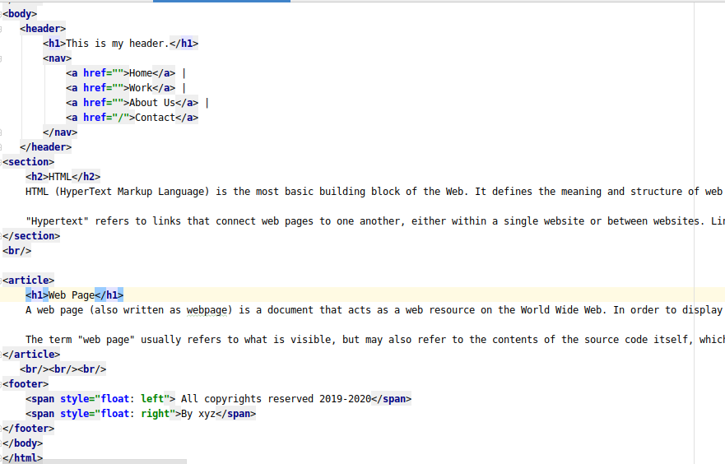
<nav>: The <nav> element defines a set of navigation links.

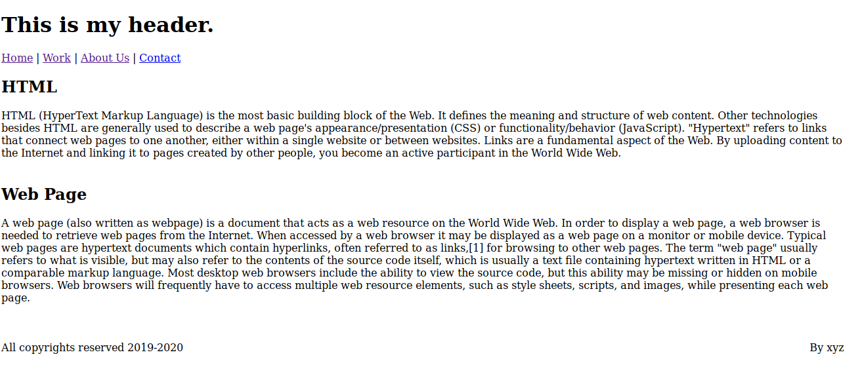
11. Create HTML for web-page.jpg (check resources, highest weightage for answers)
Ques11.html
<!DOCTYPE html>
<html>
<head>
<title> To The New </title>
<link rel="stylesheet" type="text/css" href="style.css" />
</head>
<body>
<div id = "head">
<h1> To The New </h1>
<div id = "nav">
<ul>
<li><a href="#">Home</a></li>
<li><a href="#">About Us</a></li>
<li><a href="#">Contact US</a></li>
</ul>
</div>

<div id ="body">
<div id = "main">

<div id='mainBox'>
<img src = "tree-736885_960_720.jpg" alt="Image not available" width="960" height="360">
</div>

<div id='textBox'>
<p>Lorem ipsum dolor sit amet, consectetur adipiscing elit, sed do eiusmod tempor incididunt ut labore et dolore magna aliqua. Ultrices eros in cursus turpis massa tincidunt dui ut ornare.</p>
</div>

<p id='paraText'> <strong>LATEST FROM THE GALLERY</strong> </p>

<hr id='line'>
<div id="flexContainer">
<div>
<img src="test.jpeg" height="315px" width="215px">
<p>Caption</p>
</div>
<div>
<img src="test.jpeg" height="315px" width="215px">
<p>Caption</p>
</div>

<div>
<img src="test.jpeg" height="315px" width="215px">
<p>Caption</p>
</div>

<div>
<img src="test.jpeg" height="315px" width="215px">
<p>Caption</p>
</div>
</div>

<div id="footer">
<span id="span1">Copyright © 2009-2020 - All Rights Reserved - To The New</span>
<span id="span2">Web Desing By To The New</span>
</div>
</div>
</div>
</div>

</body>

style.css
body{
background-color: rgb(31, 30, 30);
}

h1{
margin-left: 75px;
}

#head{
margin-left: 80px;
background-color:rgb(139, 131, 131);
width: 90%;
}

#nav{
margin-left: 80px;
width:84%;
height: 50px;
margin-top:10px;
background-color:#696969;
}

#nav ul{
list-style-type: none;
margin: 0;
padding: 0;
overflow: hidden;
background-color: #333;}

#nav ul li a{
display: block;
color: white;
text-align: center;
padding: 14px 16px;
text-decoration: none;

}

#nav ul li{
float: left;
}

#main {
background-color: white;
margin-top: 20px;
padding: 20px;
}
#mainBox {
margin-left: 60px;
}

#textBox {
background-color: rgba(104, 111, 114, 0.178);
max-width: 87%;
margin-left: 60px;
margin-top: 20px;
}

#paraText {
margin-left: 60px;
margin-top: 40px;
}

#line {
color: gray;
max-width: 950px;
margin-left: 60px;
}
#flexContainer {
display: flex;
margin-left: 45px;
}
#flexContainer div {
background-color: #f1f1f1;
margin: 15px;
}
#footer {
position: fixed;
left: 0;
bottom: 0;
width: 87.5%;
margin-left: 87px;
background-color: rgb(0, 0, 0);
color: white;
padding: 10px;
text-align: center;
}
#span1 {
float: left;
}
#span2 {
float: right;
}
Output:
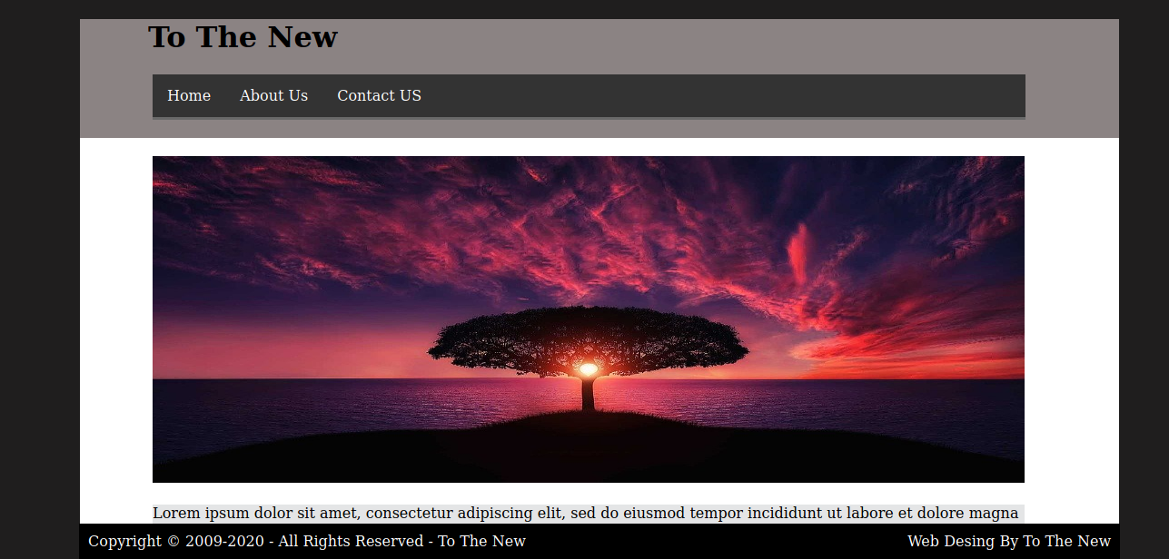
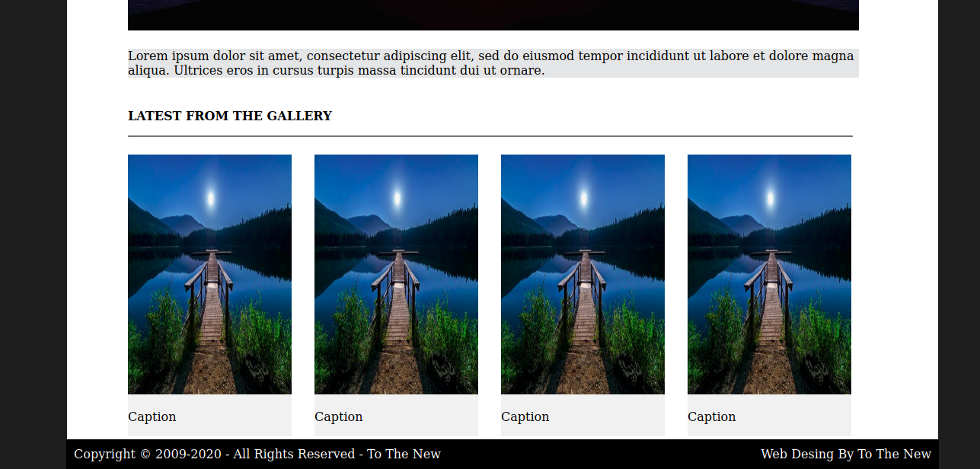

12. Create HTML for form.png (check resources, highest weightage for answers)
form.html
<!DOCTYPE html>
<html>
<head>
<link rel="stylesheet" href="form.css">
<title>To THE NEW</title>
</head>
<body>
<div id="head">
<span>TO THE NEW</span>
<div id="nav">
<ul>
<li>Home</li>
<li> Quick Help</li>
</ul>
</div>
<h3>Bug Report</h3>
<form class="form" method="post" action="#">
<label>
Title*:
</label>
<input type="text">
<label>
Description*:
</label>
<textarea name="message" rows="5" cols="20"></textarea>
<label>
Operating System:
</label>

<select name="Operating System">
<option class="select" value="Windows XP">Windows XP</option>
<option class="select" value="Windows 7">Windows 7</option>
<option class="select" value="Windows 10">Windows 10</option>
<option class="select" value="Windows Vista">Windows Vista</option>
</select>
<label>
Product*:
</label>
<select name="Product">
<option value="Windows XP">Formoid</option>
<option value="Windows 7">Microsoft Office</option>
</select>
<label>
Version*:
</label>
<input type="number" name="version" min=1 max=4>
<label>
License:
</label>
<fieldset>
<input type="radio" name="license" value="Free"><label>Free </label>
<input type="radio" name="license" value="Business"><label>Business </label>
</fieldset>

<label>
Severity:
</label>
<select name="Severity">
<option class="select" value="Critical">Critical</option>
<option class="select" value="Major">Major</option>
</select>

<label>
Attachments:
</label>
<input type="file" name="documents" accept="file/*">

<div class="divide">
<input type="Submit" name="Send" value="Send">
</div>
</form>
<br/>
<br/>

</body>
</html>

form.css
*{
font-family:sans-serif;
}
body{
margin-top:20px;
}
#head{
color:green;
border-bottom:0.5px solid #E7E4E4;
height:50px;
}

#head span{
font-size:20px;
color:green;

}

#nav{
margin-top:-30px;
}

#nav ul li{
display:inline;
margin-left:20px;
float:right;
}

.form{
display:flex;
flex-direction:column;
border-radius:10px;
}
h3{color:white;

width:30%;
padding: 15px 2.5px 15px 2.5px;
margin:auto;
margin-top:80px;
background-color: #E7E4E4;
}
form{
border:2px solid #E7E4E4;
color:black;
margin:auto;

width:30%;

}
form input,select,textarea{
margin-top:20px;
padding:5px 2px 5px 2px;
width:90%;
margin:auto;
border-radius:5px;
border:1px solid #E7E4E4;
}

form label{
font-size:14px;
margin-left:20px;
margin-top:15px;
}
input[type=number]{
margin-left:20px ;
width: 90px;
}

input[type="radio"]{
margin-right:20px;
margin-left:10px;
width:3px;
}
fieldset{
border: 3px;
}
.select,select{
background-color:#06A061;
color:white;
border:none;
font-weight:500;
}
input[type="submit"]
{
background-color:#06A061;
color:white;
width:60px;
float:right;
margin-top:10px;
}
.divide{
margin-top:5px;
height:50px;
background-color:#E7E4E4;
}

OUTPUT:
