Testing Concepts (Day 2) assessment
1) One of the fields on a form contains a text box which accepts numeric values in the range of 18 to 25. Identify the invalid Equivalence class.
a) 17
b) 19
c) 24
d) 21
Ans. a) 17

2) Input Box should accept the Number 1 to 10. Identify Equivalence partitioning and Boundary values for testing
Ans. In the range of 1-10 the test conditions are:
Invalid: Values less than 1
Valid: Values in the range of 1 to 10
Invalid: Two digit values between 11 to 99
Invalid: Three digit values 100 and above
Equivalence partitioning Values: in Equivalence Testing we test any one value from the test if it passes then the whole set of partition is considered pass.
The values for the test cases are:
Invalid: 0
Valid: 4
Invalid: 77
Invalid: 108
Boundary Values: In Boundary Value Analysis we test on the boundary values only.
The boundary values are:
- Minimum: 0, above minimum: 1, nominal value: 5, below maximum:10 and maximum: 11
The values for the test cases are:
Invalid: 0
Valid: 1
Valid: 5
Invalid: 10
Invalid: 11
Invalid: 100
3) Why Equivalence & Boundary Analysis Testing is used?
Ans. Equivalence Partitioning Technique is a black box testing technique in which the input domain is divided into different equivalence data classes. It is used because is helps reduce large number of test cases. It is applied where there is a range used in the input field. The purpose is to cover each partition at least once, so we select a value from a particular partition and if it passes the whole partition is considered valid.
Example:
Suppose there is an input field that accepts a value in the range 1-10.
In this case 1-10 is a valid range partition, 0 and below is an invalid range partiton, 11-99 is an invalid range partition, 100 and above is an invalid range partition.
Boundary Analysis Testing Technique is a black box testing technique where it is impossible to test all the values, so we make test cases around the boundary values.
Example:
In the range of the input field of 1-10, select input variable values at their:
- Minimum: 0, above minimum: 1, nominal value: 5, below maximum:10 and maximum: 11

4) Write Test Cases For This Scenario:
If A Job Fails It Should Get Restarted Again. This Should Happen For Three Times. If It Fails again, then It should quit
Spreadsheet link:
https://docs.google.com/spreadsheets/d/1hd3usX72cbERjovmFF9oSjDBgyNivwovF5fSb4b4axc/edit?usp=sharing
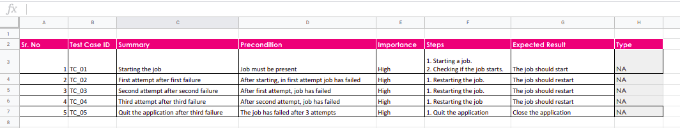

5) Write The Test Case/scenario For A Login Page?
Spreadsheet link:
https://docs.google.com/spreadsheets/d/19ec1Xa7gl28TxVlpunEyPyKaWNcyUOhn2xJlGMZHB50/edit?usp=sharing
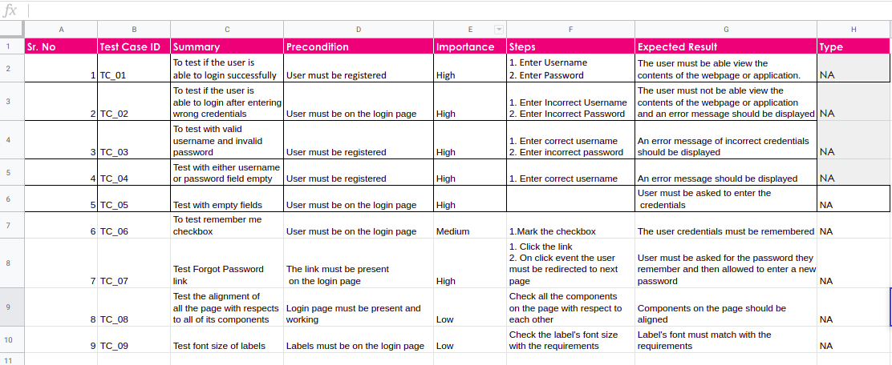
6) What Are The Test Cases/scenario For Mouse? (To verify the functionalities of a mouse)
Spreadsheet link:
https://docs.google.com/spreadsheets/d/1rTPmizB-7hoz9u5Tl2cjnqsPcQq5O9OXW7WnhDWpqGw/edit?usp=sharing

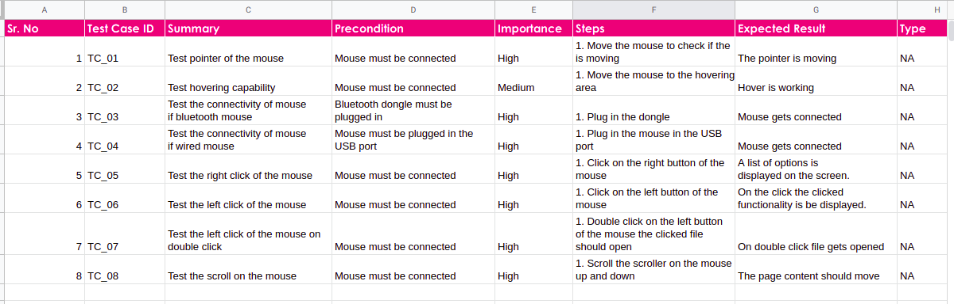

7) Write test cases/scenarios to verify the functionality of a printer?
Spreasheet link:
https://docs.google.com/spreadsheets/d/11OdnAV6lFj38KRd9f3li1ess7tc4BQiaol9dEyMvpPc/edit?usp=sharing
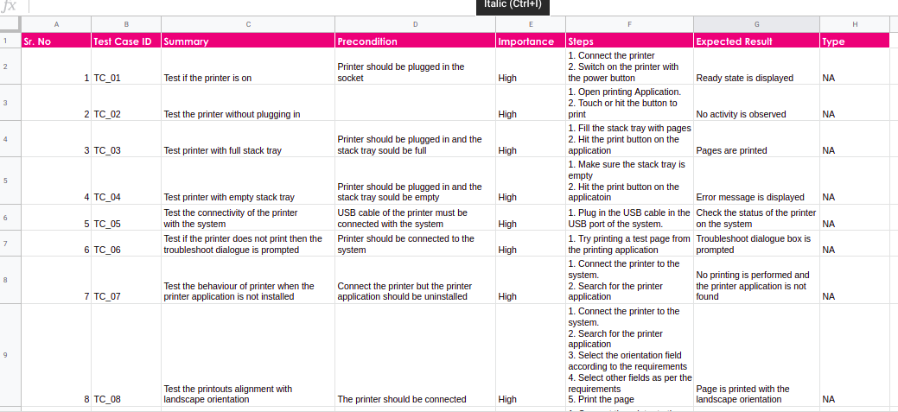
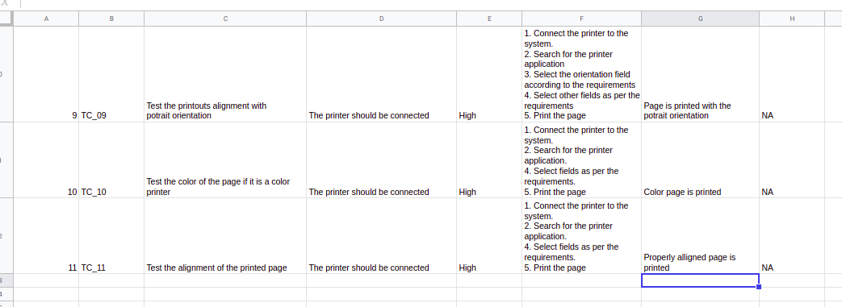

8) Write down test case/scenarios to list down possible steps to test a smart phone
Spreadsheet link:
https://docs.google.com/spreadsheets/d/1-OPm_QYwz2ZatxpiSRS-KHDFI0q_LpH0Zki7iszY5eM/edit?usp=sharing
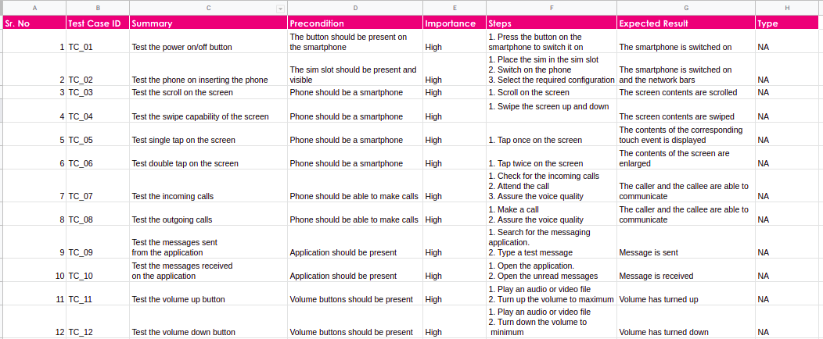
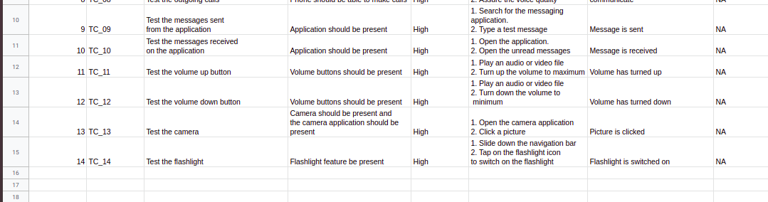
9) There is a text box which accepts numbers from 1-10. List down the test data which needs to be tested for Boundary value analysis.
Ans. Boundary Values: In Boundary Value Analysis we test on the boundary values only.
The boundary values are:
- Minimum: 0, above minimum: 1, nominal value: 5, below maximum:10 and maximum: 11
The values for the test cases are:
Invalid: 0
Valid: 1
Valid: 5
Invalid: 10
Invalid: 11
Invalid: 100

10) Suppose you have a bank account that offers variable interest rates:
5% for the first $1000 credit;
10% for the next $1000;
And 15% for the rest.
If you wanted to check that the bank was handling your account correctly what valid input partitions might you use?
Ans. In this case, there would be 3 valid partitions and 1 invalid partition which are:
Partition | Valid / Invalid
Below $0 | Invalid
$0 - $1000 | Valid
$1001 - $2000 | Valid
$2001 and above | Valid

11) A mail order company charges $2.95 postage for deliveries if the package weighs less than 2 kg, $3.95 if the package weighs 2 kg or more but less than 5 kg, and $5 for packages weighing 5 kg or more.
Generate a set of valid test cases using equivalence partitioning.
Ans. The set of valid test cases are:
Class | Test Case | Valid / Invalid
Below 0kg | -4kg | Invalid
0kg - 2kg | 1kg | Valid
2kg - 5kg | 3kg | Valid
5kg and above | 8kg | Valid

12) Boiling point of water is at 100 degrees Celsius. Determine the boundary values
Ans. The Boundary Values for this scenerio would be
99 degrees
100 degrees
101 degrees

13) Exam pass – for 40 marks; merit at 60 and above; and distinction at 80 and above.
Determine the boundary values.
Ans. The boundary values are:
Criteria | Boundary Values
For exam pass | 39, 40, 41
For merit | 59, 60, 61
For distinction | 79, 80, 81

14) Order numbers on a stock control system can range between 10000 and 99999 inclusive. Which of the following inputs might be a result of designing tests for only valid equivalence classes and valid boundaries:
a)1000, 5000, 99999
b)9999, 50000, 100000
c)10000, 50000, 99999
d)10000, 99999
e)9999, 10000, 50000, 99999, 100000
Ans. c)10000, 50000, 99999

15) A program validates a numeric field as follows:
Values less than 10 are rejected, values between 10 and 21 are accepted, values greater than or equal to 22 are rejected. which of the following input values cover all of the equivalence partitions?
a. 10,11,21
b. 3,20,21
c. 3,10,22
d. 10,21,22
Ans. c. 3,10,22

16) Which test cases are written first: white boxes or black boxes?
Ans. White box testing is a type of testing technique which requires system understanding and architectural clarity which is not available in the initial phases of the project.
Black box testing is a type of testing which does not require any system understanding, the analysis is done only on the functional perspective, so black box test cases are written first and after that the white box test cases are written.
17) Can you explain requirement traceability and its importance?
Ans. Requirement traceability is a document that links the test cases with the requirements. It is basically the mapping of requirements to the test cases.
It’s main purpose is to test if all the test cases are covered so that no functionality is missed while performing testing.
There are three types of RTM:
1. Forward Traceability: It is the mapping of requirements to the test cases.
2. Backward Traceability: It is the mapping of test cases to the requirements.
3. Bi-directional Traceability: It is the mapping of requirements to test cases and test cases to requirements.

Importance:
- It helps in linking the requirements, test cases and defects.
- End to end testing of an application is achieved.
- It ensures if a particular test case is based on one or more requirements are mentioned in the document.
- It helps in identifying how many test cases are affected whenever there is any change in the application.

