- Write Java code to define List . Insert 5 floating point numbers in List, and using an iterator, find the sum of the numbers in List.
Code:
import java.util.ArrayList;
public class Ques1 {
public static void main(String[] args) {
float sum = 0;
ArrayList<Float> arr = new ArrayList<Float>();
arr.add(1.2f);
arr.add(1.3f);
arr.add(1.4f);
arr.add(1.5f);
arr.add(1.6f);
System.out.println("Elements are: ");
for (Float value1 : arr) System.out.println(value1);
for (Float value2 : arr) sum = sum + value2;
System.out.println("Sum is: " + sum);
}
}
Using Iterator Interface
import java.util.ArrayList;
import java.util.Iterator;
public class Ques1 {
public static void main(String[] args) {
float sum = 0;
ArrayList<Float> arr = new ArrayList<Float>();
arr.add(1.2f);
arr.add(1.3f);
arr.add(1.4f);
arr.add(1.5f);
arr.add(1.6f);
System.out.println("Elements are: ");
Iterator<Float> it = arr.iterator();
while (it.hasNext()) {
float num = it.next();
System.out.println(num);
sum = sum + num;
}
System.out.println("Sum is: " + sum);
}
}
Output:

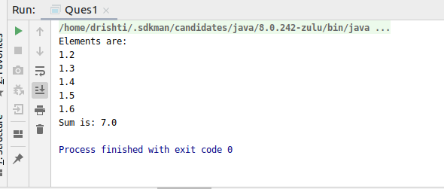

- Write a method that takes a string and returns the number of unique characters in the string.
Code:
import java.util.HashMap;
import java.util.HashSet;
import java.util.Scanner;
import java.util.Set;
//Write a method that takes a string and returns the number of unique characters in the string.
public class Ques2 {
public int countChars(String word) {
Set<Character> w = new HashSet<>();
for (Character c : word.toCharArray()) {
w.add(c);
}
System.out.println("The Unique Characters are: " + w);
return w.size();
}
public static void main(String[] args) {
System.out.println("Enter Input: ");
Scanner input = new Scanner(System.in);
String word = input.next();
word.toLowerCase();
Ques2 q = new Ques2();
System.out.println("The number of unique characters are: " + q.countChars(word));
}
}
Output:
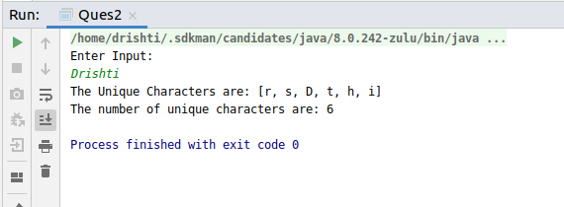

- Write a method that takes a string and print the number of occurrence of each character characters in the string.
Code:
import java.util.HashMap;
import java.util.Scanner;
public class Ques3 {
public static void main(String[] args) {
System.out.println("Enter Input: ");
Scanner input = new Scanner(System.in);
String s = input.next();
s.toLowerCase();
HashMap<Character, Integer> hm = new HashMap<>();
for (int i = 0; i < s.length(); i++) {
if (hm.containsKey(s.charAt(i))) {
int count = hm.get(s.charAt(i));
hm.put(s.charAt(i), ++count);
} else {
hm.put(s.charAt(i), 1);
}
}
System.out.println("The occurances of each character is: " + hm);
}
}
Output:
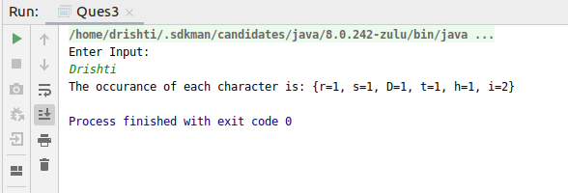

- Write a program to sort HashMap by value.
Code:
import java.util.*;
import java.lang.*;
public class Ques4 {
public static void main(String[] args) {
Map<Integer, String> m = new HashMap<Integer, String>();
m.put(1, "Drishti");
m.put(2, "Akshita");
m.put(3, "Nisha");
m.put(4, "Shreya");
m.put(5, "Neha");
List<Map.Entry<Integer, String>> list = new LinkedList<Map.Entry<Integer, String>>(m.entrySet());
Collections.sort(list, new Comparator<Map.Entry<Integer, String>>() {
@Override
public int compare(Map.Entry<Integer, String> o1, Map.Entry<Integer, String> o2) {
return o1.getValue().compareTo(o2.getValue());
}
});
System.out.println("Sorting by Value..");
for (Map.Entry<Integer, String> items : list) {
System.out.println("Key = " + items.getKey() +
", Value = " + items.getValue());
}
}
}

Output:
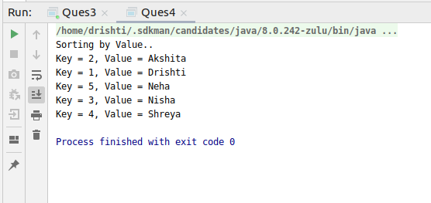

- Write a program to sort Employee objects based on highest salary using Comparator. Employee class{ Double Age; Double Salary; String Name
Code:
//Write a program to sort Employee objects based on highest salary using Comparator.
// Employee class{ Double Age; Double Salary; String Name
import java.util.ArrayList;
import java.util.Collections;
import java.util.Comparator;
import java.util.List;
class Employee {
Double age;
Double salary;
String name;
public Employee(Double a, Double s, String n) {
age = a;
salary = s;
name = n;
}
public Double getSalary() {
return salary;
}
public String toString() {
return "Employee [ age = " + age + ", salary = " + salary + ", name = " + name + "]";
}
}
public class Ques5 {
public static void main(String[] args) {
List<Employee> emp = new ArrayList<>();
emp.add(new Employee(24.0, 24060.0, "Drishti"));
emp.add(new Employee(25.0, 24050.0, "Nisha"));
emp.add(new Employee(26.0, 24040.0, "Akshita"));
emp.add(new Employee(27.0, 24030.0, "Shreya"));
emp.add(new Employee(28.0, 24020.0, "Neha"));
Comparator<Employee> com = new Comparator<Employee>() {
@Override
public int compare(Employee o1, Employee o2) {
if (o1.getSalary() > o2.getSalary())
return 1;
else
return -1;
}
};
Collections.sort(emp, com);
for (Employee e : emp) {
System.out.println(e);
}
}
}
Output:
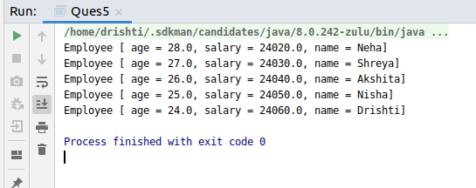

- Write a program to sort the Student objects based on Score , if the score are same then sort on First Name . Class Student{ String Name; Double Score; Double Age
Code:
//Write a program to sort the Student objects based on Score ,
// if the score are same then sort on First Name .
// Class Student{ String Name; Double Score; Double Age
import java.util.ArrayList;
import java.util.Collections;
import java.util.Comparator;
import java.util.List;
class Student {
String name;
Double score;
Double age;
public Student(String n, Double s, Double a) {
name = n;
score = s;
age = a;
}
public Double getScore() {
return score;
}
public String getName() {
return name;
}
public String toString() {
return "Name is: " + name + " score is: " + score + " age is: " + age;
}
}
public class Ques6 {
public static void main(String[] args) {
List<Student> s = new ArrayList<>();
s.add(new Student("Shreya", 96.0, 24.0));
s.add(new Student("Drishti", 96.0, 25.0));
s.add(new Student("Nisha", 97.0, 24.0));
s.add(new Student("Akshita", 94.0, 22.0));
s.add(new Student("Neha", 93.0, 21.0));
Collections.sort(s, new Comparator<Student>() {
@Override
public int compare(Student o1, Student o2) {
if (o1.getScore() > o2.getScore()) {
return 1;
} else if (o1.getScore() < o2.getScore()) {
return -1;
}
return 0;
}
});
System.out.println("Sorting on the basis of score...");
for (Student student : s) {
System.out.println(student);
}
Collections.sort(s, new Comparator<Student>() {
@Override
public int compare(Student o1, Student o2) {
if (o1.getScore() > o2.getScore()) {
return 1;
} else if (o1.getScore() < o2.getScore()) {
return -1;
}
return o1.getName().compareTo(o2.getName());
}
});
System.out.println("\nSorting on the basis of name when score is same... ");
for (Student student : s) {
System.out.println(student);
}
}
}
Output:
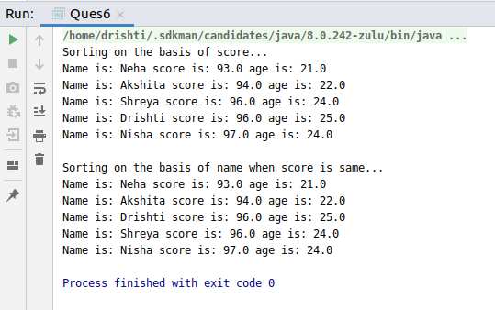

- Print the elements of an array in the decreasing frequency if 2 numbers have same frequency then print the one which came first.
Code:
import java.util.*;
import static java.util.Map.*;
//Print the elements of an array in the decreasing frequency if 2 numbers have same frequency
// then print the one which came first.
public class Ques7 {
public static void main(String[] args) {
Map<Integer, Integer> m = new LinkedHashMap<Integer, Integer>();
System.out.println("Enter the size of the array: ");
Scanner scanner = new Scanner(System.in);
int size = scanner.nextInt();
int[] arr = new int[size];
for (int i = 0; i < size; i++) {
arr[i] = scanner.nextInt();
}
System.out.println("Array elements with their frequencies are: ");
for (int j = 0; j < arr.length; j++) {
if (!m.containsKey(arr[j])) {
m.put(arr[j], 1);
} else {
m.put(arr[j], m.get(arr[j]) + 1);
}
}
for (Map.Entry<Integer, Integer> entry : m.entrySet()) {
int key = entry.getKey();
int value = entry.getValue();
System.out.println(key + " : " + value);
}
List<Entry<Integer, Integer>> decfreq = new ArrayList<>(m.entrySet());
Collections.sort(decfreq, new Comparator<Entry<Integer, Integer>>() {
@Override
public int compare(Entry<Integer, Integer> o1, Entry<Integer, Integer> o2) {
return o1.getValue().compareTo(o2.getValue());
}
});
System.out.println("Elements with decreasing frequencies..");
for (Entry<Integer, Integer> entry : decfreq) {
int frequency = entry.getValue();
while (frequency >= 1) {
System.out.print(entry.getKey() + " ");
frequency--;
} } } }
Output:
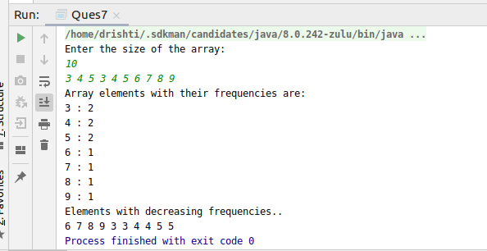

- Design a Data Structure SpecialStack that supports all the stack operations like push(), pop(), isEmpty(), isFull() and an additional operation getMin() which should return minimum element from the SpecialStack. (Expected complexity O(1))
Code:
import java.util.Stack;
public class SpecialStack extends Stack<Integer> {
Stack<Integer> st = new Stack<>();
public void push(int item) {
if (isEmpty() == true) {
st.push(item);
super.push(item);
} else {
super.push(item);
int y = st.pop();
st.push(y);
if (item <= y) {
st.push(item);
}
else
st.push(y);
}
}
public Integer pop() {
int x = super.pop();
int y = st.pop();
return x;
}
public Integer getMin() {
int x = st.peek();
return x;
}
public static void main(String[] args) {
SpecialStack specialStack = new SpecialStack();
specialStack.push(30);
specialStack.push(20);
specialStack.push(70);
specialStack.push(90);
specialStack.push(60);
specialStack.push(50);
System.out.println("Elements pushed in the stack: " + specialStack);
System.out.println("Minimum element: "+ specialStack.getMin());
specialStack.pop();
System.out.println("After popping an element: " + specialStack);
System.out.println("Minimum element: " + specialStack.getMin());
}
}
Output:
