Java: Unit testing & Clean Code

1. First.java

package com.healthycoderapp;
import java.lang.reflect.Array;
import java.math.BigDecimal;
import java.util.ArrayList;
import java.util.Iterator;
import java.util.List;
import java.util.stream.Collectors;
import java.util.stream.IntStream;
import java.util.stream.Stream;
public class First {
public static void main(String[] args) {
First first = new First();
//System.out.println(first.replaceSubString("This is my main string text", "main", "modified"));
//System.out.println(first.filterEvenElements(IntStream.of(1,2,3,4,5).boxed().collect(Collectors.toList())));
BigDecimal result = first.calculateAverage(new ArrayList<>());
}
/**
* This method is used to replace the part of string with new string.
* @param mainString string which needs to be modified
* @param subString string which needs to be replaced
* @param replacementString string to be replaced with
* @return updated string if mainString contains substring, else original string
*/
public String replaceSubString(String mainString, String subString, String replacementString) {
if(!mainString.isEmpty() && subString != null && replacementString != null && mainString.contains(subString)) {
return mainString.replaceAll(subString, replacementString);
}else {
return mainString;
}
}
/**
* This method is used to filter even elements from list.
* @param list list of integer
* @return list
*/
public List<Integer> filterEvenElements(List<Integer> list) {
Iterator<Integer> it = list.iterator();
while(it.hasNext()) {
if(it.next() % 2 == 0) {
it.remove();
}
}
return list;
}
public BigDecimal calculateAverage(List<BigDecimal> values) {
if (values == null || values.size() < 1) {
throw new RuntimeException("Invalid input");
} else {
BigDecimal sum = values.stream().reduce(BigDecimal.ZERO, BigDecimal::add);
System.out.println(sum);
return (sum.divide(new BigDecimal(values.size())));
}
}
public Boolean isPallindrome(String origString) {
Boolean isPallindrome = false;
String reverseString = new StringBuilder(origString).reverse().toString();
// Check palindrome string
if (origString.equals(reverseString)) {
isPallindrome = true;
}
return isPallindrome;
}
}

FirstTest.java

package com.healthycoderapp;
import org.junit.jupiter.api.BeforeEach;
import org.junit.jupiter.api.Test;
import org.junit.jupiter.api.function.Executable;
import org.junit.jupiter.params.ParameterizedTest;
import org.junit.jupiter.params.provider.ValueSource;
import java.math.BigDecimal;
import java.util.ArrayList;
import java.util.Arrays;
import java.util.List;
import static org.junit.jupiter.api.Assertions.*;
class FirstTest {
private First first = new First();
List<BigDecimal> decimalValue = new ArrayList();
@ParameterizedTest
@ValueSource(strings = {"bob","lol"})
public void should_return_true_isPallindrome( String checkString){
//given
String str = checkString;
//when
boolean output = first.isPallindrome(str);
//then
assertTrue(output);
}
@Test
public void should_return_false_isNotPallindrome(){
//given
String str = "Miracle";
//when
boolean output = first.isPallindrome(str);
//then
assertFalse(output);
}
@Test
public void should_Throws_RuntimeException_Calculate_Average(){
//given
List<BigDecimal> decimal = new ArrayList<>();
//when
Executable executable = () -> first.calculateAverage(decimal);
//then
assertThrows(RuntimeException.class, executable);
}
@Test
public void should_Calculate_Corect_Average(){
//given
decimalValue.add(new BigDecimal(1));
decimalValue.add(new BigDecimal(2));
decimalValue.add(new BigDecimal(3));
decimalValue.add(new BigDecimal(4));
decimalValue.add(new BigDecimal(5));
//when
BigDecimal actual = first.calculateAverage(decimalValue);
BigDecimal expected = new BigDecimal(3);
//then
assertEquals(expected,actual);
}
@Test
public void should_Filter_Even_Corectly(){
//given
List<Integer> actual = new ArrayList<>(Arrays.asList(3,4,5,6,8,10));
//when
actual = first.filterEvenElements(actual);
List<Integer> expected = new ArrayList(Arrays.asList(3,5));
//then
assertEquals(expected,actual);
}
@Test
public void should_return_correct_string() {
//given
String str = "Big Daddy";
String rpStr = "Small";
String substr= "Big";
//when
String expected = "Small Daddy";
String actual = first.replaceSubString(str,substr,rpStr);
//then
assertEquals(expected,actual);
}
@Test
public void try_to_use_null_replacement_string() {
//given
String str = "Big Daddy";
String rpStr = null;
String substr= "Big";
//when
String expected = "Big Daddy";
String actual = first.replaceSubString(str,substr,rpStr);
//then
assertEquals(expected,actual);
}
}
OUTPUT:
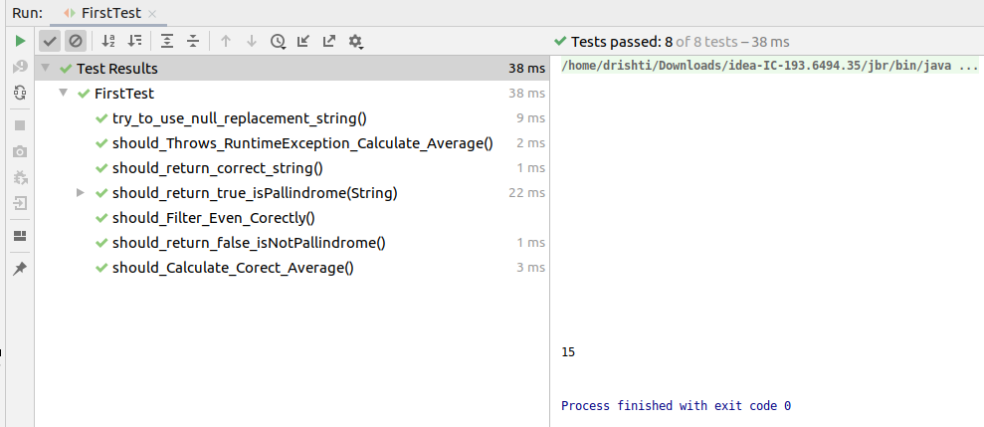

HealthCoderAppTest

package com.healthycoderapp;
import org.junit.jupiter.api.BeforeEach;
import org.junit.jupiter.api.DynamicTest;
import org.junit.jupiter.api.Test;
import org.junit.jupiter.api.function.Executable;
import org.junit.jupiter.params.ParameterizedTest;
import org.junit.jupiter.params.provider.ValueSource;
import java.util.ArrayList;
import java.util.List;
import static org.junit.jupiter.api.Assertions.*;
public class HealthCoderAppTest{
private DietPlanner dietPlanner;
private Coder coder;
@ParameterizedTest
@ValueSource(doubles = {87.6,90.1,80.2})
public void should_return_true_when_diet_is_Recommended( double checkWeight){
//given
double weight = checkWeight;
double height = 1.7;
//when
boolean output = BMICalculator.isDietRecommended(weight, height);
//then
assertTrue(output);
}
@Test
public void should_return_false_when_diet_is_Recommended() {
//given
double weight = 50;
double height = 1.9;
//when
boolean output = BMICalculator.isDietRecommended(weight, height);
//then
assertFalse(output);
}
@Test
public void should_throw_arithmaticException_when_height_isZero() {
//given
double weight = 50;
double height = 0;
//when
Executable executable = () -> BMICalculator.isDietRecommended(weight, height);
//then
assertThrows(ArithmeticException.class, executable);
}
// Multiple Assertions
@Test
public void should_return_worst_BMI() {
//given
List list = new ArrayList();
list.add(new Coder(1.8, 60));
list.add(new Coder(1.5, 70));
list.add(new Coder(1.8, 92));
//when
Coder BMI = BMICalculator.findCoderWithWorstBMI(list);
//then
assertAll(
() -> assertEquals(1.5, BMI.getHeight()),
() -> assertEquals(70, BMI.getWeight()));
}
@Test
public void should_true_if_List_is_NULL() {
//given
List list = new ArrayList();
//when
Coder BMI = BMICalculator.findCoderWithWorstBMI(list);
//then
assertNull(BMI);
}
@Test
public void check_correct_BMI_Scores() {
//given
List<Coder> list = new ArrayList();
list.add(new Coder(1.8, 60));
list.add(new Coder(1.5, 70));
list.add(new Coder(1.8, 92));
//when
double[] expected = {18.52,31.11,28.4};
double[] actual = BMICalculator.getBMIScores(list);
//then
assertAll(
() -> assertArrayEquals(expected, actual));
}
@BeforeEach
void setup(){
this.dietPlanner = new DietPlanner(20,30,50);
}
@Test
void should_calculate_correctDiet_plan() {
//given
Coder coder = new Coder(1.82,75,26,Gender.MALE);
DietPlan expected = new DietPlan(2202,110,73,275);
//when
DietPlan actual = dietPlanner.calculateDiet(coder);
assertAll(
()->assertEquals(expected.getCalories(),actual.getCalories()),
()->assertEquals(expected.getCarbohydrate(),actual.getCarbohydrate()),
()->assertEquals(expected.getFat(),actual.getFat()),
()->assertEquals(expected.getProtein(),actual.getProtein())
);
}
}

OUTPUT:
