API Testing - Day 1
Questions:
1) Create new collection and map the API's in the same folder
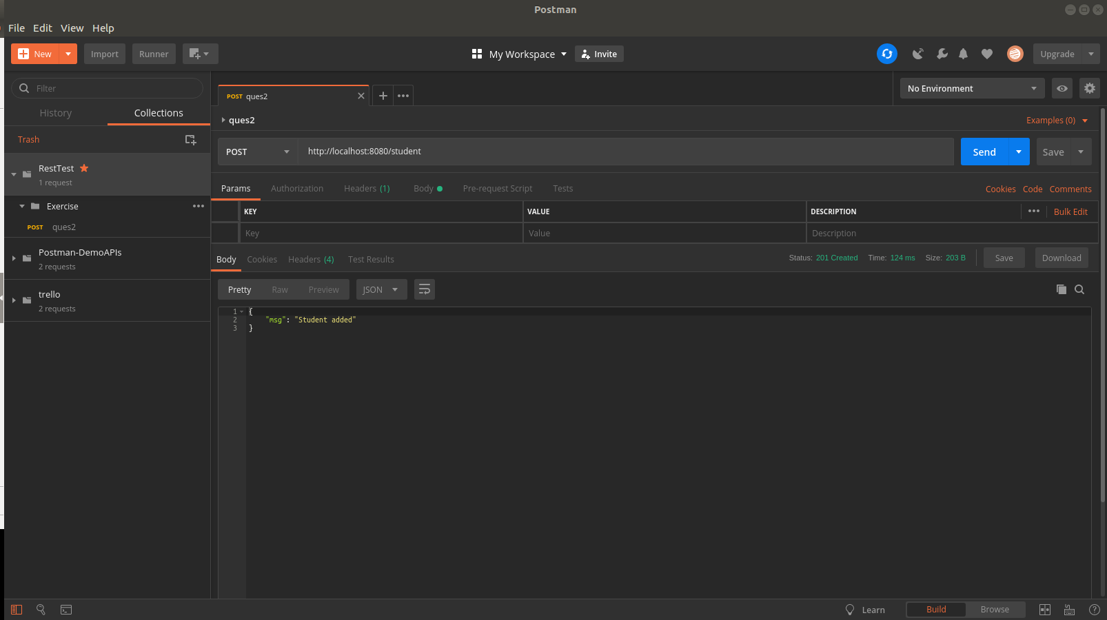
2) Post any student Data and get the created data by Student ID
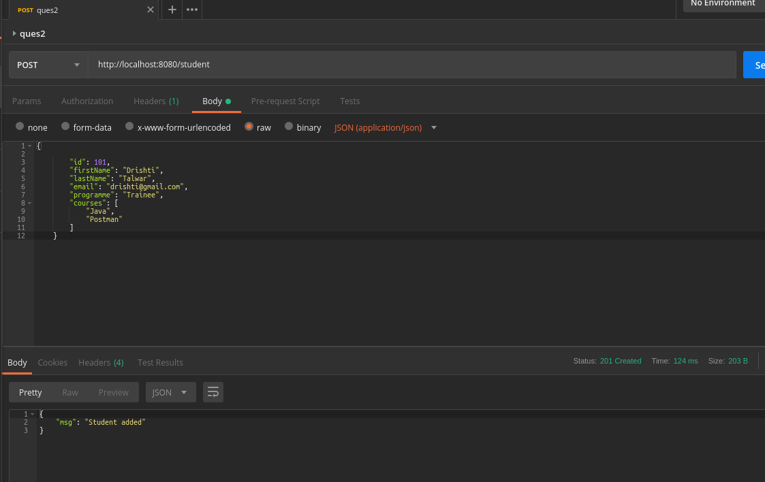
3) Fetch the data only by programme "Financial Analysis"
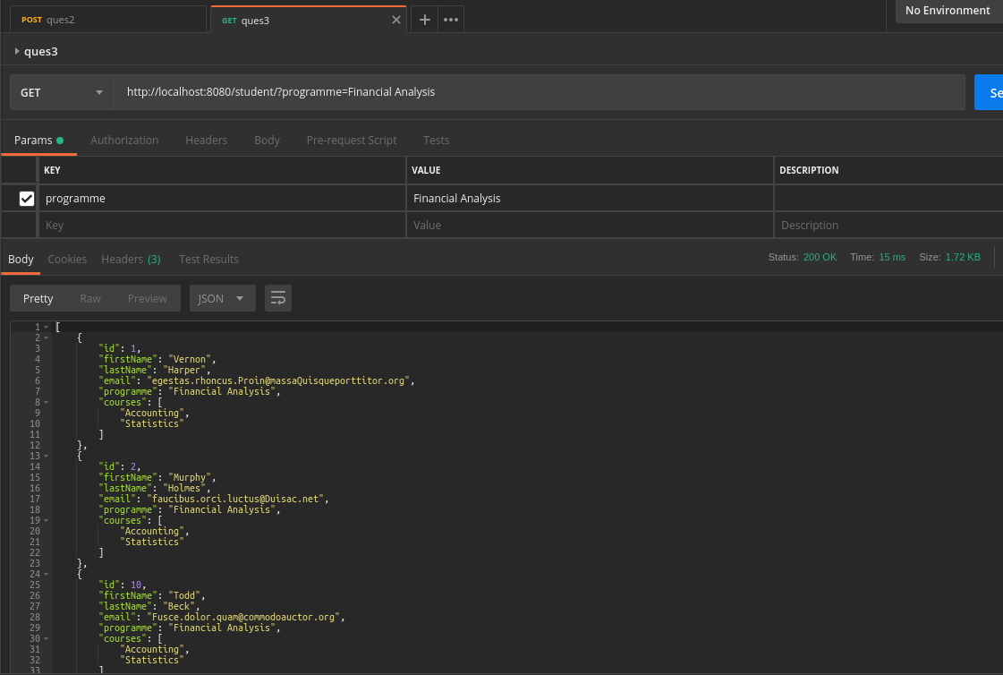
4) Post student data with existing email Id and check for the error message. Mention the test script.
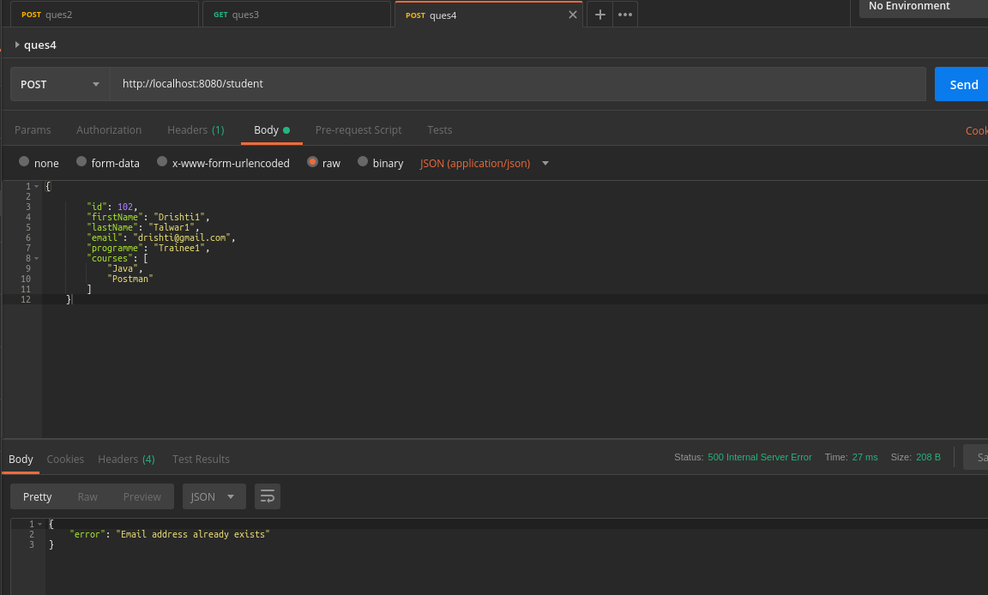
5) Post student data with an incorrect format of email Id and check for the error message. Mention the test script.
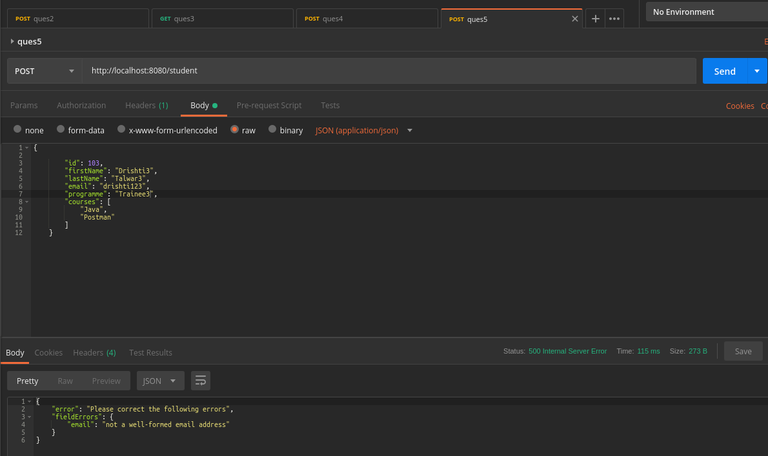
6) Fetch the data only by the programme "Computer Science" and " Criminology". Mention the test script
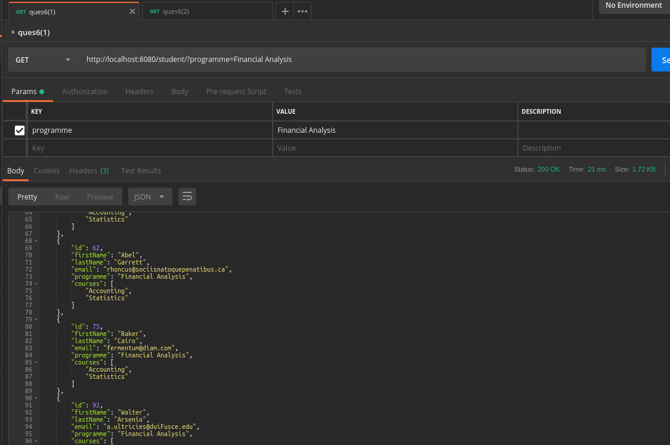

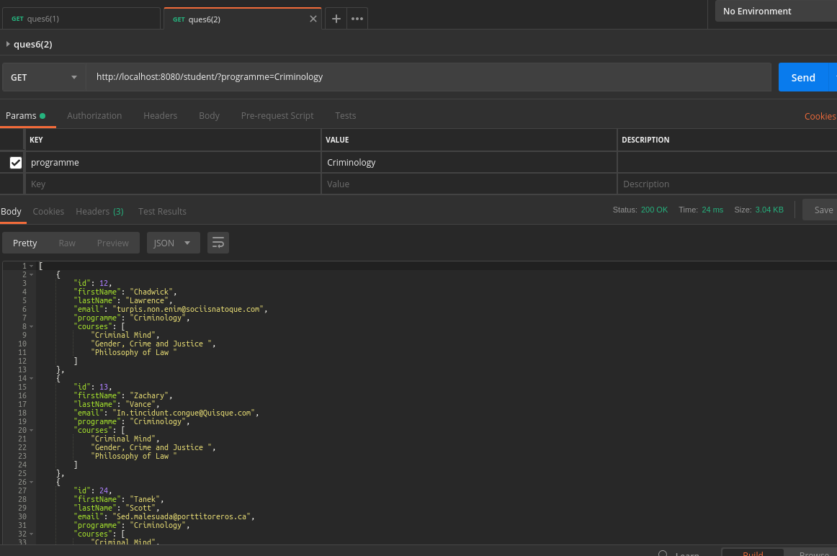
7) Run all the above cases and generate the report.
