Javascript Exercise

1. Prompt for amount, interest rate and no. of years and calculate simple interest.
Program1.html

<!DOCTYPE html>
<html>
<head>
<title>Calculate SI</title>
<script type="text/javascript" src="prog1.js"></script>
<style>
h1 {color: blue; text-align:center}
.button {
text-align: center;
background-color: crimson;
color: wheat;
padding: 20px;
margin-left: 45%;
}
</style>
</head>
<body>
<h1>Calculation of Simple Interest</h1>
<button class="button" onclick="calculate()">Calculate SI</button>
<p id="result"></p>
</body>
</html>

Program1.js
function calculate(){
var p,roi,t;
p=prompt("Enter Principle Amount");
roi=prompt("Enter Rate Of Interest");
t=prompt("Enter Time In Years");
var si= (p*roi*t)/100;
result=document.getElementById("result");
result.innerHTML=("The Simple Interest is " + si);
}

output
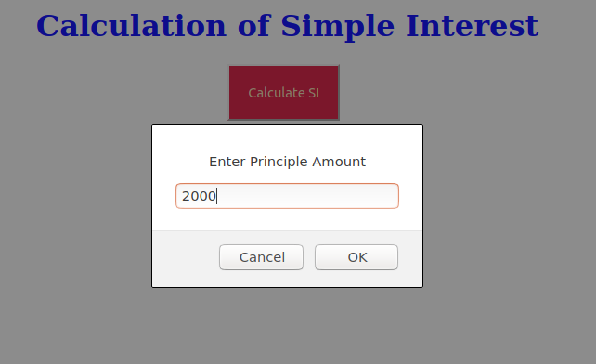

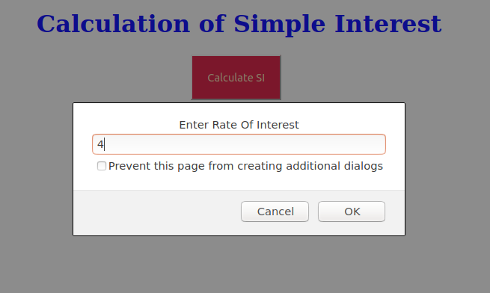
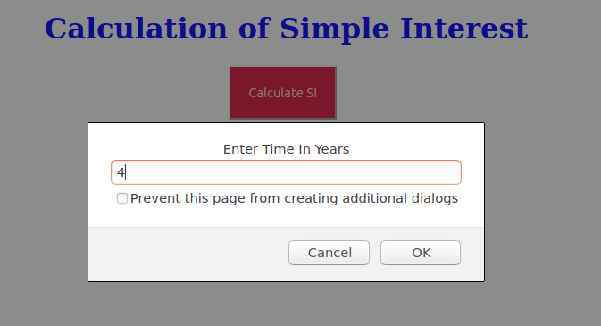

Program 2. is palindrome string
prog2.html
<!DOCTYPE html>
<html lang="en">
<head>
<title>Check for Palindrome</title>
<style>
div{margin-top:40px;
text-align: center;}
h2{
text-align: center;
}
</style>
</head>
<body>
<h2>Is the string palindrome?</h2>
<script type="text/javascript" src="prog2.js"></script>
</body>
</html>

prog2.js
function palindrome(myString){
var removeChar = myString.replace(/[^A-Z0-9]/ig, "").toLowerCase();
var isPalindrome = removeChar.split('').reverse().join('');
if(removeChar === isPalindrome){
document.write("<div>"+ myString + " is a Palindrome <div>");
}else{
document.write("<div>" + myString + " is not a Palindrome </div>");
}
}
palindrome('"STAR WARS"')
palindrome('"Madam"')

Output:
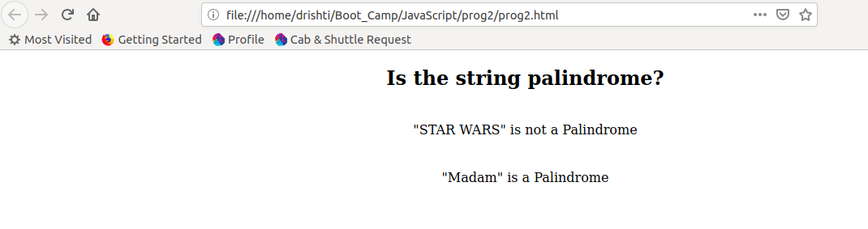

Program 3. Area of circle
Prog3.html
<html>
<head>
<title>Find the area of a circle</title>
</head>
<body>
<script language="JavaScript">
function Area(){
var radius =document.form1.r.value;
document.write("<P>The area of the circle is " + (radius * radius * Math.PI) + "</p>");
}
</script>
<form name=form1>
Enter the radius of circle:
<input type="text" name="r" size=10>
<br>
<input type="button" value="Calculate" onClick='Area();'>
</form>
</script>
</body>
</html>

Output:

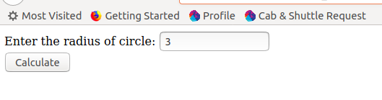

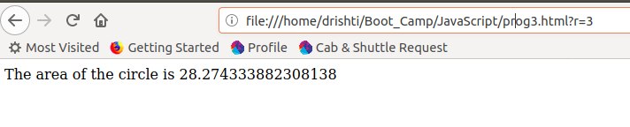

Program 4: Copy information of one object to another and log it to console.

<!DOCTYPE html>
<html>
<head>
<title>Objects Copy</title>
<script>
var obj={
a:"Drishti",
b:"Talwar"
};
var obj_cpy=obj;
document.writeln("Original Object key a: "+obj.a);
document.writeln("<br>Original Object key b: "+obj.b);
document.writeln("<br><br>Object copy key a: "+obj_cpy.a);
document.writeln("<br>Original copy key b: "+obj_cpy.b);
</script>
</head>
</html>

Output
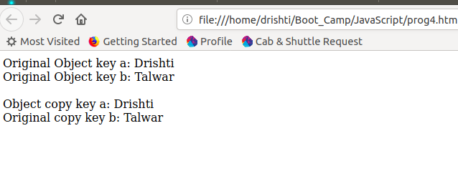
Program 5:
create a list of objects of Employee with info as follow :
- Name, age, salary ,DOB
- filter all employees with salary greater than 5000
- group employee on the basis of their age
- fetch employees with salary less than 1000 and age greater than 20. Then give them an increment 5 times their salary.
Prog5.html

<!DOCTYPE html>
<html>
<head>
<meta charset="UTF-8">
<title>Employee Details</title>
<!-- <script src='https://cdn.jsdelivr.net/lodash/4.17.2/lodash.min.js'></script> -->
<script src="https://cdnjs.cloudflare.com/ajax/libs/underscore.js/1.9.1/underscore.js"></script>
<script type="text/javascript" src="prog5.js"></script>
</head>
</html>

Prog5.js

// ques 5.1
var emp= [
{ name: "Drishti", age:23,salary:5000,dob:"07-10-1996"},
{ name: "Nisha", age:22,salary:5500,dob:"07-01-1997"},
{ name: "Prabhat", age:22,salary:600,dob:"21-07-1995"},
{ name: "Shreya", age:24,salary:5800,dob:"06-10-1995"}
];
console.log(emp);

//ques 5.2
var emps=emp.filter(function(items1){
return (items1.salary>=5000);
});
console.log(emps);

//ques5.3
var result=_.groupBy(emp,function(employee){
return employee.age;
});
console.log(result);

//ques 5.4
var inc=emp.filter(function(items1){
return (items1.salary<1000 && items1.age>20)
});
console.log(inc);

var result=inc.map(x=>{x.salary;
var arr={}
arr[x.salary]=x.salary*5;
return arr;
});
console.log(result);

Output
output 5.1
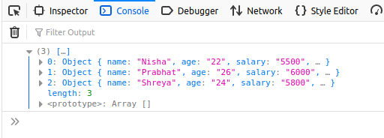
output 5.2
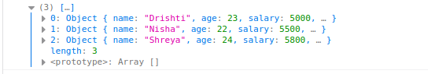

output 5.3

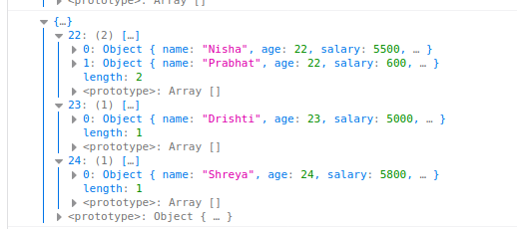
output 5.4

