Exercises: MultiThreading

1. Write a programe do to demonstrate the use of volatile keyword.
Code:

class Demo1 extends Thread {
public static volatile int count = 0;
public void run() {
System.out.println(Thread.currentThread().getName());
System.out.println("Updating Count ");
try {
count++;
System.out.println(count);
sleep(100);
} catch (Exception e) {
e.printStackTrace();
}
}
}
public class Ques1 {
public static void main(String[] args) {
Demo1 d1 = new Demo1();
Demo1 d2 = new Demo1();
d1.start();
d2.start();
}
}
Output:
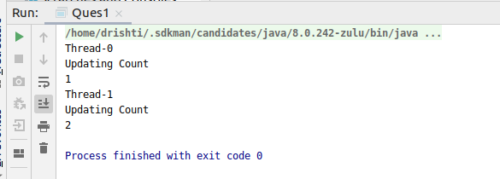

2. Write a program to create a thread using Thread class and Runnable interface each.
Code:
Thread Class
class A extends Thread {
public void run() {
for (int i = 0; i < 5; i++) {
System.out.println(Thread.currentThread().getName());
System.out.println(i);
try {
sleep(100);
} catch (Exception e) {
e.printStackTrace();
}
}
}
}
public class Ques2a {
public static void main(String[] args) {
A t1 = new A();
A t2 = new A();
t1.start();
t2.start();
}
}

Output:
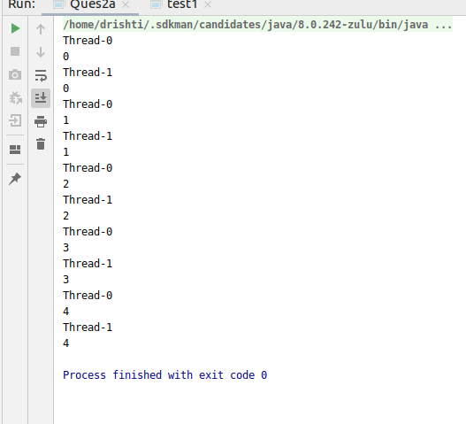

Code:
Runnable Interface
class Demo implements Runnable {
@Override
public void run() {
for (int i = 0; i < 5; i++) {
System.out.println(Thread.currentThread().getName());
System.out.println(i);
try {
Thread.sleep(100);
} catch (Exception e) {
e.printStackTrace();
}
}
}
}
public class Ques2b {
public static void main(String[] args) {
Thread t1 = new Thread(new Demo());
Thread t2 = new Thread(new Demo());
t1.start();
t2.start();
}
}

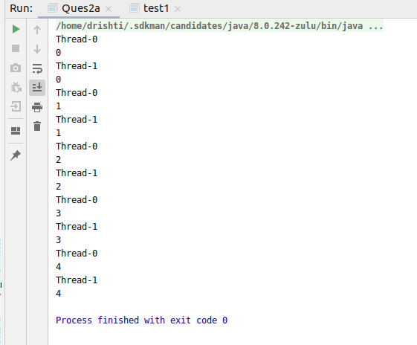
Output:

3. Write a program using synchronization block and synchronization method
Code:
Synchronized Block
//synchronization block
class A1 {
void test1(int n) {
synchronized (this) {
System.out.println("Thread " + Thread.currentThread());
for (int i = 1; i <= 5; i++) {
System.out.println(n + i);
try {
Thread.sleep(100);
} catch (Exception e) {
System.out.println(e);
}
}
}
}
}
class T1 extends Thread {
A1 t;
T1(A1 t) {
this.t = t;
}
public void run() {
t.test1(5);
}
}
class T2 extends Thread {
A1 t;
T2(A1 t) {
this.t = t;
}
public void run() {
t.test1(2);
}
}
public class Ques3 {
public static void main(String[] args) {
A1 obj = new A1();
T1 t1 = new T1(obj);
T2 t2 = new T2(obj);
t1.start();
t2.start();
}
}
Code:
Synchronized Method
//synchronization block
class A1 {
synchronized void test1(int n) {
//synchronized (this) {
System.out.println("Thread "+Thread.currentThread());
for (int i = 1; i <= 5; i++) {
System.out.println(n + i);
try {
Thread.sleep(100);
} catch (Exception e) {
System.out.println(e);
}
}
}
}
class T1 extends Thread {
A1 t;
T1(A1 t) {
this.t = t;
}
public void run() {
t.test1(5);
}
}
class T2 extends Thread {
A1 t;
T2(A1 t) {
this.t = t;
}
public void run() {
t.test1(2);
}
}
public class Ques3 {
public static void main(String[] args) {
A1 obj = new A1();
T1 t1 = new T1(obj);
T2 t2 = new T2(obj);
t1.start();
t2.start();
}
}
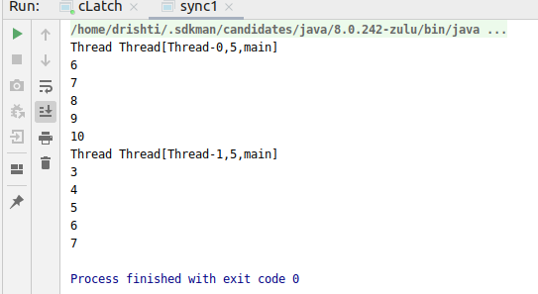
Output:

4. Write a program to create a Thread pool of 2 threads where one Thread will print even numbers and other will print odd numbers.
Code:
import java.util.concurrent.ExecutorService;
import java.util.concurrent.Executors;
import static java.lang.Thread.sleep;
//Write a program to create a Thread pool of 2 threads
// where one Thread will print even numbers
// and other will print odd numbers
public class Ques4 {
public static void main(String[] args) {
ExecutorService executorService = Executors.newFixedThreadPool(2);
Runnable task1 = new Runnable() {
@Override
public void run() {
System.out.println("Performing function to print odd number");
System.out.println("Starting " + Thread.currentThread().getName());
try {
//int n=0;
for (int i = 1; i <= 10; i++) {
if (i % 2 != 0)
System.out.println("Odd: " + i);
sleep(100);
}
} catch (InterruptedException e) {
e.printStackTrace();
}
System.out.println("Ending task to print odd numbers");
}
};
Runnable task2 = new Runnable() {
@Override
public void run() {
System.out.println("Performing function to print even number");
System.out.println("Starting " + Thread.currentThread().getName());
try {
for (int i = 1; i <= 10; i++) {
if (i % 2 == 0)
System.out.println("Even: " + i);
sleep(100);
}
} catch (InterruptedException e) {
e.printStackTrace();
}
System.out.println("Ending task to print even numbers");
}
};
executorService.submit(task1);
executorService.submit(task2);
executorService.shutdown();
executorService.shutdown();
}
}

Output:
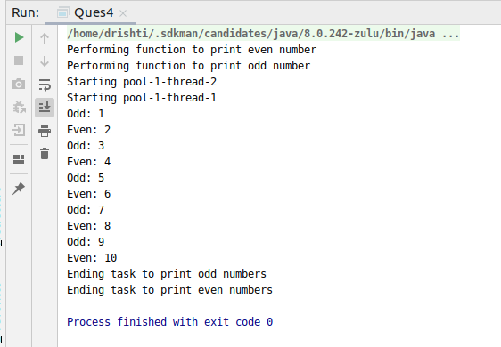

5. Write a program to demonstrate wait and notify method.
Code:
class User {
int amt = 1000;
synchronized void withdraw(int amt) {
System.out.println("Withdrawing the amount");
if (this.amt < amt) {
System.out.println("Your Balance is low");
try {
wait();
} catch (InterruptedException e) {
e.printStackTrace();
}
this.amt = this.amt - amt;
System.out.println("Amount Withdrawn");
}
}
synchronized void deposit(int amt) {
System.out.println("Depositing the amount");
this.amt = this.amt + amt;
System.out.println("Amount Deposited");
notify();
}
}
public class Ques5 {
public static void main(String[] args) {
User u = new User();
Thread t1 = new Thread() {
public void run() {
u.withdraw(1500000);
}
};
Thread t2 = new Thread() {
public void run() {
u.deposit(10000);
}
};
t1.start();
t2.start();
}
}
Output:
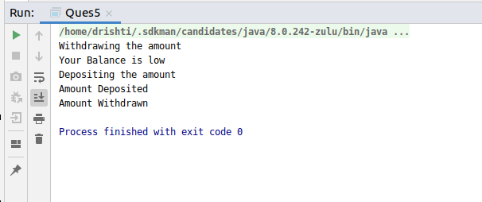

6. Write a program to demonstrate sleep and join methods.
Code:
class MyThread extends Thread {
public void run() {
int value = 1;
for (int i = 0; i < 5; i++) {
System.out.println("Thread 1 running...");
System.out.println(i);

try {
Thread.sleep(2000);
} catch (InterruptedException e) {
e.printStackTrace();
}
}
}
}

public class Ques6{

public static void main(String[] args) throws InterruptedException {

MyThread m=new MyThread();
m.start();
m.join();
System.out.println("Waiting for Thread 1 to complete");
for(int i=0;i<5;i++){
System.out.println("Thread 2 running...");
}
}

}
Output:
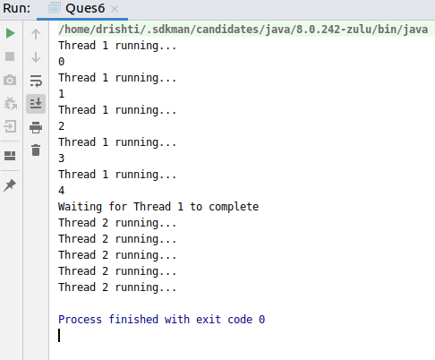

7. Run a task with the help of callable and store it's result in the Future.
Code:
import java.util.concurrent.*;
class Product implements Callable<Integer> {
@Override
public Integer call() throws Exception {
Thread.sleep(200);
return table();
}
private Integer table() {
int num = 5;
int result = 1;
System.out.println("Printing table");
for (int i = 1; i <= 10; i++) {
System.out.println(num * i);
result = num * i;
}
return result;
}
}
public class Ques7 {
public static void main(String[] args) throws ExecutionException, InterruptedException {
ExecutorService executorService = Executors.newSingleThreadExecutor();
System.out.println("Table of 5 ");
Future<Integer> fut = executorService.submit(new Product());
Integer answer = fut.get();
executorService.shutdown();
}
}
Output:
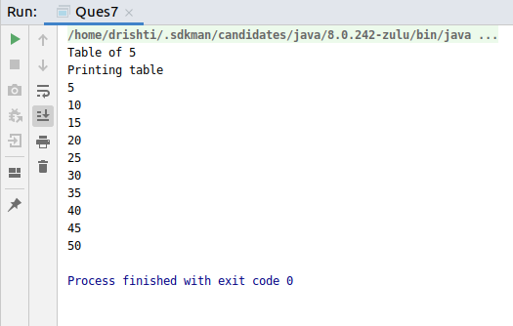

8. Write a program to demonstrate the use of semaphore.
Code:
import java.util.concurrent.Semaphore;
public class Ques8 {
int count = 0;
Semaphore s = new Semaphore(1);
public static void main(String[] args) {
Ques8 q1 = new Ques8();
Thread t1 = new Thread() {
public void run() {
try {
q1.func();
} catch (InterruptedException e) {
e.printStackTrace();
}
}
};
t1.start();
Thread t2 = new Thread() {
public void run() {
try {
q1.func();
} catch (InterruptedException e) {
e.printStackTrace();
}
}
};
t2.start();
}
private void func() throws InterruptedException {
try {
s.acquire();
System.out.println(Thread.currentThread().getName() + "Lock Aquired");
count++;
System.out.println("Count is: " + count);
Thread.sleep(1000);
} catch (InterruptedException e) {
e.printStackTrace();
} finally {
s.release();
System.out.println(Thread.currentThread().getName() + "Lock Released");
}
}
}
Output:
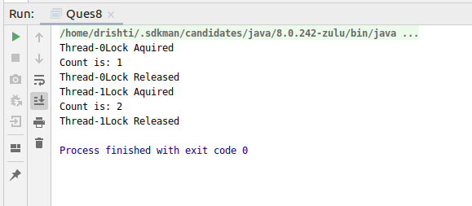
9. Write a program to demonstrate the use of CountDownLatch
Code:
import java.util.concurrent.CountDownLatch;
import java.util.concurrent.ExecutorService;
import java.util.concurrent.Executors;
class Processor implements Runnable {
private CountDownLatch latch;
Processor(CountDownLatch latch) {
this.latch = latch;
}
public void run() {
System.out.println("Process started");
try {
Thread.sleep(200);
} catch (InterruptedException e) {
e.printStackTrace();
}
latch.countDown();
}
}
public class Ques9 {
public static void main(String[] args) {
CountDownLatch latch = new CountDownLatch(4);
ExecutorService exe = Executors.newFixedThreadPool(4);
for (int i = 0; i < 4; i++) {
exe.submit(new Processor(latch));
}
try {
latch.await();
} catch (InterruptedException e) {
e.printStackTrace();
}
System.out.println("Completed task");
}
}
Output:
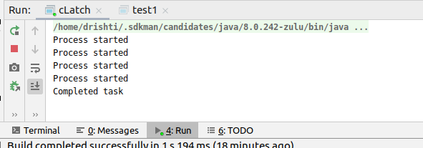
10. Write a program which creates deadlock between 2 threads
Code:
public class Ques10 {
public static void main(String[] args) {
Object lock1 = new Object();
Object lock2 = new Object();
Thread t1 = new Thread() {
public void run() {
synchronized (lock1) {
System.out.println("Acquired Lock 1 on " + Thread.currentThread().getName());
try {
Thread.sleep(100);
} catch (Exception e) {
}
}
synchronized (lock2) {
System.out.println("Waiting for Lock 2 on " + Thread.currentThread().getName());
try {
Thread.sleep(100);
} catch (Exception e) {
}
}
}
};
Thread t2 = new Thread() {
public void run() {
synchronized (lock2) {
System.out.println("Acquired Lock 2 on " + Thread.currentThread().getName());
try {
Thread.sleep(100);
} catch (Exception e) {
}
}
synchronized (lock1) {
System.out.println("Waiting for Lock 1 on " + Thread.currentThread().getName());
try {
Thread.sleep(100);
} catch (Exception e) {
}
}
}
};
t1.start();
t2.start();
}
}
Output:
