Ques 1

<!DOCTYPE html>
<html lang="en">

<head>
<meta charset="utf-8">
<meta name="viewport" content="width=device-width, initial-scale=1, shrink-to-fit=no">
<link rel="stylesheet" href="https://maxcdn.bootstrapcdn.com/bootstrap/4.0.0/css/bootstrap.min.css"
integrity="sha384-Gn5384xqQ1aoWXA+058RXPxPg6fy4IWvTNh0E263XmFcJlSAwiGgFAW/dAiS6JXm" crossorigin="anonymous">

<script src="https://code.jquery.com/jquery-3.2.1.slim.min.js"
integrity="sha384-KJ3o2DKtIkvYIK3UENzmM7KCkRr/rE9/Qpg6aAZGJwFDMVNA/GpGFF93hXpG5KkN" crossorigin="anonymous">
</script>

<script src="https://cdnjs.cloudflare.com/ajax/libs/popper.js/1.12.9/umd/popper.min.js"
integrity="sha384-ApNbgh9B+Y1QKtv3Rn7W3mgPxhU9K/ScQsAP7hUibX39j7fakFPskvXusvfa0b4Q" crossorigin="anonymous">
</script>

<script src="https://maxcdn.bootstrapcdn.com/bootstrap/4.0.0/js/bootstrap.min.js"
integrity="sha384-JZR6Spejh4U02d8jOt6vLEHfe/JQGiRRSQQxSfFWpi1MquVdAyjUar5+76PVCmYl" crossorigin="anonymous">
</script>

<title>To The New</title>
</head>
<body class="bg-dark">
<div class="container bg-secondary pb-2">
<h2 class="text-white">TO THE NEW</h2>
<div class="container bg-dark">
<nav class="navbar navbar-expand-md bg-dark navbar-light">
<button class="navbar-toggler bg-light ml-auto" type="button" data-toggle="collapse"
data-target="#collapsibleNavbar">
<span class="navbar-toggler-icon"></span>
</button>
<div class="collapse navbar-collapse" id="collapsibleNavbar">
<ul class="navbar-nav">
<li class="nav-item">
<a class="nav-link text-white" href="#">Text Link</a>
</li>
<li class="nav-item">
<a class="nav-link text-white" href="#">Text Link</a>
</li>
<li class="nav-item">
<a class="nav-link text-white" href="#">Text Link</a>
</li>
<li class="nav-item">
<a class="nav-link text-white" href="#">Text Link</a>
</li>
<li class="nav-item">
<a class="nav-link text-white" href="#">Text Link</a>
</li>
</ul>
</div>
</nav>
</div>
</div>
<div class="container bg-white py-3">
<div class="container">
<div style="width:85%; max-height:auto; overflow: hidden;" class="mx-auto">
<img class="img-fluid mx-auto d-block" src="img1.jpg" alt="layout-1">
</div>
</div>
<div class="container">
<div class="row justify-content-center bg-secondary mx-5 my-3">
<div class="col-md-10 col-sm-10 mx-auto my-3">
<p class="text-white">
Speedily say has suitable disposal add boy. On forth doubt miles of child. Exercise joy man
children rejoiced. Yet uncommonly his ten who diminution astonished. Demesne new manners savings
staying had. Under folly balls death own point now men. Match way these she avoid see death. She
whose drift their fat off.
</p>
</div>
</div>
</div>
<div class="container mx-1 my-2 justify-content-center">
<div class="mx-5 my-2">
<h3>Latest From Gallery</h3>
<hr class="bg-secondary">
</div>
<div class="mx-3">
<div class="row">
<div class="col-md-3 col-sm-6 my-1 ">
<img class="img-fluid mx-auto d-block" src="img2.jpeg">
<p class="text-center text-secondary mt-1">Caption-1</p>
</div>
<div class="col-md-3 col-sm-6 my-1">
<img class="img-fluid mx-auto d-block" src="img2.jpeg">
<p class="text-center text-secondary mt-1">Caption-2</p>
</div>
<div class="col-md-3 col-sm-6 my-1">
<img class="img-fluid mx-auto d-block" src="img2.jpeg">
<p class="text-center text-secondary mt-1">Caption-3</p>
</div>
<div class="col-md-3 col-sm-6 my-1">
<img class="img-fluid mx-auto d-block" src="img2.jpeg">
<p class="text-center text-secondary mt-1">Caption-4</p>
</div>
</div>
</div>
</div>
</div>
<div class="container bg-dark border border-secondary d-flex">
<p class="text-white mr-auto">Copyright ©- All Right Reserved-To The New </p>
<p class="text-white ml-auto">Web Layout By To The New</p>
</div>
</body>
</html>

Output:

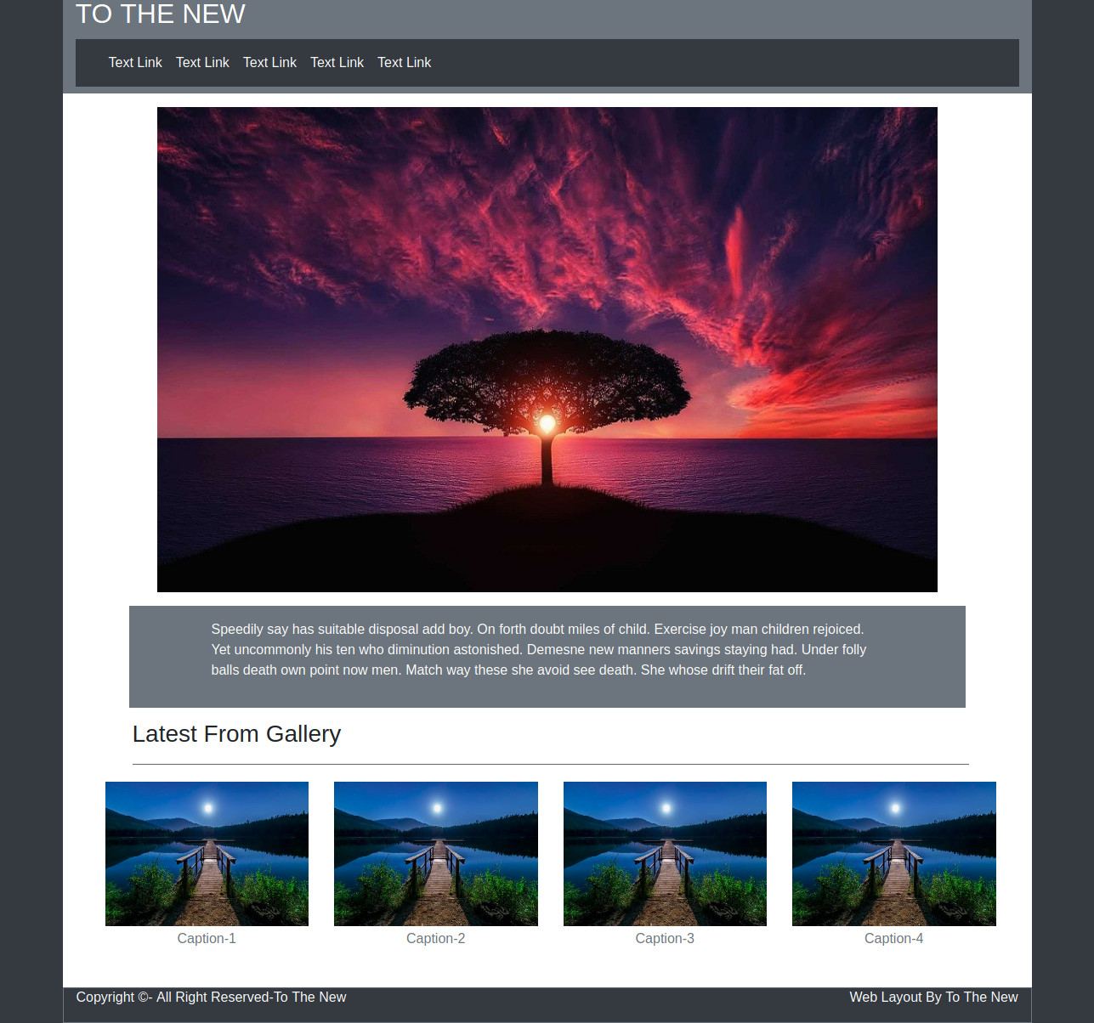

Ques 2.

<!doctype html>
<html lang="en">
<head>
<meta charset="utf-8">
<meta name="viewport" content="width=device-width, initial-scale=1, shrink-to-fit=no">
<link rel="stylesheet" href="https://stackpath.bootstrapcdn.com/bootstrap/4.4.1/css/bootstrap.min.css"
integrity="sha384-Vkoo8x4CGsO3+Hhxv8T/Q5PaXtkKtu6ug5TOeNV6gBiFeWPGFN9MuhOf23Q9Ifjh" crossorigin="anonymous">
<script src="https://code.jquery.com/jquery-3.4.1.slim.min.js"
integrity="sha384-J6qa4849blE2+poT4WnyKhv5vZF5SrPo0iEjwBvKU7imGFAV0wwj1yYfoRSJoZ+n" crossorigin="anonymous">
</script>
<script src="https://cdn.jsdelivr.net/npm/popper.js@1.16.0/dist/umd/popper.min.js"
integrity="sha384-Q6E9RHvbIyZFJoft+2mJbHaEWldlvI9IOYy5n3zV9zzTtmI3UksdQRVvoxMfooAo" crossorigin="anonymous">
</script>
<script src="https://stackpath.bootstrapcdn.com/bootstrap/4.4.1/js/bootstrap.min.js"
integrity="sha384-wfSDF2E50Y2D1uUdj0O3uMBJnjuUD4Ih7YwaYd1iqfktj0Uod8GCExl3Og8ifwB6" crossorigin="anonymous">
</script>
<title>To The New</title>
</head>
<body>
<div class="container d-flex bg-white border-bottom border-secondary">
<h2 class="mr-auto py-1 text-info">TO THE NEW</h2>
<a class="ml-auto pt-2 text-info" href="#">
<h4>Home</h4>
</a>
<a class="ml-2 pt-2 text-info" href="#">
<h4>Quick Help</h4>
</a>
</div>
<div class="container mt-5">
<div class="row">
<div class="col-6 border border-secondary rounded mx-auto mb-5 p-0">
<h2 class="bg-secondary m-0 p-2 text-white">Bug Report</h2>
<div class="container m-1">
<form action="">
<div class="form-group">
<label for="title">Title*:</label>
<input type="text" class="form-control border border-secondary" id="title"
placeholder="Enter Title" name="title">
</div>
<div class="form-group">
<label for="desc">Description*:</label>
<textarea class="form-control border border-secondary" rows="3" id="desc"
placeholder="enter description"></textarea>
</div>
<div class="form-group">
<label for="os">Operating System:</label>
<select class="form-control border border-secondary bg-info text-white" id="os">
<option>Ubuntu</option>
<option>WindowsXP</option>
<option>Windows 8</option>
<option>Windows 10</option>
</select>
</div>
<div class="form-group">
<label for="prdct">Product*:</label>
<select class="form-control border border-secondary bg-info text-white" id="prdct">
<option>VLC Media Player</option>
<option>Media Player</option>
<option>VS Code</option>
<option>Microsoft Office</option>
</select>
</div>
<div class="form-group">
<label for="version">Version*:</label>
<input type="number" class="form-control border border-secondary" id="version">
</div>
<div class="form-group">
<label class="d-block" for="#">License*:</label>
<div class="custom-control custom-radio custom-control-inline mr-5">
<input type="radio" class="custom-control-input" id="free" name="License">
<label class="custom-control-label mr-5" for="free">Free</label>
</div>
<div class="custom-control custom-radio custom-control-inline">
<input type="radio" class="custom-control-input" id="business" name="License">
<label class="custom-control-label" for="business">Business</label>
</div>
</div>
<div class="form-group">
<label for="Severity">Severity*:</label>
<select class="form-control border border-secondary bg-info text-white" id="Severity">
<option>Critical</option>
<option>High</option>
<option>Medium</option>
<option>Low</option>
</select>
</div>
<div class="form-group">
<label class="d-block" for="file">Attachments*:</label>
<input type="file" class="form-group">
</div>
</form>
</div>
<hr class="bg-secondary mb-0">
<div class="d-flex bg-secondary">
<button type="submit" class="btn btn-primary ml-auto mr-2 my-2">Submit</button>
</div>
</div>
</div>
</div>
</body>
</html>

Output:

