- Add a gradle dependency and its related repository url.
Code:
plugins {
id 'java'
}
group 'org.example'
version '1.0-SNAPSHOT'
sourceCompatibility = 1.8
sourceSets{
main{
java.srcDirs=['src']
}
}
repositories {
mavenCentral()
}
dependencies {
testCompile group: 'junit', name: 'junit', version: '4.12'
}

Output:

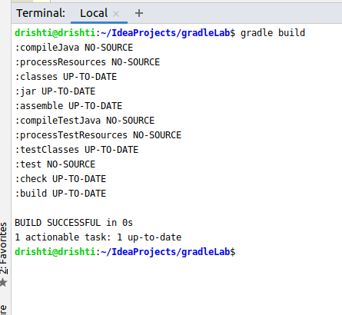

- Using java plugin, make changes in the manifest to make the jar executable. Using java -jar JAR_NAME, the output should be printed as "Hello World"
Code:
plugins {
id 'java'
}
group 'org.example'
version '1.0-SNAPSHOT'
sourceCompatibility = 1.8
repositories {
mavenCentral()
maven{
url "https://mvnrepository.com/artifact/com.google.code.gson/gson"
}
}
dependencies {
testCompile group: 'junit', name: 'junit', version: '4.12'
compile group: 'com.google.code.gson', name: 'gson', version: '2.8.6'
}

PrintHello.java
public class PrintHello {
public static void main( String[] args ){
System.out.println( "Hello World!" );
}
}
Output:
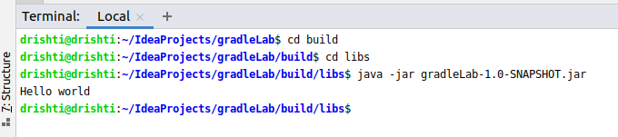
- Differentiate between the different dependency scopes: compile, runtime, testCompile, testRuntime using different dependencies being defined in your build.gradle.
Compile:
We will make use of dependencies that are required to compile the production source of the project at compile time.
Test Compile:
These dependencies are required to compile the test source of the project.It also contains the compiled production classes and the compile time dependencies.
Runtime:
These dependencies are used at runtime by production classes. It also conatains the compile time dependencies by default.
Test Runtime:
These dependencies are required to run the tests. It also contains runtime and test compile dependencies.
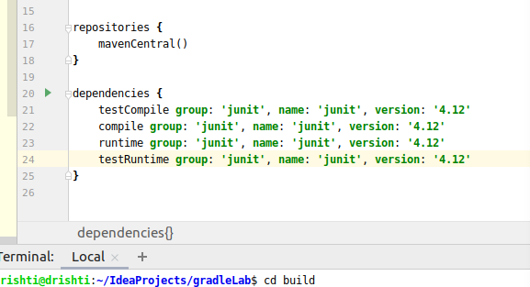

- Create a custom plugin which contains a custom task which prints the current date-time. Using that plugin in your project, execute that task after the jar task executes.
Code:
showDate.groovy
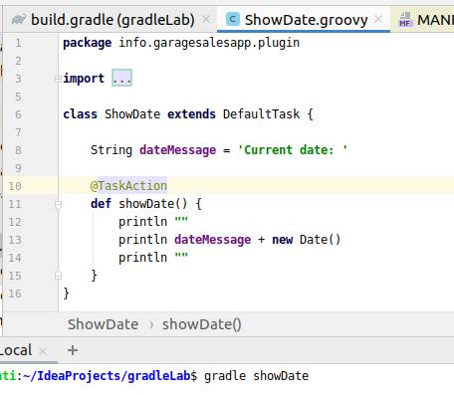

build.gradle
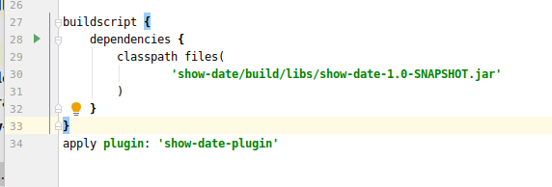

Manifest.mf
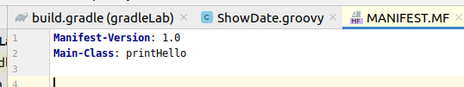

Output:
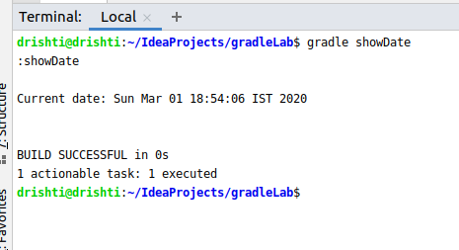

- Instead of using default source set, use src/main/javaCode1, src/main/javaCode2 to be taken as code source. Make sure that the JAR created contains files from both the directories and not from src/main/java.
1. Create 2 folders in the src/main named javaCode1 and javaCode2, each of these folders have java classes with name Code1 and Code2.
2. In gradle.build
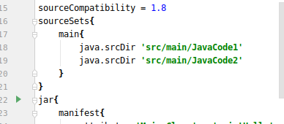

Output:
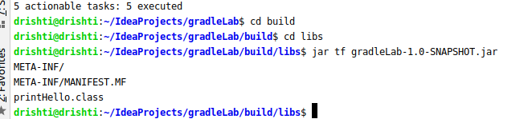

- Override the Gradle Wrapper task to install a different version of gradle. Make sure that the task written in Q4 also executes with it.

On the terminal:
Output:
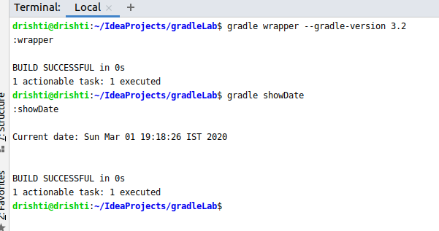

In gradle.wrapper.properties file
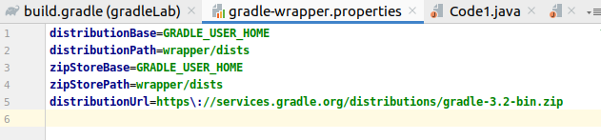

- Run the gradle profile command and attach the resulting files.
On the terminal:

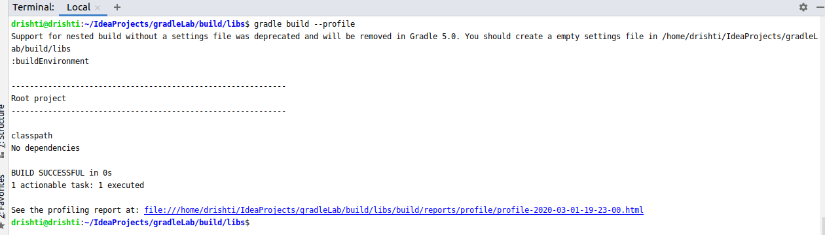

Project Report on the browser:

