- Write the following a functional interface and implement it using lambda:
(a) First number is greater than second number or not Parameter (int ,int ) Return boolean
Code:
//(1) First number is greater than second number or not Parameter (int ,int ) Return boolean
@FunctionalInterface
interface Check {
boolean greaterOrNot(int a, int b);
}
public class Ques1a {
public static void main(String[] args) {
Check c = (a, b) -> {
if (a > b)
return true;
else
return false;
};
System.out.println(c.greaterOrNot(20, 10));
}
}
Output:

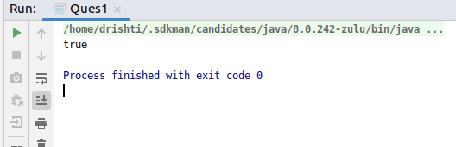

(b) Increment the number by 1 and return incremented value Parameter (int) Return int
Code:
//2. Increment the number by 1 and return incremented value Parameter (int) //Return int
interface Inc {
int increment(int a);
}
public class Ques1b {
public static void main(String[] args) {
Inc i = (a) -> {
System.out.println("Number is: " + a);
a++;
return a;
};
System.out.println("Incrementing the number by 1: " + i.increment(4));
}
}

Output:
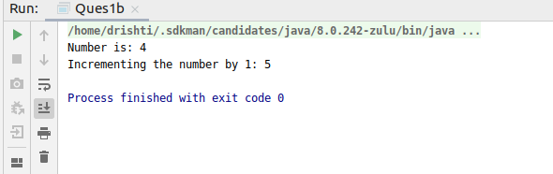
(c) Concatination of 2 string Parameter (String , String ) Return (String)
Code:
//3. Concatination of 2 string Parameter (String , String ) Return (String)
interface Concat {
String concat(String s1, String s2);
}
public class Ques1c {
public static void main(String[] args) {
Concat c = ((s1, s2) -> {
return s1 + s2;
});
System.out.println(c.concat("Hello ", "World"));
}
}
Output:
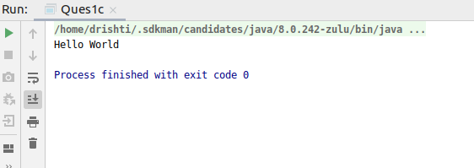

(d) Convert a string to uppercase and return .Parameter (String) Return (String)
Code:
//4. Convert a string to uppercase and return .Parameter (String) Return //(String)
interface changeCase {
String upperCase(String s);
}
public class Ques1d {
public static void main(String[] args) {
changeCase cc = (s -> {
System.out.println("String is: " + s);
return s.toUpperCase();
});
System.out.println("String in uppercase ");
System.out.println(cc.upperCase("hello"));
}
}
Output:
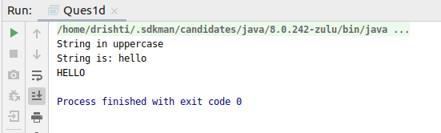

- Create a functional interface whose method takes 2 integers and return one integer.
Code:
//2. Create a functional interface whose method takes 2 integers and return one integer.
@FunctionalInterface
interface Demo {
int method(int a, int b);
}
public class Ques2 {
public static void main(String[] args) {
Demo d = ((a, b) -> {
System.out.println("a is:" + a + ", b is:" + b);
return a + b;
});
System.out.println("Returning one integer: " + d.method(3, 4));
}
}
Output:
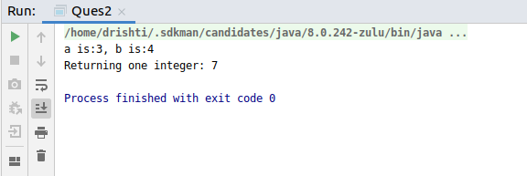

- Using (instance) Method reference create and apply add and subtract method and using (Static) Method reference create and apply multiplication method for the functional interface created.
Code:
//Using (instance) Method reference create and apply add and subtract method and using (Static)
// Method reference create and apply multiplication method for the functional interface created.
@FunctionalInterface
interface Calc {
int method(int a, int b);
}
public class Ques3 {
int add(int a, int b) {
return a + b;
}
int subtract(int a, int b) {
return a - b;
}
public static int product(int a, int b) {
return a * b;
}
public static void main(String[] args) {
Calc c = new Ques3()::add;
System.out.println("Adding 2 numbers: " + c.method(20, 3));
Calc c1 = new Ques3()::subtract;
System.out.println("Subtracting 2 numbers: " + c1.method(20, 3));
Calc c3 = Ques3::product;
System.out.println("Product of 2 numbers: " + c3.method(20, 3));
}
}
Output:
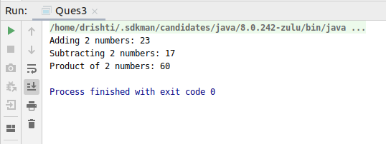
- Create an Employee Class with instance variables (String) name, (Integer)age, (String)city and get the instance of the Class using constructor reference
Code:
//Create an Employee Class with instance variables
// (String) name, (Integer)age, (String)city and get
// the instance of the Class using constructor reference
@FunctionalInterface
interface constructorReference {
Employee getEmp(String name, Integer age, String city);
}
class Employee {
String name;
Integer age;
String city;
Employee(String n, Integer a, String c) {
name = n;
age = a;
city = c;
}
public void display() {
System.out.println("Name: " + name + ",Age: " + age + ",City: " + city);
}
}
public class Ques4 {
public static void main(String[] args) {
constructorReference conref = Employee::new;
Employee e = conref.getEmp("Drishti", 23, "New Delhi");
e.display();
}
}
Output:
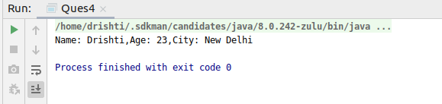

- Implement following functional interfaces from java.util.function using lambdas:
  - (1) Consumer
Code:
//(1) Consumer
import java.util.function.Consumer;
public class Ques5a {
static void printName(String name) {
System.out.println("Hello " + name);
}
static void printValue(int val) {
System.out.println(val);
}
public static void main(String[] args) {
Consumer<String> consumer1 = Ques5a::printName;
consumer1.accept("Drishti");
Consumer<Integer> consumer2 = Ques5a::printValue;
consumer2.accept(10);
}
}

Output:
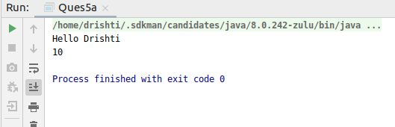
  - (2) Supplier
Code:
import java.util.function.Supplier;
public class Ques5b {
public static void main(String[] args) {
Supplier<Employee> supplier = () -> new Employee("Drishti", 23, "New Delhi");
Employee e = supplier.get();
System.out.println("Employee Details: \n " + e.name + " , " + e.age + " , " + e.city);
}
}
Output:
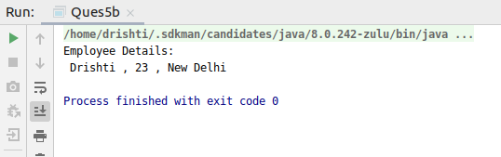
  - (3) Predicate
Code:
import java.util.function.Predicate;
public class Ques5c {
public static void main(String[] args) {
Predicate<Integer> predicate = a -> (a > 20);
System.out.println(predicate.test(30));
}
}
Output:
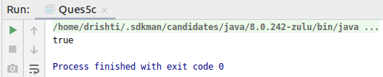

  - (4) Function
Code:
import java.util.function.Function;
public class Ques5d {
static String print(String message) {
return "Hello " + message;
}
public static void main(String[] args) {
Function<String, String> function = Ques5d::print;
System.out.println(function.apply("Drishti"));
}
}
Output:
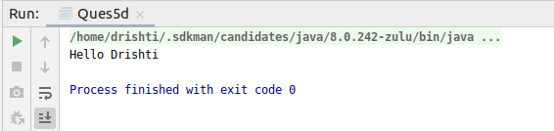
- Create and access default and static method of an interface.
Code:
//Create and access default and static method of an interface.
interface Test {
public void dec(int a);
default void show() {
System.out.println("In default method..");
}
static void display() {
System.out.println("In static method..");
}
}
public class Ques6 implements Test {
@Override
public void dec(int a) {
System.out.println("Value of a: " + a);
int result = --a;
System.out.println("After decrement: " + result);
}
public static void main(String[] args) {
Ques6 q = new Ques6();
q.dec(5);
q.show();
Test.display();
}
}

Output:
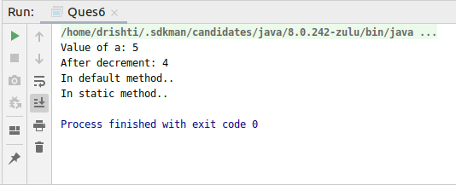

- Override the default method of the interface.
Code:
//Override the default method of the interface.
interface myInterface {
public void inc(int a);
default void display() {
System.out.println("In default method..");
}
}
public class Ques7 implements myInterface {
public void inc(int a) {
int result = ++a;
System.out.println("After Increment: " + result);
}
public static void main(String[] args) {
Ques7 q = new Ques7();
q.inc(4);
q.display();
}
}

Output:
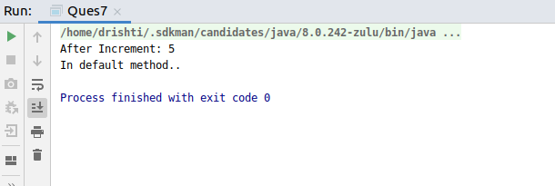

- Implement multiple inheritance with default method inside interface.
Code:
//Implement multiple inheritance with default method inside interface.
interface Rectangle {
default void area(int length, int breadth) {
System.out.println("Area of Rectangle is.. " + 2 * length * breadth);
}
}
interface Square {
default void area(int side) {
System.out.println("Area of Square is.. " + side * side);
}
}
public class Ques8 implements Rectangle, Square {
public void show() {
Rectangle.super.area(4, 3);
Square.super.area(3);
}
public static void main(String[] args) {
Ques8 q = new Ques8();
q.show();
}
}
Output:
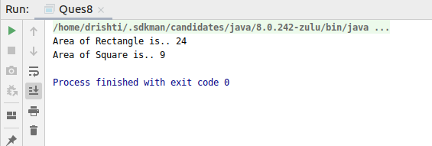

- Collect all the even numbers from an integer list.
Code:
//9. Collect all the even numbers from an integer list.
import java.util.Arrays;
import java.util.List;
import java.util.stream.Collectors;
public class Ques9 {
public static void main(String[] args) {
List<Integer> list = Arrays.asList(1, 2, 3, 4, 5, 6);
System.out.println("Even numbers in the integer list are: ");
System.out.println(
list
.stream()
.filter(e -> e % 2 == 0)
.collect(Collectors.toList())
);
}
}
Output:
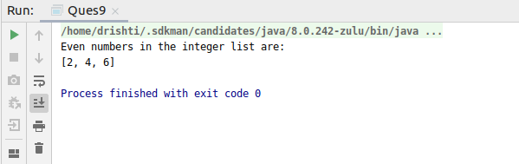

- Sum all the numbers greater than 5 in the integer list.
Code:
//10. Sum all the numbers greater than 5 in the integer list.
import java.util.Arrays;
import java.util.List;
public class Ques10 {
public static void main(String[] args) {
List<Integer> list = Arrays.asList(1, 2, 3, 4, 5, 6, 7, 8);
System.out.println("Sum of numbers greater than 5 in the list is: ");
System.out.println(
list
.stream()
.filter(e -> e > 5)
.mapToInt(e -> e).sum()
);
}
}

Output:
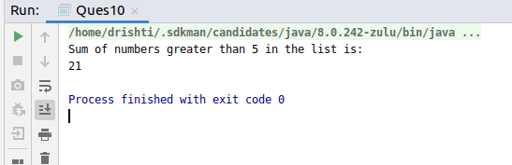

- Find average of the number inside integer list after doubling it.
Code:
import java.lang.reflect.Array;
import java.util.Arrays;
import java.util.List;
//11. Find average of the number inside integer list after doubling it.
public class Ques11 {
public static void main(String[] args) {
List<Integer> list = Arrays.asList(1, 2, 3, 4, 5, 6);
System.out.println("Average of the numbers after doubling them is: ");
System.out.println(
list
.stream()
.map(e -> e * 2)
.mapToInt(e -> e).average()
.orElse(-1)
);
}

Output:
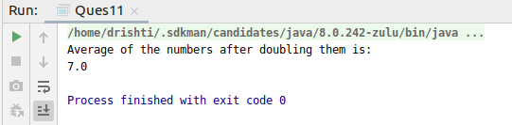

- Find the first even number in the integer list which is greater than 3.
Code:
import java.lang.reflect.Array;
import java.util.Arrays;
import java.util.List;
//12. Find the first even number in the integer list which is greater than 3
public class Ques12 {
public static void main(String[] args) {
List<Integer> list = Arrays.asList(1, 2, 3, 4, 5, 6);
System.out.println("First even number in the integer list which is greater than 3: ");
System.out.println(
list
.stream()
.filter(e -> e > 3)
.filter(e -> e % 2 == 0)
.findFirst()
.orElse(-1)
);
}
}

Output:
