Selenium Testing- Session 1
Exercise
Q1. Write a script to open the Firefox browser and open https://www.google.com/
Code:
package assignment;

import org.openqa.selenium.WebDriver;
import org.openqa.selenium.firefox.FirefoxDriver;

public class ques1 {

public static void main(String[] args) {
// TODO Auto-generated method stub
System.setProperty("webdriver.gecko.driver", "/home/drishti/Desktop/selenium/geckodriver-v0.26.0-linux64/geckodriver");
WebDriver driver =new FirefoxDriver();
driver.get("http://google.com");

}

}

Output:
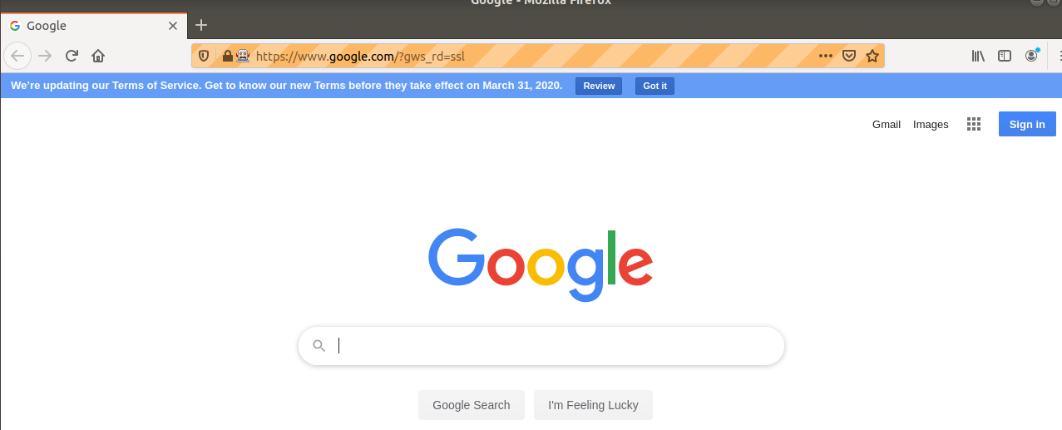

Q2. Write a script launch the Google Chrome browser and open https://www.google.com/
Code:
package assignment;

import org.openqa.selenium.WebDriver;
import org.openqa.selenium.chrome.ChromeDriver;

public class ques2 {

public static void main(String[] args) {
// TODO Auto-generated method stub
System.setProperty("webdriver.chrome.driver", "/home/drishti/Desktop/selenium/chromedriver");
WebDriver driver =new ChromeDriver();
driver.get("http://google.com");
}

}
Output:

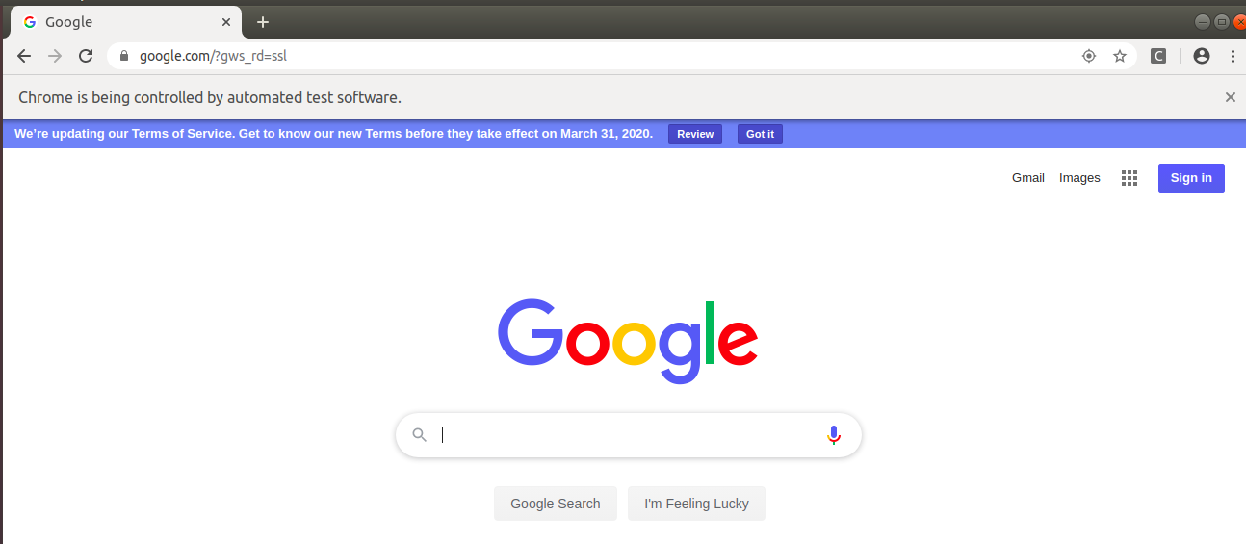

Write the following scripts in any of your desired browsers-
Q3: Write a script to search the “To The New” string in google.
Code:
package assignment;

import org.openqa.selenium.By;
import org.openqa.selenium.WebDriver;
import org.openqa.selenium.chrome.ChromeDriver;

public class ques3 {

public static void main(String[] args) {
// TODO Auto-generated method stub
System.setProperty("webdriver.chrome.driver", "/home/drishti/Desktop/selenium/chromedriver");
WebDriver driver =new ChromeDriver();
driver.get("http://google.com");
driver.findElement(By.name("q")).sendKeys("To The New\n");
//driver.findElement(By.className("gNO89b")).click();
}
}

Output:
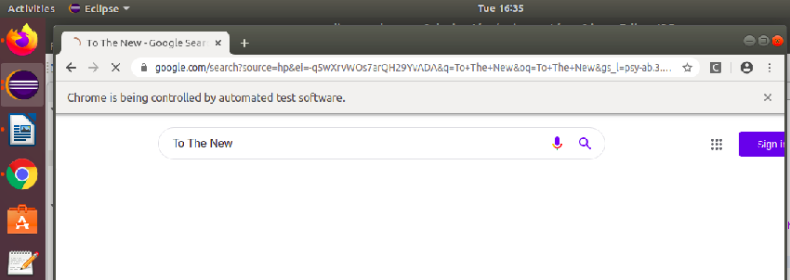

Q4: Write a script to open http://www.tothenew.com/ and then navigate to the contact us page using 1) XPath
Code:
package assignment;
import org.openqa.selenium.By;
import org.openqa.selenium.WebDriver;
import org.openqa.selenium.chrome.ChromeDriver;
public class ques4 {
public static void main(String[] args) {
// TODO Auto-generated method stub
System.setProperty("webdriver.chrome.driver","/home/drishti/Desktop/selenium/chromedriver");
WebDriver driver =new ChromeDriver();
driver.get("http://tothenew.com");
//using xPath
driver.findElement(By.xpath("/html/body/div[1]/div/header[2]/div/div/nav/div[2]/ul/li[8]/a")).click();
}
}
2) ID
package assignment;
import org.openqa.selenium.By;
import org.openqa.selenium.WebDriver;
import org.openqa.selenium.chrome.ChromeDriver;
public class ques4 {
public static void main(String[] args) {
// TODO Auto-generated method stub
System.setProperty("webdriver.chrome.driver", "/home/drishti/Desktop/selenium/chromedriver");
WebDriver driver =new ChromeDriver();
driver.get("http://tothenew.com");
//using id
driver.findElement(By.xpath("(//a[@id='h-contact-us'])[2]")).click();
}

}
Output:
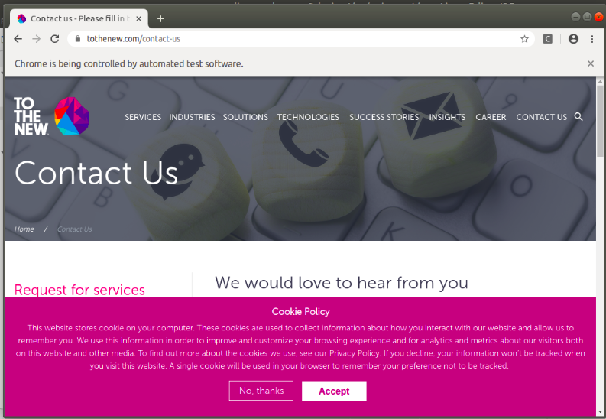

Q5. Write a script to get the title of the “Contact Us” page.
Code:
package assignment;
import org.openqa.selenium.By;
import org.openqa.selenium.WebDriver;
import org.openqa.selenium.chrome.ChromeDriver;
public class ques5 {
public static void main(String[] args) {
// TODO Auto-generated method stub
System.setProperty("webdriver.chrome.driver","/home/drishti/Desktop/selenium/chromedriver");
WebDriver driver =new ChromeDriver();
driver.get("http://tothenew.com");
driver.findElement(By.xpath("/html/body/div[1]/div/header[2]/div/div/nav/div[2]/ul/li[8]/a"));
System.out.println(driver.getTitle());
}
}

Output:
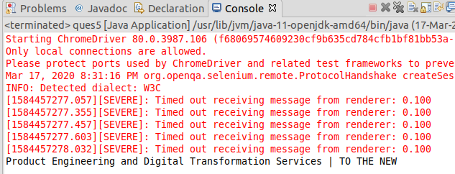

Q6. Write a script to get the url of the "Contact Us' page.
Code:
package assignment;
import org.openqa.selenium.By;
import org.openqa.selenium.WebDriver;
import org.openqa.selenium.chrome.ChromeDriver;
public class ques6 {
public static void main(String[] args) {
// TODO Auto-generated method stub
System.setProperty("webdriver.chrome.driver","/home/drishti/Desktop/selenium/chromedriver");
WebDriver driver =new ChromeDriver();
driver.get("http://tothenew.com");
driver.findElement(By.xpath("/html/body/div[1]/div/header[2]/div/div/nav/div[2]/ul/li[8]/a")).click();
System.out.println(driver.getCurrentUrl());
}
}

Output:
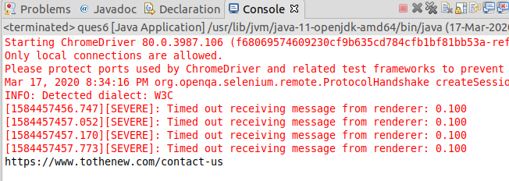

Q7: Write the disadvantages of selenium.
1. It supports web application only.
2. It is difficult to test image based application.
3. It can’t automate a captcha and OTP.
4. It is difficult to process pop-ups.
5. Selenium IDE does not support error handling.

Q8: Difference between get() & navigate() method
driver.get()
It is a function which is used to go to the particular website , but it doesn't maintain the browser History and cookies so, we can't use forward and backward button.
Eg: driver.get("http://www.google.com");
driver.navigate()
It is a function which is used to go to the particular website , but it maintains the browser history and cookies, so we can use forward and backward button to navigate between the pages during the coding of Testcases.
Eg: driver.navigate().to("http://www.google.com");

Q9. What is the difference between Selenium RC & Selenium WebDriver.
Selenium RC | Selenium WebDriver
It is a testing framework that enables a QA or a developer to write test cases in any programming language in order to automate UI tests for web applications against any HTTP website. | It is a web automation framework that allows you to execute your tests against different browsers.
It has a more complicated architecture. | It has a simpler architecture than that of Selenium RC, unlike Selenium RC it does not involve any proxy server and it controls the browser directly from the OS.
Test Script execution is slower. | Test Script execution is faster than Selenium RC as it makes direct calls to the browser using browser drivers for a particular browser.
Selenium RC uses a JavaScript program called Selenium core. It is the one that directly controls the browser.  Selenium RC needs the help of RC Server in order to talk to the browser. | Web Driver interacts with the page elements in a more realistic way.
It is more matured but contains redundencies and often confusing commands. | It does not contain redundant and confusing commands.

Q10. What are locators & types of locators in selenium
Locator is a command that tells Selenium IDE which GUI elements it needs to operate on. Selenium provides a number of Locators to precisely locate a GUI element.
The different types of Locators in Selenium IDE:
1. ID: This is the most comman way of locating elements since ID’s are supposed to be unique for each element.
2. Name: Locating elements bu name a very similar to locating by ID, except that we use the “name=” prefix instead.
3. Link Test: This type of locator applies to hyperlink texts. We access the link by prefixing our target with “link=” and then followed by the hyperlink text.
4. CSS Selector: Selectors are the string patterns used to identify an element based on a combination of HTML tag, id, class and attributes.
The various combinations are:
- Tag and ID
- Tag and class
- Tag and attribute
- Tag, class and attribute
- Inner text
5. Xpath: It is the language used when locating XML nodes. We can also use Xpath in locating HTML elements.

Q11. Write an automation script for filling all fields of the registration page. (Registration.html)
a- Validate that Refresh button is disabled.
b- Validate that your respective gender is selected or not.
c- Validate that header of the registration page is Automation Demo Site.
d- Validate that title of the page is Register.
Code:
package assignment;
import org.openqa.selenium.By;
import org.openqa.selenium.Keys;
import org.openqa.selenium.WebDriver;
import org.openqa.selenium.WebElement;
import org.openqa.selenium.chrome.ChromeDriver;
import org.openqa.selenium.support.ui.Select;
public class ques11 {
public static void main(String[] args) throws InterruptedException {
// TODO Auto-generated method stub
System.setProperty("webdriver.chrome.driver", "/home/drishti/Desktop/selenium/chromedriver");
WebDriver driver =new ChromeDriver();
driver.get("http://demo.automationtesting.in/Register.html");
driver.findElement(By.xpath("//input[@placeholder='First Name']")).sendKeys("Drishti");
driver.findElement(By.xpath("//input[@placeholder='Last Name']")).sendKeys("Talwar");
driver.findElement(By.xpath("//textarea[@class=\"form-control ng-pristine ng-untouched ng-valid\"]")).sendKeys("Dwarka Sector 12");
driver.findElement(By.xpath("//input[@type='email']")).sendKeys("drishti.talwar@gmail.com");
driver.findElement(By.xpath("//input[@type=\"tel\"]")).sendKeys("8373908033");
driver.findElement(By.xpath("//input[@value=\"FeMale\"]")).click();
driver.findElement(By.id("checkbox2")).click();
driver.findElement(By.id("msdd")).click();
driver.findElement(By.linkText("Korean")).click();
driver.findElement(By.linkText("Malay")).click();
driver.findElement(By.linkText("Italian")).click();
driver.findElement(By.id("basicBootstrapForm")).click();
Select skills=new Select(driver.findElement(By.id("Skills")));
skills.selectByValue("C++");
Select country=new Select(driver.findElement(By.id("countries")));
country.selectByValue("India");
driver.findElement(By.xpath("//b[@role]")).click();
driver.findElement(By.xpath("/html/body/span/span/span[1]/input")).sendKeys("Denmark");
driver.findElement(By.xpath("/html/body/span/span/span[2]/ul/li")).click();
driver.findElement(By.xpath("//select[@placeholder='Year']")).sendKeys("2014");
driver.findElement(By.xpath("//select[@placeholder='Month']")).sendKeys("October");
driver.findElement(By.xpath("//select[@placeholder='Day']")).sendKeys("7");
driver.findElement(By.id("firstpassword")).sendKeys("drishti123");
driver.findElement(By.id("secondpassword")).sendKeys("drishti123");
//Validate that Refresh button is disabled.
WebElement refreshButton = driver.findElement(By.id("Button1"));
if(refreshButton.isEnabled()) {
driver.findElement(By.id("Button1")).click();
System.out.println("Refresh button is enabled");
}else
{
System.out.println("Refresh button is disabled");
}
//Validate that your respective gender is selected or not.
System.out.println(driver.findElement(By.xpath("//input[@value=\"FeMale\"]")).isSelected());
// Validate that header of the registration page is Automation Demo Site.
String title = driver.findElement(By.xpath("//*[@id=\"header\"]/div/div/div/div[2]/h1")).getText();
System.out.println("Heading of page is: " +title);
// Validate that title of the page is Register.
String pageTitle = driver.getTitle();
System.out.println("Title of page is: "+pageTitle);
}
}
Output:
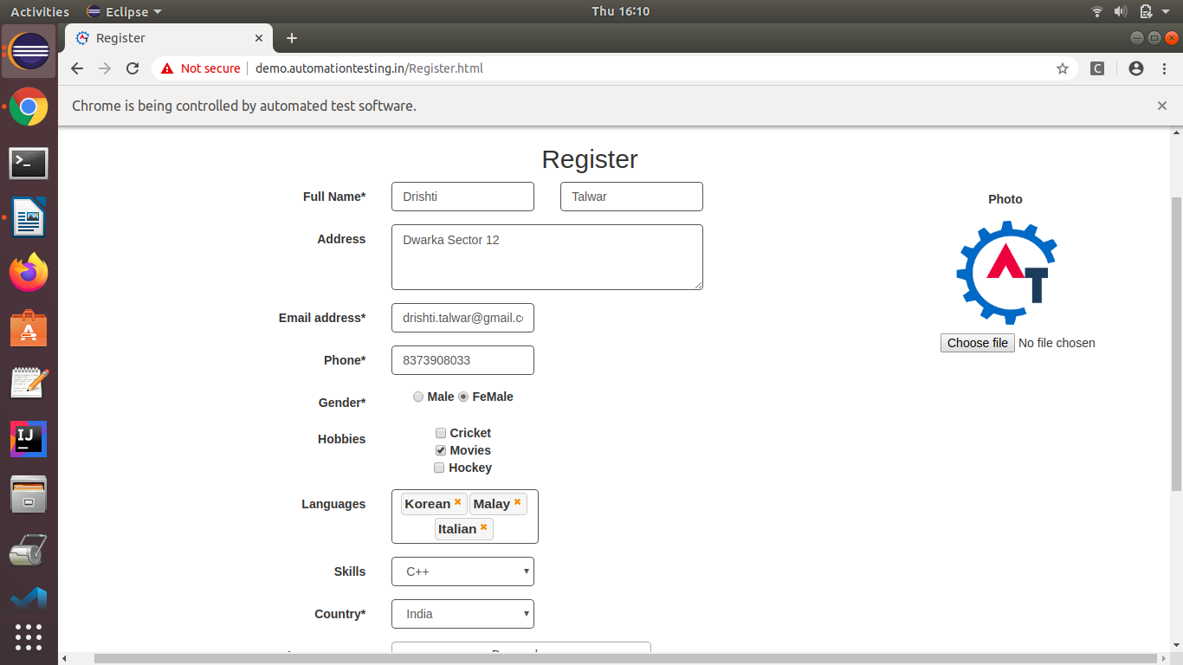
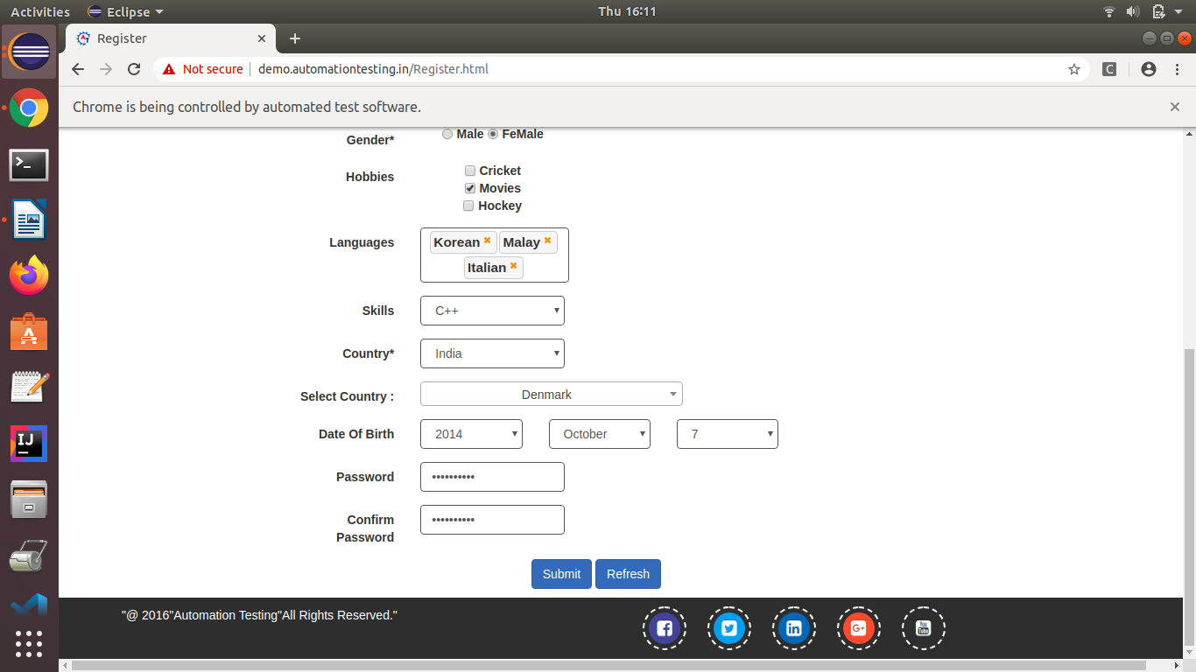
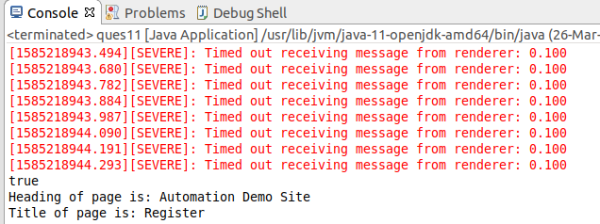
Q12. Write an automation script for filling FirstName, LastName & Email address field with the help of name locator. (Registration.html)
Code:
package assignment;
import org.openqa.selenium.By;
import org.openqa.selenium.WebDriver;
import org.openqa.selenium.chrome.ChromeDriver;
public class Ques12 {
public static void main(String[] args) {
// TODO Auto-generated method stub
System.setProperty("webdriver.chrome.driver","/home/drishti/Desktop/selenium/chromedriver");
WebDriver driver =new ChromeDriver();
driver.get("http://demo.automationtesting.in/Register.html");
driver.findElement(By.xpath("//input[@placeholder='First Name']")).sendKeys("Drishti");
driver.findElement(By.xpath("//input[@placeholder='Last Name']")).sendKeys("Talwar");
driver.findElement(By.xpath("//input[@type='email']")).sendKeys("drishti.talwar@gmail.com");
}
}

Output:
