HERCHOICE: EMPOWERING YOUNG WOMEN WITH STRUCTURED DECISION-MAKING SUPPORT

A PROJECT REPORT

BY

Drishti Chugh (S24BCAU0001)
Himanshi Gupta (S24BCAU0128)
Aisha Khan (S24BCAU0181)

SUBMITTED TO

SCHOOL OF COMPUTER SCIENCE ENGINEERING AND TECHNOLOGY, BENNETT UNIVERSITY
GREATER NOIDA, 201310, UTTAR PRADESH, INDIA

Under the Supervision of
Dr. Paawan Kumar

April 2026

DECLARATION
We hereby declare that the work presented in this report entitled "HerChoice: Empowering Young Women with Structured Decision-Making Support" is an authentic record of our own work carried out during the period from January 2026 to April 2026 at the School of Computer Science and Engineering and Technology, Bennett University, Greater Noida.
The matters and results presented in this report have not been submitted by us for the award of any other degree elsewhere.

Signature of Candidates

Drishti Chugh (S24BCAU0001)
Himanshi Gupta (S24BCAU0128)
Aisha Khan (S24BCAU0181)

ACKNOWLEDGEMENT
We would like to take this opportunity to express our deepest gratitude to our mentor, Dr. Paawan Kumar, for guiding, supporting, and helping us in every possible way throughout this project. We were extremely fortunate to have him as our mentor as he provided insightful solutions to the problems we faced, contributing immensely towards the successful completion of this capstone project.
We would also like to express our sincere gratitude to the faculty members and friends at the School of Computer Science Engineering and Technology, Bennett University, who helped us in the successful completion of this project. This work would not have been possible without the continuous encouragement and valuable feedback from all stakeholders involved.

Drishti Chugh
Himanshi Gupta
Aisha Khan

ABSTRACT
HerChoice is a guided mobile application designed to empower young women through structured, values-based decision-making support. The application addresses a critical gap in accessible, unbiased decision-support tools for young women navigating complex personal, academic, and professional choices. Decision paralysis, lack of reliable guidance, and emotional confusion are three significant barriers that prevent intentional, confident decision-making among this demographic.
HerChoice transforms emotional confusion into structured, confident decisions through a simple three-phase process: User Input (sharing the situation, mood, and values), Personal Analysis (evaluating options against priorities), and Tailored Suggestion (providing a decision path with a confidence plan). The app guides users through seven sequential steps — login, mood check-in, situation input, core values selection, option comparison, confidence plan, and final personalized output — completing a full decision session in under 10 minutes.
The application is built on a clean, intuitive purple-gradient UI with a focus on emotional support and user empowerment. Key benefits include reduced decision anxiety, enhanced self-awareness, and support for intentional, values-aligned choices. Future development plans include AI-driven personalization, journaling integration, community support, and multilingual accessibility, with the potential to expand the framework to career, education, relationships, and financial decisions.

TABLE OF CONTENTS
LIST OF TABLES .................................................................................................. iv
LIST OF FIGURES ................................................................................................ v
LIST OF ABBREVIATIONS ....................................................................................... vi
ABSTRACT ........................................................................................................ vii
1. INTRODUCTION ............................................................................................... 1
1.1 Problem Statement ....................................................................................... 1
2. BACKGROUND RESEARCH ................................................................................... 2
2.1 Proposed System ........................................................................................ 2
2.2 Goals and Objectives .................................................................................... 2
3. PROJECT PLANNING .......................................................................................... 3
3.1 Project Lifecycle .......................................................................................... 3
3.2 Project Setup ............................................................................................. 3
3.3 Stakeholders .............................................................................................. 4
3.4 Project Resources ........................................................................................ 4
3.5 Assumptions .............................................................................................. 5
4. PROJECT TRACKING .......................................................................................... 5
4.1 Tracking ................................................................................................... 5
4.2 Communication Plan ..................................................................................... 6
4.3 Deliverables ............................................................................................... 7
5. SYSTEM ANALYSIS AND DESIGN ........................................................................... 8
5.1 Overall Description ...................................................................................... 8
5.2 Users and Roles .......................................................................................... 8
6. USER INTERFACE ............................................................................................. 9
6.1 UI Description ............................................................................................ 9
6.2 App Flow Overview ....................................................................................... 9
7. ALGORITHMS / PSEUDO CODE .............................................................................. 10
8. PROJECT CLOSURE .......................................................................................... 11
8.1 Goals / Vision ............................................................................................ 11
8.2 Delivered Solution ....................................................................................... 11
8.3 Remaining Work / Future Scope ....................................................................... 11
REFERENCES ..................................................................................................... 12

1. INTRODUCTION
In an increasingly complex world, young women face a growing number of high-stakes decisions across multiple domains — from academic and career choices to personal relationships and lifestyle. Despite the significance of these decisions, accessible and structured decision-support tools designed specifically for this demographic remain scarce. Most available resources are either too generic, emotionally unsupportive, or inaccessible to those without formal training in decision theory.
HerChoice is a guided mobile application that addresses this gap by empowering young women to make structured, values-aligned decisions through an emotionally intelligent and easy-to-use digital platform. By combining mood awareness, personal values clarification, and comparative analysis, HerChoice transforms emotional confusion into confident, intentional choices.
This report documents the design, development, and evaluation of the HerChoice application, developed as a capstone project by students of Bennett University under the mentorship of Dr. Paawan Kumar.

1.1 Problem Statement
Young women today face three core challenges when making important decisions:
- Decision Paralysis: An overabundance of options combined with a lack of structured frameworks leads to anxiety and inaction. This is especially pronounced when navigating decisions about career, relationships, and personal growth.
- Lack of Guidance: Reliable, unbiased decision frameworks are rarely accessible to young women. Advice from peers or social media is often inconsistent, emotionally charged, and not grounded in individual values.
- Emotional Confusion: Without tools to process feelings and personal values, decisions become reactive rather than intentional. This undermines long-term confidence, self-awareness, and clarity.
HerChoice aims to solve these challenges by providing a structured, empathetic, and personalized digital decision-support tool.

2. BACKGROUND RESEARCH
Research in the field of decision-making consistently highlights the influence of emotions, cognitive biases, and contextual factors on the quality of choices made by individuals. Studies in behavioral psychology, such as those by Kahneman and Tversky (2000), demonstrate that structured decision-making frameworks significantly improve the quality and consistency of decisions, especially under emotionally charged conditions.
Literature on gender and decision-making further highlights that young women are disproportionately affected by social pressures, internalized expectations, and a lack of mentorship, all of which increase decision anxiety and reduce decisional confidence. Applications like mood trackers (e.g., Daylio), journaling apps (e.g., Reflectly), and general productivity tools (e.g., Notion) partially address these needs but none offer an integrated, guided decision-making workflow tailored for young women.
Existing decision-support tools in the market are primarily designed for enterprise or clinical settings and are not accessible to general users. There is a clear gap for a consumer-facing, emotionally intelligent, and values-driven decision-support application. This gap motivated the development of HerChoice.

2.1 Proposed System
HerChoice is a mobile application that guides users through a structured, three-phase decision-making process. The system captures the user's emotional state, situational context, and personal values to deliver a tailored decision path and a confidence plan. Unlike rule-based systems, HerChoice provides a flexible, user-driven framework that respects individual differences in priorities and emotional readiness.
The proposed system combines UI/UX best practices with evidence-based decision science to create an experience that is both supportive and empowering. HerChoice does not tell users what to do — it gives them the clarity and framework to decide for themselves.

2.2 Goals and Objectives

# | Goal or Objective
1 | Provide a clear, step-by-step decision-support framework that guides users through complex choices without overwhelming them.
2 | Tailor insights based on individual mood, values, and situational context, making every recommendation relevant to the user.
3 | Help users build lasting confidence and self-awareness by reinforcing reflective thinking over time.
4 | Deliver a fully functional mobile app prototype with a clean UI completing a full decision session in under 10 minutes.
5 | Establish a modular framework extensible to career, education, relationships, and financial decisions.

3. PROJECT PLANNING

3.1 Project Lifecycle
The team followed an agile development approach. Requirements were gathered and a high-level development plan was created at the onset of the project. Features were implemented iteratively over multiple sprints. A SCRUM-like approach was followed, with an emphasis on frequent team meetings, mentor reviews, and continuous collaboration between all team members.

3.2 Project Setup

# | Decision Description
1 | Platform: Mobile-first application (Android/iOS) with a purple gradient design theme.
2 | Tools: React Native / Flutter for frontend; Firebase for backend and user data storage.
3 | Coding standards: Clean code principles, modular component-based architecture.
4 | Version control: GitHub repository for source management and team collaboration.

3.3 Stakeholders

Stakeholder | Role
Dr. Paawan Kumar | Mentor and Technical Advisor
Drishti Chugh | Team Member — Lead Developer
Himanshi Gupta | Team Member — UI/UX Designer
Aisha Khan | Team Member — Research and Testing
Young Women Users (18–25) | Primary End Users

3.4 Project Resources

Resource | Description | Quantity
Development Laptops | Personal laptops used for coding, design, and testing. | 3
Mobile Test Devices | Android smartphones used for testing the application. | 2
Capstone Team | Three student developers and designers. | 3
Mentor | Dr. Paawan Kumar for technical and conceptual guidance. | 1

3.5 Assumptions

# | Assumption
A1 | Team members and mentor will meet weekly for sprint reviews and planning sessions.
A2 | Users have basic familiarity with mobile applications and can navigate the app without extensive training.
A3 | The team will have sufficient time to complete a working prototype for final demonstration.
A4 | User feedback collected during testing will be representative of the target demographic.

4. PROJECT TRACKING

4.1 Tracking

Information | Description | Link
Project Documents | Design documents and weekly reports stored in shared Google Drive. | Google Drive
Communication | Team coordination via WhatsApp group and weekly in-person meetings. | WhatsApp / In-person

4.2 Communication Plan

Meeting Type | Frequency | Who Attends
Team Standup | Daily (10 min) | Project team
Sprint Planning | Bi-weekly (start of sprint) | Project team and Mentor
Mentor Review | Weekly | Project team and Dr. Paawan Kumar
Sprint Retrospective | End of each sprint | Project team
Final Demonstration | End of project | Project team, Mentor, and Faculty Evaluators

4.3 Deliverables

# | Deliverable
1 | Functional mobile application prototype (HerChoice)
2 | UI/UX design mockups and wireframes
3 | Source code (GitHub repository)
4 | User testing results and feedback analysis
5 | Final project report (this document)
6 | Project presentation (PowerPoint slides)
7 | 3-minute demo video of the application

5. SYSTEM ANALYSIS AND DESIGN

5.1 Overall Description
HerChoice is a mobile application that operates through a linear, guided workflow. The user begins by logging in securely, then completes a mood check-in using emoji-based emotion selection. They describe their decision situation, select their core values from a curated set of priority cards, and compare their available options against those values. The system then generates a confidence plan and a personalized final recommendation.
The three-phase process at the heart of HerChoice — User Input, Personal Analysis, and Tailored Suggestion — is designed to be iterative and reflective. Each phase builds upon the previous, ensuring that the final recommendation is grounded in the user's own values and emotional context rather than external prescriptions. The app uses a clean purple-gradient design with minimal UI cards to maintain an emotionally supportive and aesthetically coherent experience throughout.

5.2 Users and Roles

User | Description
Primary User (Young Woman, 18–25) | A young woman navigating personal, academic, or professional decisions. She uses the app to clarify her values, evaluate her options, and build confidence in her choices.
Guest User | A first-time visitor who can explore the app flow before creating an account.
Registered User | A returning user with a saved profile who can access their decision history and previous confidence plans.
Administrator | A backend administrator who manages user accounts, monitors app performance, and ensures data security.

6. USER INTERFACE

6.1 UI Description
HerChoice features a clean, modern UI built around a soft purple gradient color theme. The design philosophy prioritizes emotional support and clarity. All screens use minimal UI cards, intuitive controls, and generous whitespace to avoid overwhelming the user. The color palette — soft purples and blues — was intentionally chosen to evoke calmness, trust, and empowerment.
Every screen is designed to be quick and intuitive. The entire decision session is designed to be completed in under 10 minutes, making the app suitable for use even during moments of high stress or time pressure. Key screens include the Login screen, Mood Check-In screen, Situation Input page, Core Values selection screen, Comparison screen, Confidence Plan screen, and Final Result screen.

6.2 App Flow Overview

Step | Screen | Description
1 | Login | Secure onboarding screen with a clean entry point and soft purple gradient background.
2 | Mood Check-In | Emoji-based emotion selection to capture the user's emotional state before proceeding.
3 | Input Situation | Clean text field for users to describe their decision context in their own words.
4 | Core Values | Priority cards that users select to define what matters most to them in this decision.
5 | Compare Options | Side-by-side comparison of options against the user's values with visual alignment indicators.
6 | Confidence Plan | Structured summary of the recommended decision path based on all user inputs.
7 | Final Output | Closing screen presenting the personalized decision result with options to restart or finish.

7. ALGORITHMS / PSEUDO CODE OF CORE FUNCTIONALITY
The following pseudo code describes the core decision-recommendation algorithm used by HerChoice to generate a personalized recommendation and confidence plan based on the user's mood, situation, values, and options:

Sample screenshot of code for first page is attached below:
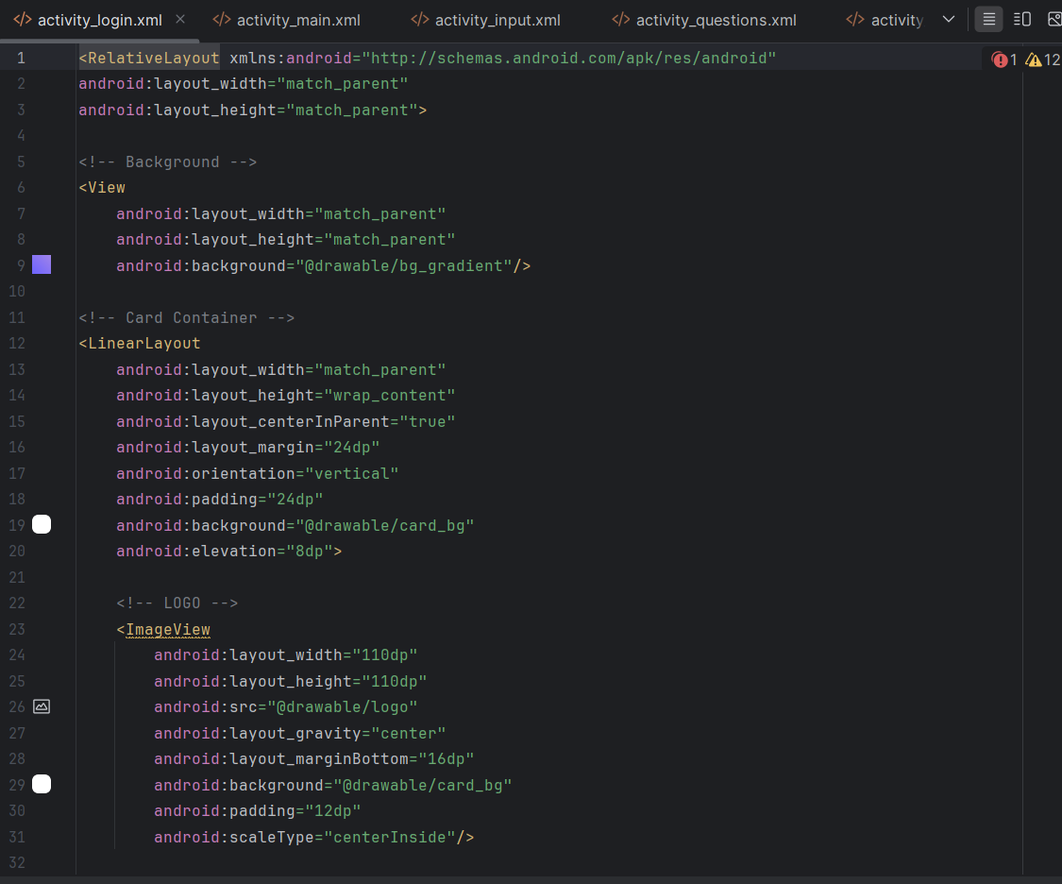

8. PROJECT CLOSURE

8.1 Goals / Vision
The original vision for HerChoice was to build a mobile application that could guide young women through complex personal decisions by combining emotional intelligence with structured decision-making frameworks. This goal was successfully realized. The application provides a clear, empathetic, and structured pathway through decision paralysis, emotional confusion, and value misalignment — the three core challenges identified at the project's inception.

8.2 Delivered Solution
The delivered solution is a fully functional mobile application prototype that implements the complete HerChoice decision flow across seven screens. Key deliverables include:
- A working mobile prototype with a purple-gradient UI theme and minimal card-based design.
- A seven-step guided decision workflow covering mood check-in, situational input, value selection, option comparison, confidence planning, and final recommendation.
- A values-based scoring algorithm that generates a personalized recommendation and confidence plan based on user inputs.
- A modular application architecture designed for future extensibility across multiple decision domains.

8.3 Remaining Work / Future Scope
While the current prototype successfully demonstrates the core HerChoice experience, several enhancements are planned for future development phases:
- AI-driven personalization using machine learning to improve recommendation accuracy over repeated use and refine suggestions based on historical decision patterns.
- Journaling integration to allow users to reflect on past decisions and track their personal growth over time.
- Community support features, including peer decision-sharing groups and access to mentor connections.
- Multilingual accessibility to serve a broader, more diverse user base across different linguistic communities.
- Expansion of the decision framework to cover career, education, financial decisions, and relationship choices, making HerChoice a comprehensive life-navigation tool.

REFERENCES
1. Kahneman, D., & Tversky, A. (2000). Choices, Values, and Frames. Cambridge University Press.
2. Schwartz, B. (2004). The Paradox of Choice: Why More Is Less. Ecco Press.
3. Gigerenzer, G., & Gaissmaier, W. (2011). Heuristic Decision Making. Annual Review of Psychology, 62, 451-482.
4. Loewenstein, G., & Lerner, J. S. (2003). The role of affect in decision making. In R. J. Davidson, K. R. Scherer, & H. H. Goldsmith (Eds.), Handbook of Affective Sciences. Oxford University Press.
5. Simon, H. A. (1955). A behavioral model of rational choice. The Quarterly Journal of Economics, 69(1), 99-118.
6. Daylio App. (2023). Retrieved from https://daylio.net
7. Reflectly App. (2023). Retrieved from https://reflectly.app

