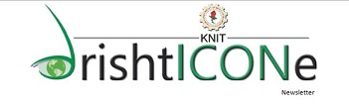

This is to inform all the students that recruitment for the various departments of DRISHTICONE, our very own newsletter, is scheduled to be held on 10th and 11th February, 2016. All the students interested are cordially invited.

The various departments of DRISHTICONE are:

1. Management Department

2. Literary Department

3. Designing Department

4. Web Designing Department

5. Photography Department

Note: The students interested to be a part of Literary team have to submit an article on any issue related to college in not more than 500 words. Articles can be on any issue like WIFI, WATER SCARCITY, etc. Submit the articles by **5th February, 2016** on the following link:

[**www.drishticone.org**](http://www.drishticone.org)

**You can also submit the hard copy.**

**-TEAM DRISHTICONE**

**Aryabhatt Hostel**

**Room No-F-I-14**